Project Overview

Project Overview and Background

Overview of the application
This document describes the Interest Rate Swap Instrument application being developed. An agreement between two parties where one stream of future interest payments is exchanged for another based on a specified principal amount. Interest rate swaps often exchange a fixed payment for a floating payment that is linked to an interest rate (most often the LIBOR). A company will typically use interest rate swaps to limit or manage exposure to fluctuations in interest rates, or to obtain a marginally lower interest rate than it would have been able to get without the trader.
With this application the bank can replace the existing costlier banking solutions such as manual registration, deal booking, currency data etc. to an automatic and easily accessible system. The admin who will control the entire application can register a new trader.
The registered trader will then be able to check the existing trades, see the done deals and book the new deals. The trader would be helped by the Cash Flow Table and The Cash Flow Graph. Also, the trader would be able to access risk associated with the interest rate swap. The Trader Hierarchy would be implemented so that the trader gets to be answerable to the superiors and the risk can be minimized.
This application is built using J2EE Technology which makes use of the following technologies.
(i) Oracle – To connect to Database
(ii) Spring Framework
(iii) Apache Tomcat Server
The backend (database) used is Oracle. Database is present separately in application folder App_data. The project also has a separate database layer class in App_Code in which all the code for opening a connection to the database, inserting the data into the database and returning the data from the database either as a data-set or as a data-table is written which reduces the redundancy of code.

Users of the application
There can be two types of users who will be accessing this application. They are Admin and the Registered Trader.
The Admin will create a trader. Trader will do different trades. The Admin would be responsible to maintain the entire database for the currency and the dates on which the settlements could happen. All the instruments that are to be used in the application would be put up by the Admin. The Admin would be responsible for the creation of customer who wants to go in for an Interest Rate Swap.
The Trader once assigned the trade would be responsible for it. The trader according to the risk analysis and the cash flow tables/graphs would then take a decision whether to go forward or not on the Interest Swap. The trader would be assigned a unique trader Id.

Functional Requirements

Scope of Work
The Application will help the bank in automating the manual system for the Interest Rate Swap Instrument traded in the market. There will be two main persons who would work on the application who are the Admin of the application and the Trader who would use the data provided by the Admin to decide whether to go for a swap or not. The Admin will have exclusive rights over the entire application and the traders would be the normal employees who would work for the completion of the request. In depth Risk Analysis and Cash Flow would be shown to help the trader in making the correct decision. The trader through this application would help the customer to get his requirement fulfilled of the Interest Rate Swap.

System Features

Requirement / Module / Use-case for Admin Log-in

Description
This use-case describes the Login page functionality.
REQ-101: Login page has two fields and one button and one link for forgot password.
REQ-102: The Username field is marked mandatory
REQ-103: The Password field is marked mandatory
REQ-104: Employee clicks on Login button after entering valid Username and Password and will be navigated to Home page.

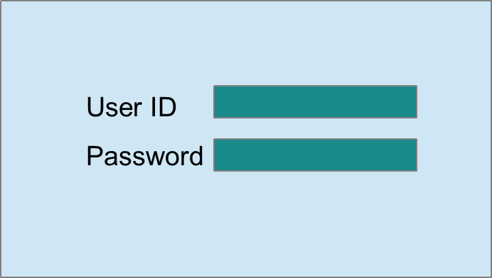

Screen Prototype

Screen Flow / Business Flow & User Actions
User enters the “username” and “password”
Logs-in to the respective home page.
Clicks on “Login” Button
If validated

Business Rules & Validations
The business rule to be considered while entering this screen is, the user must be connected to the website.
The business rule to be considered while moving to the next page is that the username and password should be entered and both the fields should be valid, if they are valid only, after clicking on the login button the user will be navigated to the next page.

Requirement / Module / Use-case for Static and Market Data

Description
This use case describes Data.
REQ-501: Inside Static data we have a button for adding trader.
REQ-502: Inside Static data we have a button for editing existing trader info.
REQ-503: Inside Static data we have a button for deleting trader from the system.
REQ-504: Inside Market Data we have separate options for uploading/viewing/editing/publishing and deleting Market Data.
REQ-505: The file format for Market data can be .xls only.
REQ-506: Market data can be uploaded by the admins only
REQ-507: Once uploaded the admin can view the data and send it to the trading manager for approval.
REQ-508: Market data can be viewed by the admins and traders
REQ-509: Drop down will be provided to view the market data
REQ-510: Market Data can be edited by the admin only
REQ-511: Market Data can only be approved and published by the Trading manager
REQ-512: A free text field would be provided for entering the type of market data (LIBOR, MIBOR etc.)
REQ-513: Version control of market data needs to be done.

Screen Prototype
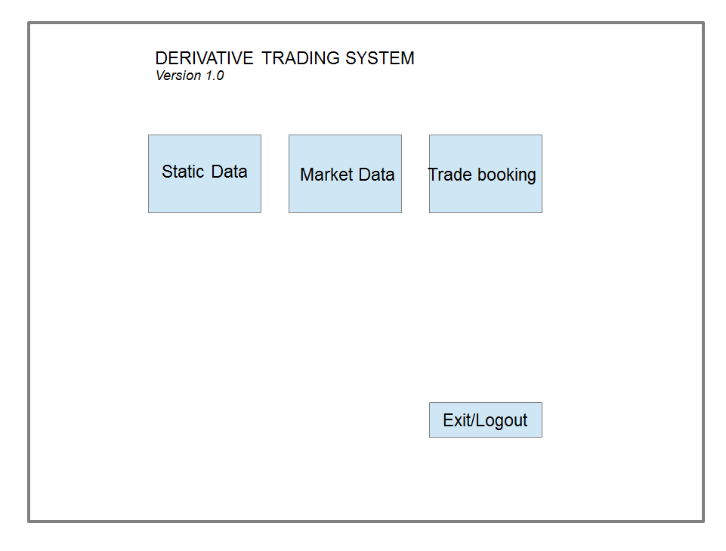

Main Page
Logout
Currency
Counterparty Data
Calendar
Create
Edit
Delete
Create
Edit
Delete
STATIC DATA

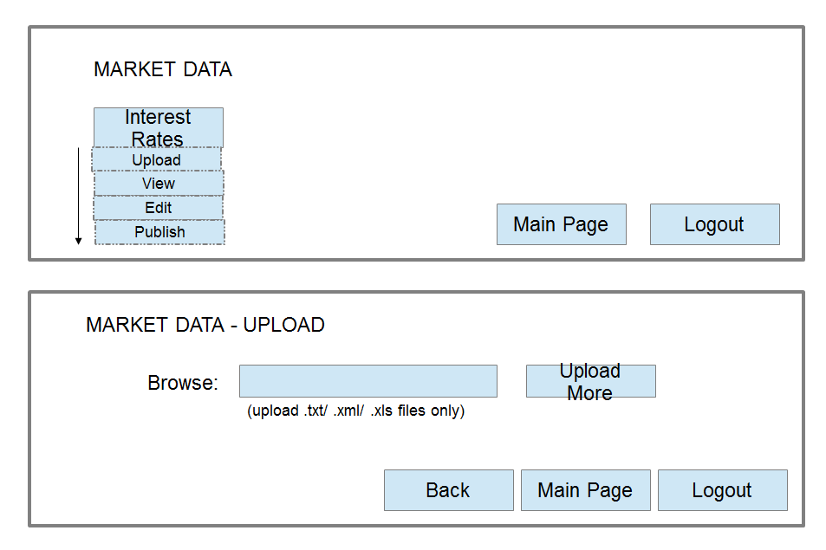
Requirement / Module / Use-case for Counterparty Creation

Description (Customer personal details)
This use-case describes the Customer Creation page functionality.
REQ-201: New user can be created by the admin. A creation page will be displayed with 12 fields and one button which is filled by the admin.
REQ-202: Customer Id field is will be auto assigned by system...
REQ-203: First Name field is mandatory.
REQ-204: Last Name field is mandatory.
REQ-205: Date of Birth field is mandatory.
REQ-206: Address field is mandatory and will be divided into multiple sub fields.
REQ-207: Phone Number field is mandatory.
REQ-208: State field is mandatory.
REQ-209: Pin code (Zip) field is mandatory.
REQ-210: The Country field is mandatory.

2.2.5.2 Screen Flow / Business Flow & User Actions

Admin enters all the details required in the registration page
New Customer is registered.
Clicks on “Register” Button
Checks for validations

2.2.5.3 Business Rules & Validations
The business rule to be considered while entering this page is the user must be connected to network and the user must click on Sign-In link.
The business rule to be considered while moving to next page is that all the mandatory field values must be filled by the user and the data in all the fields should be valid. Requirement / Module / Use case for Currency

CUSTOMER CREATION
Name:
Country:
Address1:
Bank Details:
Main Page
Logout
Back

2.2.5.4 Customer’s Bank Details

This use case describes the Bank Data of customer
REQ-1901: Admin has privilege to Access Bank related data
REQ-1902: Two dropdown tabs will be displayed namely view and edit under the bank data tab.
REQ-1906: This page has a main page option
REQ-1907: This page has a 'go back to previous menu' option
REQ-1908: Bank Name is mandatory and non-editable
REQ-1910: Nostro account information of the Bank is mandatory
REQ-1911: Desk code is mandatory
REQ-1912: Treasury information is mandatory
REQ-1913: Successful registration will be done after clicking 'Submit' Button
REQ-1914: Admin can edit the Bank related data
REQ-1915: Bank name cannot be edited
REQ-1917: Country with which is associated is mandatory field
REQ-1918: Bank address field is mandatory
REQ-1919: Branch name is mandatory
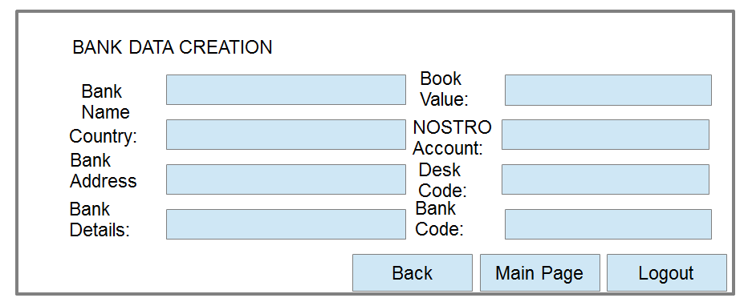

Exit/Logout
Main Page
Bank Details
Customer Details
COUNTERPARTY DATA
Bank and Branch Details
BANK_ID:
NOSTRO_ACCOUNT:
BANK_NAME:
BANK_LEGAL_ENTITY:
DESK_CODE:
MICR_CODE:
BANK_ZIP_CODE:
BANK_ADDRESS:
BANK_CITY:
BANK_COUNTRY:

Requirement / Module / Use-case Currency module
This use case describes the Currency
REQ-1701: Currency tab has three drop down menu
REQ-1705: User navigates to respective tab by clicking on any one of the tabs provided on the currency tab
REQ-1706: New currency can be added by clicking on add new currency drop down.
REQ-1707: Currency description field is mandatory
REQ-1708: Currency code field is mandatory
REQ-1709: Currency symbol field is optional
REQ-1710: Country in which currency is used field is mandatory
REQ-1711: The admin can also update currency details
REQ-1712: Currency tab provides a button to navigate to previous page
REQ-1714: User removes the added currency by clicking on delete button
REQ-1716: Oracle data server is required.
REQ-1717: The response time of the system is approximately 1-2 seconds.
REQ-1718: A successful message must be displayed upon addition or else an error message must be displayed
REQ-1719: A successful message must be displayed after editing or else an error message must be displayed
REQ-1720: While editing records the non-changeable data should not be edited

CURRENCY CREATION
Currency Code:
Country:
Currency Name
Currency Symbol:
Currency Description:

Back

Requirement / Module / Use case for Calendar

Description

This use case describes the Calendar
REQ-1801: Calendar page has Country drop down
REQ-1803: Text box for entering event description
REQ-1805: Month wise display of calendar
REQ-1806: Arrow button for navigation between months
REQ-1807: Description will be displayed below the Date on the calendar
REQ-1809: Govt. Holidays, Market Holidays will be separately marked
REQ-1810: Calendar date will be displayed DD/MON/YYYY
REQ-1811: Holidays list will be generated country wise

Requirement / Module / Use case for Bank Data

Description
This use case describes the Bank Data
REQ-1901: Admin has privilege to Access Bank related data
REQ-1902: Two dropdown tabs will be displayed namely view and edit under the bank data tab.
REQ-1903: A page with all the branches of the bank will open. Upon selecting a branch a new page will open having details of the branch.
REQ-1904: The branch page will also have create new and delete branch option.
REQ-1905: Branch detail page will open asking details about Bank related data of the branch
REQ-1906: This page has a main page option
REQ-1907: This page has a 'go back to previous menu' option
REQ-1908: Bank Name is mandatory and non-editable
REQ-1909: Bank Book is mandatory
REQ-1910: Nostro account information of the Bank is mandatory
REQ-1911: Desk code is mandatory
REQ-1912: Treasury information is mandatory
REQ-1913: Successful registration will be done after clicking 'Submit' Button
REQ-1914: Admin can edit the Bank related data
REQ-1915: Bank name cannot be edited
REQ-1916: Admin can delete any branch related data
REQ-1917: Country with which is associated is mandatory field
REQ-1918: Bank address field is mandatory
REQ-1919: Branch name is mandatory

Requirement / Module / Use-case for Trader creation

Description
This use case describes about the Trader creation.
REQ 401: Separate login credentials need to be created for trading managers
REQ-402: Name of the trader is a mandatory field. It has to be entered with all
the validation checks.
REQ-403: Date of joining is a mandatory field. Date of joining should not be a Saturday or Sunday. Calendar would be provided for this.
REQ-404: Date of birth is a mandatory field. It has to be entered with all the validation checks. Calendar would be provided for this.
REQ-405: Email-ID field is mandatory.
REQ-406: Phone number is mandatory. It has to be entered with all the validation checks.
REQ-407: Secondary phone number is optional. It has to be entered with all the validation checks.
REQ-408: Address field is mandatory. (House No., Street No., City, State). It has to be entered with all the validation checks.
REQ-409: Pin code is mandatory. It has to be entered with all the validation checks.
REQ-410: A role field (Trader or trading manager) will be a dropdown while creating a new trader
REQ-411: Trading manager has to be assigned to every trader. (Drop down)
REQ-412: A unique auto generated trader username and password would be provided to each trader on successful registration.
REQ-413: Username and password will be automatically mailed to the trader.
REQ-414: A field for specifying the maximum limit a trader can trade in a single day has to be provided.

Business Rules & Validations
The business rule to be considered while entering this screen is the user must click on Create
The business rule to be considered while navigating to the next page is the admin must fill all fields.

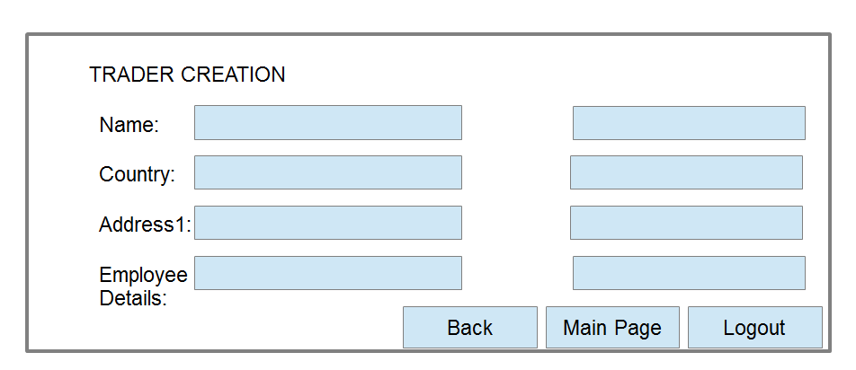

Requirement / Module / Use-case for deleting Trader

Description
This use case describes deletion of Trader.
REQ-601: Trader info can be deleted by entering either the trader username or name
REQ-602: Auto fill functionality would be provided for deleting.
REQ-603: On selecting the trader to be deleted control would be directed to another screen containing all the trader info.
REQ-604: The delete button on this screen would delete the trader from the system.

Requirement / Module / Use-case for Trader Login

Description
This use-case describes how to navigate to Logged-in Home.
REQ-301: Trader navigates to any page by clicking on any one of the links provided on top of the Home page.
REQ-302: Trader can navigate to some pages where he can do assigned works.
REQ-303: Employee clicks on logout button given on top of any page and his session will be closed.

Screen Flow / Business Flow & User Actions

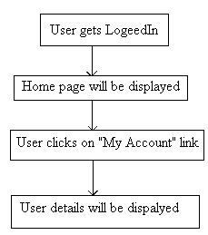

Business Rules & Validations
The business rule to be considered while entering this page is the user must Login.

Requirement / Module / Use case for Forgot Password

Description
This use case describes the Confirmation of Booking
REQ-1501: Forgot Password page has one field and two buttons.
REQ-1502: The field requires the user to enter his emailid/user id
REQ-1503: The button 1 is 'Next' that enables him to move to next screen.
REQ-1504: The button 2 is 'Cancel' that gives him an option to cancel and go back to login screen.
REQ-1505: User Id/Email ID field is mandatory.
REQ-1506: The answers to the security questions are to be added on whose matching the new random password will be sent to the email and that will be updated to the database
REQ-1507: The User can then login through that password and changes his/her password by clicking the button on the Home Screen.

Requirement / Module / Use case for Trader Home

Description
This use case describes the Trader Home Page
REQ-1601: Trader Home page has three navigable labels and two buttons.
REQ-1602: The three labels are 'Previous Deals', 'Ongoing Deals', 'Book new Deal'.
REQ-1603: The two buttons are 'Change Password' and 'Log Out'.
REQ-1604: When the user clicks on the 'Previous Deals' label, he/she will be navigated to the concerned page that displays the details of his past deals.
REQ-1605: When the user clicks on the 'Ongoing Deals' label, he/she will be navigated to the concerned page that displays the details of his ongoing deals.
REQ-1606: When the user clicks on the 'Book Deal' label, he/she will be navigated to the concerned page that will enable him to book a new deal.
REQ-1607: On clicking the change password button, he will be directed to a page that will enable him to change his existing password.
REQ-1608: On clicking the 'Log Out' button; he will be signed out of the application.
REQ-1609: On clicking the ‘RISK’ button; he will be directed to the risk analysis page

Requirement / Module / Use case for Deal Booking

Description
This use case describes the Deal Booking
REQ-1201: Option to select type for floating rate. (LIBOR.GBP, MIBOR etc.). The rate is quoted with currency type.
REQ-1202: Dropdown for Stub Length (3M, 6M etc.)
REQ-1203: Display the Bid and Ask Quotes, as generated by the PAR SWAP Analysis
REQ-1204: Option to select one of the Quotes and Bid/Ask, from comparison for multiple tenures.
REQ-1205: Option to enter the Notional Amount in text field.
REQ-1206: Button to next page, which will take us to the economic details page of trade booking.
REQ-1207: Bid and ask quotes are compared for different tenures during the trade booking

Requirement / Module / Use-Case For At Par Value Swap

Description
This use case describes calculation of at par value of swap
REQ-701: Market Data (LIBOR and MIBOR rates for different currencies and different durations) will be retrieved from database.
REQ-702: The At PAR value will be calculated using this market data for all possible combinations of stub frequency and tenure.
REQ-703: Bid and ask rates will be calculated based on the par value and the spread, which will be customizable for each par-value calculated.
REQ-704: The entire programming will be done in a batch at a fixed time everyday using a scheduler.
REQ-705: The ask and bid rates are then stored in the database and can be accessed from the trader deal booking module.

Requirement / Module / Use case for displaying Non-Economic Details

Description
This use case describes the Confirmation of Booking
REQ-1401: Trade ID is mandatory, and generated by the system.
REQ-1402: Trader ID is mandatory
REQ-1403: Trade Date is mandatory
REQ-1404: Bank Book entry is mandatory
REQ-1405: Bank Legal Entity is mandatory
REQ-1406: Customer ID is mandatory
REQ-1407: Settlement/Confirmation Advice type is mandatory
REQ-1408: Button is provided to return to the Deal Booking Screen
REQ-1409: Button is provided to return to Exit/Logout Deal Booking
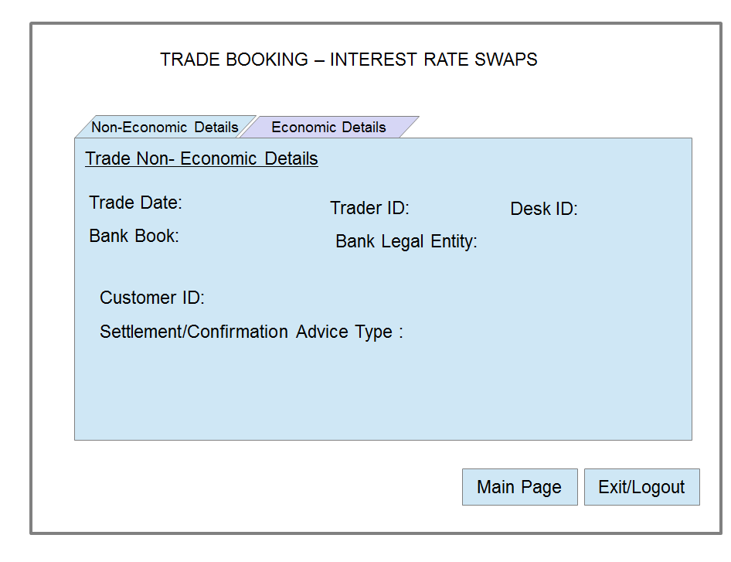

Requirement / Module / Use case for displaying Economic details

Description
This use case describes the Settlement.
REQ-1301: Trade Date is mandatory
REQ-1302: End Date is mandatory.
REQ-1304: Option to generate Cash Flow Table and Graph for the two legs
REQ-1306: Currency Field is mandatory for both legs
REQ-1307: Day count convention should be displayed for both legs, fixed at 30/360
REQ-1308: Notional Amount is mandatory for both legs
REQ-1309: Interest Rate Benchmark Field is mandatory for Leg1
REQ-1309: Fixed Rate is mandatory for Leg2
REQ-1310: Holiday Calendar ID should also be displayed
REQ-1311: Settlement frequency is mandatory
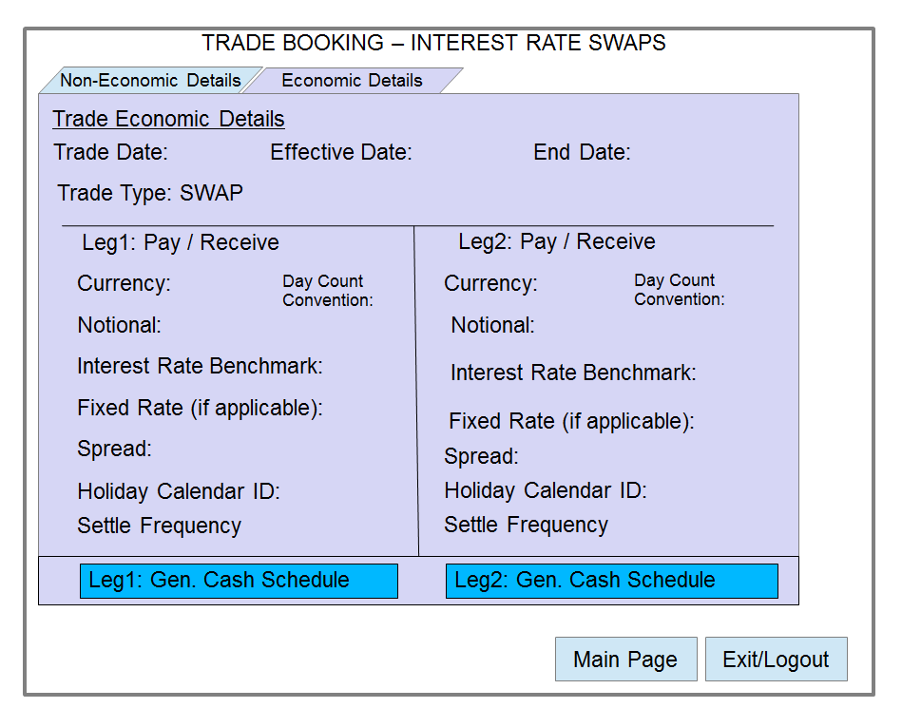
REQ-1312: Confirm trade button, which will store the details in the database.

Requirement / Module / Use case for Cash flow

Description
This use case is used to guide about Cash flow.
REQ-901: The 'Gen cash Flow Schedule' will lead to the Cash Flow Screen.
REQ-902: The Cash Flow screen will have 'Trade ID' in the left-right top corner of the screen.
REQ-903: Cash Flow screen has a table displaying cash flows along with other relevant information.

Requirement / Module / Use case for Cash flow table

Description
This use case describes the Cash Flow Table.
REQ-1001: This Cash Flow table is typically identified by the Trade ID.
REQ-1001: The table will have several columns.
REQ-1002: first column is Trade ID
REQ-1003: second column is Stub No.
REQ-1004: third column is Cash Flow.
REQ-1005: fourth column is Payment Date.
REQ-1006: fifth column is Currency Code.
REQ-1007: sixth column is Rate Value.
REQ-1012: Cash Flow will be generated for each stub, based on the market data received at the end of every stub.
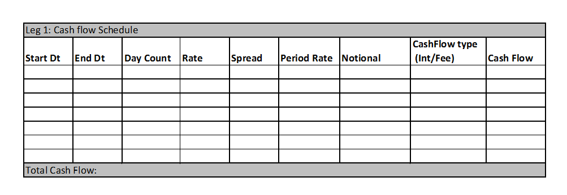

Requirement / Module / Use case for Cash flow graph

Description
This use case describes the Cash Flow Graph.
REQ-1101: At the bottom right corner of the screen there will be an option to generate the trade graph
REQ-1102: When we click the trade graph option another window will be generated with the trade graph.
REQ-1103: The graph will show the time duration on the horizontal axis with marked intervals for every stub.
REQ-1104: The vertical axis will show the cash flow amount.
REQ-1105: The currency of every trade's cash flow will be displayed on the cash flow graph screen via its currency symbol.

Requirement / Module / Use-case for Risk

Description
This use case describes Risk
REQ-801: Risk Analysis Button on two screens-Home page and Trade Booking which points to the Delta Table page.
REQ-802: Delta Table contains two tabs: Deal-vise and Currency-vise.
- Deal-vise has table with Deal ID as columns and Date as rows.
- Currency-vise has table with Currency as columns and Date as rows.
REQ-803: Delta Table Description:
- Contains delta values for the IRS Deals which are calculated by taking PV of the discounted cash flows of every stub.
- Delta value calculation by varying the floating rates by 1 basis point and using the same values for Projection Curve as well as Discounting Curve.
- Deal-vise delta values are addable across both rows and columns, while Currency-vise delta values are addable across rows.
REQ-804: Net Value of deltas (across deals and settlement dates) of all transactions is also displayed.
REQ-805: When the deal is booked the delta table is updated.

3. Stakeholders

The following comprises the internal and external stakeholders whose requirements are represented by this document:

 | Stakeholders
1. | RBS MENTORS
2. | POLARIS TRAINER
3. | RBS GRADUATE TRAINEES

4. Key Assumptions and Constraints

# | Assumptions
 | Admin is preregistered bank employee
 | All traders are bank employee
 | Admin has all details of a bank employee to be registered as a trader
 | Currency value is static during the transaction period
 | Admin can only set the static data
 | Admin has all the details of the bank , currency and calendar
 | Bank is the counterparty.
 | Trader can view only the deals booked by him or his subordinates.
 | Cash flow for each stub will be calculated based on the market data of floating rate on that particular staring stub date
 | Stub duration is to be taken as 3, 6 and 12 months only.
 | Cash flows are being generated from the perspective of the bank
 | Loss will be represented by a negative amount
 | Cash flow graph is generated for a particular trade for entire tenure
 | Projection and discount curves are the same
 | The trade date and effective date are same. Thus the IRS will become active as soon as the trade is confirmed and cash flows will take place at the end of each stub. This was done to reduce calculation done on par swap
# | Constraints
 | Upload file format (market data)
 | Upload file size(market data)
 | Bank Name can’t be changed
 | Currency code is also not changeable
 | Automatic updation of records are not implemented
 | Notional amount is to be same for both parties
 | Market data is updated only once a day
 | Cross currency swaps are not allowed
 | Notional should be a multiple of thousand

