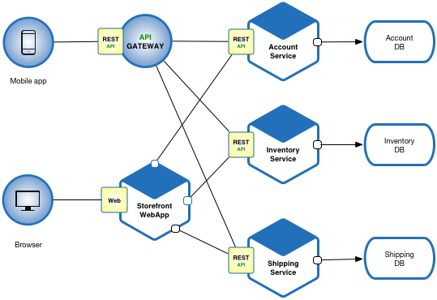

Models Required

Inventory Service

Product

Category

Location

Supplier

Field simple or composed

Simple

Price

Id

Composed

Date

Detail

==================================

Category

Category Id

Name

Created Date

Created By

Modified Date

Modified By

Status

Product

Product Id

Name

Product Description

SKU

Product Description (Value Object)

Purchased Date

Expiry Date

Cost

Buffer Level