**Virtusa Corp.**

2000 West Park Drive

Westboro, MA 01581

Phone : (508) 389-7300

Fax : (508) 366 9901

E-mail : [info@virtusa.com](mailto:Info@techprov.com)

URL : [www.virtusa.com](http://www.techprov.com)



**Detailed Software Requirements Specification (DSRS) for**

**Vcarpooling**

Table of Contents

1. Introduction 3

1.1 Purpose: 3

1.2 Scope: 3

1.3 Overview: 2

2 Project Vision: 4

2.1 Problem Statement: 4

2.2 Statement of Business Need: 4

3 Current Business Process 5

3.1 Current Process Flow: 5

3.2 Limitations of the Current Process: 5

4 Business Requirements: 5

4.1 Proposed Process Flow: 4

4.2 Assumptions and Constraints 6

4.3 Sample Screens : - 7

4.3.1 HOME PAGE 8

4.3.2 HOME -- Search PAGE : 8

4.3.3 USER – POFILE PAGE 9

4.3.4 USER PROFILE – REMAING PAGES 10

# Introduction

## Purpose:

## The purpose of V-carpooling is the sharing of car journey so that more than one person/employee can travel in a car. The greatest advantage of carpooling is the feeling of relaxation while reaching to office. You don’t need to struggle all the way driving to office and feel relaxed - No Parking / Traffic tensions. The feeling of relaxation rejuvenates you to start your work natural fresh. And also Carpooling reduces the costs involved in car travel by sharing journey expenses between the employees travelling. Carpooling is also seen as a more environmentally friendly and sustainable way to travel as sharing journeys reduces carbon emissions, traffic on the roads, and the need for parking spaces. So it builds virtual relationships in our organization among the people commuting.

## Scope:

In this V-carpooling any virtusan who own a car can offer to share his/her car. And any other virtusan who wants to use this service can search for journey through this portal. After finding a match they will contact and carry out their journey as planned

## 1.3 Overview:

In this project we provide an automated system replacing the manual work which includes contacting each other who wants to provide the car and who wants to use that car. Without registration users can explore car pool data. If they want to use the services they have to register. In the create Pool they have to select pool type Rider/provider, start time, return time, origin, destination. If they found any matches as per their requirements they can contact the user using this site a mail will be sent to their Email Ids.

# Project Vision:

## Problem Statement:

|  |  |
| --- | --- |
| **The Problem** | In organization if anyone wants to share the car manually it is difficult to find the carpool partner as per user’s requirement.  By this site anyone can find carpool partner easily as per their requirements. |
| **Stakeholders** | Employees |
| **Impact** | you to start your work natural fresh and traffic problems on the roads, and the need for parking spaces |
| **Key Benefits** | Automation, Quick Intimation through generating mails |

## 2.2 Statement of Business Need:

This project will be developed keeping in mind the problems faced by the employees to plan journey. The current scenario requires the employees to manually gather and discuss regarding the journey planning, which is solved in the developed project by automating the above specified functions and making their task easier.

**2.3 Project Objectives:**

The project objective is to make the entire program automotive that is for sharing and requesting .one can find available carpools using search option and they can use those services.

# Current Business Process

## Current Process Flow:

In this project, we provide an automated system replacing the manual work which includes contacting the each other who wants to share the car and use that car.

Here employees has to register in this portal and they have to login as per their requirements. Owners have to enter their journey details. According to these details users can search and contact the provider for the car. Without registration also users can search for the available of cars.

## Limitations of the Current Process:

The present system involves the manual work which includes contacting each other who wants to share the car and who use that car and to arrange details for the journey.

# Business Requirements:

In our project, we will be having following requirements.

## Proposed Process Flow:

**Employee:**

**Register:**

User has to register into Car pooling system for further process. User can able to edit/delete his profile details.

**Login:**

User has to first login to the Car pooling system using his/her

Employee id and Password.

**Providing Details:**

User has to enter his/her journey details like whether he is a provider/rider origin, destination and starting time to create a carpool. User can able to edit/delete/active and deactivate his pool details.

**Search:**

Without registration also user can search for the availability of cars to

His/ Her destination. After finding matches he/she has to register in the

Carpool system to contact the person.

## Technology Stack

|  |  |
| --- | --- |
| Presentation Layer | HTML, CSS3, JSP with JSTL tags, jQuery for DOM/Form-Validation/AJAX Calls |
| Server Side | Spring MVC, Spring JPA (w) ORM, Spring Security(username & Token) |
| Application Server | Tomcat 8 |
| Database | MySQL 8 |
| IDE | Eclipse STS |
| JDK | Oracle JDK 8 64b |
| Build Management | Maven 3 |
| Unit Testing | jUnit 5 |
| Mapping Solution | Google Maps & API |

## Quality Attributes

|  |  |
| --- | --- |
| Security | SSL for Transport Layer  Username/Token(hashed) for User Security  Role based Authorization Privileges  Sensitive data @Session/@Request to be protected for integrity (ex Shopping Card Data, User Data, User Session etc) |
| User Base | |  |  |  | | --- | --- | --- | | Employee Apps | | | | Total users | Concurrent Users | Y0Y Growth % | | 20000 | 10000 | 15% |  |  |  |  | | --- | --- | --- | | Faculty Apps | | | | Total users | Concurrent Users | Y0Y Growth % | | 100 | 25 | 20% | |
| Performance | Peak Load Performance (during Festival days, National holidays etc)  eCommerce -< 3 Sec  Admin application < 2 Sec  Non Peak Load Performance  eCommerce < 2 Sec  Admin Application < 2 Sec |
| Availability | eCommerce – 100% Availability  Admin Application – 99% Availability |
| Standard Features | * Scalability * Maintainability * Usability * Availability * Failover |
| Logging & Auditing | * System should support logging(app/web/db) & auditing at all levels |
| Monitoring | * Should be able get monitored via as-is enterprise monitoring tools |
| Cloud | * The Solution should be made Cloud ready, and should have minimum impact when move away to Cloud in infrastructure |
| Browser Compatible | * IE Edge+ * Mozilla FireFox Latest – 15 * Google Chrome Latest – 20 |
| External Cache | * Apply and implement external cache for avoiding costly repeatable IO Calls |

## Assumptions and Constraints

* A particular employee can only register once.
* A particular employee can have only one carpool.

## Sample Screens : -

### HOME PAGE

Search PAGE

HEADER

TOP NAVIGATION

* Search By providing input
* Contact User by login

SOME DESCRIPTION – IMAGES ABOUT CARPOOLING

* Not a Member?[Join now](http://www.carpoolglobal.com/index.php?option=com_carpooluser&view=register&layout=default)
* Forgot Password? [Get it](http://www.carpoolglobal.com/index.php?option=com_carpooluser&view=remind&layout=default)

2

LOGIN PAGE

### HOME -- Search PAGE :

HEADER

TOP NAVIGATION

* Please [Login](http://www.carpoolglobal.com/index.php?option=com_carpooluser&view=login)to contact user  
* If you are not a member, please [Register](http://www.carpoolglobal.com/index.php?option=com_carpooluser&view=register) first  
* Click on Details to view the member's profile

* Not a Member?[Join now](http://www.carpoolglobal.com/index.php?option=com_carpooluser&view=register&layout=default)
* Forgot Password? [Get it](http://www.carpoolglobal.com/index.php?option=com_carpooluser&view=remind&layout=default)

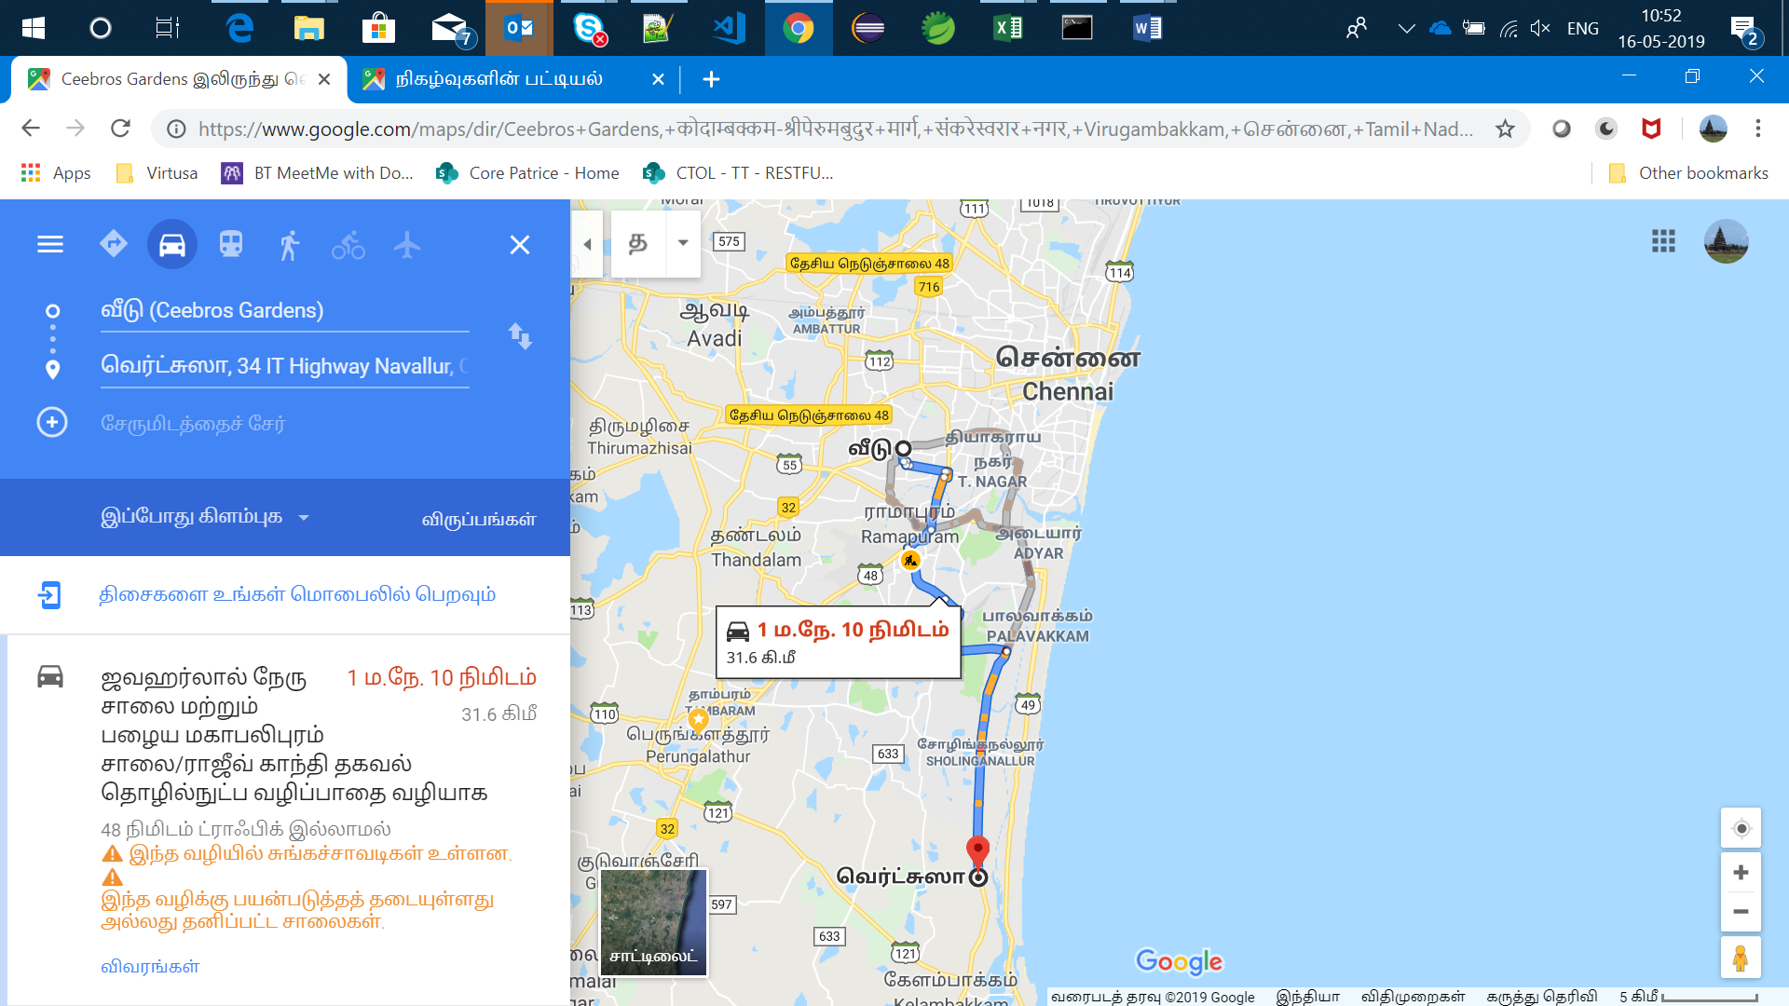

2

SEARCH PAGE

LOGIN PAGE

SEARCH RESULTS

| **Origin** | **Destinaton** | **MORE DETAILS** | **I am a** | **Start Time** | **Return Time** | **Contact** |
| --- | --- | --- | --- | --- | --- | --- |
| **Alwal** | **Banjara Hills** | [**Details**](http://www.carpoolglobal.com/index.php) | **Rider** | **12-1PM** | **7-8AM** | **Contact** |
| **Ameerpet** | **Hitech City** | [**K.konda Reddy**](http://www.carpoolglobal.com/index.php) | **Rider** | **9-10AM** | **6-7AM** | **Contact** |

### USER – POFILE PAGE

HEADER

TOP NAVIGATION

**Personal Details**

**Name:**raj

**E-mail:**raju.gouroju@gmail.com

**Gender:**Male

**Age:**18-25

**Ocupation:**Professional

**Phone:**7702348080

**Ride Details**

**I am :**Driver

**Country:**INDIA EDIT MY POOL

**City:**Hyderabad DELTE MY POOL

**Origin:**koti ACTIVE/DEACTIVE POOL

**Destination:**mehadiptnam

**Seats(Available/Wanted):**2

**Start Time:**6-7AM

**Return Time:**3-4PM

**Looking For:**Male Carpoolers

**Comments:**dfgsdfg

2

MEMBER AREA

View my profile

Edit

Delete

Change password

Logout

SERCH PAGE

### USER PROFILE – REMAING PAGES

HEADER

TOP NAVIGATION

EDIT /DELTE /CHANGE PWD PAGES



**Looking For:**Male Carpoolers

**Comments:**dfgsdfg

2