Detailed Software Requirements Specification
(DSRS)
For
VFORUM

..........

Table of Contents

1 Introduction 1
1.1 Purpose 1
1.2 Summary 1
1.3 Project Overview 2
1.4 Problem Statement 3
1.5 Assumptions 3
1.6 Definitions, Acronyms and Terminology 4
2 Project Scope and Impact 4
2.1 Scope Inclusions 5
2.2 Scope Exclusions 5
2.3 Statement of Business Need 5
2.4 Project Objectives 5
3 Current Business Process 6
3.1 Current Architecture 6
3.2 Limitations of the Current Process 6
4 Business Requirements 7
4.1 Business Benefits 7
5.1 Functions 8
5.1.1 Home page is common for all the users. Employee need to register by providing his details. 8
5.1.2 Once registered, the employee details will be stored in the database. 8

Document Revisions
Date | Version | Description | Author
28th April 2011 | 1.0 | Initial document | Naga Manohar
29th April 2011 | 1.1 | Review | Samba Siva/ Satish
2nd May 2011 | 1.2 | Final document | Shiva Kondala Rao

Note: These documents are strictly for Virtusa/the specific client use only. They shall not be shared with an external party other than the client concerned. These documents should always be kept securely and employees shall use reasonable care protecting these documents from unauthorized use or disclosure to a third party. This category also covers client intellectual property where Virtusa has a non-disclosure agreement with the client.

Document Approval

Virtusa Corporation and Client have reviewed this document and agree that the contents of the document are accurate. Any changes to this document must be communicated in writing, approved and signed off by both parties.

Signature | Signature
Date: | Date:
Name: | Name:
Client:: | Virtusa Corporation

Introduction

Purpose

- The main objective of this project is to make the people in an organization feel free to ask any question related to any particular topic, in general or in technical perspective.
- This project will give the user more flexibility of finding an answer to the question answered by other people in the organization.

Summary
People in any organization face some basic problems like a technical doubt or a general information on how things are going around in the organization. This project is forum available for all the users to post a question and get answers from any user in the organization.

1.3 Project Overview
This project is mainly concentrates on the problems or any general doubts of the user who is new to the organization. This project cannot be accessed by any user out of the organization. The existing user can also use this forum in case of any problem. Any user can post a question and wait for the answers. When a user posts a question it will be displayed in the home page so that the users entering later will be able to look at the post and answer it. When a question is answered, the user who raised it will be intimated by through an e-mail to check it.

1.4 Problem Statement
Any person new to the organization will find a lot of things new that he did not see earlier in his career so he might face a lot of problems and takes more time to adapt to the new culture. By using a forum in the organization, user can ask any question and get a clear idea of how things are going on and get used to the new culture faster than normal time.
Disturbing people at work for very small doubts may not be advisable. Instead posting a question in the forum will let the users interact with the organization as a whole.

Assumptions
By default it is assumed that the project is having limited access inside an organization.

Definitions, Acronyms and Terminology

Forum:- A website where a user can post any question and wait for the reply that best suits your question.
Post:- Any entry in the forum is called a post. Whether a question or an answer which is basically entered for information purpose is a post.
Thread:- Any question starts a thread. A question and all of its answers together are called a thread.
2 Project Scope and Impact
This project will give the users to directly ask questions in technical or general perspective and get the answers without disturbing the people at work. Different people will face different problems while solving a problem and the solution when posted in a thread will provide information to the user so that when a user will face the same problem then he will be having a prepared solution to not make the same mistake and waste time solving it.

Scope Inclusions
- VFORUM supports the employees in an organization to interact with all the other employees in more sophisticated way.
- Provides user to review the questions so that if anyone previously has faced the problem and get a solution for that.

Scope Exclusions
VFORUM can be directly integrated into the virtusa portal and the details of the employee can be fetched from the HEART when an employee id is entered in the registration form.

2.3 Statement of Business Need

- Employee

2.4 Project Objectives

To provide all the employees in an organization a place to raise doubts and answer the doubts they have previously faced and solved. Employees answering the question will have a clear idea of what they are dealing with. As the sharing of knowledge is main objective here, all the employees will interact with each other properly.
Any technical or a general doubt is all what an employee of an organization will face, so the best solution can be with other employees of the organization who already have solved it. So in turn saving time and not disturbing people at work will be an efficient way of working.

Current Business Process

3.1 Current Architecture

The existing system is, when any new person in the organization needs to solve any question, he will have to disturb any of the other employees and clear his doubt. If he is new to the whole place then he might actually face a lot of problems.

3.2 Limitations of the Current Process

There is no official way of putting these matters. So currently a team member or a person known to the employee would help him out with his problems.

Business Requirements

Registration:- Employee should register by entering employee-id, employee-name, an alias and his designation.

Raising a question:- When a question is raised, it will be on the home page so that the users who are logging in can view them on top and answer them.

Posting an answer:- When a user knows the answer to a thread then he can use the option to post an answer.

4.1 Business Benefits

People new to the organization will not take much time to adapt to the new culture. Employees need not waste time to answer to the questions when they are at work. New employees need not be embarrassed to ask questions continuously in the same perspective and are not actually disturbing any person at work. This makes people new to organization more in an interactive way.

5 Functional requirements

The minimum functional requirements of the project is as listed below
5.1 Functions

5.1.1 Home page is common for all the users. Employee need to register by providing his details.

5.1.2 Once registered, the employee details will be stored in the database.
5.1.3 Employee raises a question and starts a thread.
5.1.4 The question is shown in the home page for 2 days even without a reply.
5.1.5 Employees will answer the question if he is free and provides a solution to the problem.

User will be associated with the following functions:

- Registration- user need to register by providing the details like employee id, employee name and location.
- Raise a question- After registering, user can post a question related to any perspective in the proper location and find an answer if any employee finds a solution.
- View- If the employee wants to get the details of his previously raised questions.
- Update- If the employee wants to change his post, he can update his post.
- Delete- If a post is unanswered from a long time then the thread will be automatically deleted.

Administrator functions

Administrator will be associated with the following details:

Login- Administrator needs to login with userid and password which involves a validation process.

Validation- If the administrator login with the valid username and password then he will get the user page or else the homepage will be displayed.

User Details- The details of the employee are displayed under his post.

Search- If a user wants to search any thread before posting that has already been answered, he will be provided with a search option.

5.1.2 System Administration

The highest level of the user is an administrator. An administrator will have the right to delete the posts of the users as well as moderators. Administrators will have the access to the whole forum. Adding and deleting the procedures in the database are done by the administrator. Any new feature can only be updated by the administrator.

Quality Attributes
Security | SSL for Transport Layer  Username/Token(hashed) for User Security  Role based Authorization Privileges  Sensitive data @Session/@Request to be protected for integrity (ex Shopping Card Data, User Data, User Session etc)
User Base
  Employee Apps
  Total users | Concurrent Users | Y0Y Growth %
  20000 | 10000 | 15%
Performance | Peak Load Performance (during Festival days, National holidays etc)  eCommerce -< 3 Sec  Admin application < 2 Sec  Non Peak Load Performance  eCommerce < 2 Sec  Admin Application < 2 Sec
Availability | Employee – 100% Availability
Standard Features | - Scalability  - Maintainability  - Usability  - Availability  - Failover
Logging & Auditing | - System should support logging(app/web/db) & auditing at all levels
Monitoring | - Should be able get monitored via as-is enterprise monitoring tools
Cloud | - The Solution should be made Cloud ready, and should have minimum impact when move away to Cloud in infrastructure
Browser Compatible | - IE Edge+  - Mozilla FireFox Latest – 15  - Google Chrome Latest – 20
External Cache | - Apply and implement external cache for avoiding costly repeatable IO Calls

Technical requirements:
Presentation Layer | HTML, CSS3, JSP with JSTL tags, jQuery for DOM/Form-Validation/AJAX Calls
Server Side | Spring MVC, Spring JPA (w) ORM, Spring Security(username & Token)
Application Server | Tomcat 8
Database | MySQL 8
IDE | Eclipse STS
JDK | Oracle JDK 8 64b
Build Management | Maven 3
Unit Testing | jUnit 5

Prototype:
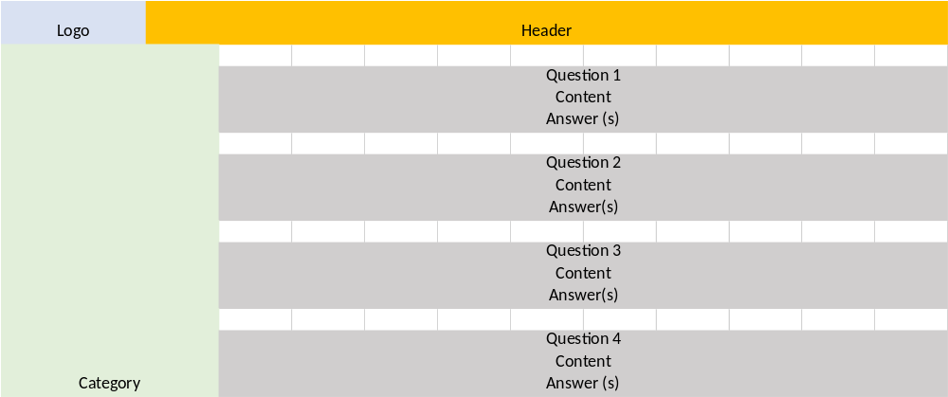

Example Screen
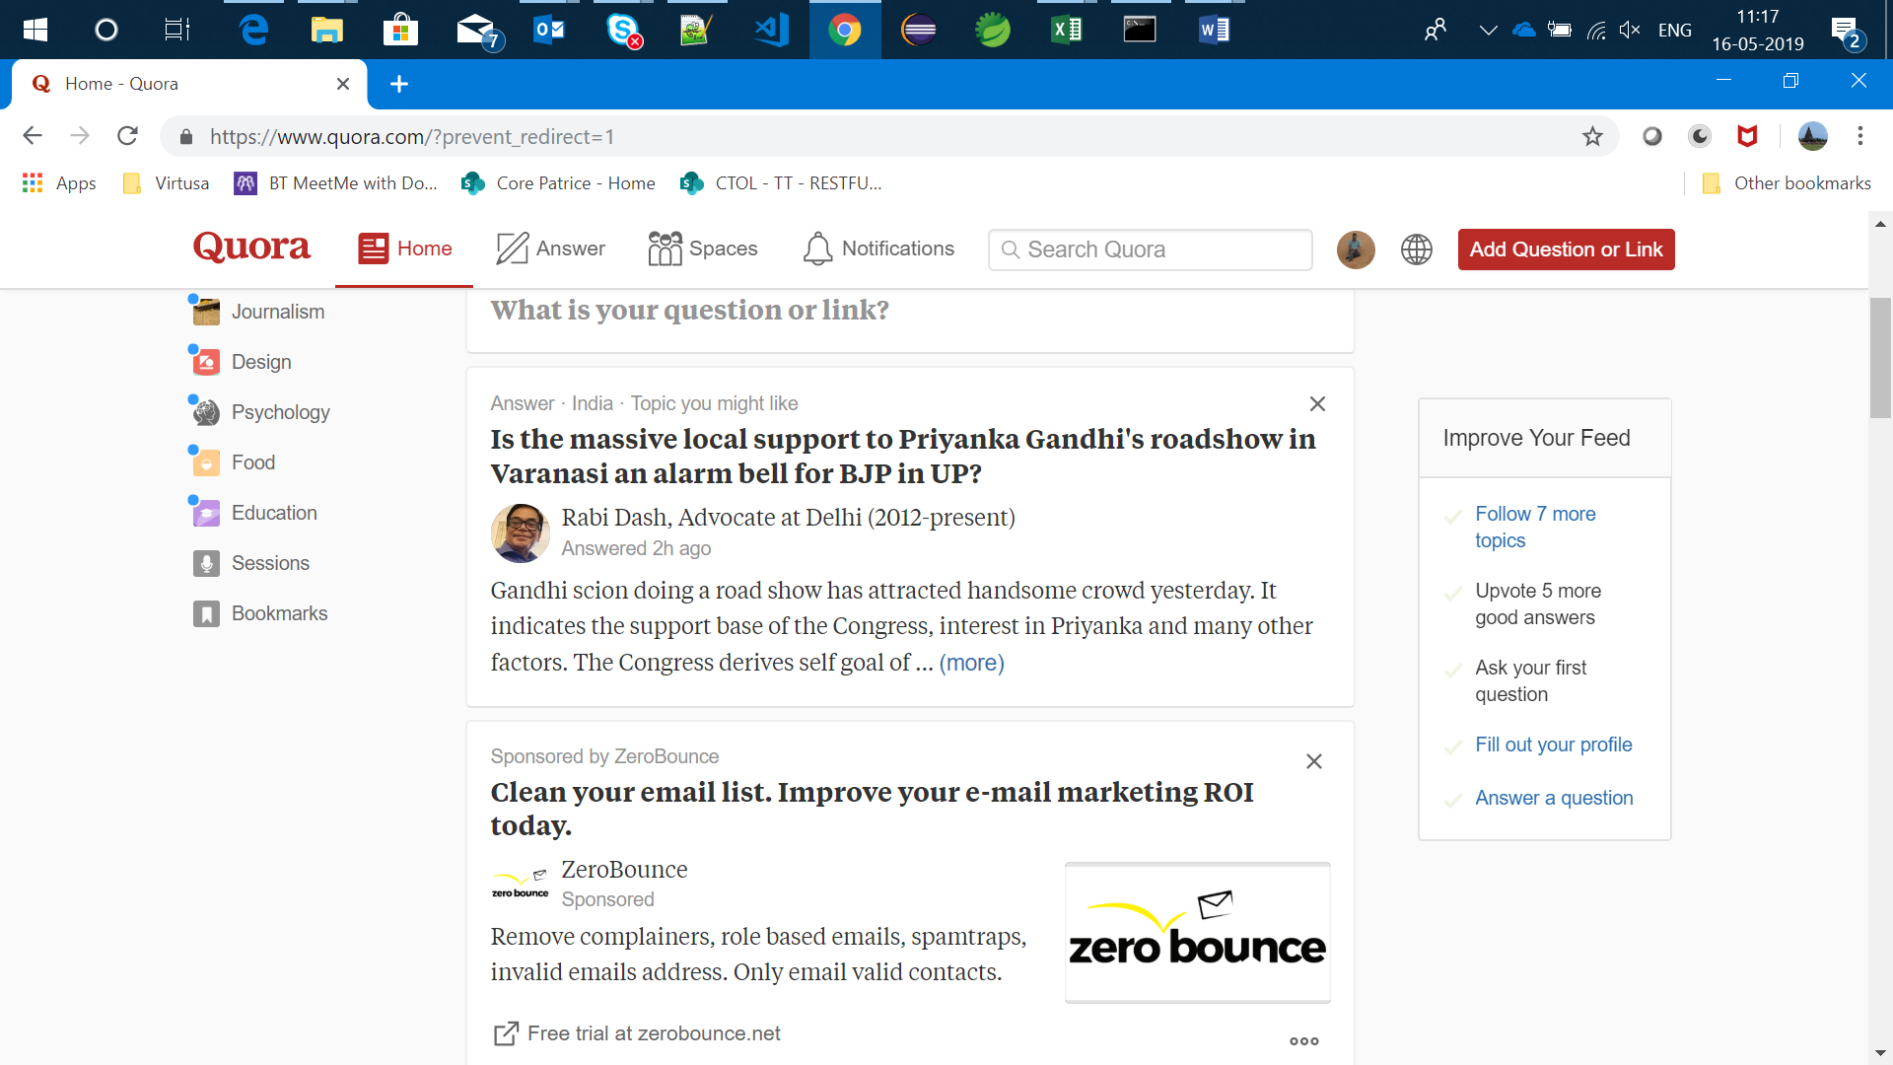

Forum Question View
