Business Requirements & Design Document
WEBSTORE APPLICATION
Practice Lab Project 1
Table of Contents
Table of Contents 2
1 Overview 4
1.1 Overview of the application 4
1.2 Users of the application 4
2 Functional Requirements 5
2.1 Scope of Work 5
2.2 System Features 6
2.2.1 Requirement / Module / Use case – LogIn 3
2.2.2 Requirement / Module / Use case – Registration 8
2.2.3 Requirement / Module / Use case –MyAccount 11
2.2.4 Requirement / Module / Use case – Home 13
2.2.5 Requirement / Module / Use case – Adding to the cart 16
2.2.6 Requirement / Module / Use case –Updating the cart 18
2.2.7 Requirement / Module / Use case – Removing from the cart 19
2.2.8 Requirement / Module / Use case – Order 21
2.2.9 Requirement / Module / Use case – Help 24
2.2.10 Requirement / Module / Use case – Logout 25
2.2.11 Other Requirements 27
3 Design 28
3.1 Architecture Diagram 28
3.2 Database Design 29
3.2.1 E-R Diagram 29
3.2.2 Dataflow Diagram 30
3.2.3 Table Structure 30
3.3 Detail Design 40
3.3.1 Requirement / Module / Use case – LogIn 40
3.3.2 Requirement / Module / Use case – Registration 41
3.3.3 Requirement / Module / Use case –MyAccount 42
3.3.4 Requirement / Module / Use case – Home 43
3.3.5 Requirement / Module / Use case – Adding to the cart 45
3.3.6 Requirement / Module / Use case –Updating the cart 46
3.3.7 Requirement / Module / Use case – Removing from the cart 47
3.3.8 Requirement / Module / Use case – Order 48
3.3.9 Requirement / Module / Use case – Help 50
3.3.10 Requirement / Module / Use case – Logout 51
3.3.11 Class Description and File Name……………………………………………………52
3.4 Packaging Structure. 71
3.5 Configuration Changes 76
3.6 Deployment Guidelines 76

Overview

Overview of the application
This document describes the online shopping portal functionality. With this portal user can navigate through a web-site where a new user can register with the web-site and a registered user can do shopping online.
If the user is already registered then he/she can log in to the website, can view his/her profile, can search for products/items ordered by different categories and catalogs, he/she can place the selected items/products in the cart and the user can make an order by providing his details like address to where the ordered items/products to be shipped and he/she can make payment using his credit/debit card.

This application is built using J2EE Technology which makes use of the following technologies.
(i) Struts – As controller
(ii) Hibernate – For managing the persistence
(iii) JTA – To perform transactions
(iv) JNDI – To connect to the database
The backend (database) used is MySQL. Database is present separately in application folder App_data. The project also has a separate database layer class in App_Code in which all the code for opening a connection to the database, inserting the data into the database and returning the data from the database either as a data-set or as a data-table is written which reduces the redundancy of code.

Users of the application
There can be two types of users who will be accessing this application. They are Registered User and Un-registered user.
Un-registered user can view the home page of the website where he/she can search the items/products by a specific category/catalog which displays all the items/products belonging to that category/catalog along with the photo and all the sub-categories of the specified category will be displayed along with the photo and he/she can browse the items/products in that category. The products/items will be displayed along with the detailed description (such as price, brand etc) and photo. Generally if the user wants to view the items/products belonging to a category he/she can do so by clicking on the photo of that particular category. But the unregistered user cannot make an order, only he can browse the items/products and categories. Only registered user can make an order.
Registered user is allowed to access all the features that are provided by the application. Once the user is logged in he/she can view his/her profile, can search for products/items, can make an order by adding them in the cart, can either remove/update cart. After he/she made an order he will be provided with a unique order id so that he/she can keep track of his/her status of the order.

Functional Requirements

Scope of Work
Many websites on internet are providing online shopping facilities. The web store online shopping website is generic enough to directly support all types of products/categories. Also features a fully functional cart which simultaneously stores products as well as items.
It Represents the commodities for sale under the below mentioned classifications:
a. Catalog
b. Category
c. Sub-Category
d. Product/Item
In addition it also offers other shopping categories like IPods at reasonable prices and mobile phones of all major brands like Nokia, Samsung, Sony Ericsson and LG are offered online.

System Features

Requirement / Module / Use-case for Log-in

Description
This use-case describes the Login page functionality.
REQ-101: The Login page has two fields (One is UserName and the other is Password) and one (Login) button.
REQ-102: The UserName field is marked mandatory and the registered user must enter his/her Username in this field to login.
REQ-103: The Password field is marked mandatory and the registered user must enter his/her Password in this field to login.
REQ-104: Once the registered user enters valid UserName and Password and clicks on Login button, the user will be logged in to his/her account and the user will be directed to Home page displaying the Username of the user on the top of the page.
REQ-105: The login screen provides few links to go to Home page, Cart page, Login page and Help page on top of the page.

Screen Prototype
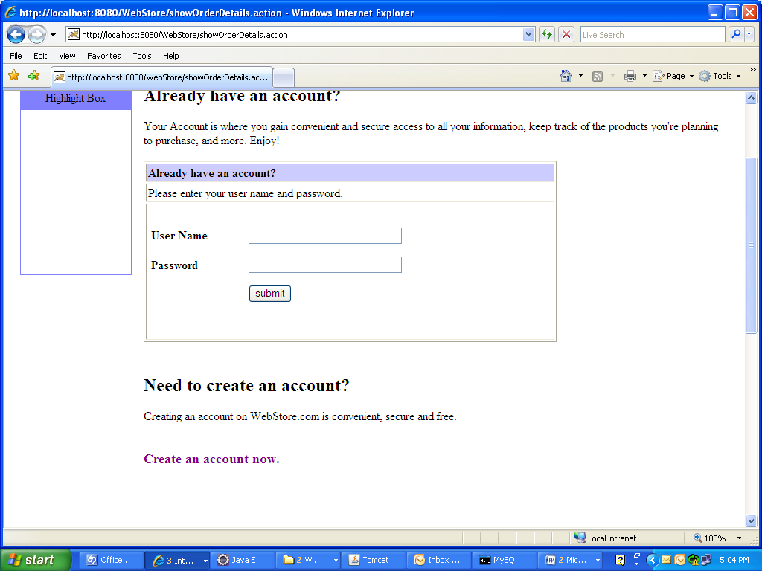

Screen Flow / Business Flow & User Actions
User enters the “username” and “password”
Logs-in to the respective user account
Clicks on “Login” Button
If validated

Business Rules & Validations
The business rule to be considered while entering this screen is, the user must be connected to the website and the user must click on “Sign-In” link.
The business rule to be considered while moving to the next page is that the username and password should be entered and both the fields should be valid, If they are valid only, after clicking on the login button the user will be navigated to the next page.

Requirement / Module / Use-case for Registration

Description
This use-case describes the Registration page functionality.
REQ-201: New user can register by clicking on Create an account now. A registration page will be displayed with 13 fields and one button.
REQ-202: The UserName field is marked mandatory and this field will accept letters, digits and any other special symbols. This field accepts maximum of 20 characters only.
REQ-203: The Password field is marked mandatory and this should be at-least 6-8 characters long. It accepts alphabets, numerics and special symbols.
REQ-204: The Confirm Password field will be marked mandatory and this should match with the Password.
REQ-205: The FirstName field is marked mandatory and this field will accept only alphabets. This field accepts maximum of 20 characters only.
REQ-206: The LastName field is marked mandatory and this field will accept only alphabets. This field accepts maximum of 20 characters only.
REQ-207: The Date of Birth field is mandatory and this field accepts digits only.
REQ-208: The Email-ID field is mandatory and this field will accept alphabets, digits and two special characters (@ and dot) only.
REQ-209: The Address field is marked mandatory and this field accepts alphabets, digits, special symbols.
REQ-210: The Phone Number field is marked mandatory and this field will accept only digits excluding alphabets and any other special characters.
REQ-211: The City field is marked mandatory and this field will accept only alphabets.
REQ-212: The State field is marked mandatory and this field will accept only alphabets.
REQ-213: The Zip field is mandatory and this field will accept only numbers.
REQ-214: The Country field is mandatory and this field will accept only alphabets.
REQ-215: Once the user enters valid data in all the fields and clicks on Register button, the user will get registered with WebStore and user will be directed to Home page.
REQ-216: The Registration page also provides an option to Login for registered users using the link Sign-In provided at the top of screen and few links to go to Home page, Cart page and Help page etc.

Screen Prototype
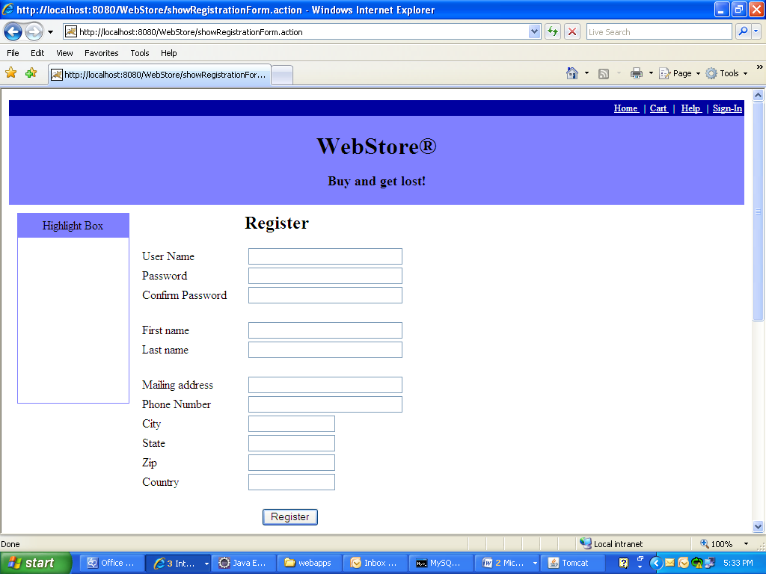

Screen Flow / Business Flow & User Actions
User enters all the details required in the registration page
New User is registered and can be able to purchase the products
Clicks on “Register” Button
Checks for validations

Business Rules & Validations
The business rule to be considered while entering this page is the user must be connected to Webstore and the user must click on Sign-In link.
The business rule to be considered while moving to next page is that all the mandatory field values must be filled by the user and the data in all the fields should be valid.

Requirement / Module / Use-case for My Account

Description
This use-case is describes how to navigate to Logged-in User’s profile page.
REQ-301: Once the user Logs-in to the web store, he/she can view his/her profile by clicking on My Account link. When User clicks on My Account link, the User Information page will be displayed showing all the details of the user which he enters at the time of registration.
REQ-302: The User Information page provides one Update icon at the bottom of the page to change/update his/her profile/details.
REQ-303: This page provides few links to Sign-out from his/her account and to go to Home page, Cart page and Help page provided at the top of screen. This page also provides the flexibility for the user to change his/her Password through the link Change Password.

Screen Prototype
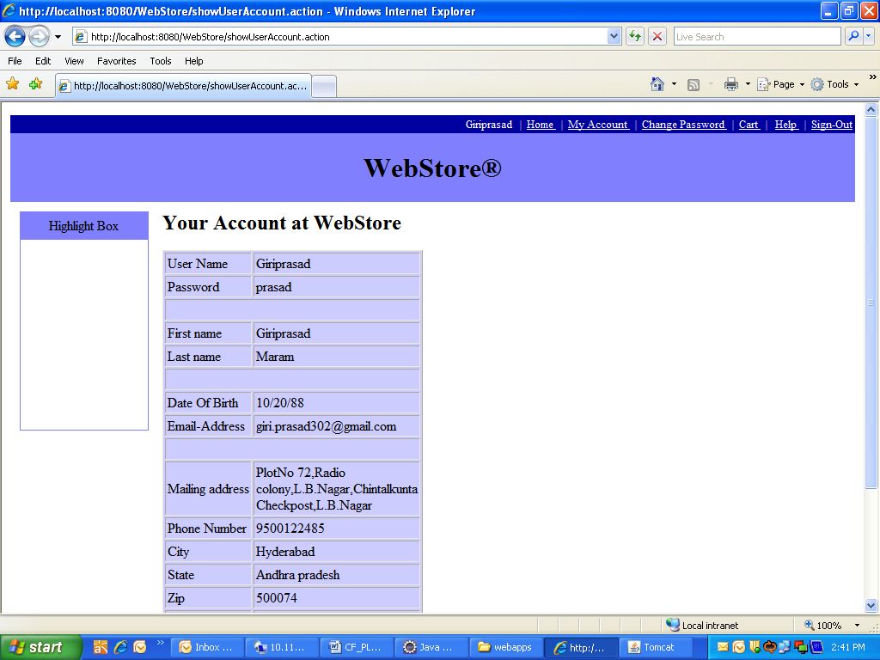

Screen Flow / Business Flow & User Actions
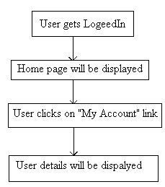

Business Rules & Validations
The business rule to be considered while entering this page is the user must Login. The business rule to be considered while moving to the next page is, to make sure that the user clicked on My Account link.

Requirement / Module / Use-case for Home

Description
This use case describes about all the available products in the portal.
REQ 401: User clicks on Home link and a page will be displayed showing
all the available Catalogs in the portal along with the images.
REQ-402: User selects any Catalog by clicking on a particular catalog
Image/name and all the available Categories under the selected catalog will be
displayed along with images.
REQ-403: User selects a category from the resulting categories list by
Clicking on that particular category image/name and all the products/items
Under the selected category will be displayed along with the images, if there are
any products/items available in that category.
REQ-404: User selects a product/item from the resulting products/items
List just by clicking on the image/name of that particular product/item. The
product/item will be displayed along with the image, description and price
REQ-405: Home page provides few links to navigate to Home page, Cart page, Login page etc.

Screen Prototype
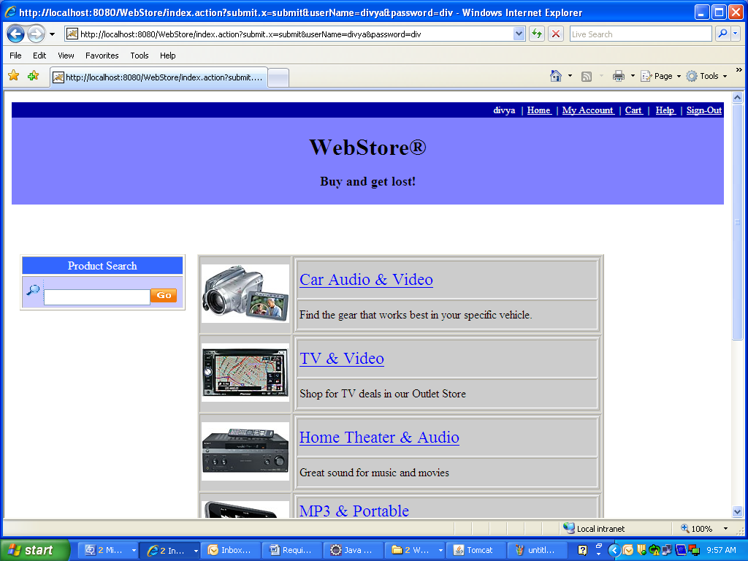

Screen Flow / Business Flow & User Actions

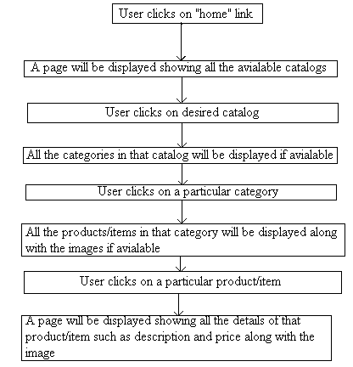

Business Rules & Validations
The business rule to be considered while entering this screen is the user must click on Home link.
The business rule to be considered while navigating to the next page is the user must select at least one of the available catalogs.

Requirement / Module / Use-case for Adding to the cart

Description
This use case describes adding a product/item to the cart.

REQ-501: Once the user selects a product/item by clicking on that particular product/item, he/she can add them to the cart by clicking on Add to cart icon (which will be present beside that product/item) and after the product is added to cart, the cart page will be displayed showing the details of products/items that are added to cart.
REQ-502: User can get his/her Cart after logging in also, if he adds items to Cart before logging in. But the user cannot get his/her Cart if he logs in after he/she logs out.
REQ-503: User navigates to any page by clicking on any one of the links provided on top of the Cart page and user can navigate to Home page by clicking on Keep Shopping icon in cart page.

Screen Prototype
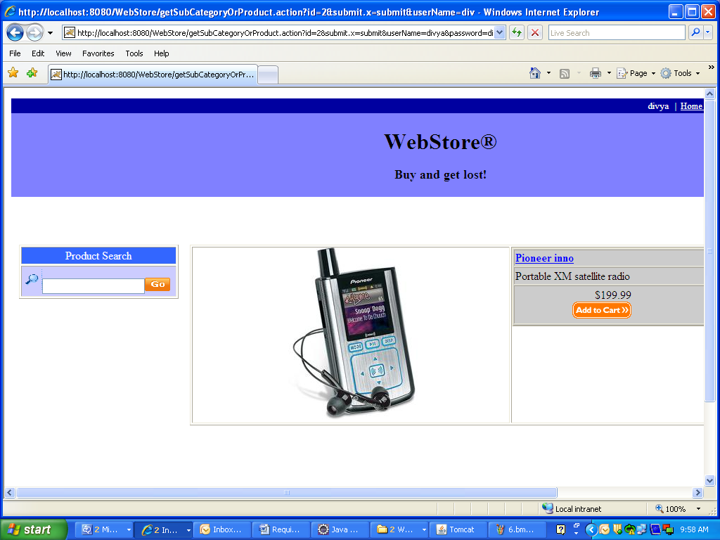

Screen Flow / Business Flow & User Actions
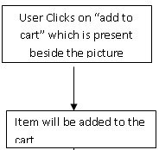

Business Rules & Validations
The business rule to be considered while entering this screen is, the user (registered/unregistered) must select a category.
The business rule to be considered while navigating to next page is, the user (registered/unregistered) must add a product to cart.

Requirement / Module / Use-case for updating the cart

Description
This use case describes updating the existing cart.
REQ-601: Once the user adds the products to cart, he/she can update the cart (if there are any changes made to cart) by clicking on Update link. If the user changed the quantity of that particular product/item by changing the value in the Quantity field and if the user clicks on update then the cart will be updated with the new quantity which has been set.

Screen Prototype

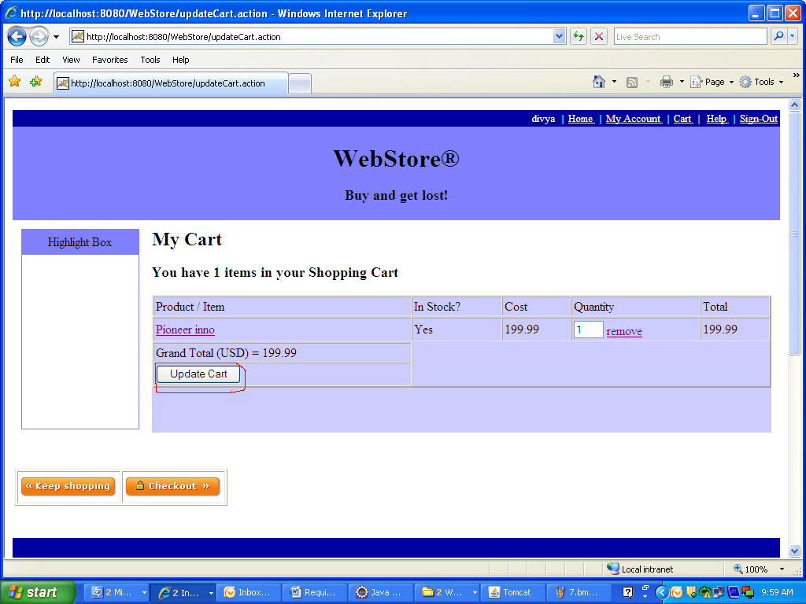

Screen Flow / Business Flow & User Actions
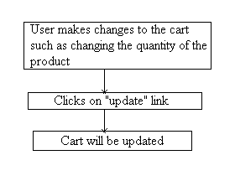

Business Rules & Validations
The business rule to be considered while entering this screen is that the user must add at least one item to the cart.
The business rule to be considered when navigating to next page is the user must update the cart.

Requirement / Module / Use-case for removing from the cart

Description
This use case describes removing the existing products/items from the cart.
REQ-701: Once the user adds the products to cart, he/she can remove those products/items from the cart by clicking on Remove link.

Screen Prototype

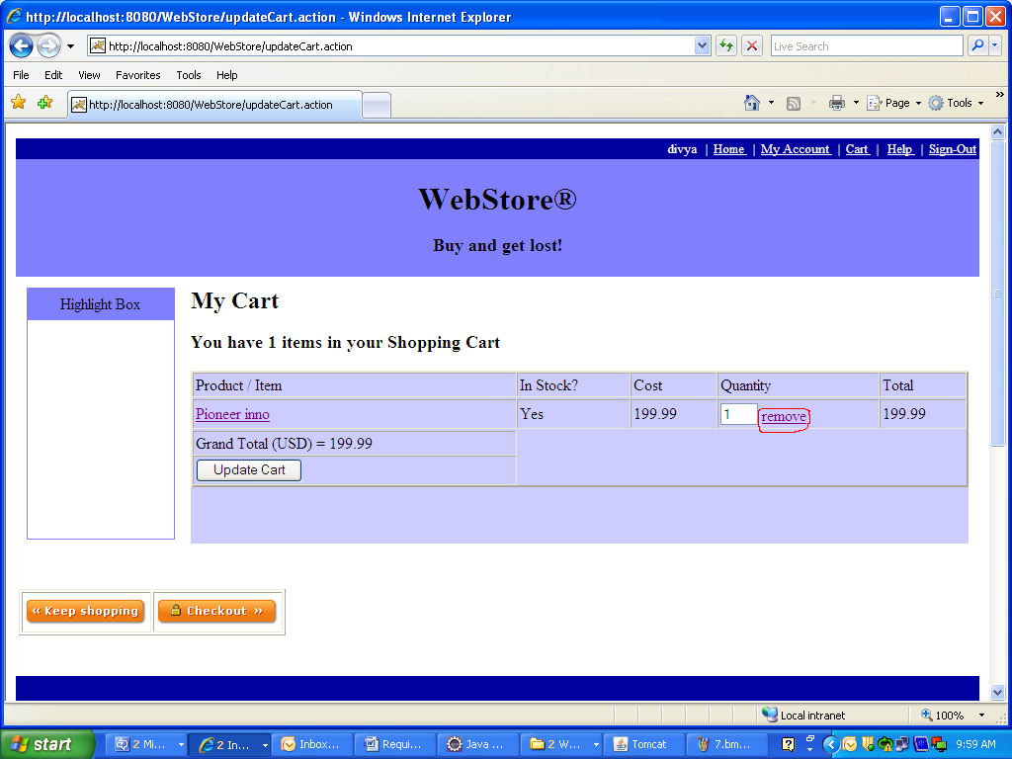

Screen Flow / Business Flow & User Actions
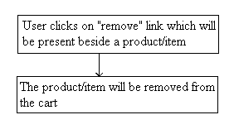

Business Rules & Validations
The business rule to be considered while entering this screen is that the user must add at least one item to cart.
The business rule to be considered when navigating to next page is the user must remove at least one product/item from the cart.

Requirement / Module / Use-case for order

Description
This use case describes how to order/purchase the products after adding them to cart.
REQ-801: User clicks on Checkout icon to order/purchase the products and billing page is displayed with 13 fields and one button.
REQ-802: The first one is the Shipping Address field and it is marked mandatory. It accepts alphabets, digits and special symbols.
REQ-803: The next field is the Phone Number and it is mandatory. It accepts only digits.
REQ-804: The next is the name of the City and it is mandatory. It accepts only alphabets.
REQ-805: The next field is the State name and it is mandatory. It accepts only alphabets.
REQ-806: The next is the pin code (zip) of the City and it is mandatory. It accepts only digits.
REQ-807: The next field is the name of the Country and it is mandatory. It accepts only alphabets.
REQ-808: The next is the Type of credit card used to pay the price of the product/item purchased and it is mandatory. It accepts only alphabets.
REQ-809: The next field is Card Number and it is mandatory. It accepts only digits.
REQ-810: The next field is the Expiry Date of the card which the user used to pay the price of the item to be purchased and it is mandatory. It accepts only digits and it does not accept special symbols other than hyphen (-).
REQ-811: Once the user enters valid address, city, state, country, zip, card details and clicks on Continue button, a (Order) page will be displayed showing all the details about the order and the user will be provided with a unique order id to track his order.
REQ-812: User will be provided with few links to navigate to Home page, Help page, Cart page, Profile page (by clicking on My Account link) and two more links to Sign-Out from his/her account and to change his/her Password.
If user wants to make one more order then he/she can do so by clicking on Home icon provided at the bottom of this page.

Screen Prototype

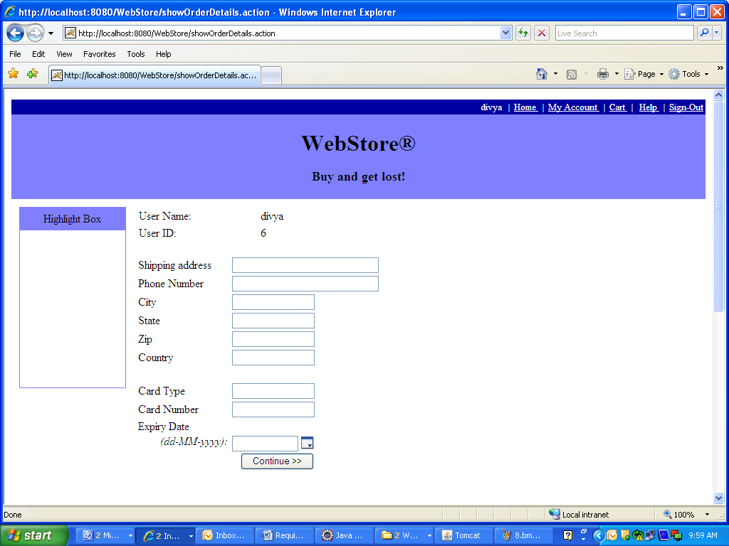

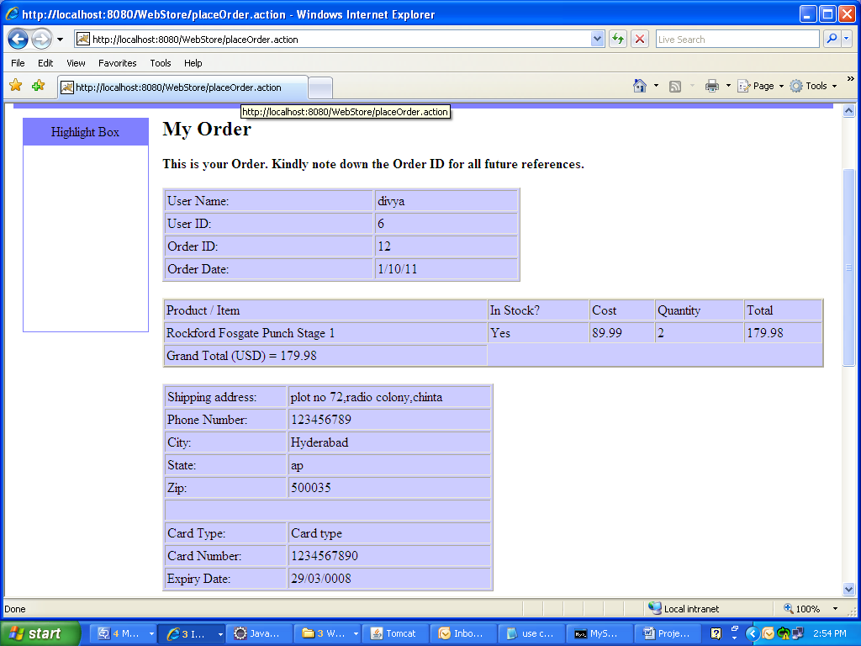

Screen Flow / Business Flow & User Actions
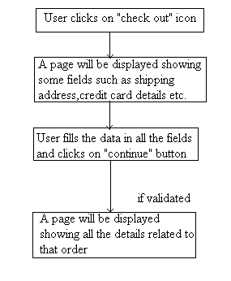

Business Rules & Validations
The business rule to be considered while entering this page is the user must click on Check out icon.
The business rule to be considered while navigating to next page is the user must provide valid data in all the fields and the user must click on Continue button.

Requirement / Module / Use case for help

Description
This use case is used to guide a new user.
REQ-901: If a new user visits the website then he will be guided using this use case. When the user clicks on Help link, a page will be displayed guiding the user how to login to and register with Web store.

Screen Prototype
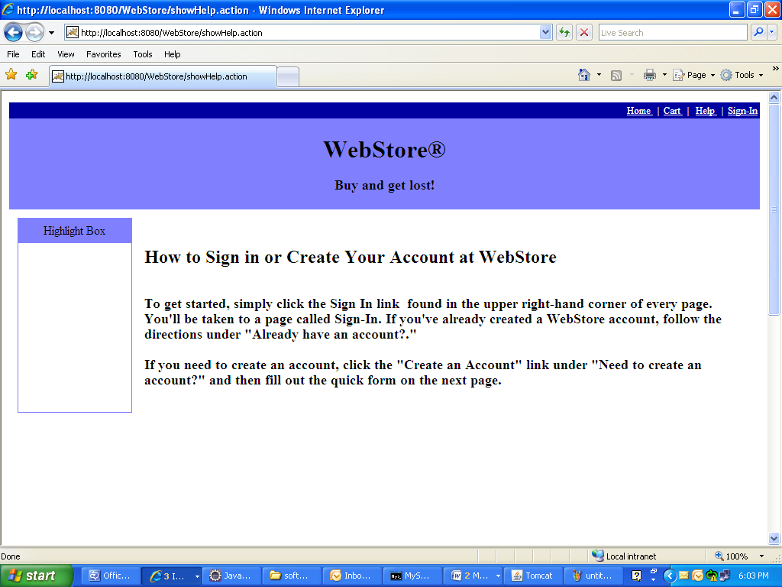

Screen Flow / Business Flow & User Actions
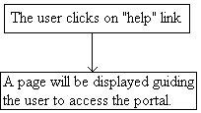

Business Rules & Validations
The business rule to be considered while entering this page is, the user must be able to connect to Web store and the user must click on Help link.

Requirement / Module / Use case for logout

Description
This use case describes the logout action.
REQ-1001: This use case describes about the security reasons so that no other unauthorized user can access the previous user account. After the user clicks on Sign-Out link, the user will be directed to Login page and the previous user’s session will be set to null.

Screen Prototype

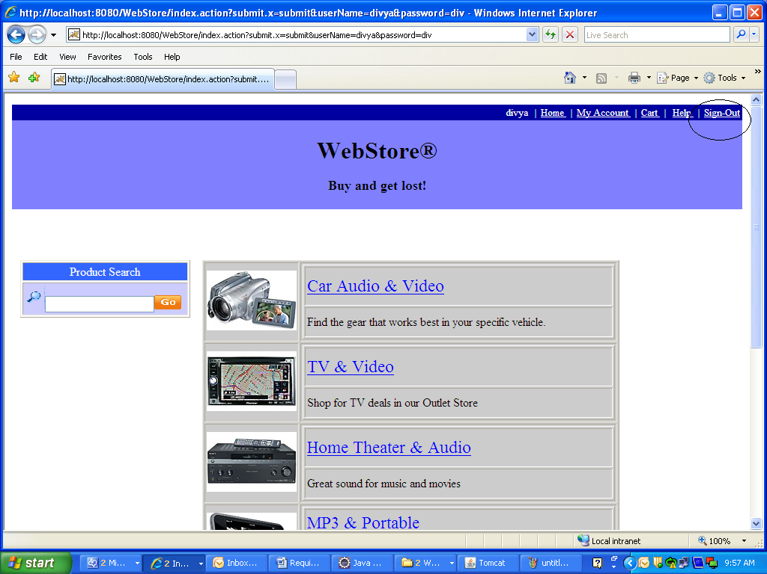

Screen Flow / Business Flow & User Actions
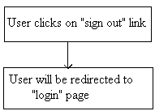

Business Rules & Validations
The business rule to be considered while entering this page is the user must be logged in to his account.

Other Requirements

REQ-1101 | Webstore provides 24/7 technical support.
REQ-1102 | Product images are good representations of what Webstore is offering.
REQ-1103 | Home page provides an overview of key products that Webstore is offering to buy.
REQ-1104 | User must have a bank account and credit card inorder to purchase products.
REQ-1105 | Provides safety by hiding user's details at the time of Registration and Login and Paying price for the product.
REQ-1106 | System should not crash when multiple users are accessing Webstore at a time.
REQ-1107 | MySql data server is required.
REQ-1108 | In order to access the Web store the user must be able to have access to a computer, which has an internet connection
REQ-1109 | The response time of the system is approximately 1-2 seconds.
REQ-1110 | Provides the access to the web portal at all times.

Design

Architecture Diagram

User
Unregistered Customer
Registered Customer

Registration
Sign-In
Browse/Search the Products/Items for shopping
Add to the Cart
Update the Cart
Remove from the Cart
Order
Shipping Details

Payment Details
Sign-Out

Database Design

E-R Diagram
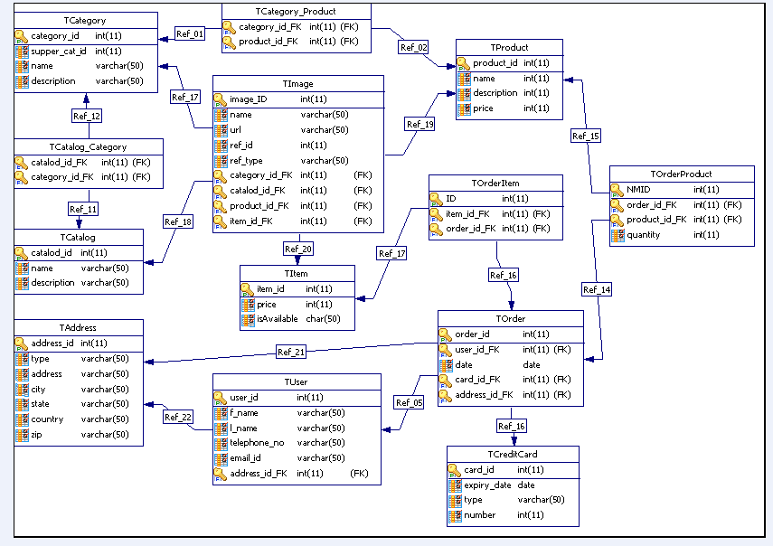

Dataflow Diagram
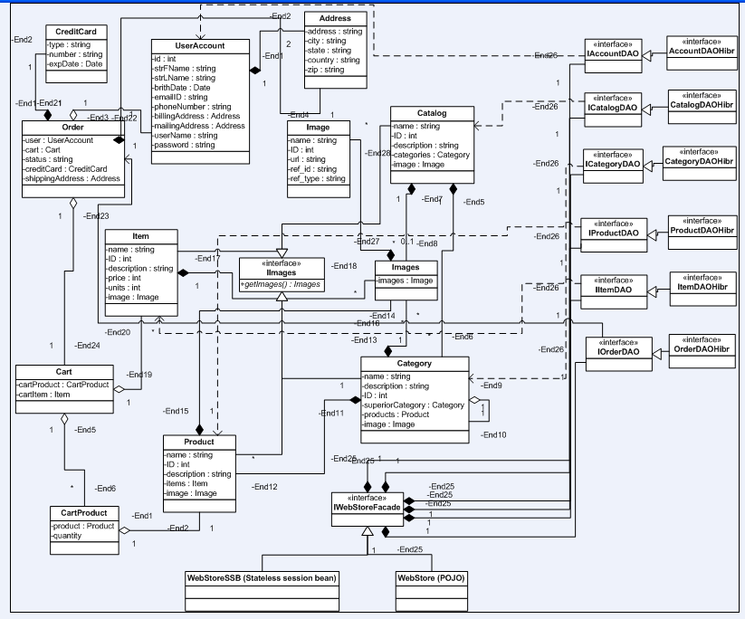

Table Structure

Table Name: Address
Primary Key: ADDRESS_ID
Description: It contains the residence/shipping address of the user.
Column Name | Data Type | Description | Key Type
ADDRESS_ID | bigint(20) | Address ID | Primary key
ADDRESS | varchar(255) | Locality of the user | -
CITY | varchar(255) | City name | -
STATE | varchar(255) | State name | -
COUNTRY | varchar(255) | Country name | -
ZIP | varchar(255) | Pin code | -
TYPE | varchar(255) | Type of the Address | -
PHONE_NUM | varchar(255) | Contact Number | -

Table Name: Catalog
Primary Key: CATALOG_ID
Description: It contains the details of products.

Column Name | Data Type | Description | Key type
CATALOG_ID | Integer | Catalog ID | Primary key
Name | varchar[255] | Catalog Name | -
Description | Integer | Description of the Catalog | -

Table Name: Catalog_Category
Primary Key: CATALOG_ID, CATEGORY_ID
Description: It contains details of categories for each catalog.

Column Name | Data Type | Description | Key type
CATALOG_ID | bigint(20) | ID of catalog | Primary key
CATEGORY_ID | bigint(20) | ID of category | Primary key

Table Name: Category
Primary Key: CATEGORY_ID
Description: It contains the details of categories and the subcategories.

Column Name | Data Type | Description | Key type
CATEGORY_ID | bigint(20) | ID of category | Primary key
Name | Varchar(255) | Name of the category | -
Description | Varchar(255) | Description of the category | -
SUP_ID | bigint(20) | ID of sub category | Foreign key

Table Name: Category_product
Primary Key: CATEGORY_ID,PRODUCT_ID
Description: It contains the details of products under each category.

Column Name | Data Type | Description | Key type
CATEGORY_ID | bigint(20) | ID of category | Primary key
PRODUCT_ID | bigint(20) | ID of product | Primary key

Table Name: Creditcard
Primary Key: CARD_ID
Description: It contains details of credit card used for payment.

Column Name | Data Type | Description | Key type
CARD_ID | bigint(20) | ID of creditcard | Primary key
CARD_NUMBER | Varchar(255) | Credit card number | -
CARD_TYPE | Varchar(255) | Credit card type | -
EXP_DATE | Date | Date of expiry | -

Table Name: Image
Primary Key: IMAGE_ID
Description: It contains THE details of images of catalogs, categories, items & products.

Column Name | Data Type | Description | Key type
IMAGE_ID | bigint(20) | ID of image | Primary key
Name | Varchar(255) | Name of the image | -
PATH | Varchar(255) | Location of image | -
ITEM_ID | bigint(20) | ID of the item | Foreign key
PRODUCT_ID | bigint(20) | ID of the product | Foreign key
CATEGORY_ID | bigint(20) | ID of the category | Foreign key
CATALOG_ID | bigint(20) | ID of catalog | Foreign key

Table Name: Order_item
Primary Key: ORDER_ID, O_I_ID
Description: It contains details of the order, items/products which are ordered.

Column Name | Data Type | Description | Key type
ORDER_ID | bigint(20) | ID of order | Primary key
ITEM_ID | bigint(20) | Item ID | unique
O_I_ID | Integer | Ordered Item ID | Primary key

Table Name: Item
Primary Key: ITEM_ID
Description: It contains the details of items such as description, price etc.
Column Name | Data Type | Description | Key type
ITEM_ID | bigint(20) | ID of Item | Primary key
ITEM_NAME | varchar(255) | Name of the item | -
DESCRIPTION | varchar(255) | Description of the item | -
PRICE | double | Price of the item | -
AVAILABLE | bit(1) | Status of the item (available or not) | -
PRODUCT_ID | bigint(20) | ID of product | Foreign key

Table Name: Order_product
Primary Key: ORDER_ID, O_P_ID
Description: It contains details of products which are ordered

Column Name | Data Type | Description | Key type
ORDER_ID | bigint(20) | ID of order | Primary key
quantity | bigint(20) | Quantity of the product ordered | -
PRODUCT_ID | bigint(20) | ID of product | Foreign key
O_P_ID | Integer | ID of ordered product | Primary key

Table Name: Product
Primary Key: PRODUCT_ID
Description: It contains details of products such as description, price etc.
Column Name | Data Type | Description | Key type
PRODUCT_ID | bigint(20) | ID of subcategory | Primary key
name | varchar(255) | Name of the product | -
description | varchar(255) | description of the product | -
cost | double | Cost of the product | -
units | bigint(20) | No of units | -

Table Name: Torder
Primary Key: ORDER_ID
Description: It contains details of ordered items/products.

Column Name | Data Type | Description | Key type
ORDER_ID | bigint(20) | ID of order | Primary key
orderStatus | varchar(255) | Status of the order | -
date | Date | Date on which the Order is made | -
USER_ID | bigint(20) | ID of user | Foreign key
CREDIT_CARD_ID | bigint(20) | Id of creditcard | unique
ADDRESS_ID | bigint(20) | ID of user address | unique

Table Name: User_account
Primary Key: USER_ID
Description: It contains the details of user .
Column Name | Data Type | Description | Key type
USER_ID | bigint(20) | ID of user | Primary key
FNAME | varchar(255) | FirstName | -
LNAME | varchar(255) | LastName | -
DOB | dateTime | Date of birth | -
EMAIL_ID | varchar(255) | Email id | -
USER_NAME | varchar(255) | Name of the user for logging in | unique
PASSWORD | varchar(255) | Password for logging in | -
ADDRESS_ID | bigint(20) | ID of Address | unique

Detail Design

Requirement / Module / Use-case for Log-in

Class Diagram
NA

Sequence Diagram / Flowchart
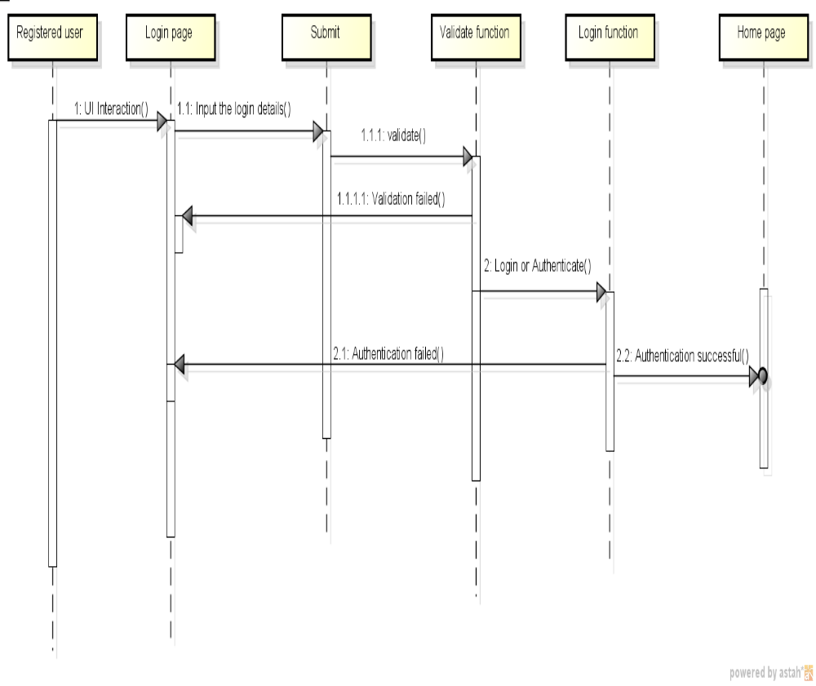

Requirement / Module / Use case for Registration

Class Diagram
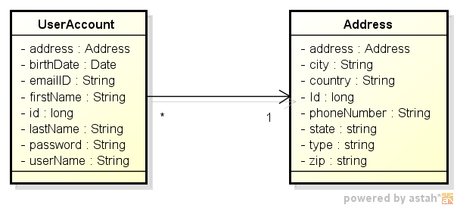

Sequence Diagram / Flowchart
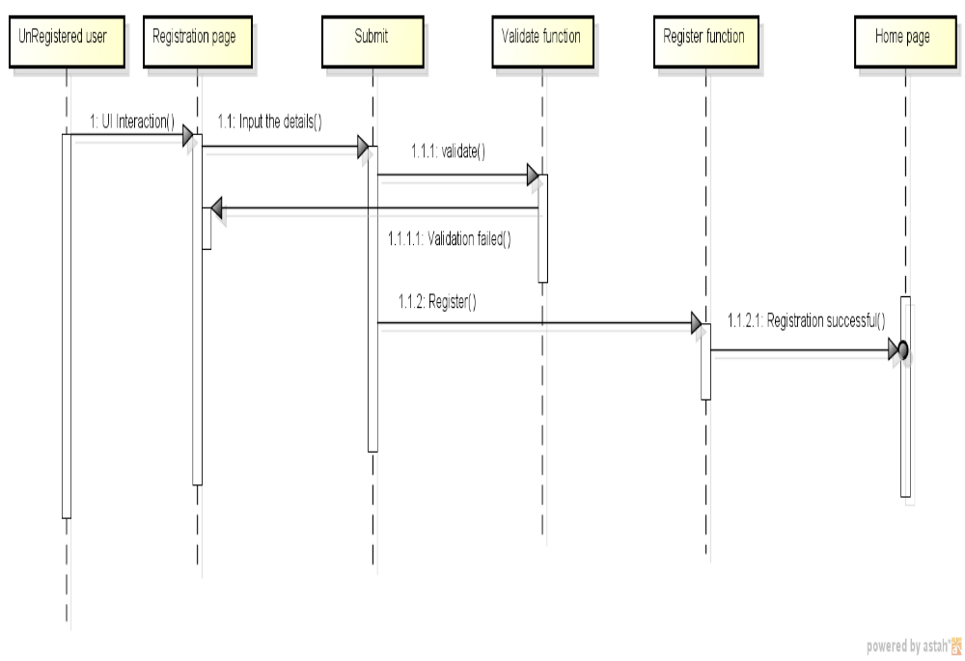

Requirement / Module / Use case for My Account

Class Diagram

Sequence Diagram / Flowchart
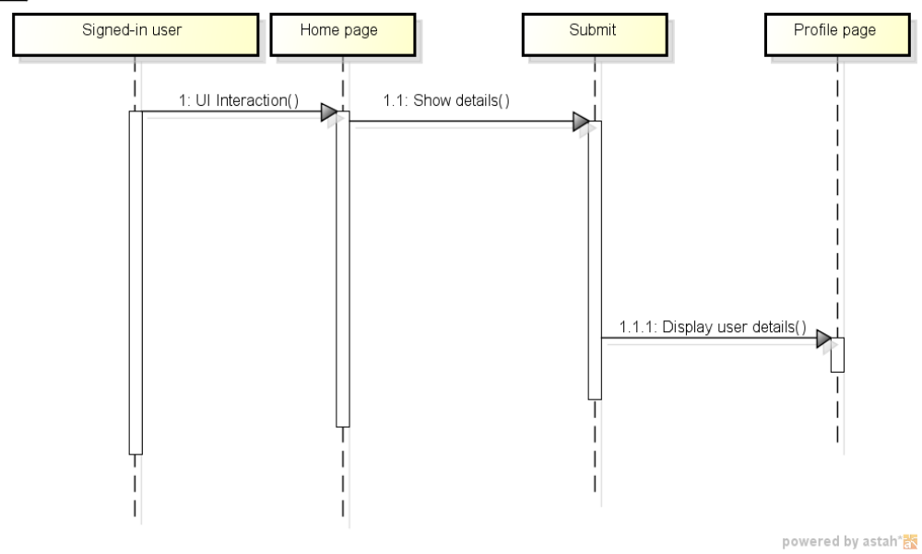

Requirement / Module / Use case for Home

Class Diagram

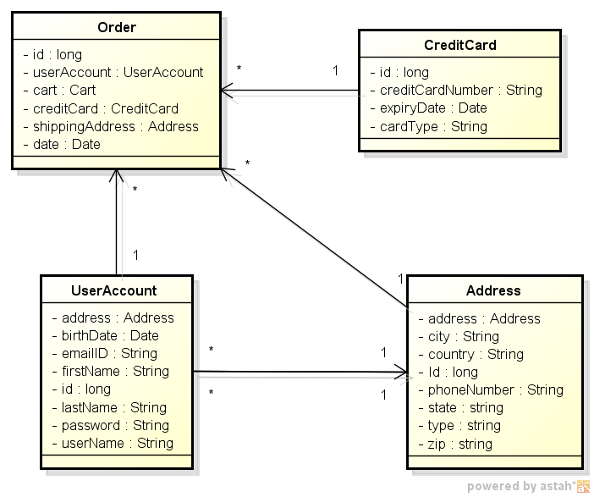

Sequence Diagram / Flowchart
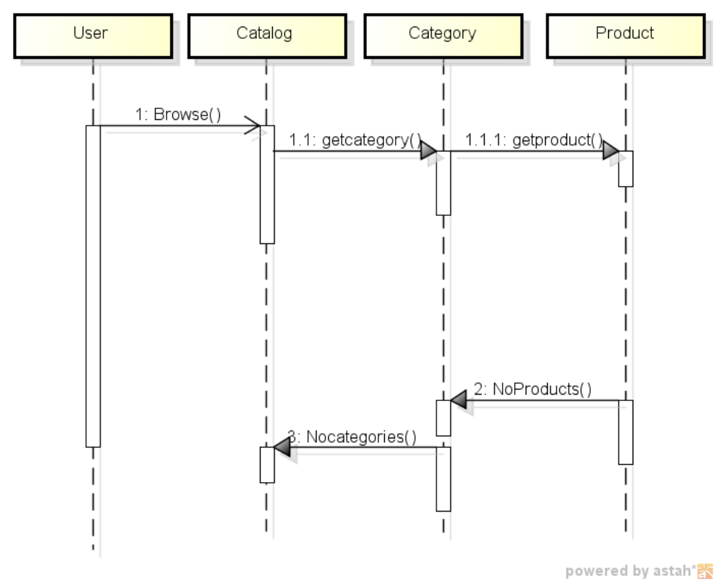

Requirement / Module / Use case for Add to the cart

Class Diagram
NA

Sequence Diagram / Flowchart
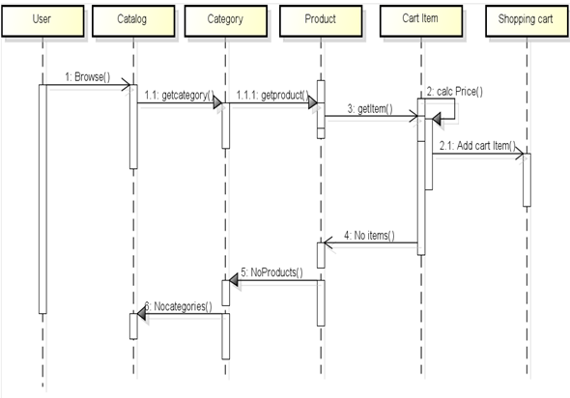

Requirement / Module / Use case for Update the cart

Class Diagram
NA

Sequence Diagram / Flowchart
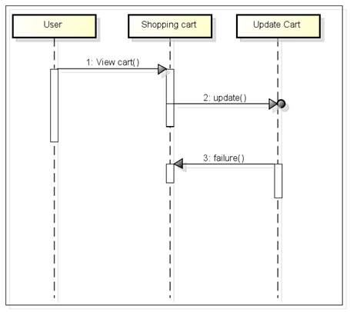

Requirement / Module / Use case for Remove from the cart

Class Diagram
NA

Sequence Diagram / Flowchart
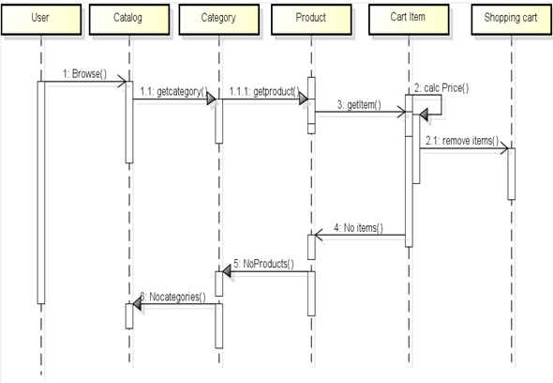

Requirement / Module / Use case for Order

Class Diagram
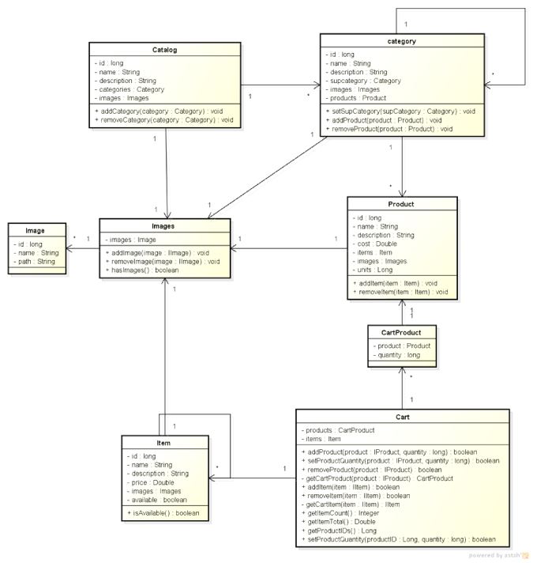

Sequence Diagram / Flowchart
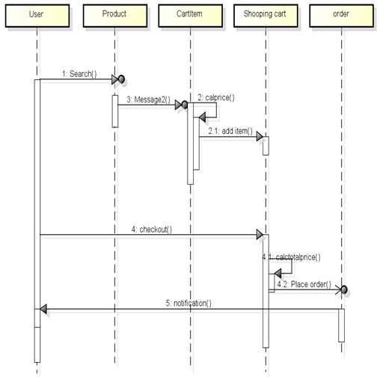

Requirement / Module / Use case for Help

Class Diagram
NA

Sequence Diagram / Flowchart

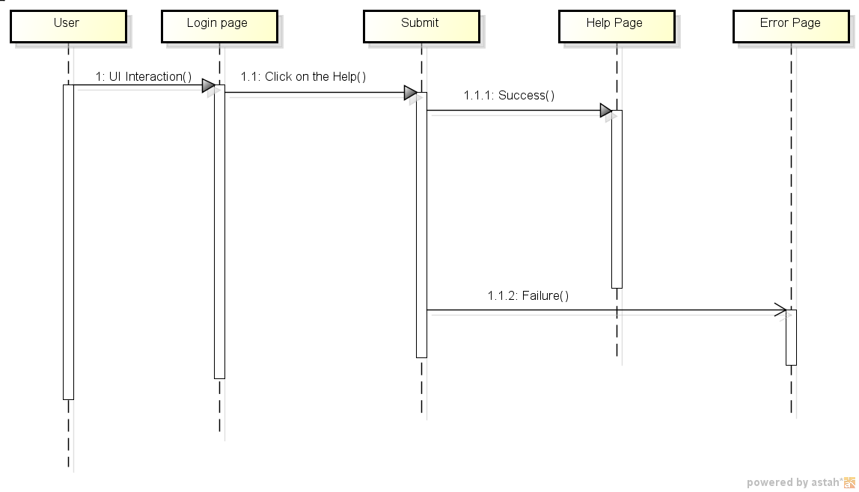

Requirement / Module / Use case for Sign-out

Class Diagram
NA

Sequence Diagram / Flowchart
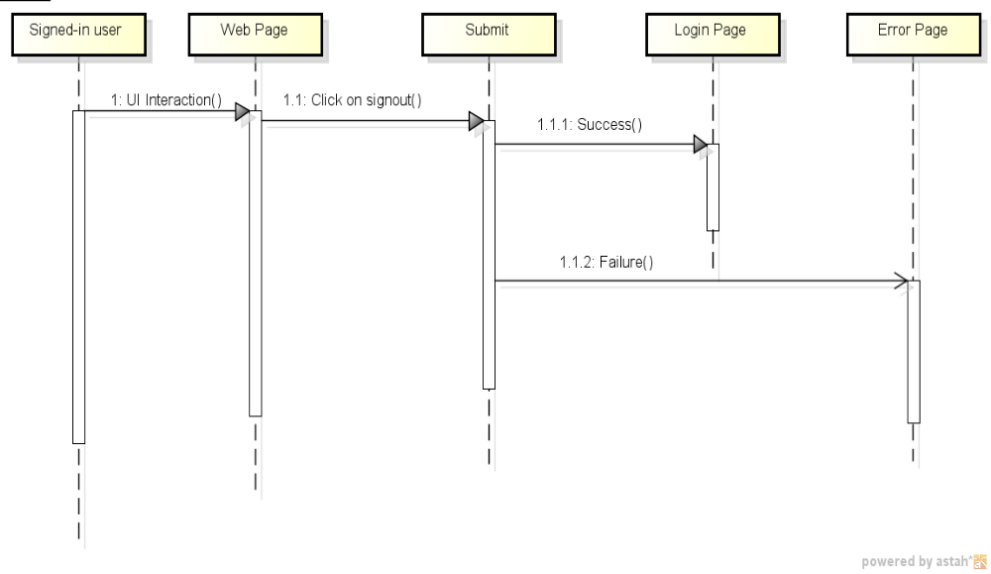

Class/File Description

3.3.11.1 Class Name and Type
Address (Public)
Description
This class stores the address of user such as street, phone number, city, state etc.
Data Items:

Protection Level | Data-type | Variable Name | Initial Value | Comments
Private | String | address | Null | It stores the street name and house no. / plot no etc.
Private | String | city | Null | It stores the name of the city.
Private | String | state | Null | It stores the name of the state.
Private | String | country | Null | It stores the name of the country.
Private | long | zip | Zero | It stores the pin code of city.
Private | long | phoneNumber | Zero | It stores the phone number.
Private | String | type | Null | It specifies the type of the address i.e. shipping/billing.

3.3.11.2 Class Name and Type
UserAccount (public)

Description
This class stores user details such as first name, last name, user name, password etc.
Data Items:
Protection Level | Data-type | Variable Name | Initial Value | Comments
Private | IAddress | Address | Null | It specifies the address of the user.
Private | String | userName | Null | It specifies the User Name of the user.
Private | String | password | Null | It specifies the Password of the user.
Private | String | firstName | Null | It specifies the First Name of the user.
Private | String | lastName | Null | It specifies the Lat Name of the user.
Private | Date | birthDate | 01/01/0001 | It specifies the Date Of birth of the user.
Private | String | emailID | Null | It specifies the Email-ID of the user.

3.3.11.3 Class Name and Type
Credit Card (public)

Description
This class specifies user’s credit card details such as expiry date, card number, and card type
Data Items:
Protection Level | Data-type | Variable Name | Initial Value | Comments
Private | long | creditCardNumber | Zero | It specifies Credit Card Number.
Private | String | cardType | Null | It specifies Type of the Credit Card.
Private | Date | expirtDate | 01/01/0001 | It specifies the Expiry Date of Credit Card.

3.3.11.4 Class Name and Type
Order (public)

Description
This class stores user’s order details such as User details, Order status etc.
Data Items:
Protection Level | Data-type | Variable Name | Initial Value | Comments
Private | IUserAccount | UserAccount | Null | It specifies the details of user.
Private | ICreditCard | CreditCard | Null | It specifies the Credit Card details of user.
Private | ICart | Cart | Null | It specifies the Cart (products/items) which the user ordered.
Private | String | shippingAddress | Null | It specifies the address of the user to which the ordered products have to be shifted.
Private | Date | date | 01/01/0001 | It specifies the Date on which the user ordered the products.
Private | String | orderStatus | Null | It specifies the Order status i.e. pending/delivered.

3.3.11.5 Class Name and Type
Catalog (public)

Description
This class stores details of Catalog such as name of the Catalog, which categories are present in it and the images describing about the Catalog etc.

Data Items:
Protection Level | Data-type | Variable Name | Initial Value | Comments
Private | String | name | Null | It specifies name of the Catalog.
Private | String | description | Null | It specifies description about the Catalog.
Private | Set<Category> | categories | Null | It specifies set of Categories under the Catalog.
Private | Images | images |  | It specifies Image of the Catalog.

3.3.11.6 Class Name and Type
Category (public)

Description
This class stores details of Category such as name of the Category, which subcategories/products/items are present in it etc.
Data Items:
Protection Level | Data-type | Variable Name | Initial Value | Comments
Private | String | name | Null | It specifies name of the Category.
Private | String | description | Null | It specifies description about the Category.
Private | Set<Product> | products | Null | It specifies set of Products under the Category.
Private | Images | images |  | It specifies Image of the Category.
Private | Category | subCategory | Null | It specifies Image of the Sub Category.

3.3.11.7 Class Name and Type
Images (public)

Description
This class stores Images such as images of products, images of categories etc.
Data Items:
Protection Level | Data-type | Variable Name | Initial Value | Comments
Private | Set<Image> | images |  | It specifies Image of the Category/Catalog/product etc.

Member Functions:
Protection Level | Function Description/Algorithm
Public | The Add Image function adds the specified image to the set of Images.
Public | The Remove Image function removes the specified image from the set of Images.
Public | The Has Images method checks whether the Set has any images or not.

3.3.11.8 Class Name and Type
Image (public)

Description
This class stores details of Image such as Name and Path.
Data Items:
Protection Level | Data-type | Variable Name | Initial Value | Comments
Private | String | name | Null | It specifies Name of the Image.
Private | String | path | Null | It specifies Path of the Image i.e. the path where the Image resides.

3.3.11.9 Class Name and Type
Product (public)

Description
This class stores details of Product such as Name, Description, Price etc.
Data Items:
Protection Level | Data-type | Variable Name | Initial Value | Comments
Private | String | name | Null | It specifies Name of the Image.
Private | String | description | Null | It specifies Description about the Product.
Private | Double | cost | Zero | It specifies the Cost of the Product.
Private | Long | units | Zero | It specifies number of units of Products.
Private | Set<Item> | items | Null | It specifies the set of Items which are under the Products.
Private | Images | images |  | It specifies the images of Products.

3.3.11.10 Class Name and Type
Item (public)

Description
This class stores details of Item such as Name, Description, Price etc.
Data Items:
Protection Level | Data-type | Variable Name | Initial Value | Comments
Private | String | name | Null | It specifies Name of the Item.
Private | String | description | Null | It specifies Description about the Item.
Private | Double | price | Zero | It specifies the Price of the Item.
Private | Images | images |  | It specifies the images of Items.
Private | boolean | available | false | It specifies whether the item is available or not.

3.3.11.11 Class Name and Type
CartProduct (public)

Description
This class stores details of Product the User ordered.
Data Items:
Protection Level | Data-type | Variable Name | Initial Value | Comments
Private | Product | product | Null | It specifies the details of the Product that the user ordered.
Private | long | quantity | Zero | It specifies Quantity of the Product that the user ordered.

3.3.11.12 Class Name and Type
Cart (public)

Description
This class stores details of Product and Items the User ordered.
Data Items:
Protection Level | Data-type | Variable Name | Initial Value | Comments
Private | List<CartProduct> | products | Null | It specifies the details of the Product that the user ordered.
Private | List<Items> | items | Null | It specifies details of the Items that the user ordered.

Member Functions:
Protection Level | Function Description/Algorithm
Public | The Add Product method adds the specified Product to Cart with specified Quantity and this method returns true if the Product is added to Cart.
Public | The Set Product Quantity method sets the specified Product with specified Quantity and this method returns true if the Product is set with specified Quantity.
Public | The Remove Product method removes the specified Product from Cart and this method returns true if the specified Product is removed from Cart.
Public | The Get Cart Product method returns the specified Product if the Product is same as the Product which is added to Cart and if not it returns false.
Public | The Add Item method adds the specified Item to Cart and it returns true if the Item is added to Cart.
Public | The Remove Item method removes the specified Item from Cart and this method returns true if the Item is removed from Cart.
Public | The Get Cart Item method returns the specified Item if the Item is same as the Item which is added to Cart and if not it returns false.
Public | The Get Item Count method returns the total number of Products and Items added to the Cart.
Public | The Get Item Total method returns the total cost of the Products and Items which are added to Cart.
Public | The Get Product IDs method returns the list of IDs of all the Products which are added to Cart.

3.3.11.13 Class Name and Type
CatalogDAO (public)

Description
This class contains the business logic for the application that allows the user to perform any operations on the catalog class.
Member Functions:
Protection Level | Function Description/Algorithm
Public | The Add Catalog method adds the specified Catalog into Catalog table in the database.
Public | The Add Category method adds the specified Category into Category table in the database under the specified catalog.
Public | The Get Catalog method fetches the selected catalog from the Catalog table in the database.
Public | The Get Catalogs method fetches all the catalogs from the Catalog table.
Public | The Get Categories method fetches the all the categories present under the specified catalog from Category table.
Public | The Remove Catalog method removes the specified catalog from the Catalog table.
Public | The Remove Category method removes the specified category from Category table and also from Catalog table.
Public | The Update Catalog method updates the specified catalog in Catalog table in the database.

3.3.11.14 Class Name and Type
CategoryDAO (public)

Description
This class contains the business logic for the application that allows the user to perform any operations on Category class.
Member Functions:
Protection Level | Function Description/Algorithm
Public | The Add Product method adds the specified product into Product table in the database under the specified category.
Public | The Add SubCategory method adds the specified subcategory into Category table in the database under the specified category.
Public | The Get Category method fetches the Category with specified id from Category table in the database.
Public | The Get Products method fetches set of all the products under the specified Category from Product table in the database.
Public | The Get Subcategories method fetches set of all subcategories under the specified Category from Category table in the database.
Public | The Has Products method checks for the availability of products in Product table in the database under the specified Category.
Public | The Has Subcategories method checks for the availability of subcategories in Category table in the database under the specified Category.
Public | The Remove Product method removes the specified product from Product table and also from Category table.
Public | The Update Category method updates the specified category in Category table in the database.

3.3.11.15 Class Name and Type
ItemDAO (public)

Description
This class contains the business logic for the application that allows the user to perform any operations on Item class.
Member Functions:
Protection Level | Function Description/Algorithm
Public | The Get Item method fetches the item with specified from Item table in database.
Public | The Update Item method updates the specified item in Item table in the database.

3.3.11.16 Class Name and Type
OrderDAO (public)

Description
This class contains the business logic for the application that allows the user to perform any operations on Order class.

Member Functions:
Protection Level | Function Description/Algorithm
Public | The Add Order method adds the specified order into Order table in the database.
Public | The Get Order method fetches the order with specified from Order table in the database.
Public | The Get Orders method fetches the set of orders with specified UserName from Order table in database.

3.3.11.17 Class Name and Type
ProductDAO (public)

Description
This class contains the business logic for the application that allows the user to perform any operations on Product class.
Member Functions:
Protection Level | Function Description/Algorithm
Public | The Add Item method adds the specified item into Item table in the database under the specified product.
Public | The Get Items method fetches set of all the items under the specified product from Item table in the database.
Public | The Get Product method fetches the product with specified id from the Product table
Public | The Has Displayable Item method checks for availability of items in Item table under the specified Product.
Public | The Get Item count method fetches the number of items present under the specified product in Item table.
Public | The Remove Item method removes the specified item from Item table and also from Product table.
Public | The Update Product method updates the specified product in Product table in the database.

3.3.11.17 Class Name and Type
UserAccountDAO (public)

Description
This class stores details of User
  - updateUserAccount(IUserAccount account)
  - getCreditcard(long id)
Member Functions:
Protection Level | Function Description/Algorithm
Public | The Add User Account method adds the specified user’s personal details into User_Account table and address details into Address table in the database.
Public | The first Get User Account method fetches the details of user with specified id from User_Account table in the database.
Public | The second Get User Account method fetches the details of user with specified user name and password from User_Account table in the database.
Public | The third Get User Account method fetches the details of user with specified user name from User_Account table in the database.
Public | The Remove User Account method removes the specified user’s personal details from User_Account table and address details from Address table in the database.
Public | The Update User Account method updates the specified user’s personal details in User_Account table and address details in Address table in the database.
Public | The Get Credit Card method fetches the credit card object/row with specified id from CreditCard table in the database.

3.3.11.18 Class Name and Type
WebStorePOJO (public)

Description
This class includes the business logic to perform various operations on the application. The business logic is implemented by the methods in this class. Most of the methods in this class are implemented by the DAO classes as explained above.

Member Functions:
Protection Level | Function Description/Algorithm
Public | The Create Address method creates a new Address object.
Public | The Create Catalog method creates a new Catalog object.
Public | The Create Category method creates a new Category object.
Public | The Create Cart method creates a new Cart object.
Public | The Create CreditCard method creates a new CreditCard object.table.
Public | The Create Item method creates a new Item object.
Public | The Create Image method creates a new Image object.
Public | The Create Product method creates a new Product object.
Public | The Create Order method creates a new Order object.
Public | The Create UserAccount method creates a new UserAccount object.

Packaging Structure.
The software used to develop this application is organized in different folders. The folder structure is explained as follows.
The src folder contains packages which include all the classes. Each package is explained as follows.
- com.hcl.cf.webstore.dao.interfaces
This package has six interfaces. They are,
- ICatalogDAO.java
- ICAtegoryDAO.java
- IItemDAO.java
- IOrderDAO.java
- IProductDAO.java
- IUserAccounyDAO.java
- com.hcl.cf.webstore.dao.implementation
This package has six classes. Each class implements the methods defined in the above interfaces.
  - CatalogDAO.java
  - CAtegoryDAO.java
  - ItemDAO.java
  - OrderDAO.java
  - ProductDAO.java
  - UserAccounyDAO.java
- com.hcl.cf.webstore.domain.interfaces
This package has eleven interfaces. They are,
  - IAddress.java
  - ICart.java
  - ICatalog.java
  - ICategory.java
  - ICreditCard.java
  - IImage.java
  - IImages.java
  - IItem.java
  - IOrder.java
  - IProduct.java
  - IUserAccount.java
  - IWebStoreFacade.java
- com.hcl.cf.webstore.domain.entities
This package has twelve classes which implement the methods defined in the above interfaces except for the methods in IWebStoreFacade interface.
  - Address.java
  - Cart.java
  - CartProduct.java
  - Catalog.java
  - Category.java
  - CreditCard.java
  - Image.java
  - Images.java
  - Item.java
  - Order.java
  - Product.java
  - UserAccount.java
- com.hcl.cf.webstore.domain.constants
This package has three interfaces. Each interface has two static variables of type String.
- IAddressType.java
- ICreditCardType.java
- IOrderStatus.java
- com.hcl.cf.webstore.domain.validators
This package has one class.
- ProductItemCostValidator.java
- com.hcl.cf.webstore.facade
This package has one class which implements all the methods in IWebStoreFacade interface.

  - WebStorePOJO.java
- com.hcl.cf.webstore.hibernate.util
This package has one class which returns the Hibernate session factory.
  - HibernateUtil.java
- com.hcl.cf.webstore.web.struts.actions
This package has 21 classes (struts action classes) which are responsible for calling methods in DAO classes.
- AddItemToCartAction.java
- AddProductToCartAction.java
- ClearCartAndOrderAction.java
- DisplayItemAction.java
- DisplayProductAction.java
- ListCatalogAction.java
- ListCategoryAction.java
- ListItemsAction.java
- ListSubCategoryOrProductAction.java
- LoginAction.java
- PlaceOrderAction.java
- RegisterUserAction.java
- RemoveItemAction.java
- RemoveProductAction.java
- ShowCartAction.java
- ShowHelpAction.java
- ShowOrderDetailsAction.java
- ShowRegistrationFormAction.java
- ShowUserAccountAction.java
- SignOutAction.java
- UpdateCartAction.java

- com.hcl.cf.webstore.test.junit
This package has five (Junit test) classes which are used to test the methods defined in DAO classes.
- AllTests.java
- TestWebStorePOJO_Add.java
- TestWebStorePOJO_Remove.java
- TestWebStorePOJO_Select.java
- TestWebStorePOJO_Update.java
- com.sush.sample.webstore.store.domain.test.nonJUnit
This package has seven (Non-Junit test) classes.
- TestAddress.java
- TestCatalog.java
- TestCategory.java
- TestCreditCard.java
- TestItem.java
- TestProduct.java
- TestUser.java
This folder also contains the configuration files such as struts configuration file (struts.xml), hibernate configuration file (hibernate.cfg.xml) and one subfolder (hibernate) which contains hibernate mapping files.
The WebContent folder has five sub folders. One is db, second is images, third is jsp, fourth is WEB-INF and the last is META-INF. The db folder has all the jpg images and images folder contains all gif images. The jsp folder includes all the web (jsp) pages that are used in this application.
The WEB_INF has one folder named as lib which contains all the library (jar) files that are required for this application and one configuration file named as web.xml.
The dbscripts folder has database (SQL) script to create all the tables used in this application and the script to insert values into the tables.

Configuration Changes
NA

Deployment Guidelines
Step 1: In project folder open bin folder consists of three files namely Buil.xml, Build.bat, and Deploy.bat.
Step 2: Modify the local machine class path for ApacheAnt, Tomcat and Java_Home which has server class path information in all the three files.
Step 3: Open Command prompt type “build war” it will compile.
Step 4: Then type deploy.bat it will copy the files into the project folder.
Step 5: Start Tomcat and execute the project in the browser by giving
http://localhost:8080//WebStore/jsp/Header.jsp.

