**Identifying and Prioritising Pain Points**

The next day I reviewed the recordings of the tests and jotted down each user’s pain point onto a Post-It. Then I used affinity mapping to group the pain points into similar categories on a whiteboard.

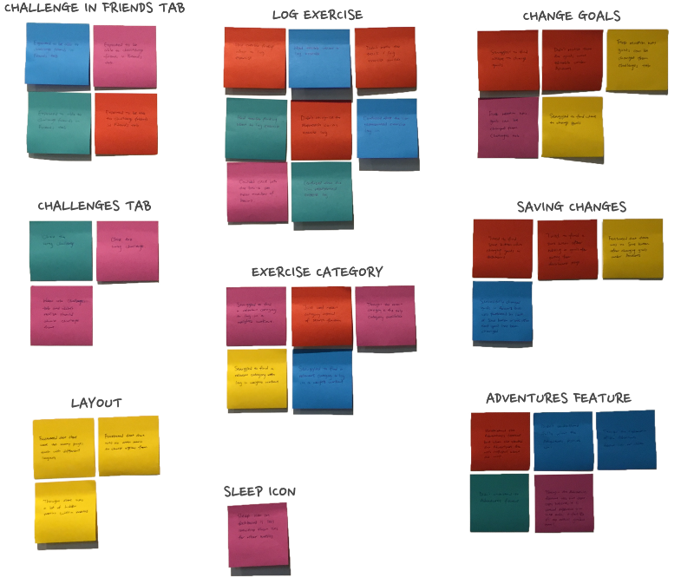

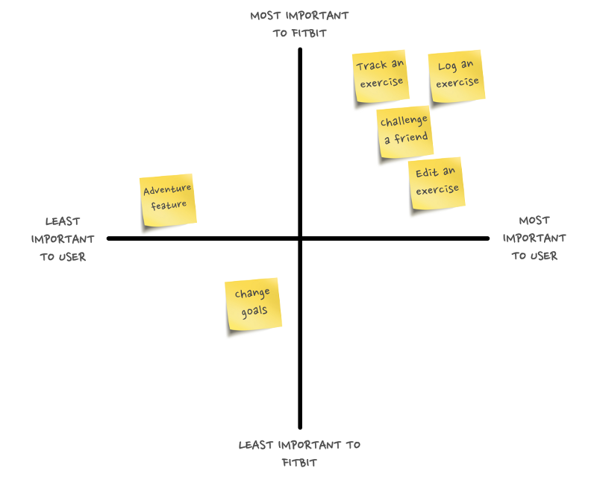

**Pain Point 1: Discoverability issue with tracking and logging exercise**

There are two entry points to track or log an exercise on the app: through a floating action button on the dashboard page and through the exercise page, but both entry points have discoverability issues.

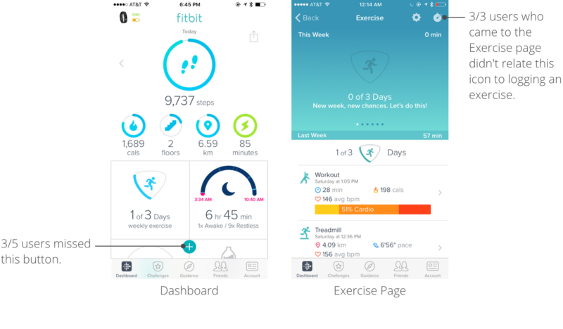

**Pain Point 2: Users had difficulty finding the relevant exercise type to log**

Fitbit has a large database of over 100 exercises that users can use to log exercise (and only 19 exercises available for tracking). But the app does not show a list of all exercises (presumably because such a long list may be overwhelming). For a user trying to log a new exercise, she can only use the search function, but this poses a problem when the exercise that she is trying to search for does not match the exact exercise in Fitbit’s database.

For the usability test, the prompt was to log a chest and arms workout at the gym. The user could not find any matching result by searching “chest”, “workout”, “arms” or “gym”. The most relevant exercise type on the database is weights but this is unknown to the user.

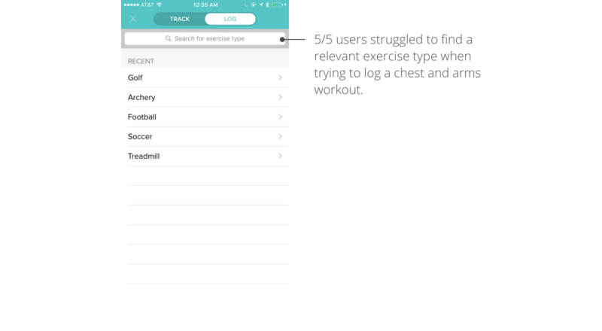

**Pain Point 3: Users could not edit exercise records apart from exercise type**

There are four different ways to record an exercise onto the Fitbit app. I did some further research by visiting Fitbit’s online customer service forum and conducting user interviews to learn more about how an exercise can be recorded.

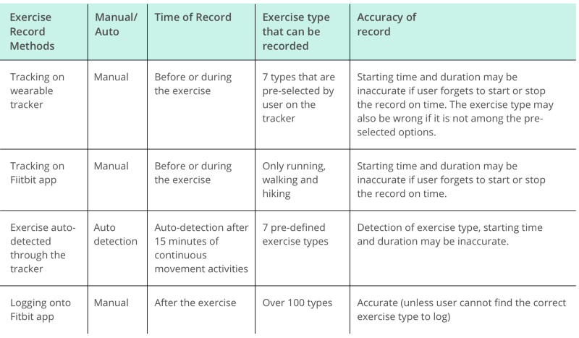

User interviews revealed that keeping a (roughly) accurate record of exercises is important for a user to motivate her to achieve her fitness goal. Currently, a user can only change the exercise type after an exercise is recorded. The ability to edit the starting time and duration of exercise is equally important because a user may forget to start or stop recording on time and the auto-detection on the tracker, although helpful, is not always accurate. This leads to either an exaggerated or inflated exercise time which could be discouraging and frustrating to the user.

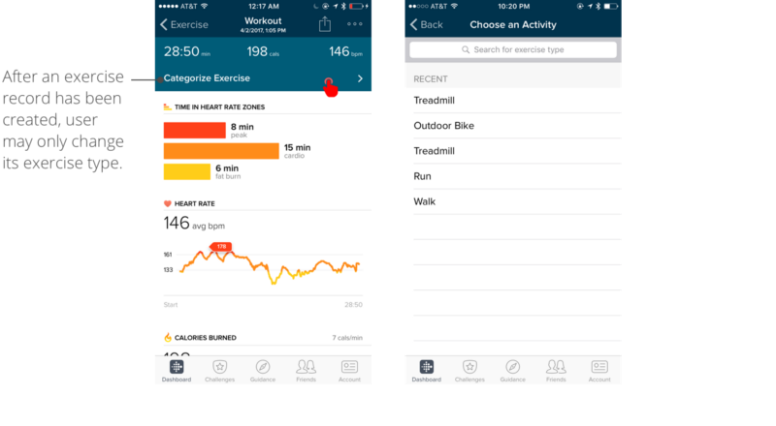

**Pain Point 4: Users had trouble finding how to challenge a friend**

Creating a challenge with friends is one of the standout features that made Fitbit so socially popular when it launched. Currently, to create a challenge, a user has to go to the Challenges tab, select a challenge, then pick friend(s) to compete with. In the usability test, 3 out of 5 users tried to look for how to create a challenge on a friend’s page and were frustrated when they couldn’t find a way. This showed that for a user who already had a friend in mind that she wanted to compete with, the current flow did not match their mental model. She would expect to be able to perform social actions (including challenging a friend) on the friend’s page.

