**Task Flow**

I also created a task flow to show the flow for a user who wants to accurately record her exercise on the Fitbit app. The highlighted areas represent the first 3 pain points which I will tackle in my design solutions.

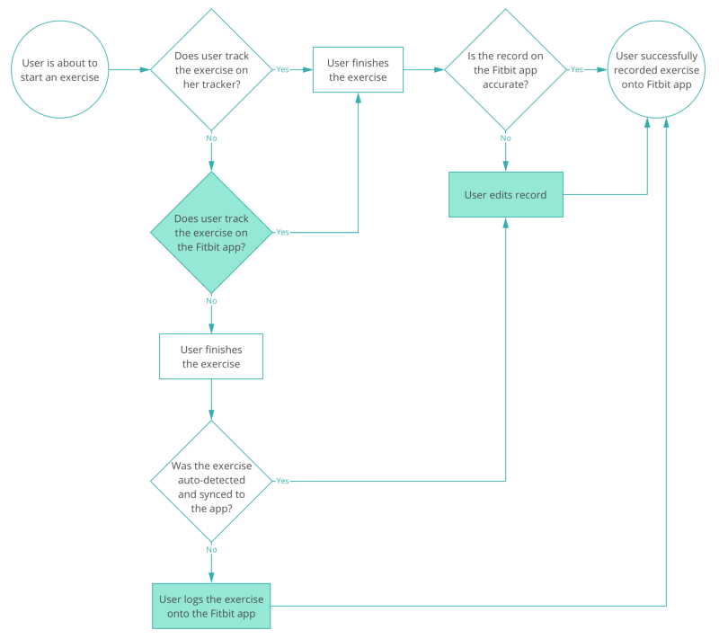

**Ideating the Solution**

Then it was time to start sketching. I came up with several potential solutions to each of the pain points and made some rough UI sketches.

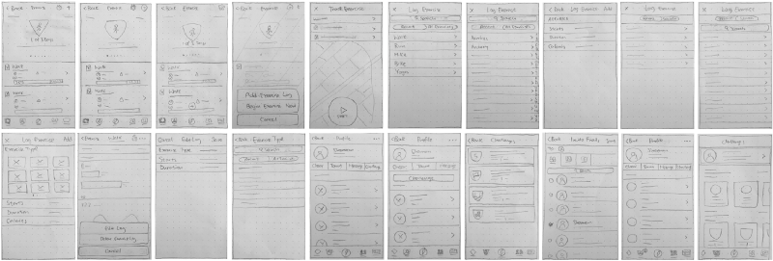

I did some preliminary validation on the Lo-Fi UI sketches and used the feedback to refine my sketches and narrow down my solutions for the Hi-Fi mockups.

**Prototyping and Validation**

I jumped into Sketch to create Hi-Fi mockups of my proposed solutions and used Marvel to create a clickable prototype. I tested the prototype with 5 new individuals. Insights from the validation test led me to reiterate on one of the screens. Below are the Hi-Fi mockups of my final solutions including the results of the user testing before and after implementing my design solutions.

***Pain Point 1: Discoverability issue with tracking and logging exercise on Fitbit app***

**Design solution:**Make the two entry points on the dashboard and exercise page more easily discoverable and make the choice between track and log exercise more apparent.

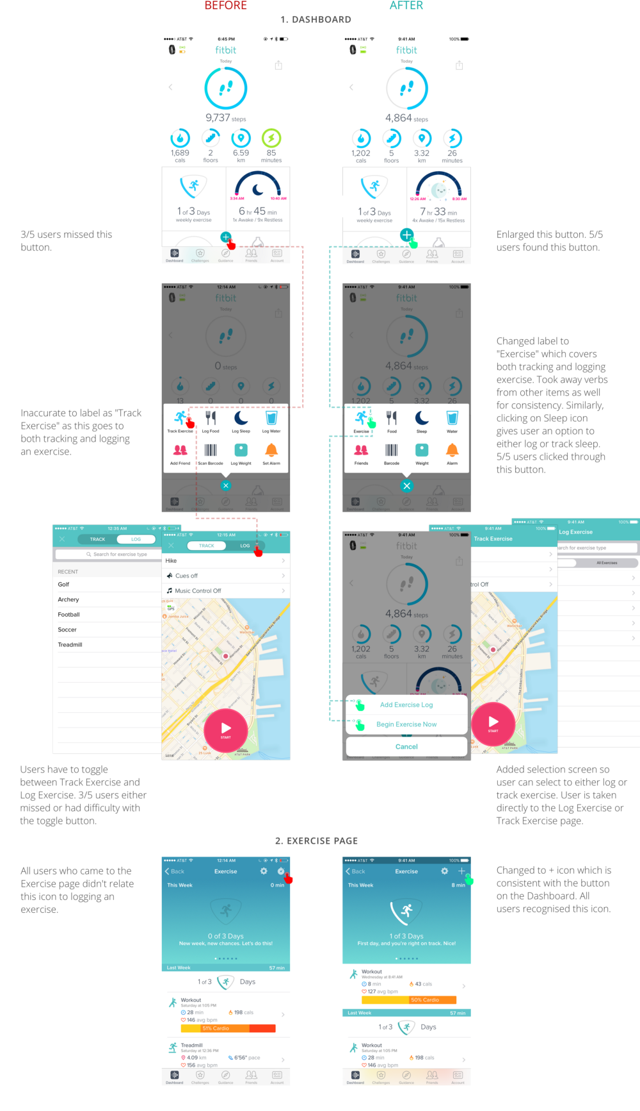

***Pain Point 2: Users had difficulty finding the correct exercise type to log***

**Design solution:**Add a way for users to browse all exercise types.

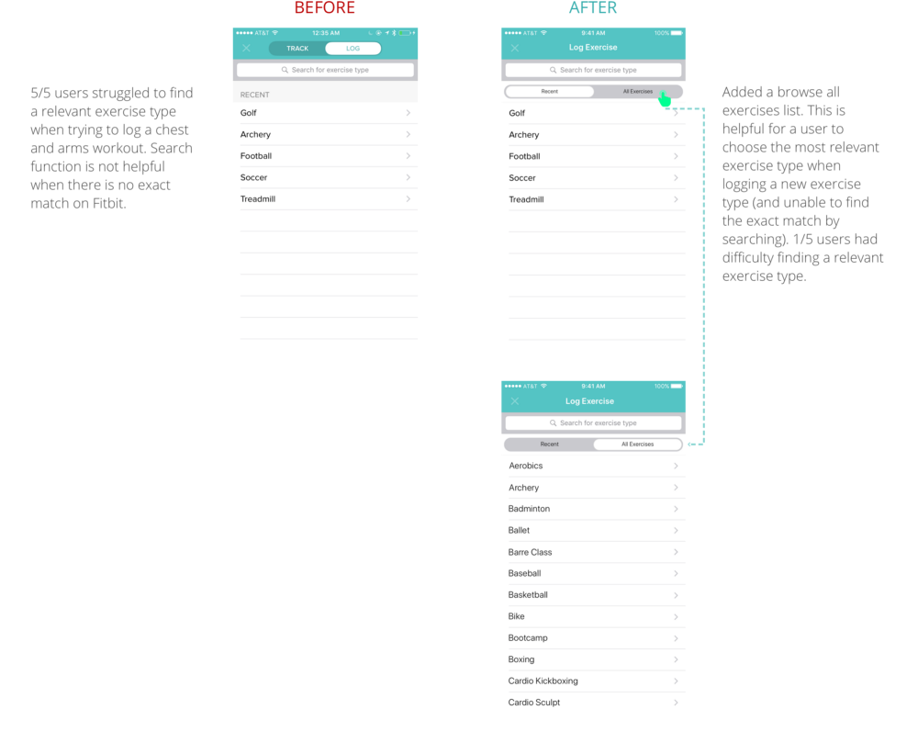

***Pain Point 3: Users could not edit exercise records apart from exercise type***

**Design solution:**Allow the user to be able to edit starting time and duration of an exercise.

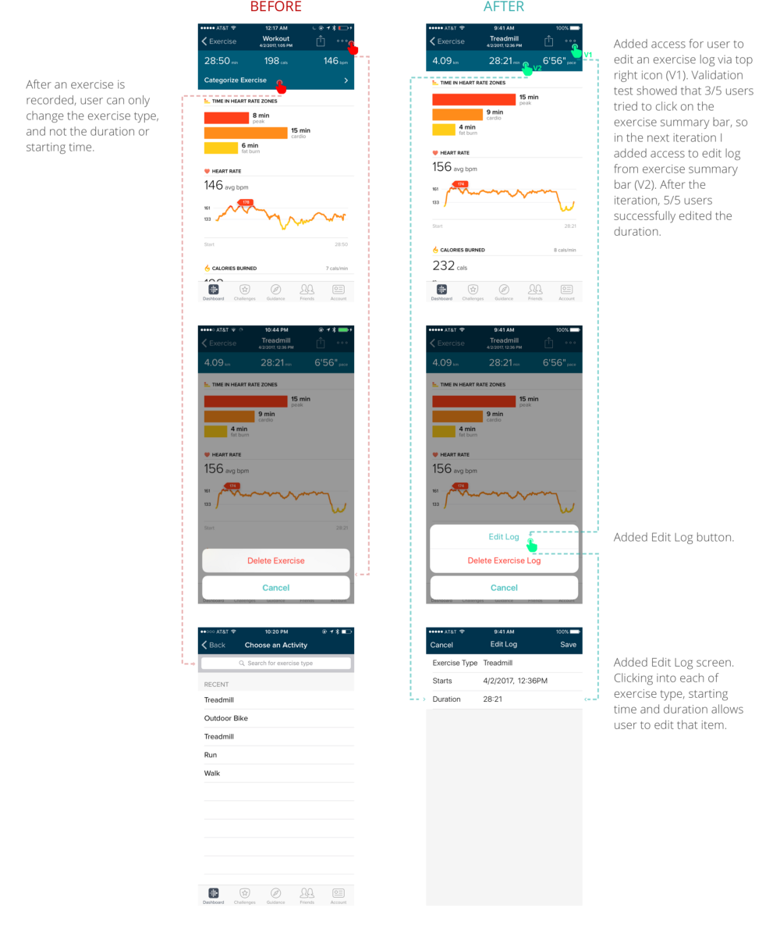

***Pain Point 4: Users had trouble finding how to challenge a friend***

**Design solution:**Allow a user to challenge a friend on the friend’s page.

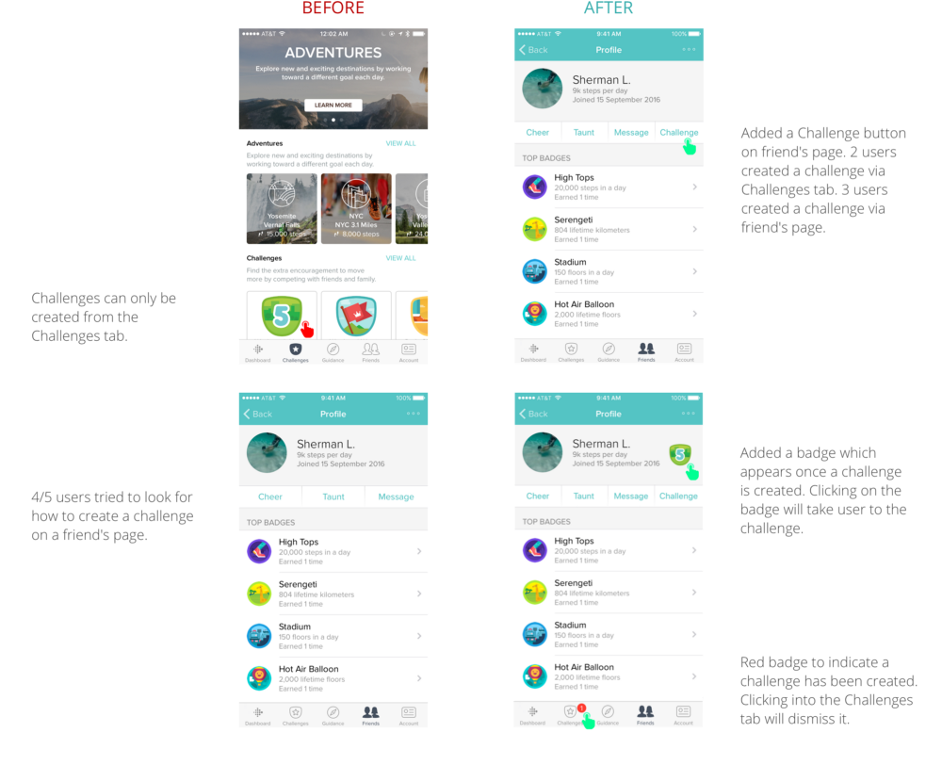

Here’s an overview of the results of my design changes.

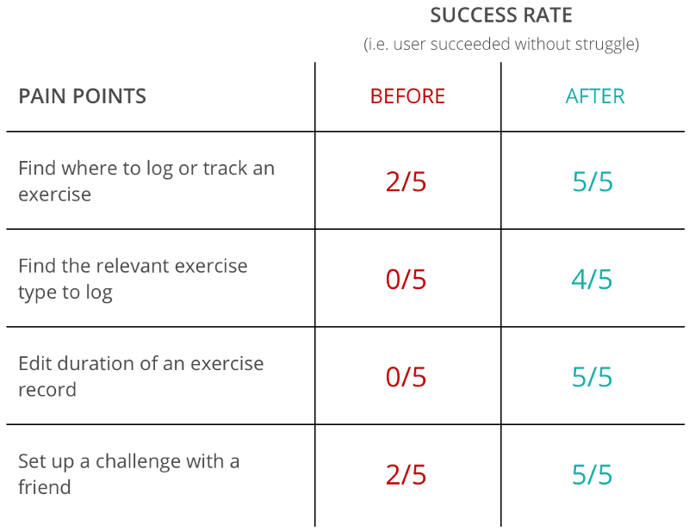

**Takeaways**

Fitbit is a great product with a grand mission to get people moving. To achieve this, it faces one of the biggest challenges — changing a person’s habit. It’s packed with a lot of powerful tools to do just that, such as setting personal goals, tracking and logging exercise and social fitness challenges. But changing a habit is painful, so it’s even more important to make it as easy and friction-less as possible for a user to use those tools. And sometimes a change as small as enlarging a button or changing an icon can make a difference.