**A/B Testing**

A/B testing is a method used to compare two versions of a variable to determine which performs better. A/B testing—also called split testing or bucket testing—compares the performance of two versions of content to see which one appeals more to visitors/viewers.

It tests a control (A) version against a variant (B) version to measure which one is most successful based on your key metrics. This is done by splitting traffic between the two versions, and metrics are collected to determine which version performs better.

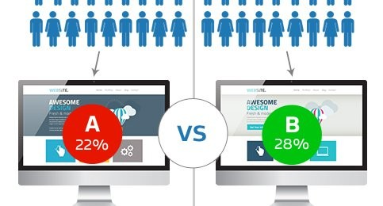

**Core Components:**

1. **Hypothesis Formation**  
   a hypothesis is a testable statement about how a change will impact a specific aspect of the product or user behaviour. It aims to predict the effect of a proposed change.  
   Eg: Changing the Submit button color from blue to green will increase the click-through rate.
2. **Variants**  
   **Control (A)**: original version  
   **Variant (B)**: This is the modified version that incorporates the change you want to test. It's the "challenger" to your current version.
3. **Sample size selection and Randomization/Segmentation**  
   Determine the sample size needed for statistical significance. Decide how you will segment your audience for the test. Typically, users are randomly divided into two groups: one sees the control, and the other sees the variant.
4. **Layer**  
   In a single page if you have multiple experiments, One experiment can affect another experiment metrics. That time we can use layers

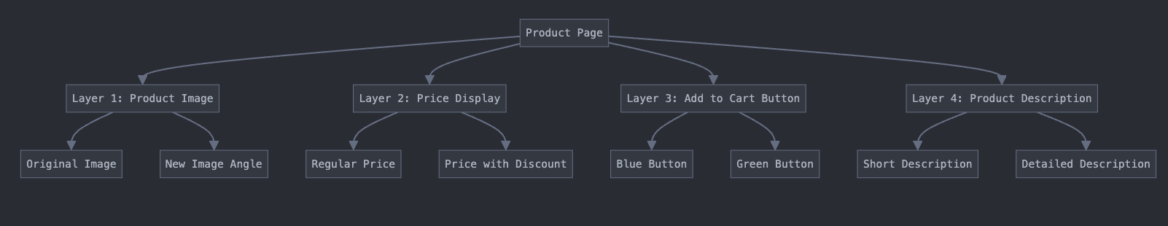

1. **Treatment**Treatmentrefers to the specific way in which a user interface (UI) element is treated differently between the control(A) and variant(B).
2. **Test Duration**   
   A/B testing requires a sufficient sample size and duration to produce reliable results. This can be anywhere from a few hours to several weeks or even months
3. **Conversion:**

**conversion** is the completion of a desired action that reflects the effectiveness of different treatments or variations being tested. By measuring and analyzing conversions, you can determine which version of your UI or feature is most successful in achieving your goals and making data-driven improvements.  
  
The goal of A/B testing is to identify which version of content (variant) performs better than the original version (control) in terms of conversion rate. The conversion rate is calculated by dividing the number of conversions by the total number of users who interacted with the content.  
  
Eg:

-100 visitors see the control version (original design)

-20 visitors fill out the form (conversion)

-100 visitors see the variant version (new design)

-25 visitors fill out the form (conversion)

In this case, the conversion rate for the control version is 20% (20/100), and the conversion rate for the variant version is 25% (25/100)

1. **Metrics for Evaluation**The key performance indicators (KPIs) used to measure the success of each variant are crucial in determining which one performs better. These might include metrics such as conversion rate, click-through rate, revenue generated, etc.