Http2

Why we need http2:

Let's say we have hosted our application on Port 8080, Which means our application is listening for **incoming requests** on **port 8080.** HerePort 8080 is used for communication when client sends request to server. But when our application is making request to another application it won't use 8080 it uses random high number port for outbound. By using random port, we can reuse and have multiple connections from our source application.

So, when I make 1000 concurrent request 1000 outbound ports will be open.

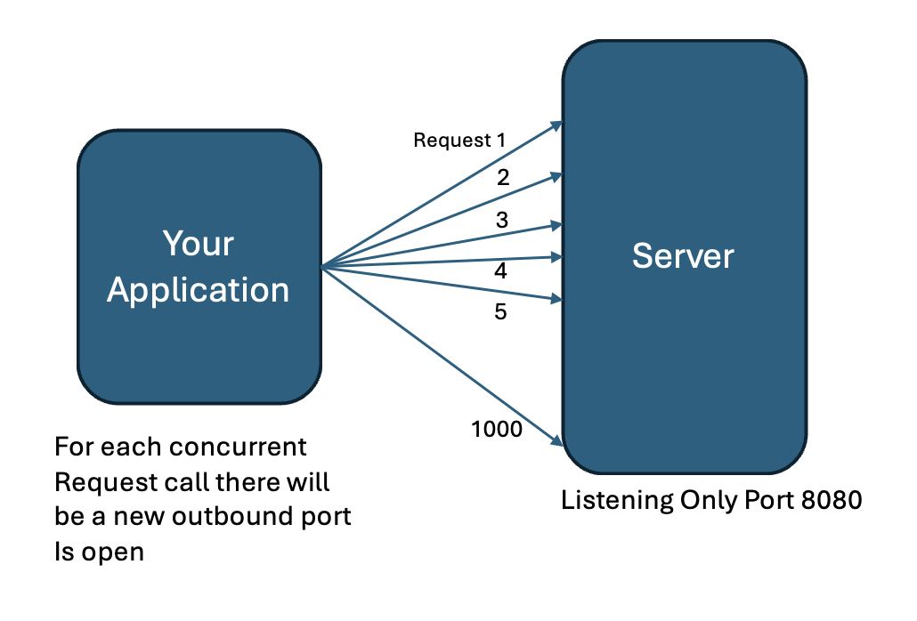

How is this solved by Http2?  
Http2 uses multiplexing to solve this. Using single TCP connection multiple requests can be sent as stream and can receive multiple response at same time as stream(bidirectionally).

## Multiplexing:

By introducing **streams** and **binary framing**, allowing multiple requests and responses to be sent **simultaneously** over a single connection which is known as multiplexing

### Streams:

Each stream represents a **single HTTP request-response pair**, but the key difference is that **multiple streams** can be active simultaneously over a single TCP connection. That’s how protocol is designed.

A stream can carry both request and response data in **both directions**.

### **Binary framing:**

**Binary framing** refers to splitting data into small units called **frames** and sending them in a stream (same stream).

Let’s say, a POST request can be split as

1. HEADERS Frame – Headers of the request
2. DATA frame – Request body
3. PRIORITY – can have if this request has priority than another concurrent request made

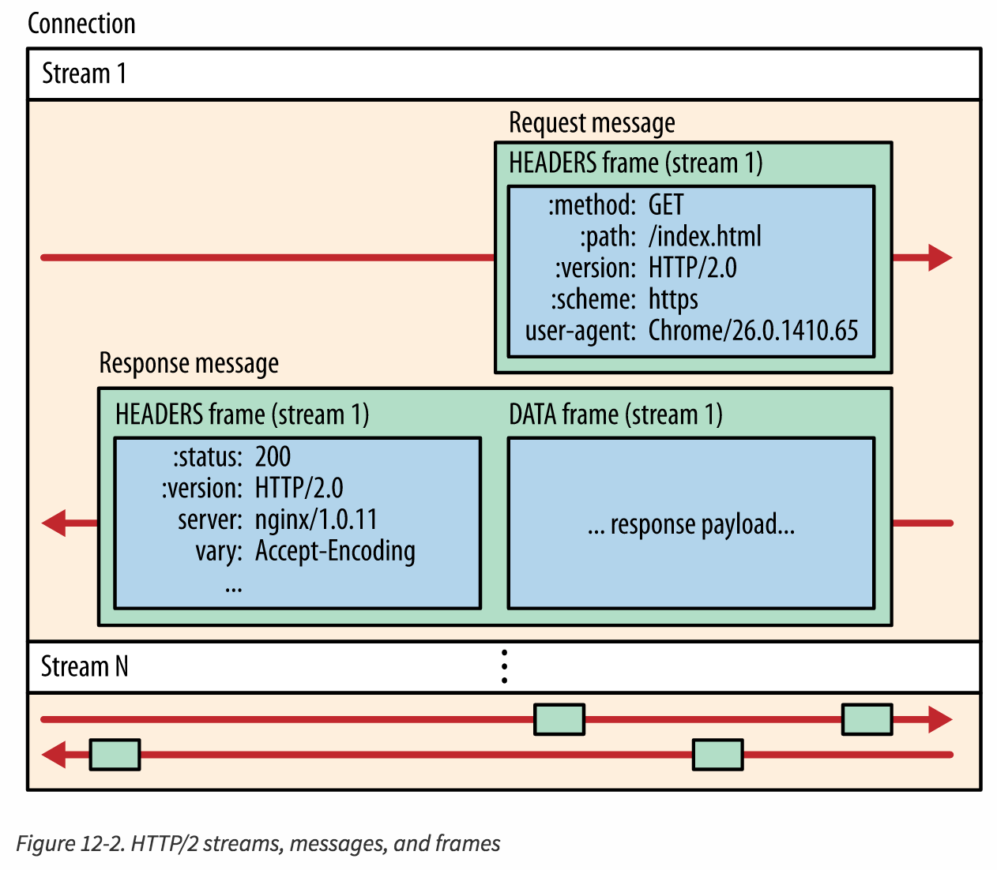

What is the maximum number of streams can be carried concurrently?

**2³² - 1** (because stream IDs range from 1 to 2³² - 1, where 0 is reserved).

## Other Advantages:

* Header Compression (HPACK)
* **Flow Control**: prevent any stream from being overwhelmed by too much data at once
* Stream Prioritization
* Server push: proactively sends resources the server knows the client will need.