Finance Tracker  Project Documentation |  | August 19  2025
<Document Abstract>


DO THE MATH

Contents
1. Introduction 3
1.1 Project Overview 3
1.2 Business Problem Statement 3
1.3 Objectives & Goals 4
1.4 Target Audience 4
1.5 Key Deliverables 5
2. System Architecture 5
2.1 High-Level Client–Server Architecture 5
2.2 Component Interaction (Frontend ↔ Backend ↔ Database) 6
2.3 Project Structure (frontend/, backend/) 8
3. Tech Stack 8
3.1 Frontend 8
3.2 Backend 8
3.3 Database 9
3.4 Testing 9
3.5 Email Services 9
3.6 Others 9
4. Features & Functionality 9
4.1 Authentication & Authorization 9
4.2 Transactions Management 9
4.3 Savings Goals 9
4.4 User Transaction Details 9
4.5 Logs & Monitoring 10
4.6 Admin Functionality 10
4.7 Testing & Quality Assurance 10
5. Backend Services 10
5.1 User Service 10
5.2 Transaction Service 10
5.3 Logging Service 10
5.4 Notification Service 10
5.5 Analytics Service 10
6. Database Design 11
6.1 Entity-Relationship Design (ERD) 11
6.2 Relationships Between Tables 12
6.3 Indexing & Optimization 12
7. Frontend Architecture 13
7.1 Project Structure 13
7.2 Redux Store 13
7.3 Controlled Components 13
7.4 API Integration 13
7.5 Error Handling 13
7.6 Recharts 13
8. Logging & Monitoring 13
9. Testing & QA 13
10. Deployment & Setup 14
11. Performance Optimization 14
12. Security Considerations 14
13. Documentation & Maintenance 14

Project Documentation

1. Introduction

1.1 Project Overview
This document provides an exhaustive technical overview of a comprehensive full-stack personal finance management application engineered to deliver enterprise-grade financial tracking, budget management, and savings goal achievement capabilities. The application leverages modern web technologies, implementing a React-based Single Page Application (SPA) frontend, a FastAPI-powered Python backend with comprehensive API services, and a robust PostgreSQL database infrastructure, all orchestrated within a carefully structured monorepo architecture.
The system is designed with scalability, maintainability, and security as core principles, implementing industry best practices including comprehensive logging, monitoring, testing, and quality assurance measures. The application supports real-time data synchronization, advanced analytics with interactive visualizations, role-based access control, and extensive audit trails for compliance and debugging purposes.

Key Technical Highlights:
- Redux Toolkit for sophisticated state management
- PostgreSQL with optimized indexing and query performance
- JWT-based authentication with cookie management
- Real-time data visualization using Recharts
- Extensive test coverage with Vitest and SonarQube integration
- EmailJS integration for client-side email services

1.2 Business Problem Statement
In today's complex financial ecosystem, individuals face significant challenges in managing their personal finances effectively due to:

Primary Pain Points:
- Data Fragmentation: Financial information scattered across multiple platforms, accounts, and institutions
- Lack of Real-time Insights: Limited visibility into spending patterns and financial trends
- Manual Tracking Overhead: Time-consuming manual entry and reconciliation processes
- Goal Tracking Difficulties: Inadequate tools for setting, monitoring, and achieving financial objectives

Market Gap Analysis:
Existing solutions often fall short by either being too simplistic for power users or too complex for everyday consumers. They frequently lack comprehensive logging for audit purposes, real-time synchronization, or fail to provide the granular control and customization that users require for effective financial management.

1.3 Objectives & Goals

Primary Objective:
To architect and deliver a robust, scalable, and user-centric web application that serves as a comprehensive solution for personal finance management, incorporating enterprise-level security, monitoring, and analytical capabilities.

Strategic Goals:
- Security Excellence:
  - Implement military-grade authentication and authorization mechanisms
  - Ensure complete data protection through encryption and secure transmission
  - Establish comprehensive audit trails for compliance and forensic analysis
  - Deploy role-based access control with granular permissions
- Feature Completeness:
  - Deliver comprehensive transaction management with advanced categorization
  - Provide sophisticated savings goal tracking with progress analytics
  - Implement real-time data visualization and reporting capabilities
  - Enable data export and email integration for external consumption
- Technical Excellence:
  - Establish comprehensive logging infrastructure for monitoring and debugging
  - Implement extensive testing coverage with automated quality gates
  - Ensure optimal performance with sub-second response times
  - Design for horizontal scalability and future enhancement
- User Experience:
  - Create intuitive, responsive interfaces with accessibility compliance
  - Provide real-time feedback and validation
  - Implement progressive web app capabilities for mobile experience
  - Ensure cross-browser compatibility and performance optimization

1.4 Target Audience

Primary User Segments:
- Individual Financial Managers (Ages 25-45):
  - Professionals managing multiple income streams
  - Individuals with complex expense categories
  - Users requiring detailed financial reporting and analytics
  - Budget-conscious consumers seeking optimization opportunities
- Small Business Owners:
  - Entrepreneurs tracking business and personal finances
  - Freelancers managing irregular income patterns
  - Service providers needing expense categorization
- Financial Planning Enthusiasts:
  - Users with specific savings goals (retirement, major purchases)
  - Investment trackers requiring portfolio insights
  - Individuals preparing for major life events

1.5 Key Deliverables

Technical Deliverables:
- Frontend Application:
  - Responsive React SPA with Redux state management
  - Progressive Web App (PWA) capabilities
  - Comprehensive test suite with >90% coverage
  - Performance optimized with Lighthouse score >95
- Backend API Services:
  - RESTful API with OpenAPI documentation
  - Microservices architecture with service separation
  - Comprehensive error handling and validation
  - Performance monitoring and logging infrastructure
- Database Infrastructure:
  - Optimized PostgreSQL schema with proper indexing
  - Data migration and seeding scripts
  - Backup and recovery procedures
  - Performance monitoring and optimization
- Quality Assurance:
  - Automated testing pipelines
  - SonarQube integration with quality gates
  - Security vulnerability scanning
  - Performance benchmarking and monitoring

2. System Architecture

2.1 High-Level Client–Server Architecture
The application implements sophisticated three-tier architecture designed for optimal separation of concerns, scalability, and maintainability:

Presentation Tier (Client Side):
- React SPA: Single Page Application built with React 18+ utilizing functional components and hooks
- State Management: Redux Toolkit for global state with RTK Query for efficient data fetching
- Client-Side Routing: React Router v6 with protected routes and lazy loading
- UI Framework: Custom component library with consistent design system
- Build Tool: Vite for fast development and optimized production builds

Application Tier (Server Side):
- FastAPI Framework: High-performance Python web framework with automatic API documentation
- Authentication Service: JWT-based authentication with refresh token rotation
- Business Logic Layer: Service-oriented architecture with clear separation of concerns
- Validation Layer: Pydantic models for request/response validation and serialization
- Middleware Stack: CORS, authentication, logging, and error handling middleware

Data Tier (Database Layer):
- PostgreSQL Database: Primary data storage with ACID compliance
- Connection Pooling: Optimized database connections with psycopg2
- Indexing Strategy: Carefully designed indexes for query optimization

Integration Layer:
- Email Services: EmailJS for client-side email functionality
- Logging Infrastructure: Centralized logging with structured log formats
- Monitoring: Application performance monitoring with custom metrics

2.2 Component Interaction (Frontend ↔ Backend ↔ Database)

Request Flow Architecture
- User performs an action on the UI (e.g., submits a form, clicks a button).
- The React component captures this action via an event handler.
- The handler dispatches a Redux action.
- The action triggers middleware (Thunk / RTK Query).
- Middleware uses Axios (HTTP client) to send a request.
- The request hits the FastAPI router.
- FastAPI applies dependency injection (auth/session/db).
- The request is passed to the Service Layer for business logic.
- Service Layer calls the Repository Pattern for data access.
- Repository uses SQLAlchemy ORM to construct queries.
- The query is executed on the PostgreSQL database.

Response Flow Architecture
- PostgreSQL executes the query and returns the result.
- The result is mapped to SQLAlchemy models.
- The Service Layer processes / applies business logic.
- Data is converted into Pydantic response models.
- FastAPI performs serialization into JSON.
- JSON is sent back as an HTTP Response.
- Axios response handler receives the response.
- Redux state is updated with the new data.
- The React component re-renders with updated state.
- The UI updates and displays the result to the user.

Detailed Interaction Patterns:
- Authentication Flow:
  - User submits credentials through LoginForm component
  - Redux authentication slice dispatches login action
  - RTK Query mutation calls /auth/login endpoint
  - FastAPI validates credentials and generates JWT tokens
  - Response includes access token and user profile data
  - Frontend stores tokens in httpOnly cookies
  - User state updated in Redux store
  - Protected routes become accessible
- Transaction Management Flow:
  - User creates/edits transaction in TransactionForm
  - Form validation occurs in real-time using controlled components
  - Submit triggers Redux action with transaction data
  - Backend validates data using Pydantic models
  - Service layer processes business logic (categories, goals)
  - Database transaction ensures data consistency
  - Success response triggers state update and UI refresh
- Real-time Analytics Flow:
  - Dashboard component mounts and requests analytics data
  - RTK Query automatically handles caching and background refetching
  - Backend aggregates transaction data with optimized queries
  - Recharts components receive processed data for visualization
  - WebSocket connections (future enhancement) for real-time updates

2.3 Project Structure (frontend/, backend/)
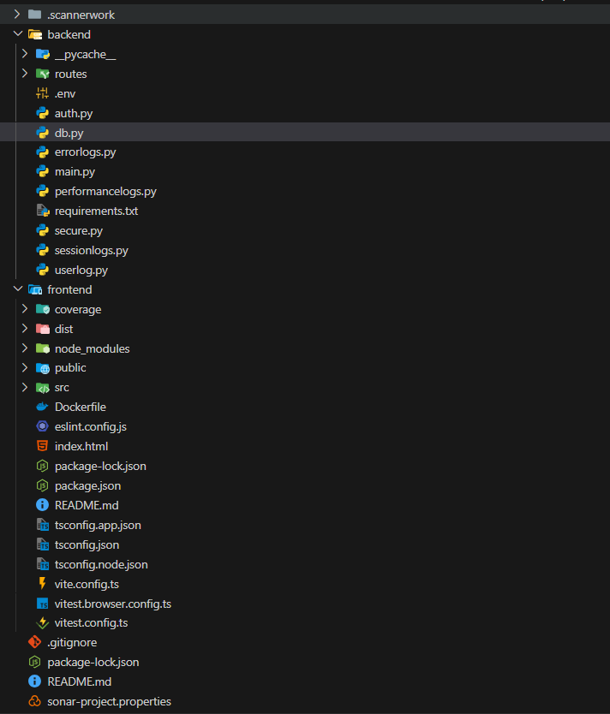

3. Tech Stack

3.1 Frontend
- React (SPA, JSX components)
- Vite (bundler)
- Redux Toolkit (state management)
- Recharts (data visualization)

3.2 Backend
- FastAPI (routes, async endpoints, OpenAPI docs)
- Uvicorn (ASGI server)
- Pydantic.
- jwt

3.3 Database
- PostgreSQL
- SQLAlchemy ORM (models, queries)

3.4 Testing
- Vitest (React testing)
- SonarQube (coverage + static analysis)

3.5 Email Services
- EmailJS (frontend → user notifications)

3.6 Others
- Node.js/NPM
- Python virtualenv
- Git (monorepo management)

4. Features & Functionality

4.1 Authentication & Authorization
- Register/Login: via FastAPI → PostgreSQL users table.
- Session: JWT stored in cookie.
- Role-based: user vs admin roles.

4.2 Transactions Management
- TransactionForm: Controlled component with validation.
- TransactionList: Paginated table, filtering by date/category.
- Recurring Transactions: Mark transactions with recurrence.
- Goal-based Savings: Transactions linked to savings goals.

4.3 Savings Goals
- CRUD for savings goals.
- Goal progress visualized (Recharts).

4.4 User Transaction Details
- Detailed per-user analytics.
- Export CSV.
- Email summary report (EmailJS).

4.5 Logs & Monitoring
- Error Logs: Captures stack trace + metadata.
- User Activity Logs: Tracks login/logout, CRUD ops.
- Performance Logs: Captures API latency + DB query time.
- Session Logs: Lifecycle (login → logout).

4.6 Admin Functionality
- Dashboard view of users, transactions.
- Log management (view/filter).
- Trigger email notifications.

4.7 Testing & Quality Assurance
- Vitest unit tests for components & hooks.
- MSW mocks for API.
- SonarQube coverage enforcement.

5. Backend Services

5.1 User Service
- /register, /login, /profile endpoints.

5.2 Transaction Service
- CRUD for transactions.
- Linked to saving_goals.

5.3 Logging Service
- Insert + fetch logs (error_logs, performance_logs, session_logs, user_activity_logs).

5.4 Notification Service
- Future-ready; currently frontend uses EmailJS.

5.5 Analytics Service
- Provides aggregate queries (e.g., total monthly expenses).

6. Database Design

6.1 Entity-Relationship Design (ERD)

Users
- id (PK)
- username
- email (unique)
- password_hash
- created_at
- updated_at

Transactions
- id (PK)
- user_id (FK → Users.id)
- amount
- type (income/expense)
- category
- description
- is_recurring (boolean)
- goal_id (FK → SavingGoals.id, nullable)
- created_at

SavingGoals
- id (PK)
- user_id (FK → Users.id)
- goal_name
- target_amount
- current_amount
- deadline
- status (in-progress/completed)
- created_at

ErrorLogs
- id (PK)
- user_id (FK → Users.id, nullable for system errors)
- error_message
- stack_trace
- endpoint
- created_at

SessionLogs
- id (PK)
- user_id (FK → Users.id)
- session_id
- login_time
- logout_time
- status (active/expired)

PerformanceLogs
- id (PK)
- user_id (FK → Users.id, nullable)
- endpoint
- execution_time_ms
- query_time_ms
- timestamp

UserActivityLogs
- id (PK)
- user_id (FK → Users.id)
- activity_type (login, add transaction, edit goal, download CSV, etc.)
- activity_details (JSON or text)
- timestamp

6.2 Relationships Between Tables
- One User → Many Transactions
- One User → Many SavingGoals
- One User → Many ErrorLogs
- One User → Many SessionLogs
- One User → Many PerformanceLogs
- One User → Many UserActivityLogs
- One SavingGoal → Many Transactions (via goal_id)

6.3 Indexing & Optimization
- Index on user_id for all tables → fast user-specific queries
- Index on created_at for Transactions & Logs → efficient sorting & filtering
- Composite index (user_id, category) on Transactions → faster category filtering
- Proper normalization, but allow JSON fields in logs for flexibility

7. Frontend Architecture

7.1 Project Structure
- src/pages: e.g., LoginPage, DashboardPage.
- src/components: reusable UI.
- src/hooks: e.g., useAuth, useFetch.
- src/store: Redux slices.

7.2 Redux Store
- authSlice, transactionSlice, logSlice.

7.3 Controlled Components
- All forms use useState/Redux form state.

7.4 API Integration
- api.js: Axios instance with interceptors.

7.5 Error Handling
- React error boundaries.

7.6 Recharts
- PieChart (expenses by category).
- LineChart (spending over time).
- BarChart

8. Logging & Monitoring
- Session Logs: Created at login, updated at logout.
- Error Logs: Captures error + stack trace.
- Performance Logs: Response times recorded per endpoint.
- Activity Logs: Track CRUD + auth events.
- Admin Access: Logs shown in Admin Dashboard with filters.

9. Testing & QA
- Vitest tests in /__tests__/.
- MSW mocks for API calls.
- Coverage via vitest --coverage.
- SonarQube integrated.

10. Deployment & Setup
- Clone repo → frontend/ + backend/.
- Install dependencies: npm install, pip install -r requirements.txt.
- Start backend: uvicorn app.main:app --reload.
- Start frontend: npm run dev.

11. Performance Optimization
- Lighthouse audits for FCP, LCP, CLS.
- Minification + Tree shaking in Vite.
- Indexed queries in PostgreSQL.

12. Security Considerations
- JWT session cookies.
- Role-based access.
- Pydantic validation.
- Passwords hashed.

13. Documentation & Maintenance
- Auto API docs via Swagger (FastAPI).
- Inline code comments.
- README for setup guide.

