EXPERIMENT 1: BREADTH FIRST SEARCH (BFS)
AIM
To implement Breadth First Search (BFS) to find the shortest path in an unweighted graph by exploring nodes level by level.
ALGORITHM
1. Start from the source node and place it in a queue with its path.
2. Mark the source as visited.
3. Remove the front item from the queue.
4. If the current node is the destination, display the path and stop.
5. Add each unvisited adjacent node to the queue along with the updated path.
6. Repeat until the destination is found or the queue becomes empty.
PYTHON CODE
from collections import deque

graph = {
'A': ['B', 'C'],
'B': ['D', 'E'],
'C': ['F'],
'D': [],
'E': ['F'],
'F': []
}

def bfs(start, goal):
queue = deque([(start, [start])])
visited = {start}

while queue:
node, path = queue.popleft()
if node == goal:
return path

for neighbor in graph[node]:
if neighbor not in visited:
visited.add(neighbor)
queue.append((neighbor, path + [neighbor]))

return None

start = input("Enter source (A-F): ").upper()
goal = input("Enter destination (A-F): ").upper()
print("Shortest path:", bfs(start, goal))
INPUT:
Enter source (A-F): A
Enter destination (A-F): F
OUTPUT:
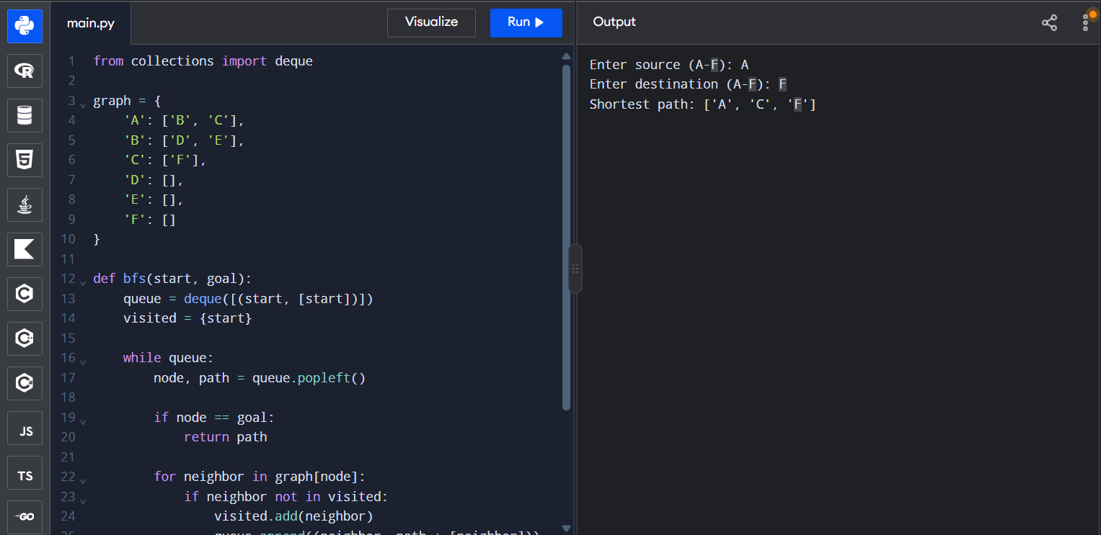
Shortest path: ['A', 'C', 'F']
RESULT
BFS was implemented successfully and found the shortest path in the unweighted graph.

