EXPERIMENT 2: DEPTH FIRST SEARCH (DFS)
AIM
To implement Depth First Search (DFS) to traverse a graph by exploring as deeply as possible before backtracking.
ALGORITHM
1. Start from the source node.
2. Mark the current node as visited and display it.
3. Visit an unvisited adjacent node recursively.
4. If no unvisited adjacent node remains, backtrack to the previous node.
5. Continue until all nodes reachable from the source have been visited.
PYTHON CODE
graph = {
'A': ['B', 'C'],
'B': ['D', 'E'],
'C': ['F'],
'D': [],
'E': ['F'],
'F': []
}

def dfs(node, visited):
if node in visited:
return

visited.add(node)
print(node, end=" ")

for neighbor in graph[node]:
dfs(neighbor, visited)

start = input("Enter source (A-F): ").upper()
print("DFS traversal:")
dfs(start, set())
print()
INPUT
Enter source (A-F): A
OUTPUT:
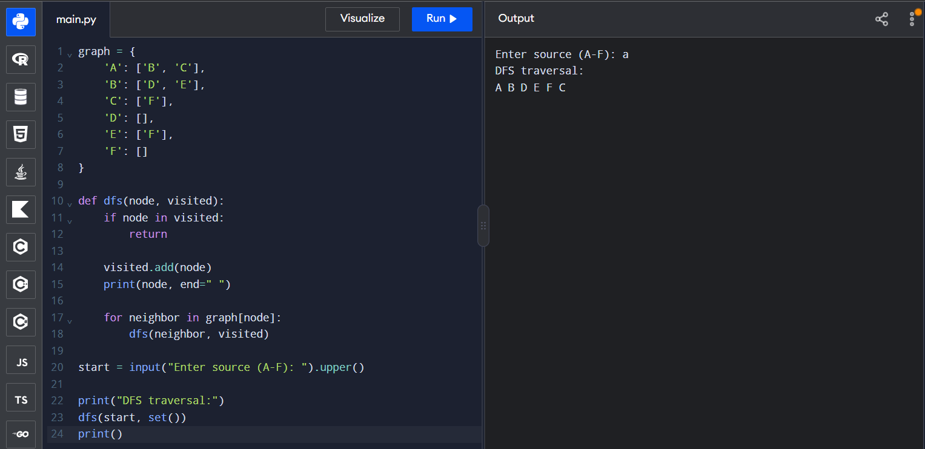
DFS traversal:
A B D E F C
RESULT
DFS was implemented successfully and traversed the reachable graph using depth-first exploration.

