EXPERIMENT 3: UNIFORM COST SEARCH (UCS)
AIM
To implement Uniform Cost Search (UCS) to find the least-cost path from a source node to a destination node.
ALGORITHM
1. Insert the source node into a priority queue with total cost zero.
2. Remove the entry with the smallest cumulative cost.
3. If the node is the destination, return its path and total cost.
4. Calculate the new cumulative cost for every adjacent node.
5. Update a node when a lower cost is found and insert the updated entry into the priority queue.
6. Repeat until the destination is reached or the queue becomes empty.
PYTHON CODE
import heapq

graph = {
'A': [('B', 1), ('C', 4)],
'B': [('D', 2), ('E', 5)],
'C': [('F', 2)],
'D': [('F', 3)],
'E': [('F', 1)],
'F': []
}

def ucs(start, goal):
pq = [(0, start, [start])]
best_cost = {start: 0}

while pq:
cost, node, path = heapq.heappop(pq)

if cost != best_cost.get(node):
continue
if node == goal:
return path, cost

for neighbor, weight in graph[node]:
new_cost = cost + weight
if new_cost < best_cost.get(neighbor, float('inf')):
best_cost[neighbor] = new_cost
heapq.heappush(
pq, (new_cost, neighbor, path + [neighbor])
)

return None, float('inf')

start = input("Enter source (A-F): ").upper()
goal = input("Enter destination (A-F): ").upper()
path, cost = ucs(start, goal)
print("Least-cost path:", path)
print("Total cost:", cost)
INPUT
Enter source (A-F): A
Enter destination (A-F): F
OUTPUT:
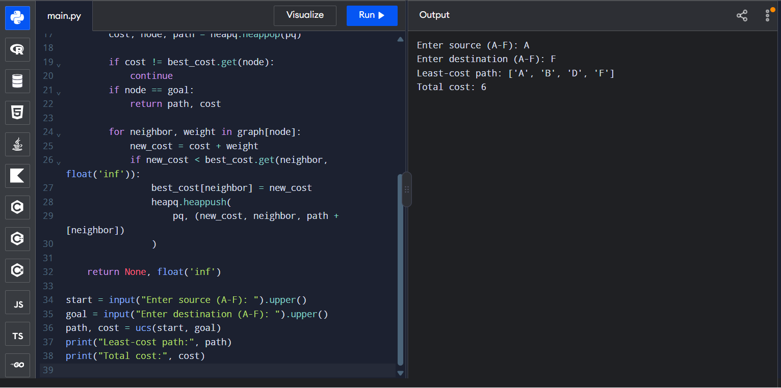
Least-cost path: ['A', 'B', 'D', 'F']
Total cost: 6
RESULT
UCS was implemented successfully and returned a least-cost path for the graph with non-negative edge costs.

