EXPERIMENT 4: BEST FIRST SEARCH
AIM
To implement heuristic-based Best First Search to find a path by expanding the node with the most promising heuristic value.
ALGORITHM
1. Assign a heuristic value to each node representing its estimated distance to the goal.
2. Insert the source node into a priority queue using its heuristic value.
3. Remove the node with the lowest heuristic value.
4. If the node is the destination, return the path.
5. Add unvisited adjacent nodes to the priority queue with their heuristic values.
6. Repeat until the destination is found or the queue becomes empty.
PYTHON CODE
import heapq

graph = {
'A': ['B', 'C'],
'B': ['D', 'E'],
'C': ['F'],
'D': ['F'],
'E': ['F'],
'F': []
}

heuristic = {
'A': 5, 'B': 4, 'C': 2,
'D': 3, 'E': 1, 'F': 0
}

def best_first(start, goal):
pq = [(heuristic[start], start, [start])]
visited = set()

while pq:
_, node, path = heapq.heappop(pq)
if node in visited:
continue
visited.add(node)

if node == goal:
return path

for neighbor in graph[node]:
if neighbor not in visited:
heapq.heappush(
pq, (heuristic[neighbor], neighbor, path + [neighbor])
)

return None

start = input("Enter source (A-F): ").upper()
goal = input("Enter destination (A-F): ").upper()
print("Path:", best_first(start, goal))
INPUT:
Enter source (A-F): A
Enter destination (A-F): F
OUTPUT:
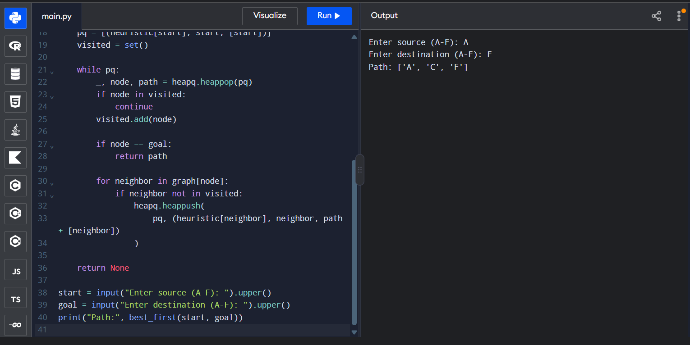
Path: ['A', 'C', 'F']
RESULT
Best First Search was implemented successfully and selected a path using heuristic evaluation.

