EXPERIMENT 5: GREEDY BEST FIRST SEARCH
AIM
To implement Greedy Best First Search to guide pathfinding by selecting the node with the smallest heuristic estimate to the goal.
ALGORITHM
1. Define the graph and heuristic values for its nodes.
2. Insert the source node into a priority queue, prioritized by its heuristic value.
3. Remove the node with the smallest heuristic value.
4. If it is the destination, return the path.
5. Otherwise, add its unvisited neighbors to the priority queue.
6. Repeat until the destination is found or no nodes remain.
PYTHON CODE
import heapq

graph = {
'A': ['B', 'C'],
'B': ['D', 'E'],
'C': ['F'],
'D': ['F'],
'E': ['F'],
'F': []
}

heuristic = {
'A': 5, 'B': 4, 'C': 2,
'D': 3, 'E': 1, 'F': 0
}

def greedy_best_first(start, goal):
pq = [(heuristic[start], start, [start])]
visited = set()

while pq:
_, node, path = heapq.heappop(pq)
if node in visited:
continue
visited.add(node)

if node == goal:
return path

for neighbor in graph[node]:
if neighbor not in visited:
heapq.heappush(
pq, (heuristic[neighbor], neighbor, path + [neighbor])
)

return None

start = input("Enter source (A-F): ").upper()
goal = input("Enter destination (A-F): ").upper()
print("Greedy path:", greedy_best_first(start, goal))
INPUT
Enter source (A-F): A
Enter destination (A-F): F
OUTPUT:
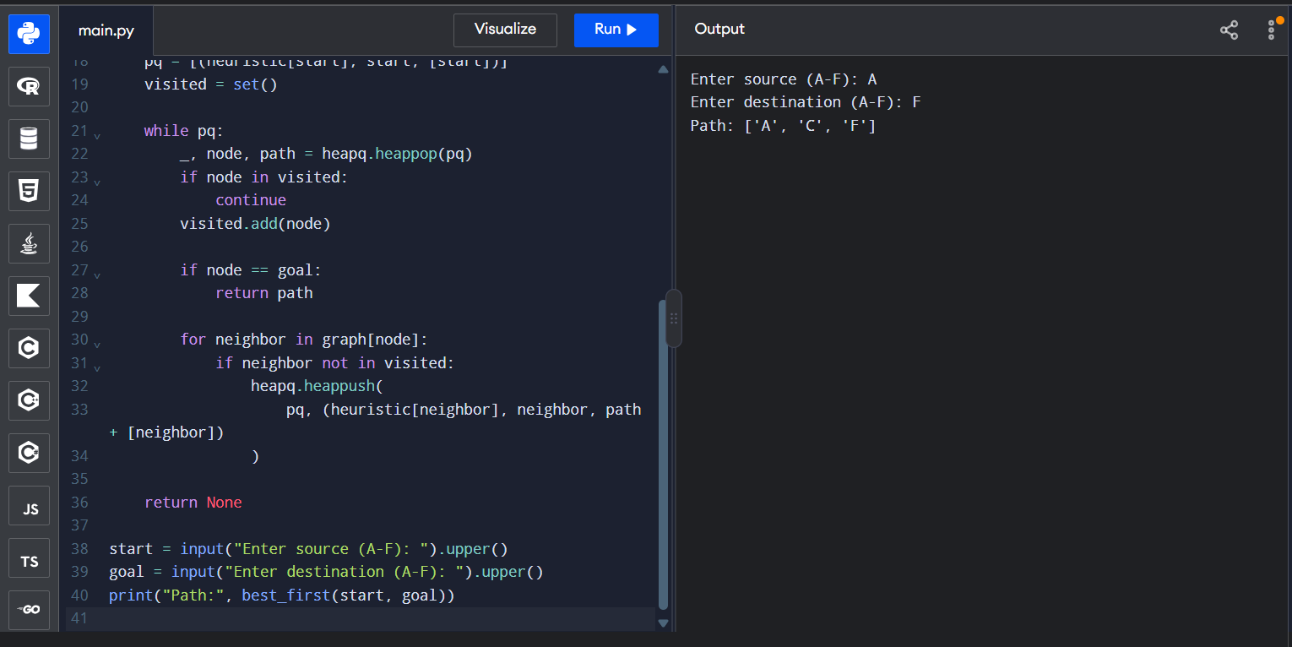
Greedy path: ['A', 'C', 'F']
RESULT
Greedy Best First Search was implemented successfully using heuristic guidance. It does not guarantee a least-cost path.

