Public health awareness campaign analysis using IBM Cognos

Building a public health awareness campaign analysis using IBM Cognos for visualization involves several key steps, including defining analysis

objectives, collecting campaign data, and processing and cleaning the data. Here's a step-by-step guide on how to get started:

1. **Define Analysis Objectives:**

Start by clearly defining the objectives of your public health awareness campaign analysis. What specific insights are you trying to gain from the data? For example:

* + **Assess the effectiveness of the campaign in terms of reach and engagement.**
  + **Identify target demographics that responded well to the campaign.**
  + **Evaluate the impact of the campaign on public health awareness and behaviour.**
  + **Measure the return on investment (ROI) of the campaign.**

1. **Implementing a dataset Kaggle dataset**

link:h [ttps://www.kaggle.com/datasets/osmi/mental-health-in-tech-survey](https://www.kaggle.com/datasets/osmi/mental-health-in-tech-survey)

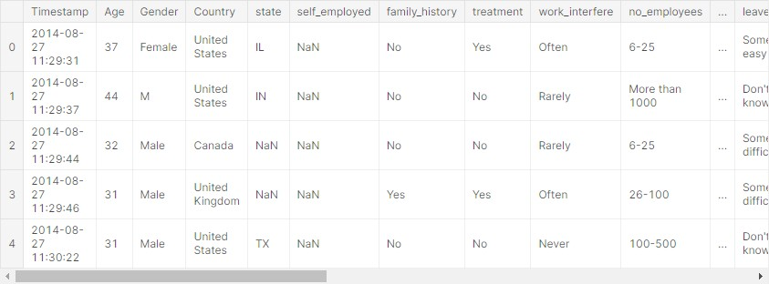

1. **Collect Campaign Data:**

To collect data for your analysis, you'll need access to the campaign data source. This may involve reaching out to relevant public health organisations, government agencies, or partners who have run the campaign. Ensure you

have permission to use and analyse the data. The data you collect may include:

* **Social media engagement metrics (likes, shares, comments).**
* **Website traffic and click-through rates.**
* **Surveys or questionnaires to assess public awareness and behaviour change.**
* **Demographic data of the campaign's audience.**

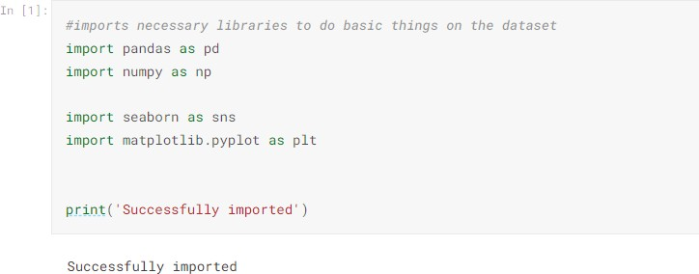

1. **Process and Clean Data:**

Data processing and cleaning are critical to ensuring the quality and accuracy of your analysis. Here are some steps to follow:

* 1. **Data Integration: If your campaign data is stored in different formats or sources, integrate them into a single dataset. This may involve using ETL**

(Extract, Transform, Load) tools.

* 1. **Data Cleaning:**
     + **Handle missing data: Identify and deal with missing values, either by imputation or removal.**
     + **Remove duplicates: Eliminate duplicate records.**
     + **Data format standardisation: Ensure that date formats, units of measurement, and naming conventions are consistent.**

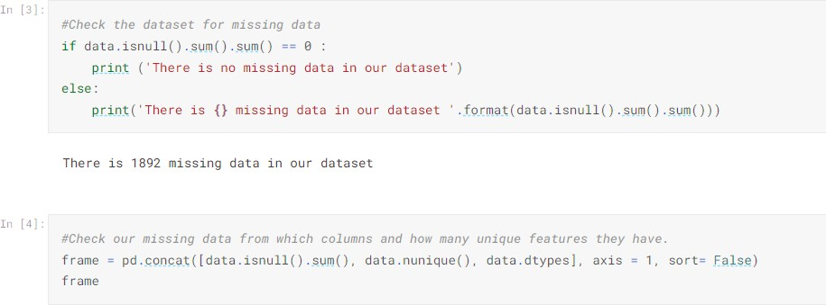

* 1. **Data Transformation:**
     + **Convert data types: Ensure that data types are appropriate for analysis (e.g., dates as date objects, numbers as numeric types).**
     + **Create calculated fields: Generate new variables if needed (e.g., calculate engagement rates).**
     + **Aggregation: Summarise data as needed, e.g., daily, weekly, or monthly aggregates.**

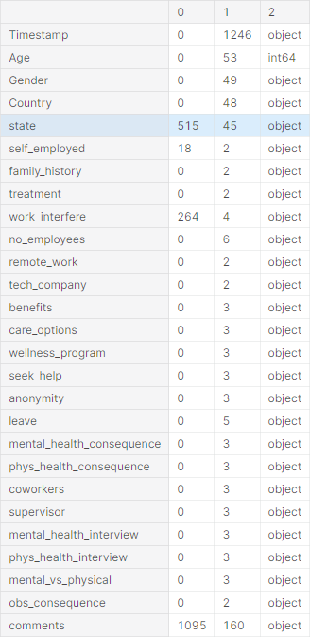

* 1. **Data Quality Check:**
* **Check for outliers and anomalies that may affect analysis.**
* **Validate data against the defined analysis objectives.**

1. **Create Visualizations and Reports:**

With your data in IBM Cognos, you can start building visualizations and reports to address your analysis objectives. You can use various chart types, tables, and graphs to present the data effectively.

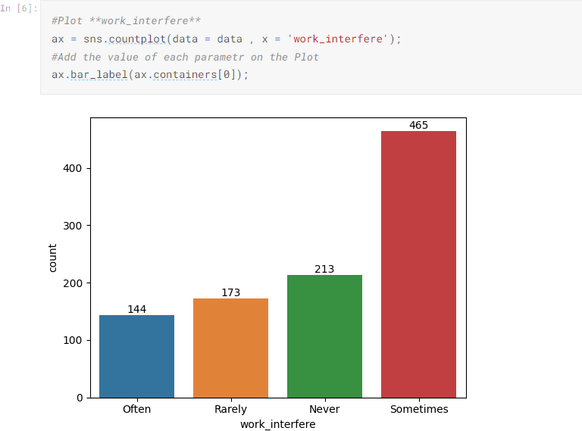

1. **Analyze the Data:**

Analyze the data to draw insights and conclusions related to your campaign's effectiveness. Use features within IBM Cognos to perform statistical analysis or apply business intelligence techniques to discover patterns and trends.

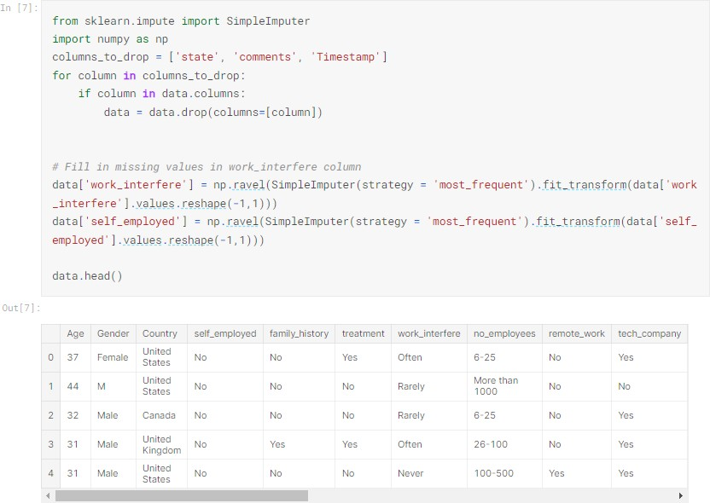

1. **Share Insights:**

Finally, share the insights and findings from your analysis with relevant stakeholders, including campaign organizers, public health officials, or other decision-makers. Use the reports and visualizations created in IBM Cognos for this purpose.

* People with no family history of mental health issues tend to have lower mental issues.
* People with family history of mental health issues tend to have slightly higher chance of having physical issues.
* People who work remotely tend to have no physical issues.
* People who work remotely have low chance for mental issues.
* People in the age group of 20 - 50 tend to have mental issues.
* People who are self-employed have low chance of having mental health issues.
* People who have undergone treatment for mental health issues have lower chance of having mental health issues.
* People who work in tech companies have more chance of having mental health issues.
* People who seek help for mental health issues have more chance of improvement than those who don't.

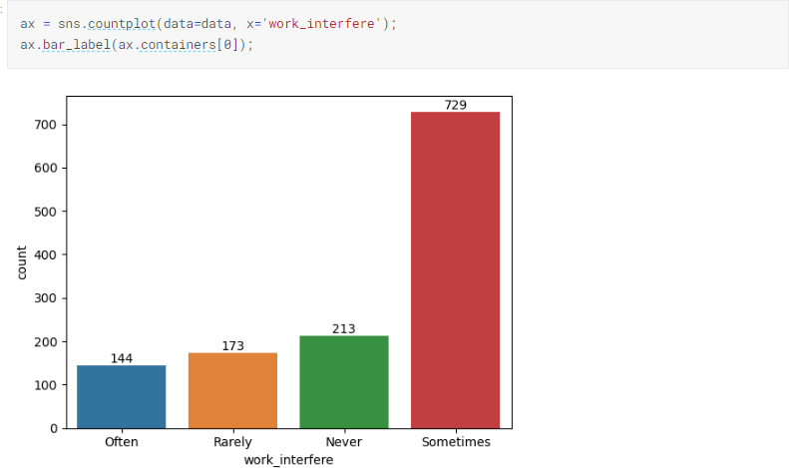

1. **Iterate and Refine:**

Data analysis is an iterative process. If your analysis reveals areas for improvement in the campaign, work with stakeholders to refine strategies and potentially run new campaigns.

Remember to document your analysis process, including the data sources, data cleaning steps, and the rationale behind your analysis choices. This

documentation will be valuable for future reference and for ensuring the transparency and reproducibility of your work.