PYTHON DEEP LEARNING

ICP – 3

Authored By

Eswar Valluru – 27

**Lesson Overview:**

In this lesson, we are going to discuss types of ANNsand Recurrent Neural Network.

**Use Case Description:**

1. Sentiment Analysis on the imdb dataset

**In class programming:**

1.In the code provided there are three mistake which stops the code from running successfully; find those mistakes and explain why they need to be corrected to be able to get the code run.

* The first mistake I have found was the tensorboard version.
* Second is that the input_dim was not initialized or defined. So I have done it input_dim=np.prod(X_train.shape[1:]. Since we have 2000 num_words, I have sent 2000 as the input_dim
* Third mistake is that since we have 3 labels or classes (positive, negative and unsupported), we cannot use sigmoid. Sigmoid is used when we have 2 classes. So I have used softmax.
* Next, since we have 3 classes, I have taken 3 as the output layer neurons.

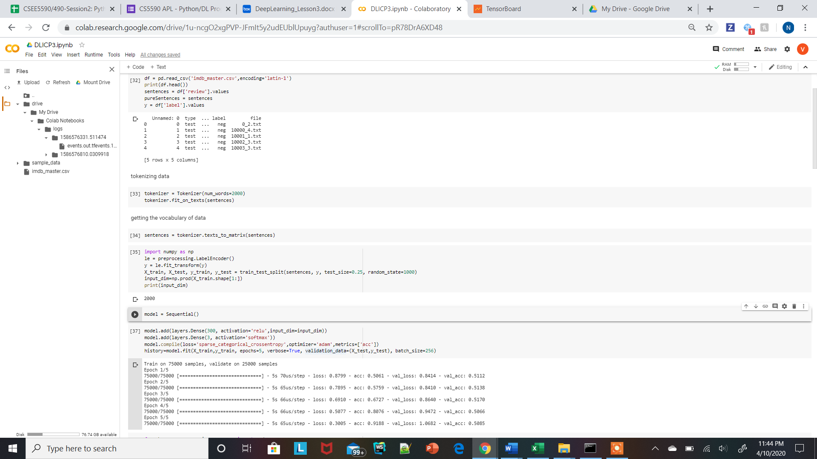

2.Add embedding layer to the model, did you experience any improvement?

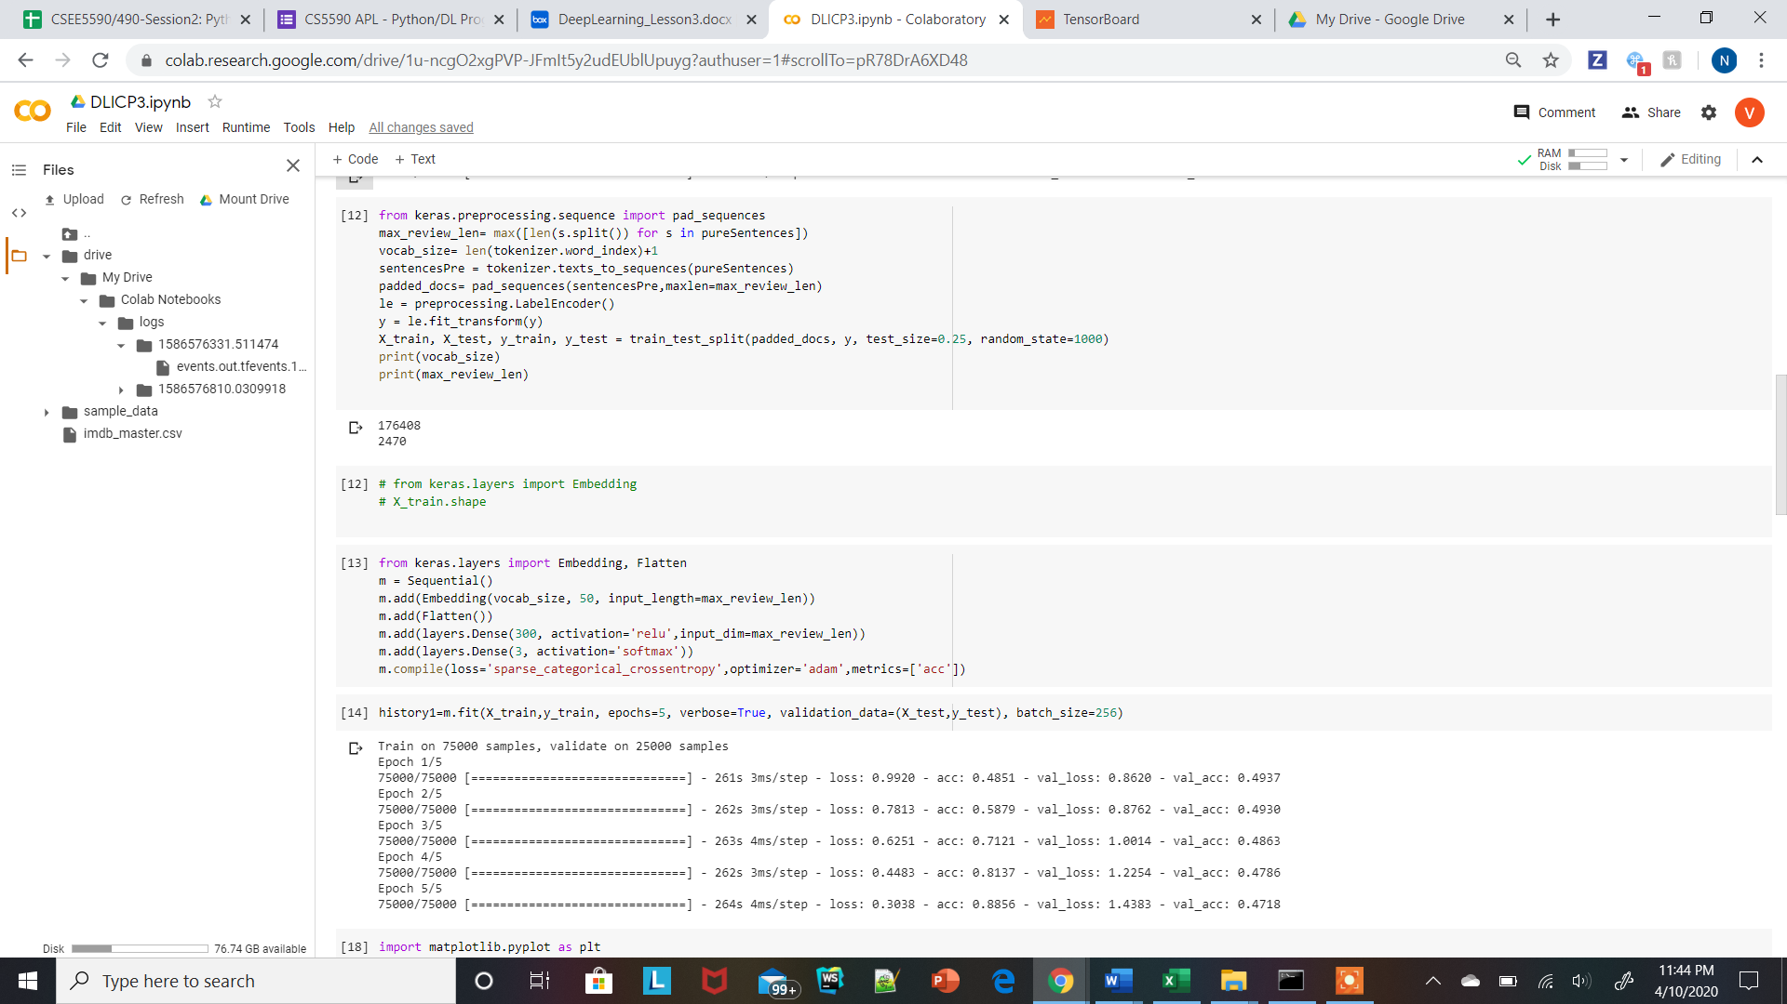

3.Apply the code on 20_newsgroup data set we worked in the previous classes from sklearn.datasets importfetch_20newsgroupsnewsgroups_train =fetch_20newsgroups(subset='train', shuffle=True, categories=categories,)

* We have 20 news groups and so I have taken 20 as the number of neurons in the output dense layer.

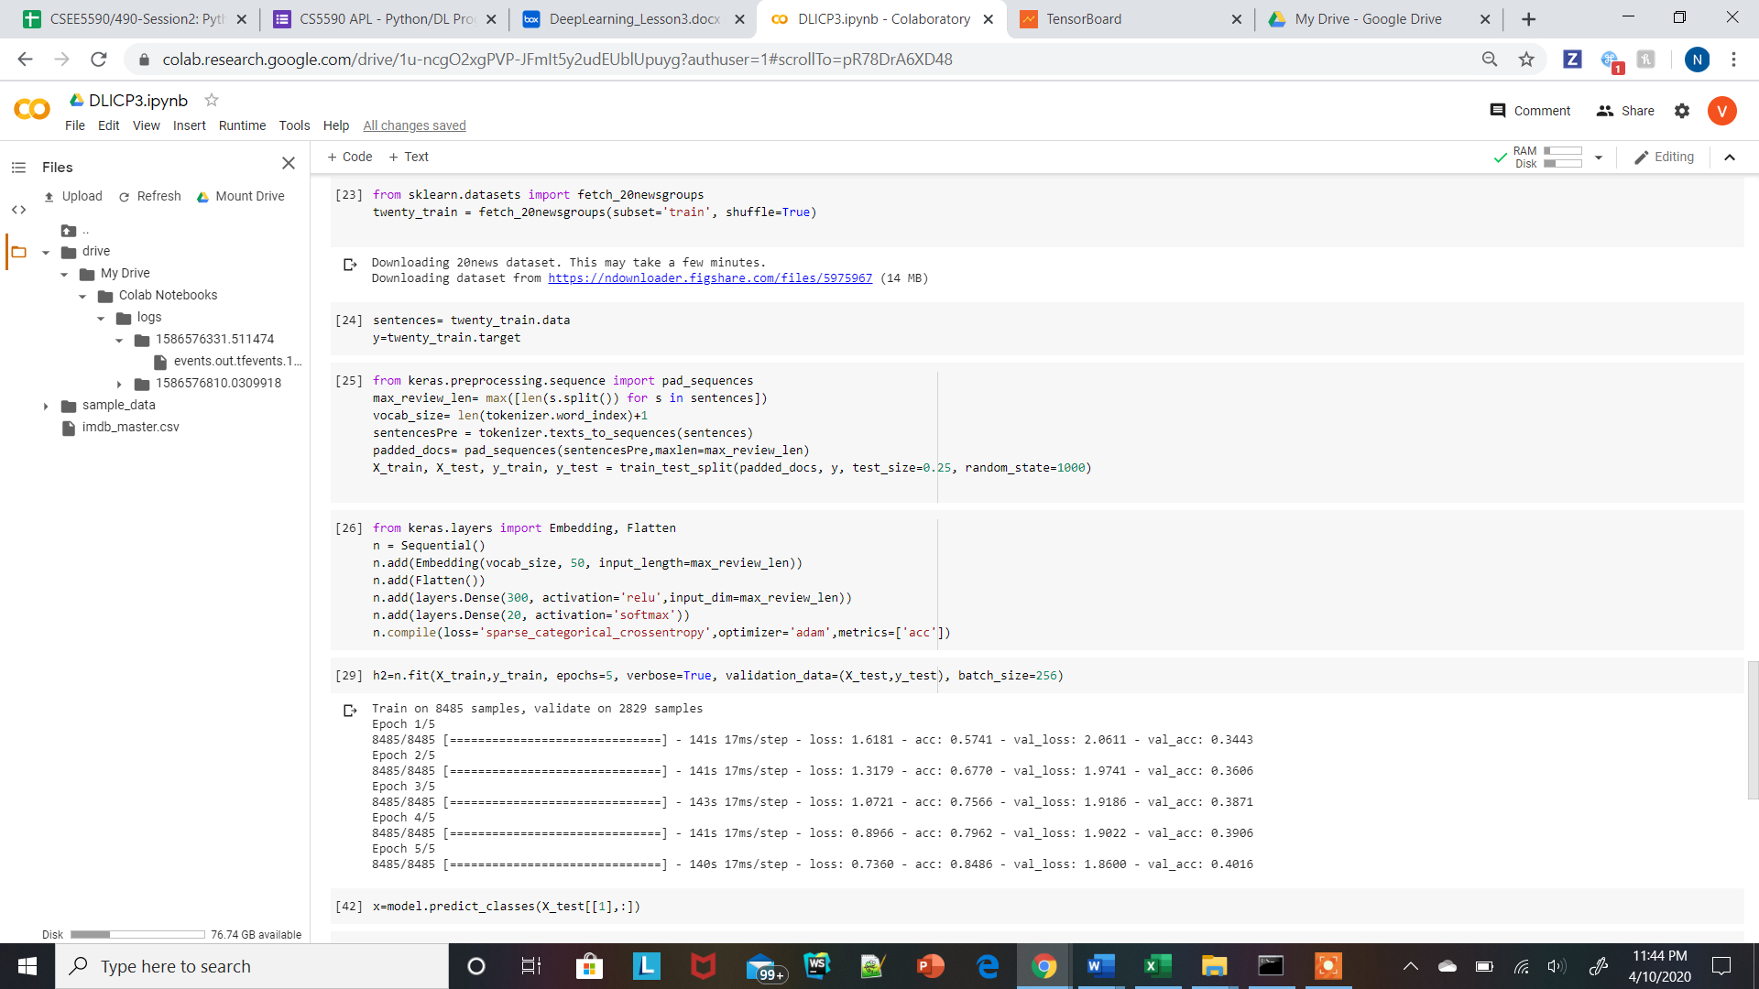

4.Plot the loss and accuracy using history object

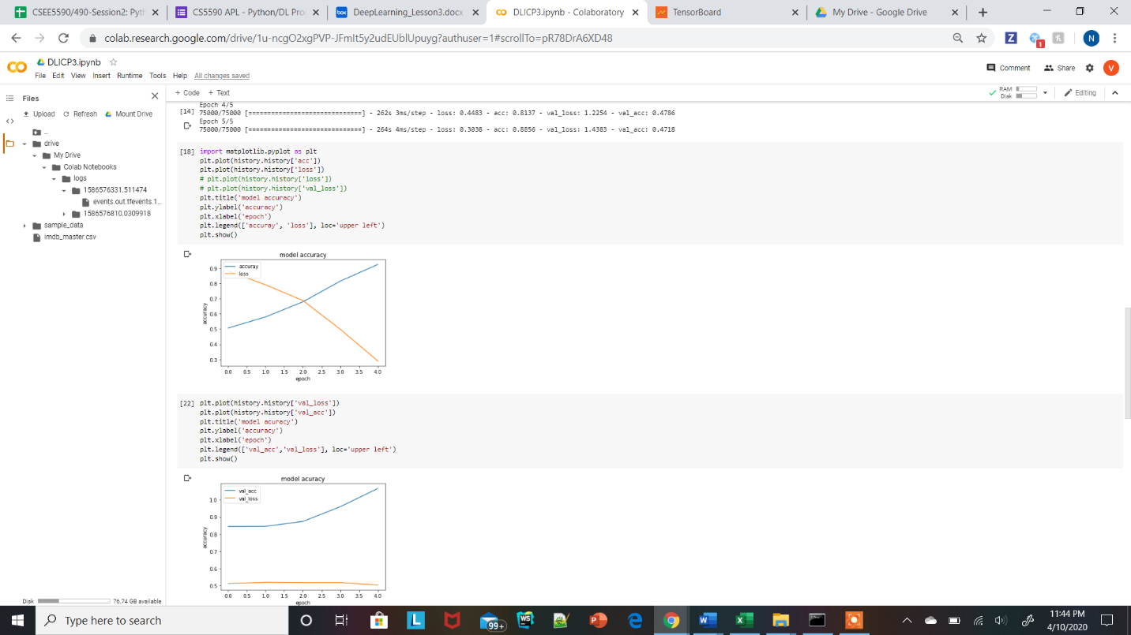

*Bonus question

1.Predict over one sample of data and check what will be the prediction for that.

* The actual value and the predicted value are the same. So which means our model is good. I have the actual value as unsupported and got the predicted value as unsupported.

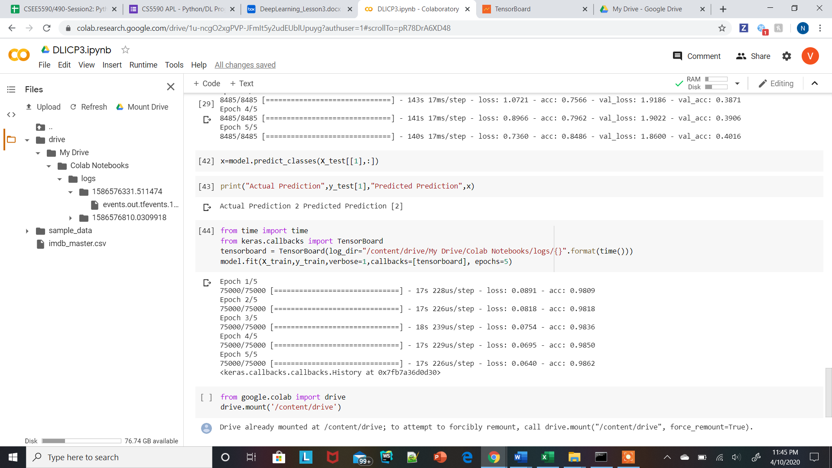

2.Plot loss and accuracy in Tensorboard.

* Have loaded the logs into the specified folder in the drive and downloaded it into the local.

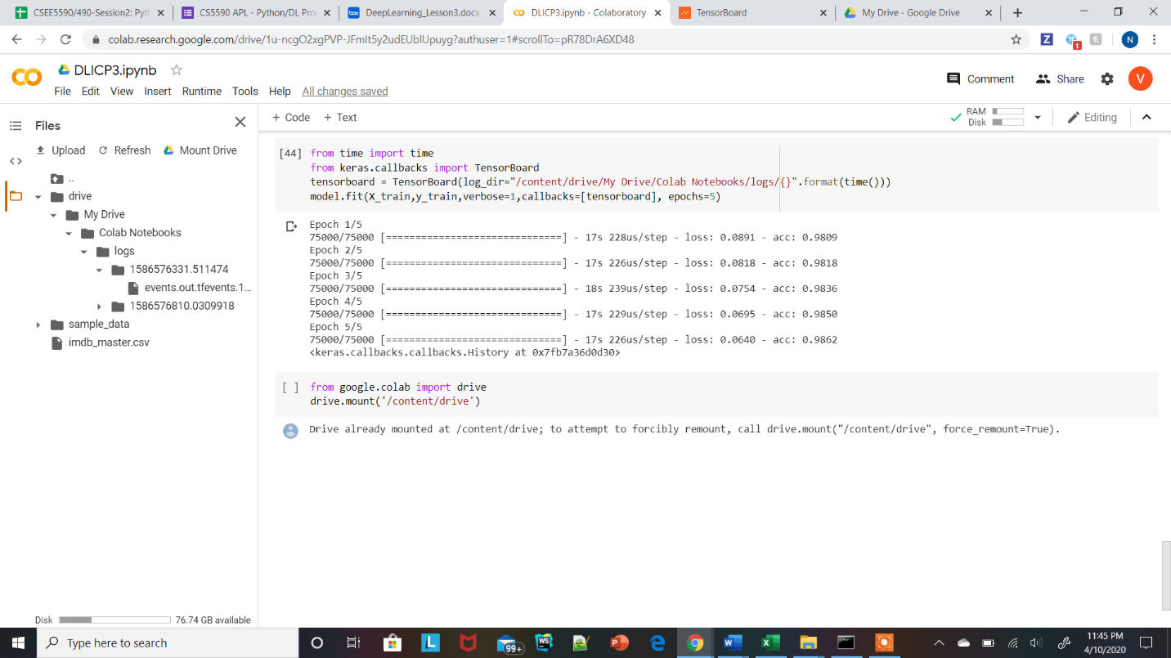

* Then I have installed the tensorboard. Then I have used the tensorboard command to plot the loss and accuracy.

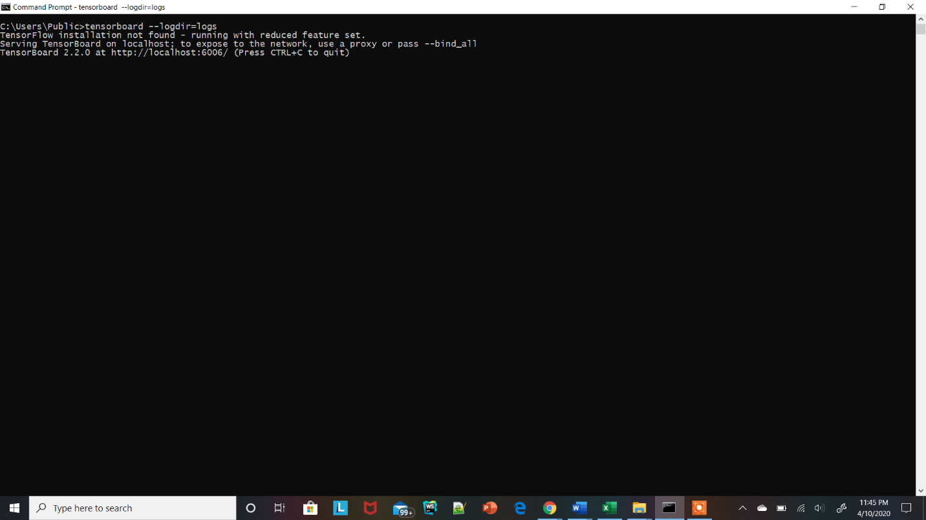

* In the <http://localhost:6006/#scalars> we will get our plots for accuracy and loss.

