Erin Sweet

May 14, 2021

IT FDN 130

Assignment 6

**USING SQL VIEW**

**INTRODUCTION**

In this paper I will review the several topics related to the use of SQL VIEW. The learning material for week six of IT FND 130 described these differences in detail and the week six assignment reiterated these concepts in practice.

**WHEN TO USE A SQL VIEW**

In relational databases, data is structured using various database objects like tables, stored procedure and view. Using view in SQL server creates a virtual table that contains data from one or multiple tables, and from one or multiple databases. It does not form part of the physical schema of a relational database. It contains a set of SQL queries used to extract data from the database. SQL view allows the author to return data while protecting any sensitive data in the source tables the author does not want revealed.

FIGURE 1. SQL VIEW SCHEMA

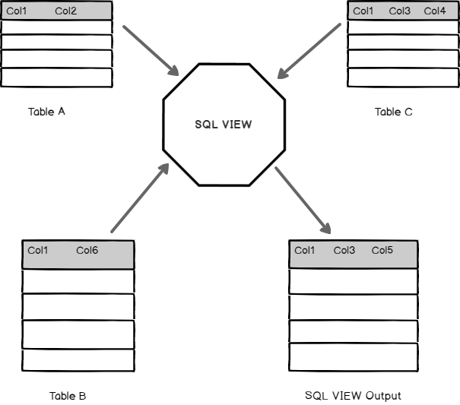

<https://www.sqlshack.com/sql-view-a-complete-introduction-and-walk-through/>. Accessed 5/14/21.

**DIFFERENCES AND SIMILARITIES BETWEEN A VIEW, FUNCTION AND STORED PROCEDURE**

A view represents a virtual table. Using view is a means of simplifying data queries by obtaining data from a database without having to write queries repeatedly. A view can join multiple tables and present the data as if it were coming from a single table. Using a SELECT statement, you can query all or a specific portion of the view using WHERE clauses. A view cannot be used to modify a table. Views have some security benefits in that a limited subset of data from an underlying table containing sensitive information can be used.

Stored procedures are simply stored queries used to perform common INSERT, DELETE, and UPDATE statements on data. Stored procedures retain SQL statements for easy execution of repeatedly used queries and can be used to modify or update a table.

A view is use to look at a set of data in the same way easily. A stored procedure used to repeat a set of actions the same way easily.

SQL functions are used with SELECT statements and WHERE clauses to calculate values and manipulate data. They are commonly used and re-used throughout SQL database applications for processing data. SQL contains many built-in functions for performing calculations on data (for example, aggregate functions such as SUM, MIN, MAX, AVG). A function only needs to be written once and can be reused multiple times.

FIGURE 2. VIEWS VS. FUNCTIONS AND STORED PROCEDURES

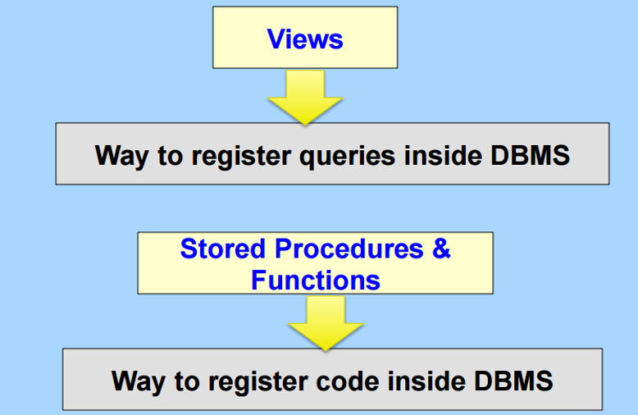

<https://codeandwork.github.io/courses/cs/sp_cursors_triggers_indexes.html>. Accessed 5/14/21.

**SUMMARY**

There are several useful tools available including the use of views, which support processing data when working with a relational database. A view represents a virtual table and used to look at a set of data in the same way easily. A stored procedure is a stored query used to repeat a set of actions the same way easily. SQL functions are used to calculate values and manipulate data and include commands such as SUM, MIN, MAX and AVG. A function only needs to be written once and can be reused multiple times.