**Criterion B: Design**

**Classes:**

1. main: Handles navigation of pages
2. HomePage: Start menu
3. NotecardPage: Window to choose subjects to create notecards
4. MathCreate: Handles creation of math notecards
5. EnglishCreate: Handles creation of math notecards
6. ScienceCreate: Handles creation of math notecards
7. CSCreate: Handles creation of math notecards.
8. JeopardyGame: Handles all jeopardy Game functions

**Functions:**

* Notecard creation feature (4 for each subject)
  + Save button to save and edit
* Jeopardy Game
  + Questions correspond with notecards
  + Test whether user answer is correct

**Basic Program structure (Initial Structures)**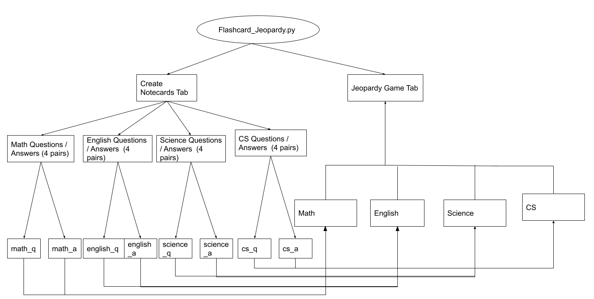

**Notecard Creation and Save (ex. Math)**

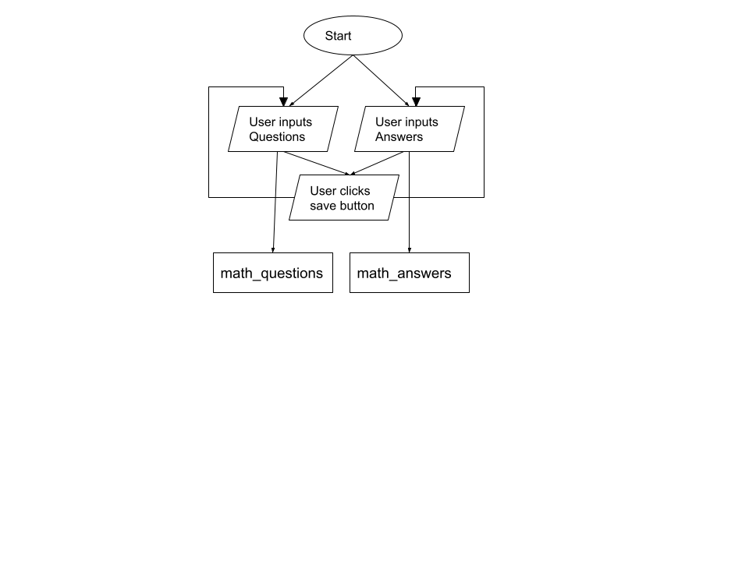

**Jeopardy Game Feature** (subject_question and subject_answer data from notecard creation)

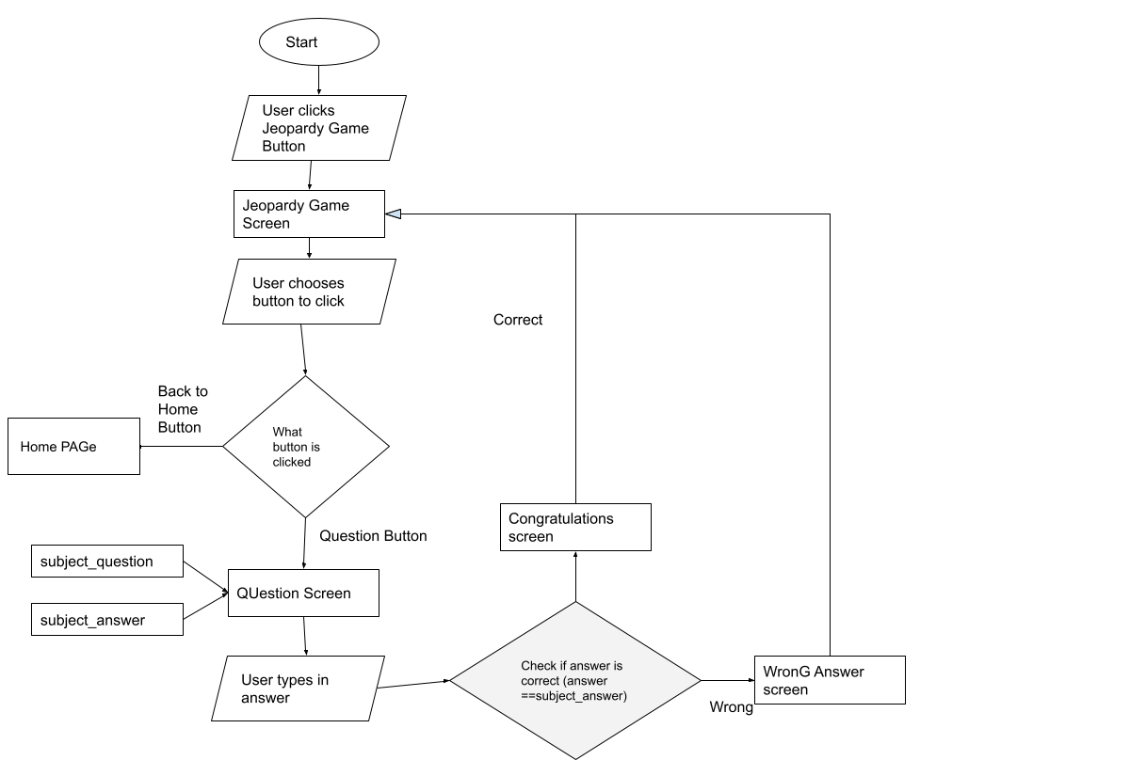

**Home Screen (Main Menu PAGe)**

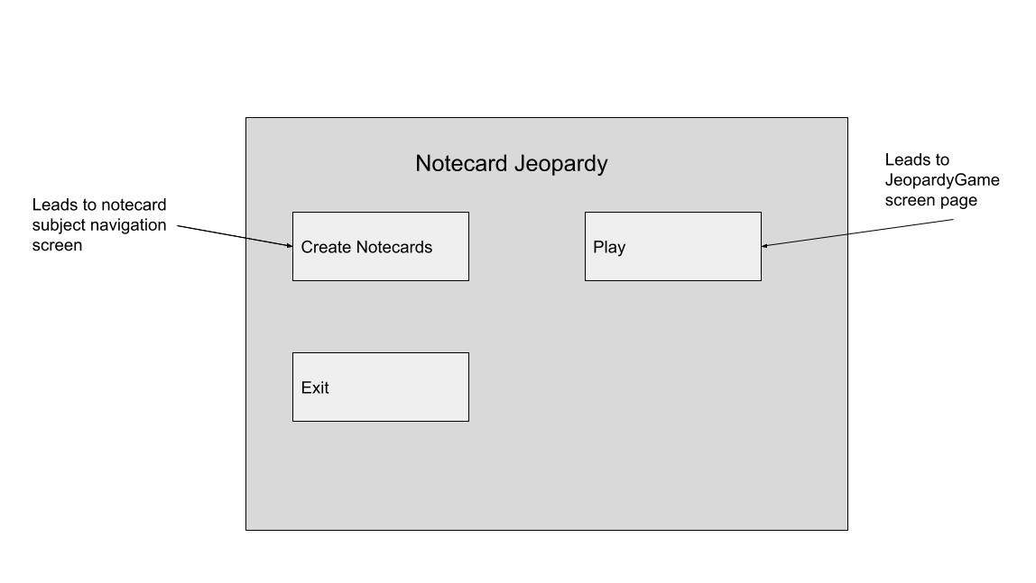

**Notecard Creating Navigation**

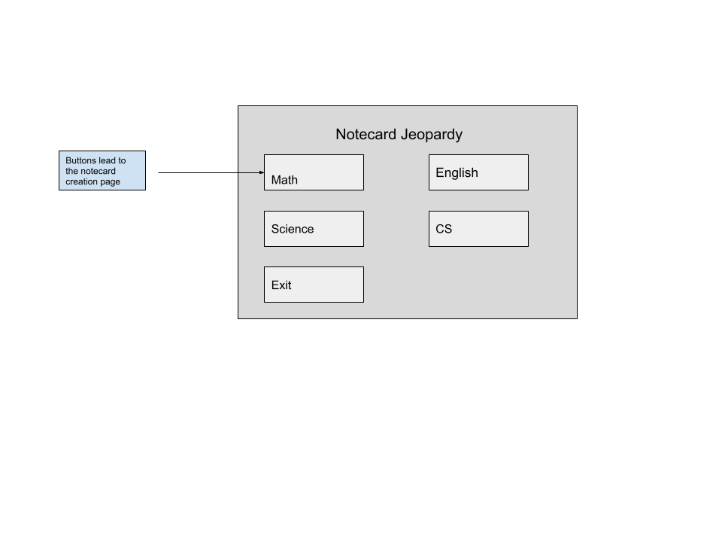

**Notecard Creation Pages**

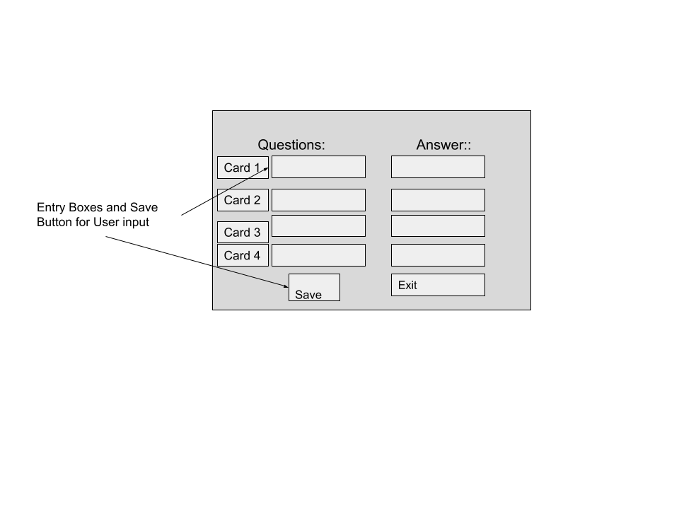

J**eopardy Game**

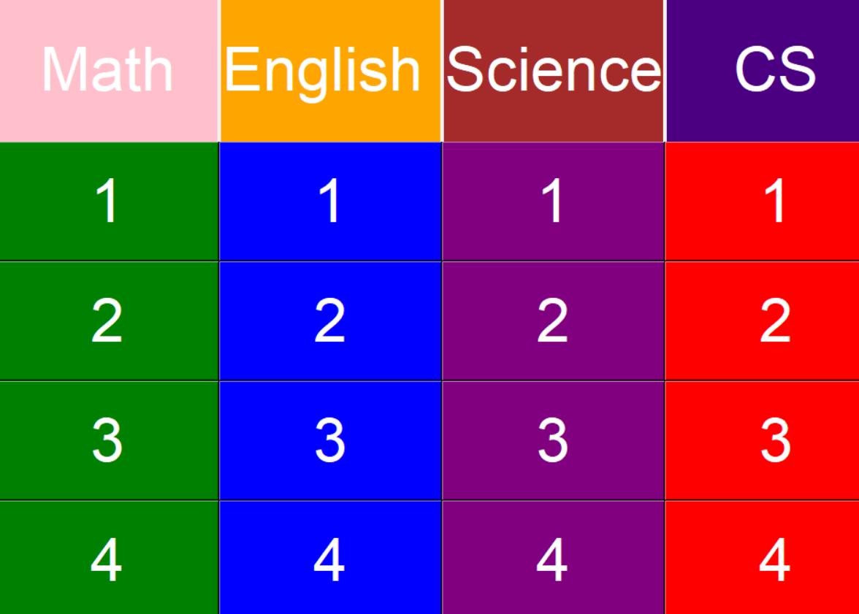

**Testing Plans**

|  |  |  |
| --- | --- | --- |
| Action of Test | Nature of Test | Example |
| The program should have three buttons/options on the main window: one for creating “notecards”/question-answer pairs, and another for students to play the Jeopardy style game, and another to exit the program page. | Upon startup, check that menu is displayed right, and buttons are working properly | User clicks “Create Notecards”, and notecard creation navigation page shows up |
| The program will have four buttons on the creating notecards tab, each button will correspond with one of the four subjects and lead to a new tab that allows users to create 4 question-answer notecards for the corresponding subject | Navigate to the notecard navigation pagee and click on each button to test. Verify buttons are working. | User clicks on english button, and screen switch to English notecard creation tab. |
| Notecard tab has a Save button and it saves the user input data for notecards | input Data and press the Save button, then go to Jeopardy game, click on corresponding question to verify that save Button is working. | User input “2+2” and “4” for math q1. Jeopardy game displays “2+2” when question is pressed.. |
| To edit notecards, the user can go to create notecard tab and re-enter the question-answer pair for the notecard intended | After saving once, return to notecard creation tab, retype different data and press save. Then verify in Jeopardy Game again to see if editing works. | Change “2+2 =” and “4” to “3+5” and “8”. Then, open the JeopardyGame and press on the corresponding question to verify. |
| The Jeopardy game functions well and the user is able to access all of the questions they create | Enter notecard data for each subject, then open Jeopardy tab. Click on the questions to see if they work. | User clicks on Math 1. Question is *“2+3 =”?..*  User goes back and clicks on CS 2, question works as well |
| Correct answers will give the user a “correct” message, wrong answers will give user a “wrong “ message. | Check that answer checking is accurate. Type in correct and incorrect answers. | User clicks on Math 1. Question is “2+34 =??” User types 23 and clicks Answer. User gets led to “Wrong Answer ”. User types 36 and goes to congratulation page. |
| The program will be accessible locally both online and offline | Check that program function effectively both for online and offline. | With internet connection, user open the file and checks the functions. Then turn off internet, and then open the file and check all of the functions. |