**README FOR THE DEVELOPER**

**The Readme file provides information on the software and hardware requirements of G-v-G to the developers. It contains instructions on how to set up and run G-v-G on a desktop besides providing other additional requirements for successful execution of G-v-G.**



**Introduction**

Geometry via Gestures. i.e. G-v-G allows students to interact with the 3D objects via gestures. The interaction is facilitated by the affordances provided by Leap Motion technology. G-v-G along with certain activities, enable learners to visualize and manipulate 3D structures using gestures. The application guides learners through a series of activities involving 2D and 3D structures. The application senses gestures done by learners and modifies the object on the screen accordingly. For example, a swipe gesture will enable the learner to construct a right circular cylinder from a rectangle. The learner will be able to view on the screen the initial state, trajectory made by the rectangle and modified state due to effect of user gesture on the rectangle.

The application screen contains the following components as displayed in  Figure 1. A brief description of the same is in  Table 1.

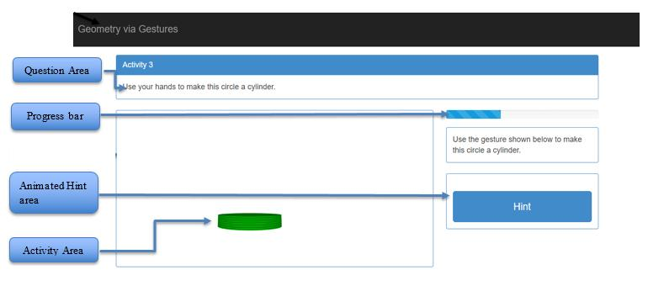

|  |  |
| --- | --- |
|  | **Figure 1. Screen components of G-v-G application** |
|  |  |
| **Screen components** | **Description** |
|  |  |
| Question Area | The space on the screen where the activity question is provided to the learner. |
|  |  |
| Progress bar | Indicates the progress of the activity |
|  |  |
| Animated Hint Area | The space on the screen where hints based on the activities are provided to the |
|  | learner. The hint can be used at any time during the course of the activity. |
|  |  |
| Activity Area | The space on the screen where the learner initially sees a 2D shape. Based on |
|  | the learner’s gestures, transformations occur in this area and finally a 3D |
|  | structure is formed. |
|  |  |

**Table 1: Screen components with description**

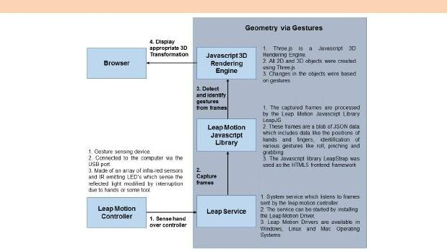**Geometry via Gestures Architecture**

**Figure 2: Functional blocks of G-v-G**



**Requirements needed to use G-v-G**

G-v-G requires the Leap Motion Device to recognize gestures. You can purchase it here:  [https://www.amazon.in/Leap-Motion-Gesture-Controller](https://www.amazon.in/Leap-Motion-Gesture-Controller-MAC/dp/B00E3CP9UM/ref=sr_1_2?ie=UTF8&qid=1522055470&sr=8-2&keywords=leap+motion&dpID=310zzpBz0eL&preST=_SY300_QL70_&dpSrc=srch)- [MAC/dp/B00E3CP9UM/ref=sr_1_2?ie=UTF8&qid=1522055470&sr=8](https://www.amazon.in/Leap-Motion-Gesture-Controller-MAC/dp/B00E3CP9UM/ref=sr_1_2?ie=UTF8&qid=1522055470&sr=8-2&keywords=leap+motion&dpID=310zzpBz0eL&preST=_SY300_QL70_&dpSrc=srch)- [2&keywords=leap+motion&dpID=310zzpBz0eL&preST=_SY300_QL70_&dpSrc=src](https://www.amazon.in/Leap-Motion-Gesture-Controller-MAC/dp/B00E3CP9UM/ref=sr_1_2?ie=UTF8&qid=1522055470&sr=8-2&keywords=leap+motion&dpID=310zzpBz0eL&preST=_SY300_QL70_&dpSrc=srch)h



**Additional Requirements**

Leap motion driver for:

Windows:  [https://www.leapmotion.com/setup/desktop/window](https://www.leapmotion.com/setup/desktop/windows)s

Linux:  [https://www.leapmotion.com/setup/desktop/linu](https://www.leapmotion.com/setup/desktop/linux)x

Mac:  [https://www.leapmotion.com/setup/desktop/os](https://www.leapmotion.com/setup/desktop/osx)x

Minimum system requirements for Leap motion:  [https://support.leapmotion.com/hc/en](https://support.leapmotion.com/hc/en-us/articles/223783668)- [us/articles/22378366](https://support.leapmotion.com/hc/en-us/articles/223783668)8

**Steps to install and run G-v-G on your system**

1. Download the G-v-G zipped folder from Github -  [https://github.com/prajishprasad/GeometryviaGestures2.](https://github.com/prajishprasad/GeometryviaGestures2.0)0
2. Extract the folder
3. Plug in the Leap motion device to your computer
4. Click on index.html from the Geometry via Gestures 2.0 folder
5. Get started with G-v-G



**Operating guidelines:**

* Let the students and the instructors play around with leap motion controller for maybe a week before the activities.
* Leap Motion Controller sensors are very sensitive to direct light. When exposed to direct light the sensors will be unable to detect the hand gestures of the students. We advise the users to do the following:
  + Avoid using leap motion controller in direct sunlight
  + Avoid harsh lighting (powerful/photography lighting) directly on the leap motion controller



**Reference to the Code**

* GitHub links **-**  [https://github.com/prajishprasad/GeometryviaGestures2.](https://github.com/prajishprasad/GeometryviaGestures2.0)0
* G-v-G uses JSModeler to render 3D shapes. You can find the code here -  [https://github.com/kovacsv/JSModele](https://github.com/kovacsv/JSModeler)r
* G-v-G uses the LeapStrap library to make the web pages compatible with LeapMotion -  [http://wilkesalex.github.io/leapstrap](http://wilkesalex.github.io/leapstrap/)/



**Additional Reference**

[Narayana, S., Prasad, P., Lakshmi, T. G., & Murthy, S. (2016, December). Geometry via Gestures](http://ieeexplore.ieee.org/document/7814789/):  [Learning 3D geometry using gestures. In *Technology for Education (T4E), 2016 IEEE Eighth Internationa*](http://ieeexplore.ieee.org/document/7814789/)*l*  [*Conference on* (pp. 26-33). IEEE](http://ieeexplore.ieee.org/document/7814789/).

|  |  |  |
| --- | --- | --- |
| **People involved** | **Designation** | **Year** |
| Prajish Prasad | Research Scholar | 2015 - 2016, 2018 |
| Lakshmi Ganesh | Research Scholar | 2015 - 2016, 2018 |
| N Soumya | Research Scholar | 2015 - 2016, 2018 |
| Ajit Mhatre | Sr. Project Technical Assistant | 2018 |
| Rahul Dolui | Project Technical Assistant | 2018 |
| Ulfa Khwaja | Sr. Project Technical Assistant | 2018 |
| Dr. Gargi Banerjee | Senior Scientist | 2018 |

Developed as part of Next Education Research Lab

This work is licensed under a **Creative Commons Attribution 4.0 International License**.