1. **GeoSolvAR (Geometry of Solids via Augmented Reality)**
   * **Augmented Reality based solution for visualising 3D solids**
2. **Demo Video** (No video yet)
3. **Purpose of using GeoSolvAR**
   * Learning activities in GeoSolvAR is build on the theoretical foundations of Predict-Observe-Explain (POE) strategy to teach concepts of 3D views like top, front, and side view. The activities in GEoSolvAR are facilitated with the use of Augmented Reality application to view the 3D model.
4. **Resources required:** 
   * Android tablet/mobile with GeoSolvAR’s Augmented Reality application

AR’s ability of layering (augmenting) virtual 3D objects instantly in real 3D space makes it an appropriate technology for 3D visualisation of solid shapes. Since AR allows 3D objects to pop up immediately over their 2D represented image, students can easily relate both 2D and 3D representations of the object.

1. **Getting started with GeoSolvAR:** 
   * To access the web interface of GeoSolvAR, click on the link:
   * To download the GeoSolvAR.apk file, click on the download button below. Install the Android application in an Android tablet/ phone with minimum Android OS version 4.0.
2. **Researcher’s corner**
   * **Abstract of the GeoSolvAR work done**

Geometry concepts like 3-Dimensional (3D) views have importance in various fields like computer-aided design (CAD), geometric modeling, robotics, medical imaging and many more. Understanding such concepts requires students to employ spatial visualisation skills. Visualisation requires a series of manipulations of spatial representation and hence is a difficult skill to learn. Visualisation of 3D solid shapes is traditionally taught using 2D images of the solid objects. It was found that students face difficulty in imagining and reasoning from the 2D representation of the 3D solid shapes. Other methods of teaching include physical models and materials like paper nets. Although helpful, these methods have their limitations. The efficiency of 3D models in teaching visualisation largely depends on the strategies followed by the teacher in their usage. Use of web-based software for teaching 3D geometry restricts the user to interact and manipulate objects on the computer screen only. The objects and shapes on the computer screens may not have the required spatial depth. As a result, this can hinder the learning of the visualisation skills.

GeoSolvAR enables learners to interact with 3D objects using Augmented Reality and the learning activities is based on the instruction strategy Predict-Observe-Explain (POE). GeoSolvAR (Geometry Solids via augmented reality), leverages the benefits of AR technology and proposes to provide a solution to the problems as mentioned above in the existing methods of teaching concepts of 3D visualisation.

Preliminary results of an exploratory study shows learners perception of role of GeoSolvAR in helping them visualise solid shapes and the challenges faced by the learners while interacting with the application.

Navneet Kaur, Rumana Pathan, Ulfa Khwaja, Sahana Murthy (2018, July). GeoSolvAR: Augmented Reality based solution for visualising 3D solids. In the Eighteenth International Conference on Advanced Learning Technologies (To be published in ICALT 2018)

**Future work ‘What are the other aspects of learning with GeoSolvAR that can be explored?’ (to be updated after 4th June)**

Aspect: Functional property

Description:

* + - * The current research has helped students learn concepts of visualising 3D solids such as top, front, and side view. Further research can explore other topics in 3D solid geometry such as “cross-sectional area,” “volume of solids” etc. It would be desirable to include new related learning objectives, such as “developing skills related to visualisation of cross-sectional areas.” For this, we may require building features that support slicing of 3D solid objects using intuitive user interactions.
      * Additional training modules or help sections could be added to the App to familiarise the learner with the necessary know-how of the app usage.

1. **Developer’s corner**

**Design and Workflow of GeoSolvAR:**

The overall design of GeoSolvAR is based on three important aspects, namely the web-based interface, AR-based android application, and the physical markers (Refer figure 1).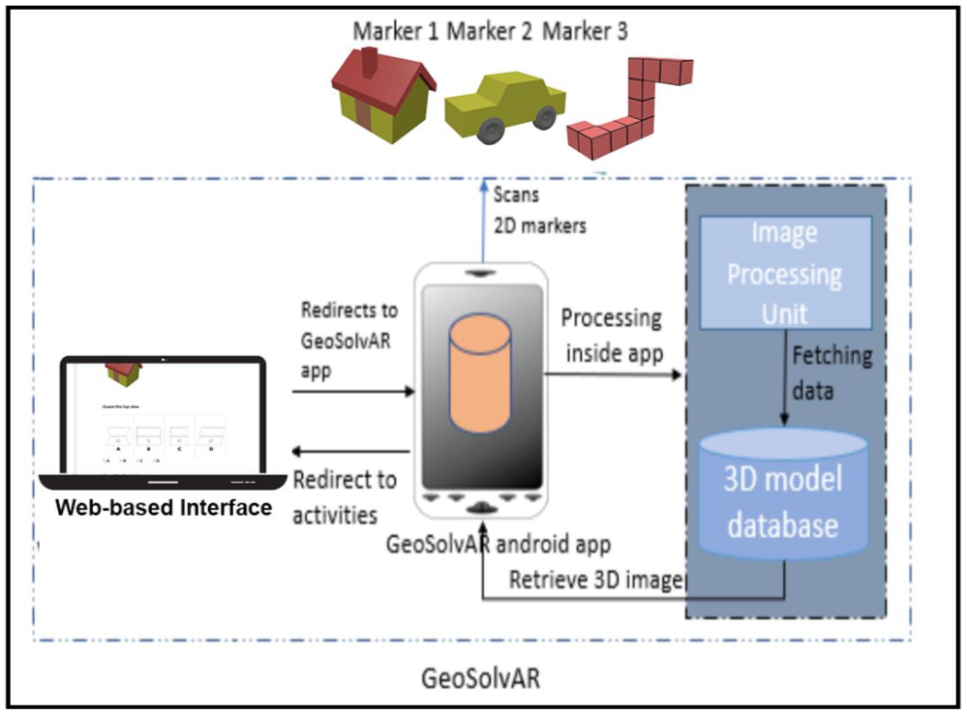

To provide easy accessibility to the learning activities, the entire content was converted into web-based. The web- based application can be accessed over a network connection using HTTP and can be used in a mobile/tablet browser. The interface contains activities and a button which on click, leads one to the Android-based Augmented Reality application.

The Android-based application is one of the leading constituents of GeoSolvAR and is Augmented Reality enabled. The application is primarily used to scan 2D image markers and augment their 3D equivalent on the mobile/tablet screen as shown in figure 1. The affordance of this application enables one to view virtual objects in a real environment and runs interactively in real time.

The marker cards are targets which trigger the 3D models superimposed on the 2D image. The image is recognized and tracked by a mobile/tablet devices camera and serves as an origin to the augmentation. Once the image is recognized, the content associated with it will be displayed as long as the image target is at least partially in the cameras field of view. A very important practice that followed while choosing image targets is to choose an image with feature points which has several edges, corners, etc, which are used for tracking while image processing. Figure 1 summarizes the overall workflow of GeoSolvAR encapsulating all the three aspects mentioned above.

**AR Implementation Flow:**

There are numerous approaches to make an Augmented Reality application. The approach used in GeoSolvAR is marker based and made using a combination of two developmental portals, namely Vuforia and Unity 3D. Figure 2 summarizes the application creation process.

Vuforias developmental portal is predominantly used for two purposes, one to create a license key for the application to be developed and secondly to create a database and an image target. To create a database in Vuforia, image targets needs to be added. The Vuforia target manager supports JPG, PNG in RGB or grayscale. The targets do not need special regions/ qualities/ codes to be recognized, in fact, the SDK detects and tracks the features that are naturally found in the image itself, which is then compared to a known target resource database. This database can then be downloaded in the form of a unity package, which can then be imported into Unity 3D and used.

The development in Unity begins with a project, onto which packages downloaded via Vuforia are imported. 3D models are then embedded into the image targets by choosing the appropriate frame. These 3D models can be either modeled in Unity itself or Blender or can be downloaded via an inbuilt 3D asset store. If one wishes to use customized 3D models, one needs to create them in either unity/blender and import them in the same project. By some additional settings in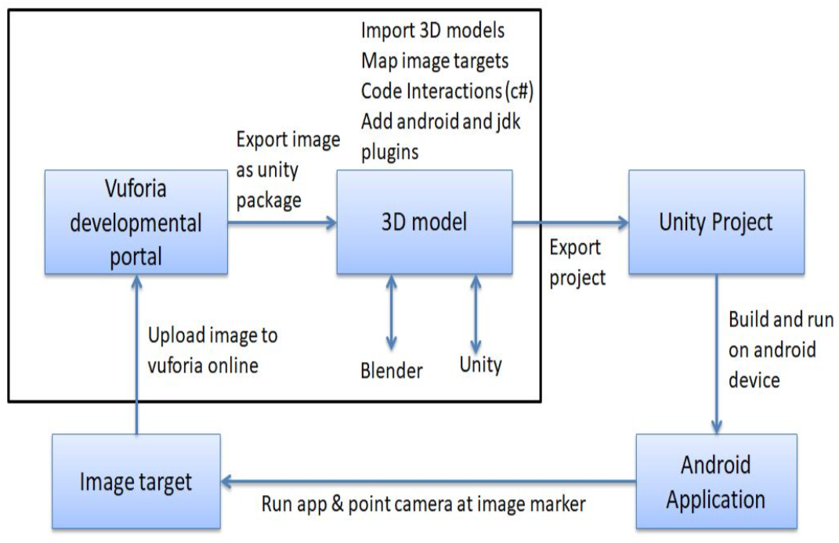 Unity, an AR based android application can be built which can then be used to view the image targets, scan them, and trigger the appropriate 3D models.