

Universidade do Minho - Dep.^{to} Informática
2º Semestre, 2020/2021

Trabalho Prático Nº1

Virtualização de Redes

MERSTEL

Erikson Neves Tomas
PG-44102

VR
1. How to create a container from a Linux alpine that has the container 9999 port
mapped in the host 8668. It should also have a bind mount, mounting the container
/home/internal_dir in the hosts /home/user/docker_dir/.

$docker run -it --name alpine -p 8668:9999 ubuntu:latest /bin/bash -v /home/et007/docker_dir/:/home/internal_dir ubuntu:latest/bin/bash

2. How to create the volume “my-volume-1”? (a) What is the volume mountpoint?
(b) Which driver is being used?

$docker volume create my-volume-1

$docker volume inspect my-volume-1

a) O Mountpoint é o directorio da imagem.
b) "local"
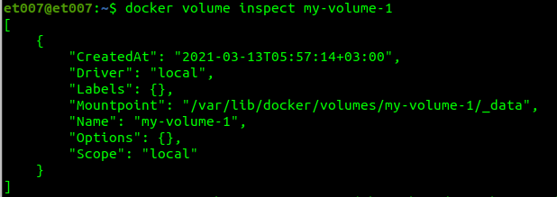
3. Create two basic containers (They should not be attached to any manually created
network).
(a) Is it possible to inspect the bridge network and find their IP addresses?
(b) Is it possible for the containers to communicate among themselves using their
names?
(c) And with their IPs?

$docker run -it --name net01 ubuntu:latest /bin/bash
$docker run -it --name net02 ubuntu:latest /bin/bash

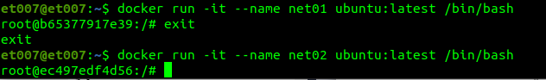
a) Sim, na figura abaixo podemos verificar os IPs

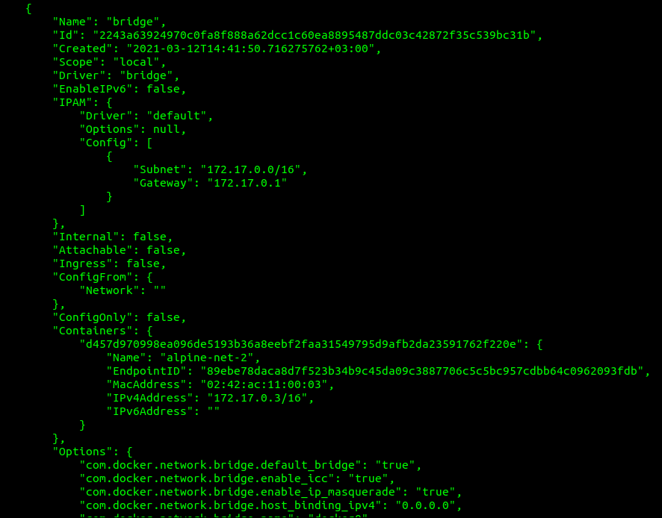
b) Não, não é possível comunicar atraves dos nome
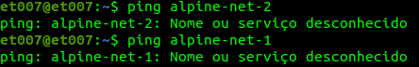

c) Sim, os container consegeum comunicar através dos IPs
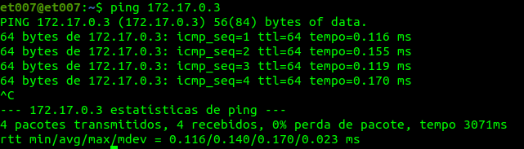
4. What is the command to create the network “my-network-1”?
$docker network create my-network-1
(a) How to attach two containers to that network?
(b) Which relevant parameter is possible to found about that network?
Através do inspect à network podemos observar vários dados: Id, Nome, Subnet, Driver, Gateway,containners …

$docker network inspect my-network-1

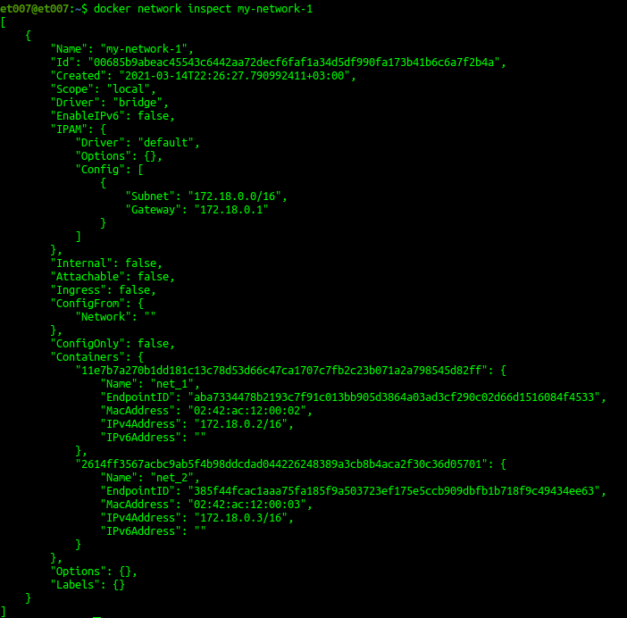
(c) Can the containers ping one another using their name?

Sim, é possível fazer a comunicação

5) Which were the results obtained from the commands docker network ls, docker net-
work inspect and docker volume ls in section 1 of this document? What conclusions
is possible to take from the result of these commands?

Que todas tarefas foram concluidas de acordo as instruções aprendidas para criação de conteineres, volumes e network. Podemos concluir que, as tarefas foram executadas com exito e que esta tudo funcionando.

6)

Docker compose: IMAGEM
Para correr o ficheiro corremos o comando:
docker-compose up -d

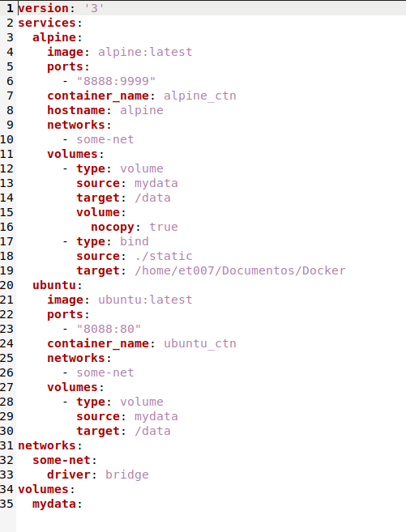

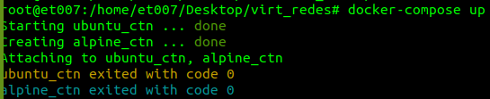

7)

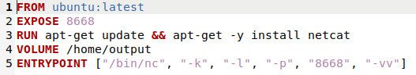

8)

