ADSB v6 (Brasilia) - RPi + UPS board

WHAT IS IT? 2
HOW DOES IT WORKS 4
USEFUL TOOLS 5
Disk cloning application – HDD Raw copy 5
SSH and Telnet– Puttty 5
Linux partition reading tool - DiskInternals Linux reader for Windows 5
BACK UP AND RESTORE SD CARD 6
Backup SD Card 6
Restore SD Card 7
HARDWARE LIST 9
SPECIFICS BOARDS SCHEME 10
RTC and signal level adapter 10
Specific UPS driver board 11
RPi / UPS CONNECTIONS 12
SD CARD AND FILES DESCRITPION 13
USB FLASH DRIVE DESCRIPTION 15
DUO/CUBE CONFIGURATION 16
CONNECTING TO THE RASPBERRY PI 17
USEFUL COMMANDS 18
Set date/time and write RTC module 18
Get the RPi IP address 18
Start and stop DUMP1090 program 18
Manually transfer files to the DUO or Cube 19
Shutdown the RPi 19
DUMP1090 command-line options 20
TROUBLESHOOTING 21
Network and FTP 21
Check if ftp is setting up in CRON 21
IDSB USB module 22
RTC (date/time) 22
RPi GPIO 23
USB flash drive 23
DUMP1090 24
LINKS 26

WHAT IS IT?

The Brasilia International Airport (BSB) need to know which fly is respecting the maximum noise level fixed by the Brazilian Government Health and Safety Regulation.

Basically, it’s an embedded system based on UPS and a Raspberry Pi (RPi) linked to a 01DB Duo Noise Station (or Cube station). The software is based on a C++ modified version of the Linux DUMP1090 program https://github.com/MalcolmRobb/dump1090 (Dump1090 was written by Salvatore Sanfilippo antirez@gmail.com and is released under the BSD three clause license).

When the Duo Noise Station detect a high-level noise issued from a plane, it’s generate an alarm (TTL level output). The RPi system detect this alarm and save on the SD Card and Pen drive a file with all informations issued from the ADS-B decoder.

To be an autonomous system, a solar panel will provide all the power needed, an UPS will start, and safety stop the RPi system. The start is delay (approximately 30min) to let the battery get a minimal charge. Alarm and stop signals are detected by the RPi using interrupt process.

Some LEDs for displaying basics informations. A RTC chip provide a real date and time with backup and finally, the system is linked to the network to let access to all saved files.

The new version of the DUMP1090 program read the BCM2835 serial number of the RPi and if needed, can compare for security reason this serial to the dump1090.bcm file in order to authorize (or not) the all process.
Some features:

- Powered by solar panel (and battery)
- General start and stop system button
- UPS with safety stop (close all file before stopping the RPi)
- Power fail detection and automatic stop (after 15s)
- Delayed start (30min)
- Immediate RPi start button
- File Safe power off button
- Double backup (SD Card and Pen drive)
- Alarm input signal optically isolated
- Alarm signal and UPS signal detection based on interruption
- RTC chip for Real Time (I2C)
- Basic state LEDs display
- Network connection
- Wi-Fi is optional
- Smalls dimensions (about 10x15cm)
- During alarm signal, all informations about planes are saved on independent files (Fly code, GPS position, altitude, velocity…)

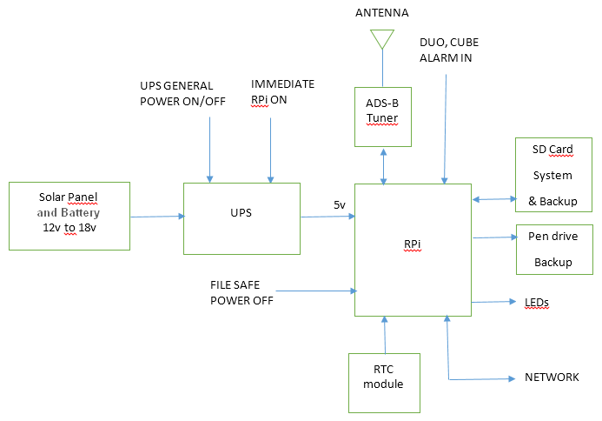
HOW DOES IT WORKS

You can use the Raspberry Pi (RPi) without UPS. No need to change anything, just use the 5v power supply directly with the RPi.

If you want to use the UPS:
- connect a power supply (12v to 18v) to the UPS.
- connect the USB cable between the UPS and the RPi
- connect the 3.5mm stereo jack cable between the UPS and the RPi

Switch on the main red switch button (on the UPS case). After 30min, the RPi will start. (This delay is needed to charge the solar battery). If you switch off the main red button, the RPi will stop immediately (and without protection).

If you do not want to wait for 15min and have an immediate start, just press the green button on the UPS case.

In case of main power fail, the RPi will stay on 15seg. and then, close all files and stop.
If during the 15seg., the main power came back, the RPi will continue working as normal.
30min after the main power came back, the RPi will start automatically.

If you want to stop immediately and securely the RPi, just press 5seg. the black
push button from the RPi case.

USEFUL TOOLS

Download and install all tools on your Windows PC.

Disk cloning application – HDD Raw copy
http://hddguru.com/software/HDD-Raw-Copy-Tool/

SSH and Telnet– Puttty
http://www.chiark.greenend.org.uk/~sgtatham/putty/download.html

Linux partition reading tool - DiskInternals Linux reader for Windows
http://www.diskinternals.com/linux-reader/

BACK UP AND RESTORE SD CARD

Backup SD Card
(Generally not needing)

1. Run HDD Raw copy
2. Select the SD Card (here, disk E)

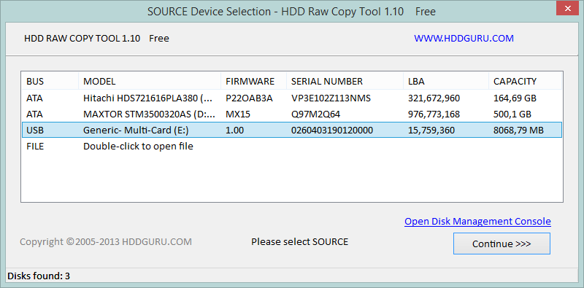

3. Select a file or open a new one. (Be careful, selecting an old file will overwrite it)

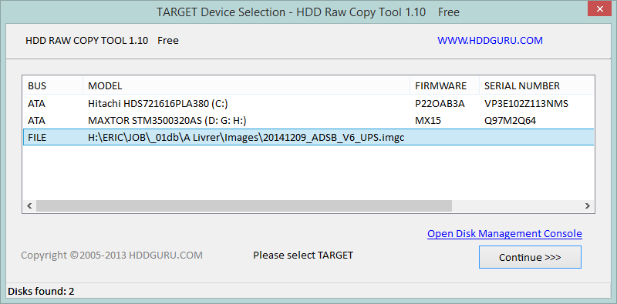

4. Press Start and wait for the 100% complete message (up to 7 to 10 min.)

Restore SD Card

1. Run HDD Raw copy
2. Select an existing file

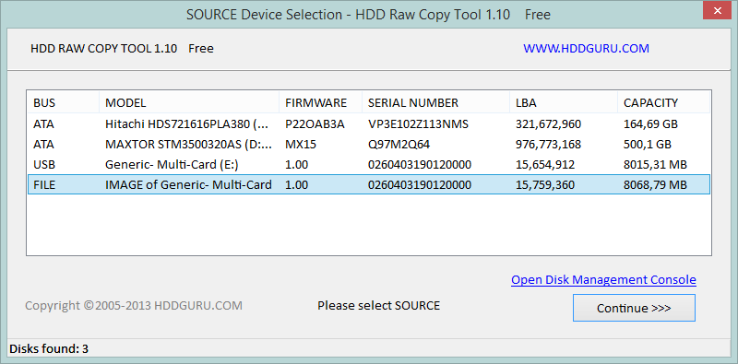
3. Select a destination SD card. (Be careful, all data will be irreversibly overwritten)
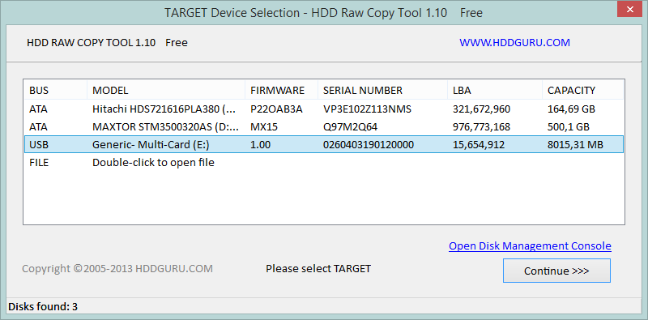
4. Press Start and wait until the end of the writing procedure (up to 7 to 10 min.)
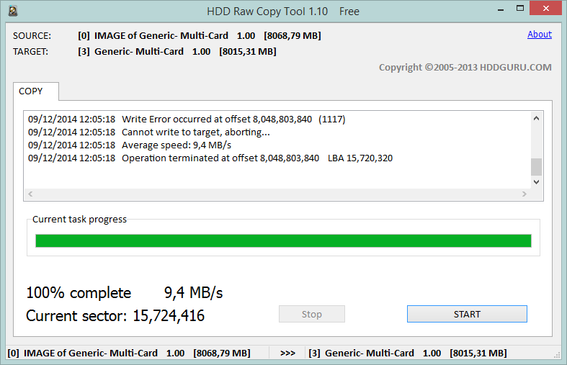
Writing procedure could not be completed successfully, it depend on your SD Card size BUT THIS IS NOT A PROBLEM as the end os the original SD Card was not used (empty sector).

HARDWARE LIST

1x Raspberry PI model B 512Mb
http://www.farnellnewark.com.br/

1x 8Gb SD Card - CLASS 10 (or at least Class 6)
1x 8Gb USB flash drive (generic Windows and Linux compatible)

1x ISDB-T Tuner (NooElec or clone model)
http://www.corujamix.com.br/

1x No-break board 3.3V 1A / 2Ah Li-Ion battery (at least 1.4 Ah Li-Ion battery)
http://www.zuchishop.com.br/

1x USB to micro USB cable
1x Ethernet RJ 45 cable
2x 3.5mm Stereo Jack cables

1x RTC and signal level adapter board*
1x Specific UPS driver board for RPi *

* See the next section

SPECIFICS BOARDS SCHEME

RTC and signal level adapter

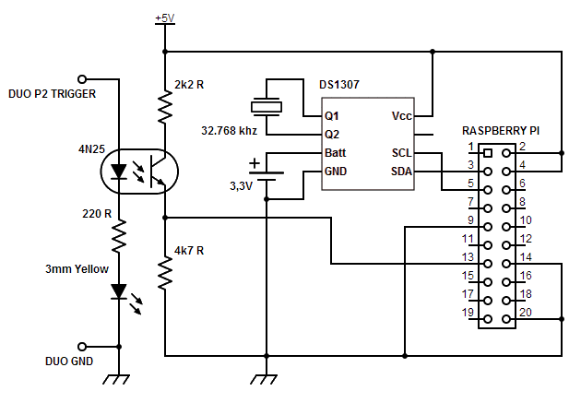

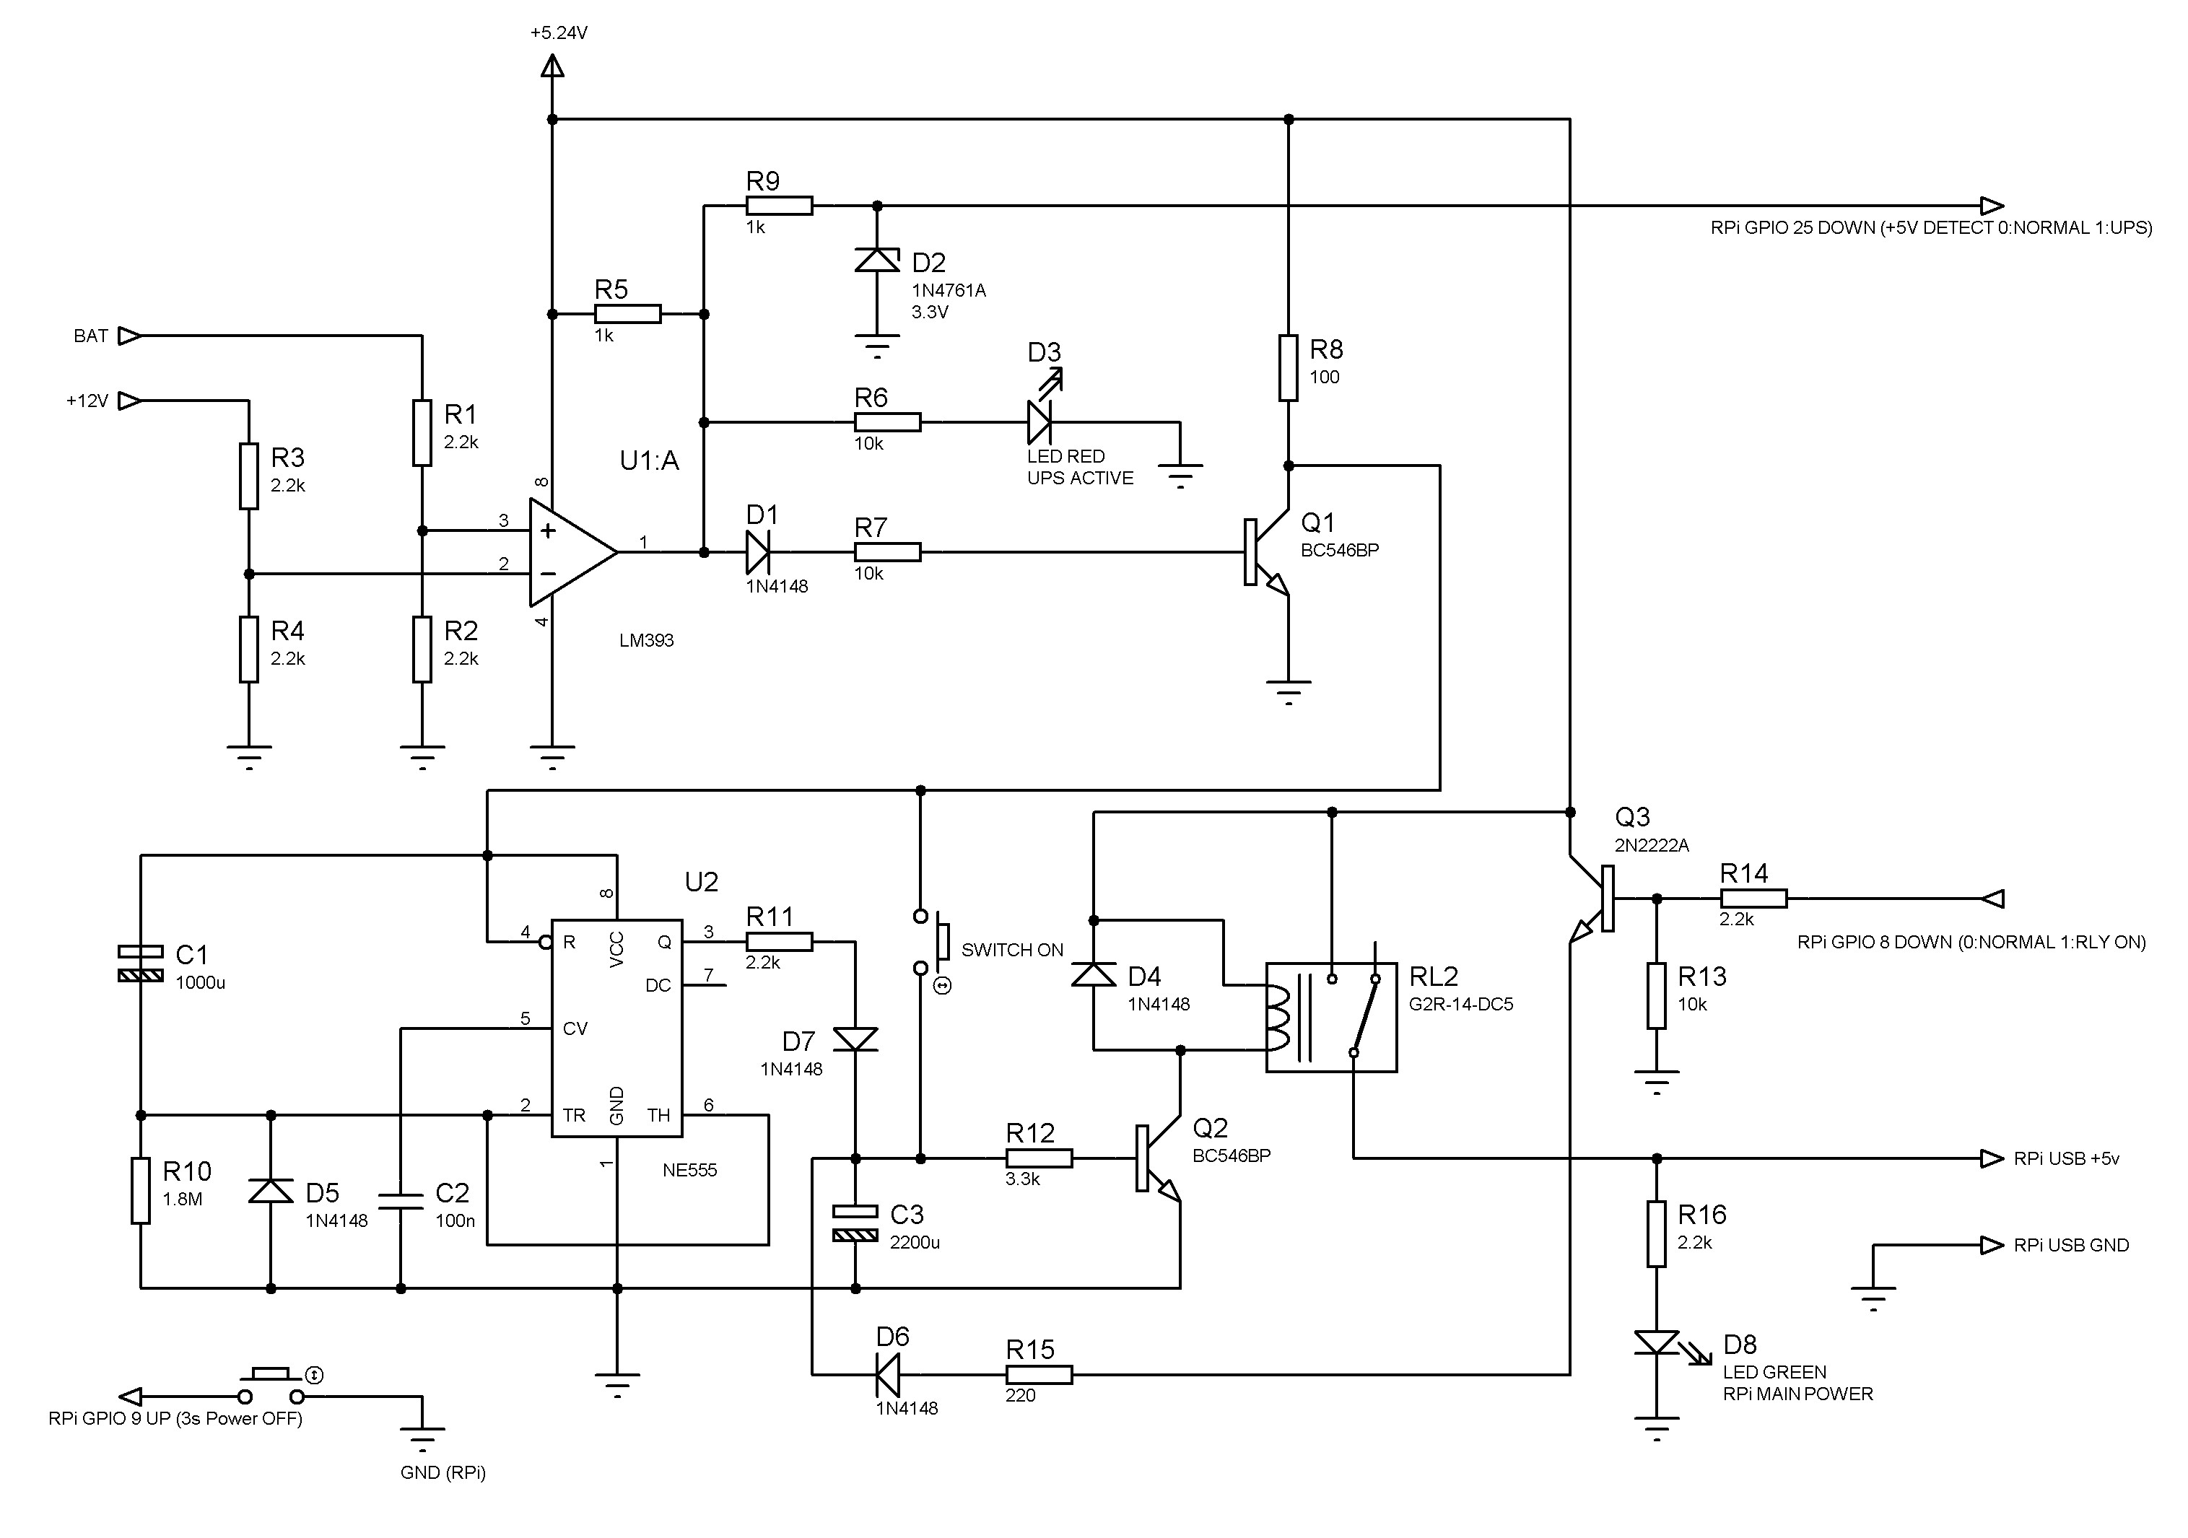
Specific UPS driver board

RPi / UPS CONNECTIONS
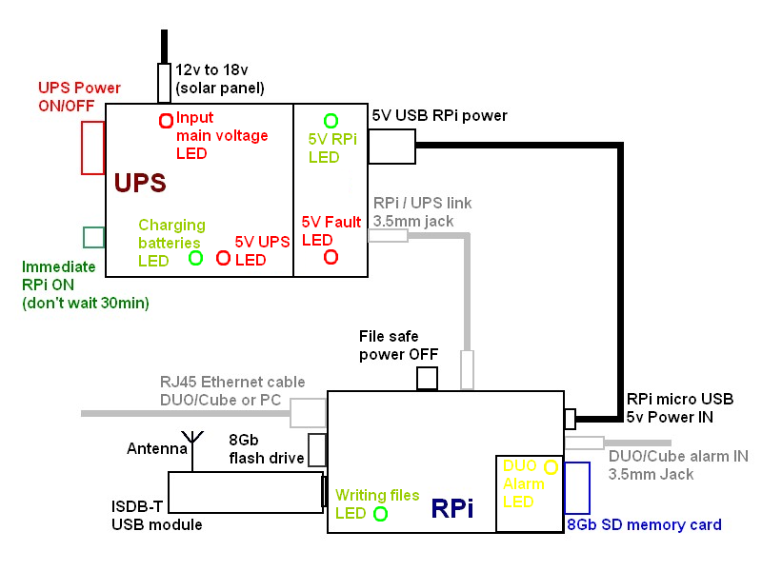

UPS Power ON/OFF: UPS Main power ON or OFF. Will switch off immediately and without security the UPS and the RPi. Use only during installation.

Immediate RPi ON: Start immediately the RPi, do not wait 30min.

Fail safe power OFF: Press 5seg. to switch off the RPi after closing all files.
SD CARD AND FILES DESCRITPION

~/backup
Backup of /dump1090 forlder

/dump1090
Main program and tools folder

public_html
cleaneth.sh reset ETH interface script
dump1090 main program
dump1090.bcm config file (do not modify)
ftplogs.sh Transfer script (used every days for transfering files from RPi to Duo or cube)
net.sh activate or deactivate ETH interface script
noblank.sh disable screen saver script
purge180.sh delete files older than 180 days
setdate.sh set date/time script
shutdown.sh shutdown script for UPiS extension board
temp.sh display RPi internal temperature script

/logs
Logs files from dump1090 program
/etc/rc.local
Initialization script
# cat /etc/rc.local
#!/bin/sh -e
#
# rc.local
# Last update 12/09/2014
#
# This script is executed at the end of each multiuser runlevel.
# Make sure that the script will "exit 0" on success or any other
# value on error.
#
# In order to enable or disable this script just change the execution
# bits.
#
# By default this script does nothing.
# No blank screen on HDMI after powersafe mode
sh -c 'setterm -blank 0 -powersave off -powerdown 0 < /dev/console > /dev/console 2>&1'

# Create logs directories
# GPIO Initialization
# GPIO p26 (wp7) OUT : RELAY COMMAND
echo "GPIO Initialization"
/root/wiringPi/gpio/gpio -g mode 7 OUT
/root/wiringPi/gpio/gpio -g mode 7 DOWN
/root/wiringPi/gpio/gpio -g write 7 1
# GPIO p21 (wp9) IN: Power OFF (3s)
/root/wiringPi/gpio/gpio -g mode 9 IN
/root/wiringPi/gpio/gpio -g mode 9 UP
# GPIO p22 (wp25) IN : UPS DETECT
/root/wiringPi/gpio/gpio -g mode 25 IN
/root/wiringPi/gpio/gpio -g mode 25 DOWN

# Create logs directories
echo "Creating /logs and /mnt/usb/logs directories"
if [ ! -d "/logs" ]; then
mkdir /logs
fi

if [ ! -d "/mnt/usb/logs" ]; then
mkdir /mnt/usb/logs
fi

# Print the IP address
_IP=$(hostname -I) || true
if [ "$_IP" ]; then
printf "My IP address is %s\n" "$_IP"
fi

echo 'RTC: Updating time and date'
modprobe rtc-ds1307
echo ds1307 0x68 > /sys/class/i2c-adapter/i2c-1/new_device
sleep 2
hwclock -s
date

sleep 3
echo 'Starting DUMP1090: Trigger mode with UPS support'
/dump1090/dump1090 --trigger --ups --nocheck &

exit 0

USB FLASH DRIVE DESCRIPTION

/mnt/usb/backup
All backup files ( /dump1090 , /etc/rc.local …etc).

/mnt/usb/logs
Copies of /logs files.

DUO/CUBE CONFIGURATION
This configuration is absolutely needed.

DUO/Cube IP Ethernet address: 192.168.0.1

FTP login: 01db
FTP password: ____

DUO/Cube must have a /LOGS_RPi folder in root directory. Use FTP program to create it. All dump1090 data’s will be transferred there.
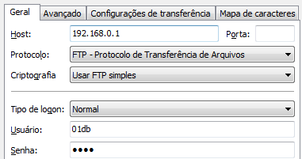

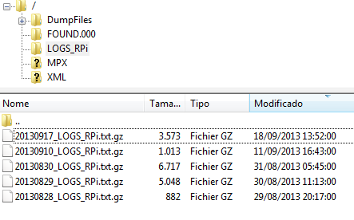

CONNECTING TO THE RASPBERRY PI

1. Run Putty
2. In Host Name, put the RPi IP address: 192.168.0.9 and let the 22 default port number

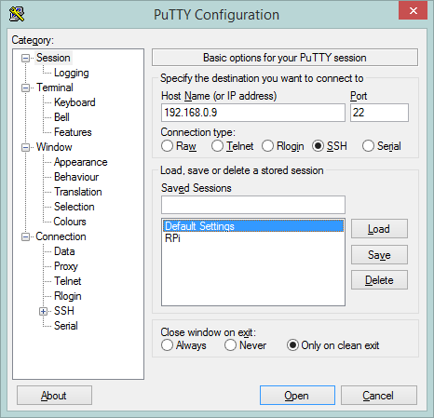

3. Insert default login: root and password: raspberry

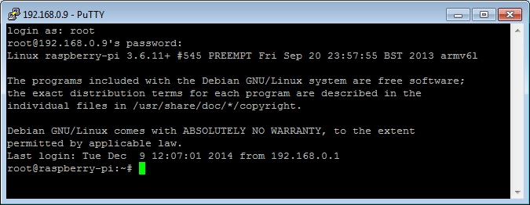

USEFUL COMMANDS

Set date/time and write RTC module
Ex: set date to 9th of December of 2014 and set time to 1 hour, 39 min. and 20 sec.
# date -s “20141209 13:39:20”
Tue Dec 9 13:39:20 BRST 2014
# hwclock -w

Get the RPi IP address
Must be a capital “i”
# hostname -I
192.168.0.9

RPi Ethernet configuration from /etc/network/interfaces file.
# cat /etc/network/interfaces
# interfaces(5) file used by ifup(8) and ifdown(8)
auto lo
iface lo inet loopback

auto eth0
allow-hotplug eth0
#iface eth0 inet dhcp

iface eth0 inet static
address 192.168.0.9
# broadcast 192.168.0.255
# gateway 192.168.0.1
# netmask 255.255.255.0

Start and stop DUMP1090 program

1. Start dump1090
This command will start the dump1090 program selecting the UPS and Duo Alarm detection options, executing in background mode.
# /dump1090/dump1090 --trigger --ups &

2. Stop dump1090
This command close all files and then stop the dump1090 program.
# pkill dump1090 --signal SIGUSR1

Manually transfer files to the DUO or Cube
Assuming that DUO/Cube IP address is 192.168.0.1, DUO/Cube ftp login is 01db and password ____.

Ex: transfer “test” files from RPi /logs folder to the DUO /logs folder
# ftp -n 192.168.0.1
Connected to 192.168.0.1.
220 Server ready…
ftp> user 01db
331 Password required for 01db.
Password: ____
230 User 01db logged in.
Remote system type is UNIX.
Using binary mode to transfer files.
ftp> lcd /logs
Local directory now /logs
ftp> cd /logs
250 CWD command successful. “/logs” is current directory.
ftp> put test
Local: test remote: test
200 Port command successful.
150 Opening date connection for test.
226 File received complete
5 bytes sent in 0.00 secs (17.6 kB/s)
ftp> bye
221 Goodbye!

Shutdown the RPi

It’s highly recommended to stop manually the dump1090 program before quit.
# pkill dump1090 --signal SIGUSR1
# halt

DUMP1090 command-line options
# cat /dump1090/dump1090 --help
-----------------------------------------------------------------------------
| dump1090 ModeS Receiver Ver : 1.07.2305.13 |
-----------------------------------------------------------------------------
--device-index <index> Select RTL device (default: 0)
--gain <db> Set gain (default: max gain. Use -100 for auto-gain)
--enable-agc Enable the Automatic Gain Control (default: off)
--freq <hz> Set frequency (default: 1090 Mhz)
--ifile <filename> Read data from file (use '-' for stdin)
--interactive Interactive mode refreshing data on screen
--interactive-rows <num> Max number of rows in interactive mode (default: 15)
--interactive-ttl <sec> Remove from list if idle for <sec> (default: 60)
--interactive-rtl1090 Display flight table in RTL1090 format
--raw Show only messages hex values
--net Enable networking
--modeac Enable decoding of SSR Modes 3/A & 3/C
--net-beast TCP raw output in Beast binary format
--net-only Enable just networking, no RTL device or file used
--net-http-port <port> HTTP server port (default: 8080)
--net-ri-port <port> TCP raw input listen port (default: 30001)
--net-ro-port <port> TCP raw output listen port (default: 30002)
--net-sbs-port <port> TCP BaseStation output listen port (default: 30003)
--net-bi-port <port> TCP Beast input listen port (default: 30004)
--net-bo-port <port> TCP Beast output listen port (default: 30005)
--net-ro-size <size> TCP raw output minimum size (default: 0)
--net-ro-rate <rate> TCP raw output memory flush rate (default: 0)
--lat <latitude> Reference/receiver latitide for surface posn (opt)
--lon <longitude> Reference/receiver longitude for surface posn (opt)
--fix Enable single-bits error correction using CRC
--no-fix Disable single-bits error correction using CRC
--no-crc-check Disable messages with broken CRC (discouraged)
--phase-enhance Enable phase enhancement
--aggressive More CPU for more messages (two bits fixes, ...)
--mlat display raw messages in Beast ascii mode
--stats With --ifile print stats at exit. No other output
--onlyaddr Show only ICAO addresses (testing purposes)
--metric Use metric units (meters, km/h, ...)
--snip <level> Strip IQ file removing samples < level
--debug <flags> Debug mode (verbose), see README for details
--quiet Disable output to stdout. Use for daemon applications
--ppm <error> Set receiver error in parts per million (default 0)
--trigger Trigger mode
--trigger_verbose Trigger mode: output on screen + file
--ups UPS mode
--help Show this help

Debug mode flags: d = Log frames decoded with errors
D = Log frames decoded with zero errors
c = Log frames with bad CRC
C = Log frames with good CRC
p = Log frames with bad preamble
n = Log network debugging info
j = Log frames to frames.js, loadable by debug.html

TROUBLESHOOTING

Network and FTP

Check RPi IP address: Must be 192.168.0.9
Check DUO/Cube address: Must be 192.168.0.1
Check cable between RPi and DUO/Cube: Interfaces both must have link lights

Test connection between RPi and DUO/Cube
Assuming RPi IP address is 192.168.0.9 and DUO/Cube IP address is 192.168.0.1
# ping –c3 192.168.0.1
PING 192.168.0.1 (192.168.0.1) 56(84) bytes of data.
64 bytes from 192.168.0.1; icmp_req=1 ttl=128 time=1.07 ms
64 bytes from 192.168.0.1; icmp_req=1 ttl=128 time=0.859 ms
64 bytes from 192.168.0.1; icmp_req=1 ttl=128 time0.948 ms

--- 192.168.0.1 ping statistics ---
3 packets transmitted, 3 received, 0% packet loss, time 2002ms
rtt /min/avg/max/mdev = 0.859/0.961/1.078/0.096 ms

Sometimes, RPi Ethernet interfaces will stay in a “sleep mode”, so you can “wake up” the interfaces by extending the ping test:
# ping –c10 192.168.0.1

Reset RPi Ethernet interface
# /etc/init.d/networking reload
# /etc/init.d/networking restart

Check if ftp is setting up in CRON
# crontab –l
# Edit this file to introduce taks to be run by cron.
#
# each [...]
#...
# m h dom mon dow command
30 2 * * * /dump1090/ftplogs.sh >/dev/null 2>&1
0 2 1 * * /dump1090/purge180.sh >/dev/null 2>&1

If missing, just add the two last lines at the end of the CRON list by using the crontab –e command. Add 2 or 3 <CR> after all lines. (<CTRL> + O, <CTRL> X to save file)

In case of problem, you can restart the CRON service.
# service cron start
[ ok ] starting periodic command scheduler: cron.

IDSB USB module

Driver test
# rtl_test -t
Found 1 device(s):
0: ezcap USB 2.0 DVB-T/DAB/FM dongle

Using device 0: ezcap USB 2.0 DVB-T/DAB/FM dongle
Found Rafael Micro R820T tuner
Supported gain values (29): 0.0 0.9 1.4 2.7 3.7 7.7 8.7 12.5 14.4 15.7 16.6 19.7 20.7 22.9 25.4 28.0 29.7 32.8 33.8 36.4 37.2 38.6 40.2 42.1 43.4 43.9 44.5 48.0 49.6
No E4000 tuner found, aborting.

RTC (date/time)

Check RPi date/time
# date
Tue Dec 9 14:51:59 BRST 2014

Change RPi date/time
# date -s "20141209 14:56:00"
Tue Dec 9 14:56:00 BRST 2014

Check RTC date/time (on chip)
# hwclock –r
Tue Dec 9 14:53:00 -0.569846 seconds

Set RPi with RTC date/time
# hwclock –s

Set RTC date/time with RPi date/time
Check your RPi date/time before updating RTC chip
# hwclock -w

Check I2C communication with RTC chip (ds1307)
# i2cdetect -y 1
0 1 2 3 4 5 6 7 8 9 a b c d e f
00: -- -- -- -- -- -- -- -- -- -- -- -- --
10: -- -- -- -- -- -- -- -- -- -- -- -- -- -- -- --
20: -- -- -- -- -- -- -- -- -- -- -- -- -- -- -- --
30: -- -- -- -- -- -- -- -- -- -- -- -- -- -- -- --
40: -- -- -- -- -- -- -- -- -- -- -- -- -- -- -- --
50: -- -- -- -- -- -- -- -- -- -- -- -- -- -- -- --
60: -- -- -- -- -- -- -- -- UU -- -- -- -- -- -- --
70: -- -- -- -- -- -- -- --

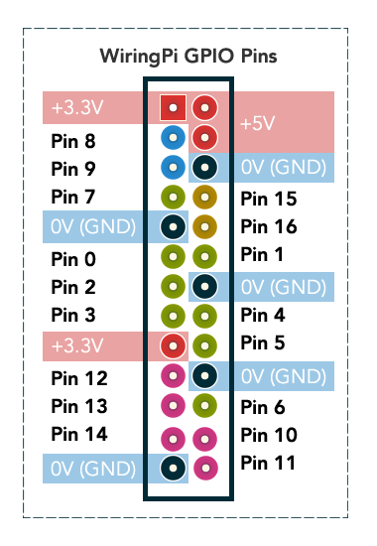
RPi GPIO

Check GPIO driver
# gpio -v
gpio version: 2.13
Copyright (c) 2012-2013 Gordon Henderson
This is free software with ABSOLUTELY NO WARRANTY.
For details type: gpio -warranty

This Raspberry Pi is a revision 2 board.

Check GPIO status
# gpio readall
+----------+-Rev2-+------+--------+------+-------+
| wiringPi | GPIO | Phys | Name | Mode | Value |
+----------+------+------+--------+------+-------+
| 0 | 17 | 11 | GPIO 0 | IN | Low |
| 1 | 18 | 12 | GPIO 1 | IN | Low |
| 2 | 27 | 13 | GPIO 2 | IN | Low |
| 3 | 22 | 15 | GPIO 3 | IN | Low |
| 4 | 23 | 16 | GPIO 4 | IN | Low |
| 5 | 24 | 18 | GPIO 5 | IN | Low |
| 6 | 25 | 22 | GPIO 6 | IN | Low |
| 7 | 4 | 7 | GPIO 7 | IN | Low |
| 8 | 2 | 3 | SDA | IN | High |
| 9 | 3 | 5 | SCL | IN | High |
| 10 | 8 | 24 | CE0 | IN | Low |
| 11 | 7 | 26 | CE1 | IN | Low |
| 12 | 10 | 19 | MOSI | IN | Low |
| 13 | 9 | 21 | MISO | IN | Low |
| 14 | 11 | 23 | SCLK | IN | Low |
| 15 | 14 | 8 | TxD | ALT0 | High |
| 16 | 15 | 10 | RxD | ALT0 | High |
| 17 | 28 | 3 | GPIO 8 | IN | Low |
| 18 | 29 | 4 | GPIO 9 | IN | Low |
| 19 | 30 | 5 | GPIO10 | IN | Low |
| 20 | 31 | 6 | GPIO11 | IN | Low |
+----------+------+------+--------+------+-------+

USB flash drive

Check if USB flash drive has been mounted
# ls /mnt/usb
RECYCLER System Voluçe Information autorun.inf backup logs

If needed, add (at the end of file) auto-mount on reboot.
# nano /etc/fstab
/dev/sda1 /mnt/usb vfat defaults 0 0

DUMP1090

Check dump1090 program
You must kill all dump1090 instances (in background) before testing.
Check if dump1090 is already running
# ps –e|grep dump1090
1766 pts/1 00 :000 :000 dump1090
Kill instance
# kill 1766
Check program
# ./dump1090 –trigger_verbose
Found 1 device(s):
0: Realtek, RTL2838UHIDIR, SN: 00000001 (currently selected)
Found Rafael Micro R820T tuner
Max available gain is: 49.60
Setting gain to: 49.60
Exact sample rate is: 2000000.052982 Hz
Gain reported by device: 49.60
Trigger mode
- Verbose mode
- Waiting for synchronisation...
Hex Flight Alt Spd Hdg Lat Long Date Time
------------------------------------------------------------------
e47f91; ; ; ; ; ; ;2013/09/22;12:15:03
e47f91; ; ; ; ; ; ;2013/09/22;12:15:03
e47f91; ; 2700; ; ; ; ;2013/09/22;12:15:04
e47f91; ; 2700; ; ; ; ;2013/09/22;12:15:04
e47f91; ; 2700; ; ; ; ;2013/09/22;12:15:05
Receiving GPIO interrupt BOTH (Note: start of alarm DUO: trigger UP)
Level 1
RISING
Opening file: /logs/20130922_122436_Flights.txt
e48044;TAM3706 ; 5500;219;073;-23.611; -46.585;2013/09/22;12:24:37
e4827c; ; 8100; ; ; ; ;2013/09/22;12:24:37
e47cc4; ; 7500; ; ; ; ;2013/09/22;12:24:37
e486d1; ;15400; ; ; ; ;2013/09/22;12:24:37
e48519; ; 3875;162;148;-23.646; -46.644;2013/09/22;12:24:38
e48044;TAM3706 ; 5500;219;073;-23.611; -46.585;2013/09/22;12:24:38
aa8474; ; 5900; ; ; ; ;2013/09/22;12:24:38
e48519; ; 3875;162;148;-23.646; -46.644;2013/09/22;12:24:38
e48044;TAM3706 ; 5500;219;073;-23.611; -46.585;2013/09/22;12:24:38
Receiving GPIO interrupt BOTH (Note: end of alarm DUO: trigger DOWN)
Level 0
FALLING
Closing file
e47fe0;TAM3729 ; 3025;137;147;-23.597; -46.677;2013/09/22;12:25:21
e48519;TAM3121 ; 5550;135;261;-23.668; -46.669;2013/09/22;12:25:21

Check logs format
# cd /logs
# cat 20130922_122436_Flights.txt
e48044;TAM3706 ; 3675;182;081;-23.648; -46.628;2013/09/22;12:23:36
e48395;GLO7682 ;16100;354;204;-23.741; -46.732;2013/09/22;12:23:36
e48044;TAM3706 ; 3675;182;081;-23.648; -46.628;2013/09/22;12:23:36
e48395;GLO7682 ;16100;354;204;-23.741; -46.732;2013/09/22;12:23:36
e48395;GLO7682 ;16100;354;204;-23.741; -46.732;2013/09/22;12:23:37
e48044;TAM3706 ; 3675;182;081;-23.648; -46.628;2013/09/22;12:23:37
e48395;GLO7682 ;16100;354;204;-23.741; -46.732;2013/09/22;12:23:37
e48044;TAM3706 ; 3675;182;081;-23.648; -46.628;2013/09/22;12:23:37
e48395;GLO7682 ;16100;354;204;-23.741; -46.732;2013/09/22;12:23:38

LINKS

Raspberry Pi fundation
http://www.raspberrypi.org/

Raspbian Wheezy armhf Raspberry Pi minimal image
http://www.linuxsystems.it/raspbian-wheezy-armhf-raspberry-pi-minimal-image/

Dump1090
https://github.com/antirez/dump1090

Adding RTC to the RPi
https://learn.adafruit.com/adding-a-real-time-clock-to-raspberry-pi/set-rtc-time

Eth0 or Eth1 problem - Network unreachable
http://www.raspberrypi.org/phpBB3/viewtopic.php?t=7421&p=91816
remove /etc/udev/rules.d/70-persistent-net.rules and reboot

