INSTALLATION

Windows tools
win32diskimager-v0.8-binary

Cartão de 2gb no mínimo
RASPBERRY v2 (B) - 512MB

Raspbian Wheezy armhf Raspberry Pi minimal image
http://www.linuxsystems.it/raspbian-wheezy-armhf-raspberry-pi-minimal-image/
Login : root
Password : raspberry

Puttty http://www.chiark.greenend.org.uk/~sgtatham/putty/download.html
RPi IP 192.168.0.9

TYPSoft FTP Server http://sourceforge.net/projects/ftpserv/

Ext2Read
http://www.howtogeek.com/howto/33387/how-to-browse-your-linux-partition-from-windows/

Win32 Disk Image

- Insert a SD card
- Run the program
- Choose the right image
- Select the SD drive
- Use the Write button to write the image on the SD card (destructive)

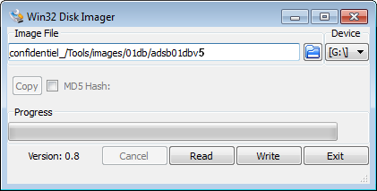

Insert SD card in the RPI and start using Putty

Putty

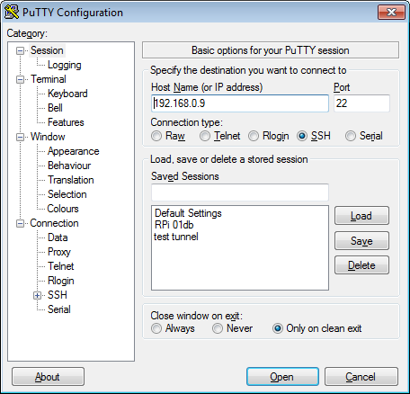
Time zone
dpkg-reconfigure tzdata
(America / São Paulo)

Localization
dpkg-reconfigure locales
(unselect IT / select PT-BR (UTF8) + validation “None”)

Modificar os parâmetros rede
nano /etc/network/interfaces
auto lo
iface lo inet loopback
auto eth0
#iface eth0 inet dhcp

iface eth0 inet static
address 192.168.0.9
netmask 255.255.255.0
#broadcast 192.168.0.255 (apagar os ‘#’ para acessar internet e indicar a gateway/endereço do seu roteador)
gateway 192.168.0.1
#network 192.168.0.0
#allow-hotplug wlan0
#iface wlan0 inet manual
#wpa-roam /etc/wpa_supplicant/wpa_supplicant.conf
#iface default inet dhcp

Reset interfaces rede
/etc/init.d/networking reload
/etc/init.d/networking restart

IP locale
hostname -i

(Configuração do teclado em português
nano /etc/default/keyboard
XKBMODEL="pc105"
XKBLAYOUT="br"
XKBVARIANT=""
XKBOPTIONS="” (XKBOPTIONS="lv3:alt_switch,compose:rctrl")
#BACKSPACE="guess")

Atualização do sistema
apt-get update
(apt-get upgrade)

Instalação dos utilitários
apt-get install sudo
apt-get install pkg-config

nano /etc/hosts
(add)
127.0.0.1 raspberry-pi

INSTALLAÇÂO DO RTC

Desinstalar ntp e fake-clock
dpkg --purge ntp

Install apps I2C
apt-get -y install python-smbus
(apt-get install i2c-tools)
apt-get -y autoremove

Set config
nano /etc/modules
(add)
i2c-bcm2708
i2c-dev

nano /etc/modprobe.d/raspi-blacklist.conf
(comment)
#blacklist spi-bcm2708
#blacklist i2c-bcm2708

reboot

Check I2C ds1307 address
i2cdetect -y 1
0 1 2 3 4 5 6 7 8 9 a b c d e f
00: -- -- -- -- -- -- -- -- -- -- -- -- --
10: -- -- -- -- -- -- -- -- -- -- -- -- -- -- -- --
20: -- -- -- -- -- -- -- -- -- -- -- -- -- -- -- --
30: -- -- -- -- -- -- -- -- -- -- -- -- -- -- -- --
40: -- -- -- -- -- -- -- -- -- -- -- -- -- -- -- --
50: -- -- -- -- -- -- -- -- -- -- -- -- -- -- -- --
60: -- -- -- -- -- -- -- -- 68 -- -- -- -- -- -- -- --> ou UU
70: -- -- -- -- -- -- -- --

Config ds1307
modprobe rtc-ds1307
echo ds1307 0x68 > /sys/class/i2c-adapter/i2c-1/new_device
printf "0.0 0 0.0\n0\nUTC\n" > /etc/adjtime
hwclock -r
Fri Dec 31 22:48:47 1999 -0.569112 seconds

date +%Y%m%d -s "20130912"
date +%T -s "15:59:25"
date
Thu Sep 12 15:59:26 BRT 2013

hwclock -w
hwclock -r
Thu Sep 12 16:01:13 2013 -0.522130 seconds

Start automatically
nano /etc/modules
(add)
rtc-ds1307

(para testar o RTC antes do fim da instalação de todos os programas, modificar o arquivo /etc/rc.local - ver no fim do documento -)

I2C conflit (with RTL driver)
nano /etc/modprobe.d/blacklist.conf
(add)
blacklist dvb_usb_rtl28xxu
blacklist rtl2830
blacklist dvb_usb_v2
blacklist dvb_core

INSTALAÇÂO RTL-SDR / DUMP1090 / wiringPi

Instalação git e drivers USB
apt-get install git-core
(apt-get install git)
apt-get -y install cmake
apt-get install libusb-1.0-0-dev
apt-get install build-essential

RTL-2832U USB Drivers
git clone git://git.osmocom.org/rtl-sdr.git
cd rtl-sdr
mkdir build
cd build
cmake ../ -DINSTALL_UDEV_RULES=ON
make
make install
ldconfig

cd ~
cp ./rtl-sdr/rtl-sdr.rules /etc/udev/rules.d/
halt

Inserir o tuner
(reboot)

Test os drivers
rtl_test -t
Found 1 device(s):
0: ezcap USB 2.0 DVB-T/DAB/FM dongle

Using device 0: ezcap USB 2.0 DVB-T/DAB/FM dongle
Found Rafael Micro R820T tuner
Supported gain values (29): 0.0 0.9 1.4 2.7 3.7 7.7 8.7 12.5 14.4 15.7 16.6 19.7 20.7 22.9 25.4 28.0 29.7 32.8 33.8 36.4 37.2 38.6 40.2 42.1 43.4 43.9 44.5 48.0 49.6
No E4000 tuner found, aborting.

(Instalação dump1090
cd ~
git clone git://github.com/MalcolmRobb/dump1090.git
cd dump1090
make

Test dump1090
./dump1090 --interactive)
GPIO Library (wiringPi)
cd ~
git clone git://git.drogon.net/wiringPi
cd wiringPi
(git pull origin)
./build

Test
gpio -v
gpio version: 2.13
Copyright (c) 2012-2013 Gordon Henderson
This is free software with ABSOLUTELY NO WARRANTY.
For details type: gpio -warranty

This Raspberry Pi is a revision 2 board.

gpio readall

+----------+-Rev2-+------+--------+------+-------+
| wiringPi | GPIO | Phys | Name | Mode | Value |
+----------+------+------+--------+------+-------+
| 0 | 17 | 11 | GPIO 0 | IN | Low |
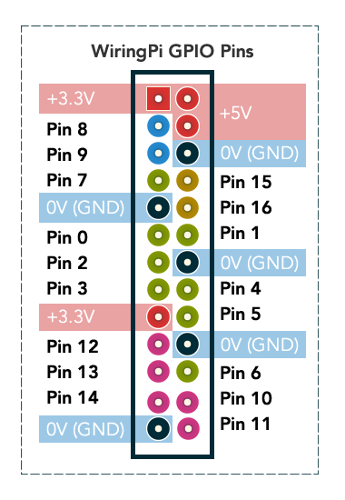
| 1 | 18 | 12 | GPIO 1 | IN | Low |
| 2 | 27 | 13 | GPIO 2 | IN | Low |
| 3 | 22 | 15 | GPIO 3 | IN | Low |
| 4 | 23 | 16 | GPIO 4 | IN | Low |
| 5 | 24 | 18 | GPIO 5 | IN | Low |
| 6 | 25 | 22 | GPIO 6 | IN | Low |
| 7 | 4 | 7 | GPIO 7 | IN | Low |
| 8 | 2 | 3 | SDA | IN | High |
| 9 | 3 | 5 | SCL | IN | High |
| 10 | 8 | 24 | CE0 | IN | Low |
| 11 | 7 | 26 | CE1 | IN | Low |
| 12 | 10 | 19 | MOSI | IN | Low |
| 13 | 9 | 21 | MISO | IN | Low |
| 14 | 11 | 23 | SCLK | IN | Low |
| 15 | 14 | 8 | TxD | ALT0 | High |
| 16 | 15 | 10 | RxD | ALT0 | High |
| 17 | 28 | 3 | GPIO 8 | IN | Low |
| 18 | 29 | 4 | GPIO 9 | IN | Low |
| 19 | 30 | 5 | GPIO10 | IN | Low |
| 20 | 31 | 6 | GPIO11 | IN | Low |
+----------+------+------+--------+------+-------+

Reboot
Instalação FTP
apt-get install ftp

cd /
mkdir logs
mkdir dump1090

Importar dump1090 modificado
cd ~
cd dump1090
ftp 192.168.0.3 (endereço do seu servidor)
(login/password)
get dump1090
get dump1090.bcm
get ftplogs.sh
get net.sh
get noblank.sh
get purge180.sh
get setdate.sh
get temp.sh
bye

chmod +x *.sh
chmod +x dump1090

cp *.sh /dump1090/.
cp dump1090 /dump1090/.
cp dump1090.bcm /dump1090/.

Testar o programa
./dump1090 –trigger_verbose
Found 1 device(s):
0: Realtek, RTL2838UHIDIR, SN: 00000001 (currently selected)
Found Rafael Micro R820T tuner
Max available gain is: 49.60
Setting gain to: 49.60
Exact sample rate is: 2000000.052982 Hz
Gain reported by device: 49.60
Trigger mode
- Verbose mode
- Waiting for synchronisation...
Hex Flight Alt Spd Hdg Lat Long Date Time
------------------------------------------------------------------
e47f91; ; ; ; ; ; ;2013/09/22;12:15:03
e47f91; ; ; ; ; ; ;2013/09/22;12:15:03
e47f91; ; 2700; ; ; ; ;2013/09/22;12:15:04
e47f91; ; 2700; ; ; ; ;2013/09/22;12:15:04
e47f91; ; 2700; ; ; ; ;2013/09/22;12:15:05
e47f91; ; 2700; ; ; ; ;2013/09/22;12:15:05
Receiving GPIO interrupt BOTH (start of alarm DUO: trigger UP)
Level 1
RISING
Opening file: /logs/20130922_122436_Flights.txt
e48044;TAM3706 ; 5500;219;073;-23.611; -46.585;2013/09/22;12:24:37
e4827c; ; 8100; ; ; ; ;2013/09/22;12:24:37
e47cc4; ; 7500; ; ; ; ;2013/09/22;12:24:37
aa8474; ; 5900; ; ; ; ;2013/09/22;12:24:37
e486d1; ;15400; ; ; ; ;2013/09/22;12:24:37
e48519; ; 3875;162;148;-23.646; -46.644;2013/09/22;12:24:38
e48044;TAM3706 ; 5500;219;073;-23.611; -46.585;2013/09/22;12:24:38
e4827c; ; 8100; ; ; ; ;2013/09/22;12:24:38
e47cc4; ; 7500; ; ; ; ;2013/09/22;12:24:38
aa8474; ; 5900; ; ; ; ;2013/09/22;12:24:38
e48519; ; 3875;162;148;-23.646; -46.644;2013/09/22;12:24:38
e48044;TAM3706 ; 5500;219;073;-23.611; -46.585;2013/09/22;12:24:38
Receiving GPIO interrupt BOTH (end of alarm DUO: trigger DOWN)
Level 0
FALLING
Closing file
e48519;TAM3121 ; 5550;135;261;-23.668; -46.669;2013/09/22;12:25:21
e47fe0;TAM3729 ; 3025;137;147;-23.597; -46.677;2013/09/22;12:25:21
e48519;TAM3121 ; 5550;135;261;-23.668; -46.669;2013/09/22;12:25:21

cd /logs
cat 20130922_122436_Flights.txt
e48044;TAM3706 ; 3675;182;081;-23.648; -46.628;2013/09/22;12:23:36
e48395;GLO7682 ;16100;354;204;-23.741; -46.732;2013/09/22;12:23:36
e48044;TAM3706 ; 3675;182;081;-23.648; -46.628;2013/09/22;12:23:36
e48395;GLO7682 ;16100;354;204;-23.741; -46.732;2013/09/22;12:23:36
e48395;GLO7682 ;16100;354;204;-23.741; -46.732;2013/09/22;12:23:37
e48044;TAM3706 ; 3675;182;081;-23.648; -46.628;2013/09/22;12:23:37
e48395;GLO7682 ;16100;354;204;-23.741; -46.732;2013/09/22;12:23:37
e48044;TAM3706 ; 3675;182;081;-23.648; -46.628;2013/09/22;12:23:37
e48395;GLO7682 ;16100;354;204;-23.741; -46.732;2013/09/22;12:23:38

Programa DUMP1090 modificado ~/dump1090/dump1090 --help
-----------------------------------------------------------------------------
| dump1090 ModeS Receiver Ver : 1.07.2305.13 |
-----------------------------------------------------------------------------
--device-index <index> Select RTL device (default: 0)
--gain <db> Set gain (default: max gain. Use -100 for auto-gain)
--enable-agc Enable the Automatic Gain Control (default: off)
--freq <hz> Set frequency (default: 1090 Mhz)
--ifile <filename> Read data from file (use '-' for stdin)
--interactive Interactive mode refreshing data on screen
--interactive-rows <num> Max number of rows in interactive mode (default: 15)
--interactive-ttl <sec> Remove from list if idle for <sec> (default: 60)
--interactive-rtl1090 Display flight table in RTL1090 format
--raw Show only messages hex values
--net Enable networking
--modeac Enable decoding of SSR Modes 3/A & 3/C
--net-beast TCP raw output in Beast binary format
--net-only Enable just networking, no RTL device or file used
--net-http-port <port> HTTP server port (default: 8080)
--net-ri-port <port> TCP raw input listen port (default: 30001)
--net-ro-port <port> TCP raw output listen port (default: 30002)
--net-sbs-port <port> TCP BaseStation output listen port (default: 30003)
--net-bi-port <port> TCP Beast input listen port (default: 30004)
--net-bo-port <port> TCP Beast output listen port (default: 30005)
--net-ro-size <size> TCP raw output minimum size (default: 0)
--net-ro-rate <rate> TCP raw output memory flush rate (default: 0)
--lat <latitude> Reference/receiver latitide for surface posn (opt)
--lon <longitude> Reference/receiver longitude for surface posn (opt)
--fix Enable single-bits error correction using CRC
--no-fix Disable single-bits error correction using CRC
--no-crc-check Disable messages with broken CRC (discouraged)
--phase-enhance Enable phase enhancement
--aggressive More CPU for more messages (two bits fixes, ...)
--mlat display raw messages in Beast ascii mode
--stats With --ifile print stats at exit. No other output
--onlyaddr Show only ICAO addresses (testing purposes)
--metric Use metric units (meters, km/h, ...)
--snip <level> Strip IQ file removing samples < level
--debug <flags> Debug mode (verbose), see README for details
--quiet Disable output to stdout. Use for daemon applications
--ppm <error> Set receiver error in parts per million (default 0)
--trigger Trigger mode
--trigger_verbose Trigger mode: output on screen + file
--help Show this help

Debug mode flags: d = Log frames decoded with errors
D = Log frames decoded with zero errors
c = Log frames with bad CRC
C = Log frames with good CRC
p = Log frames with bad preamble
n = Log network debugging info
j = Log frames to frames.js, loadable by debug.html

Ajustar data e rodar automaticamente dump1090
nano /etc/rc.local
(add no fim e antes do exit 0)

_IP=$(hostname -I) || true
if [ "$_IP" ]; then
printf "My IP address is %s\n" "$_IP"
fi

echo 'RTC: Updating time and date'
modprobe rtc-ds1307
echo ds1307 0x68 > /sys/class/i2c-adapter/i2c-1/new_device
sleep 2
hwclock -s
date

sleep 3
echo 'Starting DUMP1090: Trigger mode'
/dump1090/dump1090 --trigger --aggressive &

FTP automático
(todos os dias 2:30AM)

Copia automática dos arquivos /logs/ para o DUO as 2:30AM todos os dias
nano /dump1090/ftplogs.sh
#!/bin/sh
echo "RPi project ADS-B / 01db acoem"
echo "FTPLOGS script"

HOST='192.168.0.1'
USER='01db'
PASSWD='____'

day_list=`date --date="1 day ago" +"%Y%m%d*Flights.txt"`
day_logs=`date --date="1 day ago" +"%Y%m%d_LOGS_RPi.txt.gz"`

cd /logs
gzip -c $day_list > $day_logs

ping -c20 $HOST

ftp -n $HOST <<END_SCRIPT
user $USER $PASSWD
binary
lcd /logs
cd /LOGS_RPi
put $day_logs
quit
END_SCRIPT
rm $day_list
exit 0

chmod 777 ftplogs.sh

Desativar o economizador de tela do Raspberry
nano /dump1090/noblank.sh
#!/bin/sh
echo "No blank screen"
sh -c "TERM=linux setterm -blank 0 >/dev/tty0"
exit 0

chmod 777 noblank.sh

Script para apagar os arquivos /logs/ de mais de 180 dias
nano /dump1090/purge180.sh
#!/bin/sh
echo "Delete files older than 180 days in /logs"
find /logs/* -mtime +180 -exec rm {} \;
exit 0

chmod 777 purge180.sh

Script para ler a temperature do CPU
nano /dump1090/temp.sh
#!/bin/sh
/opt/vc/bin/vcgencmd measure_temp
exit 0

chmod 777 temp.sh

Script para carregar as configurações ETH
nano /dump1090/net.sh
cp /etc/init.d/networking ~/dump1090/net.sh

Tarefa ftplogs
(add)
crontab -e
30 2 * * * /dump1090/ftplogs.sh >/dev/null 2>&1
0 2 1 * * /dump1090/purge180.sh >/dev/null 2>&1
Pasta /logs
-rw-r--r-- 1 root root 3573 Sep 18 10:53 20130917_LOGS_RPi.txt.gz
-rw-r--r-- 1 root root 0 Sep 18 06:22 20130918_062207_Flights.txt
-rw-r--r-- 1 root root 268 Sep 18 07:28 20130918_072824_Flights.txt
-rw-r--r-- 1 root root 13936 Sep 18 07:28 20130918_072828_Flights.txt

Pasta ~/dump1090
-rw-r--r-- 1 root root 573 Sep 16 18:17 Makefile
-rw-r--r-- 1 root root 9838 Sep 14 14:05 README.md
-rw-r--r-- 1 root root 2627 Sep 16 18:15 anet.h
-rwxr-xr-x 1 root root 140839 Sep 16 18:17 dump1090
-rw-r--r-- 1 root root 169160 Sep 16 18:21 dump1090.c
-rw-r--r-- 1 root root 19361 Sep 16 18:20 dump1090.h
-rwxrwxrwx 1 root root 339 Sep 18 10:54 ftplogs.sh
-rwxr-xr-x 1 root root 4400 Sep 18 08:55 net.sh
-rwxrwxrwx 1 root root 88 Sep 18 10:55 noblank.sh
drwxr-xr-x 3 root root 4096 Sep 14 14:05 public_html
-rwxrwxrwx 1 root root 106 Sep 18 10:54 purge180.sh
drwxr-xr-x 2 root root 4096 Sep 18 07:14 sources
-rwxrwxrwx 1 root root 52 Sep 18 10:55 temp.sh
drwxr-xr-x 2 root root 4096 Sep 14 14:05 tools

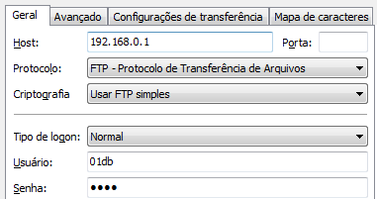
Pastas DUO

ftp 192.168.0.1
Login ftp: 01db
Password: ____

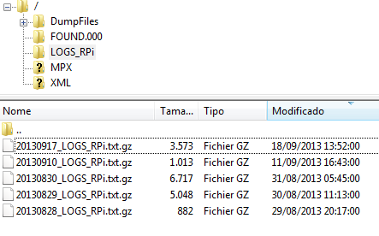
criar pasta /LOGS_RPi

PLACA

Lista dos componentes

4N25
DS1307
Q 32,768 khz
Battery 3,3v
R 220 ohm
R 2,2k ohm

R 4,7k ohm
LED 3mm Yellow
Connector 2x10
Connector P2 ST
Support for 3.3v battery
Jack P2 ST connector

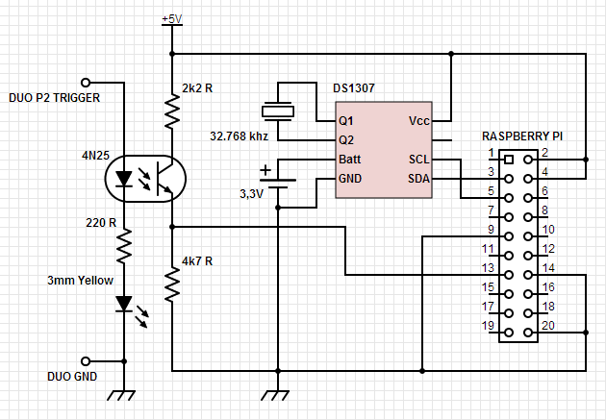

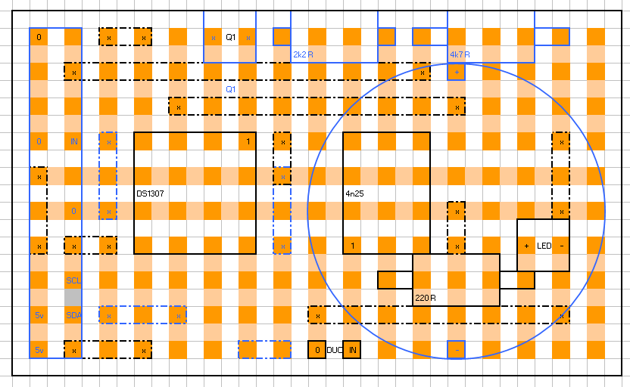
INFORMAÇÕES GERAIS (Linux)

Login/Pass
root/raspberry

Parametragem da hora
dpkg-reconfigure tzdata

Reset interfaces rede
/etc/init.d/networking reload
/etc/init.d/networking restart

IP locale
hostname –i

Stop Raspberry
halt
(evitar no máximo o “sudo reboot” para parar mesmo o sistema)

Reboot Raspberry
reboot (desaconselhado)

Ver o dump1090 rodando
ps -e | grep dump1090
1642 ? 19:17:37 dump1090

Kill o dump1090
killall 1642

CRON (edição)
crontab –e

CRON (lista)
contrab –l

Restart o service CRON
service cron start

BUG

(Eth0 or Eth1 problem) Network unreachable
http://www.raspberrypi.org/phpBB3/viewtopic.php?t=7421&p=91816
remove /etc/udev/rules.d/70-persistent-net.rules and reboot

AUTO-MOUNT EXTERNAL USB FLASH DRIVE

mkdir /mnt/usb
mount /dev/sda1 /mnt/usb

Check if USB flash drive has been mounted
mount
ls /mnt/usb

Add auto-mount on reboot
nano /etc/fstab
(add to the end)
/dev/sda1 /mnt/usb vfat defaults 0 0

