Solid Mechanics 101 — Illustrated
Reason out loud, name the variable that dominates, and you win. Numbers optional; intuition is the point.
📏 1 · CANTILEVER BEAM (the one that got me!)
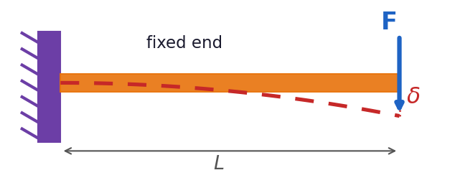
σ = M c / I δ = F L³ / (3 E I)
▸ I = b h³ / 12: height is CUBED, so depth beats width. Deflection scales with L³.
💬 "Stiffen it? Add depth or ribs, or shorten the span. Length dominates: 2× longer = 8× the sag."
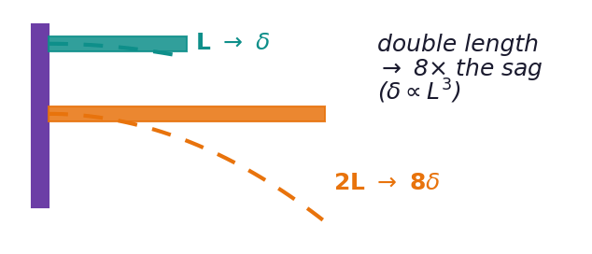
🌀 2 · SPRINGS (a beam is just a spring)
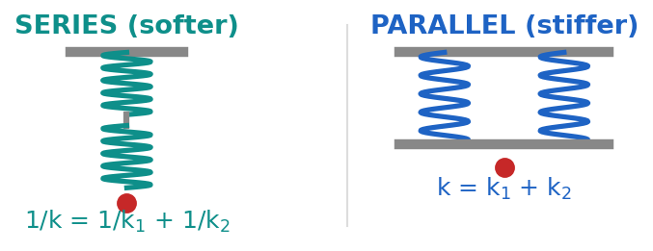
F = k x U = ½ k x² cantilever tip: k = 3EI / L³
▸ Parallel adds (stiffer); series softens. Same math as a beam — k = 3EI/L³.
💥 3 · BUCKLING (slender = collapses early)
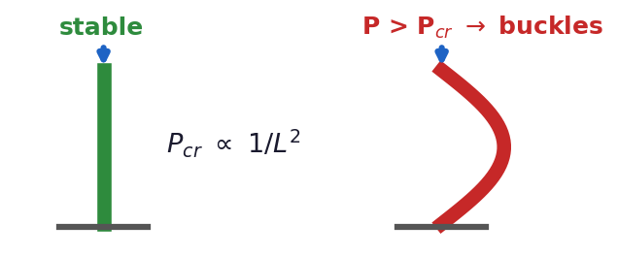
P_cr = π² E I / (K L)²
▸ Long thin things fail by buckling before yielding. Depends on L² and I, not strength. K: pinned 1.0, fixed 0.5, cantilever 2.0.
💬 "A vacuum vessel or long strut is a buckling problem — add stiffening rings, don’t just add strength."
🔩 4 · BOLTED JOINTS & PRELOAD
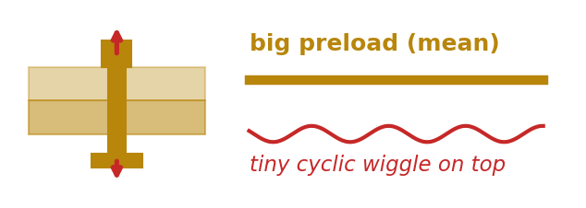
Preload F = T / (K d) (K ≈ 0.2 dry steel)
▸ A pre-stretched bolt makes the cyclic load a tiny wiggle on a big mean — huge fatigue win, and it stops loosening.
🌡️ 5 · THERMAL STRESS (heat = force)
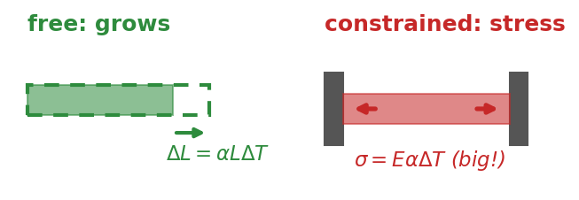
ΔL = α L ΔT constrained: σ = E α ΔT
▸ Block the growth and strain becomes stress; E is big, so it climbs fast. Add flexures / slots to let it breathe.
🧱 6 · THE REST, IN ONE LINE EACH
▸ Stress/strain: σ = F/A, ε = ΔL/L, σ = Eε. E = stiffness (steel ~200 GPa, Al ~70).
▸ Fatigue: repeated loads fail below static strength; steel has an endurance limit, aluminum does not; kill stress risers with fillets.
▸ Pressure vessel: hoop stress σ = pr/t is 2× axial; vacuum vessels buckle inward.
⭐ THE MOVE: blanked on the number? Say what it depends on and which variable dominates (h³, L³, L², EαΔT). "Deflection goes as L-cubed over EI, so length matters most" beats a memorized constant.

