Check-In Highlights
July 10, 2026 | Aditi Kalle | MarineSitu DOE Fellowship

Where we are
- 41 days of hourly IMTA telemetry (May 20 to June 30). Buoy retrieved; data collection closed.
- Scheduler prototype works end-to-end. Test picked 29 of 48 hours, all daylight.
- June benchmark of 11 models complete. Naive Seasonal and SVR traded the lead across three data pulls.
- ERA5 weather correlation with panel_w came in weak (r=0.194).

The shift (June to July)
The June work was asking "which model works best?" After a July 9 methodology meeting with Jack, the more productive question is "what data actually matters, and how clean are the inputs?"
Model choice is roughly 10% of the work. Data preparation and variable selection is roughly 90%.
Why this lands: fractional-watt differences between models across three data pulls suggests a ceiling on how much better any model can do with the current inputs. The weak ERA5 correlation is the same story in a different form.
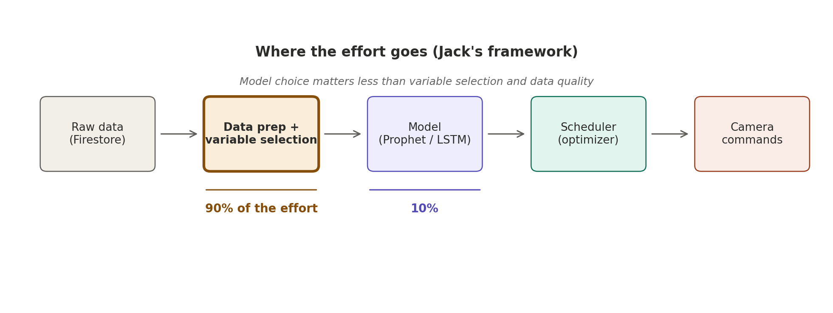

What's different now
- Data exploration comes before model iteration, not after
- Lit review re-scoped: read for the variables authors used and what didn't matter, not model architecture
- NOAA is the working weather source. ERA5 shelved for this location.
- Prophet as reasonable default when a model is needed; LSTM if warranted

Next 2 weeks
- Data exploration on the 41-day CSV: correlations, redundancy, quality
- NOAA weather research for the buoy's coordinates
- Re-scope lit review with the new lens
- Paper review session with Jack after retreat

Timeline
Roughly 2.5 to 3 months remaining. Data is final at 41 days. Quality of analysis is the frontier from here.

