Check-In with Paul
July 10, 2026 | Aditi Kalle

Since your last report
- ERA5 correlation with panel_w came in at r=0.194 (weak). Shifting to NOAA.
ERA5 is a global historical weather dataset on a ~30 km grid. The correlation coefficient (r) measures how linearly two variables move together: +1 is perfect, 0 is none. r=0.194 means only ~4% of solar-output variation is explained by ERA5. Likely because a 30 km grid can't resolve coastal fog or local cloud cover for a specific buoy. NOAA has higher-resolution station data near U.S. coasts.
- Scheduler prototype runs end-to-end. Test picked 29 of the next 48 hours, all daylight.
The scheduler pulls a 7-day Open-Meteo forecast, converts it to expected solar power, then picks which hours to run cameras subject to a battery-floor constraint. "End-to-end" means the whole pipeline runs unattended. Daylight-only is the sanity check: the panel doesn't generate at night, so an optimizer that picked nighttime hours would be broken.
- IMTA system retrieved. Data closed at 41 days (May 20 to June 30).
The buoy was pulled from the water. No more inflow. Improvements can't come from "wait for more data" anymore. They have to come from getting more signal out of the 41 days we have.
- July 9 meeting with Jack: strategic pivot to data-first.
Jack's rule of thumb: about 90% of the work is understanding, cleaning, and selecting input variables; about 10% is choosing the model. The reasoning: modern models are commodity-good when given clean, relevant data, so accuracy gains come from the inputs, not the architecture. The ERA5 r=0.194 result is a symptom of skipping this step. See the diagram below for where in the pipeline this changes emphasis.
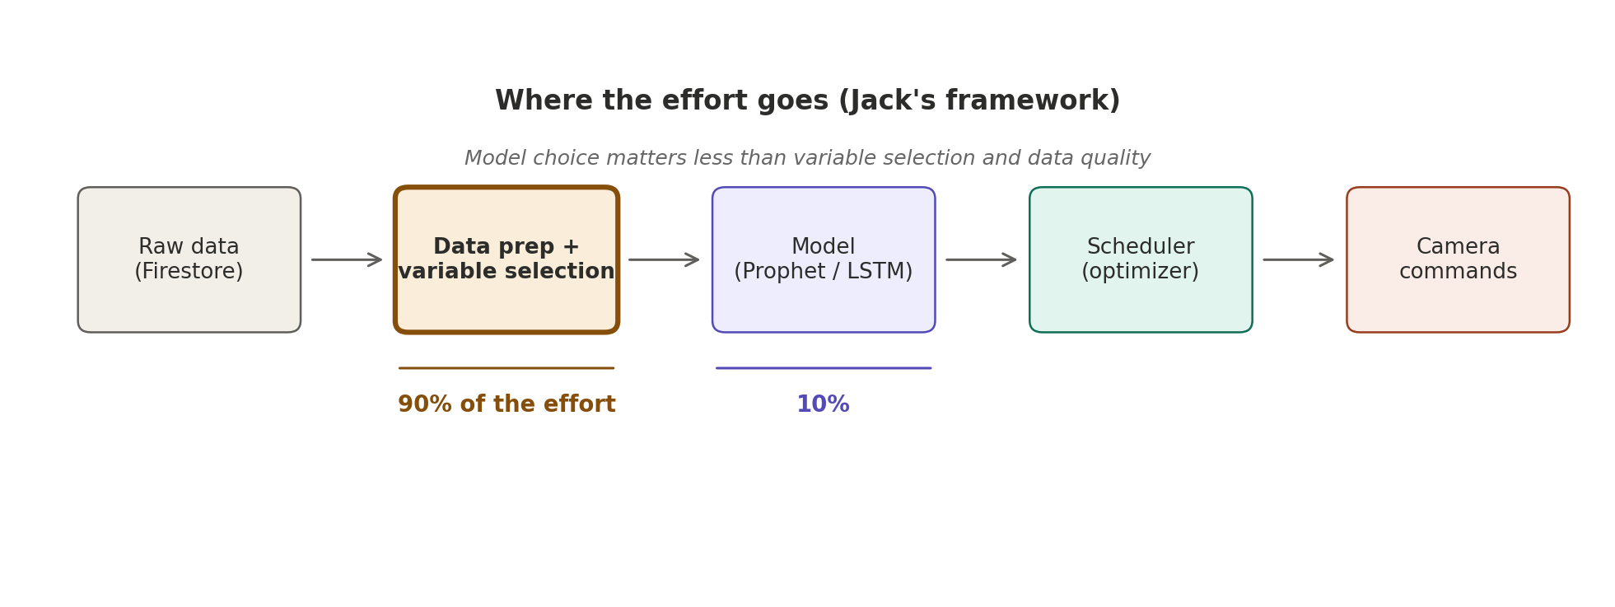

June benchmark (context, from last report)
Mean Absolute Error on solar output (lower is better). Best in each column marked with a check. This is what you saw before; showing it here so the pivot makes sense in context.
Model | Jun 4 | Jun 14 | Jun 24 | Trend
Naive Seasonal (24h) | 5.06 W | 0.72 W ✓ | 4.04 W | Peaked mid-June, then degraded
SVR | 5.87 W | 3.43 W | 4.14 W ✓ | Steadily closing the gap
RandomForest | 6.24 W | 2.55 W | 5.27 W | Middle of the pack
ExtraTrees | 6.20 W | 2.74 W | 4.68 W | Middle of the pack
What the trend shows: no model has a clear, durable win. Naive Seasonal beat everyone in mid-June (0.72 W) but got worse as weather grew more variable. SVR is slowly catching up. Fractional-watt differences between models are the signature of an input-quality ceiling: better inputs, not better models, is the way forward. This is why Jack's pivot lands.

Next 2 weeks (Jack at retreat)
- Data exploration on the 41-day CSV: correlations, redundancy, data-quality issues
- NOAA weather research for the buoy's coordinates (and university or harbor stations nearby)
- Re-scope lit review to read for variables used and data preparation, not model architecture
- Paper review session with Jack after retreat (mutual critique using his framework)

For you
- Is 41 days of hourly data realistic for a 1-week forecast?
41 days at hourly resolution is ~984 observations. A 1-week forecast is 168 hours. A common rule of thumb is that you want at least 10 times the forecast horizon in history to learn seasonal patterns reliably: ~70 days minimum. We have about 5.8 times. Borderline. Worth your read.
- Any weather sources beyond NOAA worth trying?
Candidates: nearby university weather stations, harbor and port sensors, coastal buoys with met packages, third-party APIs. Local knowledge of the deployment coastline would save research time.
- Does the pivot read right with ~2.5 to 3 months remaining?
Pivoting means less time on model variations, more time on data quality and variable selection. It's the right move if you agree that (a) more model variations wouldn't help much and (b) 41 days is enough to work with. If either premise is wrong, I'd want to know before spending two weeks on it.

