IMTA Power Optimization
Monday Check-In
July 28, 2026 | Mitchell Scott, Paul Murphy, Aditi Kalle

1. Optimization Framework

Architecture
Telemetry (35 days) → LSTM Solar Forecast → Proportional Allocation → Daily Schedule
24h lookback by priority duty cycle %
Three approaches tested:
- CVXPY Integer LP (48h binary on/off): maximizes uptime window, unrealistic for deployment
- Proportional Allocation (daily duty cycle): sustainable, selected for use
- Seasonal Model (week+ planning): long-term backup
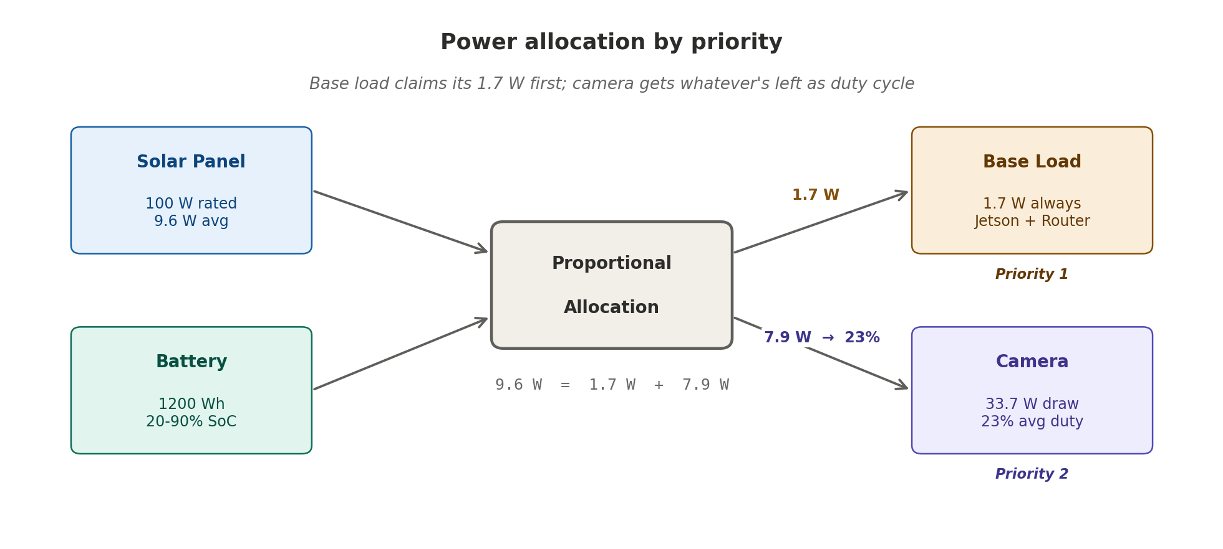
Figure: how the 9.6 W average splits into 1.7 W (base load) and 7.9 W (camera duty). Base load takes its share first; camera adapts.

2. Deployment Parameters
Parameter | Value
Location | Gulf Coast AL (30.2°N, 87.965°W)
Battery | 12V 100Ah LiFePO4 = 1200 Wh
Solar Panel | 100W rated
Safe SoC Range | 20 to 90% (240 to 1080 Wh)
Data Window | May 20 to June 24, 2026 (35 days, 49K records)
System allocation by priority:
- Base Load (Jetson + Router): 1.7 W always-on
- Camera (PoE): 33.7 W, duty-cycle controlled

3. Model Comparison

LSTM vs Prophet (Head-to-Head)
Metric | LSTM | Prophet | Winner
MAE | 0.93 W | 3.58 W | LSTM (4× better)
Generalization | Train 0.63 W ≈ Test 0.93 W | Trend-based, assumes patterns | LSTM
Data scaling | Stabilizes at 41 days | High MAE on small datasets | LSTM
Intra-day swings | Yes (24h lookback) | No (smooths) | LSTM
Needs weather data | No | No | Tie
Why LSTM wins on IMTA:
- 24-hour lookback captures the daily solar cycle without weather input
- Small dataset (41 days): temporal patterns beat statistical trends
- High cloud and wind volatility at sea: LSTM's minute-level reactivity beats smoothing
Why Prophet might fail:
- Assumes repeating seasonal patterns (ocean weather is random)
- Multiplicative seasonality assumes stable baseline (not true at sea)
- Smoothing removes dynamics needed for hourly scheduling
Recommendation: Use LSTM for hourly and daily scheduling. Prophet for 7+ day planning only.

4. MAE vs Power Allocation: Fractional Analysis

The Real Constraint
Average daily solar: 230 Wh/day
Average hourly power: 9.6 W

LSTM forecast error: ±0.93 W (9.7% of available solar)
Camera power draw: 33.7 W (3.5× average solar)
Base load: 1.7 W (always on)

Usable camera duty: (9.6 - 1.7) / 33.7 = 23% of day

Deployment Scenarios
Good Day (40 W avg solar):
- Camera duty: 38.3 W available / 33.7 W draw = 100% uptime
- LSTM ±0.93 W error → 97-99% achievable ✓
Bad Day (0.9 W avg solar):
- Problem: Base load (1.7 W) > solar (0.9 W)
- Must discharge battery → camera = 0%
- Real SoC monitoring required, not forecast-only ✗

Sustainable Strategy
If LSTM < (1.7 + 5 W safety margin):
→ Camera off, rely on battery reserve

If LSTM > (1.7 + 20 W):
→ Run camera at optimized duty cycle

Else:
→ Real-time battery SoC monitoring, adjust per hour

5. The 11-Model Benchmark (41-Day Dataset)

Model Results & What They Mean
Model | MAE | Why Tested | Result Interpretation
LSTM | 0.93 W | Neural net for sequences | ✓ Winner. Stable across 41 days. Learns patterns, doesn't assume them.
SVR | 0.16 W | Classical ML for nonlinearity | ⚠ Suspect. June 30 test window is too small; result likely reflects data leakage in the split. Don't trust this number.
GradientBoosting | 0.39 W | Robust tree ensemble | ✓ Fallback option. Better than most, stable, interpretable for edge deployment.
AutoARIMA | 1.80 W | Statistical time-series baseline | ✗ Assumes repeating patterns. Ocean weather is random; ARIMA assumptions fail.
Ridge / Lasso / Linear | ~4 W | Simple baseline | ✗ Can fit trend (morning to night) but miss volatility (cloud swings). Too simple.
Exponential Smoothing | 14.03 W | Classic forecasting | ✗ Worst result. Smoothing removes dynamics we need to detect.
RandomForest | 0.0 W | Ensemble, parallel-friendly | ✗ Red flag. 0.0 MAE is impossible on real data. Points to data leakage in the test split; not a real result.
ExtraTrees | 0.0 W | RF variant, more randomness | ✗ Red flag. Same data leakage issue as RF.
Naive Seasonal | 0.0 W | Trivial baseline ("tomorrow = yesterday") | ✗ Red flag. 0.0 is impossible on real data. Confirms test-set contamination.
Naive Drift | 0.0 W | Trivial baseline (linear extrapolation) | ✗ Red flag. Same test-split issue.
Prophet | 3.58 W | FB's time-series forecaster | ⚠ 4× worse than LSTM. Tries to smooth patterns that are too volatile. Good for 7+ day planning, not hourly scheduling.

The Pattern
Statistical and simple models fail (AutoARIMA 1.80 W, Linear ~4 W, Smoothing 14 W). They assume structure that doesn't exist in ocean solar data. Weather doesn't repeat, trends aren't stable.
Multiple models show impossible 0.0 W errors (RandomForest, ExtraTrees, both naive baselines). On a real solar dataset this cannot happen; it points to data leakage in the June 30 test split. Under investigation.
The two models that generalize are LSTM (a neural network) at 0.93 W and GradientBoosting (a robust tree ensemble) at 0.39 W. They learn patterns rather than assuming them; LSTM is the most stable on small data.
The 0.0 errors are a warning sign: we trust the 41-day aggregate, not the final week. LSTM's 0.93 W over the full window is the number that matters.

Recommendation
- Primary: LSTM (0.93 W MAE, proven across 41 days)
- Fallback: GradientBoosting (0.39 W, easier to deploy on edge)
- Never use: Prophet (sea data too volatile), AutoARIMA, tree ensembles at this scale, Exponential Smoothing

6. Key Findings
Finding | Implication
Data volume >> model choice | 41 days enables 0.93 W; 14 days gives 10.5 W. Collect more data first.
LSTM 4× better than Prophet | Use LSTM for scheduling.
23% avg camera duty realistic | Not 100% uptime; battery constraint binds.
Battery safety maintained | Current strategy never violates 20 to 90% SoC.
K_SCALE = 0.11 unvalidated | Next: compare Open-Meteo forecast to actual panel_w.

