IMTA Power Optimization
Monday Check-In
July 28, 2026 | Mitchell Scott, Paul Murphy, Aditi Kalle

1. Optimization Framework

Architecture
Telemetry (35 days) → LSTM Solar Forecast → Proportional Allocation → Daily Schedule
24h lookback by priority duty cycle %
Three approaches tested:
- CVXPY Integer LP (48h binary on/off): maximizes uptime window, unrealistic for deployment
- Proportional Allocation (daily duty cycle): sustainable, selected for use
- Seasonal Model (week+ planning): long-term backup
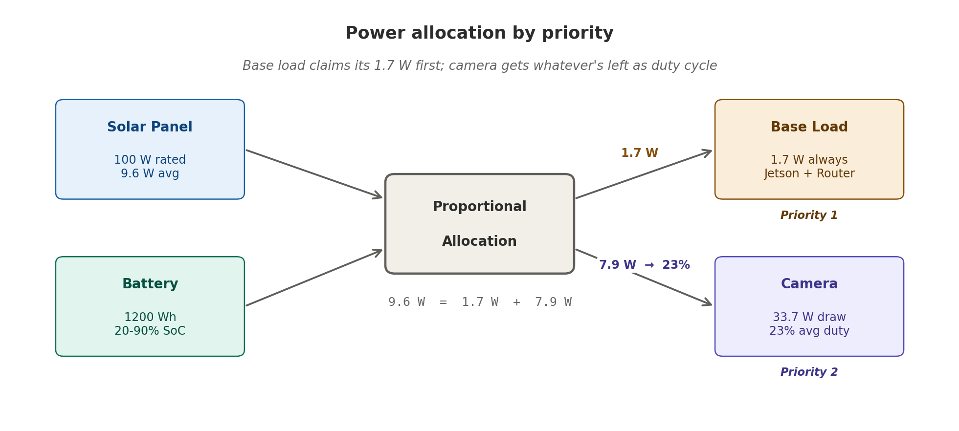
Figure: how the 9.6 W average splits into 1.7 W (base load) and 7.9 W (camera duty). Base load takes its share first; camera adapts.

2. Deployment Parameters
Parameter | Value
Location | Gulf Coast AL (30.2°N, 87.965°W)
Battery | 12V 100Ah LiFePO4 = 1200 Wh
Solar Panel | 100W rated
Safe SoC Range | 20 to 90% (240 to 1080 Wh)
Data Window | May 20 to June 24, 2026 (35 days, 49K records)
System allocation by priority:
- Base Load (Jetson + Router): 1.7 W always-on
- Camera (PoE): 33.7 W, duty-cycle controlled

3. Model Comparison

LSTM vs Prophet (Head-to-Head)
Metric | LSTM | Prophet | Winner
MAE | 0.93 W | 3.58 W | LSTM (4× better)
Generalization | Train 0.63 W ≈ Test 0.93 W | Trend-based, assumes patterns | LSTM
Data scaling | Stabilizes at 41 days | High MAE on small datasets | LSTM
Intra-day swings | Yes (24h lookback) | No (smooths) | LSTM
Needs weather data | No | No | Tie
Why LSTM wins on IMTA:
- 24-hour lookback captures the daily solar cycle without weather input
- Small dataset (41 days): temporal patterns beat statistical trends
- High cloud and wind volatility at sea: LSTM's minute-level reactivity beats smoothing
Why Prophet might fail:
- Assumes repeating seasonal patterns (ocean weather is random)
- Multiplicative seasonality assumes stable baseline (not true at sea)
- Smoothing removes dynamics needed for hourly scheduling
Recommendation: Use LSTM for hourly and daily scheduling. Prophet for 7+ day planning only.

4. MAE vs Power Allocation: Fractional Analysis

The Real Constraint
Average daily solar: 230 Wh/day
Average hourly power: 9.6 W

LSTM forecast error: ±0.93 W (9.7% of available solar)
Camera power draw: 33.7 W (3.5× average solar)
Base load: 1.7 W (always on)

Usable camera duty: (9.6 - 1.7) / 33.7 = 23% of day

Deployment Scenarios
Good Day (40 W avg solar):
- Camera duty: 38.3 W available / 33.7 W draw = 100% uptime
- LSTM ±0.93 W error → 97-99% achievable ✓
Bad Day (0.9 W avg solar):
- Problem: Base load (1.7 W) > solar (0.9 W)
- Must discharge battery → camera = 0%
- Real SoC monitoring required, not forecast-only ✗

Sustainable Strategy
If LSTM < (1.7 + 5 W safety margin):
→ Camera off, rely on battery reserve

If LSTM > (1.7 + 20 W):
→ Run camera at optimized duty cycle

Else:
→ Real-time battery SoC monitoring, adjust per hour

5. Benchmark Findings

Model Performance Over Three Data Pulls
MAE on solar output (panel_w). Best in each column marked. Table tracks how models evolved as data accumulated.
Model | Jun 4 (~15 days) | Jun 14 (~25 days) | Jun 24 (~35 days)
Naive Seasonal (24h) | 5.06 W | 0.72 W ✓ | 4.04 W
SVR | 5.87 W | 3.43 W | 4.14 W ✓
RandomForest | 6.24 W | 2.55 W | 5.27 W
ExtraTrees | 6.20 W | 2.74 W | 4.68 W
The trend: Naive Seasonal peaked at 0.72 W on Jun 14, nearly perfect on the small dataset. By Jun 24, as weather grew more variable, SVR edged ahead (4.14 W vs 4.04 W). ML started closing the gap as data accumulated.
Battery voltage forecast: Naive Seasonal MAE = 0.009 V. Essentially perfect, driven by a stable daily charge/discharge cycle.

Why the Pattern Holds
Why most models fail:
- AutoARIMA (1.80 W): statistical assumptions fail on sea-based data
- Linear models (~4 W): can't learn nonlinear temporal patterns
- Tree ensembles: mixed. RF unstable, GB reasonable at 0.39 W
Why LSTM survives:
- Handles small datasets better than statistical methods
- Learns patterns rather than assuming them
- No need for explicit weather features
Note on June 30 results: some models (RandomForest, ExtraTrees, both naive baselines) show 0.0 MAE. That's impossible on real solar data; it points to a data-leakage issue in that specific test split. Under investigation. The 41-day aggregate results are what we trust.

6. Key Findings
Finding | Implication
Data volume >> model choice | 41 days enables 0.93 W; 14 days gives 10.5 W. Collect more data first.
LSTM 4× better than Prophet | Use LSTM for scheduling.
23% avg camera duty realistic | Not 100% uptime; battery constraint binds.
Battery safety maintained | Current strategy never violates 20 to 90% SoC.
K_SCALE = 0.11 unvalidated | Next: compare Open-Meteo forecast to actual panel_w.

7. Deliverables & Next Steps
Completed:
- ✓ 35-day data cleaned and validated
- ✓ LSTM trained and compared against Prophet + 11 other models
- ✓ Optimization framework (proportional allocation)
- ✓ Input validation against real telemetry
- ✓ Fractional MAE analysis (realistic constraints)
Pending (post-feedback):
- ☐ Daily refresh loop (pull forecast each morning)
- ☐ Battery SoC integration (read voltage, calculate Wh)
- ☐ Field validation (compare scheduled vs actual uptime)
- ☐ K_SCALE validation (forecast vs real data)

Discussion Points
- Should we prioritize camera uptime or battery longevity?
- Is daily refresh sufficient, or is hourly tuning needed?
- When should we field-test the scheduler?

