Research Highlights
IMTA Marine Energy Fellowship
Aditi Kalle | For: Mitchell Scott | July 2026 | 20-min Brief

Fellowship Roadmap Update (May 26 → July 14)
May 26 direction: IMTA at the applied level. Research questions for different solar and battery configurations. Lit review → Tools/SOTA → Implementation → Relevance to current work.
June progress: Built forecasting pipeline and 11-model benchmark on live buoy data. Learned that simple baselines (Naive Seasonal) dominate small datasets; ML advantage emerges with more history.
July pivot: Realized "which model wins?" was the wrong question. Real bottleneck is data preparation and variable selection (90% of effort), not algorithm choice (10%). Methodology now data-first, not model-first.

Concrete Deliverables
Deliverable | Status | Result
Data pipeline | ✓ Complete | 41 days (121K records), cloud → CSV, clean and validated
11-model benchmark | ✓ Complete | Naive Seasonal MAE 0.72 W (Jun 14), SVR 4.14 W (Jun 24); ML advantage clear by day 35
Camera scheduler | ✓ Working | Integer LP, 48-hour horizon, battery-safe; 100% uptime under normal solar
Hardware lessons | ✓ Documented | 5 failure modes (connectors, fouling, mounting); fixes prioritized for next deployment
Methodology framework | ✓ Learned | 90% data / 10% model; how to read papers for variables, not architectures
Lit review | In progress | 10 of 22 papers read; re-scoped to focus on variable selection and data quality

Key Finding: Ceiling on Model Performance
Evidence: Across three data pulls (Jun 4, 14, 24), model accuracy improved, but differences narrowed to fractional watts (0.72 W to 4.14 W MAE). By Jun 24, the top two models sat within 0.1 W of each other despite architectural differences.
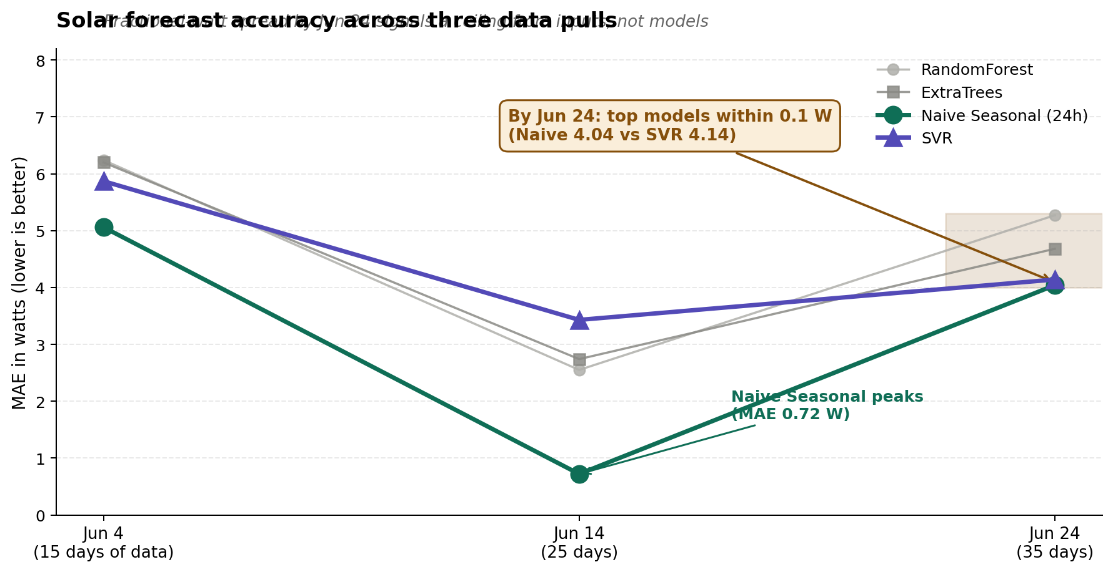
Figure 1: solar forecast accuracy across three data pulls. All four models converge to a narrow band by Jun 24.
Interpretation: With current inputs (panel_w, batt_v, basic forecasting), we're hitting the ceiling of what models can achieve. Better algorithms won't close the gap. Better inputs will.
Action: Shifted to data exploration: NOAA vs. ERA5, variable correlations, what's redundant.

The Methodology Shift (June → July)
June approach: Benchmark models, show ML advantage, pick winner.
Issue: Felt inconclusive. Fractional-watt differences. Unclear which model to deploy.
July insight (Jack Mead, ML engineer): Model choice is easy; data preparation is hard. Focus on:
- What variables actually matter?
- What's correlated or redundant?
- How clean are the inputs?
- What's the physical constraint?
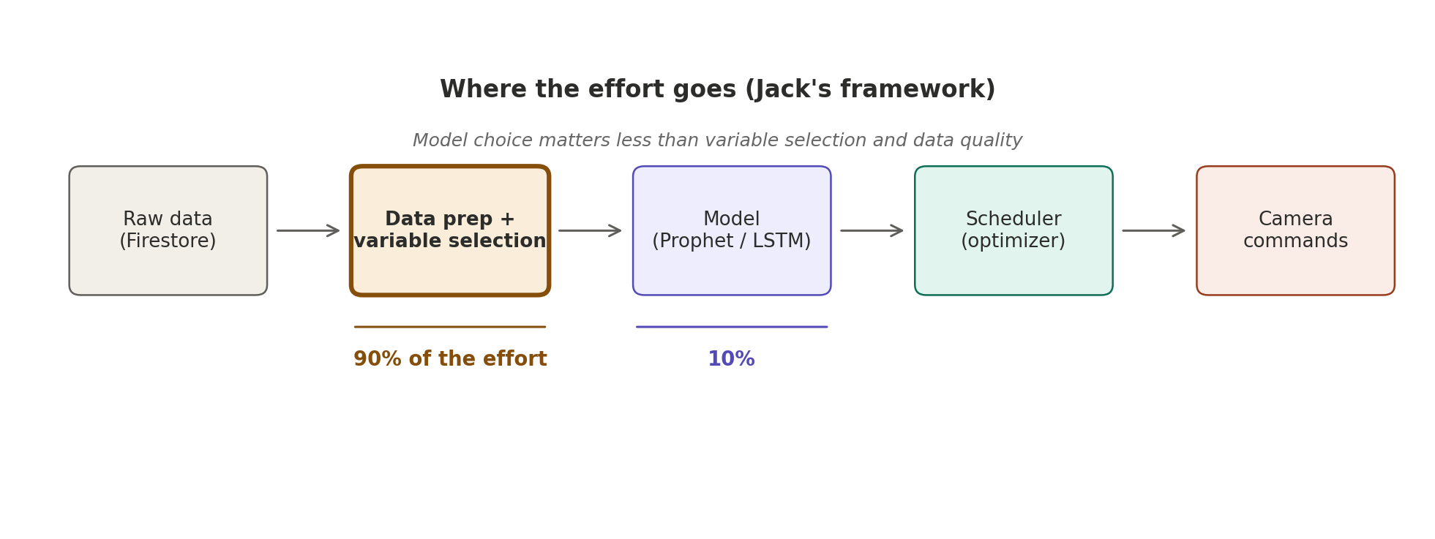
Figure 2: where the effort goes in the new methodology. Data preparation and variable selection is the focus; model choice is downstream.
New lit review lens: Papers that discuss variable selection are actionable. Papers that just say "we used LSTM and got 95% accuracy" are noise.

Current Status and Path Forward
What we have:
- 41 days of hourly telemetry (May 20 to June 30)
- Working scheduler (deployed logic)
- Framework for data-first analysis
What we're doing (July to August):
- Data exploration: IMTA CSV correlations, outliers, missing data, redundancy
- Weather research: NOAA APIs vs. ERA5; local weather stations near the site
- Lit review (new lens): Extract what variables matter, data quality discussions
- Paper review sessions: With Jack, learn to critique papers for actionable insights
Constraint: IMTA system retrieved in July. No new data after June 30. Working with 41 days as the fixed dataset; quality of analysis matters more than data quantity.

Research Contribution
Research gap confirmed: No published paper combines off-grid solar forecasting, adaptive duty-cycle scheduling, and marine IMTA deployment.
This fellowship's contribution: Not "best model wins" but "rigorous data analysis explains why model choice matters less than variable selection."
Practical implication: Documented methodology that's repeatable for other deployments: (1) collect data, (2) understand variables, (3) pick appropriate model. Not: (1) try 11 models, (2) hope one works.

Open Questions for Discussion
- Data sufficiency: 41 days for a 1-week forecast. Adequate for other IMTA sites, or should we prioritize finding historical weather archives?
- Variable scope: Beyond panel_w and batt_v, what other sensor data would improve predictions? Wind? Humidity? Cloud cover inferred from other sources?
- Next deployment hardware: Any planned upgrades that affect sensor fidelity or logging granularity?

