**INTRODUCTION**

The following document describes the requirements and the user guide for successfully interacting with the dashboard. It is divided into two parts:

1. Requirements and startup-guide
   1. MAC
   2. WINDOWS

2) User guide

3) Demo

**REQUIREMENTS AND STARTU-UP**

The dashboard executes Python scripts to forecast the time series, for this reason it is requires a TabPy (<https://tableau.github.io/TabPy/>) server active, we will guide you through the installation:

**MAC**

1. Install TabPy if you have not already done it (included in requirements.txt)

pip install tabpy-server

1. Navigate to the source code contained of the TabPy installation in */site-packages* and go subsequently into the tabpy-server directory. In our case:  *python3.7/site-packages/tabpy_server*
2. Execute *sh startup.sh* or python tabpy.py to start up a server, and don’t close the terminal.

**WINDOWS**

1. Open the Conda Prompt as an administrator and run “*conda install -c anaconda tabpy-server* “, and click “y” to proceed with the installation
2. Navigate to the directory where the configuration files are installed. using Anaconda is either:

*“\Users\*your_user*\Anaconda3\pkgs\tabpy-server-0.2-py37_1\Lib\site-packages\tabpy_server”, or*

*“\Users\*your_user*\.conda\pkgs\tabpy-server-0.2-py37_1\Lib\site-packages\tabpy_server”*

1. Execute *startup.bat* on the Conda Prompt.

*WARNING: if an error with an .asyncronous method arises, downgrade your Tornado package to 5.1.1.*

**CONTINUATION FOR WINDOWS AND MAC:**

1. Go to the Tableau Dashboard and open it. You will get a warning and, potentially don’t see the end of it – it is normal.

Click NO, if you see the button, or press ENTER.

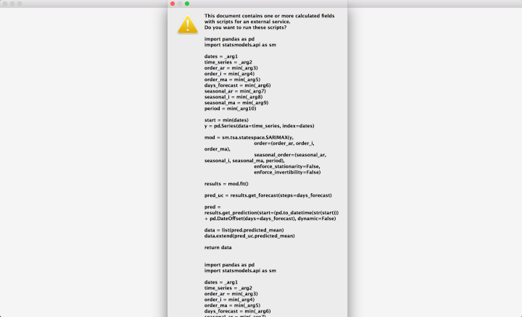 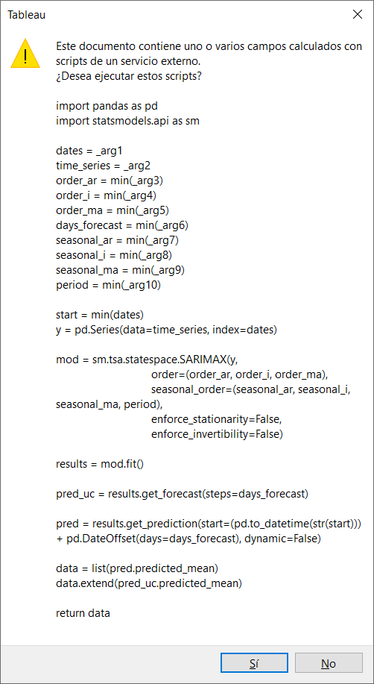

1. Now, set Tableau to sniff port 9004:
   1. Go to Help → Settings and Performance → Manage External Service Connection
   2. Select Tabpy, and enter the Server (localhost if running TabPy on the same computer) and the Port (default is 9004).

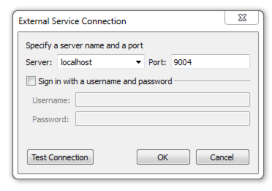

1. Now Tableau should now be able to execute python scripts.

Please not that:

1. Tableau may take some time to compute the last Panel, especially on windows on the first execution.

The order of magnitude for the first time on MAC was around 40 sec, and 15 sec after some filters were performed. However, for Windows the order of magnitude the first time was over 10 minutes, and then 15 sec after filtering.

(Please note that performance of the dashboard has not considered under scope of the project).

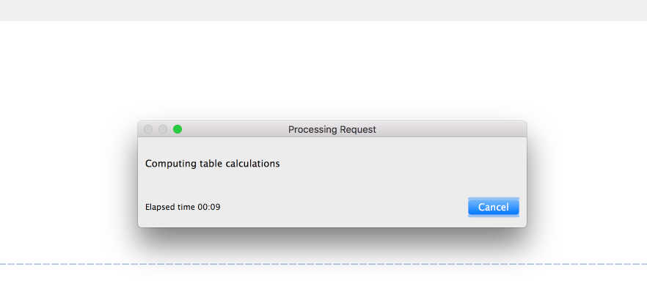

1. An error/warning indicating problems with the connection to the sources may pop-up suddenly, or when you click on Data Sources. This is also normal, and occurs due to the live connections not being included in the Tableau file, instead we have included a snapshot of the data for simplicity and integration purposes.

The error will leave automatically if it came up suddenly, and you will have to close it if you clicked on Data Sources.

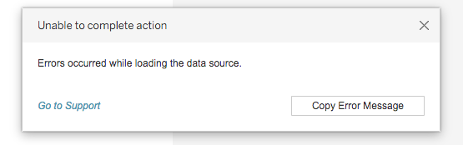

**USER GUIDE**



In order to have a better experience with the dashboard, please click on ,on the top bar.

**PANEL 0 – Introduction**

Describes the objective of the dashboard and lists the panels. There is no real interaction.

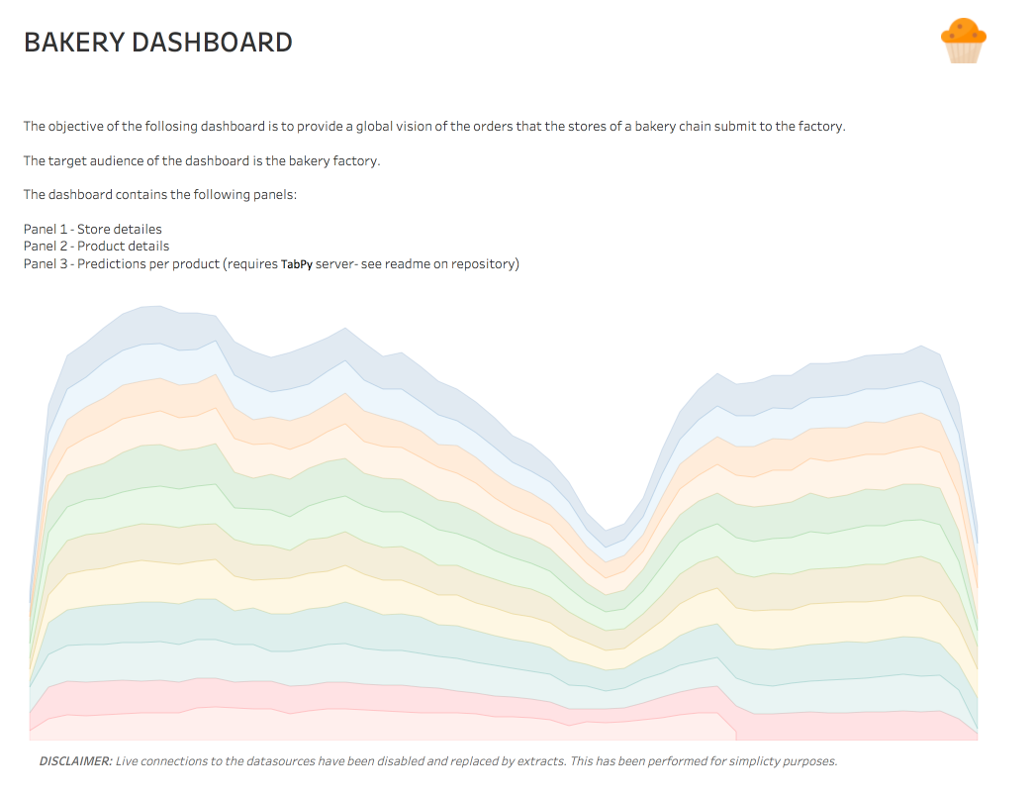

**PANEL 1 – Store Details**

Chart 1: Map of current stores. Clicking on one of the stores filters the other charts.

Chart 2: Stacked time series of the products, filtered by store (if selected) and time-range.

Chart 3: Bar-chart of total products ordered to the factory for the selected store/s and time-range.

**How to Interact?**

By clicking on each store on Chart 1 you select the store

By selecting de date-range o the top right corner.

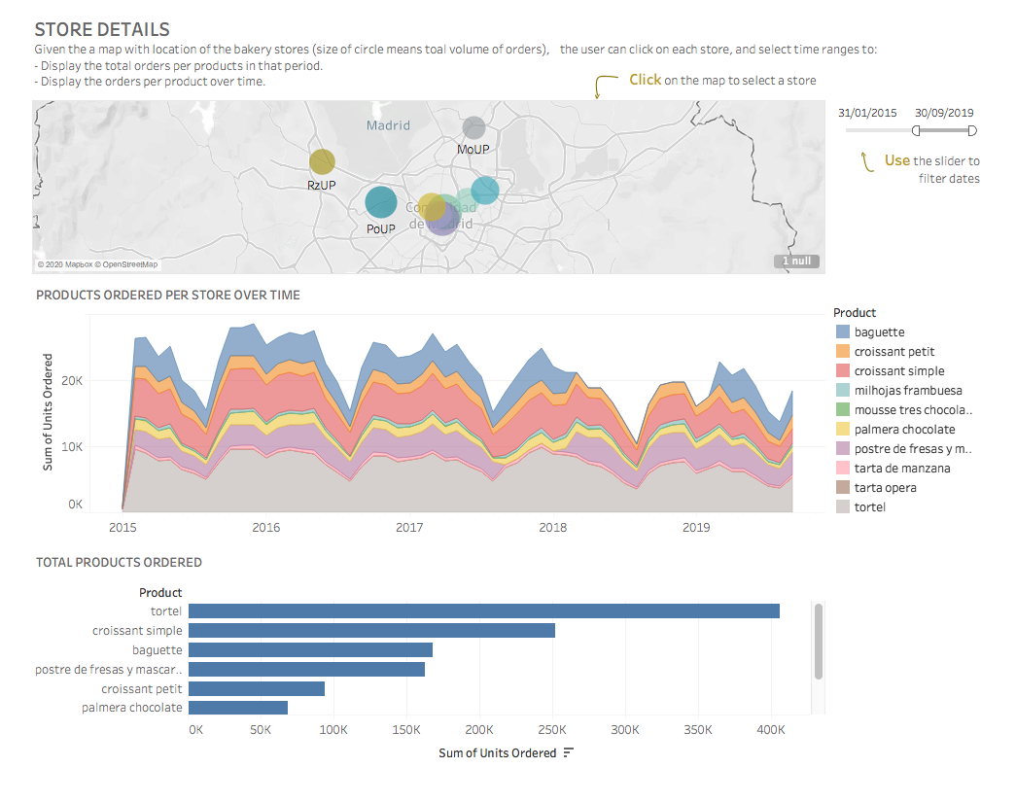

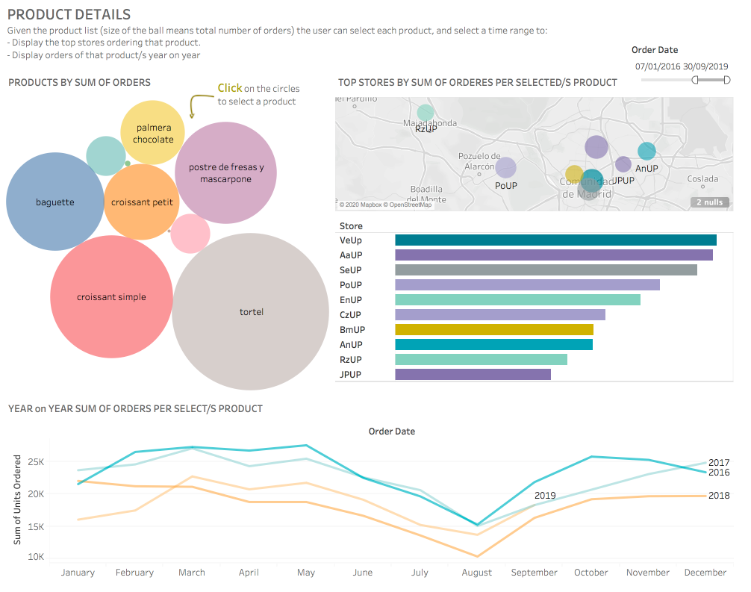

**PANEL 2 – Product Details**

Chart 1: Circles indicate products order volume.

Chart 2: Location of the stores. Size means volume per store for the product selected.

Chart 3: Top 10 stores ordering that product.

Chart 4: year over year time series of the product/s selected.

**How to interact?**

- Clicking on each product on Chart 1 you filter the data

- Clicking on each store on Chart 2 you select the product

- Selecting de date-range o the top right corner

**PANEL 3 – Forecasting**

Describes the objective of the dashboard and lists the panels.

Chart 1: Programmatically updates the name of the product selected, and the total number of that product ordered to the factory in the selected period.

Chart 2: Displays the results of the SARIMAX (programmatically) of the product/s selected for the last year of data (between 30/09/2018 and 20/09/2019) and the prediction of the selected period.

**How to interact?**

By selecting the (a) Product/s and the (b) prediction timeframe at the bottom.

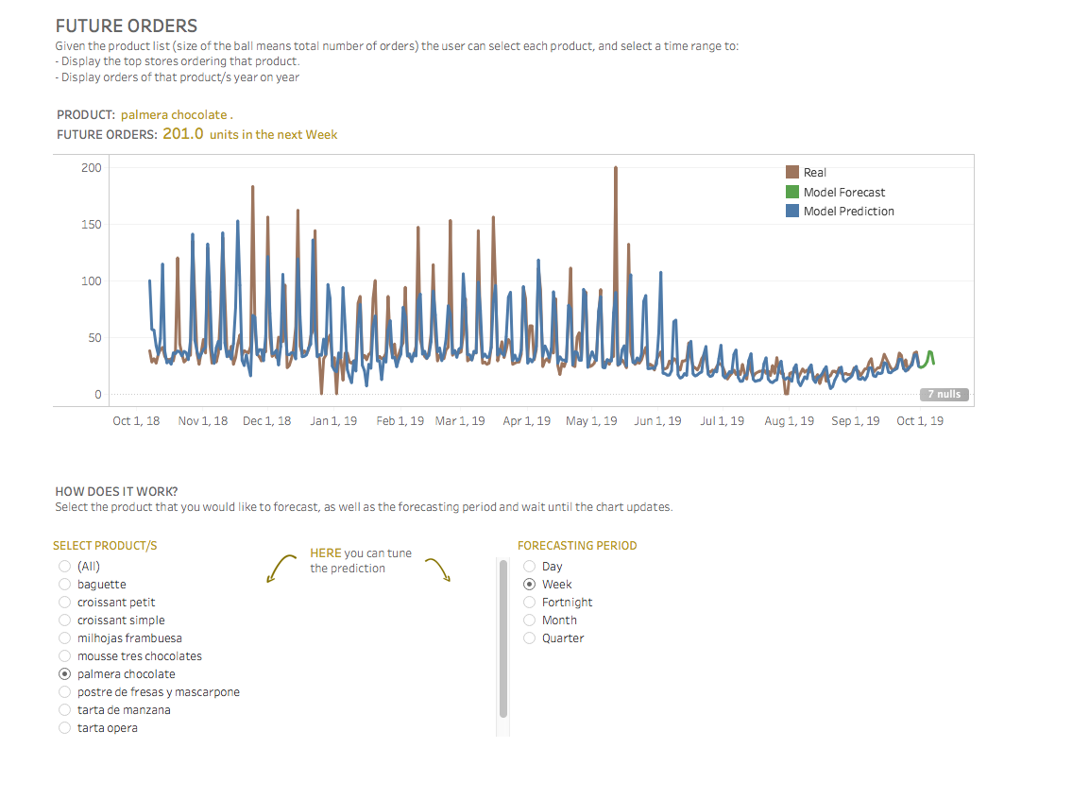

**DEMO**

To see a demo of the dashboard, please click here: <https://youtu.be/1LE4jTcW4JE>