1.What are the two values of the Boolean data type? How do you write them?

**Answer:**

True – means 1

False – means 0

2. What are the three different types of Boolean operators?

**Answer:**

AND, OR ,NOT

3. Make a list of each Boolean operator's truth tables (i.e. every possible combination of Boolean values for the operator and what it evaluate ).

**Answer:**

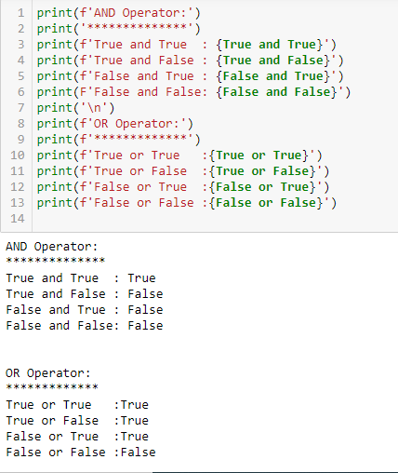

4. What are the values of the following expressions?

(5 > 4) and (3 == 5) - False

not (5 > 4) - False

(5 > 4) or (3 == 5) - True

not ((5 > 4) or (3 == 5)) - False

(True and True) and (True == False) - False

(not False) or (not True) - True

5. What are the six comparison operators?

**Answer:**

1.Equal To

2.Not Equal To

3.Greater than

4.Greater than or equal to

5.Less than

6.Less than or equal to

6. How do you tell the difference between the equal to and assignment operators?Describe a condition and when you would use one.

**Answer:**

**Comparison operators(==):**

Compare two values

Eg:1==2 returns False

**Assignment operator(=):**

Assign a value to a variable

Eg: a=1

7. Identify the three blocks in this code:

spam = 0

if spam == 10:

print('eggs')

if spam > 5:

print('bacon')

else:

print('ham')

print('spam')

print('spam')

**Answer:**

ham

spam

spam

8. Write code that prints Hello if 1 is stored in spam, prints Howdy if 2 is stored in spam, and prints Greetings! if anything else is stored in spam.

**Answer:**

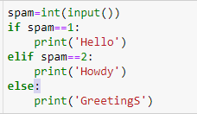

9.If your programme is stuck in an endless loop, what keys you’ll press?

**Answer:**

Interrupt the kernel or Restart the kernel

10. How can you tell the difference between break and continue?

**Answer:**

**Break:**

Break- will break the current enclosing loop

**Continue:**

Continue – skip to next iteration

11. In a for loop, what is the difference between range(10), range(0, 10), and range(0, 10, 1)?

range(10) – it will print number from 0 to 9

range(0, 10) – it will print number from 0 to 9

range(0, 10, 1) – it will print number from 0 to 9

12. Write a short program that prints the numbers 1 to 10 using a for loop. Then write an equivalent program that prints the numbers 1 to 10 using a while loop.

**Answer:**

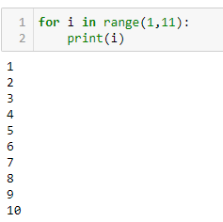

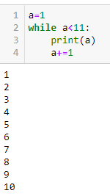

13. If you had a function named bacon() inside a module named spam, how would you call it after importing spam?

**Answer:**

spam.bacon()