1. What exactly is []?

**Answer:**

[] or list() represents **empty list.**

1. In a list of values stored in a variable called spam, how would you assign the value 'hello' as the third value? (Assume [2, 4, 6, 8, 10] are in spam.)

**Answer:**

spam.insert(2,’hello’)

Let's pretend the spam includes the list ['a', 'b', 'c', 'd'] for the next three queries.

1. What is the value of spam[int(int('3' * 2) / 11)]?

**Answer:**

‘d’

1. What is the value of spam[-1]?

**Answer:**

‘d’

1. What is the value of spam[:2]?

**Answer:**

[‘a’,’b’]

Let's pretend bacon has the list [3.14, 'cat,' 11, 'cat,' True] for the next three questions.

1. What is the value of bacon.index('cat')?

**Answer:**

1

1. How does bacon.append(99) change the look of the list value in bacon?

**Answer:**

[3.14, 'cat', 11, 'cat', True,99]

8. How does bacon.remove('cat') change the look of the list in bacon?

**Answer:**

[3.14, 11, 'cat,' True]

9. What are the list concatenation and list replication operators?

**Answer:**

* List concatenation: +
* List Replication: *

10. What is difference between the list methods append() and insert()?

**Answer:**

* append() - It will add the element only at the end of the list
* insert() – It will add the element at specific index location in the list

11. What are the two methods for removing items from a list?

**Answer:**

* remove() – It will remove the very first matching element in the list
* pop() – By default, it will remove the last element from the list. If index is specified, then it will remove that specific index location value
* clear() – It will remove all the elements from the list

12. Describe how list values and string values are identical.

**Answer:**

* both are sequences
* both supports indexing and slicing
* List is mutable but strings are immutable
* List can contain a different data types but string can contain only characters or string type

13. What's the difference between tuples and lists?

**Answer:**

|  |  |
| --- | --- |
| **List** | **Tuple** |
| * Empty List: [] or list() | * Empty tuple: tuple() or () |
| * Mutable | * Immutable |
| * Supports indexing and slicing | * Supports indexing and slicing |
| * It can contain a variety of datatypes | * It can contain a variety of datatypes |

14. How do you type a tuple value that only contains the integer 42?

**Answer:**

Integer

15. How do you get a list value's tuple form? How do you get a tuple value's list form?

**Answer:**

**Tuple values’s list form**

**Method1: using zip() function**

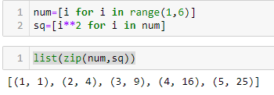

**Method2: using iter() function**

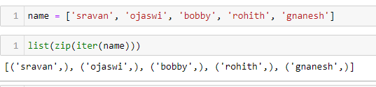

**Method3: using list comprehension**

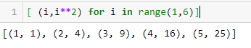

**List values’s Tuple form**

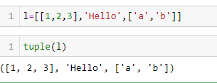

16. Variables that "contain" list values are not necessarily lists themselves. Instead, what do they contain?

**Answer:**

Variables will contain references to list values rather than list values themselves. But for strings and integer values, variables simply contain the string or integer value.

17. How do you distinguish between copy.copy() and copy.deepcopy()?

**Answer:**

Copy.copy()

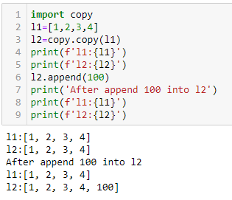

Copy.deepcopy()

