1. What is the name of the feature responsible for generating Regex objects?

**Answer:**

The **re.compile()**  function returns regex objects.

1. Why do raw strings often appear in Regex objects?

**Answer:**

Raw strings are used **so that backslashes do not have to be escaped.**

1. What is the return value of the search() method?

**Answer:**

The re.search() function takes two parameters and returns a match object if there is a match. If there is more than one match, only the first occurrence of the match will be returned. **If no matches are found, the value None is returned**.

1. From a Match item, how do you get the actual strings that match the pattern?

**Answer:**

The group() method returns strings of the matched text.

1. In the regex which created from the r'(\d\d\d)-(\d\d\d-\d\d\d\d)', what does group zero cover? Group 2? Group 1?

**Answer:**

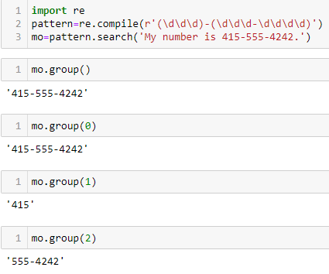

1. In standard expression syntax, parentheses and intervals have distinct meanings. How can you tell a regex that you want it to fit real parentheses and periods?

**Answer:**

Periods and parentheses can be escaped with a backslash: \., \(, and \).

1. The findall() method returns a string list or a list of string tuples. What causes it to return one of the two options?

**Answer:**

* If the regex has **no groups,** a list of strings is returned.
* If the regex has **groups,** a list of tuple of string is returned.

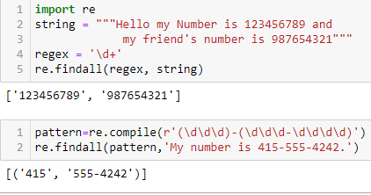

1. In standard expressions, what does the | character mean?

**Answer:**

| - means ‘OR’

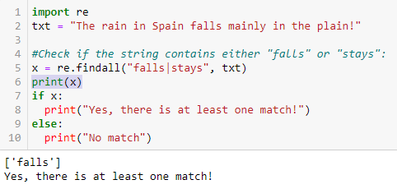

1. In regular expressions, what does the character stand for?

**Answer:**

[] – a set of characters

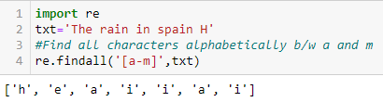

10.In regular expressions, what is the difference between the + and * characters?

**Answer:**

+ - 1 or more occurences

* - 0 or more occurences

11. What is the difference between {4} and {4,5} in regular expression?

**Answer:**

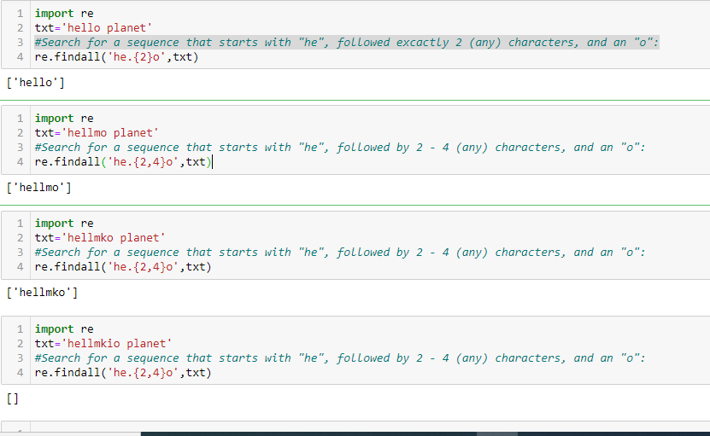

The {4} matches exactly four instances of the preceding group.

The {4,5} matches between four and five instances.

12. What do you mean by the \d, \w, and \s shorthand character classes signify in regular expressions?

**Answer:**

* \d-Returns a match where the string contains digits (numbers from 0-9)
* \s-Returns a match where the string contains a white space character
* \w-Returns a match where the string contains any word characters (characters from a to Z, digits from 0-9, and the underscore _ character)

13. What do means by \D, \W, and \S shorthand character classes signify in regular expressions?

**Answer:**

* \D-Returns a match where the string DOES NOT contain digits
* \S-Returns a match where the string DOES NOT contain a white space character
* \W-Returns a match where the string DOES NOT contain any word characters

14. What is the difference between .*? and .*?

**Answer:**

* (.*?) matches any character (.) any number of times (*), as few times as possible to make the regex match (?). You'll get a match on any string, but you'll only capture a blank string because of the question mark.
* (.*)? captures a group zero or one times (?). That group consists of a run of any length (*) of any character (.). This also will match anything, but it will capture the first line, since the dot matches anything except a newline.

15. What is the syntax for matching both numbers and lowercase letters with a character class?

**Answer:**

Either [0-9a-z] or [a-z0-9]

16. What is the procedure for making a normal expression in regax case insensitive?

**Answer:**

Passing re.I or re.IGNORECASE as the second argument to re.compile() will make the matching case insensitive.

17. What does the . character normally match? What does it match if re.DOTALL is passed as 2nd argument in re.compile()?

**Answer:**

* . – matches any possible character except new-line character.
* Re.DOTALL – matches any possible character including new-line character

18. If numReg = re.compile(r'\d+'), what will numRegex.sub('X', '11 drummers, 10 pipers, five rings, 4 hen') return?

**Answer:**

'X drummers, X pipers, five rings, X hen'

19. What does passing re.VERBOSE as the 2nd argument to re.compile() allow to do?

**Answer:**

The re.VERBOSE argument allows you to add whitespace and comments to the string passed to re.compile().

20. How would you write a regex that match a number with comma for every three digits? It must match the given following:

'42'

'1,234'

'6,368,745'

but not the following:

'12,34,567' (which has only two digits between the commas)

'1234' (which lacks commas)

**Answer:**

re.compile(r'^\d{1,3}(,\d{3})*$') will create this regex, but other regex strings can produce a similar regular expression.

21. How would you write a regex that matches the full name of someone whose last name is Watanabe? You can assume that the first name that comes before it will always be one word that begins with a capital letter. The regex must match the following:

'Haruto Watanabe'

'Alice Watanabe'

'RoboCop Watanabe'

but not the following:

'haruto Watanabe' (where the first name is not capitalized)

'Mr. Watanabe' (where the preceding word has a nonletter character)

'Watanabe' (which has no first name)

'Haruto watanabe' (where Watanabe is not capitalized)

**Answer:**

re.compile(r'[A-Z][a-z]*\sWatanabe')

22. How would you write a regex that matches a sentence where the first word is either Alice, Bob, or Carol; the second word is either eats, pets, or throws; the third word is apples, cats, or baseballs; and the sentence ends with a period? This regex should be case-insensitive. It must match the following:

'Alice eats apples.'

'Bob pets cats.'

'Carol throws baseballs.'

'Alice throws Apples.'

'BOB EATS CATS.'

but not the following:

'RoboCop eats apples.'

'ALICE THROWS FOOTBALLS.'

'Carol eats 7 cats.'

**Answer:**

re.compile(r'(Alice|Bob|Carol)\s(eats|pets|throws)\s(apples|cats|baseballs)\.', re.IGNORECASE)