**Nama: Etasa Karenisa**

**Kode Peserta: FSDO001ONL007**

**Tugas: Postman PaymentAPIMySql**

1. 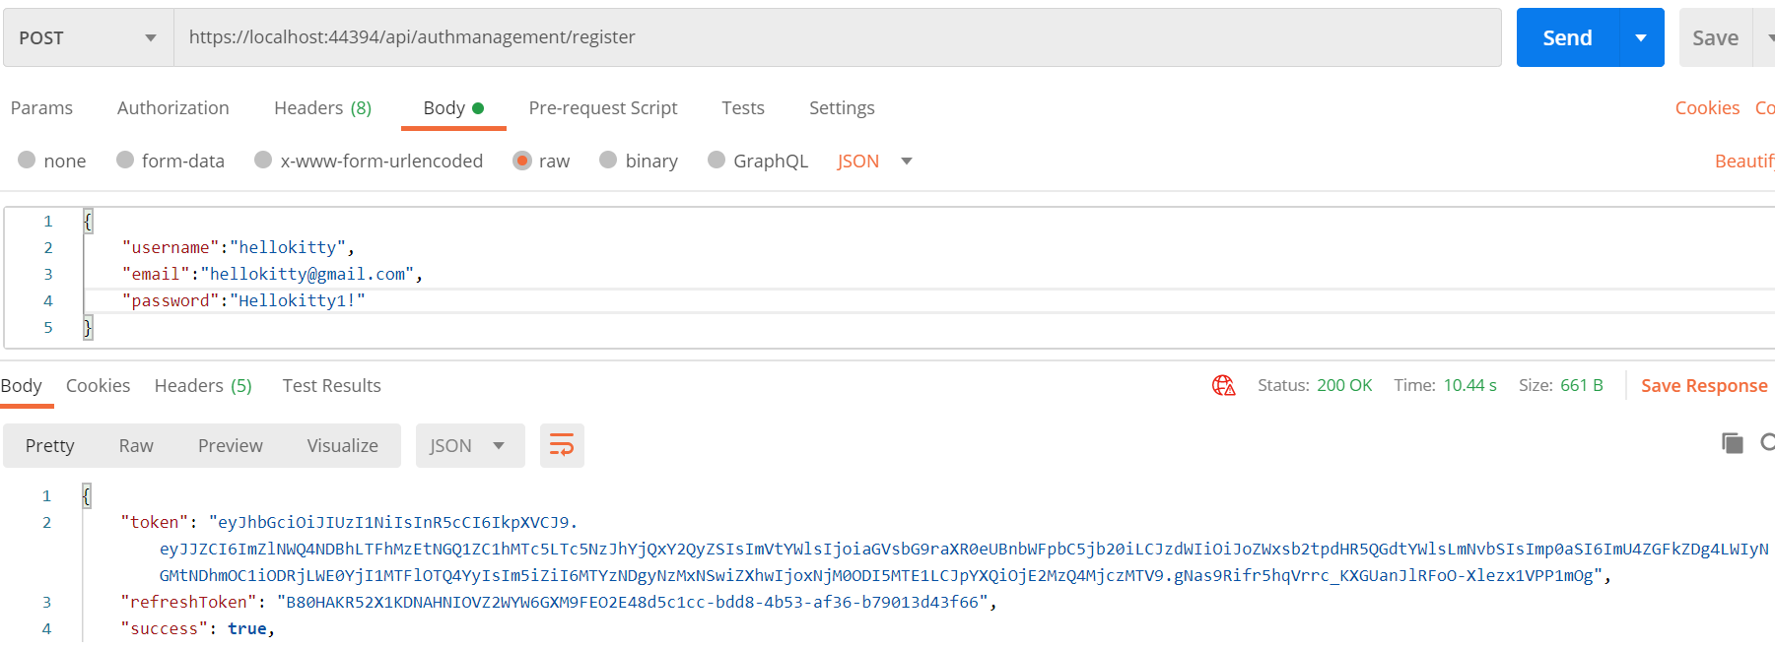POST register
2. 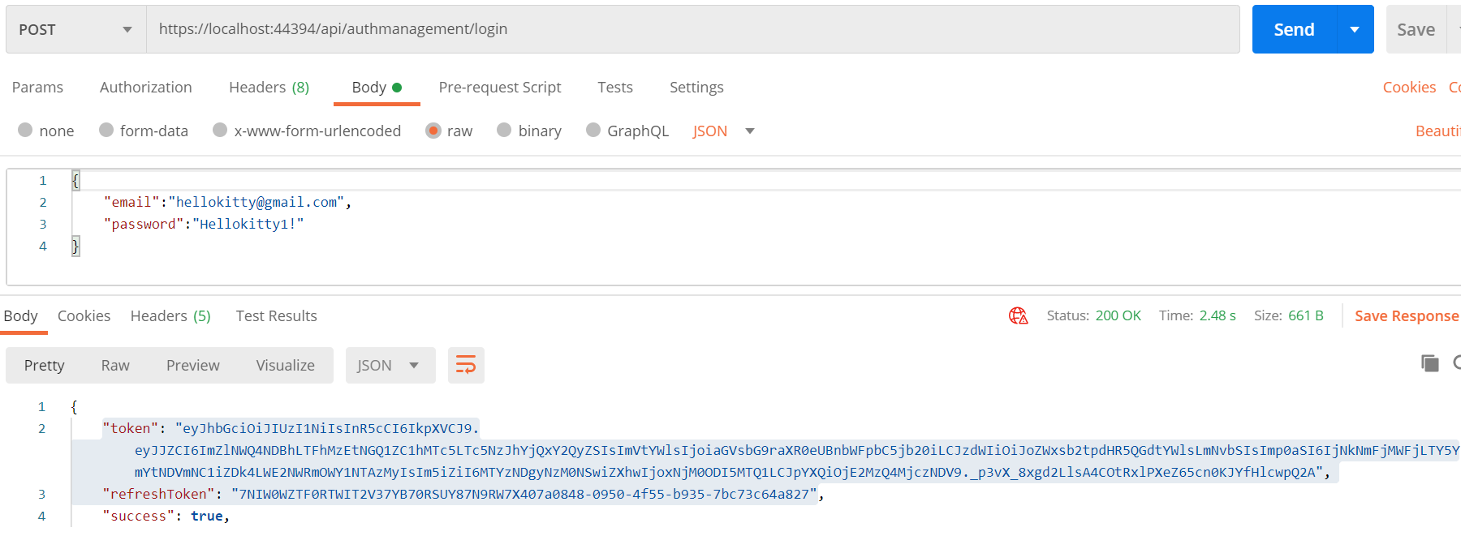POST login
3. 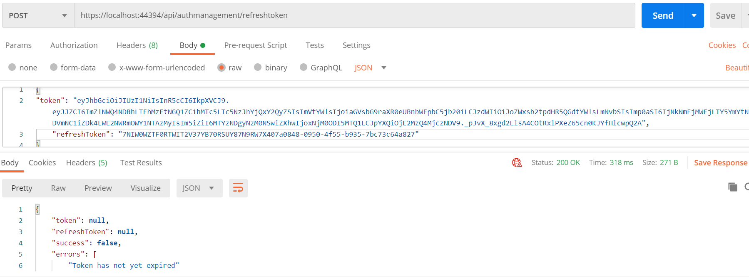POST Refresh token
4. 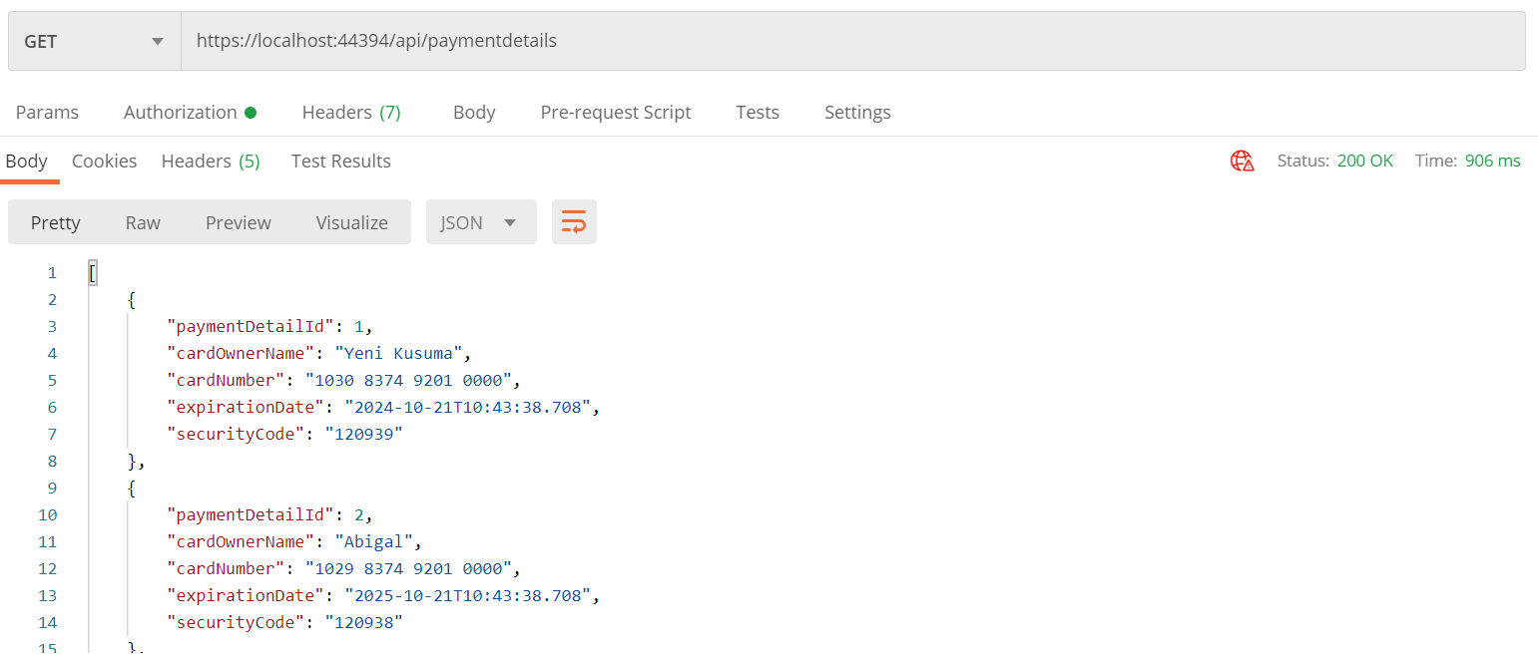GET
5. 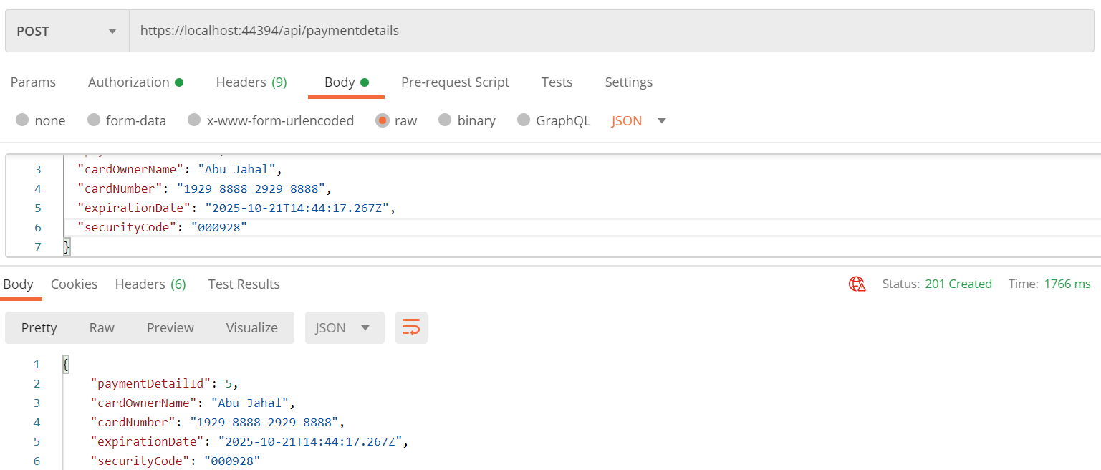POST
6. 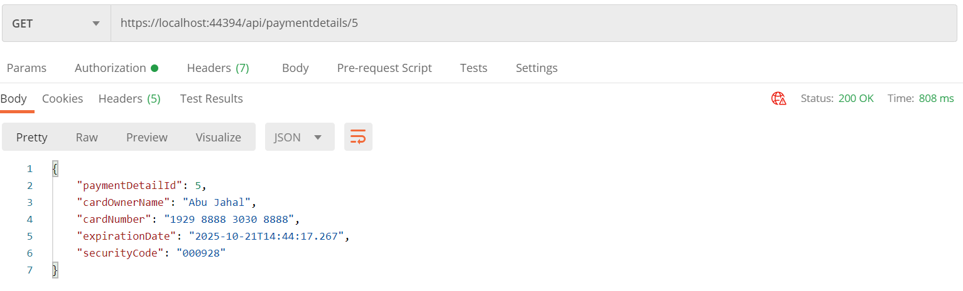GET/{id}
7. PUT/{id}

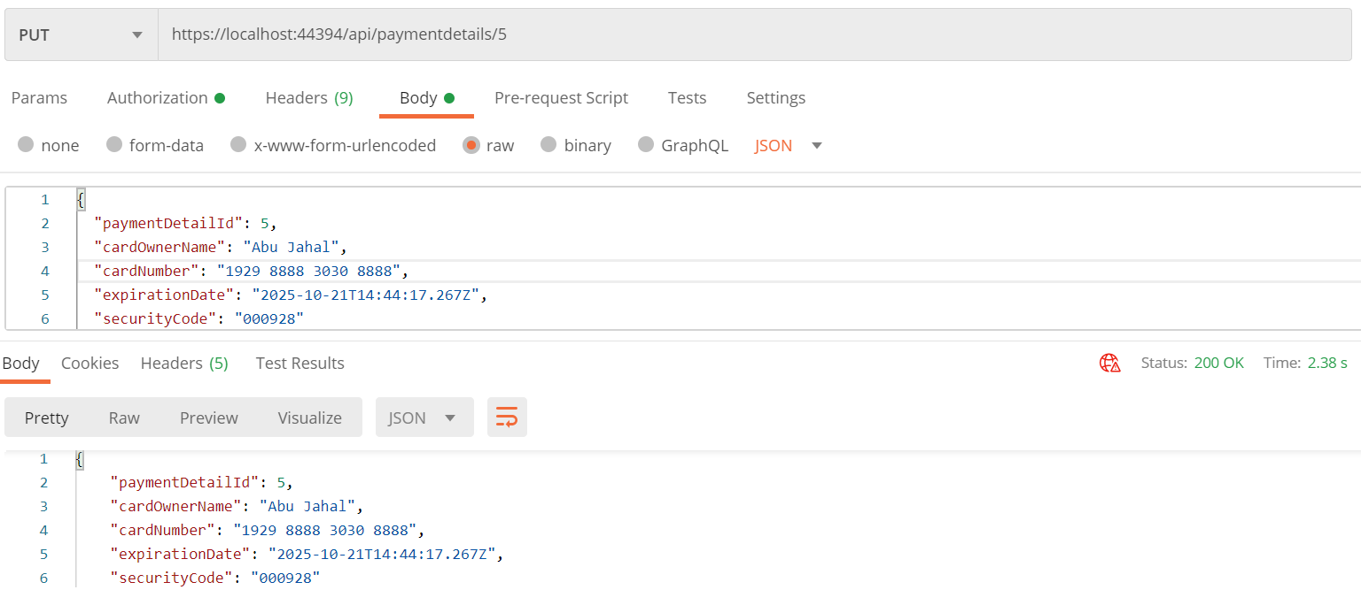

1. 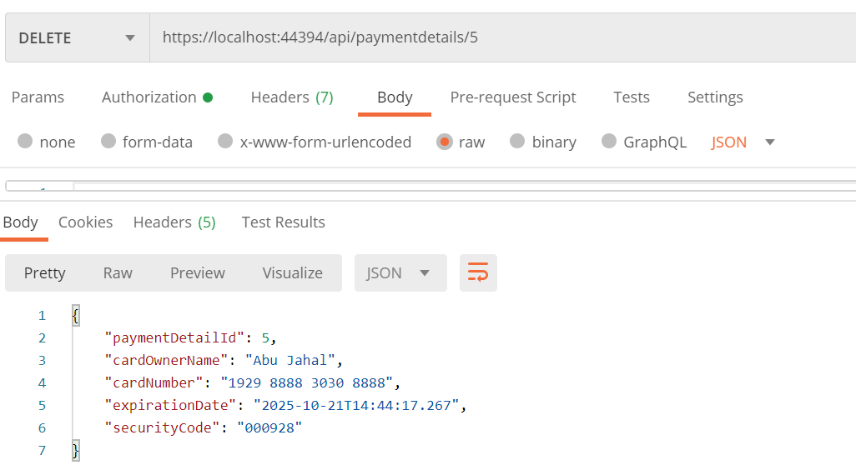DELETE/{id}