EduBlock

HSGamer

11/8/22

Table of contents

# Preface

This is the final report of EduBlock

# 1. Acknowledgement

# 2. Definition and Acronyms

# 3. Project Introduction

## 3.1 Overview

### 3.1.1 Project Information

• Project name: BlockChain application in academy record management to support online University/College admissions

• Project code: EduBlock

• Group name: ETASES

• Software type: Web app

### 3.1.2 Project Team

#### 3.1.2.1 Supervisor

| Full Name | Email | Phone Number | Title |
| --- | --- | --- | --- |
| Quach Luyl Da | daql@fpt.edu.vn | ########## | Lecture |

#### 3.1.2.2 Team Members

| Full Name | Email | Phone Number | Title |
| --- | --- | --- | --- |
| Huynh Quang Tien | TienHQCE150130@fpt.edu.vn | ########## | Leader |
| Le Xuan Tu | TuLXCE150344@fpt.edu.vn | ########## | Member |
| Nguyen Dang Khoa | KhoaNDCE140165@fpt.edu.vn | 0382554293 | Member |
| Cao Hoang Anh Uy | UyCHACE150661@fpt.edu.vn | ########## | Member |
| Nguyen Minh Khoi | KhoiNMCE150103@fpt.edu.vn | ########## | Member |

## 3.2 Background

Keeping track of and managing student records is typically time-consuming and challenging, needing approval from the school and certain permissible circumstances. When transferring transcripts from high school to university, this causes difficulties. When applying to universities based only on their transcripts, students must request permission from the institution in order to be given a temporary transcript, which is both time-consuming and inconvenient. My group then developed the concept for a web application that enables students to monitor their academic progress over the course of their education. In order to make the academic records stand out and add additional features to the web app that improve user experience, we used the Blockchain platform.

## 3.3 Existing Systems

In the project, we use 4 main systems 1. Blockchain and Node system 2. Smart contract 3. Request server and client server 4. OCR

### 3.3.1 Blockchain and Node system

Blockchain, at its heart, is a distributed digital ledger that houses all types of data. The ownership of NFTs, bitcoin transactions, and smart contract definitions can all be recorded on a blockchain.

This type of data may be stored in any conventional database, but blockchain is distinct since it is totally decentralized. The blockchain database is held on numerous computers dispersed throughout the network, as opposed to being kept in one place by a centralized administrator. These solitary machines are referred as nodes.

Blockchains can be public or private. Anyone can participate in a public blockchain, which allows them to access, write, or verify data on the blockchain. Because there is no single organization in charge of all the blockchain’s nodes, it is challenging to alter transactions that have been recorded on a public blockchain.

A private blockchain, however, is managed by a company or group. Only that company or group has the authority to select users for the system, after which it has the right to modify the blockchain. Similar to an internal data storage system, this private blockchain procedure is spread over numerous nodes for added protection.

The following are some benefits of blockchain should be mentioned:

• Transactions are more accurate since a blockchain transaction requires numerous nodes to verify it. This can reduce mistakes.

• Absence of Middlemen Using blockchain, two parties to a transaction can confirm and finish it directly amongst themselves.

• Additional Protection: Theoretically, it is nearly impossible to conduct fraudulent transactions on a decentralized network like blockchain. They would have to hack each node and alter each piece of data in the ledger in order to carry out fraudulent transactions.

Despite its many benefits, blockchain still has the following drawbacks:

• Limit on Transactions Per Second: Because Blockchain relies on a broader network to authorize transactions, its speed is constrained.

• Risk of Asset Loss: Some digital assets, like cryptocurrencies in a blockchain wallet, are safeguarded using a cryptographic key. This key needs to be properly guarded. There is presently no means to recover a private cryptographic key that grants access to a digital asset, thus the asset will be lost forever if the owner misplaces it.

### 3.3.2 Smart contract

Smart Contract is a computer program, or a transaction protocol designed to automatically carry out, manage, and record legally significant events and activities in accordance with the conditions of a contract or agreement.

Simply said, a stored program is run on the blockchain under predetermined conditions, ensuring that users receive immediate results free from the influence of middlemen.

Smart Contracts are written as code on the blockchain and work with a straightforward “if/when… then…” statement. A network of computers that will act when a verification condition is satisfied.

Only parties who have been given permission may access the results; the transaction cannot be changed at will. If so, they must develop guidelines for dealing, trade standards, planning for all potential deviations, and dispute resolution. The signing of the contract will be more successful as a result of the participants’ satisfaction.

Pros:

• When compared to using conventional contracts, smart contracts sometimes help save time and money.

• High security means that data is virtually completely safe.

• Because a smart contract is a collection of programmable code, developers can quickly alter and construct it into numerous contracts to accommodate various kinds of services and goods.

• Furthermore, because Smart Contracts are decentralized systems, they cannot be hampered by outside parties. This contributes to greater operational efficiency, reduced operating expenses, and increased transparency.

Cons:

• The information in the contract is essentially unchangeable because it is kept on a ledger. If the parties decide to alter some of the terms of the contract, this is advantageous but also disadvantageous.

• It is difficult for hackers to attack since the system is very secure, unaffected by intermediaries, and data protection is guaranteed, but this also implies that it will be challenging to fix.

### 3.3.3 Request server and client server

A computer network paradigm with a client and a server as its two major parts. The server serves as the location for storing resources, setting up service applications, and handling client requests in this approach. The client is responsible for submitting the server’s request.

Provides the network with the ability to concentrate applications and operations into one or more specific file services. Additionally enables simultaneous usage of the same resource by users, independent of their location.

Pros:

• Ensure data integrity in case of errors.

• Expanding your network is simple.

• Possesses the capacity to withstand network overload.

### 3.3.4 OCR

Optical Character Recognition is referred to as OCR. This specialized software program reads text from picture files. This technology is used to transfer and enter data. It is referred to as a digital scanning instrument that specializes in identifying characters, handwriting, or written letters.

A printed or handwritten page that is scanned using OCR is saved in the TIF file format. This graphic underneath the display is clear and easy to read. However, a sequence of images with either white or black dots will be present, depending on the computer. To check whether the markers match, the technology now examines each line of the image.

Pros:

• OCR can scan and interpret words on a screen, which will be helpful to the blind and visually impaired. People with eyesight impairments can readily understand things from here.

• Fast data entry: OCR ensures functionality to increase productivity and office job efficiency. The demand to scan papers is growing because the majority of people work in offices. By doing this, users will benefit from time savings and accurate, timely data updates.

Cons:

• On the basis of clear photos, the majority of OCR software and applications can only reliably recognize roughly 80–90% of documents.

• OCR is challenging to identify because the accessible images include backgrounds and text that are similar in colour.

## 3.4 Business Opportunity

Although many high schools in Vietnam still keep paper records for post-graduation and enrolment in college or university, many now employ an online system to track students’ academic progress and inform parents of any latest outcomes. Because they must do it for both the paper records and the internet system, teachers find it challenging to update the information on their students. There is also a minimum level of transparency for students who wish to verify their information at any time because the internet system is centralized and only administrators and teachers have access to it. As a result, a system is required to help teachers and students manage student records in an easier, quicker, and more effective manner.

## 3.5 Software Product Vision

With the use of this system, students may simply keep track of changes to their grades in their academic records, reducing teacher grade entry errors. In order to gain rapid admission to graduate programs and colleges, students can also more conveniently retrieve their transcripts. High security and restrictions on data editing also assist in limiting the issue of phony points that are inaccurate representations of reality. Additionally, it eliminates challenges with entering grades into instructors’ school records because doing so will be quicker and easier with the aid of the system.

## 3.6 Project Scope & Limitations

A record management system will always be the best in terms of security and purity because it must, of course, assure data security. When interacting with and storing the data, always keep it intact and unaltered. Additionally, it must be user-friendly, with an interface that is clear and unambiguous and avoids misinterpretations of the translation or the information on the screen. Without the responsible user’s consent, data editing procedures cannot be carried out at will.

### 3.6.1 Major Features

FE-01: Using the blockchain platform, store data.

FE-02: Transcripts can be updated by converting photos to alphanumeric data.

FE-03: May replace paper school records entirely (electronic school records but have the nature of paper school records).

FE-04: Enhancing the effort teachers put into entering grades.

FE-05: Utilization dependability for admissions parties.

### 3.6.2 Limitations & Exclusions

LI-1: It is impossible to synchronize student counts between institutions due to the dispersed nature of the data.

LI-2: The only time to use the system is at the end of the year because it only saves the semester’s overall grade (can be expanded later)

LI-3: There is no option to switch schools (due to not processing student codes synchronously)

# 4. Project Management Plan

## 4.1 Overview

### 4.1.1 WBS & Estimation

### 4.1.2 Project Objectives

### 4.1.3 Project Risks

## 4.2 Management Approach

### 4.2.1 Project Process

### 4.2.2 Quality Management

### 4.2.3 Training Plan

| Area | Participants | When, Duration | Waiver Criteria |
| --- | --- | --- | --- |
| Blockchain | Project Team | 20/07/2022, 2 weeks | Mandatory |
| Hyperledger Fabric | Project Team | 01/10/2022, 2 weeks | Mandatory for Backend Team |
| Java, Javalin | Project Team | 01/09/2022, 1 weeks | Mandatory |

## 4.3 Master Schedule

## 4.4 Project Organization

## 4.5 Project Communication

### 4.5.1 Communication Plan

| Item | Target | Purpose | When | Type |
| --- | --- | --- | --- | --- |
| Discord | Project Team | Review meeting & Status report | Monday, Friday | Voice, Remote |
| Google Meeting | Project Team & Supervisor | Review meeting, Sprint revision & Closeup | Wednesday | Voice, Remote |
| Messenger | Project Team & Supervisor | Meeting planning, Q&A & Status report | Everyday | Text, Remote |
| FU Library | Project Team | Pair programming & Code review | Planned | Offline |

### 4.5.2 External Interfaces

## 4.6 Configuration Management

### 4.6.1 Tools & Infrastructures

#### 4.6.1.1 Common

| Type | Tool |
| --- | --- |
| Version Control | Git, GitHub |
| UML | PlantUML, Graphviz |
| Deployment | Docker |
| Project Management | Quarto, GitHub Projects |

### 4.6.2 Backend

| Type | Tool |
| --- | --- |
| Programming Language | Java |
| Library | Javalin, Fabric SDKs, HSCore, Guava, Genson, EvalEx, JWT |
| Compiler | JDK, Lombok |
| UI | TinyLog, JLine, Fabric CLI |
| DBMS | H2, Hibernate, Minifabric |
| IDE / Editor | IntelliJ IDEA, VSCode |

### 4.6.3 Frontend

| Type | Tool |
| --- | --- |
| Programming Language | TypeScript |
| Library | React |
| Compiler | Node |
| UI | React |
| IDE / Editor | VSCode |

### 4.6.4 Document Management

We use Quarto to build documents from Markdown files and use GitHub to manage the files and their changes. A participant will create a new branch to edit the files, create pull requests and wait for the project manager to review the changes and merge to the main branch. Then, it’ll be built in three outputs: a website using GitHub Pages for visualization, A PDF document & A MS-Word document.

### 4.6.5 Source Code Management

We manage the source code by using GitHub. Endpoints of the project will be upload into separated repositories. Once the code is changed, the participant will create a new branch, create a relevant pull request, and wait for code owners to review and merge to the main branch.

# 5. Software Requirement Specification

## 5.1 Overall Description

### 5.1.1 Product Overview

This is the software requirement specification for the project “EduBlock”. EduBlock is an web-application that will help the school to manage their student’s records, more specifically, the students and teachers can reduce paper’s work to manage their records. Lately, the school has been using paper to manage their student’s record, which is not efficient and not environmental friendly. EduBlock will help the school to manage their student’s records in a more efficient way, although there are some other 3rd party applications that can help school to keep their student’s records nowdays, but it is not really efficient and safe, our application use blockchain technology to make sure the data is safe and secure. Every step of the process that need to be work with the records will be tracked by EduBlock, so the school can easily track the data changes and make sure the data is not being tampered.

### 5.1.2 Business Rules

| **ID** | **Rules Description** |
| --- | --- |
| BR-1 | The application will be used by the students, teachers, staff and admin. |
| BR-2 | Only Staff have permission to manage classroom including create new class, edit class, assign or remove teacher from the class, assign student to class, remove student from class. |
| BR-3 | Only Admin have permission to manage account including create new account, edit account |
| BR-4 | Only Teacher who teach the subject can edit the grade of the student. |
| BR-5 | Student can only view their class, profile and academic record. |
| BR-6 | In Blockchain, the data is immutable, so the data cannot be changed once it is created. Because of this, the data can just be append, can’t be edit or delete, this will help ensure student’s record is safe and secure. |
| BR-7 | A node if want to join the network, it must have other nodes permission or the node must be approved by the admin. |
| BR-8 | In private blockchain, every node know each other, which node own the data. Data is shared between nodes so the data can be recovered if one node is down. |
| BR-9 | Other nodes can only read the data, they cannot change the data. |

## 5.2 User Requirements

* The Academic record management web-app has four active actors: Student, Teacher, Staff and Administrator.
* Students can view their academic record.
* Teachers can manage their class and view their students’ academic record.
* Staff can manage the classroom and view the academic record of the students, assign or delete teacher from the class, assign student to class, create new class.

### 5.2.1 a. System Actors

| **ID** | **Actor** | **Description** |
| --- | --- | --- |
| 1 | ADMIN | Admin is the person who has the highest authority in the system. Admin can manage the account of the other actors. |
| 2 | STAFF | Staff is the person who has the authority to manage the classroom. Staff can assign or remove teacher from the class, assign student to class, remove student from class. |
| 3 | TEACHER | Teacher is the person who has the authority to manage their class. Teacher can view their students’ academic record, subject teacher can send request to edit student grade. |
| 4 | STUDENT | Student is the person who has the authority to view their academic record. |

### 5.2.2 b. Use cases list

### 5.2.3 **Admin Features**

#### 5.2.3.1 UC-1 Admin Login

* **Description:** Admin can login with their username and password.
* **Actors:** Admin.
* **Preconditions:** Admin has an account.
* **Postconditions:** Admin can access the system.
* **Flow of Events:**
  + Admin go to EduBlock.
  + Admin enters their username and password.
  + System verifies the username and password.
  + System displays the dashboard.
* **Exceptions:**
  + If the username or password is incorrect, the system will display an error message.

#### 5.2.3.2 UC-2 Admin view list of accounts

* **Description:** Admin can view list of all accounts.
* **Actors:** Admin
* **Preconditions:** Admin is logged in.
* **Postconditions:** System show list of all accounts.
* **Flow of Events:**
  + Admin go to EduBlock.
  + Admin login with username and password.
  + Admin click on “Account”.
  + System show list of all accounts.
* **Alternate Flow:**
  + System displays notification “No account found” if there is no account.
* **Exception:**
  + System displays notification “No account found” if there is no account.

#### 5.2.3.3 UC-3 Admin view account details

* **Description:** Admin can view account details.
* **Actors:** Admin
* **Preconditions:** Admin is logged in.
* **Postconditions:** System show account details.
* **Flow of Events:**
  + Admin go to EduBlock.
  + Admin login with username and password.
  + Admin click on “Account”.
  + Admin click on “Details” (human icon) on actions column.
  + System show account details.
* **Alternate Flow:**
  + System displays notification “No account found” if there is no account.
* **Exception:**
  + System displays notification “No account found” if there is no account.

#### 5.2.3.4 UC-4 Admin create (multiple) account

* **Description:** Admin can create (multiple) account for each role such as staff, student, teacher.
* **Actors:** Admin
* **Preconditions:** Admin is logged in.
* **Postconditions:** System create (multiple) account.
* **Flow of Events:**
  + Admin go to EduBlock.
  + Admin login with username and password.
  + Admin click on “Account”.
  + Admin click on “Create” button.
  + Admin fill in the form.
  + Admin click on “Create” button.
  + System create account.
* **Alternate Flow:**
  + Admin can create multiple accounts by clicking on “Add Account” button.
  + Admin fill in the form.
  + Admin click on “Create” button.
  + System create accounts.
* **Exception:**
  + System displays notification if the form is not filled correctly.

#### 5.2.3.5 UC-5 Admin search account

* **Description:** Admin can search account by text, username, email, id, first name and last name.
* **Actors:** Admin
* **Preconditions:** Admin is logged in.
* **Postconditions:** System show list of accounts that match the search criteria.
* **Flow of Events:**
  + Admin go to EduBlock.
  + Admin login with username and password.
  + Admin click on “Account”.
  + Admin click on “Search” button.
  + Admin input text to search account.
  + System show list of accounts that match the search criteria.
* **Alternate Flow:**
  + Admin add search criteria by clicking on Search in” field.
  + Admin choose which criteria to search and combine with search by text.
  + system show list of accounts that match the search criteria.
* **Exception:**
  + System displays notification “No account found” if there is no account that match the search criteria.

#### 5.2.3.6 UC-6 Admin update their profile

* **Description:** Admin can update their profile’s information.
* **Actors:** Admin
* **Preconditions:** Admin is logged in.
* **Postconditions:** System update admin’s profile.
* **Flow of Events:**
  + Admin go to EduBlock.
  + Admin login with username and password.
  + Admmin click on their avatar above logout button at bottom left.
  + Admin click on “Update” button at top right corner.
  + A form will appear, admin then input their new information.
  + Admin click “Submit”.
  + System update admin’s information and show success message.
* **Alternate Flow:**
  + System displays notification if the form is not filled correctly.
* **Exception:**
  + System displays notification if the form is not filled correctly.

#### 5.2.3.7 UC-7 Admin change password of other account

* **Description:** Admin can change password of other account.
* **Actors:** Admin
* **Preconditions:** Admin is logged in.
* **Postconditions:** System change password of target account.
* **Flow of Events:**
  + Admin go to EduBlock.
  + Admin login with username and password.
  + Admin click on “Account”.
  + System show list of all account.
  + Admin click on “Change Password” (lock icon) on actions column.
  + Admin input new password.
  + Admin click “Submit”.
  + System change password of target account and show success message.
* **Alternate Flow:**
  + System displays notification if passowrd is invalid.
* **Exception:**
  + System displays notification if passowrd is invalid.

#### 5.2.3.8 UC-8 Admin get grade report and get classification report in a year

* **Description:** Admin get grade report or classification report in a year.
* **Actors:** Admin
* **Preconditions:**
  + Staff is logged in.
  + Class exists.
* **Postconditions:** System export report to admin’s computer.
* **Flow of Events:**
  + Admin go to EduBlock.
  + Admin login with username and password.
  + At dashboard Admin choose year and grade to get report.
  + Admin click “Get Report” button.
  + System ready to export report to admin’s computer.
  + Admin choose where to save export and click “Save”.
* **Alternate Flow:**
  + Admin click “Get Classification Report” to get classification report.
  + System ready to export classification report to Admin’s computer.
  + Admin choose where to save export and click “Save”.
* **Exception:**
  + Button will be disabled if there is nothing to report.

#### 5.2.3.9 UC-9 Admin get report of a class

* **Description:** Admin get report of a class.
* **Actors:** Admin
* **Preconditions:**
  + Staff is logged in.
  + Class exists.
* **Postconditions:** System export report to admin’s computer.
* **Flow of Events:**
  + Admin go to EduBlock.
  + Admin login with username and password.
  + Admin choose “Classroom” on sidebar.
  + System show list of all clases.
  + Admin click on “Details” button on actions column to view detail of a class.
  + On details page Admin click “Get classroom report” button.
  + System ready to export report to admin’s computer.
  + Admin choose where to save export and click “Save”.
* **Exception:**
  + If class don’t exist Admin will not able to get report.

#### 5.2.3.10 UC-10 Admin view classrooms list

* **Description:** Admin can view list of all classrooms.
* **Actors:** Admin
* **Preconditions:** Admin is logged in.
* **Postconditions:** System show list of all classrooms.
* **Flow of Events:**
  + Admin go to EduBlock.
  + Admin login with username and password.
  + Admin click on “Classroom” on sidebar.
  + System show list of all classrooms.
* **Alternate Flow:**
  + System displays notification “No classroom found” if there is no classroom.
* **Exception:**
  + System displays notification “No classroom found” if there is no classroom.

#### 5.2.3.11 UC-11 Admin view classroom details

* **Description:** Admin can view details of a classroom.
* **Actors:** Admin
* **Preconditions:**
  + Admin is logged in.
  + Classroom exists.
* **Postconditions:** System show details of a classroom.
* **Flow of Events:**
  + Admin go to EduBlock.
  + Admin login with username and password.
  + Admin click on “Classroom” on sidebar.
  + System show list of all classrooms.
  + Admin click on “Details” button on actions column to view detail of a classroom.
  + System show details of a classroom.
* **Alternate Flow:**
  + System displays notification “Classroom not found” if classroom don’t exist.
* **Exception:**
  + System displays notification “Classroom not found” if classroom don’t exist.

### 5.2.4 **Staff Features**

#### 5.2.4.1 UC-12 Staff Login

* **Description:** Staff can login with their username and password.
* **Actors:** Staff.
* **Preconditions:** Staff has an account.
* **Postconditions:** Staff can access the system.
* **Flow of Events:**
  + Staff go to EduBlock.
  + Staff enters their username and password.
  + System verifies the username and password.
  + System redirect Staff to dashboard.
* **Exceptions:**
  + If the username or password is incorrect, the system will display an error message.

#### 5.2.4.2 UC-13 Staff view list of accounts

* **Description:** Staff can view list of all accounts.
* **Actors:** Staff
* **Preconditions:** Staff is logged in.
* **Postconditions:** System show list of all accounts.
* **Flow of Events:**
  + Staff go to EduBlock.
  + Staff login with username and password.
  + Staff click on “Account”.
  + System show list of all accounts.
* **Alternate Flow:**
  + System displays notification There’s nothing do show” if there is no account.
* **Exception:**
  + System displays notification “No account found” if there is no account.

#### 5.2.4.3 UC-14 Staff view account details

* **Description:** Staff can view account details.
* **Actors:** Staff
* **Preconditions:** Staff is logged in.
* **Postconditions:** System show account details.
* **Flow of Events:**
  + Staff go to EduBlock.
  + Staff login with username and password.
  + Staff click on “Account”.
  + Staff click on “Details” (human icon) on actions column.
  + System show account details.
* **Alternate Flow:**
  + System displays notification “No account found” if there is no account.
* **Exception:**
  + System displays notification “No account found” if there is no account.

#### 5.2.4.4 UC-15 Staff search account

* **Description:** Staff can search account by text, username, email, id, first name and last name.
* **Actors:** Staff
* **Preconditions:** Staff is logged in.
* **Postconditions:** System show list of accounts that match the search criteria.
* **Flow of Events:**
  + Staff go to EduBlock.
  + Staff login with username and password.
  + Staff click on “Account”.
  + Staff click on “Search” button.
  + Staff input text to search account.
  + System show list of accounts that match the search criteria.
* **Alternate Flow:**
  + Admin add search criteria by clicking on Search in” field.
  + Admin choose which criteria to search and combine with search by text.
  + system show list of accounts that match the search criteria.
* **Exception:**
  + System displays notification “No account found” if there is no account that match the search criteria.

#### 5.2.4.5 UC-16 Staff view class list

* **Description:** Staff can view list of all classes.
* **Actors:** Staff
* **Preconditions:** Staff is logged in.
* **Postconditions:** System show list of all classes.
* **Flow of Events:**
  + Staff go to EduBlock.
  + Staff login with username and password.
  + Staff click on “Classroom”.
  + System show list of all classes.
* **Alternate Flow:**
  + System displays notification “No class found” if there is no class.
* **Exception:**
  + System displays notification “No class found” if there is no class.

#### 5.2.4.6 UC-17 Staff create new class

* **Description:** Staff create a new class.
* **Actors:** Staff
* **Preconditions:** Staff is logged in.
* **Postconditions:** System create a new class.
* **Flow of Events:**
  + Staff go to EduBlock.
  + Staff login with username and password.
  + Staff click on “Classroom”.
  + Staff click on “Create” button.
  + A form will appear, staff then input class’s information and choose homeroom teacher.
  + Staff click “Create classroom”.
  + System create a new class and show success message.
* **Alternate Flow:**
  + System displays error notification if the form is not filled correctly.
* **Exception:**
  + System displays error notification if the form is not filled correctly.

#### 5.2.4.7 UC-18 Staff view class details

* **Description:** Staff view details of a class.
* **Actors:** Staff
* **Preconditions:** Staff is logged in.
* **Postconditions:** System show class details.
* **Flow of Events:**
  + Staff go to EduBlock.
  + Staff login with username and password.
  + Staff click on “Classroom”.
  + Staff click on “Details” (details icon) on actions column.
  + System show class details.
* **Alternate Flow:**
  + System displays notification “No class found” if there is no class.
* **Exception:**
  + System displays notification “No class found” if there is no class.

#### 5.2.4.8 UC-19 Staff edit class

* **Description:** Staff edit class’s information.
* **Actors:** Staff
* **Preconditions:** Staff is logged in.
* **Postconditions:** System edit class’s information.
* **Flow of Events:**
  + Staff go to EduBlock.
  + Staff login with username and password.
  + Staff click on “Classroom”.
  + Staff click on “Details” (icon) on actions column.
  + System show class details.
  + Staff click “Update details”.
  + A form will appear, staff then edit class’s information.
  + System edit class’s information and show success message.
* **Alternate Flow:**
  + System displays error notification if the form is not filled correctly.
* **Exception:**
  + System displays error notification if the form is not filled correctly.

#### 5.2.4.9 UC-20 Staff view student of a class

* **Description:** Staff view list of students in a class.
* **Actors:** Staff
* **Preconditions:**
  + Staff is logged in.
  + Class exists.
* **Postconditions:** System show list of students in a class.
* **Flow of Events:**
  + Staff go to EduBlock.
  + Staff login with username and password.
  + Staff click on “Classroom”.
  + Staff click on “Details” (icon) on actions column.
  + System show class details.
  + Staff click “Students”.
  + System show list of students of the class.
* **Alternate Flow:**
  + System displays notification “No student found” if there is no student in the class.
* **Exception:**
  + System displays notification “No student found” if there is no student in the class.

#### 5.2.4.10 UC-21 Staff add students to a class

* **Description:** Staff add students to a class.
* **Actors:** Staff
* **Preconditions:**
  + Staff is logged in.
  + Class exists.
* **Postconditions:** System add students to a class.
* **Flow of Events:**
  + Staff go to EduBlock.
  + Staff login with username and password.
  + Staff click on “Classroom”.
  + Staff click on “Details” (icon) on actions column.
  + System show class details.
  + Staff click “Students”.
  + System show list of students of the class.
  + Staff click “Add students”.
  + A form will appear, staff then choose students to add to the class.
  + Staff click “Add student” to add more students.
  + Staff click “Confirm”.
  + System add student to the class and show success message.
* **Alternate Flow:**
  + In add student form Staff click “Add student” to add more student.
  + Staff choose students to add to the class.
  + Staff click “Confirm”.
  + System add students to the class and show success message.
* **Exception:**
  + System displays error notification if the form is not filled correctly.
  + System displays error notification if the student is already in the class.
  + System displays error notification if no student is selected.

#### 5.2.4.11 UC-22 Staff view student details

* **Description:** Staff view details of a student.
* **Actors:** Staff
* **Preconditions:**
  + Staff is logged in.
  + Student exists.
  + Student is in a class.
* **Postconditions:** System show student details.
* **Flow of Events:**
  + Staff go to EduBlock.
  + Staff login with username and password.
  + Staff click on “Classroom”.
  + Staff click on “Details” (icon) on actions column.
  + System show class details.
  + Staff click “Students”.
  + System show list of students of the class.
  + Staff click “Details” (icon) on actions column.
  + System show student details.
* **Alternate Flow:**
  + System displays notification “No student found” if there is no student in the class.
* **Exception:**
  + System displays notification “No student found” if there is no student in the class.

#### 5.2.4.12 UC-23 Staff edit student information

* **Description:** Staff edit student’s information.
* **Actors:** Staff
* **Preconditions:**
  + Staff is logged in.
  + Student exists.
  + Student is in a class.
* **Postconditions:** System edit student’s information.
* **Flow of Events:**
  + Staff go to EduBlock.
  + Staff login with username and password.
  + Staff click on “Classroom”.
  + Staff click on “Details” (icon) on actions column.
  + System show class details.
  + Staff click “Students”.
  + System show list of students of the class.
  + Staff click “Details” (icon) on actions column.
  + System show student details.
  + Staff click “Update” button.
  + A form will appear, staff then edit student’s information.
  + System edit student’s information and show success message.
* **Alternate Flow:**
  + Staff click “Reset” button in case they want to reset the form.
* **Exception:**
  + System displays error notification if the form is not filled correctly.

#### 5.2.4.13 UC-24 Staff remove student from a class

* **Description:** Staff remove student from a class.
* **Actors:** Staff
* **Preconditions:**
  + Staff is logged in.
  + Class exists.
  + Student exists.
  + Student is in a class.
* **Postconditions:** System remove student from the class.
* **Flow of Events:**
  + Staff go to EduBlock.
  + Staff login with username and password.
  + Staff click on “Classroom”.
  + Staff click on “Details” (icon) on actions column.
  + System show class details.
  + Staff click “Students”.
  + System show list of students of the class.
  + Staff click “Remove” (icon) on actions column.
  + System remove student from the class and show success message.
* **Alternate Flow:**
  + System displays error notification if the student is not in the class.
* **Exception:**
  + System displays error notification if the student is not in the class.

#### 5.2.4.14 UC-25 Staff view teacher of a class

* **Description:** Staff view list of teachers in a class.
* **Actors:** Staff
* **Preconditions:**
  + Staff is logged in.
  + Class exists.
* **Postconditions:** System show list of teachers in a class.
* **Flow of Events:**
  + Staff go to EduBlock.
  + Staff login with username and password.
  + Staff click on “Classroom”.
  + Staff click on “Details” (icon) on actions column.
  + System show class details.
  + Staff click “Teachers”.
  + System show list of teachers of the class.
* **Alternate Flow:**
  + System displays notification “No teacher found” if there is no teacher in the class.
* **Exception:**
  + System displays notification “No teacher found” if there is no teacher in the class.

#### 5.2.4.15 UC-26 Staff assign teacher(s) to a class

* **Description:** Staff assign teacher(s) to a class.
* **Actors:** Staff
* **Preconditions:**
  + Staff is logged in.
  + Class exists.
* **Postconditions:** System assign teacher(s) to a class.
* **Flow of Events:**
  + Staff go to EduBlock.
  + Staff login with username and password.
  + Staff click on “Classroom”.
  + Staff click on “Details” (icon) on actions column.
  + System show class details.
  + Staff click “Teachers”.
  + System show list of teachers of the class.
  + Staff click “Add teachers”.
  + A form will appear, staff then choose teacher and the subject they will teach.
  + Staff click “Confirm”.
  + System add teacher to the class and show success message.
* **Alternate Flow:**
  + Staff click “Add teacher” to add more teachers.
  + Staff choose teacher and subject.
  + Staff click “Confirm”.
  + System add teachers to the class and show success message.
* **Exception:**
  + System displays error notification if the form is not filled correctly.
  + System displays error notification if the teacher is already in the class.
  + System displays error notification if no teacher is selected.
  + System displays error notification if no subject is selected.

#### 5.2.4.16 UC-27 Staff remove teacher from a class

* **Description:** Staff remove teacher from a class.
* **Actors:** Staff
* **Preconditions:**
  + Staff is logged in.
  + Class exists.
  + Teacher exists.
  + Teacher is in a class.
* **Postconditions:** System remove teacher from the class.
* **Flow of Events:**
  + Staff go to EduBlock.
  + Staff login with username and password.
  + Staff click on “Classroom”.
  + Staff click on “Details” (icon) on actions column.
  + System show class details.
  + Staff click “Teachers”.
  + System show list of teachers of the class.
  + Staff click “Remove” (icon) on actions column.
  + System remove teacher from the class and show success message.
* **Alternate Flow:**
  + System displays error notification if the teacher is not in the class.
* **Exception:**
  + System displays error notification if the teacher is not in the class.

#### 5.2.4.17 UC-28 Staff edit their profile

* **Description:** Staff edit their profile.
* **Actors:** Staff
* **Preconditions:**
  + Staff is logged in.
* **Postconditions:** System edit staff’s profile.
* **Flow of Events:**
  + Staff go to EduBlock.
  + Staff login with username and password.
  + Staff click on their avatar at bottom left of screen.
  + System display staff’s profile.
  + Staff click “Update” button.
  + A form will appear, staff then edit their information.
  + Staff click “Submit” button.
  + System edit staff’s information and show success message.
* **Alternate Flow:**
  + Staff click Change Password button to change their password.
  + A form will appear, staff then edit their password.
  + Staff click “Submit” button.
  + System edit staff’s password and show success message.
* **Exception:**
  + System displays error notification if the form is not filled correctly.

#### 5.2.4.18 UC-29 Staff print student record

* **Description:** Staff print student’s records.
* **Actors:** Staff
* **Preconditions:**
  + Staff is logged in.
  + Student exists.
* **Postconditions:** System will save a file for staff to print student’s records.
* **Flow of Events:**
  + Staff go to EduBlock.
  + Teacher login with username and password.
  + On classroom list Staff click on “Details” (icon) on actions column.
  + System show class details.
  + Staff click “Students”.
  + System show list of students of the class.
  + Staff choose a student and click “Details” (icon) on actions column.
  + System show student details.
  + Staff click “Print Record” button at Record session of student profile.
  + System show print preview of student’s records.
  + Staff click “Save” button.
  + System save student’s records to teacher’s computer.
  + Staff using printer to print student’s records.
* **Alternate Flow:**
  + On save, staff click “Cancel” button to cancel.

#### 5.2.4.19 UC-30 Staff get grade report and get classification report in a year

* **Description:** Staff get grade report or classification report in a year.
* **Actors:** Staff
* **Preconditions:**
  + Staff is logged in.
  + Class exists.
* **Postconditions:** System export report to staff’s computer.
* **Flow of Events:**
  + Staff go to EduBlock.
  + Staff login with username and password.
  + At dashboard Staff choose year and grade to get report.
  + Staff click “Get Report” button.
  + System ready to export report to staff’s computer.
  + Staff choose where to save export and click “Save”.
* **Alternate Flow:**
  + Staff click “Get Classification Report” to get classification report.
  + System ready to export classification report to staff’s computer.
  + Staff choose where to save export and click “Save”.
* **Exception:**
  + Button will be disabled if there is nothing to report.

### 5.2.5 **Teacher Features**

#### 5.2.5.1 UC-31 Teacher Login

* **Description:** Teacher login to EduBlock.
* **Actors:** Teacher
* **Preconditions:**
  + Teacher has an account.
* **Postconditions:** System login teacher to EduBlock.
* **Flow of Events:**
  + Teacher go to EduBlock.
  + Teacher go to login page.
  + Teacher enter username and password.
  + Teacher click “Login” button.
  + System authorize and login teacher to EduBlock.
* **Alternate Flow:**
  + System displays error notification if the username or password is incorrect.
* **Exception:**
  + System displays error notification if the username or password is incorrect.

#### 5.2.5.2 UC-32 Teacher view their profile

* **Description:** Teacher view their profile.
* **Actors:** Teacher
* **Preconditions:**
  + Teacher is logged in.
* **Postconditions:** System display teacher’s profile.
* **Flow of Events:**
  + Teacher go to EduBlock.
  + Teacher login with username and password.
  + Teacher click on their avatar at bottom left of screen.
  + System display teacher’s profile.

#### 5.2.5.3 UC-33 Teacher change their password

* **Description:** Teacher change their password.
* **Actors:** Teacher
* **Postconditions:** System successfully change their password.
* **Flow of Events:**
  + Teacher go to EduBlock.
  + Teacher login with username and password.
  + Teacher click on their avatar at bottom left of screen.
  + System display teacher’s profile.
  + Teacher click “Change Password” button.
  + System display form to change password.
  + Teacher enter old password, new password and confirm new password.
  + Teacher click “Submit” button.
  + System change teacher’s password and show success message.
* **Alternate Flow:**
  + Teacher click con “X” button to cancel.
* **Exception:**
  + System displays error notification if the password is invalid.

#### 5.2.5.4 UC-34 Teacher view their classes

* **Description:** Teacher view their classes.
* **Actors:** Teacher
* **Preconditions:**
  + Teacher is logged in.
* **Postconditions:** System display teacher’s classes.
* **Flow of Events:**
  + Teacher go to EduBlock.
  + Teacher login with username and password.
  + On login succes, system will redirect teach to dashboard where their classes will be display.
* **Alternate Flow:**
  + System displays notification “No class found” if there is no class.
* **Exception:**
  + System displays notification “No class found” if there is no class.

#### 5.2.5.5 UC-35 Teacher view class details

* **Description:** Teacher view class details.
* **Actors:** Teacher
* **Preconditions:**
  + Teacher is logged in.
  + Class exists.
  + Teacher is assigned to the class.
  + Teacher is in the class.
* **Postconditions:** System display class details.
* **Flow of Events:**
  + Teacher go to EduBlock.
  + Teacher login with username and password.
  + At dashboard Teacher choose a class and click on “Details” (icon) on actions column.
  + System show class details.
* **Alternate Flow:**
  + System displays error notification if the class is not found.
* **Exception:**
  + System displays error notification if the class is not found.

#### 5.2.5.6 UC-36 Teacher view students in a class

* **Description:** Teacher view list of students in a class.
* **Actors:** Teacher
* **Preconditions:**
  + Teacher is logged in.
  + Class exists.
  + Teacher is assigned to the class.
  + Teacher is in the class.
* **Postconditions:** System show list of students in a class.
* **Flow of Events:**
  + Teacher go to EduBlock.
  + Teacher login with username and password.
  + On dashboard Teacher click on “Details” (icon) on actions column.
  + System show class details.
  + Teacher click “Students”.
  + System show list of students of the class.
* **Alternate Flow:**
  + System displays notification “No student found” if there is no student in the class.
* **Exception:**
  + System displays notification “No student found” if there is no student in the class.

#### 5.2.5.7 UC-37 Teacher view teachers in the class

* **Description:** Teacher view list of teachers who teach in the class.
* **Actors:** Teacher
* **Preconditions:**
  + Teacher is logged in.
  + Class exists.
  + Teacher is assigned to the class.
  + Teacher is in the class.
* **Postconditions:** System show list of teachers in the class.
* **Flow of Events:**
  + Teacher go to EduBlock.
  + Teacher login with username and password.
  + On dashboard Teacher click on “Details” (icon) on actions column.
  + System show class details.
  + Teacher click “Teachers”.
  + System show list of teachers of the class.
* **Alternate Flow:**
  + System displays notification “No teacher found” if there is no teacher in the class.
* **Exception:**
  + System displays notification “No teacher found” if there is no teacher in the class.

#### 5.2.5.8 UC-38 Teacher view Student details

* **Description:** Teacher view student details.
* **Actors:** Teacher
* **Preconditions:**
  + Teacher is logged in.
  + Student exists.
  + Teacher is assigned to the class.
  + Teacher is in the class.
  + Student is in the class.
* **Postconditions:** System show student details.
* **Flow of Events:**
  + Teacher go to EduBlock.
  + Teacher login with username and password.
  + On dashboard Teacher click on “Details” (icon) on actions column.
  + System show class details.
  + Teacher click “Students”.
  + System show list of students of the class.
  + Teacher click “Details” (icon) on actions column.
  + System show student details.
* **Alternate Flow:**
  + System displays “Student not found” if no student in class.
* **Exception:**
  + System displays “Student not found” if no student in class.

#### 5.2.5.9 UC-39 Teacher print student’s records

* **Description:** Teacher export student’s records.
* **Actors:** Teacher
* **Preconditions:**
  + Teacher is logged in.
  + Student exists.
  + Teacher is assigned to the class.
  + Teacher is in the class.
  + Student is in the class.
* **Postconditions:** System export student’s records.
* **Flow of Events:**
  + Teacher go to EduBlock.
  + Teacher login with username and password.
  + On dashboard (*classroom list*) Teacher click on “Details” (icon) on actions column.
  + System show class details.
  + Teacher click “Students”.
  + System show list of students of the class.
  + Teacher click “Details” (icon) on actions column.
  + System show student details.
  + Teacher scroll down to “Record” section.
  + Teacher choose class to print.
  + Teacher click “Print Record” button at Record session of student profile.
  + System show print preview of student’s records.
  + Teacher click “Save” button.
  + System save student’s records to teacher’s computer.
  + Teacher then use printer to print saved file.
* **Alternate Flow:**
  + On save, teacher click “Cancel” to cancel the save.

#### 5.2.5.10 UC-40 Subject teacher send request to edit student’s grade

* **Description:** Subject teacher send request to edit student’s grade.
* **Actors:** Teacher
* **Preconditions:**
  + Teacher is logged in.
  + Student exists.
  + Teacher is assigned to the class.
  + Teacher is in the class.
  + Student is in the class.
* **Postconditions:** System send request to edit student’s grade.
* **Flow of Events:**
  + Teacher go to EduBlock.
  + Teacher login with username and password.
  + On dashboard (*classroom list*) Teacher click on “Details” (icon) on actions column.
  + System show class details.
  + Teacher click “Students”.
  + System show list of students of the class.
  + Teacher click “Details” (icon) on actions column.
  + System show student details.
  + Teacher click “Request Update” (icon) on Action column at Record session of student profile.
  + System show edit grade form.
  + Teacher fill the form and click “Request” button.
  + System send request to edit student’s grade.
* **Alternate Flow:**
  + System displays error notification if the form is not filled correctly.
* **Exception:**
  + System displays error notification if the form is not filled correctly.

#### 5.2.5.11 UC-41 Teacher upload Record using image

* **Description:** Teacher upload Record using image.
* **Actors:** Teacher
* **Preconditions:**
  + Teacher is logged in.
  + Student exists.
  + Teacher is assigned to the class.
  + Teacher is in the class.
  + Student is in the class.
* **Postconditions:** System analyze and generate Record from the image.
* **Flow of Events:**
  + Teacher go to EduBlock.
  + Teacher login with username and password.
  + On dashboard (*classroom list*) Teacher click on “Details” (icon) on actions column.
  + System show class details.
  + Teacher click “Students”.
  + System show list of students of the class.
  + Teacher click “Details” (icon) on actions column.
  + System show student details.
  + Teacher click “Upload Record” button at Record session of student profile.
  + System show upload methods.
  + Teacher choose upload methods.
  + Teacher upload image.
  + System analyze and generate Record from the image.
  + Teacher click “Upload” button.
  + System save the Record.
* **Alternate Flow:**
  + If system can’t recognize the image it’s will show notification.
* **Exception:**
  + If system can’t recognize the image it’s will show notification.

#### 5.2.5.12 UC-42 Teacher view list of Pending Records’s Request and Approve or Reject

* **Description:** Teacher view list of pending records’s request.
* **Actors:** Teacher
* **Preconditions:**
  + Teacher is logged in.
  + Student exists.
  + Teacher is assigned to the class.
  + Teacher is in the class.
  + Student is in the class.
  + Subject teacher sent request to edit student’s grade.
* **Postconditions:** System show list of pending records’s request.
* **Flow of Events:**
  + Teacher go to EduBlock.
  + Teacher login with username and password.
  + Teacher click on “Pending Verification” button at sidebar.
  + System show list of pending records’s request.
  + Teacher click “Approve” (check icon) on Action column to approve the request.
  + System approve the request.
* **Alternate Flow:**
  + Teacher click “Reject” (close icon) on Action column to reject the request.
  + System reject the request.
* **Exception:**
  + System displays “No pending request” if there is no pending request.

#### 5.2.5.13 UC-43 Teacher view history of student’s records changes

* **Description:** Teacher view history of student’s records changes.
* **Actors:** Teacher
* **Preconditions:**
  + Teacher is logged in.
  + Student exists.
  + Teacher is assigned to the class.
  + Teacher is in the class.
  + Student is in the class.
* **Postconditions:** System show history of student’s records changes.
* **Flow of Events:**
  + Teacher go to EduBlock.
  + Teacher login with username and password.
  + On dashboard (*classroom list*) Teacher click on “Details” (icon) on actions column.
  + System show class details.
  + Teacher click “Students”.
  + System show list of students of the class.
  + Teacher click “Details” (icon) on actions column.
  + System show student details.
  + Teacher scroll down to “Record” section.
  + Teacher hover on “History” button(icon) at Action columns of Record session.
  + System show history of student’s records changes.
* **Alternate Flow:**
  + System displays nothing if there is no changes.
* **Exception:**
  + System displays nothing if there is no changes.

### 5.2.6 **Student Features**

#### 5.2.6.1 UC-44 Student login

* **Description:** Student can login to EduBlock.
* **Actors:** Student
* **Preconditions:** Student has an account.
* **Postconditions:** EduBlock bring student to dashboard.
* **Flow of Events:**
  + Student go to EduBlock.
  + Student click “Login” at homepage.
  + System redirect student to login page.
  + Student enter username and password.
  + System check the credentials.
  + System bring student to dashboard.
* **Alternate Flow:**
  + System displays error notification if the credentials is not correct.
* **Exception:**
  + System displays error notification if the credentials is not correct.

#### 5.2.6.2 UC-45 Student view list of class they are in

* **Description:** Student view list of class they are in.
* **Actors:** Student
* **Preconditions:**
  + Student is logged in.
  + Student is in the class.
* **Postconditions:** System show list of class they are in.
* **Flow of Events:**
  + Student go to EduBlock.
  + Student login with username and password.
  + System bring student to dashboard.
  + Classes are listed on the dashboard.
* **Alternate Flow:**
  + System displays “No class” if there is no class.
* **Exception:**
  + System displays “No class” if there is no class.

#### 5.2.6.3 UC-46 Student view class details

* **Description:** Student view class details.
* **Actors:** Student
* **Preconditions:**
  + Student is logged in.
  + Student is in the class.
* **Postconditions:** System show class details.
* **Flow of Events:**
  + Student go to EduBlock.
  + Student login with username and password.
  + System bring student to dashboard.
  + Classes are listed on the dashboard.
  + Student click “Details” (icon) on actions column.
  + System show class details.
* **Alternate Flow:**
  + System displays “No class” if there is no class.
* **Exception:**
  + System displays “No class” if there is no class.

#### 5.2.6.4 UC-47 Student view teachers in the class

* **Description:** Student view teachers in the class.
* **Actors:** Student
* **Preconditions:**
  + Student is logged in.
  + Student is in the class.
* **Postconditions:** System show list of teachers in the class.
* **Flow of Events:**
  + Student go to EduBlock.
  + Student login with username and password.
  + System bring student to dashboard.
  + Classes are listed on the dashboard.
  + Student click “Details” (icon) on actions column.
  + System show class details.
  + Student click “Teachers”.
  + System show list of teachers in the class.
* **Alternate Flow:**
  + System displays “No teacher” if there is no teacher.
* **Exception:**
  + System displays “No teacher” if there is no teacher.

#### 5.2.6.5 UC-48 Student view their profile

* **Description:** Student view their profile.
* **Actors:** Student
* **Preconditions:**
  + Student is logged in.
  + Student is in the class.
* **Postconditions:** Student is able to view their profile.
* **Flow of Events:**
  + Student go to EduBlock.
  + Student login with username and password.
  + System bring student to dashboard.
  + Student click on their avatar at bottom left corner.
  + System show student details.

#### 5.2.6.6 UC-49 Student view their academic records

* **Description:** Student view their academic records.
* **Actors:** Student
* **Preconditions:**
  + Student is logged in.
  + Student is in the class.
* **Postconditions:** System show their academic records.
* **Flow of Events:**
  + Student go to EduBlock.
  + Student login with username and password.
  + System bring student to dashboard.
  + Student click on their avatar at bottom left corner.
  + System show student details.
  + Student scroll down to “Record” section.
  + Student view their academic records.
* **Alternate Flow:**
  + At dashboard, student click on “View My Record” (icon) on actions column.
  + System show their academic records.
  + Student view their academic records.
* **Exception:**
  + System displays “No record” if there is no record.

#### 5.2.6.7 UC-50 Student send request to ask for re-check their academic records

* **Description:** Student send request to ask for re-check their academic records.
* **Actors:** Student
* **Preconditions:**
  + Student is logged in.
* **Postconditions:** System send request of student.
* **Flow of Events:**
  + Student go to EduBlock.
  + Student login with username and password.
  + System bring student to dashboard.
  + Student click on their avatar at bottom left corner.
  + System show student details.
  + Student scroll down to “Record” section.
  + Student click “Request record change” icon on action column.
  + System show form to send request.
  + Student fill the form and click “Submit”.
  + System send request of student.
* **Alternate Flow:**
  + System display notification if the form is not filled correctly.
* **Exception:**
  + System display notification if the form is not filled correctly.

#### 5.2.6.8 UC-51 Student create key for parent to view their academic profile and records

* **Description:** Student create key for parent to view their academic profile and records.
* **Actors:** Student
* **Preconditions:**
  + Student is logged in.
* **Postconditions:** System create a key for student.
* **Flow of Events:**
  + Student go to EduBlock.
  + Student login with username and password.
  + System bring student to dashboard.
  + Student click on manage verified key.
  + Student click “Create key” button.
  + System create a key for student.
  + The key is displayed on the screen.
  + Student copy the key and send it to parent.
  + Parent use the key to view student’s academic profile and records.
* **Alternate Flow:**
  + On entering the key, system displays “Invalid key” if the key is invalid.
* **Exception:**
  + On entering the key, system displays “Invalid key” if the key is invalid.

## 5.3 Functional Requirements

### 5.3.1 System Functional Overview

The system is designed to provide a platform for school to manage their student’s record, information with high security, fast and pivate.

### 5.3.2 Features

#### 5.3.2.1 **Account Features**

* **User Login**
  + Use cases: UC-1, UC-12, UC-31, UC-44
  + Description: The system shall allow user to login to EduBlock using their account.
* **Create Account**
  + Use cases: UC-4
  + Description: System shall allow admin to create account for staff, teacher, student, parent.
* **View list of all accounts**
  + Use cases: UC-2, UC-13
  + Description: System shall allow admin and staff to view list of accounts.
* **View account’s detail**
  + Use cases: UC-3, UC-14, UC-22, UC-32, UC-38, UC-48
  + Description: The system shall allow user to view account’s detail.
* **Update profile**
  + Use cases: UC-6, UC-23, UC-28
  + Description: The system shall allow only admin and staff to update account’s profile.
* **Update password**
  + Use cases: UC-7, UC-28, UC-33
  + Description: The system shall allow user to reset their password.

#### 5.3.2.2 **Class Features**

* **View classroom list**
  + Use cases: UC-10, UC-16, UC-34, UC-45
  + Description: The system shall allow user to view list of classes filter by their role.
* **View classroom detail**
  + Use cases: UC-11, UC-18, UC-35, UC-46
  + Description: The system shall allow user to view class detail.
* **View student in class**
  + Use cases: UC-11, UC-20, UC-36
  + Description: The system shall allow user who have the right to view list of students in class.
* **View teacher in class**
  + Use cases: UC-11, UC-25, UC-36, UC-47
  + Description: The system shall allow user who have the right to view list of teachers in class.
* **Create classroom**
  + Use cases: UC-17
  + Description: The system shall allow staff to create new class
* **Update classroom detail**
  + Use cases: UC-19
  + Description: THe system shall allow only staff to update class detail.
* **Add student to class**
  + Use cases: UC-21
  + Description: The system shall allow only staff to add student to class.
* **Assign teacher to class**
  + Use cases: UC-26
  + Description: The system shall allow only staff to assign teacher to class.
* **Remove student from class**
  + Use cases: UC-24
  + Description: The system shall allow only staff to remove student from class.
* **Remove teacher from class**
  + Use cases: UC-27
  + Description: The system shall allow only staff to remove teacher from class. #### **Record Features**
* **View student’s record** (view, print)
  + Use cases: UC-22, UC-29, UC-38, UC-39, UC-48, UC-49
  + Description: The system shall allow user to view student’s record and print the record.
* **Send request to change student’s record**
  + Use cases: UC-40, UC-50
  + Description: The system shall allow student to send request to re-check their record.
* **View list of pending change requests** (view, approve, reject)
  + Use cases: UC-42
  + Description: The system shall allow homeroom teacher to view list of pending change requests and approve or reject the request.

#### 5.3.2.3 **Student Key Features**

* **Student create verified key**
  + Use cases: UC-51
  + Description: The system shall allow student to create verified key for their parents to use it to view their academic profile and records.

## 5.4 Non-Functional Requirements

### 5.4.1 External Interfaces

#### 5.4.1.1 **User Interfaces**

* **UI-1:** The system shall provide a user interface for admin manage all accounts.
* **UI-2:** The system shall provide a user interface for staff to manage classes.
* **UI-3:** The system shall provide a user interface for teacher to view classes and manage students, student’s records.
* **UI-4:** The system shall provide a user interface for teacher to view list of requests to change student’s records.
* **UI-5:** The system shall provide a user interface for student to view classes and view their records.
* **UI-6:** The system shall provide a user interface for parent to view their children’s records.
* **UI-7:** The system shall provide a user interface for student to generate private key for their parents to view their records.
* **UI-8:** The system shall permit complete access to the system via a web browser.
* **UI-9:** The web-application shall permit complete navigation.
* **UI-10:** The web-application shall permit complete all functions.

#### 5.4.1.2 **Hardware Interfaces**

* **HI-1:** The web-app shall be able to run on any device that can run a web browser.
* **HI-2:** Graphic card is required to upload student’s academic record using image file.

#### 5.4.1.3 **Software Interfaces**

* **SI-1:** Hyperledger Fabric network.
  + **SI-1.1:** The system shall initialize decentralized network using Mini-fabric smoothly.
  + **SI-1.2:** The network shall install chaincode in all peers smoothly.
* **SI-2:** EduBlock client
* The request server shall communicate with user interface through RESt API to perform following operations:
  + **SI-2.1:** The system shall allow user to login.
  + **SI-2.2:** The system shall allow user to view their profile.
  + **SI-2.3:** The system shall allow user to reset their password.
  + **SI-2.4:** The system shall allow Admin to perform CRUD operations on account.
  + **SI-2.5:** The system shall allow Staff to perform CRU operations on classes.
  + **SI-2.6:** Teacher to send request to change student’s academic record.
  + **SI-2.7:** Teacher to approve or reject request to change student’s academic record.
  + **SI-2.8:** Student to send request to re-check student’s academic record.
  + **SI-2.9:** Student to upload student’s academic record.

### 5.4.2 Quality Attributes

Our application ensures the following quality attributes:

* **Usability:** The application is easy to use and understand. The application is designed to be intuitive and easy to use. The application is designed to be used by both teachers and students.
* **Reliability:** The application is designed to be reliable. The application is designed to be used with blockchain technology to ensure data integrity.
* **Performance:** The application is designed to be fast and responsive.
* **Security:** The application is designed to be secure. The application is designed to be used with blockchain technology to ensure data integrity.
* **Maintainability:** The application is designed to be easy to maintain, update, and extend.
* **Portability:** The application is designed to be portable.
* **Scalability:** The application is designed to be scalable and can be extended to support more users and more features.
* **Interoperability:** The application is designed to be interoperable with other applications.
* **Reusability:** The application is designed to be reusable.
* **Testability:** The application is designed to be easy to test.

## 5.5 Other Requirements

# 6. Software Design Description

## 6.1 Overall Description

### 6.1.1 Assumptions

* The target platform is a Docker-compatible operating system (Preferably Linux).
* The target web browser is Google Chrome.
* All products are run and operated in the same machine (Monolithic architecture).
* Only administrators can access the running system. Other users can only access the system through the frontend server.
* The blockchain is a private blockchain.
* The blockchain is an optional feature that can be turned on or off.
* The database is a H2 database.
* The mode of the database can be in-memory (for testing), file or remote (for production).

### 6.1.2 Design Constraints

* The backend system is a REST API server.
* The backend system is a Java application.
* The blockchain is a Hyperledger Fabric blockchain.
* There should be an option to turn on or off the blockchain. If the blockchain is turned off, the backend system should still work as a normal REST API server with a local database.

### 6.1.3 Technology Suggestion

* The endpoints of the backend system can be exposed so that a node browser can be developed to search & access the endpoints and get the necessary information.

## 6.2 System Architecture Design

### 6.2.1 Overall Architecture

|  |
| --- |
| Figure 6.1: Overall architecture |

| Component | Description |
| --- | --- |
| Chain Node (CN) | A node of the blockchain. This stores the records and handles the history and transaction requests from the Request Server (Change/View the score, information, etc.) |
| Request Server | The off-chain backend of a CN. This stores the pending requests from the user and is the only way to call a request to the CN. Each Request Server may have a different way to handle user requests (Voting, Direct Request, etc.) |
| Frontend Server | Provide the UX/UI for interacting with the Request Server |

### 6.2.2 System Architecture

### 6.2.3 Package Diagram

|  |
| --- |
| Figure 6.2: Package Diagram of Request Server |

| Package Name | Description |
| --- | --- |
| root | Main classes |
| api | The abstract classes & interfaces |
| entity | The entities of the database |
| handler | The handlers of the endpoints of the REST API server |
| internal | Internal classes used by other packages |
| internal/student | The instances of the Student Updater |
| model | The input / output objects |
| model/input | The input objects for the handlers |
| model/output | The output objects returned from the handlers |
| model/fabric | The models used internally by the student updater |

## 6.3 System Detailed Design

### 6.3.1 Class Specification

|  |
| --- |
| Figure 6.3: Class Diagram of the Request Server |

#### 6.3.1.1 Account

| Field Name | Type | Description |
| --- | --- | --- |
| id | long | The account id |
| username | String | The username |
| hashedPassword | String | The hashed password |
| salt | String | The salt of the password |
| role | String | The role of the account |
| createdAt | Date | The date when the account was created |
| classrooms | List ClassTeacher | The list of references to the classrooms that the account participates if its role is Teacher |
| recordEntries | List RecordEntry | The list of record entries related to the subjects the the account is teaching if its role is Teacher |
| requestedRecordEntries | List RecordEntry | The list of verified record entries that the account requested to changes |
| approvedRecordEntries | List RecordEntry | The list of verified record entries that the account accepted |
| pendingRecordEntries | List PendingRecordEntry | The list of pending record entries related to the subjects the the account is teaching if its role is Teacher |
| requestedPendingRecordEntries | List PendingRecordEntry | The list of pending record entries that the account requested to changes |
| homeClassrooms | List Classroom | The list of classrooms the the account is a homeroom teacher at |

#### 6.3.1.2 Profile

| Field Name | Type | Description |
| --- | --- | --- |
| id | long | The account id |
| account | Account | The reference to the Account object |
| firstName | String | The first name |
| lastName | String | The last name |
| male | boolean | Is the person male? false if she is a female |
| avatar | String | The link to the avatar image |
| birthDate | Date | The date of the birthday |
| address | String | The address |
| phone | String | The phone number |
| email | String | The email |
| updated | boolean | The flag indicates that the profile requires sychronization with the Chain Node |

#### 6.3.1.3 Student

| Field Name | Type | Description |
| --- | --- | --- |
| id | long | The account id |
| account | Account | The reference to the Account object |
| ethnic | String | The ethnic of the student |
| fatherName | String | The name of the father of the student |
| fatherJob | String | The job of the father of the student |
| motherName | String | The name of the mother of the student |
| motherJob | String | The job of the mother of the student |
| guardianName | String | The name of the guardian of the student |
| guardianJob | String | The job of the guardian of the student |
| homeTown | String | The home town of the student |
| classrooms | List ClassStudent | The list of references to the classrooms that the student participates |
| records | List Record | The list of records related to the classrooms that the student participates |
| updaterKey | List UpdaterKey | The list of updater keys of the student. Used to allow outsiders to get infomation of the student. |

#### 6.3.1.4 Classroom

| Field Name | Type | Description |
| --- | --- | --- |
| id | long | The classroom id |
| name | String | The name of the classroom |
| grade | int | The grade of the classroom |
| year | int | The year of the classroom |
| homeroomTeacher | Account | The reference to the homeroom teacher of the classroom |
| students | List ClassStudent | The list of references to the students that participate in the classroom |
| teachers | List ClassTeacher | The list of references to the teachers that participate in the classroom |
| records | List Record | The list of records related to the classroom |

#### 6.3.1.5 ClassStudent

| Field Name | Type | Description |
| --- | --- | --- |
| id | long | The id of the reference |
| classroom | Classroom | The reference to the classroom |
| student | Student | The reference to the student |

#### 6.3.1.6 ClassTeacher

| Field Name | Type | Description |
| --- | --- | --- |
| id | long | The id of the reference |
| classroom | Classroom | The reference to the classroom |
| teacher | Account | The reference to the teacher |
| subjectId | long | The id of the subject that the teacher teaches |

#### 6.3.1.7 Record

| Field Name | Type | Description |
| --- | --- | --- |
| id | long | The record id |
| classroom | Classroom | The reference to the classroom |
| student | Student | The reference to the student |
| recordEntry | List RecordEntry | The list of verified record entries related to the record |
| pendingRecordEntry | List PendingRecordEntry | The list of pending record entries related to the record |

#### 6.3.1.8 RecordEntry

| Field Name | Type | Description |
| --- | --- | --- |
| id | long | The record entry id |
| subjectId | long | The id of the subject that the record entry is related to |
| firstHalfScore | int | The score of the first semester of the subject |
| secondHalfScore | int | The score of the second semester of the subject |
| finalScore | int | The final score of the subject |
| requestDate | Date | The date when the record entry was requested |
| approvalDate | Date | The date when the record entry was approved |
| updateComplete | boolean | The flag indicates that the record entry was updated to the Chain Node |
| teacher | Account | The reference to the teacher that teaches the subject |
| requester | Account | The reference to the account that requested the record entry |
| approver | Account | The reference to the account that approved the record entry |
| record | Record | The reference to the record that the record entry is related to |

#### 6.3.1.9 PendingRecordEntry

| Field Name | Type | Description |
| --- | --- | --- |
| id | long | The pending record entry id |
| subjectId | long | The id of the subject that the pending record entry is related to |
| firstHalfScore | int | The score of the first semester of the subject |
| secondHalfScore | int | The score of the second semester of the subject |
| finalScore | int | The final score of the subject |
| requestDate | Date | The date when the pending record entry was requested |
| teacher | Account | The reference to the teacher that teaches the subject |
| requester | Account | The reference to the account that requested the pending record entry |
| record | Record | The reference to the record that the pending record entry is related to |

#### 6.3.1.10 UpdaterKey

| Field Name | Type | Description |
| --- | --- | --- |
| id | String | The unique key |
| student | Student | The reference to the student that the key is related to |

#### 6.3.1.11 StatisticKey

| Field Name | Type | Description |
| --- | --- | --- |
| id | String | The unique key |
| year | int | The year that the key is referred to |
| grade | int | The grade that the key is referred to |

### 6.3.2 Sequence Diagram

#### 6.3.2.1 Create Account

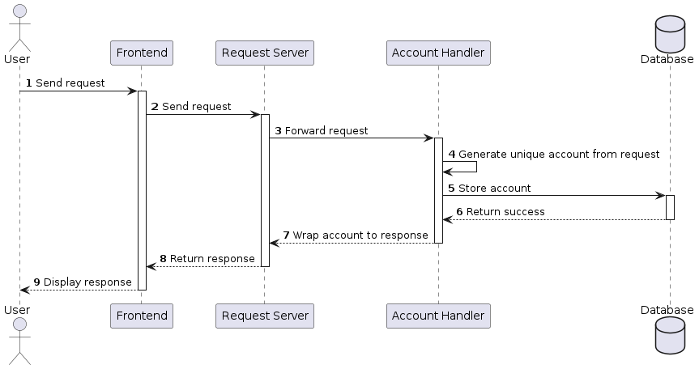

#### 6.3.2.2 Get Account

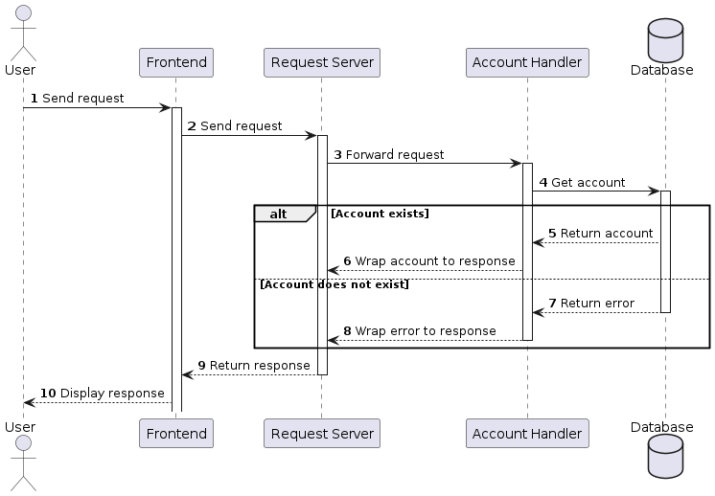

#### 6.3.2.3 Get Account List

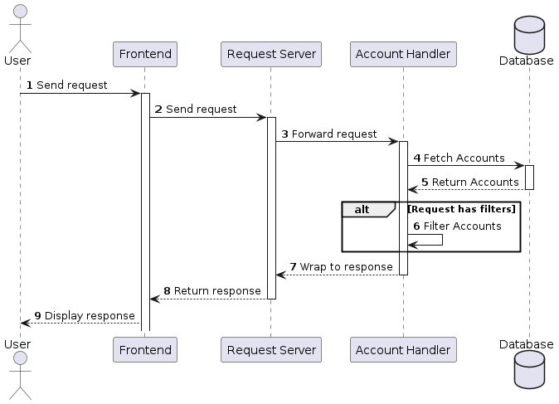

#### 6.3.2.4 Login

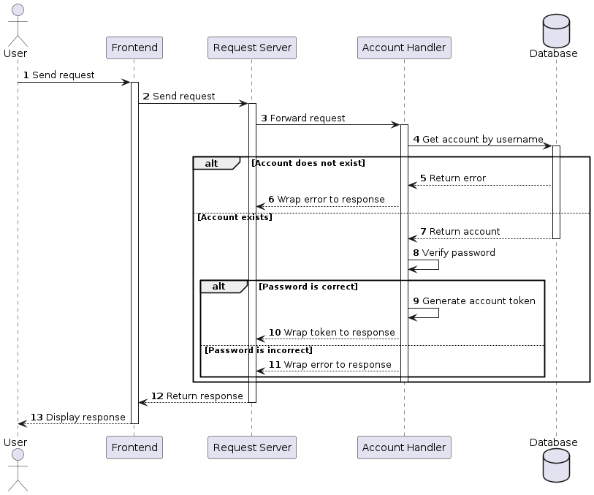

#### 6.3.2.5 Update Account Password

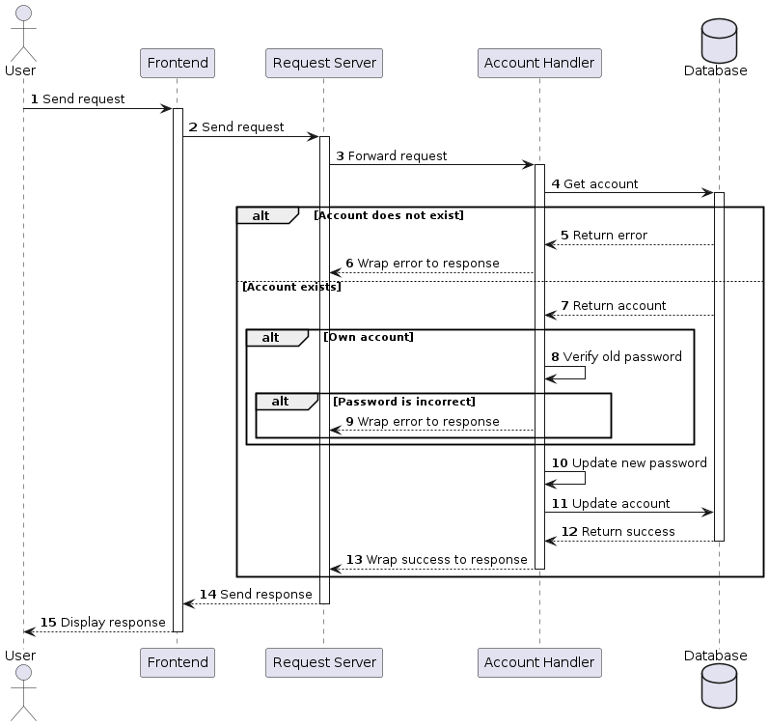

#### 6.3.2.6 Update Account Profile

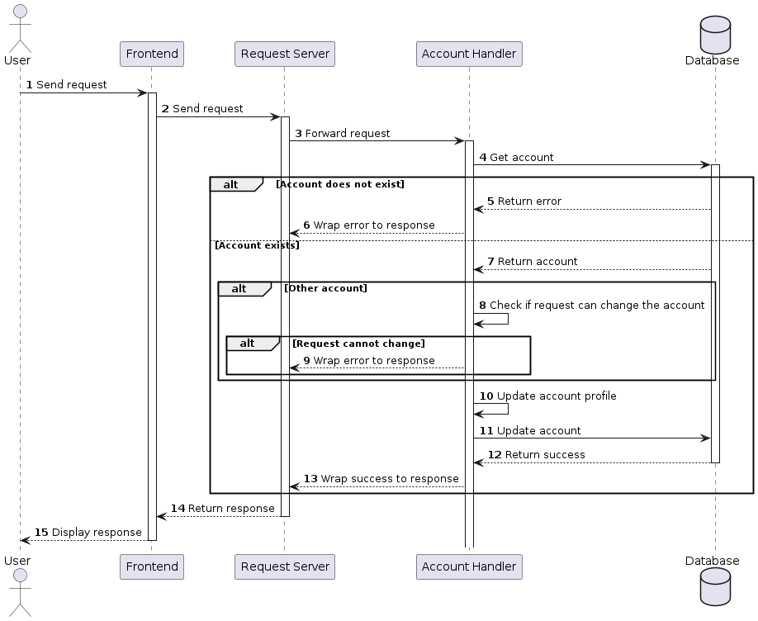

#### 6.3.2.7 Create Classroom

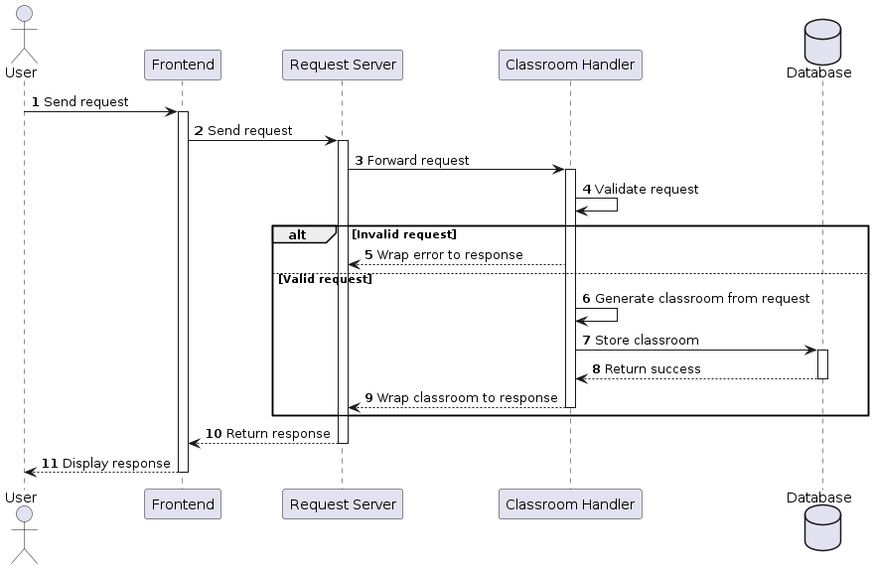

#### 6.3.2.8 Add Students To Classroom

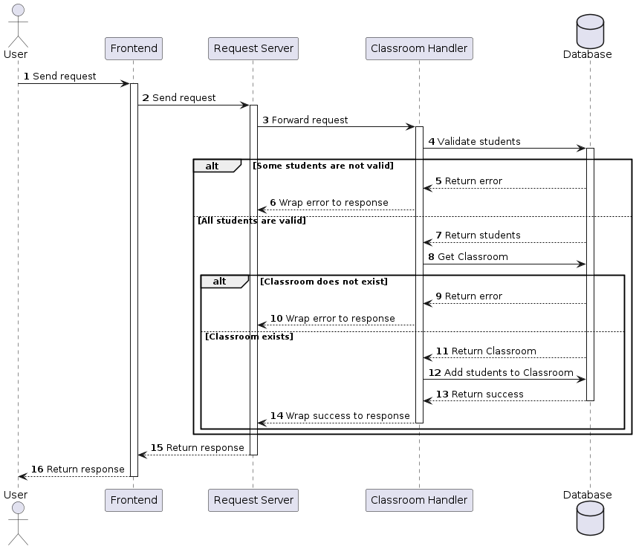

#### 6.3.2.9 Remove Students From Classroom

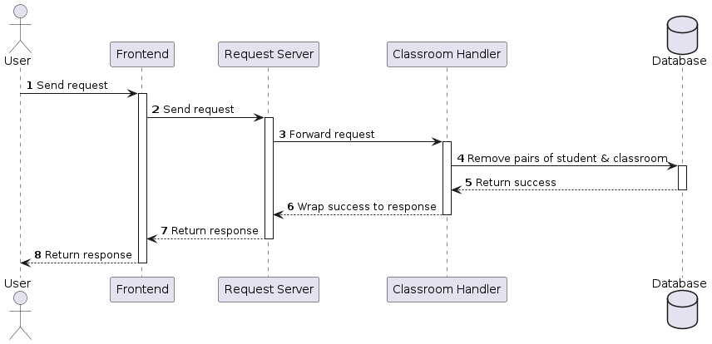

#### 6.3.2.10 Add Teachers To Classroom

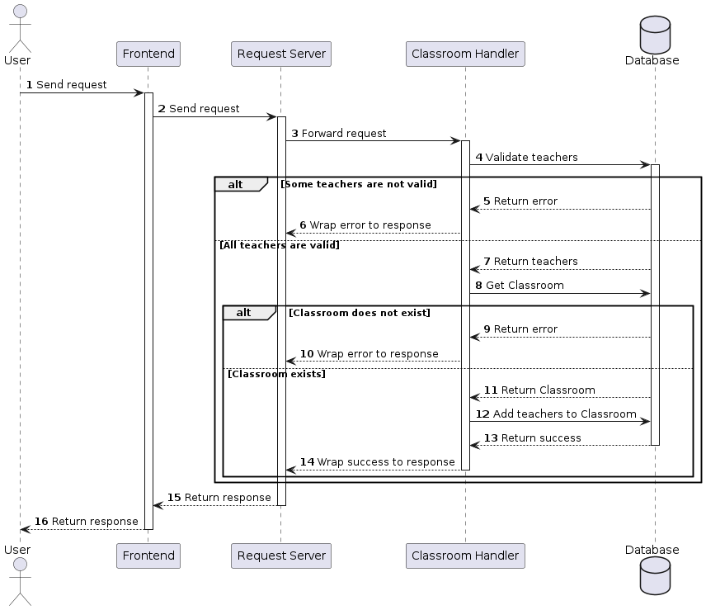

#### 6.3.2.11 Remove Teachers From Classroom

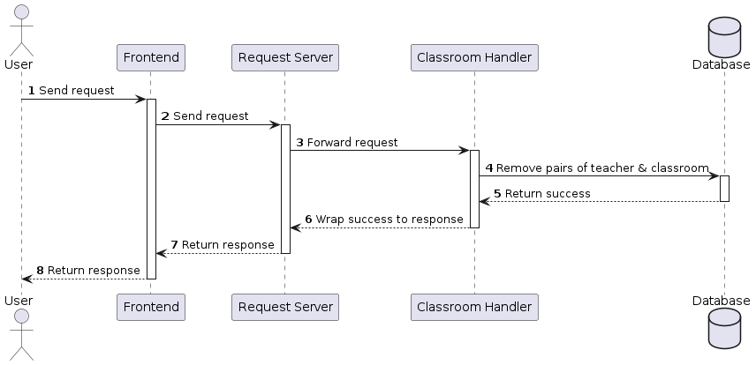

#### 6.3.2.12 Update Classroom

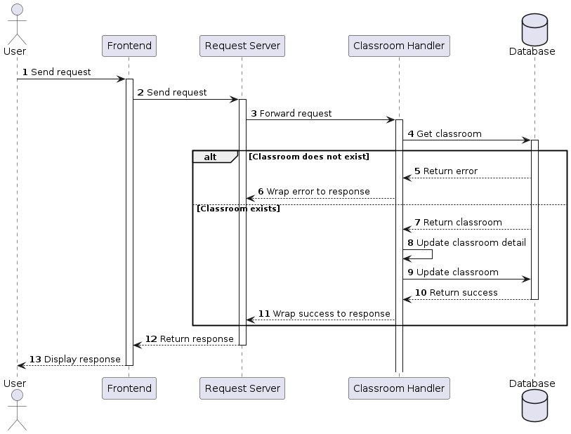

#### 6.3.2.13 Get Classroom

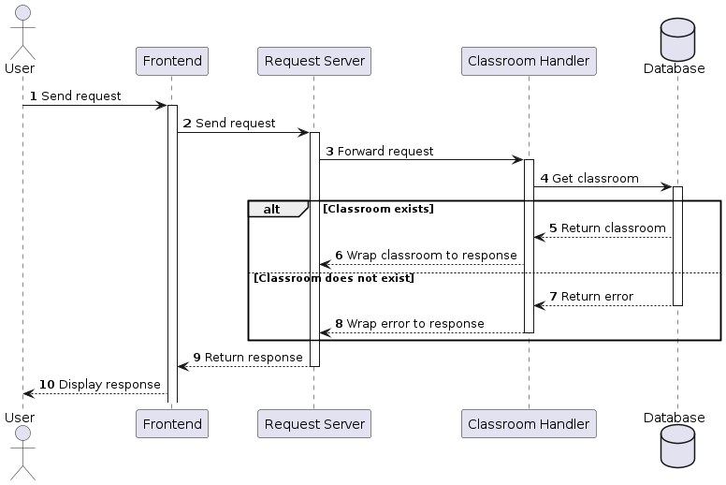

#### 6.3.2.14 Get Classroom List

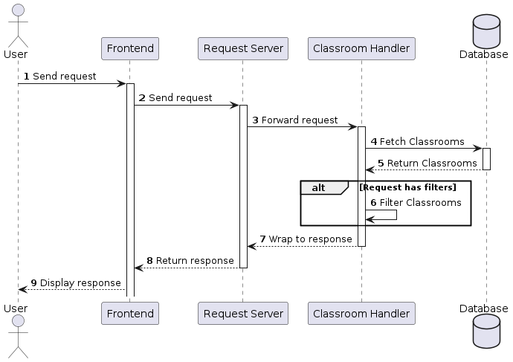

#### 6.3.2.15 Get Students In Classroom

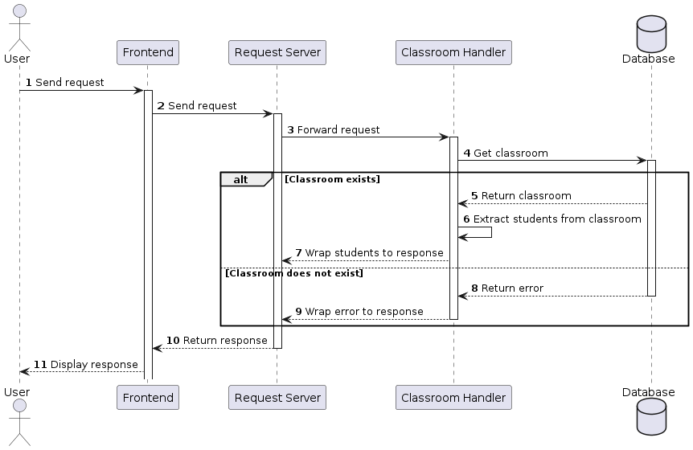

#### 6.3.2.16 Get Teachers In Classroom

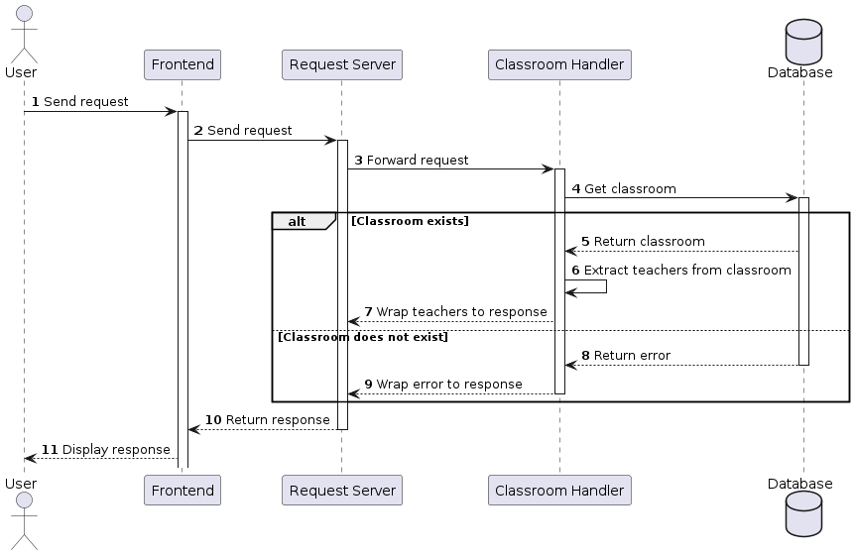

#### 6.3.2.17 Get Student Record

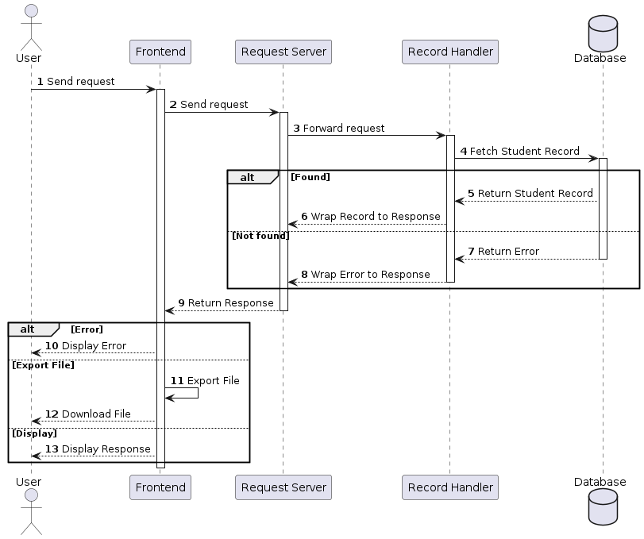

#### 6.3.2.18 Get Student Record List

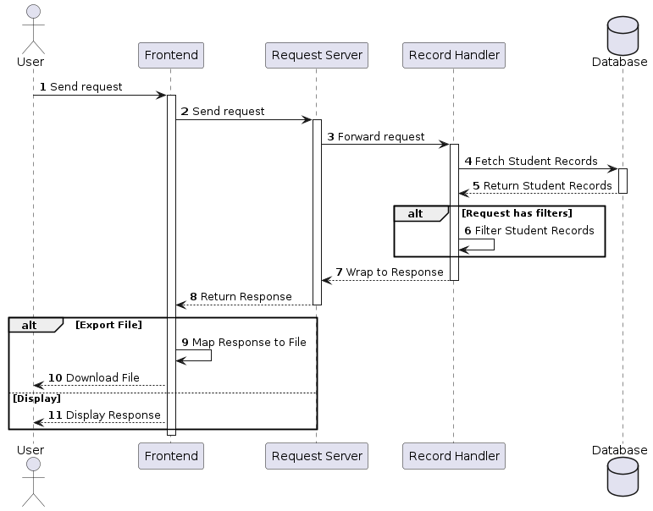

#### 6.3.2.19 Create Request To Update Student Record

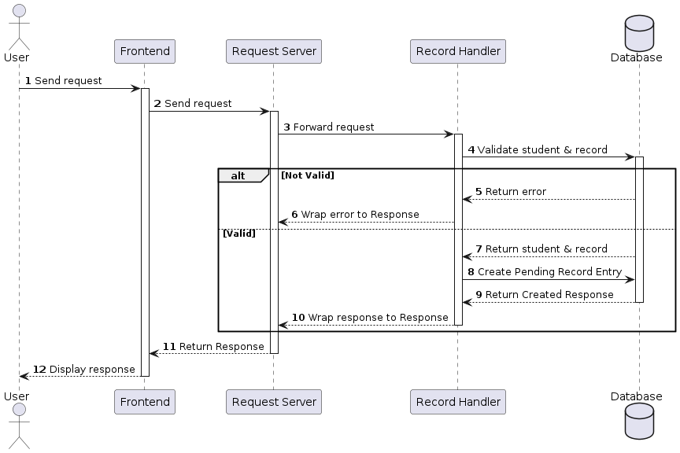

#### 6.3.2.20 Get Pending Record Requests

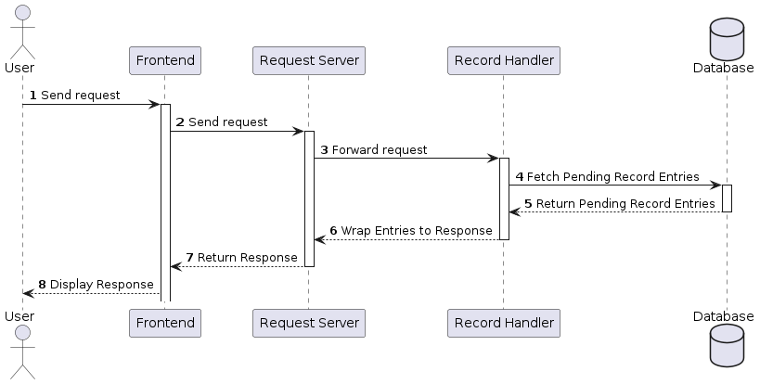

#### 6.3.2.21 Approve Pending Record Request

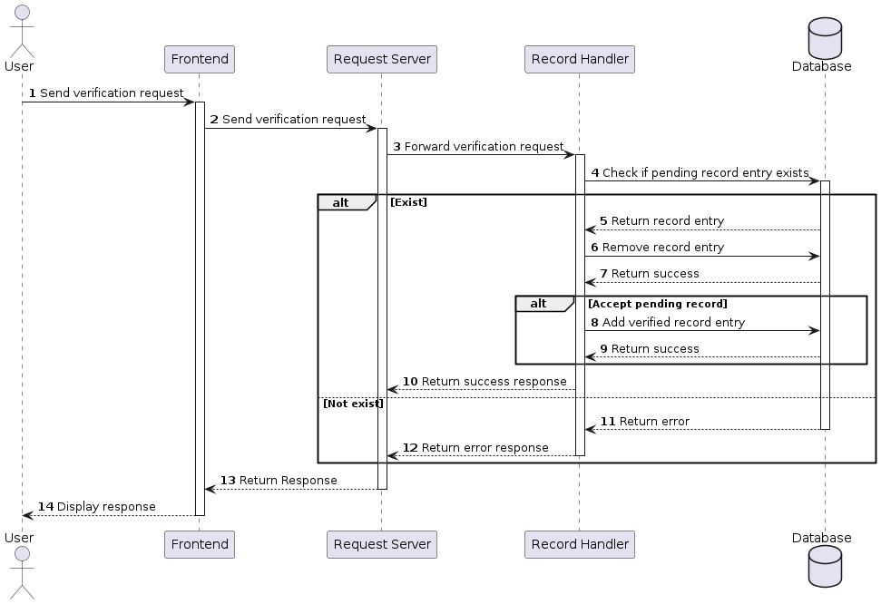

#### 6.3.2.22 Upload Record To Chain Node

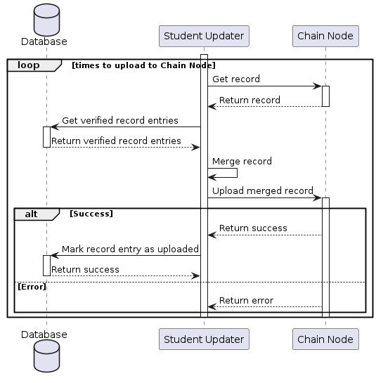

#### 6.3.2.23 Create Statistic Key

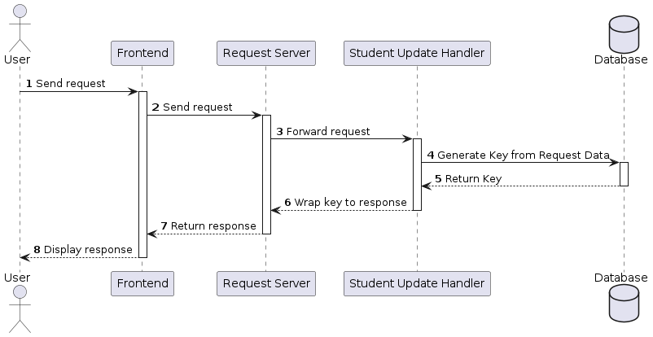

#### 6.3.2.24 Get Statistic Key List

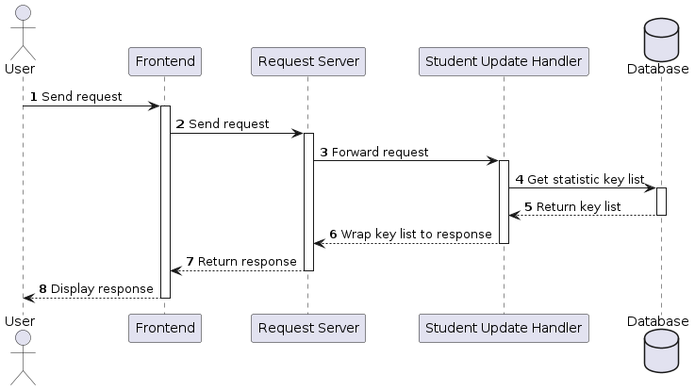

#### 6.3.2.25 Delete Statistic Key

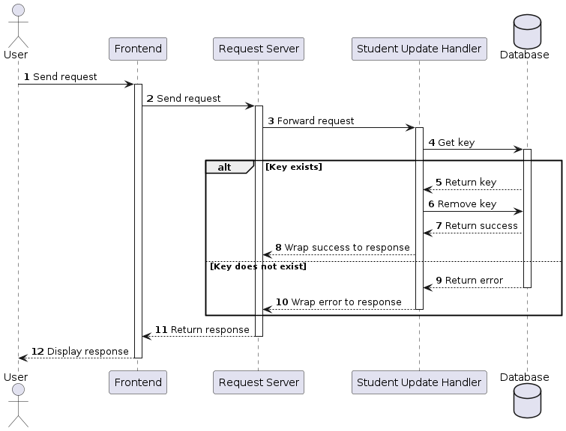

#### 6.3.2.26 Get Statistic Data

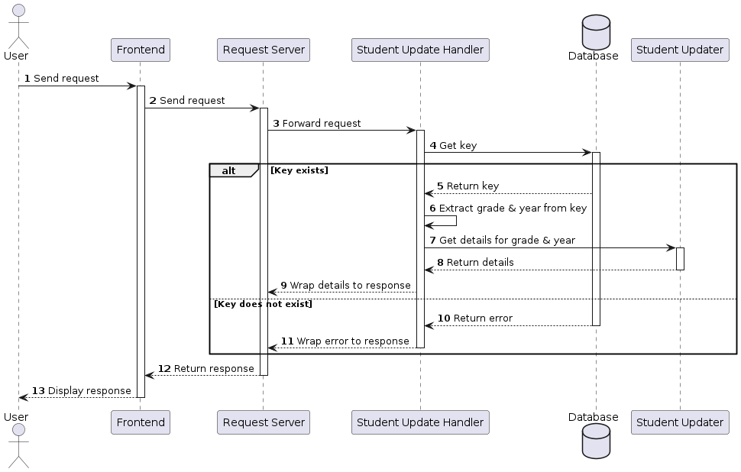

#### 6.3.2.27 Create Student Key



#### 6.3.2.28 Get Student Key List

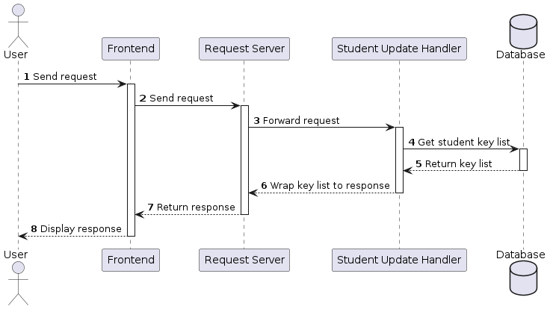

#### 6.3.2.29 Delete Student Key



#### 6.3.2.30 Get Student Data From Key

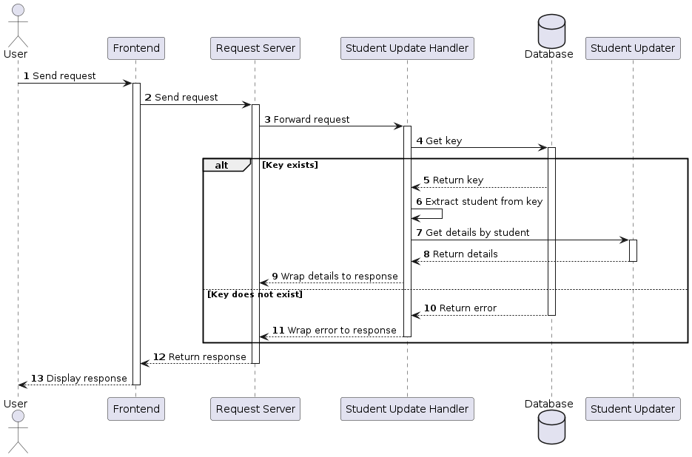

## 6.4 Data & Database Design

### 6.4.1 Database Design

|  |
| --- |
| Figure 6.4: Database Design of the Request Server |

#### 6.4.1.1 Account

| Field Name | Type | Size | Unique | Not Null | Flag | Notes |
| --- | --- | --- | --- | --- | --- | --- |
| ID | bigint |  | x | x | PK |  |
| USERNAME | character varying | 255 | x | x |  |  |
| HASHEDPASSWORD | character varying | 255 |  | x |  |  |
| SALT | character varying | 255 |  | x |  |  |
| ROLE | character varying | 255 |  | x |  |  |
| CREATEDAT | timestamp |  |  | x |  |  |

#### 6.4.1.2 Profile

| Field Name | Type | Size | Unique | Not Null | Flag | Notes |
| --- | --- | --- | --- | --- | --- | --- |
| ACCOUNT_ID | bigint |  | x | x | PK, FK |  |
| ADDRESS | character varying | 255 |  | x |  |  |
| AVATAR | character varying | 255 |  | x |  |  |
| BIRTHDATE | timestamp |  |  | x |  |  |
| EMAIL | character varying | 255 |  | x |  |  |
| FIRSTNAME | character varying | 255 |  | x |  |  |
| LASTNAME | character varying | 255 |  | x |  |  |
| MALE | boolean |  |  | x |  |  |
| PHONE | character varying | 255 |  | x |  |  |
| UPDATED | boolean |  |  | x |  | Used internally by student updater |

#### 6.4.1.3 Student

| Field Name | Type | Size | Unique | Not Null | Flag | Notes |
| --- | --- | --- | --- | --- | --- | --- |
| ACCOUNT_ID | bigint |  | x | x | PK, FK |  |
| ETHNIC | character varying | 255 |  | x |  |  |
| FATHERJOB | character varying | 255 |  | x |  |  |
| FATHERNAME | character varying | 255 |  | x |  |  |
| GUARDIANJOB | character varying | 255 |  | x |  |  |
| GUARDIANNAME | character varying | 255 |  | x |  |  |
| HOMETOWN | character varying | 255 |  | x |  |  |
| MOTHERJOB | character varying | 255 |  | x |  |  |
| MOTHERNAME | character varying | 255 |  | x |  |  |

#### 6.4.1.4 Classroom

| Field Name | Type | Size | Unique | Not Null | Flag | Notes |
| --- | --- | --- | --- | --- | --- | --- |
| ID | bigint |  | x | x | PK |  |
| NAME | character varying | 255 |  | x |  |  |
| GRADE | character varying | 255 |  | x |  |  |
| HOMEROOMTEACHER_ID | bigint |  |  | x | FK |  |
| START_YEAR | integer |  |  | x |  |  |

#### 6.4.1.5 Class Student

| Field Name | Type | Size | Unique | Not Null | Flag | Notes |
| --- | --- | --- | --- | --- | --- | --- |
| ID | bigint |  | x | x | PK |  |
| CLASSROOM_ID | bigint |  |  | x | FK |  |
| STUDENT_ID | bigint |  |  | x | FK |  |

#### 6.4.1.6 Class Teacher

| Field Name | Type | Size | Unique | Not Null | Flag | Notes |
| --- | --- | --- | --- | --- | --- | --- |
| ID | bigint |  | x | x | PK |  |
| CLASSROOM_ID | bigint |  |  | x | FK |  |
| TEACHER_ID | bigint |  |  | x | FK |  |
| SUBJECTID | bigint |  |  | x |  | Defined in the system’s config |

#### 6.4.1.7 Record

| Field Name | Type | Size | Unique | Not Null | Flag | Notes |
| --- | --- | --- | --- | --- | --- | --- |
| ID | bigint |  | x | x | PK |  |
| CLASSROOM_ID | bigint |  |  | x | FK |  |
| STUDENT_ACCOUNT_ID | bigint |  |  | x | FK |  |

#### 6.4.1.8 Record Entry

| Field Name | Type | Size | Unique | Not Null | Flag | Notes |
| --- | --- | --- | --- | --- | --- | --- |
| ID | bigint |  | x | x | PK |  |
| RECORD_ID | bigint |  |  | x | FK |  |
| REQUESTER_ID | bigint |  |  |  | FK |  |
| TEACHER_ID | bigint |  |  |  | FK |  |
| APPROVER_ID | bigint |  |  |  | FK |  |
| APPROVALDATE | timestamp |  |  | x |  |  |
| REQUESTDATE | timestamp |  |  | x |  |  |
| FIRSTHALFSCORE | double precision |  |  | x |  |  |
| SECONDHALFSCORE | double precision |  |  | x |  |  |
| FINALSCORE | double precision |  |  | x |  |  |
| SUBJECTID | bigint |  |  | x |  | Defined in the system’s config |
| UPDATECOMPLETE | boolean |  |  | x |  | Used internally by student updater |

#### 6.4.1.9 Pending Record Entry

| Field Name | Type | Size | Unique | Not Null | Flag | Notes |
| --- | --- | --- | --- | --- | --- | --- |
| ID | bigint |  | x | x | PK |  |
| RECORD_ID | bigint |  |  | x | FK |  |
| REQUESTER_ID | bigint |  |  | x | FK |  |
| TEACHER_ID | bigint |  |  | x | FK |  |
| REQUESTDATE | timestamp |  |  | x |  |  |
| FIRSTHALFSCORE | double precision |  |  | x |  |  |
| SECONDHALFSCORE | double precision |  |  | x |  |  |
| FINALSCORE | double precision |  |  | x |  |  |
| SUBJECTID | bigint |  |  | x |  | Defined in the system’s config |

#### 6.4.1.10 Updater Key

| Field Name | Type | Size | Unique | Not Null | Flag | Notes |
| --- | --- | --- | --- | --- | --- | --- |
| ID | character varying | 255 | x | x | PK |  |
| STUDENT_ACCOUNT_ID | bigint |  |  | x | FK |  |

#### 6.4.1.11 Statistic Key

| Field Name | Type | Size | Unique | Not Null | Flag | Notes |
| --- | --- | --- | --- | --- | --- | --- |
| ID | character varying | 255 | x | x | PK |  |
| GRADE | integer |  |  | x |  |  |
| START_YEAR | integer |  |  | x |  |  |

### 6.4.2 Data File Design

| File Name | Type | Notes |
| --- | --- | --- |
| db | Folder | The folder of The H2 Database files |
| updater | Folder | Contains the data files of the local student updater |

# 7. Software Testing Documentation

## 7.1 Overall Description

### 7.1.1 Test Model

We apply the V-model in our project, which is a development of the waterfall model. Testing is carried out concurrently with the software development cycle in the V-model, where a testing phase corresponds to a phase of software development.

### 7.1.2 Testing Levels

About the Testing levels in our project, we apply all those levels including Unit testing, Integration testing, System testing and Acceptance testing.

With Unit testing, we test each small module in the system, each class and function. Eg (………)

With Integration testing is a type of testing in which individual software modules or functions are logically integrated and tested in groups together. For instance, we can test the interoperability of two functions, add 1 item and search for the item to see if they interact well with each other, after successfully creating an item, we can proceed to search for the newly created item. or not.

System testing is the last test phase to determine whether the system is about to deliver satisfying the requirements and goals. It tests the whole functionality and interface of the system. For instance, a database test for a system test is used to see if the data displayed on the system matches the data in the database.

Finally, with Acceptance Test, similar to System Test but usually tested by customers, the purpose is to see if the software meets the customer’s requirements or not.

### 7.1.3 Testing Types

Functional testing is checking if the system is working according to the business requirements and is performed in every level of testing. Non-Functional testing is similar to Functional testing in that both occur in all levels of testing. Non-functional testing is primarily concerned with the software’s other features, such as its security and if data is exposed by straightforward queries in any input field. Structural testing is often considered a type of white box testing. Instead than focusing on the software’s functionality, this method examines what is happening inside the program. Structural testing is also applicable at all testing levels. Changes Testing is done to determine whether or not the program is functioning correctly after bugs have been fixed.

## 7.2 Test Plan

### 7.2.1 Test Stages

| Type of Test | Stage of Test |  |  |  |
| --- | --- | --- | --- | --- |
|  | Unit | Integration | System | Acceptance |
| Function Test | X | X | X | X |
| User Interface Test |  |  |  |  |
| Performance Test | X | X | X | X |
| Load, Stress, Volume test | X | X | X | X |
| Security test | X | X | X | X |
| Data integrity test | X | X | X | X |

### 7.2.2 Resources

#### 7.2.2.1 Human Resources

| Worker/ Doer | Role | Specifice Responsibilities/Comments |
| --- | --- | --- |
| TienHQ |  |  |
| TuLX |  |  |
| KhoaND |  |  |
| UyCHA |  |  |
| KhoiNM |  |  |

#### 7.2.2.2 Environment

| Purpose | Tool | Provider | Version |
| --- | --- | --- | --- |
|  |  |  |  |
|  |  |  |  |

### 7.2.3 Test Milestones

| Milestone Task | Efford (md) | Start Date | End Date |
| --- | --- | --- | --- |
|  |  |  |  |
|  |  |  |  |

### 7.2.4 Deliverables

| No | Deliverables | Due Data |
| --- | --- | --- |
|  |  |  |
|  |  |  |

## 7.3 Test Cases

• Unit Test Cases: [Report_Unit-Test-Case.xls](excel/Report_Unit-Test-Case.xls)

• Other Test Cases: [Report_Test-Case-Document.xls](excel/Report_Test-Case-Document.xls)

## 7.4 Test Reports

Test Report has been fully integrated in Unit_Test-Case and Test-Case-Document.

# 8. Release Package & User Guides

## 8.1 Deliverable Package

### 8.1.1 Source Codes & Documents

| No. | Items | Sub-Items | Type | Version |
| --- | --- | --- | --- | --- |
| **Code package** |  |  |  |  |
| 1 | EduBlock | EduBlock Client | New | 1.0 |
| 2 | Blockchain Network | Blockchain Chaincode | New | 1.0 |
| 3 | OCR | Record Table Processor | New | 1.0 |
| **Database** |  |  |  |  |
| 1 | Tables | accounts.sql | New | 1.0 |
|  |  | classrooms.sql | New | 1.0 |
|  |  | subjects.sql | New | 1.0 |
| **Documents** |  |  |  |  |
| 1 | Requirement | SRS_v1.0.docx | New | 1.0 |
| 2 | Deployment | UserGuide_v1.0.docx | New | 1.0 |

### 8.1.2 Known Issues, Limitations & Restrictions

## 8.2 Installation Guides

### 8.2.1 System Requirements

OS: any

CPU: at least 4 cores

RAM: at least 4Gb

NETWORK: required

SOFTWARE: Docker

### 8.2.2 Setup Files

* Dockerfile.backend
* Dockerfile.frontend
* Dockerfile.ocr

### 8.2.3 Installation Instruction

## 8.3 User Manual

### 8.3.1 Terms & Definitions

| No. | Term | Definition |
| --- | --- | --- |
| 01 | F.FT | Feature |
| 02 | R.ADM | Admin |
| 03 | R.STF | Staff |
| 04 | R.TCH | Teacher |
| 05 | R.STD | Student |
| 06 | R.ANY | Any role |

### 8.3.2 System Requirements

OS: any

CPU: any

RAM: at least 1Gb

NETWORK: required

### 8.3.3 Application Usage

#### 8.3.3.1 Overview

| No. | Feature | Role | Note |
| --- | --- | --- | --- |
| 01 | Create new account | R.ADM |  |
| 02 | View account list | R.ADM, R.STF |  |
| 03 | View profile | R.ANY | Each role have different behavior |
| 04 | Update profile | R.ADM, R.STF | Each role have different behavior |
| 05 | Update password | R.ANY | Each role have different behavior |
| 06 | Create new classroom | R.STF |  |
| 07 | View classroom list | R.STF, R.TCH, R.STD | Each role have different behavior |
| 08 | View classroom information | R.STF, R.TCH, R.STD |  |
| 09 | View students of classroom | R.STF, R.TCH, R.STD |  |
| 10 | View teachers of classroom | R.STF, R.TCH, R.STD |  |
| 11 | Update classroom information | R.STF |  |
| 12 | Update student in classroom | R.STF |  |
| 13 | Update teacher in classroom | R.STF |  |
| 14 | View update request list | R.TCH |  |
| 15 | Verify update request | R.TCH |  |
| 16 | Request update record | R.TCH, R.STD |  |

#### 8.3.3.2 Feature 01: Create new account

**Description:**

* Admin create account for other user usage

**Details:**

* R.ADM
  + Step 1: Click Account on the left navigation bar to navigate to account list page
  + Step 2: Click Create at the top left of the page to open a modal with form
  + Step 3: Input user First name, Last name and select a role for user
  + Step 4: (Optional) Click Add at the bottom left of the form to add more account and repeat from Step 1
  + Step 5: Click Create at the bottom right of the form to confirm the account creation

#### 8.3.3.3 Feature 02: View account list

**Description:**

* Admin, Staff view the account list to manage account information and find reference for other operations

**Details:**

* R.ADM
  + Step 1: Click Account on the left navigation bar to navigate to account list page
  + Step 2: (Optional) Click Search to reveal filter options below
  + Step 2.1: Select search field on the left
  + Step 2.2: Input search text on the right
  + Step 2.3: Click Search button at the right most to apply list filter
  + Step 3: View list of account
  + Step 4: (Optional) Click page number at the top right to view other accounts

#### 8.3.3.4 Feature 03: View profile

**Description:**

* Admin, Staff view user profile
* User view personal profile

**Details:**

* R.ANY (Personal)
  + Step 1: Click personal card at the bottom of the Vertical Navigation bar to navigate to the profile page
* R.ADM, R.STF
  + Step 1: Click Account on the left navigation bar to navigate to account list page
  + Step 2: Look for the specific account row in table
  + Step 3: Click Details in the Actions column to navigate to the profile page of that account

#### 8.3.3.5 Feature 04: Update profile

**Description:**

* Admin, Staff update personal profile
* Staff update Teacher, Student profile

**Details**

* R.ADM, R.STF (Personal)
  + Step 1: Click personal card at the bottom of the Vertical Navigation bar to navigate to the profile page
  + Step 2: Click Update in the profile section to open a modal with form
  + Step 3: Change the form data to desired value
  + Step 4: Click Confirm to save the changes.
* R.STF
  + Step 1: Click Account on the left navigation bar to navigate to account list page
  + Step 2: Look for the specific account row in table
  + Step 3: Click Update in the Actions column to open an update modal with form
  + Step 4: Change the form data to desired value
  + Step 5: Click Confirm to save the changes

#### 8.3.3.6 Feature 05: Update password

**Description:**

* Admin update other user password
* User self update password

**Details**

* R.ANY (Personal)
  + Step 1: Click personal card at the bottom of the Vertical Navigation bar to navigate to the profile page
  + Step 2: Click Update password at the top right of the page to open a modal with form
  + Step 3: Input the new password
  + Step 4: Click Confirm to save the new password
* R.ADM
  + Step 1: Click Account on the left navigation bar to navigate to account list page
  + Step 2: Look for the specific account row in table
  + Step 3: Click Update password in the Actions column to open an update modal with form
  + Step 4: Input the new password
  + Step 5: Click Confirm to save the new password

#### 8.3.3.7 Feature 06: Create new classroom

**Description:**

* Staff Create new classroom in the system

**Details**

* R.STF
  + Step 1: Click Classroom on the left navigation bar to navigate to classroom list page
  + Step 2: Click Create at the top left of the page to open a modal with form
  + Step 3: Change the form data to desired value
  + Step 4: Click Confirm at the bottom right of the modal to save the created classroom

#### 8.3.3.8 Feature 07: View classroom list

**Description:**

* Staff view the list of all the classroom in the system
* Teacher view the list of all the classroom being taught by that teacher
* Student view the list of all the classroom that student taking part in

**Details**

* R.STF
  + Step 1: Click Classroom on the left navigation bar to navigate to classroom list page
* R.TCH, R.STD
  + Step 1: The list of classroom is in the dashboard page

#### 8.3.3.9 Feature 08: View classroom information

**Description:**

* Staff view classroom information
* Teacher view information of the classroom being taught by that teacher
* Student view information of the classroom that student taking part in

**Details**

* R.STF
  + Step 1: Click Classroom on the left navigation bar to navigate to classroom list page
  + Step 2: Look for the specific classroom row in table
  + Step 3: Click Details in the Actions column to navigate to the classroom details page
* R.TCH, R.STD
  + Step 1: Click Dashboard on the left navigation bar to navigate to classroom list page
  + Step 2: Look for the specific classroom row in table
  + Step 3: Click Details in the Actions column to navigate to the classroom information page

#### 8.3.3.10 Feature 09: View students of classroom

**Description:**

* Staff view all the student in a specific classroom
* Teacher view all the student in the classroom being taught by that teacher
* Student view all the student in the classroom that student taking part in

**Details**

* R.STF, R.TCH, R.STD
  + Step 1: Follow Feature 08 to navigate to the classroom information page
  + Step 2: Click Student which is the center tab at the top of the page to navigate to student list of that classroom

#### 8.3.3.11 Feature 10: View teachers of classroom

**Description:**

* Staff view all the teacher in a specific classroom
* Teacher view all the teacher in the classroom being taught by that teacher
* Student view all the teacher in the classroom that student taking part in

**Details**

* R.STF, R.TCH, R.STD
  + Step 1: Follow Feature 08 to navigate to the classroom information page
  + Step 2: Click Teacher which is right most tab at the top of the page to navigate to teacher list of that classroom

#### 8.3.3.12 Feature 11: Update classroom information

**Description:**

* Staff update a specific classroom information

**Details**

* R.STF
  + Step 1: Follow Feature 08 to navigate to the classroom information page
  + Step 2: Click Details which is right most tab at the top of the page to navigate to details page of that classroom
  + Step 3: Click Update at the bottom of the page to open a modal with form
  + Step 4: Change the form data to desired value
  + Step 5: Click Confirm at the bottom of the modal to save changes

#### 8.3.3.13 Feature 12: Update student in classroom

**Description:**

* Staff change the student of a specific classroom

**Details**

* R.STF
  + Step 1: Follow Feature 09 to navigate to the classroom student page
  + Step 2: Look for a specific account row in the table (May skip to Step 4)
  + Step 3: Click Remove in the Actions column to remove student from classroom
  + Step 4: Click Add at the top left of the page to open a modal with form
  + Step 5: Change the form data to desired value
  + Step 6: Click Confirm at the bottom right of the modal to save changes

#### 8.3.3.14 Feature 13: Update teacher in classroom

**Description:**

* Staff change the teacher of a specific classroom

**Details**

* R.STF
  + Step 1: Follow Feature 10 to navigate to the classroom teacher page
  + Step 2: Look for a specific account row in the table (May skip to Step 4)
  + Step 3: Click Remove in the Actions column to remove teacher from classroom
  + Step 4: Click Add at the top left of the page to open a modal with form
  + Step 5: Change the form data to desired value
  + Step 6: Click Confirm at the bottom right of the modal to save changes

#### 8.3.3.15 Feature 14: View update request list

**Description:**

* Teacher view list of request for updating record value

**Details**

* R.TCH
  + Step 1: Click Request on the left navigation bar to navigate to request list page

#### 8.3.3.16 Feature 15: Verify update request

**Description:**

* Teacher verify request waiting for verification

**Details**

* R.TCH
  + Step 1: Follow Feature 14 to navigate to the request list page
  + Step 2: Look for the specific request row in table
  + Step 3: Click Approve or Reject to approve or reject the request

#### 8.3.3.17 Feature 16: Request update record

**Description:**

* Teacher or student of same classroom request updating record for that student

**Details**

* R.TCH
  + Step 1: Follow Feature 09 to navigate to student profile page
  + Step 2: Look for the record need update in the record table at the bottom of the page
  + Step 3: Click Update in the Actions column to open a modal with form
  + Step 4: Change the form data to desired value
  + Step 5: Click Confirm to send the request
* R.STD
  + Step 1: Click personal card at the bottom of the Vertical Navigation bar to navigate to the profile page
  + Step 2: Look for the record need update in the record table at the bottom of the page
  + Step 3: Click Update in the Actions column to open a modal with form
  + Step 4: Change the form data to desired value
  + Step 5: Click Confirm to send the request

### 8.3.4 Troubleshooting

# References

# Appendix