WOXSEN UNIVERSITY · MBA (BUSINESS ANALYTICS)
Blockchain Supply Chain & Predictive Analytics · Bloomberg Capstone Project CP-45
Blockchain Sustainable Palm Oil Traceability
Assessing EUDR and Scope 3 risk with Bloomberg supply-chain data, a composite exposure index, and a Monte Carlo stress test of central-database versus permissioned-blockchain traceability
Case firms: Unilever PLC · Nestlé S.A. · Wilmar International Ltd
Bloomberg data captured 15 October 2026 at the Woxsen Bloomberg Lab / Terminal
Submitted by | [Team member names and student IDs — to be completed]
Programme / course | MBA BA — Blockchain Supply Chain & Predictive Analytics
Faculty supervisor | [Name — to be completed]
Submission date | [DD Month 2026 — to be completed]
Companion files | Palm_Oil_Traceability_Capstone_Workbook.xlsx (16 sheets) · CP45_Palm_Oil_Traceability_Notebook.ipynb · palm_oil_traceability_model.py

Data and licence note. Bloomberg figures were transcribed from Terminal screens (SPLC, FA, ESG, CN, HP/GP, DES) on 15 October 2026 and are used here for academic purposes under the Woxsen Bloomberg licence. Figures marked ASSUMPTION in Chapters 5–6 are modelling inputs that Bloomberg cannot supply; they are not Bloomberg data.
Contents
Executive Summary 4
Chapter 1 Introduction and Problem Context 5
1.1 The palm oil supply chain challenge 5
1.2 Regulatory and Scope 3 risks 5
1.3 Research objectives and questions 6
1.4 Scope and case-study focus 7
Chapter 2 Conceptual Framework 8
2.1 Transaction cost economics in procurement 8
2.2 Supply-chain resilience and visibility 8
2.3 The role of blockchain traceability 8
2.4 From concepts to measurable variables 9
Chapter 3 Bloomberg Supply Chain Mapping and Baseline Diagnostics 10
3.1 Network topology using SPLC 10
3.2 Financial health and margin analysis 12
3.3 ESG and controversy profiling 14
Chapter 4 Predictive Modelling and Empirical Findings 17
4.1 The Sustainable Palm Oil Exposure Index (SPOEI) 17
4.2 Model specification and methodology 19
4.3 Results and feature importance 20
Chapter 5 Blockchain Architecture and Financial Stress Testing 22
5.1 Proposed permissioned blockchain architecture 22
5.2 Simulation design 23
5.3 ROI and stress-test results 25
Chapter 6 Strategic Recommendations and Managerial Decision Rules 30
6.1 Procurement intervention strategies 30
6.2 Risk–cost trade-off heat map 31
6.3 Managerial decision rules 32
Chapter 7 Conclusion 33
7.1 Summary of findings 33
7.2 Limitations of the study 33
7.3 Future outlook 34
Appendix A Bloomberg Data Capture and Query Scripts 35
A.1 Capture log (screens used) 35
A.2 Reproduction and extension queries (templates, not executed) 35
A.3 Panel file for the classifier (spoei_panel.csv) 36
Appendix B Python Simulation Code 37
B.1 Cost-benefit and Monte Carlo engine 37
B.2 Classifier protocol (notebook Part 5, core functions) 39
References 40
List of figures and tables
Table 1.1 RSPO supply-chain models and what each can prove under the EUDR 5
Table 1.2 Exposure channels and how the model prices them 6
Table 1.3 Where each research question is answered, and how far the evidence goes 6
Table 1.4 The three case firms (Bloomberg DES, FA and ESG, 15 October 2026) 7
Table 2.1 Public versus permissioned blockchains for palm oil 9
Table 2.2 Operationalisation of the framework 9
Table 3.1 SPLC network panels (suppliers and customers listed by Bloomberg) 10
Figure 3.1 How much of the supply base is visible, and what the visible part looks like 10
Figure 3.2 Wilmar’s visible suppliers: criticality to Wilmar versus Wilmar’s leverage over the supplier 11
Table 3.2 Wilmar’s largest visible suppliers (SPLC, top 12 of 24 captured) 11
Figure 3.3 Gross and operating margins, FY2019–FY2025 13
Table 3.3 Margin and resilience diagnostics, FY2019 → FY2025 13
Figure 3.4 Crude palm oil (KOZ6) and equity prices, 17 August – 15 October 2026 14
Figure 3.5 ESG disclosure score and Scope 1 emissions, 2016–2025 15
Table 3.4 Bloomberg ESG snapshot, 2024 (BESG pillars 0–10) 15
Figure 3.6 Reported Scope 3 emissions and 2024 intensity 15
Table 3.5 Hand-coded Bloomberg News headlines, 15-Oct-2025 to 15-Oct-2026 16
Figure 3.7 Timeline of coded headlines for the three firms 16
Table 4.1 SPOEI indicators, scaling and weights 17
Figure 4.1 SPOEI indicator scores and index under four weightings 18
Table 4.2 SPOEI by weighting scheme (0–100; higher = more exposed) 18
Figure 4.2 What makes Wilmar’s SPOEI higher than Nestlé’s and Unilever’s 19
Table 4.3 Model specification 19
Table 4.4 What the available data can and cannot support 20
Figure 4.3 Positive events required to detect a given AUC against chance 21
Table 4.5 Results table to be completed when the panel is available (test window 2024-01 to 2025-09) 21
Figure 5.1 Permissioned traceability architecture: physical flow, oracle inputs, ledger events and contracts 22
Table 5.1 Architecture specification 22
Table 5.2 Global and option parameters (ASSUMPTION) 24
Table 5.3 Firm profiles and programme costs (ASSUMPTION except revenue and COGS) 24
Table 5.4 Scenario definitions (multipliers on base risk inputs) 25
Figure 5.2 PV of total cost by option, base scenario (USD m) 25
Table 5.5 Base, adverse and severe results (PV over 7 years, USD m) 26
Figure 5.3 NPV benefit versus the status quo, by firm and scenario 26
Table 5.6 Discounted payback and break-even in the base scenario 26
Table 5.7 Monte Carlo, mixed enforcement regimes (20,000 draws, USD m) 27
Figure 5.4 Distribution of NPV benefit across 20,000 mixed-regime worlds 27
Figure 5.5 Expected benefit versus downside (5th percentile) of each intervention 28
Figure 5.6 One-at-a-time sensitivity of the Unilever blockchain NPV 28
Figure 5.7 Coverage and substitution simulation: PV of supplier-substitution cost 29
Table 5.8 Effect of the realised fine rate (2% versus the 4% statutory floor for the maximum) 29
Table 6.1 Interventions assessed and verdicts 30
Table 6.2 Mean / 5th-percentile NPV benefit by strategy, mixed regimes (USD m) 30
Figure 6.1 Risk–cost heat map: SPOEI versus economic impact of untraced exposure 31
Table 6.3 If–then decision rules 32
Table 7.1 Answers to the research questions 33
Table A.1 Screens captured on 15-Oct-2026 35
Table A.2 Panel columns read by notebook Part 5 36

Executive Summary
The problem. From 30 December 2026 the EU Deforestation Regulation (EUDR, Regulation (EU) 2023/1115) obliges operators that place palm oil and derived products on the EU market to show that each product is deforestation-free, legally produced and traceable to the plot of land where it was grown, and obliges traders and downstream operators to keep the evidence chain. The maximum fine must be at least 4% of the operator’s annual EU turnover. The dominant sourcing practice, RSPO mass balance, lets certified and uncertified oil mix physically, so it cannot supply plot-level evidence. Unilever, Nestlé and Wilmar sit at different points of this chain and face the same regulatory clock.
What we did. We captured Bloomberg screens (SPLC, FA, ESG, CN, HP/GP) for the three firms on 15 October 2026 and built (i) a sourced evidence workbook, (ii) a ten-indicator Sustainable Palm Oil Exposure Index (SPOEI), and (iii) a cost-benefit model that compares status quo, a central traceability database and a permissioned blockchain under base, adverse and severe enforcement scenarios, with a 20,000-draw Monte Carlo (common random numbers) and sensitivity tests. A supervised classifier is fully specified but not estimated: the screens give 21 firm-years, whereas about 85 labelled observations (≈17 events) are needed to show an AUC of 0.70 against chance (Chapter 4).
What we found.
• Wilmar is the highest-risk node (SPOEI 63.5 vs Unilever 53.0 and Nestlé 39.9; the ranking holds under four weightings). The drivers are thin interest cover (2.1×), supplier conduct flags (37% of listed suppliers) and a 2026 news record of legal and governance events, not deforestation events.
• Bloomberg cannot see the palm chain. None of the top-24 suppliers of Unilever or Nestlé is a palm trader or plantation, and Wilmar appears in neither list; visible plantation nodes are only 0.4% of Wilmar’s cost base. This opacity is the traceability problem itself, and the evidence for it.
• Traceability pays; the blockchain premium is conditional. Relative to the status quo, a permissioned blockchain has an NPV benefit of USD 16 / 56 / 143 m (Unilever), 47 / 111 / 247 m (Nestlé) and 86 / 197 / 471 m (Wilmar) in the base / adverse / severe case. A plain central database does as well or better in the base case for Unilever and Wilmar, and the blockchain wins only if enforcement tightens or its assurance value is high (parity at 0.82–0.96 versus 0.80 for the database). In mixed-regime simulations the blockchain beats the database in 35–42% of worlds.
Recommendation. Adopt a database-first, ledger-ready programme: build the central traceability stack (plot geolocation, satellite checks, audits) now, with hash-anchored records that can migrate to a permissioned consortium ledger, and escalate to the ledger when pre-agreed triggers fire: regulatory-event probability at about 1.8–2.1 times the base rate for Unilever and Wilmar (the adverse case; Nestlé is already past parity at base inputs), consortium co-funding that cuts the ledger’s programme cost by 3–11%, or audited evidence that the ledger’s assurance value clears the parity point. Unilever and Nestlé should use Wilmar’s measurable leverage over its plantation suppliers (Wilmar supplies 27% of the revenue of the visible palm nodes, weighted by cost) through traceability covenants rather than exit on a Bloomberg ESG score, which tracks disclosure, not footprint.
Read this before relying on the numbers
All risk probabilities, fine rates, programme costs and effectiveness values are labelled ASSUMPTION and are placeholders for calibration; the results show decision logic and ranges, not forecasts. The predictive-model results (RQ3) are not reported because the data to estimate them are not yet available; Chapter 4 states exactly what is needed.

Chapter 1 Introduction and Problem Context

1.1 The palm oil supply chain challenge
Palm oil is the most widely traded vegetable oil and an input to food, home-care and personal-care products. Its production is concentrated in Indonesia and Malaysia, where oil-palm expansion has been a major driver of forest loss (Austin et al., 2017; Gaveau et al., 2022). Between the plantation and the consumer, the oil passes through several hands: smallholders and estates deliver fresh fruit bunches to mills; mills sell crude palm oil to refiners and traders; refiners sell fractions and derivatives to manufacturers such as Unilever and Nestlé. Many mills buy from hundreds of smallholders, and refineries blend oil from many mills, so the origin of any given tonne is rarely recorded beyond the first or second tier.
The industry response has been voluntary certification under the Roundtable on Sustainable Palm Oil (RSPO) and company “no deforestation, no peat, no exploitation” (NDPE) policies. Certification has had measurable local effects (Carlson et al., 2018), but supply-chain initiatives alone leave gaps because uncommitted buyers absorb the displaced volume (Lambin et al., 2018). Most of the certified volume that reaches manufacturers moves under the mass-balance model, which is central to this report.
Table 1.1 — RSPO supply-chain models and what each can prove under the EUDR
Model | Physical link to certified origin | Plot-level evidence? | EUDR fit
Identity preserved | Single certified source, kept apart end to end | Yes, if source is geolocated | Strong, costly, small volumes
Segregated | Certified oil from several sources, kept apart from non-certified | Yes, at mill-group level | Good, if inputs are geolocated
Mass balance | Certified and non-certified oil may be mixed; certified volume tracked on paper | No: the claim is an accounting entry | Weak: cannot show that this batch is deforestation-free
Book and claim (credits) | No physical link; credits traded separately | No | Not a due-diligence tool

Source: RSPO Supply Chain Certification Standard (RSPO, 2017); authors’ assessment of fit with Regulation (EU) 2023/1115, Article 9 (geolocation of plots of production).
As Table 1.1 shows, the mass-balance model is efficient for certification but opaque for regulation. A refinery can hold a ledger entry saying 1,000 tonnes of certified oil came in and 1,000 tonnes were sold as certified, while the physical oil was a blend. That is acceptable under the RSPO rules, but it cannot by itself give a buyer the plot-level geolocation that EU law now requires. The gap between what the paperwork asserts and what can be proved is the information asymmetry that this project quantifies and tests a blockchain against.

1.2 Regulatory and Scope 3 risks
EUDR. The Regulation covers seven commodities (cattle, cocoa, coffee, palm oil, rubber, soy and wood) and their derived products. Operators must file a due-diligence statement that includes geolocation of the plots of production and shows that the product is deforestation-free (no conversion after the 31 December 2020 cut-off) and legally produced; traders and downstream operators must keep and pass on the reference numbers. Application dates, as confirmed on the Commission’s site in July 2026, are 30 December 2026 for large and medium-sized operators and 30 June 2027 for other micro and small operators (European Commission, 2026). A May 2026 simplification package lightened duties for low-risk-country sourcing and for downstream traders, but kept the dates and the core obligations (Hogan Lovells, 2026). A July 2026 update to the product scope adds certain palm-oil derivatives from 30 December 2027.
Penalties. Article 25 requires Member States to set effective, proportionate and dissuasive penalties. For legal persons, the maximum fine must be at least 4% of the operator’s total annual Union-wide turnover in the preceding financial year. Penalties also include confiscation of the products and of the revenue from them, exclusion from public procurement and public funding for up to 12 months, and a temporary ban on placing or making products available on the market (Regulation (EU) 2023/1115, Art. 25). Because 4% is a floor for the maximum, and national authorities decide the realised amount, the cost-benefit model in Chapter 5 treats the realised fine as an uncertain parameter between 0.5% and 4% of EU turnover rather than as a fixed 4%.
Scope 3. For consumer-goods companies the bulk of the carbon footprint is in purchased goods, the category where palm-driven land-use change sits (GHG Protocol, 2011). Bloomberg ESG shows reported Scope 3 emissions of about 104 Mt CO₂e for Unilever (2025), 72 Mt for Nestlé (2025) and 147 Mt for Wilmar (2024). Disclosure regimes such as ESRS E1 and IFRS S2 expect Scope 3 reporting where it is material, although the scope and timing of the EU rules are still being simplified. Poor traceability makes Scope 3 figures estimates built from industry averages rather than measured supplier data. Table 1.2 groups these exposures into the channels that Chapter 5 prices.
Table 1.2 — Exposure channels and how the model prices them
Channel | Mechanism | How Chapter 5 models it
Regulatory | Fine, confiscation, market-access suspension for non-compliant EU-bound volume | Annual event probability × realised fine rate × EU-regulated revenue × (1 − mitigation)
Supply | Volume that cannot be shown to be compliant must be excluded and re-sourced at a premium | Palm spend × EU share × untraced share × exclusion share × price premium
Reputational | Controversy leads to boycotts, delisting and lost sales on palm-linked products | Annual controversy probability × revenue loss × palm-linked revenue share × (1 − mitigation)
Financing and rating | ESG-score downgrades, covenant and index exclusion (not priced) | Qualitative; discussed in Chapter 6

1.3 Research objectives and questions
The project brief (CP-45) states the following objectives and research questions, reproduced verbatim; Table 1.3 then maps each question to the evidence that answers it.
1. Build a Bloomberg-derived dataset for Unilever, Nestlé and Wilmar.
2. Identify the main drivers of blockchain sustainable palm oil traceability.
3. Develop and validate a predictive/analytical model.
4. Run base, adverse and severe simulations.
5. Recommend sourcing, blockchain, hedging, inventory or resilience actions.
RQ1: Which Bloomberg-derived indicators best explain/predict blockchain sustainable palm oil traceability?
RQ2: How do ESG, supply links, palm oil prices, controversy/news interact under normal and stressed conditions?
RQ3: Does the predictive model outperform a simple historical/statistical benchmark?
RQ4: Which supply-chain/blockchain intervention gives the best risk–cost trade-off?

Table 1.3 — Where each research question is answered, and how far the evidence goes
RQ | Chapter | Evidence used | Status
RQ1 | 3, 4 | SPOEI indicator ranking and weight-robustness; feature specification for the classifier | Partly answered. Index drivers identified; predictive ranking needs a labelled panel
RQ2 | 3, 5 | Descriptive links among BESG, Scope 1/3, SPLC flags, news coding, 8-week CPO window; stress scenarios | Answered descriptively. Price links are not statistically testable on 8 weeks of data
RQ3 | 4 | Protocol, benchmarks and power analysis | Not answered. Requires the labelled panel (about 85 firm-periods, ≥17 events)
RQ4 | 5, 6 | Three-option cost-benefit model, 20,000-draw Monte Carlo, tornado, parity points | Answered, conditional on ASSUMPTION inputs

1.4 Scope and case-study focus
The brief names three units of analysis, which sit at different points of the chain (Table 1.4). Unilever and Nestlé are downstream manufacturers and, depending on the product and the import route, operators or downstream operators/traders under the Regulation. Wilmar International is one of the world’s largest palm-oil processors and traders and also owns plantations, so it is both an upstream supplier to the manufacturers and a regulated operator in its own right. The benchmark programme named in the brief is RSPO certification. The analysis is global, with emphasis on Indonesia, Malaysia and the EU market. Data are annual (FY2019–FY2025) for fundamentals, annual (2016–2024/25) for ESG, and daily for an eight-week price window (17 August to 15 October 2026).
Table 1.4 — The three case firms (Bloomberg DES, FA and ESG, 15 October 2026)
 | Unilever | Nestlé | Wilmar
Ticker | ULVR LN | NESN SW | WIL SP
Role in the palm chain | Brand owner / EU operator | Brand owner / EU operator | Refiner, trader, plantation owner
FY2025 revenue (reporting currency, m) | EUR 50,503 | CHF 89,885 | USD 70,416
FY2025 gross margin / operating margin | 47.0% / 20.0% | 45.8% / 15.5% | 8.2% / 3.2%
Market capitalisation (local currency, m) | GBP 104,033 | CHF 203,262 | SGD 21,668
Employees | 118,000 | 271,000 | 100,000
BESG score, 2024 (0–10) | 4.82 | 5.28 | 6.15
Reported Scope 3 (Mt CO₂e) | 103.8 (2025) | 72.0 (2025) | 147.0 (2024)
Interest cover, FY2025 (operating income / interest) | 9.1× | 8.3× | 2.1×
Largest revenue market (SPLC) | USA 20.6% | USA 33.9% | China 47.3%; EU exposure indirect

Source: Bloomberg (DES, FA, ESG, SPLC), transcribed 15-Oct-2026. Unilever FY2024–25 reflect the ice-cream demerger restatement; Scope 3 series for Unilever contain boundary breaks (Chapter 3).
Scope boundary
Bloomberg SPLC lists visible Tier-1 relationships only. Private Tier-2 mills and Tier-3 smallholders are outside the data. The report therefore measures how much of the chain is invisible and what closing that gap is worth, rather than mapping the chain itself.

Chapter 2 Conceptual Framework
The framework joins three bodies of theory that the project brief names: transaction cost economics, supply-chain visibility and resilience, and blockchain traceability. Each yields testable propositions that the later chapters measure with Bloomberg data or model.

2.1 Transaction cost economics in procurement
Transaction cost economics (TCE) explains governance choices by the cost of running exchange: searching, negotiating, monitoring and enforcing (Williamson, 1979, 1985). Costs rise with asset specificity, uncertainty and the difficulty of measuring what was delivered. Palm-oil procurement scores high on the last two. A buyer cannot inspect origin by looking at the oil, and compliance depends on facts (land clearing history, plot boundaries) that sit with distant third parties.
This is Akerlof’s (1970) “market for lemons” in sustainability form. If compliant and non-compliant oil look identical and the buyer cannot verify origin, the market pays one blended price, and honest producers cannot earn a premium for the cost of proving compliance. Buyers respond with audits, certification and questionnaires, which add auditing friction: repeated, partly duplicated checks across tiers. The cost of verifying grows with the number of plots and intermediaries, while the penalty for failure (EUDR fines, market-access loss) is now paid by the buyer. The TCE prediction is that buyers will move toward governance forms that lower measurement cost, such as shared registries, vertical integration or long-term relational contracts, when the regulatory price of ignorance exceeds the price of measurement.
Proposition P1. Where the expected regulatory and reputational loss from untraced volume exceeds the annualised cost of verification, a shared traceability system has positive value. P2. The value of blockchain over a conventional shared database depends on whether it lowers coordination and trust costs among competing firms by more than it adds in set-up and running costs.

2.2 Supply-chain resilience and visibility
Visibility, the ability to see inventory, flows and risks across tiers, is a widely cited precondition for resilience (Christopher and Peck, 2004), and resilient firms combine flexibility and redundancy with early warning (Sheffi and Rice, 2005). In palm oil, the relevant shocks are exogenous and of three kinds: price shocks (crude palm oil is volatile; the Bloomberg series used here shows 17% annualised volatility over eight weeks), policy shocks (export restrictions and levies in producing countries, such as Indonesia’s 2022 export curbs, and EU rules that can suspend market access) and legal or geopolitical shocks (the May 2026 report that Russia would seize a Wilmar stake, the March 2026 conviction of a Wilmar unit executive, and the Indonesian export under-invoicing probe, all captured in Bloomberg News).
Visibility lowers the cost of these shocks in two ways. It shortens the time to identify which suppliers and plots are affected, and it widens the set of compliant substitutes that can be activated. Proposition P3. Firms with low visible coverage and high concentration should show higher news-based risk and need larger substitution premia under stress. Chapter 3 measures visibility with SPLC coverage; Chapter 5 prices substitution.

2.3 The role of blockchain traceability
A blockchain is an append-only ledger replicated across participants and updated by a consensus rule, so that no single party can alter past entries unnoticed (Nakamoto, 2008). In finance, the core problem it solves is double spending: the same digital token cannot be used twice. The supply-chain analogue is double claiming: the same tonne of certified oil sold as certified to two buyers, or a certificate reused against uncertified volume. A ledger that issues a unique lot identifier at the mill and decrements it at each split or sale can make double claiming detectable and, with smart contracts, can block payment for over-claimed volume. It also provides a shared, time-stamped record that regulators and auditors can read (Kshetri, 2018; Saberi et al., 2019; Kamilaris et al., 2019). Table 2.1 contrasts public and permissioned designs.
False certification is harder. A ledger guarantees that an entry was not changed after it was written; it does not guarantee that the entry was true when written. A forged GPS polygon, a bribed auditor or a mislabelled truck produces a tamper-proof lie. This is the oracle problem: the quality of the system is set by the off-chain data sources that feed it (Caldarelli, 2020; Babich and Hilary, 2020; Cole et al., 2019). Practical designs therefore pair the ledger with independent verification (satellite deforestation alerts, scale and sensor data, third-party audits) and with governance that lets members challenge an entry. Evidence that transparency and ledger adoption can ease financing for suppliers is promising but still model-based (Chod et al., 2020).
Table 2.1 — Public versus permissioned blockchains for palm oil
Dimension | Public (permissionless) | Permissioned (consortium) | Implication
Who can write / read | Anyone | Vetted members; read access can include regulators | EUDR needs identifiable, accountable operators
Consensus and cost | Proof-of-work or proof-of-stake; fees per transaction | Crash- or Byzantine-fault-tolerant voting among known nodes; low marginal cost | Millions of lot events favour permissioned
Throughput and latency | Limited, variable | High, predictable | Matters for daily mill and refinery events
Confidentiality | All data visible unless encrypted | Channel or field-level privacy; commercial terms stay off-chain | Competitors will not share prices and volumes openly
Governance | Diffuse; protocol changes are hard to steer | Defined by a consortium charter | Rules for membership, disputes and exit can be written
Typical role here | Optional public anchoring of hashes for independent time-stamping | System of record for lots, balances and escrow | Recommended core: permissioned, with optional public anchor

Source: authors’ synthesis of Kshetri (2018), Saberi et al. (2019) and Babich and Hilary (2020).

2.4 From concepts to measurable variables
Table 2.2 shows how each construct is measured in the following chapters. The key discipline is to keep what Bloomberg can observe separate from what the model assumes.
Table 2.2 — Operationalisation of the framework
Construct | Proxy in this report | Source | Used in
Information asymmetry / visibility | Visible supplier cost as % of COGS; number of palm nodes visible; supplier-flag shares | Bloomberg SPLC | Ch. 3.1, 4.1
Supplier concentration | HHI of visible supplier cost shares | SPLC (computed) | Ch. 3.1, 4.1
Disclosure versus footprint | BESG score; Scope 1 and Scope 3 emissions | Bloomberg ESG | Ch. 3.3, 4.1
Reputational and legal risk | Hand-coded severity of CN headlines (12 months) | Bloomberg CN | Ch. 3.3, 4.1
Commodity exposure | KOZ6 price and volatility; gross-margin trend | Bloomberg GP/HP, FA | Ch. 3.2, 5
Resilience buffer | Interest cover; inventory days | Bloomberg FA | Ch. 3.2, 4.1
Verification cost and benefit | Programme CapEx/OpEx, coverage, effectiveness, fines, premia | ASSUMPTION | Ch. 5

Chapter 3 Bloomberg Supply Chain Mapping and Baseline Diagnostics
This chapter sets the empirical baseline. It asks how much of each firm’s supply chain Bloomberg can see (3.1), how exposed profitability has been to commodity-driven margin pressure (3.2), and how ESG scores, emissions and news flow describe reputational risk (3.3). Every figure is traceable to a sheet in the companion workbook.

3.1 Network topology using SPLC

What SPLC shows
SPLC lists 508 suppliers and 172 customers for Nestlé, 287 and 126 for Unilever, but only 30 suppliers and 17 customers for Wilmar. We captured the top 24 suppliers by cost share for each firm from the screens, so all coverage figures below are lower bounds on what SPLC holds. Table 3.1 summarises the network panels.
Table 3.1 — SPLC network panels (suppliers and customers listed by Bloomberg)
Metric | Unilever | Nestlé | Wilmar
Suppliers listed (count) | 287 | 508 | 30
Customers listed (count) | 126 | 172 | 17
Suppliers with business-conduct risk flag | 40 (13.9%) | 54 (10.6%) | 11 (36.7%)
Suppliers with high GHG intensity vs peers | 59 (20.6%) | 99 (19.5%) | 4 (13.3%)
Suppliers that are ESG-score laggards | 13 (4.5%) | 21 (4.1%) | 1 (3.3%)
Suppliers sanctioned or distressed | 5 (1.7%) | 15 (3.0%) | 1 (3.3%)
Suppliers with high water stress | 72 (25.1%) | 71 (14.0%) | 5 (16.7%)

Source: Bloomberg SPLC, 15-Oct-2026 (captured rows only); authors’ calculations. Percentages are of listed suppliers. Sanctioned-or-distressed combines the two SPLC counters (Unilever 1 + 4; Nestlé 2 + 13; Wilmar 1 + 0).
Figure 3.1 — How much of the supply base is visible, and what the visible part looks like
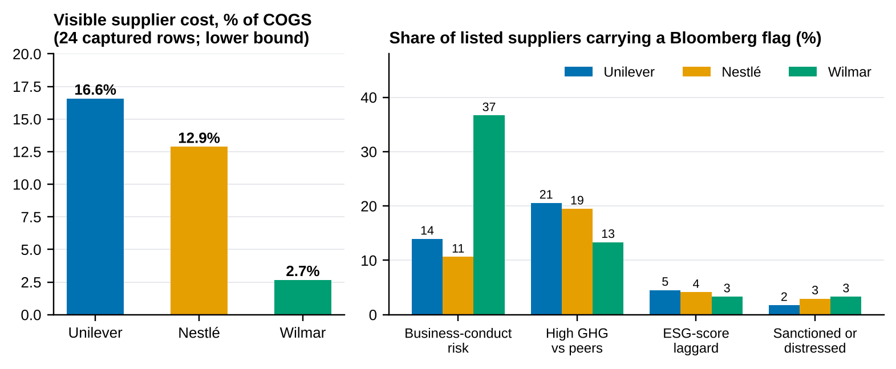
Source: Bloomberg SPLC, 15-Oct-2026 (captured rows only); authors’ calculations.

Finding 1 — the palm chain is invisible to SPLC
The 24 captured Unilever suppliers account for 16.6% of Unilever’s cost base and the 24 captured Nestlé suppliers for 12.9% (Figure 3.1); they are dominated by packaging (49% of Nestlé’s visible cost, 19% of Unilever’s), flavours and ingredients, technology and logistics. None is a palm trader, refiner or plantation. Wilmar appears in neither list, and neither Unilever nor Nestlé appears among Wilmar’s visible customers. The chain “mill → Wilmar → Unilever/Nestlé” that motivates the project is therefore an industry fact, not an SPLC finding. Nestlé’s own news flow points to other palm partners: in July 2025 Bloomberg reported that Musim Mas, Nestlé and AAK renewed a palm partnership on environmental and social issues.
For Wilmar, the 24 captured suppliers account for only 2.7% of Wilmar’s cost base (COGS plus SG&A). Ten are palm or plantation nodes, together just 0.4% of the cost base, although palm products dominate Wilmar’s business. Most palm is bought from third-party mills and smallholders that SPLC does not cover. This gap, not any single supplier, is the traceability problem.

Finding 2 — what Wilmar’s visible suppliers say about leverage
Figure 3.2 plots Wilmar’s visible suppliers (listed in Table 3.2) by their weight in Wilmar’s costs (criticality to Wilmar) and by Wilmar’s weight in their revenue (Wilmar’s leverage over them). Plantation suppliers such as Andira Agro (99% of revenue from Wilmar), Gozco (47%) and AEP Pinago (39%) are tiny in Wilmar’s cost base but depend heavily on Wilmar. Weighted by cost, Wilmar supplies 27% of the revenue of its visible palm nodes. In TCE terms (Chapter 2), the buyer holds the bargaining power: Wilmar can require geolocation and audit access from these suppliers at low cost to itself. The squares are group companies or joint ventures (Yihai Kerry Arawana, Wilmar Cahaya Indonesia, AWL Agri); these relationships are flagged from company names and should be verified.
Figure 3.2 — Wilmar’s visible suppliers: criticality to Wilmar versus Wilmar’s leverage over the supplier
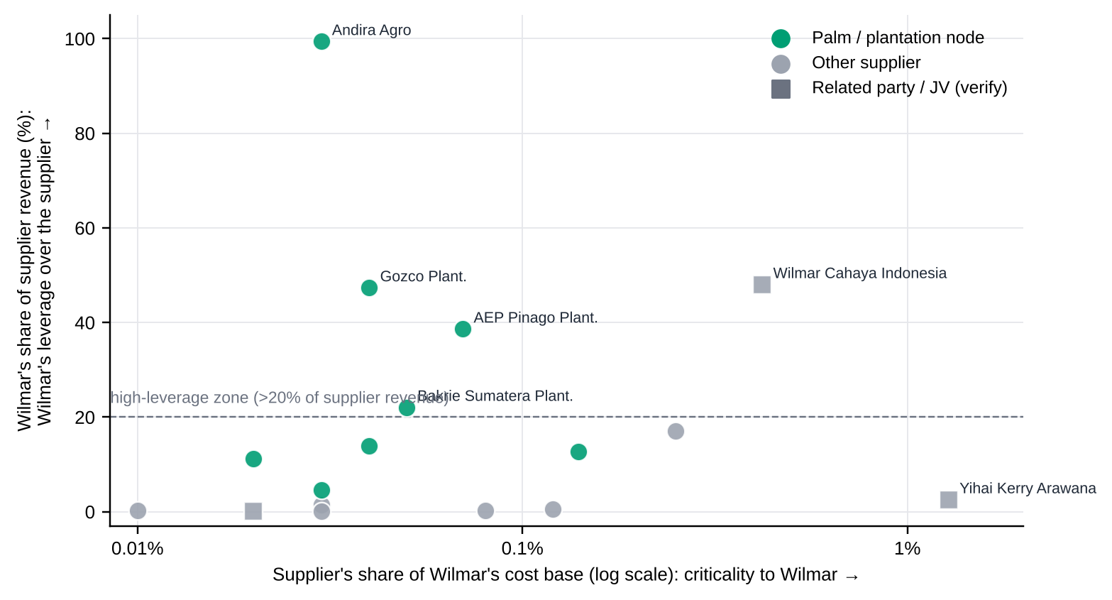
Source: Bloomberg SPLC, 15-Oct-2026 (captured rows only); authors’ calculations. Palm and related-party flags are the authors’ judgement from company names.
Table 3.2 — Wilmar’s largest visible suppliers (SPLC, top 12 of 24 captured)
Supplier | Share of Wilmar cost | Wilmar share of supplier revenue | Cost type | Palm / plantation node | Related party (verify)
Yihai Kerry Arawana Holdings | 1.28% | 2.5% | COGS | No | Yes
Wilmar Cahaya Indonesia Tbk PT | 0.42% | 48.0% | COGS | No | Yes
Shree Renuka Sugars | 0.25% | 17.0% | COGS | No | No
Dharma Satya Nusantara Tbk PT | 0.14% | 12.7% | COGS | Yes | No
GPT Group/The | 0.12% | 0.6% | SGA | No | No
Ecolab Inc | 0.08% | 0.3% | COGS | No | No
AEP Pinago Plantations Tbk PT | 0.07% | 38.6% | COGS | Yes | No
Bakrie Sumatera Plantations Tbk PT | 0.05% | 22.1% | COGS | Yes | No
Kencana Agri Ltd | 0.04% | 13.9% | COGS | Yes | No
Gozco Plantations Tbk PT | 0.04% | 47.3% | COGS | Yes | No
PPB Group Bhd | 0.03% | 1.5% | COGS | No | No
SIS Ltd | 0.03% | 0.1% | SGA | No | No

Source: Bloomberg SPLC, 15-Oct-2026 (captured rows only); authors’ calculations.

Concentration and the Wilmar-to-brand-owner link
Concentration among the visible suppliers is moderate. The Herfindahl–Hirschman Index (HHI, sum of squared cost shares ×10,000, computed on the visible rows only) is 781 for Nestlé, 1,456 for Unilever and 1,331 for Wilmar (excluding related parties; the top three unrelated suppliers hold 54% of Wilmar’s visible cost). These are within-sample measures and say little about the true concentration of the palm base.
The brief asks for “Supplier Revenue Exposure %” and “COGS Reliance %” for Wilmar as a supplier to Unilever and Nestlé. SPLC does not show this link, so we bound it. Using the palm-spend shares assumed in Chapter 5 (3.0% of Unilever’s COGS and 1.5% of Nestlé’s; ASSUMPTION), annual palm purchases would be about USD 0.9 bn for Unilever and USD 0.9 bn for Nestlé. Even if every tonne came from Wilmar, that is at most about 1.3% of Wilmar’s revenue per brand owner, while for each brand owner palm oil is a small share of COGS. The relationship is therefore important for compliance and reputation but not for the brand owner’s cost structure or for Wilmar’s revenue. That is why Chapter 5 values traceability by avoided regulatory, reputational and substitution loss rather than by input-cost savings.
To complete from the Terminal (not available from the captured screens)
Search the full SPLC supplier lists of Unilever and Nestlé for Wilmar, IOI, Musim Mas, AAK and Cargill (SPLC <GO>, enter the company, Suppliers tab, search box). If found, insert the Supplier Revenue Exposure % and Cost % into the placeholder rows of the workbook sheet Supply_Chain and replace the bounds above. Add each brand owner’s published mill list as a second source.

3.2 Financial health and margin analysis
Annual statements (Bloomberg FA) for FY2019–FY2025 show very different margin structures (Figure 3.3). Unilever and Nestlé earn gross margins of 46–47% and operating margins of 16–20%; Wilmar, a processor and merchant, earns 8% and 3%. For the brand owners, palm oil is a small part of COGS, so margins respond mainly to the broader mix of inputs, pricing and portfolio changes. Unilever’s FY2024–25 figures are restated after the ice-cream demerger and are not strictly comparable with earlier years.
Figure 3.3 — Gross and operating margins, FY2019–FY2025
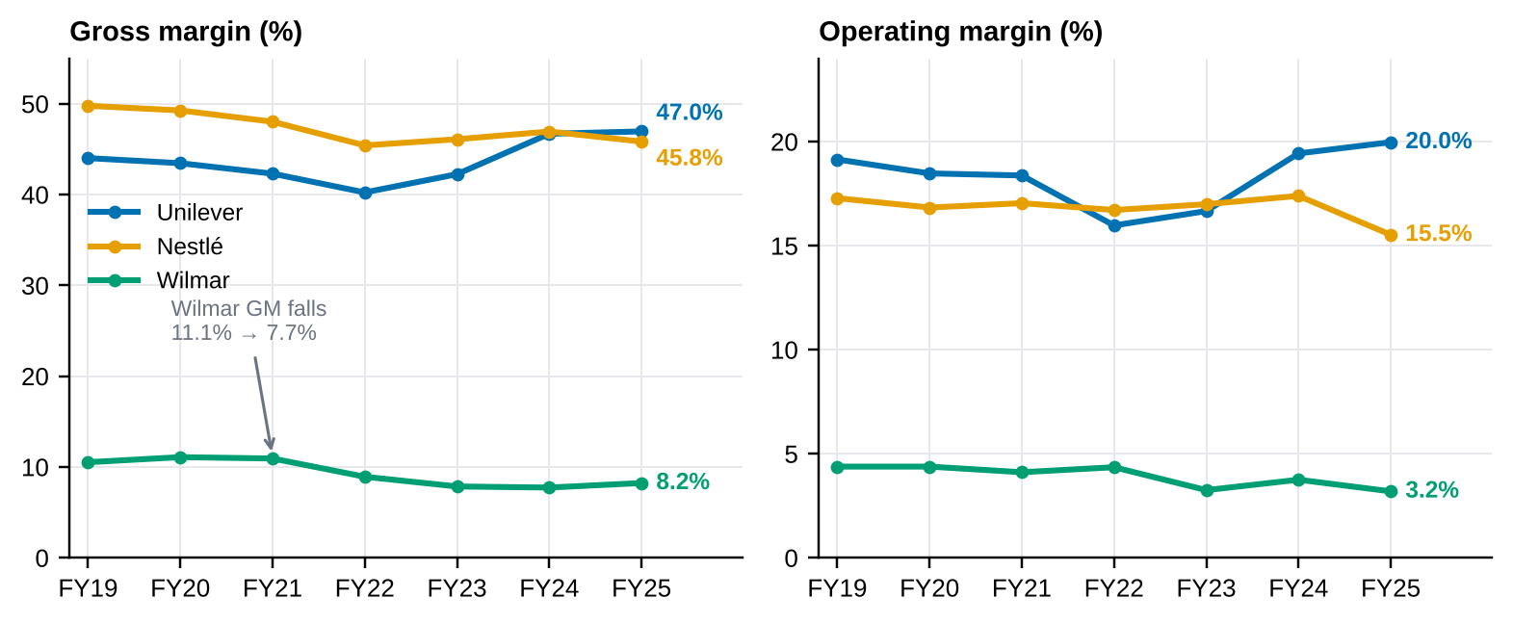
Source: Bloomberg FA, 15-Oct-2026; authors’ calculations (gross margin = (revenue − COGS)/revenue).
Table 3.3 — Margin and resilience diagnostics, FY2019 → FY2025
Firm | Gross margin %  FY19 → FY25 | Change (pp) | Gross margin range | Operating margin %  FY19 → FY25 | Change (pp) | Interest cover FY25 | Inventory days FY25
Unilever | 44.0 → 47.0 | +2.9 | 40.2–47.0 | 19.1 → 20.0 | +0.8 | 9.1× | 55
Nestlé | 49.8 → 45.8 | -3.9 | 45.4–49.8 | 17.3 → 15.5 | -1.8 | 8.3× | 96
Wilmar | 10.5 → 8.2 | -2.3 | 7.7–11.1 | 4.4 → 3.2 | -1.2 | 2.1× | 83

Source: Bloomberg FA; authors’ calculations. Inventory days = inventory / COGS × 365.
Three patterns stand out (Table 3.3). (i) Wilmar’s gross margin compressed from 10.9% in FY2021 to 7.7% in FY2024 while revenue grew by about 65% from FY2019 to FY2025 (USD 42.6 bn to 70.4 bn), consistent with commodity price inflation lifting sales faster than spread. (ii) Nestlé’s operating margin fell to 15.5% in FY2025, its lowest in the window, and Nestlé holds the most inventory (96 days). (iii) Interest cover has fallen at both brand owners, from 13.0× to 9.1× (Unilever) and from 14.3× to 8.3× (Nestlé), while Wilmar is back where it started (2.0× in FY2019, 2.1× in FY2025) after peaking at 4.6× in FY2021. Thin cover is what makes Wilmar fragile: a fine or a forced supplier substitution is a larger share of its earnings than of Unilever’s or Nestlé’s.

Palm oil price overlay
Figure 3.4 shows the Dec-2026 Bursa Malaysia crude palm oil contract (KOZ6 Comdty) and the three equities over the eight weeks captured on 15 October. KOZ6 rose to MYR 5,115 per tonne on 8 September and then fell 9% to MYR 4,666. Over the 33–36 return pairs that align with each equity, correlations with palm oil returns are 0.18 (Unilever), 0.23 (Nestlé) and −0.08 (Wilmar). With this sample a correlation must exceed about ±0.34 to be distinguishable from zero at the 5% level, so none of the three is statistically significant and we make no claim about price pass-through from these data (RQ2). Annualised volatility is 17% for palm oil, 18% for Unilever, 18% for Nestlé and 19% for Wilmar.
Figure 3.4 — Crude palm oil (KOZ6) and equity prices, 17 August – 15 October 2026
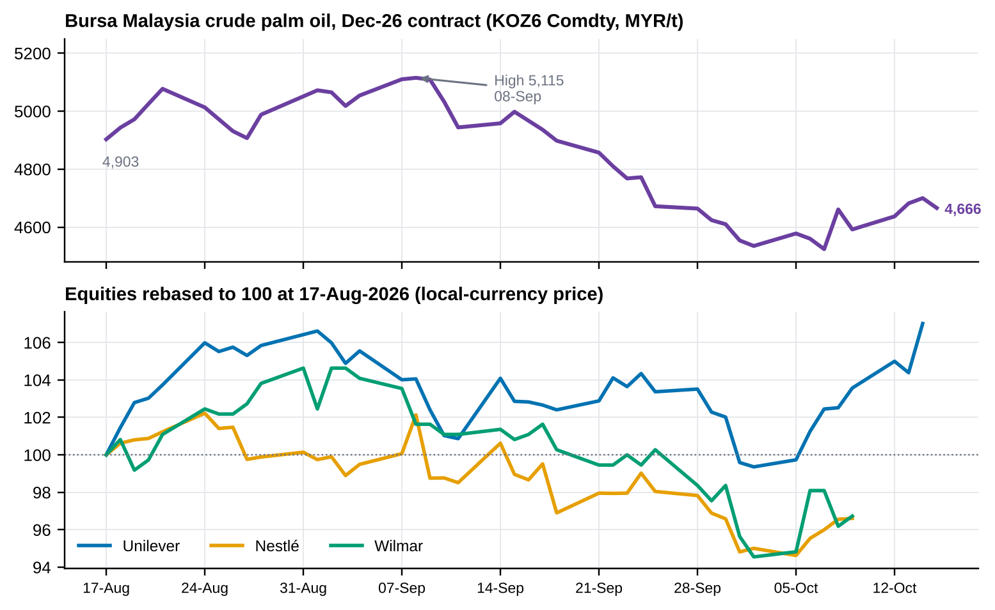
Source: Bloomberg HP / GP tables, 15-Oct-2026. KOZ6 is the Dec-2026 contract; a continuous series (KO1) is needed for multi-year work.
Multi-year overlay still to be added from the Terminal
The brief asks for 5–10 years of palm oil prices overlaid on margins. The screens we captured cover eight weeks of daily prices. Pull KO1 Comdty (monthly, 2016–2026) with the BDH query in Appendix A.2, then re-run Section 4 of the notebook; the margin table above is already annual and needs no change. The correlation test above should be repeated on monthly returns (≈120 observations).

3.3 ESG and controversy profiling
Bloomberg’s ESG disclosure score (BESG, 0–10) rises for all three firms over 2016–2024, most steeply for Wilmar (2.71 to 6.15; Figure 3.5 and Table 3.4). Reported Scope 1 emissions tell a different story: Wilmar’s rose 2.6× (3,551 to 9,100 kt CO₂e) while Unilever’s halved and Nestlé’s fell 22%. The score tracks disclosure, not footprint. A firm that discloses more earns a higher score even when its emissions grow. The correlation between Wilmar’s BESG score and its gross margin over 2019–2024 is −0.76, but with six observations it is not significant (p = 0.08) and reflects two trends moving in opposite directions, not a causal link.
Figure 3.5 — ESG disclosure score and Scope 1 emissions, 2016–2025
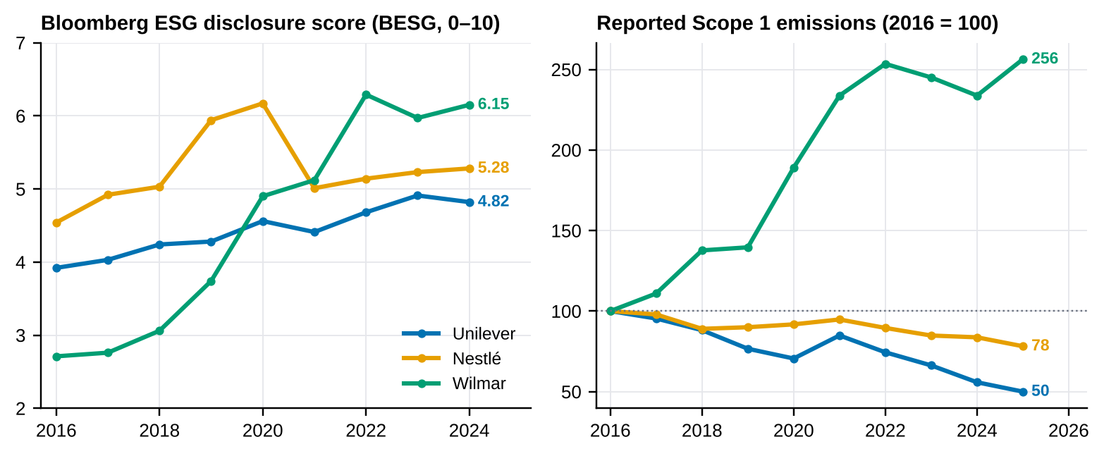
Source: Bloomberg ESG, 15-Oct-2026; authors’ calculations. Scope 1 indexed to 2016 = 100 (Wilmar 3,551 kt → 9,100 kt).
Table 3.4 — Bloomberg ESG snapshot, 2024 (BESG pillars 0–10)
Firm | BESG overall | Environmental | Social | Governance | Change in BESG 2019→24 | Scope 1, 2025 (Mt) | Scope 3, latest (Mt)
Unilever | 4.82 | 5.51 | 2.08 | 7.59 | +0.54 | 0.4 | 104
Nestlé | 5.28 | 5.18 | 4.11 | 6.71 | -0.66 | 2.8 | 72
Wilmar | 6.15 | 6.59 | 6.46 | 5.16 | +2.41 | 9.1 | 147

Source: Bloomberg ESG. Wilmar’s latest Scope 3 is 2024 (147 Mt); Unilever and Nestlé 2025. Unilever’s Scope 3 series has boundary breaks in 2020 and 2022.
Figure 3.6 — Reported Scope 3 emissions and 2024 intensity
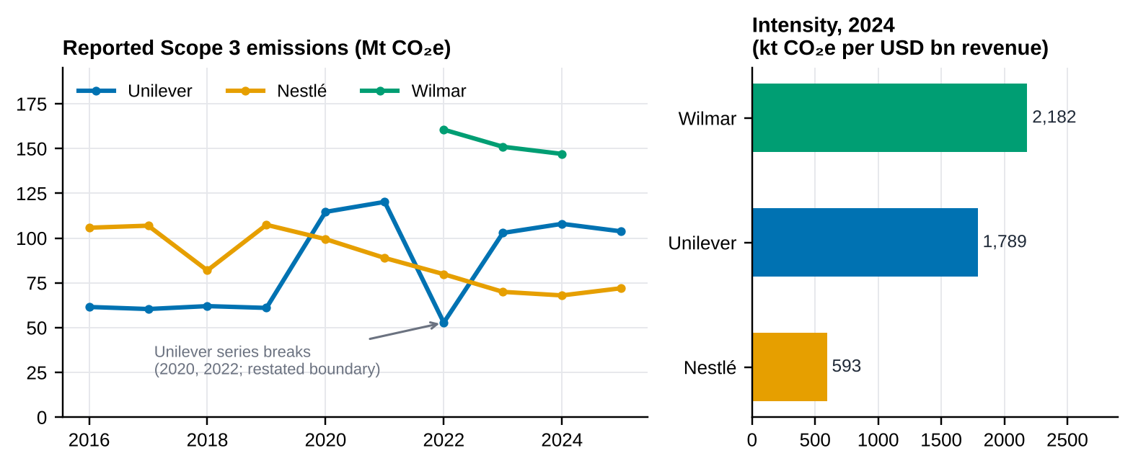
Source: Bloomberg ESG; intensity = Scope 3 (kt CO₂e) / revenue (USD bn), 2024; authors’ calculations.
In Figure 3.6, Scope 3 intensity per dollar of revenue is highest at Wilmar (2,182 kt per USD bn), then Unilever (1,789) and Nestlé (593). The Unilever and Wilmar figures are not directly comparable with Nestlé’s because they depend on different Scope 3 boundaries and methods; we use intensity only as an indicator in the SPOEI (Chapter 4), capped so that one boundary change cannot dominate the score.

News and controversy
Table 3.5 — Hand-coded Bloomberg News headlines, 15-Oct-2025 to 15-Oct-2026
Firm | CN search filter | Items coded | Adverse items | Severity (sum, 1–5 each) | Positive items | Antitrust items (excluded)
Unilever | Unilever + ESG | 7 | 5 | 12 | 0 | 2
Nestlé | Nestlé + Palm Oil | 2 | 1 | 1 | 0 | 0
Wilmar | Wilmar + Palm Oil; Wilmar + ESG | 10 | 6 | 19 | 2 | 0

Source: Bloomberg CN, captured 15-Oct-2026; severity coding by the authors (1 = minor, 5 = major). Search filters differ by firm (see caution below).
Figure 3.7 — Timeline of coded headlines for the three firms
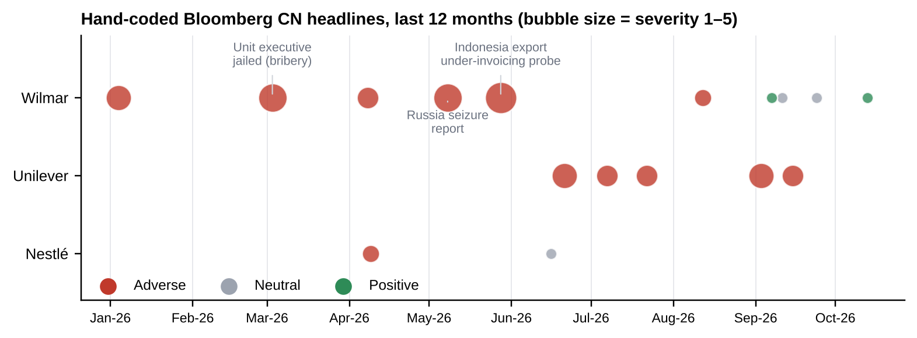
Source: Bloomberg CN; authors’ coding. Antitrust items (McCormick–Unilever Foods review, Turkey probe) are excluded because they are not supply-chain risk.
Table 3.5 and Figure 3.7 summarise the coded headlines. Wilmar carries the heaviest adverse record (six items, severity 19), led by the Indonesian export under-invoicing and transfer-pricing probe (May 2026; Wilmar shares fell most in six years), the report that Russia would seize a Wilmar stake (May 2026), the jailing of a Wilmar unit executive for bribery (March 2026), a Glass Lewis controversy alert (April 2026) and Indonesian land-seizure news (January 2026). Unilever’s items are governance, claims and product-quality stories (Sunlight greenwashing order, plant production halt, Ben & Jerry’s governance, packaging targets). Nestlé has one adverse item (a sell-side cost-inflation warning) and one neutral item on palm prices; its July 2025 palm-partnership story falls just outside the window.
Two cautions on the news evidence
Governance, not deforestation. Wilmar’s 2026 headlines are about corruption, tax and sanctions-type risk. They raise reputational and counterparty risk, but they are different from the deforestation risk the EUDR targets. The report therefore keeps the two narratives separate when reading the SPOEI.
Filters are not identical. The CN search terms differ by firm (Wilmar was searched with “Palm Oil” and “ESG”; Unilever with “ESG”; Nestlé with “Palm Oil”), so counts are not like-for-like. Chapter 4 reports the index with and without the news indicator for this reason. A time series of Bloomberg’s own sentiment score for the keywords “deforestation” and “RSPO controversy” would let us compute sentiment volatility; we did not have it, so no sentiment chart is shown.

Chapter 4 Predictive Modelling and Empirical Findings
This chapter builds the Sustainable Palm Oil Exposure Index (SPOEI) from the Bloomberg indicators (4.1), specifies the supervised model that would test whether the index and its components predict supply-chain distress (4.2), and reports what can and cannot be concluded now (4.3). We separate the three clearly: an index is a transparent weighted summary; a classifier is validated against outcomes it did not see; only the first can be built from the screens captured.

4.1 The Sustainable Palm Oil Exposure Index (SPOEI)
Definition. For firm i, SPOEI is the weighted average of K scaled indicators:
SPOEI_{i} = Σ_{k=1..K} w_{k} · S_{ik} Σ w_{k} = 1, w_{k} ≥ 0
S_{ik} = 100 × min{ 1, max{ 0, (x_{ik} − f_{k}) / (c_{k} − f_{k}) } }
where x is the raw indicator, f the floor (score 0) and c the cap (score 100), set so that the scale is meaningful rather than sample-relative (Table 4.1). Higher means more exposure. For indicators where lower is riskier (interest cover) the floor is above the cap, which reverses the scale. The ten indicators fall into four pillars that map to the four ingredients named in the brief:
• Supplier network (concentration and flags): four SPLC flag shares. HHI of visible cost shares is computed (Chapter 3) but is not scored here, because on captured rows it is a within-sample number; it enters the panel version below.
• ESG gap: BESG score gap, social-pillar gap, Scope 3 intensity.
• News: severity of adverse CN headlines over 12 months. News volatility needs a sentiment time series (panel version).
• Market and financial: equity volatility and interest cover. Commodity price variance is common to all three firms at one date, so it cannot rank them; it enters the panel version as σ²(CPO) × firm palm exposure.
Panel version (for Section 4.2). With firm-month data the index generalises to
SPOEI_{it} = ω₁ · HHI*_{it} + ω₂ · GAP_{it} + ω₃ · σ(NEWS)_{it} + ω₄ · σ²(CPO)_{t} · EXP_{i}
where HHI* is the scaled supplier concentration, GAP the scaled ESG gap, σ(NEWS) the scaled volatility of news sentiment, and EXP the firm’s palm-linked spend share. The ten-indicator index estimated here is the cross-sectional special case.
Table 4.1 — SPOEI indicators, scaling and weights
# | Indicator | Pillar | Definition (source: Bloomberg SPLC, ESG, CN, FA, DES) | Floor → cap | Base | Equal | E/S-heavy
1 | BESG score gap | ESG gap | 10 − BESG overall score, 2024 | 0 → 10 | 0.15 | 0.10 | 0.15
2 | BESG social-pillar gap | ESG gap | 10 − BESG social pillar, 2024 | 0 → 10 | 0.15 | 0.10 | 0.20
3 | Scope 3 intensity | ESG gap | Scope 3 (kt CO₂e) per USD bn revenue, 2024 | 0 → 3,000 | 0.15 | 0.10 | 0.20
4 | Supplier conduct-risk flags | Supplier network | Share of listed suppliers with Bloomberg business-conduct risk | 0 → 40% | 0.10 | 0.10 | 0.10
5 | High-GHG suppliers | Supplier network | Share of listed suppliers with high GHG intensity vs peers | 0 → 25% | 0.05 | 0.10 | 0.10
6 | ESG-laggard suppliers | Supplier network | Share of listed suppliers that are ESG-score laggards | 0 → 10% | 0.05 | 0.10 | 0.05
7 | Sanctioned / distressed suppliers | Supplier network | Share of listed suppliers sanctioned or distressed | 0 → 5% | 0.10 | 0.10 | 0.05
8 | Adverse news severity (12M) | News | Sum of severity (1–5) of adverse CN headlines, 12 months, excl. antitrust | 0 → 20 | 0.10 | 0.10 | 0.05
9 | Equity volatility (90-day) | Market and financial | 90-day annualised equity volatility, % | 10 → 40 | 0.05 | 0.10 | 0.00
10 | Interest cover (inverse) | Market and financial | Operating income / interest expense, FY2025 (lower = riskier) | 12× → 2× | 0.10 | 0.10 | 0.10
 | Sum of weights |  |  |  | 1.00 | 1.00 | 1.00

Floors and caps are the authors’ judgement and are listed in the workbook sheet Risk_Index. “E/S-heavy” raises the weights on environmental and social indicators and drops equity volatility.
Figure 4.1 — SPOEI indicator scores and index under four weightings
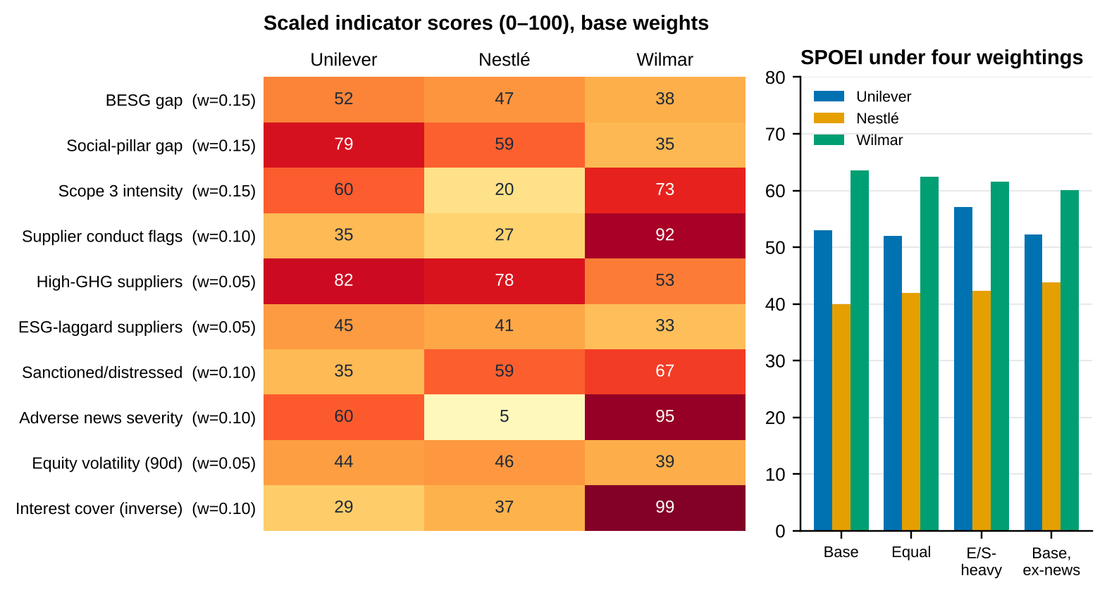
Source: Bloomberg SPLC, ESG, CN, FA, DES (15-Oct-2026); authors’ calculations. Right panel: base, equal, environmental/social-heavy weights, and base without the news indicator (re-normalised).

Descriptive statistics
Table 4.2 — SPOEI by weighting scheme (0–100; higher = more exposed)
Weighting | Unilever | Nestlé | Wilmar | Mean | Std. dev. (n = 3) | Range | Ranking (high → low)
Base | 53.0 | 39.9 | 63.5 | 52.2 | 11.8 | 23.6 | Wilmar > Unilever > Nestlé
Equal | 52.0 | 41.9 | 62.4 | 52.1 | 10.3 | 20.5 | Wilmar > Unilever > Nestlé
E/S-heavy | 57.1 | 42.2 | 61.6 | 53.6 | 10.1 | 19.3 | Wilmar > Unilever > Nestlé
Base, no news | 52.2 | 43.8 | 60.0 | 52.0 | 8.1 | 16.2 | Wilmar > Unilever > Nestlé

Source: workbook sheet Risk_Index; authors’ calculations. Only three cross-sectional observations exist, so the standard deviation describes the spread of these firms, not a sampling distribution.
Under base weights (Table 4.2, Figure 4.1) Wilmar scores 63.5, Unilever 53.0 and Nestlé 39.9 (mean 52.2, range 23.6). The order Wilmar > Unilever > Nestlé is the same under all four weightings. It also survives dropping any single indicator (10 of 10 leave-one-out runs) and holds in 78% of 20,000 random weight vectors (Dirichlet(1,…,1)); Wilmar is the top-ranked firm in 83% of them and Nestlé the lowest in 92%. The weakest link is Unilever versus Wilmar (a 10.5-point base-case gap that shrinks to 8 points when the news indicator is dropped and to 4 points when interest cover is dropped). The result is therefore robust for Nestlé’s lower position and moderately robust for Wilmar’s higher one.
What drives the ranking. Figure 4.2 decomposes Wilmar’s premium. Against Nestlé (+23.6 points) the largest contributors are adverse news (+9.0), Scope 3 intensity (+7.9), supplier conduct flags (+6.5) and interest cover (+6.2); against Unilever (+10.5) they are interest cover (+7.1), conduct flags (+5.7) and news (+3.5), partly offset by Unilever’s much weaker social-pillar score (−6.6). Notably, the BESG-based indicators work against Wilmar: its disclosure score is the best of the three, so a score-based screen would rank it safest. This is the central RQ1 observation: the indicators that best separate the firms are financial resilience, supplier conduct flags and news, not the ESG score.
Figure 4.2 — What makes Wilmar’s SPOEI higher than Nestlé’s and Unilever’s
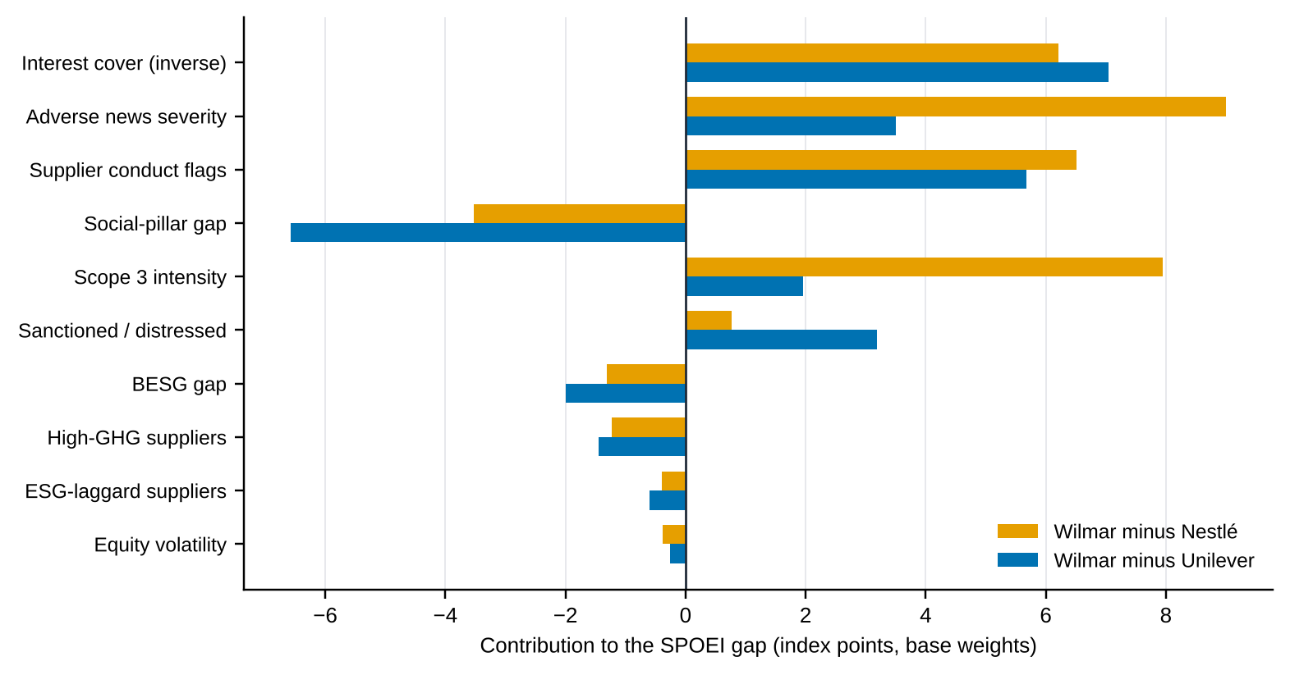
Source: workbook sheet Risk_Index; authors’ calculations. Bars are weight × indicator-score differences, so they sum to the total gap.
How far the index can be trusted
It is a screening tool, not a validated predictor. Scores are relative to judgement-based floors and caps, there are only three firms, and indicators were chosen by us. Validating the index against an outcome it does not contain is the job of the model in 4.2.
Circularity warning. If the model’s target were built from the same news and ESG signals that feed the index, a high AUC would show only that we predicted our own inputs. The specification below prevents that.

4.2 Model specification and methodology
The question behind RQ1 and RQ3 is whether Bloomberg-observable indicators observed at date t predict a supply-chain distress or controversy event in the following twelve months better than a naive benchmark. Table 4.3 gives the design, which is implemented in the companion notebook (Part 5, function load_panel()) and runs unchanged when the panel file is supplied.
Table 4.3 — Model specification
Element | Specification
Unit and panel | Firm-month, 2016-01 to 2026-09. Universe of at least 40 palm-exposed issuers: the three case firms plus SPLC peers (plantations, refiners/traders, FMCG buyers). A three-firm panel has only three independent clusters and cannot generalise.
Target Y(i,t) | 1 if, in months t+1…t+12, any of: (a) an RSPO complaint or membership sanction against the firm or a named subsidiary; (b) a new Bloomberg ESG controversy flag; (c) a CN headline matching deforestation / RSPO / EUDR / NDPE with coded severity ≥ 3. Source for (a) is external to Bloomberg to keep the target independent of the features.
Features X(i,t) | X1 HHI of supplier cost shares; X2 BESG environmental gap and its 12-month change; X3 news z-score (trailing 90 days) and sentiment volatility; X4 σ²(CPO) × palm exposure; X5 interest cover; X6 SPLC flag shares; X7 equity volatility and beta. All measured at t or earlier and lagged one period.
Benchmarks (RQ3) | B0 prevalence (constant base rate); B1 persistence (event in the previous 12 months); B2 logistic regression on the BESG gap alone; B3 SPOEI as a single score.
Advanced models | Elastic-net logistic regression (L1 ratio 0.5, C = 0.5); Random Forest (500 trees, depth ≤ 5, min. leaf 5, balanced class weights); XGBoost (300 trees, depth 3, learning rate 0.05) if installed.
Split and validation | Expanding-window walk-forward with three test blocks: 2022, 2023 and 2024-01 to 2025-09 (the headline block). Each block is trained only on rows whose 12-month label window ends before the block starts (training month ≤ block start − 13 months), which also removes the overlap between adjacent labels (Cerqueira et al., 2020). Hyperparameters are fixed in advance (below), so no tuning window can leak. Standardisation is fitted on training data only.
Metrics | ROC-AUC (with firm-clustered bootstrap CI), PR-AUC, precision and recall at the top 10% alert rate, Brier score and calibration slope. AUC differences against benchmarks tested with DeLong et al. (1988).
Explainability | Permutation importance grouped by pillar and SHAP values from the tree models (Lundberg and Lee, 2017); stability checked across walk-forward folds; partial-dependence plots for the top three features.
Leakage controls | (i) No feature uses information after t. (ii) Target source (a) is external to the feature set. (iii) Variant runs drop X3 so that news does not appear on both sides. (iv) No random k-fold across time (Kaufman et al., 2012). (v) Firm identity is not a feature.
Success criterion (pre-registered) | The model outperforms if test ROC-AUC exceeds the best of B0–B3 by at least 0.05 with a DeLong p-value < 0.05, and PR-AUC is also higher.

Random Forest: Breiman (2001). Gradient boosting: Chen and Guestrin (2016).

4.3 Results and feature importance
Status: classifier results are not reported
The screens captured on 15 October give annual fundamentals and ESG for three firms (21 firm-years) and eight weeks of prices. They contain no labelled event history, so no ROC-AUC, precision, recall or SHAP values can be computed from them, and none are reported. We did not substitute simulated or synthetic labels, because a model trained on invented outcomes would measure our own assumptions.
RQ3 therefore remains open. Table 4.4 states what is needed, Figure 4.3 shows the sample size at which the question becomes answerable, and Table 4.5 is the results shell that the notebook fills once the panel exists.

Table 4.4 — What the available data can and cannot support
Requirement for RQ3 | Held now | Needed | Gap
Labelled firm-periods | 21 firm-years (3 firms × 7) | ≈ 85 (17 events + 68 non-events) for AUC 0.70 vs 0.5 at 80% power | About 4× more observations
Events (Y = 1) | Not labelled; ≈ 4 if 20% prevalence | ≥ 17 at prevalence 20% (≥ 20 at 35%) | 13+ events
Independent clusters (firms) | 3 | ≥ 40 for out-of-firm generalisation | 37+ firms
Time depth | 7 years annual; 8 weeks daily | 10 years monthly (≈ 120 per firm) | Monthly pull via BQL
Benchmark comparison (RQ3) | None possible | B0–B3 on the same test window | Panel file

Source: Hanley and McNeil (1982) variance approximation; authors’ calculations. See notebook function n_events_required().
Figure 4.3 — Positive events required to detect a given AUC against chance
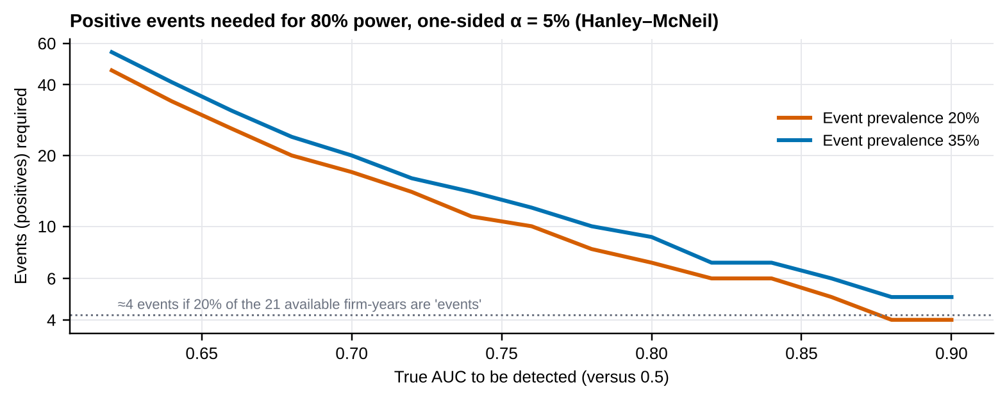
Source: Hanley–McNeil standard errors; one-sided α = 5%, power 80%; authors’ calculations. Dotted line: events if 20% of the 21 available firm-years were positives.
What can be said now about RQ1. The structural analysis in 4.1 shows which Bloomberg indicators separate the three firms (interest cover, supplier conduct flags, adverse news and Scope 3 intensity) and which do not (BESG-based gaps, equity volatility). This is an answer about the index, not about prediction; it tells us where to look but not whether those indicators foresee events. The one pairwise test we can run, Wilmar’s BESG score against its gross margin over six years, gives r = −0.76 (p = 0.08), too weak and too short to support a conclusion.
Table 4.5 — Results table to be completed when the panel is available (test window 2024-01 to 2025-09)
Model | ROC-AUC (95% CI) | PR-AUC | Precision @ top 10% | Recall @ top 10% | Brier | DeLong p vs best benchmark
B0 Prevalence | [ — ] | [ — ] | [ — ] | [ — ] | [ — ] | —
B1 Persistence | [ — ] | [ — ] | [ — ] | [ — ] | [ — ] | —
B2 Logit, BESG gap only | [ — ] | [ — ] | [ — ] | [ — ] | [ — ] | [ — ]
B3 SPOEI score | [ — ] | [ — ] | [ — ] | [ — ] | [ — ] | [ — ]
Elastic-net logit | [ — ] | [ — ] | [ — ] | [ — ] | [ — ] | [ — ]
Random Forest | [ — ] | [ — ] | [ — ] | [ — ] | [ — ] | [ — ]

Yellow cells are intentionally empty. Run notebook Part 5 after saving the panel as spoei_panel.csv (columns listed in Appendix A.3); the notebook prints this table and the SHAP/permutation-importance chart.

Chapter 5 Blockchain Architecture and Financial Stress Testing

5.1 Proposed permissioned blockchain architecture
The design follows the minimum blockchain expectation of the course brief: it names the actors, the data objects, the permission model, the transaction flow, the oracle inputs, the governance and the measurable business value (Table 5.1). Figure 5.1 shows the physical flow of palm oil (plantation → mill → refinery → manufacturer → EU market) alongside the digital flow that records and verifies it.
Figure 5.1 — Permissioned traceability architecture: physical flow, oracle inputs, ledger events and contracts
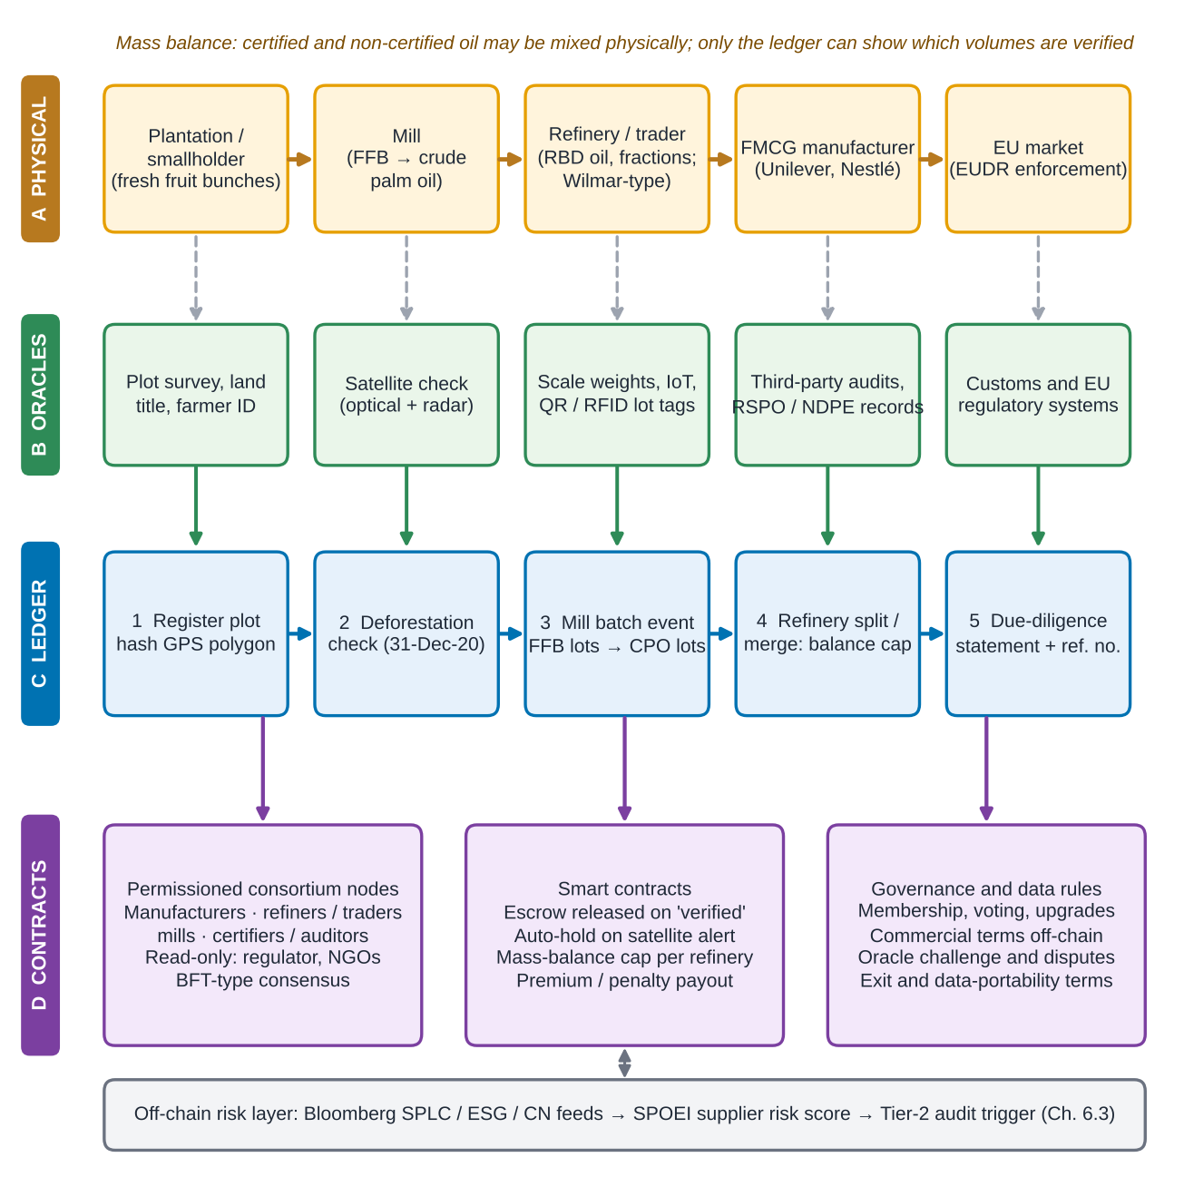
Source: authors’ design. Raw data (polygons, imagery, audit files) stay off-chain; only hashes, lot identifiers and signed attestations are written on-chain.
Table 5.1 — Architecture specification
Element | Design choice | Why
Actors (nodes) | Brand owners (Unilever, Nestlé), refiners/traders (Wilmar-type), large mills, certifiers/auditors; read-only access for EU competent authorities and NGOs | The parties that carry legal liability must be identifiable; mills and smallholders join through their mill group
Data objects | Plot record (polygon hash, owner ID, land-title reference); lot (FFB lot → CPO lot → RBD lot) with volume, date, location; verification attestation; due-diligence-statement reference | One lot ID is split and merged but never created without an upstream parent
Permission model | Permissioned, role-based. Writers are the party that physically holds the lot; validators are consortium members; regulators read | Commercial confidentiality plus regulator access
Transaction flow | (1) register plot → (2) satellite check against the 31-Dec-2020 cut-off → (3) mill batch event → (4) refinery split/merge under a mass-balance cap → (5) due-diligence statement → escrow release | Maps to EUDR Articles 9–10: geolocation, risk assessment, statement
Oracles / data inputs | Satellite deforestation alerts, scale and sensor weights, QR/RFID lot tags, third-party audits, customs and EU information-system data | The ledger is only as true as its inputs; two independent sources per critical claim
Consensus and platform | Crash- or Byzantine-fault-tolerant voting among 10–30 known nodes (e.g., Hyperledger Fabric-type); optional public hash anchoring for external time-stamps | High throughput, no mining cost, auditable
Smart contracts | Escrow release only for lots with a passing step-2 check and a balanced step-4 ledger; auto-hold on a new satellite alert; per-refinery mass-balance cap; premium or penalty payout | Converts verification into payment terms, which is where behaviour changes
Governance | Consortium charter: membership and exit, voting, upgrade control, dispute and oracle-challenge process, data-portability and wind-down terms | Without governance a ledger is just a shared spreadsheet
Measurable value | Coverage (traceable share of volume), mitigation (reduction of fines and controversy loss), time to trace a lot, cost per verified tonne | Feeds the parameters in Section 5.2

Where a ledger adds value, and where it does not
Problem | Does a permissioned ledger solve it? | What is also needed
Same certified tonne claimed twice (double claiming) | Yes. Unique lot IDs and a refinery mass-balance cap make over-claiming visible and block payment | Complete participation by refineries
Shared, tamper-evident record among competitors with no neutral intermediary | Yes. Core strength of a consortium ledger | Consortium governance
Conditional payment on verified origin | Yes, through escrow smart contracts | Reliable verification event
False data at the source (forged polygon, bribed auditor) | No. The ledger preserves lies as faithfully as truths (oracle problem) | Satellite and sensor data, independent audits, challenge rights
Smallholder onboarding and cost | No. It is an organisational and financing problem | Mill-led registration, subsidy or premium
Single company tracking its own supply | No. A central database is cheaper and equivalent | Nothing: do not use a blockchain

Source: authors’ analysis, building on Caldarelli (2020), Babich and Hilary (2020) and Cole et al. (2019).
The test for adding a ledger is therefore narrow: several mutually distrustful parties must share one state, no neutral operator can be trusted to hold it, and payments must depend on it. The cost-benefit analysis below asks whether that narrow advantage is worth its extra cost over a well-run central database.

5.2 Simulation design
We compare three options over a seven-year horizon (year 0 build, years 1–7 benefits), for each firm: the status quo (fragmented, partly certified supply), a central database (one operator holds plot, lot and verification records; satellite checks and audits feed it) and a permissioned blockchain (the architecture above). For each option the model computes expected annual loss in three channels, adds programme cost and discounts at the firm’s rate. The benefit of an option is the present value (PV) of the status-quo total cost minus the PV of the option’s total cost.
Coverage: c(t) = c₀ + (c_max − c₀) · min(1, t / ramp) Mitigation: m(t) = c(t) · eff
Regulatory loss: Reg(t) = p_reg · fine · EU · Rev(t) · (1 − m(t))
Supplier substitution: Sub(t) = PalmSpend(t) · EU · (1 − c(t)) · q · π · P(t)
Reputational loss: Rep(t) = p_ctrv · rev_loss · a · Rev(t) · (1 − m(t))
Benefit = PV(total cost, status quo) − PV(total cost, option), total cost = Reg + Sub + Rep + OpEx, plus CapEx in year 0
Here Rev and PalmSpend grow at 2% a year, P(t) is the palm-oil price index, p_reg and p_ctrv are annual probabilities of a regulatory event and a public controversy, fine is the realised fine as a share of EU turnover, EU the EU-regulated share of revenue, a the palm-linked share of revenue, q the share of untraced volume that must be excluded and re-sourced, and π the price premium on re-sourced compliant volume. The status quo has coverage c₀ and mitigation c₀ × 0.60. Break-even is solved in closed form: the factor k on p_reg at which the benefit is zero is k = max(0, 1 − Benefit / PV of regulatory loss avoided). The benefit–cost ratio is PV of losses avoided over PV of programme cost (CapEx plus discounted OpEx); ROI = ratio − 1. Tables 5.2–5.4 list the inputs and the three scenarios.
Every parameter below except revenue and COGS is an ASSUMPTION
Bloomberg supplies FY2025 revenue and COGS (Chapter 3). Probabilities, fines, premia, coverage, effectiveness and programme costs are not observable on the Terminal; they are placeholders chosen to be plausible, documented in the workbook sheet Assumptions and exposed to sensitivity analysis. Replace them with Wilmar-, Unilever- and Nestlé-specific estimates (and Bloomberg WACC and FX) before relying on absolute NPVs.

Table 5.2 — Global and option parameters (ASSUMPTION)
Parameter | Value | Meaning
Discount rate r / growth g / horizon | 8% / 2% / 7 years | Replace r with firm WACC from Bloomberg WACC <GO>
Realised fine (share of EU turnover) | 2% (range 0.5–4%) | EUDR cap is at least 4%; actual fining practice is unknown
Untraced EU-bound volume excluded, q | 30% | Share re-sourced when it cannot be shown compliant
Price premium on re-sourced volume, π | 6% | Compliant-supply premium
Traceable share today, c₀ | 30% | RSPO/NDPE-style partial coverage
Palm-oil price volatility | 17.05% a year | Bloomberg KOZ6, 8-week window; used in Monte Carlo (geometric Brownian motion)
FX to USD | EUR 1.15; CHF 1.25 | Illustrative; replace with Bloomberg FX on the data date
Status quo: effectiveness | 0.60 | Mitigation per unit of coverage
Central database: steady coverage / ramp / effectiveness | 80% / 3 years / 0.80 | Central stack plus satellite and audits
Permissioned blockchain: steady coverage / ramp / effectiveness | 90% / 4 years / 0.90 | Slower to coordinate, higher assurance

Table 5.3 — Firm profiles and programme costs (ASSUMPTION except revenue and COGS)
 | Unilever | Nestlé | Wilmar
FY2025 revenue / COGS (reporting currency, m) — Bloomberg | EUR 50,503 / 26,794 | CHF 89,885 / 48,694 | USD 70,416 / 64,620
Palm-linked revenue share, a | 25% | 15% | 40%
Palm spend as share of COGS | 3.0% | 1.5% | 30%
EU-regulated revenue share | 25% | 25% | 8% (indirect)
Annual regulatory-event probability, p_reg | 3% | 3% | 5%
Annual controversy probability, p_ctrv | 10% | 10% | 15%
Revenue lost on palm-linked sales in a controversy | 0.5% | 0.5% | 1.0%
Central database: CapEx / OpEx per year (USD m) | 8.0 / 3.0 | 7.0 / 2.5 | 25.0 / 10.0
Permissioned blockchain: CapEx / OpEx per year (USD m) | 14.0 / 4.5 | 12.0 / 4.0 | 40.0 / 14.0

Wilmar’s EU share is low because its sales are mostly in China and Asia; EUDR pressure reaches it through customers such as Unilever and Nestlé (Chapter 3).
Table 5.4 — Scenario definitions (multipliers on base risk inputs)
Scenario | Regulatory-event probability | Controversy probability | Substitution premium | Palm price level | Narrative
Base | ×1 | ×1 | ×1 | ×1.0 | Enforcement as expected: low inspection intensity in year 1–2
Adverse | ×2 | ×1.5 | ×1.5 | ×1.0 | Active enforcement; NGO and press scrutiny rises
Severe | ×4 | ×2.5 | ×2.5 | ×1.3 | Strict enforcement, a high-profile case and a palm price spike

Monte Carlo. To describe uncertainty we draw 20,000 worlds with a fixed seed (42). In each, regulatory and controversy probabilities are multiplied by log-normal noise (σ = 0.5 and 0.4), the realised fine is uniform on 0.5–4%, the exclusion share q is triangular (10%, 30%, 50%), the premium is log-normal (σ = 0.3), the discount rate is triangular (6%, 8%, 11%) and the baseline coverage triangular (15%, 30%, 45%). The palm price follows a geometric Brownian motion with the sample volatility. Programme cost overruns are log-normal (σ = 0.30 for the database and 0.35 for the ledger), and the options’ own coverage, ramp-up and effectiveness are triangular. Mixed runs draw an enforcement regime for each world (25% benign, 50% base, 25% severe). Every option is evaluated on the same random draws (common random numbers), so differences between options are not simulation noise.

5.3 ROI and stress-test results

Untraced cost versus traced cost
Figure 5.2 splits the PV of total cost in the base case into the three loss channels and the programme cost. Untraced cost is the status-quo bar: EUDR fines and market-access loss, emergency supplier substitution and brand damage. Traced cost is the option bar: the same losses reduced by coverage and mitigation, plus CapEx and OpEx. Both options cut total cost relative to the status quo in every firm, because the avoided losses exceed the programme cost.
Figure 5.2 — PV of total cost by option, base scenario (USD m)
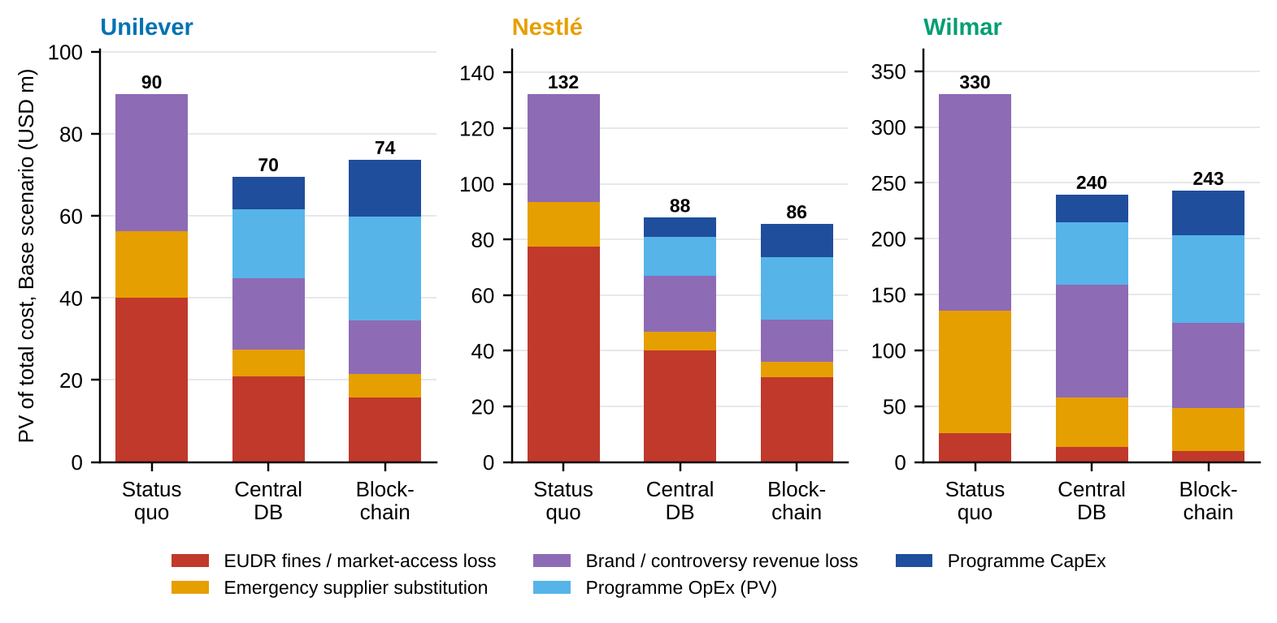
Source: palm_oil_traceability_model.py; workbook sheets ROI_ULVR, ROI_NESN, ROI_WIL. All risk inputs are ASSUMPTION.
Table 5.5 — Base, adverse and severe results (PV over 7 years, USD m)
Firm | Scenario | Untraced cost (status quo) | Traced cost (blockchain) | of which programme cost | NPV benefit, blockchain | ROI, blockchain | NPV benefit, central DB | Blockchain minus DB
Unilever | Base | 90 | 74 | 39 | 16.0 | 41% | 20.2 | -4.2
 | Adverse | 155 | 99 | 39 | 55.8 | 142% | 52.3 | +3.5
 | Severe | 297 | 153 | 39 | 143.3 | 365% | 123.8 | +19.5
Nestlé | Base | 132 | 86 | 34 | 46.7 | 136% | 44.4 | +2.3
 | Adverse | 237 | 126 | 34 | 110.8 | 322% | 95.7 | +15.0
 | Severe | 459 | 212 | 34 | 246.8 | 717% | 205.6 | +41.2
Wilmar | Base | 330 | 243 | 118 | 86.4 | 73% | 90.0 | -3.6
 | Adverse | 507 | 311 | 118 | 196.7 | 166% | 181.7 | +15.0
 | Severe | 945 | 475 | 118 | 470.5 | 397% | 414.1 | +56.4

Source: authors’ calculations from the companion model. Untraced and traced costs are PV of expected losses plus programme cost; NPV benefit = untraced − traced. ROI = PV of losses avoided / PV of programme cost − 1.
Figure 5.3 — NPV benefit versus the status quo, by firm and scenario
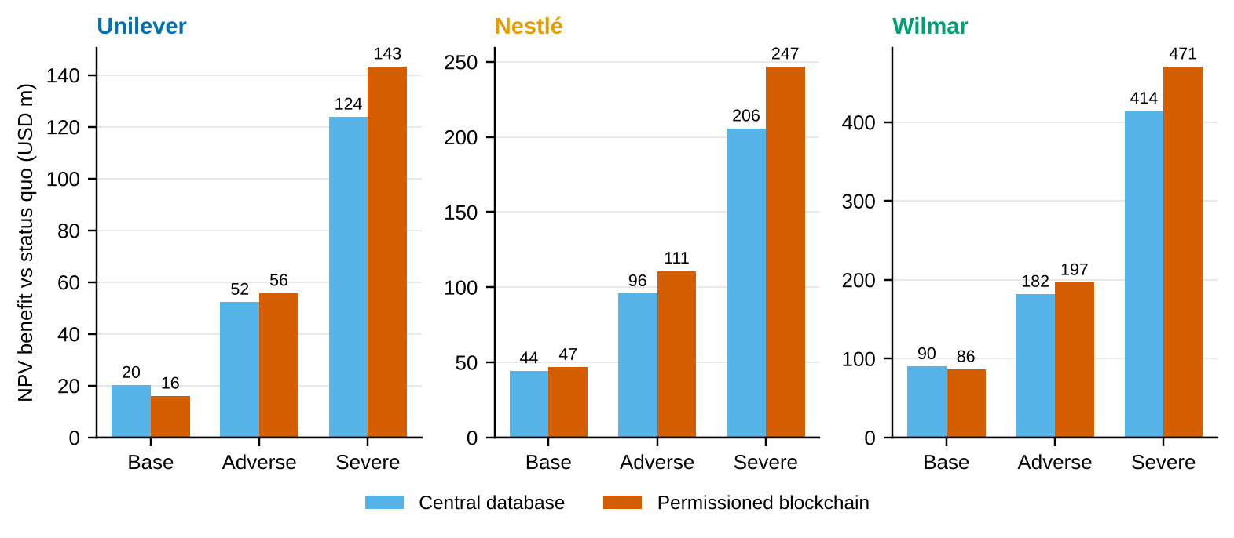
Source: authors’ calculations; companion model. USD m, PV over seven years.
Three results stand out (Table 5.5, Figure 5.3). First, traceability pays in every scenario: the NPV benefit of the blockchain ranges from USD 16 m (Unilever, base) to USD 471 m (Wilmar, severe), and the central database is positive everywhere too. Second, the technology choice is close in the base case and tips to the ledger under stress. At base inputs the central database is better for Unilever (+USD 4.2 m) and Wilmar (+USD 3.6 m), and the blockchain better for Nestlé (+USD 2.3 m). In the adverse and severe cases the ledger leads by USD 3–56 m, because its higher coverage and assurance reduce the larger expected losses by more than its extra cost. Third, scale matters: Wilmar’s absolute benefits are largest because palm is 30% of its COGS and 40% of its revenue; Unilever’s are smallest.
Table 5.6 — Discounted payback and break-even in the base scenario
 | Unilever | Nestlé | Wilmar
Discounted payback, central database (years) | 3 | 2 | 3
Discounted payback, blockchain (years) | 5 | 3 | 4
Break-even multiple on regulatory-event probability, blockchain (NPV = 0) | 0.34× | 0.01× | 0×
Blockchain assurance value needed to match the database (database = 0.80), base | 0.96 | 0.88 | 0.92
… same, adverse scenario | 0.87 | 0.82 | 0.85
Blockchain cost multiple at which it ties with the database, base | 0.89× (cost 11% lower) | 1.07× (can cost 7% more) | 0.97× (cost 3% lower)
Regulatory-event probability multiple at which blockchain ties with database | 1.82× | 0.77× | 2.09×

Source: workbook sheet Summary; authors’ root-finding on the companion model (parity points).
The parity points (Table 5.6) express the same message in decision-ready form. A blockchain with 0.90 assurance value clears the 0.80 database in the adverse case for all three firms (parity 0.82–0.87), but at base inputs it needs 0.88 to 0.96. Equivalently, a consortium that lowers the ledger’s programme cost by 3% (Wilmar) to 11% (Unilever), or an enforcement climate in which the regulatory-event probability is 1.8–2.1 times the base rate, is enough to tip the choice.

Monte Carlo: how often does each option pay?
Table 5.7 — Monte Carlo, mixed enforcement regimes (20,000 draws, USD m)
Firm | Option | Mean NPV benefit | 5th percentile | 95th percentile | P(NPV > 0) | P(blockchain beats DB)
Unilever | Central database | 41 | -13 | 172 | 79% | —
 | Blockchain | 34 | -33 | 185 | 62% | 35%
Nestlé | Central database | 79 | -2 | 294 | 93% | —
 | Blockchain | 79 | -17 | 331 | 83% | 42%
Wilmar | Central database | 143 | -23 | 518 | 89% | —
 | Blockchain | 124 | -70 | 532 | 76% | 38%

Source: authors’ calculations; seed 42; common random numbers. P(beats DB) is the share of worlds in which the blockchain NPV exceeds the database NPV.
Figure 5.4 — Distribution of NPV benefit across 20,000 mixed-regime worlds
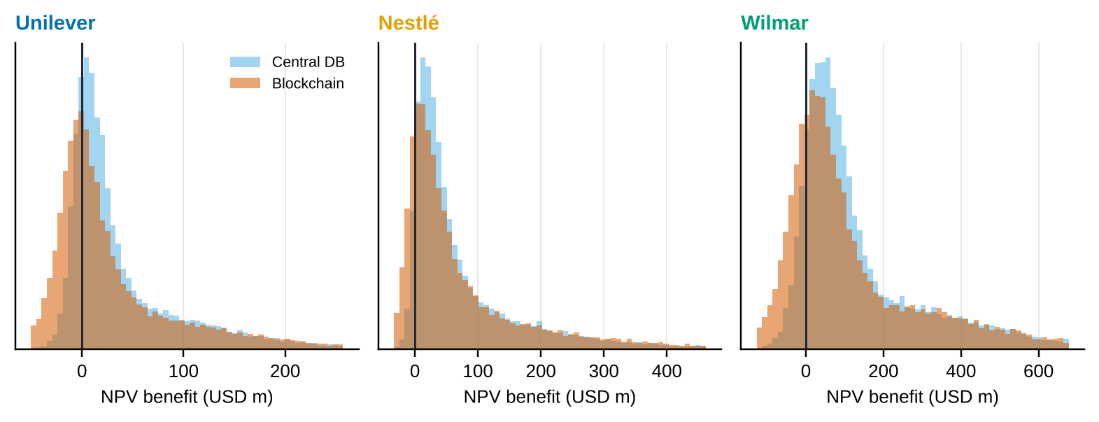
Source: authors’ calculations; companion model.
In Table 5.7 and Figure 5.4, the database pays in 79% (Unilever), 93% (Nestlé) and 89% (Wilmar) of simulated worlds, the blockchain in 62%, 83% and 76%. The blockchain has the higher mean only for Nestlé and has a fatter lower tail (5th percentile −USD 33 m, −17 m and −70 m, against −13 m, −2 m and −23 m for the database) because of its larger sunk cost and longer ramp-up, while its upper tail is fatter in the severe regime. By regime, the blockchain beats the database in 32–40% of base-regime worlds, 41–51% of adverse worlds and 51–59% of severe worlds. Figure 5.5 plots the risk–return trade-off.
Figure 5.5 — Expected benefit versus downside (5th percentile) of each intervention
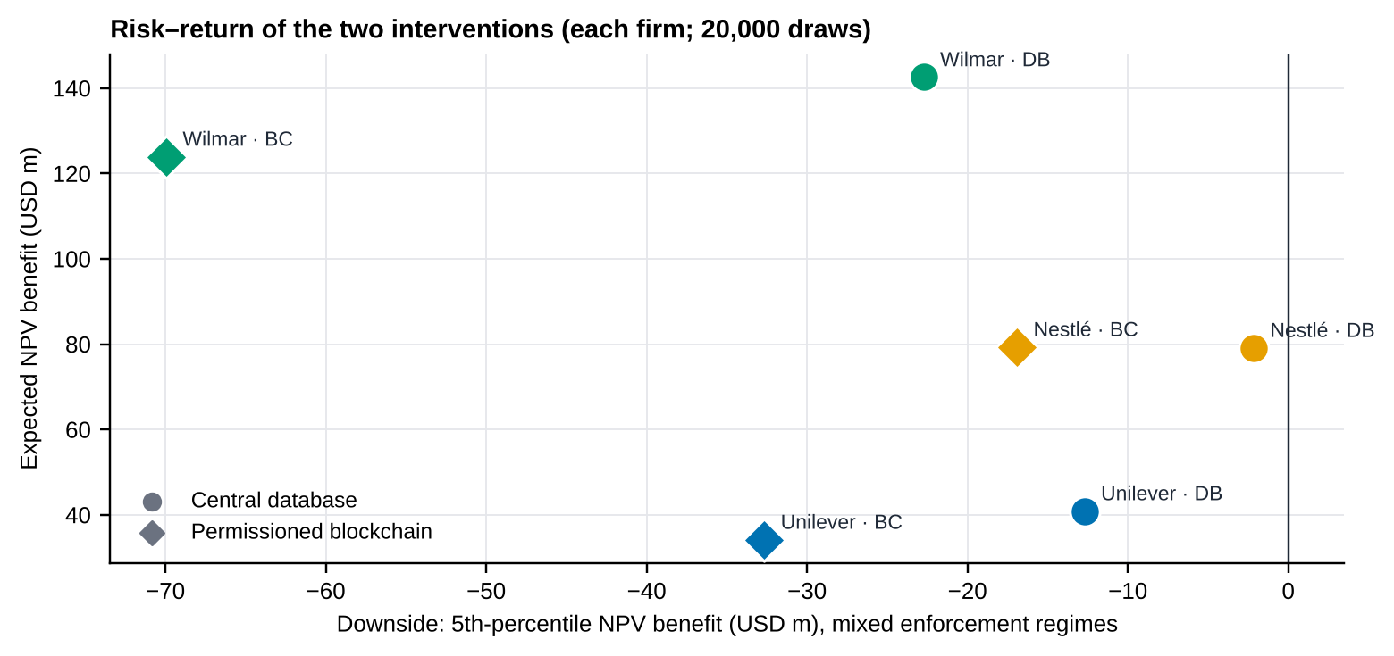
Source: authors’ calculations; mixed-regime Monte Carlo.

Sensitivity and substitution
Figure 5.6 — One-at-a-time sensitivity of the Unilever blockchain NPV
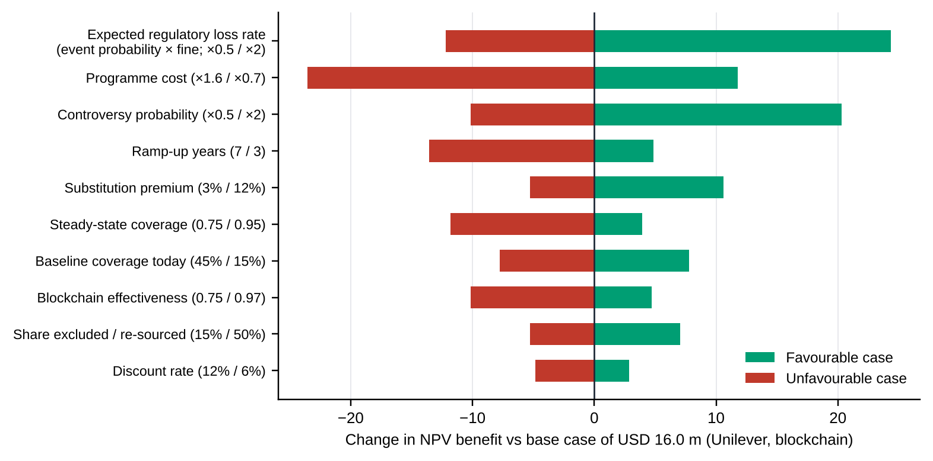
Source: authors’ calculations. Regulatory-event probability and fine rate enter the formula as a product, so they have identical effect and are shown as one bar.
For Unilever’s blockchain case (Figure 5.6) the most influential assumptions are the expected regulatory loss rate (event probability × fine; swing USD 37 m), the programme cost (35 m), the controversy probability (30 m) and the ramp-up time (18 m). The discount rate matters least (8 m). Two implications follow: the value case is mostly a bet on enforcement intensity, which a company cannot control but can monitor (Chapter 6.3), and cost discipline in the ledger programme is as valuable as any increase in its effectiveness.
Figure 5.7 — Coverage and substitution simulation: PV of supplier-substitution cost
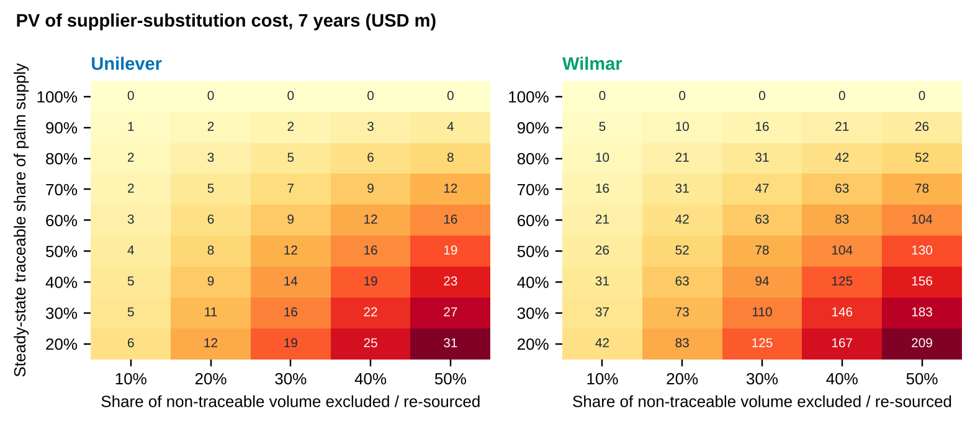
Source: authors’ calculations. Rows: steady-state traceable share; columns: share of untraced volume excluded and re-sourced. Unilever and Wilmar, USD m.
At 30% traceable supply (today’s assumption) and half of untraced volume excluded, Unilever’s PV substitution cost is USD 27 m and Wilmar’s USD 183 m; at 90% coverage they fall to USD 4 m and USD 26 m. Wilmar’s larger exposure (30% palm share of COGS) means each point of coverage is worth about seven times as much as for Unilever, which is why the high-coverage option is a strategic necessity there rather than a compliance choice.

Robustness: fine rate and ledger cost
Table 5.8 — Effect of the realised fine rate (2% versus the 4% statutory floor for the maximum)
Firm | Scenario | Blockchain NPV, fine 2% | Blockchain minus DB, fine 2% | Blockchain NPV, fine 4% | Blockchain minus DB, fine 4%
Unilever | Base | 16 | -4.2 | 40 | +0.9
 | Adverse | 56 | +3.5 | 104 | +13.7
 | Severe | 143 | +19.5 | 241 | +39.9
Nestlé | Base | 47 | +2.3 | 94 | +12.2
 | Adverse | 111 | +15.0 | 205 | +34.8
 | Severe | 247 | +41.2 | 435 | +80.8
Wilmar | Base | 86 | -3.6 | 102 | -0.3
 | Adverse | 197 | +15.0 | 228 | +21.6
 | Severe | 471 | +56.4 | 533 | +69.6

Source: authors’ calculations; USD m.
A 4% realised fine is the pessimistic end (Article 25 sets 4% only as the floor of the maximum). In Table 5.8, doubling the fine to 4% lifts Unilever’s and Wilmar’s base-case difference from negative to about zero (+0.9 and −0.3) and widens Nestlé’s edge to USD 12 m. A heavier ledger cost case (CapEx USD 25 m, OpEx USD 5 m a year, five-year horizon, Unilever) gives a blockchain NPV of −USD 8 m at a 2% fine in the base scenario (benefit–cost ratio 0.8), +USD 8.5 m at 4%, and +USD 79 m to +USD 146 m in the severe scenario: in the base case the ledger does not pay unless the realised fine is high, but it protects against the severe case.
Answer to RQ4 (conditional on the assumptions)
Traceability is worth doing for all three firms. The best risk–cost intervention is a staged programme: a central traceability stack now (satellite checks, audits), built so that its records can be anchored on a permissioned ledger later. The ledger earns its extra cost when enforcement is adverse or severe, when competing refiners must share one balance sheet of lots, or when consortium financing lowers its cost by roughly 3–11%. On its own, a blockchain does not create value: most of the benefit comes from coverage and verification, which a database also delivers.

Chapter 6 Strategic Recommendations and Managerial Decision Rules
This chapter turns the evidence into decisions for the two brand owners and for Wilmar (Table 6.1 summarises the options). Where a rule rests on the cost-benefit model or on the SPOEI, we say so; where a threshold is a starting value to be calibrated, we say that too. No rule below rests on a trained classifier, because none has been estimated (Chapter 4).

6.1 Procurement intervention strategies
Table 6.1 — Interventions assessed and verdicts
Intervention | What the evidence says | Verdict
Stay with mass balance and certification only | Cannot supply plot-level evidence (Table 1.1); highest untraced cost (Figure 5.2; Table 5.5 for the other scenarios) | Reject for EU-bound in-scope volume from 30-Dec-2026
Staged traceability: central database first, ledger-ready, escalate on triggers | Database pays in 79–93% of simulated worlds and has the thinner lower tail; ledger wins only under adverse/severe enforcement or with lower cost (Chapter 5) | Adopt (Unilever, Wilmar); Nestlé may go straight to the ledger
Permissioned consortium blockchain from day one | Higher assurance and the largest benefit in severe cases, but longer ramp-up, higher cost, and a lower tail of −USD 17 m to −70 m | Conditional on triggers R1–R2 below
Vertical integration (own plantations or mills) | Palm is about 3.0% of Unilever’s and 1.5% of Nestlé’s COGS (ASSUMPTION), against a USD 8–14 m traceability programme. The risk is informational, not capacity; the assets are not specific to the buyer (TCE logic, Chapter 2), and ownership moves deforestation liability onto the buyer’s own balance sheet | Do not pursue. Use contractual integration: offtake, premium and co-funding of mill-level traceability
Drop Wilmar if its ESG score falls below a threshold | Wilmar’s BESG score (6.15) is the highest of the three and rose 2.3× while Scope 1 emissions rose 2.6×: the score measures disclosure. A score threshold would never fire, while the real risks (interest cover 2.1×, legal and governance headlines, conduct flags) go unmanaged | Do not use an ESG-score trigger. Use verified-coverage covenants (R5) and financial/legal triggers (R4)
Diversify the refiner base (dual sourcing) | SPLC shows no visible palm refiner for either brand owner; Nestlé’s news already names Musim Mas and AAK as partners; substitution cost is small relative to the benefit (Figure 5.7: USD 5–27 m for Unilever at today’s 30% coverage) | Adopt: cap any single refiner at a share set in the pilot (starting value 40%)
Hedging and inventory | Palm price volatility is about 17% a year; for the brand owners palm is a small cost share, so hedging changes margin little. For Wilmar, with a 3.2% operating margin, price and spread management matters far more | Wilmar: formal hedge policy; brand owners: limited, via buffer stock of compliant oil

The value of staging
A staged programme pays the database cost now and the ledger cost only if enforcement becomes severe. Its value lies between two bounds: a conservative one in which the switch repeats the full ledger cost on top of the sunk database cost, and an upper one in which the firm knows the regime in advance. Table 6.2 reports both, from the same mixed-regime simulation.
Table 6.2 — Mean / 5th-percentile NPV benefit by strategy, mixed regimes (USD m)
Firm | Central database only | Blockchain now | Staged (conservative) | Staged (upper bound)
Unilever | 41 / -13 | 34 / -33 | 36 / -13 | 42 / -13
Nestlé | 79 / -2 | 79 / -17 | 79 / -2 | 84 / -2
Wilmar | 143 / -23 | 124 / -70 | 123 / -24 | 144 / -23

Source: authors’ calculations; seed 42. Switch to the ledger only in worlds drawn as severe-enforcement (25% of draws). Conservative bound subtracts the deterministic PV of the database programme when the switch occurs.
Two lessons follow. Staging keeps the database’s thin lower tail (5th percentile −USD 13 m, −2 m and −23 m, against −33 m, −17 m and −70 m for the ledger now) while keeping the ledger option. But it adds expected value over the database only if the migration is cheap: with full double payment the staged path is worse than the database alone for Unilever and Wilmar. The practical requirement is therefore a ledger-ready database, built on standard identifiers (lot IDs, plot hashes) so that migration reuses most of the earlier spend. That is a design rule for the first procurement, not an afterthought.

What each firm should do
• Unilever. Fund the central stack (CapEx about USD 8 m, OpEx 3 m a year, ASSUMPTION), require geolocated mill lists from every palm supplier by end-2026, and put refiners on the SPOEI tiering rule (R3). Treat the ledger as a trigger-based option (R1).
• Nestlé. Nestlé is the one firm whose base case already favours the ledger (+USD 2.3 m; parity at assurance 0.88). Run a consortium pilot with the refiners it already works with (Musim Mas, AAK and others) and use Wilmar’s data as an input rather than a dependency. Nestlé also holds the most inventory (96 days) and its lowest operating margin of FY2019–25, so cost discipline on the programme matters.
• Wilmar. Wilmar has the largest absolute benefit and the highest exposure: its untraced expected loss is about 15% of one year’s operating income in the base case (Section 6.2). It should build the central stack for its own supply (CapEx about USD 25 m), use its leverage over plantation suppliers (27% cost-weighted share of their revenue) to require geolocation, and publish mill-level lists. These steps also pre-empt the covenants its customers will impose.

6.2 Risk–cost trade-off heat map
Figure 6.1 places the three firms on a probability-versus-impact map. The horizontal axis is the SPOEI (the probability proxy); the vertical axis is the PV of seven-year expected untraced loss as a share of FY2025 operating income, from the Chapter 5 model (a base-case dot and a severe-case triangle for each firm). Bubble size is the blockchain’s base-case NPV benefit.
Figure 6.1 — Risk–cost heat map: SPOEI versus economic impact of untraced exposure
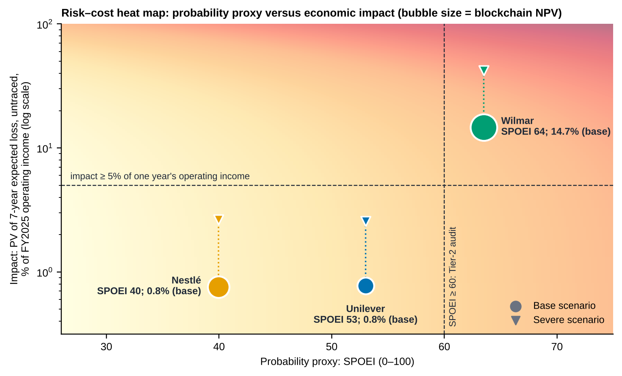
Source: Bloomberg-based SPOEI (Chapter 4); impact from companion model (ASSUMPTION inputs); FY2025 operating income converted at EUR 1.15 and CHF 1.25 per USD.
The map separates the three firms clearly. Wilmar sits in the top-right: its SPOEI is 64 and its untraced loss is 14.7% of one year’s operating income in the base case and 42% in the severe case. For Unilever and Nestlé the P&L impact is below 1% in the base case and under 3% in the severe case; their exposure is reputational and regulatory rather than financial. That is why their decision rule is to buy optionality cheaply, whereas Wilmar’s is to build capacity now.
At supplier level, Figure 3.2 is the working map for Wilmar’s visible plantation nodes. Suppliers in the high-leverage zone (Andira Agro, Gozco, AEP Pinago and Bakrie Sumatera, where Wilmar supplies 22–99% of revenue) can be required to supply geolocation and accept audits at little cost to Wilmar; suppliers with low leverage (for example, Dharma Satya with 13%) need co-investment or a longer ramp. Related parties (Wilmar Cahaya, Yihai Kerry Arawana) should be brought into the group’s own system first.

6.3 Managerial decision rules
Each rule in Table 6.3 has a trigger that can be read from Bloomberg or from the traceability system, an action, and a status. Anchored means the threshold is tied to a number in this report; starting value means it is a reasoned default to be calibrated on the 10-year panel; no rule is derived from a classifier.
Table 6.3 — If–then decision rules
# | IF (trigger) | THEN (action) | Basis and status
R1 | A member-state authority publishes the first EUDR penalty or seizure against a palm-oil operator, OR the Commission confirms a non-compliance finding for a peer | Treat enforcement as adverse: approve the migration of the central database to the permissioned ledger and open the consortium charter | Adverse case: ledger leads the database by USD 3.5–15 m (Table 5.5); regulatory-event parity at 1.8–2.1× base. Anchored
R2 | Adverse-news severity for a Tier-1 supplier rises more than 2σ above its trailing 12-month mean (CN) AND the front-month palm contract (KO1) rises 15% or more in 90 days | Start a Tier-2 audit within 30 days: re-run the satellite check on that supplier’s mills and hold escrow on new lots until it clears | Severe case combines higher controversy (×2.5) and palm price (+30%); 15% is half the severe shock. Sentiment σ needs the CN series. Starting value
R3 | Supplier SPOEI ≥ 60 (Wilmar 63.5); 50–59 (Unilever 53.0); < 50 (Nestlé 39.9) | ≥ 60: Tier-2 audit and quarterly review. 50–59: watch list, semi-annual. < 50: annual review | Cut-offs follow the observed spread and the ranking was stable (Chapter 4). Starting value, recalibrate on the panel
R4 | A counterparty’s interest cover falls below 3.0× or drops by more than 30% in a year | Qualify a second source for its volume, move payments to escrow, and ask for a financing and sanctions disclosure | Interest cover adds 6–7 points to Wilmar’s SPOEI premium (the largest single driver against Unilever); Wilmar is at 2.1×. Anchored
R5 | Verified plot-level coverage of a supplier’s volume to us is below 60% at end-2026, 80% at end-2027 or 90% at end-2029 | Cap its share of incremental volume and shift the balance to suppliers above the threshold. Escalate to exit only after two missed milestones | Steady-state coverage assumed: 80% (database) and 90% (ledger). Substitution is cheap at these levels (Figure 5.7). Anchored
R6 | A supplier’s BESG score rises while its reported Scope 1 or Scope 3 emissions rise 10% or more over two years | Flag disclosure–footprint divergence; require independently verified emissions data before the score is used in any sourcing decision | Wilmar: BESG 2.71 → 6.15 while Scope 1 rose 2.6× (Figure 3.5). Anchored
R7 | 30-day palm price volatility exceeds 25% (about 1.5× the 17% sample level) | Extend forward cover for compliant-origin volume and raise the safety stock from the current level to the next tier; for Wilmar, tighten hedge limits | Volatility sample is 8 weeks; threshold must be set on the 10-year KO1 distribution. Starting value

Rules R1–R7 are decision aids, not model outputs. Each should be backtested on the Terminal history before adoption.
Implementation note
Rules R1, R2 and R5 should be written into the consortium’s smart contracts only after the oracle inputs have two independent sources; an automatic hold based on a single unverified alert would create the false-positive and dispute costs the ledger is meant to avoid.

Chapter 7 Conclusion

7.1 Summary of findings
Table 7.1 restates what the evidence says about each research question, with an honest confidence rating.
Table 7.1 — Answers to the research questions
RQ | Answer | Confidence
RQ1 Which Bloomberg-derived indicators best explain or predict traceability risk? | Among observable indicators, the ones that separate the firms most are financial resilience (interest cover), supplier conduct flags, adverse news and Scope 3 intensity. ESG disclosure scores point the wrong way: Wilmar has the highest BESG score and the highest SPOEI. Predictive power is untested (no labelled panel). | Medium for the index drivers; none for prediction
RQ2 How do ESG, supply links, palm prices and news interact under normal and stressed conditions? | Visibility is the common thread: SPLC sees none of the palm chain, so ESG and news are the only signals. Price links cannot be established on eight weeks of data (|ρ| < 0.34 band). Under stress (Severe: enforcement ×4, controversy ×2.5, palm +30%) untraced losses rise roughly three- to three-and-a-half-fold and the ledger overtakes the database. | Medium (descriptive); low for price links
RQ3 Does the predictive model beat a simple benchmark? | Not answered. The model, benchmarks, success rule and sample-size requirement (≈ 85 observations, ≥ 17 events) are specified and the code is ready; the data are not yet held. | Open
RQ4 Which intervention gives the best risk–cost trade-off? | Traceability pays for all three firms in every scenario. A database-first, ledger-ready path has the best balance of expected value and downside; the blockchain adds value under adverse/severe enforcement, at lower cost (3–11%), or at assurance above 0.82–0.96. | Medium, conditional on ASSUMPTIONS

Three messages matter most to a manager. First, the visibility gap is the risk: for the brand owners the palm chain is invisible to Bloomberg, and for Wilmar the visible plantation nodes are 0.4% of the cost base. Second, the largest value comes from traceability itself, not from the ledger; the blockchain’s premium over a database is a close call that tips only under stress or with cost reductions. Third, ESG scores are not a substitute for verification: they measured disclosure, and a sourcing rule built on them would have missed Wilmar’s real risks.

7.2 Limitations of the study

Data
• Tier-2 and Tier-3 are invisible. Private mills and smallholder farms are not listed on Bloomberg. SPLC shows Tier-1 relationships only, and the rows we captured (24 suppliers per firm) are lower bounds.
• Screens, not an API. Values were transcribed from Terminal screens on one date (15 October 2026) and spot-checked, not pulled by script; transcription errors are possible. Unilever FY2024–25 are restated for the ice-cream demerger and its Scope 3 series has breaks.
• Short price window. Eight weeks of daily prices cannot establish price–equity or price–margin links; a multi-year KO1 series is required.
• News coding is hand-made and unequal. Severity was coded by the authors from headlines, and search filters differ by firm; no Bloomberg sentiment series was available.
• Currencies and FX. Revenues are converted at illustrative rates (EUR 1.15, CHF 1.25 per USD).

Method
• SPOEI is a screening index. Floors, caps and weights are judgement-based, only three firms are scored, and the index has not been validated against outcomes.
• No classifier results. RQ3 and SHAP-based importance remain open until a labelled panel of at least ≈ 85 firm-periods is available.
• Monte Carlo assumptions. Probabilities, fines, premia, coverage, effectiveness and programme costs are ASSUMPTIONS; inputs are drawn independently except through the regime mix, which understates correlation between enforcement, controversy and price. Only losses avoided are valued: not financing benefits, price premia for certified product, or the option value of market access.
• Oracle risk is a parameter. Data-integrity failures at the source enter only through the effectiveness values; consortium failure, cyber-risk and regulatory acceptance of ledger evidence are not modelled.
• A moving regulation. The EUDR’s scope, simplification and benchmarking are still changing; the dates and penalties in Chapter 1 reflect the Commission’s position as read in July 2026.

7.3 Future outlook
Over the next five years we expect the framework in Chapter 5 to be strengthened rather than replaced, by two technologies, and we flag what could go wrong. These are projections, not forecasts.
• Generative AI as the reading layer. Language models can read mill lists, land-title scans, audit reports and CN headlines, extract plot and lot records into the ledger’s schema, summarise supplier risk for the SPOEI, and draft due-diligence statements for human review. The caution is that a model can be wrong with confidence: every AI-extracted record should carry a source link and a human sign-off before it becomes a ledger event.
• IoT and remote sensing as the data layer. Weighbridge scales, RFID/QR lot tags, GPS-tagged trucks and combined optical and radar satellites reduce the oracle problem by providing independent, frequent measurements, and radar sees through cloud cover. They also lower the cost of verification per tonne, which is the parameter to which Chapter 5’s results are most sensitive.
• Interoperability and digital product passports. The value of a consortium ledger grows with the number of participants; open data standards and links to EU information systems would reduce migration cost, which is the practical condition for the staged path recommended here.
• Risks. Poisoned or spoofed sensor data, concentration of satellite providers, energy and cost of consortium infrastructure, and unequal access for smallholders, who may be excluded by cost unless mills and buyers co-fund onboarding.
Next steps for the research. (1) Pull the Terminal panel specified in Appendix A.3 and estimate the classifier; (2) locate Wilmar, IOI, Musim Mas, AAK and Cargill in the full SPLC lists; (3) replace ASSUMPTION inputs with firm WACC, Bloomberg FX and company disclosures; (4) extend the news coding with a consistent filter and a Bloomberg sentiment series; (5) backtest rules R1–R7.

Appendix A Bloomberg Data Capture and Query Scripts
What was actually run. The Bloomberg data in this report were captured from Terminal screens on 15 October 2026 at the Woxsen Bloomberg Lab (the function, security and fields are logged in Table A.1). No BQL or BDH script was executed for this report. The queries in A.2 reproduce the same fields programmatically and extend them to the 10-year panel the classifier needs; they have not been run and each field mnemonic must be confirmed on the Terminal with FLDS <GO> before use (mnemonics can differ by entitlement).

A.1 Capture log (screens used)
Table A.1 — Screens captured on 15-Oct-2026
Function | Security / filter | Content captured | Used in
SPLC <GO> | WIL SP, NESN SW, ULVR LN Equity | Supplier and customer counts; ESG/sanction/distress flags; geography; commodity exposures; top-24 suppliers by cost share (name, % supplier revenue, % cost, type, 3M price change); top-10 customers | Ch. 3.1, 4.1
FA <GO> | Same three; annual FY2019–FY2025 | Income statement, balance sheet and cash-flow lines: revenue, COGS, operating income, interest expense, inventory, cash, receivables, PP&E, goodwill, net income, D&A, CFO, capex, dividends | Ch. 3.2, 4.1, 5
ESG <GO> | Same three; 2016–2025 | BESG overall and E/S/G pillar scores; Scope 1, 2 and 3 emissions | Ch. 3.3, 4.1
CN <GO> | “Wilmar + Palm Oil”, “Wilmar + ESG”, “Nestlé + Palm Oil”, “Unilever + ESG”, “Unilever + Palm Oil + deforestation” | Headline, date and category of 22 stories; hand-coded sentiment and severity | Ch. 3.3, 4.1
HP / GP <GO> | KOZ6 Comdty; WIL SP, NESN SW, ULVR LN; 17-Aug to 15-Oct-2026 daily; equities 5-year table | Daily closes; 5-year high, low, average, net change | Ch. 3.2, 5
DES <GO> | Same three equities | Market cap, P/E, estimates, dividend yield, beta, employees, 52-week range, 12M total return, 30/90-day volatility | Ch. 1.4, 4.1

All captured values are in the workbook sheets Supply_Chain, Fundamentals, ESG, News_Events and Market_Data. Rows visible on screen only; SPLC lists hold more records.

A.2 Reproduction and extension queries (templates, not executed)
Excel add-in (BDH) templates. Replace the placeholders marked <…> after looking up the exact mnemonic with FLDS <GO>.
' --- 10-year monthly palm oil and equity prices (needed for Ch. 3.2 overlay and the panel's X4 feature) ---
=BDH("KO1 Comdty", "PX_LAST", "2016-10-15", "2026-10-15", "Per=M", "Fill=P")
=BDH("WIL SP Equity", "PX_LAST", "2016-10-15", "2026-10-15", "Per=M", "Currency=SGD")
=BDH("NESN SW Equity", "PX_LAST", "2016-10-15", "2026-10-15", "Per=M", "Currency=CHF")
=BDH("ULVR LN Equity", "PX_LAST", "2016-10-15", "2026-10-15", "Per=M", "Currency=GBP")
=BDH("WIL SP Equity", "VOLATILITY_90D", "2016-10-15", "2026-10-15", "Per=M")

' --- annual fundamentals, FY2016-FY2025 (reporting currency) ---
=BDH("WIL SP Equity", "SALES_REV_TURN,GROSS_PROFIT,IS_OPER_INC,IS_INT_EXPENSE,BS_INVENTORIES,CF_CASH_FROM_OPER,CF_CAP_EXPEND_PRPTY_ADD",
"2016-12-31", "2025-12-31", "Per=FY", "Fill=P")
' repeat for NESN SW Equity and ULVR LN Equity

' --- ESG: confirm each mnemonic in FLDS <GO> (search "BESG", "scope 3") ---
=BDH("WIL SP Equity", "BESG_ESG_SCORE,BESG_ENVIRONMENTAL_PILLAR_SCORE,BESG_SOCIAL_PILLAR_SCORE,BESG_GOVERNANCE_PILLAR_SCORE",
"2016-12-31", "2025-12-31", "Per=FY")
=BDH("WIL SP Equity", "<FIELD_SCOPE_1>,<FIELD_SCOPE_2>,<FIELD_SCOPE_3>", "2016-12-31", "2025-12-31", "Per=FY")

# --- BQL template (Bloomberg Query Language; run in BQuant or the Excel BQL function) ---
get(px_last(dates=range(-10Y, 0D), frq=M)) for(['KO1 Comdty'])
get(sales_rev_turn(fpt=A, fpr=range(-9Y, 0Y))) for(['WIL SP Equity', 'NESN SW Equity', 'ULVR LN Equity'])

# --- SPLC: use the screen (SPLC <GO> > Suppliers > Export to Excel); keep one export per firm and per date.
# --- CN: CN <GO>, filter by company and keywords; export headline, date, source; code severity 1-5 with a written rubric.

A.3 Panel file for the classifier (spoei_panel.csv)
Table A.2 — Panel columns read by notebook Part 5
Column | Definition | Source
firm_id, month | Issuer identifier; month-end (YYYY-MM), 2016-01 to 2026-09 | —
X1_hhi | HHI of the issuer’s supplier cost shares (SPLC snapshot, history where available) | SPLC
X2_env_gap, X2_env_gap_chg12 | 10 − BESG environmental pillar; 12-month change | ESG
X3_news_z, X3_news_vol | Trailing 90-day z-score and volatility of Bloomberg news sentiment for the issuer | CN / sentiment
X4_cpo_var_x_exposure | Variance of KO1 returns (trailing 90 days) × the issuer’s palm-linked spend share | GP + company data
X5_int_cover, X6_flag_share, X7_eq_vol | Operating income / interest; share of suppliers with Bloomberg flags; 90-day equity volatility | FA, SPLC, DES
Y_event_12m | 1 if, in months t+1 to t+12, an RSPO complaint or sanction, a new ESG controversy flag, or a CN headline on deforestation / RSPO / EUDR / NDPE with severity ≥ 3. At least one source outside the feature set | RSPO complaints record; CN; ESG

Appendix B Python Simulation Code
The listing reproduces the core engine of the companion file palm_oil_traceability_model.py: global parameters, scenario multipliers, firm profiles, the present-value engine, the deterministic scenario function and the Monte Carlo. The market-data tables, the tornado, the coverage-exclusion grid and the notebook (including the classifier in Part 5) are in the companion files. Seed 42; 20,000 simulations.

B.1 Cost-benefit and Monte Carlo engine
# --------------------------------------------------------------------------------------
# 2. COST-BENEFIT MODEL INPUTS
# Bloomberg-sourced: revenue, COGS (FY2025). Everything else = ASSUMPTION (calibrate).
# --------------------------------------------------------------------------------------
G = dict(
r=0.08, # ASSUMPTION discount rate (use each firm's WACC from Bloomberg WACC <GO>)
g=0.02, # ASSUMPTION nominal growth of revenue / COGS / programme opex
horizon=7, # years of benefits after the year-0 build
fine=0.02, # ASSUMPTION realised fine as share of EU turnover when non-compliant. EUDR cap is "at least 4%"
q=0.30, # ASSUMPTION share of non-traceable EU-bound palm volume that must be excluded / re-sourced
pi=0.06, # ASSUMPTION price premium paid on re-sourced (compliant) volume
c0=0.30, # ASSUMPTION traceable share today (RSPO / NDPE style partial coverage)
EURUSD=1.15, # ASSUMPTION replace with Bloomberg FX on the data date
CHFUSD=1.25, # ASSUMPTION replace with Bloomberg FX on the data date
)

SCEN = { # multipliers on the base inputs
"Base": dict(p_reg=1.0, p_ctrv=1.0, pi=1.0, cpo=1.00),
"Adverse": dict(p_reg=2.0, p_ctrv=1.5, pi=1.5, cpo=1.00),
"Severe": dict(p_reg=4.0, p_ctrv=2.5, pi=2.5, cpo=1.30),
}

PROFILES = { # revenue / COGS from Bloomberg FA (FY2025, reporting currency millions); rest ASSUMPTION
"ULVR": dict(name="Unilever", rev=50503.0, cogs=26794.0, fx="EURUSD",
a=0.25, ps=0.030, eu=0.25, p_reg=0.03, p_ctrv=0.10, rev_loss=0.005,
cost={"DB": (8.0, 3.0), "BC": (14.0, 4.5)}),
"NESN": dict(name="Nestle", rev=89885.0, cogs=48694.0, fx="CHFUSD",
a=0.15, ps=0.015, eu=0.25, p_reg=0.03, p_ctrv=0.10, rev_loss=0.005,
cost={"DB": (7.0, 2.5), "BC": (12.0, 4.0)}),
"WIL": dict(name="Wilmar", rev=70415.7, cogs=64619.9, fx=None,
a=0.40, ps=0.300, eu=0.08, p_reg=0.05, p_ctrv=0.15, rev_loss=0.010,
cost={"DB": (25.0, 10.0), "BC": (40.0, 14.0)}),
}
# a=palm-linked revenue share, ps=palm spend / COGS, eu=EU-regulated revenue share,
# p_reg=annual prob. of a regulatory/market-access event, p_ctrv=annual prob. of a controversy,
# rev_loss=revenue lost on palm-linked sales in a controversy. cost = (capex $m, annual opex $m).

OPTIONS = { # cmax = steady-state traceable share, ramp = years to get there, eff = assurance value of that coverage
"SQ": dict(cmax=None, ramp=1.0, eff=0.60), # cmax -> c0
"DB": dict(cmax=0.80, ramp=3.0, eff=0.80), # central / cloud database + satellite + audits
"BC": dict(cmax=0.90, ramp=4.0, eff=0.90), # permissioned ledger consortium (slower to coordinate, higher trust)
}

def usd(profile, key):
fx = G[profile["fx"]] if profile["fx"] else 1.0
return profile[key] * fx

# --------------------------------------------------------------------------------------
# 3. CORE ENGINE (vectorised: parameters may be scalars or arrays of length n)
# --------------------------------------------------------------------------------------
def pv_total(pf, opt, prm, price_idx=None):
"""PV of (expected losses + programme costs) for one option. Returns dict of arrays."""
T = G["horizon"]
t = np.arange(1, T + 1)
growth = (1 + G["g"]) ** t
rev, cogs = usd(pf, "rev") * growth, usd(pf, "cogs") * growth
c0 = prm.get("c0", G["c0"])
cmax = c0 if opt == "SQ" else prm["cmax"]

ramp = 1.0 if opt == "SQ" else prm["ramp"]
eff = prm["eff"]
col = lambda x: np.asarray(x)[:, None] if np.ndim(x) == 1 else np.asarray(x)
cov = col(c0) + (col(cmax) - col(c0)) * np.minimum(1.0, t / col(ramp))
m = cov * col(eff)
P = 1.0 if price_idx is None else price_idx
reg = col(prm["p_reg"]) * col(prm["fine"]) * pf["eu"] * rev * (1 - m)
spend = cogs * pf["ps"] * P
sub = spend * pf["eu"] * (1 - cov) * col(prm["q"]) * col(prm["pi"])
rep = col(prm["p_ctrv"]) * pf["rev_loss"] * pf["a"] * rev * (1 - m)
capex, opex = (0.0, 0.0) if opt == "SQ" else pf["cost"][opt]
if opt != "SQ":
capex = prm.get(f"capex_{opt}", capex)
opex = prm.get(f"opex_{opt}", opex)
opex_t = col(opex) * growth
df_ = 1.0 / (1 + col(prm["r"])) ** t
sumd = lambda x: np.sum(x * df_, axis=-1)
shape = np.shape(sumd(reg))
out = dict(pv_reg=sumd(reg), pv_sub=sumd(sub), pv_rep=sumd(rep),
pv_opex=sumd(opex_t * np.ones_like(reg)), capex=np.asarray(capex) * np.ones(shape))
out["pv_loss"] = out["pv_reg"] + out["pv_sub"] + out["pv_rep"]
out["pv_prog"] = out["pv_opex"] + out["capex"]
out["pv_total"] = out["pv_loss"] + out["pv_prog"]
return out

def deterministic(profile_key, scn="Base", overrides=None):
pf = PROFILES[profile_key]
s = SCEN[scn]
price = np.full(G["horizon"], s["cpo"])
res = {}
for opt in OPTIONS:
prm = dict(r=G["r"], fine=G["fine"], q=G["q"], pi=G["pi"] * s["pi"], c0=G["c0"],
p_reg=pf["p_reg"] * s["p_reg"], p_ctrv=pf["p_ctrv"] * s["p_ctrv"],
eff=OPTIONS[opt]["eff"], cmax=OPTIONS[opt]["cmax"], ramp=OPTIONS[opt]["ramp"])
if overrides: # {"all": {...shared...}, "BC": {...only that option...}}
prm.update(overrides.get("all", {}))
prm.update(overrides.get(opt, {}))
res[opt] = pv_total(pf, opt, prm, price)
sq = res["SQ"]["pv_total"]
out = {}
for opt in ("DB", "BC"):
r = res[opt]
avoided = res["SQ"]["pv_loss"] - r["pv_loss"]
reg_av = res["SQ"]["pv_reg"] - r["pv_reg"]
ben = sq - r["pv_total"]
out[opt] = dict(benefit=float(ben), avoided=float(avoided), prog=float(r["pv_prog"]),
bcr=float(avoided / r["pv_prog"]), breakeven_k=float(max(0.0, 1 - ben / reg_av)))
out["BC_minus_DB"] = out["BC"]["benefit"] - out["DB"]["benefit"]
return out

# --------------------------------------------------------------------------------------
# 4. MONTE CARLO (common random numbers: every option sees the same world)
# --------------------------------------------------------------------------------------
def tri(rng, lo, mode, hi, n):
return rng.triangular(lo, mode, hi, n)

def monte_carlo(profile_key, regime="Mixed", n=N_SIMS, seed=SEED):

rng = np.random.default_rng(seed)
pf = PROFILES[profile_key]
T = G["horizon"]
# --- regime: fixed scenario, or mixed (25% benign / 50% base / 25% severe-enforcement) -------------
if regime == "Mixed":
pick = rng.choice(3, size=n, p=[0.25, 0.50, 0.25])
mult = np.array([[0.4, 0.6, 1.0, 1.0], [1, 1, 1, 1.0], [4, 2.5, 2.5, 1.3]])[pick]
m_reg, m_ctrv, m_pi, m_cpo = mult.T
else:
s = SCEN[regime]
m_reg = np.full(n, s["p_reg"]); m_ctrv = np.full(n, s["p_ctrv"])
m_pi = np.full(n, s["pi"]); m_cpo = np.full(n, s["cpo"])
# --- shared risk parameters ---------------------------------------------------------------------------
shared = dict(
p_reg=pf["p_reg"] * m_reg * rng.lognormal(0, 0.5, n),
p_ctrv=pf["p_ctrv"] * m_ctrv * rng.lognormal(0, 0.4, n),
fine=rng.uniform(0.005, 0.04, n),
q=tri(rng, 0.10, G["q"], 0.50, n),
pi=G["pi"] * m_pi * rng.lognormal(0, 0.3, n),
r=tri(rng, 0.06, G["r"], 0.11, n),
c0=tri(rng, 0.15, G["c0"], 0.45, n),
)
# CPO price index: GBM, zero drift, sample vol (+ severe shock level)
z = rng.standard_normal((n, T))
logp = np.cumsum(-0.5 * CPO_SIGMA ** 2 + CPO_SIGMA * z, axis=1)
price = m_cpo[:, None] * np.exp(logp)
# --- option-specific parameters ----------------------------------------------------------------------
opts = {
"SQ": dict(eff=tri(rng, 0.45, OPTIONS["SQ"]["eff"], 0.70, n)),
"DB": dict(cmax=tri(rng, 0.60, 0.80, 0.92, n), ramp=tri(rng, 2.0, 3.0, 5.0, n),
eff=tri(rng, 0.55, 0.80, 0.92, n)),
"BC": dict(cmax=tri(rng, 0.65, 0.90, 0.97, n), ramp=tri(rng, 3.0, 4.0, 7.0, n),
eff=tri(rng, 0.65, 0.90, 0.98, n)),
}
overrun = {"DB": rng.lognormal(0, 0.30, n), "BC": rng.lognormal(0, 0.35, n)}
res = {}
for opt in OPTIONS:
prm = dict(shared); prm.update(opts[opt])
if opt != "SQ":
cap, opx = pf["cost"][opt]
prm["capex_" + opt] = cap * overrun[opt]
prm["opex_" + opt] = opx * overrun[opt]
res[opt] = pv_total(pf, opt, prm, price)
sq = res["SQ"]["pv_total"]
ben = {o: sq - res[o]["pv_total"] for o in ("DB", "BC")}
return ben

def mc_summary():
rows = []
for pk in PROFILES:
for regime in ("Base", "Adverse", "Severe", "Mixed"):
b = monte_carlo(pk, regime)
for opt in ("DB", "BC"):
x = b[opt]
rows.append(dict(profile=pk, regime=regime, option=opt, mean=x.mean(), p5=np.percentile(x, 5),
median=np.median(x), p95=np.percentile(x, 95), p_positive=(x > 0).mean(),
p_BC_beats_DB=(b["BC"] > b["DB"]).mean() if opt == "BC" else np.nan,
mean_BC_minus_DB=(b["BC"] - b["DB"]).mean() if opt == "BC" else np.nan))
return pd.DataFrame(rows)

B.2 Classifier protocol (notebook Part 5, core functions)
def blocks():
# three walk-forward test blocks; training rows must have their 12-month label window END before the block starts
P = lambda s: pd.Period(s, "M").ordinal
return [("2022", P("2022-01"), P("2022-12")), ("2023", P("2023-01"), P("2023-12")), ("2024-01..2025-09", P("2024-01"), P("2025-09"))]

def spoei_score(df, ref): # B3: equal-weight composite of standardised features (train-fitted mean/sd)
mu, sd = ref[FEATS].mean(), ref[FEATS].std().replace(0, 1)
return sum(SIGN.get(c, 1) * (df[c] - mu[c]) / sd[c] for c in FEATS) / len(FEATS)

def make_models():
m = {"B2 Logit, env gap only": ("one", make_pipeline(StandardScaler(), LogisticRegression(max_iter=1000))),
"Elastic-net logit": ("all", make_pipeline(StandardScaler(), LogisticRegression(penalty="elasticnet", solver="saga", l1_ratio=.5, C=.5, max_iter=5000))),
"Random Forest": ("all", RandomForestClassifier(n_estimators=500, max_depth=5, min_samples_leaf=5, class_weight="balanced", random_state=M.SEED, n_jobs=-1))}
if HAVE_XGB: m["XGBoost"] = ("all", XGBClassifier(n_estimators=300, max_depth=3, learning_rate=.05, subsample=.8, eval_metric="logloss", random_state=M.SEED))
return m

def metrics(y, p, top=.10):
k = max(1, int(round(top * len(y)))); idx = np.argsort(-p)[:k]
return dict(ROC_AUC=roc_auc_score(y, p), PR_AUC=average_precision_score(y, p), Precision_top10=y.iloc[idx].mean(), Recall_top10=y.iloc[idx].sum() / max(1, y.sum()), Brier=brier_score_loss(y, np.clip(p, 0, 1)))

def delong_p(y, p1, p2): # paired DeLong test of AUC1 == AUC2 (DeLong et al., 1988)
y = np.asarray(y); pos, neg = y == 1, y == 0; m, n = pos.sum(), neg.sum()
def comps(p):
px, py = p[pos], p[neg]
v10 = np.array([((x > py).sum() + .5 * (x == py).sum()) / n for x in px]); v01 = np.array([((px > z).sum() + .5 * (px == z).sum()) / m for z in py]); return v10, v01
c1, c2 = comps(np.asarray(p1, float)), comps(np.asarray(p2, float))
V10, V01 = np.vstack([c1[0], c2[0]]), np.vstack([c1[1], c2[1]])
auc = V10.mean(axis=1); S = np.cov(V10) / m + np.cov(V01) / n
var = S[0, 0] + S[1, 1] - 2 * S[0, 1]; z = (auc[0] - auc[1]) / np.sqrt(var) if var > 0 else np.nan
return 2 * (1 - norm.cdf(abs(z)))

References
Akerlof, G. A. (1970). The market for ‘lemons’: Quality uncertainty and the market mechanism. The Quarterly Journal of Economics, 84(3), 488–500.
Austin, K. G., Schwantes, A., Gu, Y., & Kasibhatla, P. S. (2017). Shifting patterns of oil palm driven deforestation in Indonesia and implications for zero-deforestation commitments. Land Use Policy, 69, 41–48.
Babich, V., & Hilary, G. (2020). Distributed ledgers and operations: What operations management researchers should know about blockchain technology. Manufacturing & Service Operations Management, 22(2), 223–240.
Bloomberg L.P. (2026). Supply Chain (SPLC), Financial Analysis (FA), ESG, Company News (CN), Historical Price (HP/GP) and Description (DES) functions, Bloomberg Terminal, Woxsen Bloomberg Lab, captured 15 October 2026. Product overview: https://professional.bloomberg.com/institutions/corporations/supply-chain/
Breiman, L. (2001). Random forests. Machine Learning, 45(1), 5–32.
Caldarelli, G. (2020). Understanding the blockchain oracle problem: A call for action. Information, 11(11), 509.
Carlson, K. M., Heilmayr, R., Gibbs, H. K., et al. (2018). Effect of oil palm sustainability certification on deforestation and fire in Indonesia. Proceedings of the National Academy of Sciences, 115(1), 121–126.
Cerqueira, V., Torgo, L., & Mozetič, I. (2020). Evaluating time series forecasting models: An empirical study on performance estimation methods. Machine Learning, 109, 1997–2028.
Chen, T., & Guestrin, C. (2016). XGBoost: A scalable tree boosting system. Proceedings of the 22nd ACM SIGKDD International Conference on Knowledge Discovery and Data Mining, 785–794.
Chod, J., Trichakis, N., Tsoukalas, G., Aspegren, H., & Weber, M. (2020). On the financing benefits of supply chain transparency and blockchain adoption. Management Science, 66(10), 4378–4396.
Christopher, M., & Peck, H. (2004). Building the resilient supply chain. The International Journal of Logistics Management, 15(2), 1–14.
Cole, R., Stevenson, M., & Aitken, J. (2019). Blockchain technology: Implications for operations and supply chain management. Supply Chain Management: An International Journal, 24(4), 469–483.
DeLong, E. R., DeLong, D. M., & Clarke-Pearson, D. L. (1988). Comparing the areas under two or more correlated receiver operating characteristic curves: A nonparametric approach. Biometrics, 44(3), 837–845.
European Commission (2026, 13 July). Commission updates product scope and tools to support EUDR. Directorate-General for Environment. https://environment.ec.europa.eu/news/commission-updates-product-scope-and-tools-support-eudr-2026-07-13_en
Gaveau, D. L. A., Locatelli, B., Salim, M. A., et al. (2022). Slowing deforestation in Indonesia follows declining oil palm expansion and lower oil prices. PLOS ONE, 17(3), e0266178.
Greenhouse Gas Protocol (2011). Corporate Value Chain (Scope 3) Accounting and Reporting Standard. World Resources Institute and World Business Council for Sustainable Development.
Hanley, J. A., & McNeil, B. J. (1982). The meaning and use of the area under a receiver operating characteristic (ROC) curve. Radiology, 143(1), 29–36.
Hogan Lovells (2026, 15 May). EU Deforestation Regulation: Commission publishes simplification package ahead of December 2026 application date. https://www.hlc.com/en/publications/eu-deforestation-regulation-commission-publishes-simplification-package-ahead-of-december-2026
Kamilaris, A., Fonts, A., & Prenafeta-Boldú, F. X. (2019). The rise of blockchain technology in agriculture and food supply chains. Trends in Food Science & Technology, 91, 640–652.
Kaufman, S., Rosset, S., & Perlich, C. (2012). Leakage in data mining: Formulation, detection, and avoidance. ACM Transactions on Knowledge Discovery from Data, 6(4), Article 15.
Kshetri, N. (2018). 1 Blockchain’s roles in meeting key supply chain management objectives. International Journal of Information Management, 39, 80–89.
Lambin, E. F., Gibbs, H. K., Heilmayr, R., et al. (2018). The role of supply-chain initiatives in reducing deforestation. Nature Climate Change, 8, 109–116.
Lundberg, S. M., & Lee, S.-I. (2017). A unified approach to interpreting model predictions. Advances in Neural Information Processing Systems, 30.
Nakamoto, S. (2008). Bitcoin: A peer-to-peer electronic cash system. https://bitcoin.org/bitcoin.pdf
Regulation (EU) 2023/1115 of the European Parliament and of the Council of 31 May 2023 on the making available on the Union market and the export from the Union of certain commodities and products associated with deforestation and forest degradation and repealing Regulation (EU) No 995/2010. Official Journal of the European Union, L 150, 9.6.2023. https://eur-lex.europa.eu/eli/reg/2023/1115/oj/eng
Roundtable on Sustainable Palm Oil (2017). RSPO Supply Chain Certification Standard (v1.1, June 2017). https://rspo.org/wp-content/uploads/rspo-std-t05-001-v1.1-eng_scc-standard-june-2017_.pdf
Saberi, S., Kouhizadeh, M., Sarkis, J., & Shen, L. (2019). Blockchain technology and its relationships to sustainable supply chain management. International Journal of Production Research, 57(7), 2117–2135.
Sheffi, Y., & Rice, J. B. (2005). A supply chain view of the resilient enterprise. MIT Sloan Management Review, 47(1), 41–48.
Unilever PLC, Nestlé S.A. and Wilmar International Ltd: annual and sustainability reports and investor-relations disclosures, FY2025. Data used in this report were taken from Bloomberg FA/ESG; original filings were not re-examined. https://www.unilever.com/investors/
Williamson, O. E. (1979). Transaction-cost economics: The governance of contractual relations. The Journal of Law and Economics, 22(2), 233–261.
Williamson, O. E. (1985). The Economic Institutions of Capitalism. Free Press.
World Bank (2026). Commodity Markets. https://www.worldbank.org/en/research/commodity-markets (benchmark source named in the project brief; not used for figures).

