1.

The simple threshold classifier for sentiment analysis (*check all that apply*):



**Must have pre-defined positive and negative attributes**



**Must either count attributes equally or pre-define weights on attributes**



**Defines a possibly non-linear decision boundary**

2.

For a linear classifier classifying between “positive” and “negative” sentiment in a review x, Score(x) = 0 implies (*check all that apply*):



**The review is very clearly “negative”**



**We are uncertain whether the review is “positive” or “negative”**



**We need to retrain our classifier because an error has occurred**

3.

For which of the following datasets would a **linear** classifier perform perfectly?







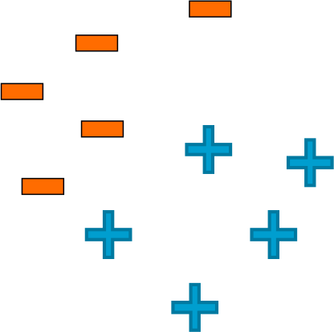



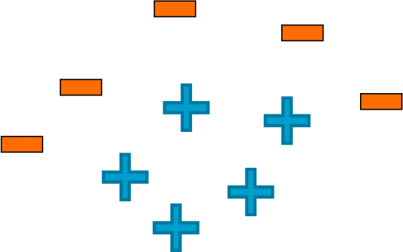

4.

***True or false:***High classification accuracy always indicates a good classifier.



**True**



**False**

5.

***True or false:***For a classifier classifying between 5 classes, there always exists a classifier with accuracy greater than 0.18.



**True**



**False**

6.

***True or false:***A false negative is always worse than a false positive.



**True**



**False**

7.

Which of the following statements are true? (*Check all that apply*)



**Test error tends to decrease with more training data**



**Test error always goes to 0 with an unboundedly large training dataset**



**Test error is never a function of the amount of training data**