Recommender Systems

9 questions

1.

Recommending items based on **global popularity** can (*check all that apply*):



**provide personalization**



**capture context (e.g., time of day)**



**none of the above**

2.

Recommending items using a **classification** approach can (*check all that apply*):



**provide personalization**



**capture context (e.g., time of day)**



**none of the above**

3.

Recommending items using a **simple count based co-occurrence matrix** can (*check all that apply*):



**provide personalization**



**capture context (e.g., time of day)**



**none of the above**

4.

Recommending items using **featurized matrix factorization** can (*check all that apply*):



**provide personalization**



**capture context (e.g., time of day)**



**none of the above**

5.

Normalizing co-occurrence matrices is used primarily to account for:



**people who purchased many items**



**items purchased by many people**



**eliminating rare products**



**none of the above**

6.

A store has 3 customers and 3 products. Below are the learned feature vectors for each user and product. Based on this estimated model, which product would you recommend most highly to *User #2*?

|  |  |
| --- | --- |
| **User ID** | **Feature vector** |
| 1 | (1.73, 0.01, 5.22) |
| 2 | (0.03, 4.41, 2.05) |
| 3 | (1.13, 0.89, 3.76) |

|  |  |
| --- | --- |
| **Product ID** | **Feature vector** |
| 1 | (3.29, 3.44, 3.67) |
| 2 | (0.82, 9.71, 3.88) |
| 3 | (8.34, 1.72, 0.02) |



**Product #1**



**Product #2**



**Product #3**

7.

For the liked and recommended items displayed below, calculate the**recall**and round to 2 decimal points. (*As in the lesson, green squares indicate recommended items, magenta squares are liked items. Items not recommended are grayed out for clarity*.)

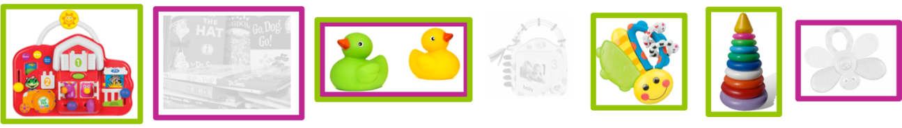



8.

For the liked and recommended items displayed below, calculate the**precision**and round to 2 decimal points. (*As in the lesson, green squares indicate recommended items, magenta squares are liked items. Items not recommended are grayed out for clarity*.)

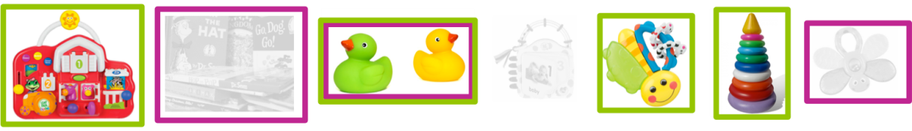



9.

Based on the precision-recall curves in the figure below, which recommender would you use?

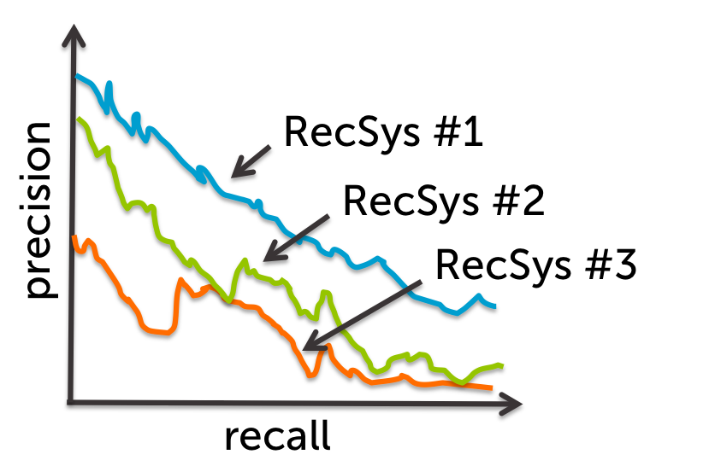



**RecSys #1**



**RecSys #2**



**RecSys #3**