# Computer Networks

|  |  |  |
| --- | --- | --- |
|  | Assignment 3 |  |

**Note**: For each question below, state the required answer precisely and then provide proper explanation. That is, if the question requires arriving at a conclusion, be sure to provide the reasoning behind the conclusion. If the question involves some computation, be sure to show all the major steps involved. Again, it is not enough to provide one- word or one-line answers.

1. For each case below, we wish to assign a unique binary representation (bit pattern) for each member of the set. Determine the **minimum** number of bits needed to uniquely represent a member of the set described.
   1. The set of ten digits 0, 1, …, 9 4 bits
   2. The set of 26 uppercase alphabet characters A, B, …, Z 5 bits
   3. The individual seconds in a 24-hour day 17 bits
   4. The individual residents of the United States (about 315 million) 29 bits
   5. Four nucleotides in Human Genome (C,T,A,G) 2 bits
   6. 20 amino acids necessary for human life 5 bits
2. Consider the 8-bit ASCII code with leading 0 as explained in class. (see the below for ASCII chart standard set). Determine the ASCII representation in **Hex number** for each of the following, if possible:
   1. Uppercase letter K 4B
   2. The exclamation mark (**!**) character 21
   3. The sequence of six characters Hello!

H: 48

e 65

l: 6C

l: 6C

o: 6F

!: 21[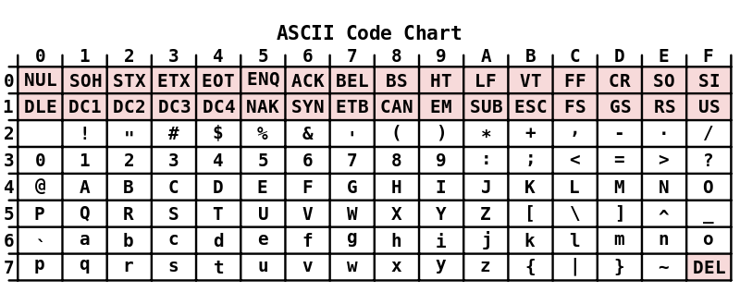](http://upload.wikimedia.org/wikipedia/commons/4/4f/ASCII_Code_Chart.svg)

1. Consider an office memo with one page of plain text (50 lines and 60 characters/line, including the newline character at the end of each line).
   1. It is typed using the Notepad application. What is the size of the text file in bytes?

Number of chararcters = 50 * 60 = 3000

3000 + 50 new line chars

Size of the file in bytes would be 3050 bytes

* 1. The text is read out and the audio is digitized, with a sampling rate of 8,000 samples per sec and using 8 bits/sample. The reading took 3 minutes. What is the size of the uncompressed digitized audio file in bytes?

180 seconds * 8000 samples = 1440000 samples

1,440,000 * 8 = 11,520,000 bytes.

1. Consider an image with 24 bit color depth, i.e., it uses 24 bits per pixel. Available memory to store the image is 4 MB. What is the highest resolution possible among the following choices and give the explanation?

* 640x480
* 800x600
* 1024x768
* 1152x864
* 1280x1024
* 1600x1200

1280 x 1024 x 24 = 31,457,280 bits = 3,932,160 bytes = 3.75 MB

1600 x 1200 x 24 = 57,600,000 bits = 7,200,000 bytes = 6.88 MB

Highest resolution you can reach without overflowing!

1. Consider a 60-minutes compact disk in which very high quality 2-channel stereo music is recorded. Determine the amount of information (in bytes) stored in it. Assume the following characteristics: sampling rate = 40,000 samples/sec; signal representation uses 16 bits/sample.

3600 seconds

2 separate audio signals (2-channel)

40,000 samples/sec per audio signal

16 bits per sample

40,000 samples/sec x 16 bits/sample x 2 audio channels = 1,280,000 bits/sec

1,280,000 bits/sec * 3600 seconds = 576,000,000 bytes

1. Consider an uncompressed full-motion video with the following parameters: 40 frames/second. 640x480 resolution and 8 bits/pixel color depth. Determine the number of bits generated per second, i.e., determine the data rate required for transmission of the video over a network in real time.

pixels per frame: 640 x 480 = 307,200 pixels

8 bits / pixel frame: 307,200 x 8 = 2,457,600 bits.

frame rate: 40 fps

total: 2,457,600 bits x 40 frames = 98,304,000 bits/sec

98,304,000 bits/sec / 1,000,000 = 98.304 mbps

data rate required 98.304 Mbps.

1. When examining x-rays, radiologists often deal with four to six images at a time. For a faithful digital representation of an x-ray photograph, a pixel array of 2048x2048 is typically used with a gray scale intensity of 12 bits/pixel. As you can imagine, radiologists do not like compression tools that degrade quality.
   1. How many bits does it take to represent one x-ray photograph based on these parameters?

2048 pixels * 2048 pixels *12 bits/pixel = 53,687,091 bits

* 1. Suppose that five x-rays have to be sent to another site over a T1 line which allows 1.544 Mbps data rate. How long would it take? (Note: Here Mbps stands for 106 bps.)

Total bits: 5 * 53,687,091 bits = 268,435,455 bits

Data rate = 1.544 Mbps = 1.544 x 106 bps

Time = Total bits / Data rate = 268,435,455 bits / (1.544 x 106 bps) = 173.8 seconds

1. Consider a geosynchronous satellite placed in an orbit 22,300 miles above the equator. In free space, the radio signal propagation speed is the same as that of light (0.3*106 KM/second). Compute the propagation time when a signal is bounced from one earth station to the satellite and down to another earth station. (Note: 1 mile = 1.6 KM)

Total distance: 2 * 22,300 = 44,600 miles

44,600 miles * 1.6 km/mile = 71,360 km

The speed of propagation is given as 0.3*106 km/second.

Propagation time = distance / speed

71,360 km / (0.3 × 10^6 km/s) = 0.238 seconds

1. Consider a rover placed on the surface of Mars. Normally, Mars is about 140 million miles away from Earth. Suppose some command to maneuver the rover is sent from Earth. In free space the signal propagation speed is the same as that of light (0.3*106 KM/second). How long will it take for the signal to propagate from the surface of Earth to the surface of Mars?

Distance: Earth, Mars: 140,000,000 miles.

Signal propagation speed: 0.3*10^6 KM/second.

1 mile = 1.60934 kilometersISH

140,000,000 * 1.60934 kilometers = 225,308,400 km

time = distance / speed

time = 225,308,800 km / 0.3*10^6 km/second = 751.03 second

751.03 seconds ÷ 60 seconds/minute ≈ 12.517 minutes

1. In order to do a “speed test” of his network connection, Sam uploaded a large file to a server and then immediately downloaded the same. He observed the average data rate of 1 Mbps for upload and 2 Mbps for download. What is the average data rate for the roundtrip of the file, i.e., including the upload and download?

Average roundtrip data rate = Upload rate + Download rate (1+2 =3)

Average roundtrip data rate = 3 Mbps.