|  |  |  |
| --- | --- | --- |
| **CIS 422 DBMS** | **LAB 04** | **Points: 20** |
| **Views** | | |

**Lab Questions**

***For each of the following question, provide the SQL statement and the screenshot for the result from the phpMyAdmin.***

1. Write a view to display detailed information about each employee, information such as employee id, first name, last name, manager name, department name, and job title?

CREATE VIEW detailed_information AS

SELECT emp.first_name, emp.last_name, emp.employee_id, CONCAT(emp1.first_name, ' ', emp1.last_name) AS manager_name, dept.department_name, job.job_title

FROM employees emp

LEFT JOIN employees emp1 ON emp.manager_id = emp1.employee_id

JOIN departments dept ON emp.department_id = dept.department_id

JOIN jobs job ON emp.job_id = job.job_id;

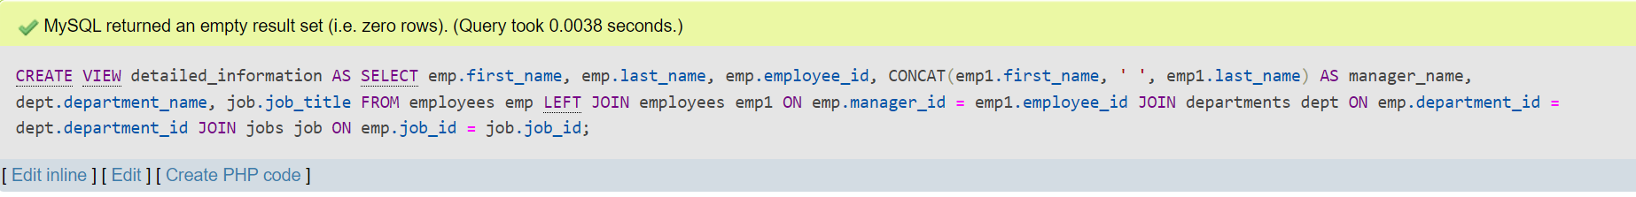

1. Write a view to display a summary of each department, including the total number of employees, the average salary, and the location?

CREATE VIEW summary AS

SELECT

dept.department_name,

dept.department_id,

COUNT(emp.employee_id) AS number,

AVG(emp.salary) AS average,

lccity

FROM

employees emp

JOIN departments dept ON emp.department_id = dept.department_id

JOIN locations loc ON dept.location_id = loc.location_id

GROUP BY

dept.department_id,

dept.department_name,

loc.city;

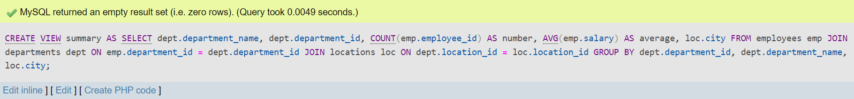

1. Write a view to display information about each employee and their dependents, including the employee's department and job title?

CREATE VIEW information AS

SELECT

emp.employee_id,

emp.first_name,

emp.last_name,

dept.department_name,

job.job_title,

dep.relationship

FROM

employees emp

JOIN

departments dept ON emp.department_id = dept.department_id

JOIN

jobs job ON emp.job_id = job.job_id

LEFT JOIN

dependents dep ON emp.employee_id = dep.employee_id;

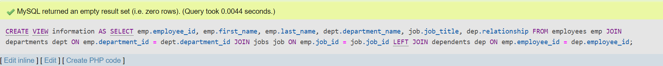

1. Write a view to display the top 5 job titles with the highest average salary within each department?

CREATE VIEW top_five_jobs AS

SELECT

J.job_title,

D.department_name,

AVG(E.salary) AS avg_salary

FROM

employees E

JOIN departments D ON E.department_id = D.department_id

JOIN jobs J ON E.job_id = J.job_id

GROUP BY

D.department_id,

J.job_title

ORDER BY

avg_salary DESC

LIMIT 5;

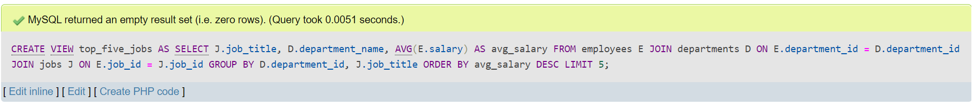

1. Write a view to display information about each manager, including the total number of employees they manage, total salary, and average salary by department?

CREATE VIEW manager_information AS

SELECT

mgr.employee_id AS id,

mgr.first_name,

mgr.last_name,

COUNT(emp.employee_id) AS total_employees,

SUM(emp.salary) AS total_salary,

AVG(emp.salary) AS average_salary,

dept.department_name

FROM

employees emp

JOIN employees mgr ON emp.manager_id = mgr.employee_id

JOIN departments dept ON emp.department_id = dept.department_id

GROUP BY

mgr.employee_id,

dept.department_name

ORDER BY

mgr.last_name,

mgr.first_name,

dept.department_name;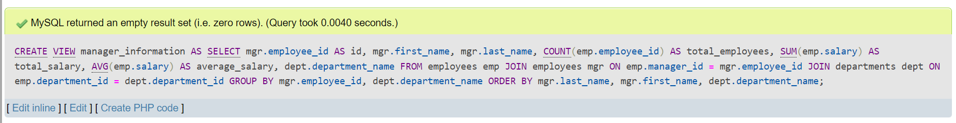

1. Write a view to display salary statistics for each job title in each region, including the number of employees, minimum, maximum, average, and standard deviation of salaries?

CREATE VIEW job_statistics AS

SELECT reg.region_name, titles.job_title,

COUNT(emp.employee_id) AS number,

MIN(emp.salary) AS minimum,

MAX(emp.salary) AS maximum,

AVG(emp.salary) AS average,

STDDEV(emp.salary) AS deviation

FROM employees emp

JOIN jobs titles ON emp.job_id = titles.job_id

JOIN departments dept ON emp.department_id = dept.department_id

JOIN Regions reg ON dept.department_id = reg.region_id

GROUP BY reg.region_name, titles.job_title

ORDER BY reg.region_name, titles.job_title;

