HDB Resale Price Predictor

Eugene Tan Boon Hong
Singapore Polytechnic Applied AI & Analytics
Overview
My project trains a regression model to predict HDB resale prices based on these flat characteristics: location, size, remaining lease, floor level, flat type, and flat model. The goal was not just to build a model, but to go through the full real world Machine Learning process; cleaning messy data, engineering useful features, comparing model approaches, and validating predictions against actual current market listings.
Data Source
- Dataset: HDB Resale Flat Prices (Jan 2017 onwards) — official transaction records published by data.gov.sg https://data.gov.sg/datasets/d_8b84c4ee58e3cfc0ece0d773c8ca6abc/view
- Size: 239,330 REAL transactions
- Columns: month, town, flat type, block, street name, storey range, floor area, flat model, lease commencement date, remaining lease, resale price

Data Cleaning & Feature Engineering
The government data was not analysis ready straight from the .csv file, Three columns needed transformation before they could be used.
Raw Column | Problem | Solution
remaining_lease | "61 years 04 months" (text) | Parsed to extract just the year count as an integer
storey_range | "10 TO 12" (text range) | Split and averaged into a single numeric floor estimate
month | "2017-01" (date string) | Converted to "months since Jan 2017" to capture market trend over time

town, flat_type, and flat_model (categorical/text fields) were one hot encoded to make them usable in my regression model
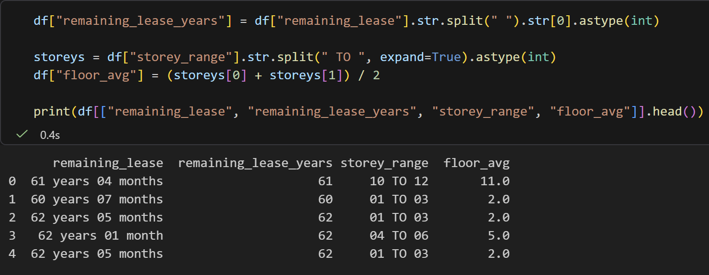

Model Iterations
Rather than accepting the first result, each change was tested in isolation to measure its actual impact:
Version | Type of Model | Mean Absolute Error | % of Average Price ($534,296)
V1 | Linear Regression | $52,760 | 9.87%
V2 | Random Forest | $26,811 | 5.01%

Linear Regression Model V1
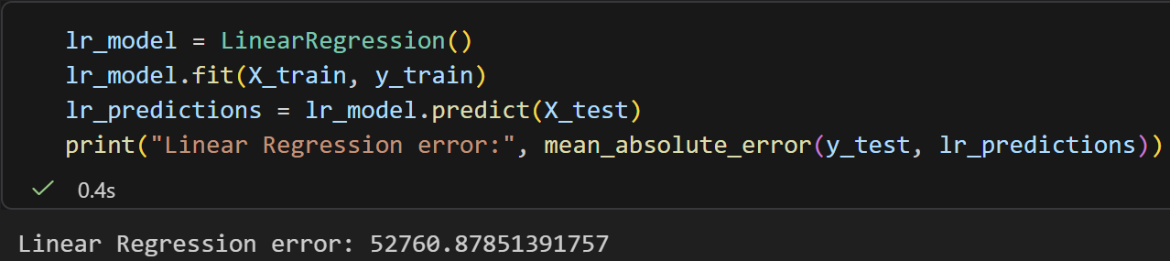

Random Forest Model V2
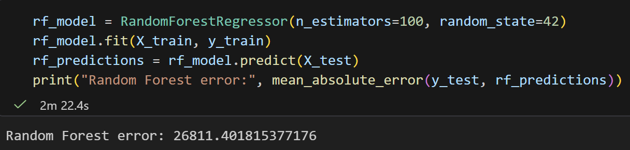
Key Findings
- Switching from a Linear Regression to Random Forest Model nearly halved the prediction error. From $52,760 to $26,811, a reduction of about 49%
- As a percentage of the average resale price ($534,296), this moved the model from roughly 9.87% off to 5.01% off, a meaningfully more accurate result.
- The improvement comes from how each model handles relationships in the data: Linear Regression assumes every feature adds up in a straight line, while Random Forest can capture other factors in its interactions; for example, floor area may matter more in some towns than others, a pattern a purely linear model could not represent
- The trade-off is, the Random Forest Model took a lot longer to train (2m 22s vs 0.4s), reflecting the added computational cost of building 100 decision trees instead of fitting a single linear equation.
Real-World Validation
To check the model beyond the test set and against real world properties, I pulled live PropertyGuru listings and compared the model's prediction against the actual asking price.
Listing | Town | Type | Size | Lease | Asking | Predicted
319 AMK Ave 1 | Ang Mo Kio | 3 Rm | 73sqm | 50yr | $440,000 | $434,234
649 Hougang Ave 8 | Hougang | 5 Rm | 120sqm | 60yr | $808,000 | $778,804
588D AMK St 52 | Ang Mo Kio | 5 Rm | 112sqm | 84yr | $1,180,000 | $936,113

Note that the asking price is the price of what the seller WANTS, PropertyGuru did not state the exact floor of the listing, hence I had to gauge it based on the listing descriptions of “High Floor” etc.
Listing Screenshots
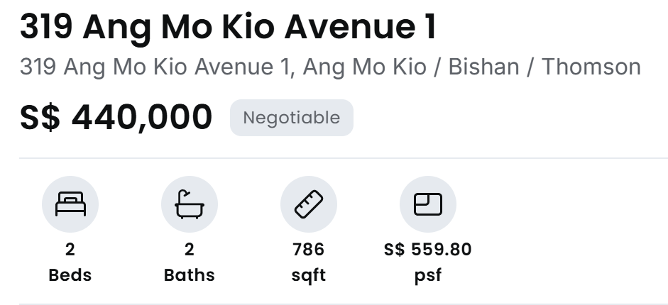
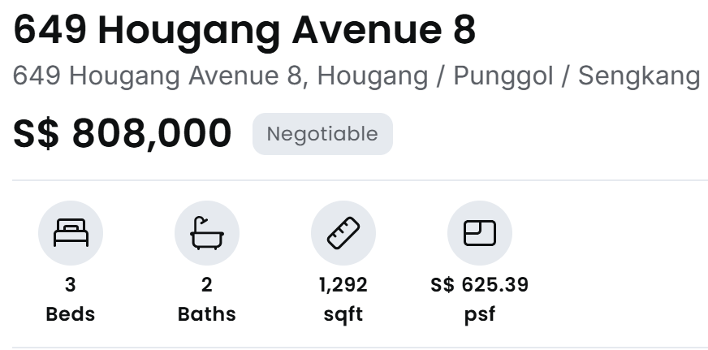
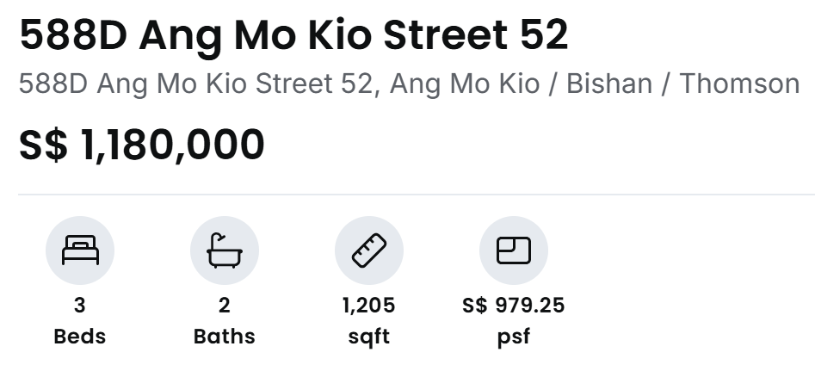
Prediction Code
The predict_price() function used to generate each prediction above:
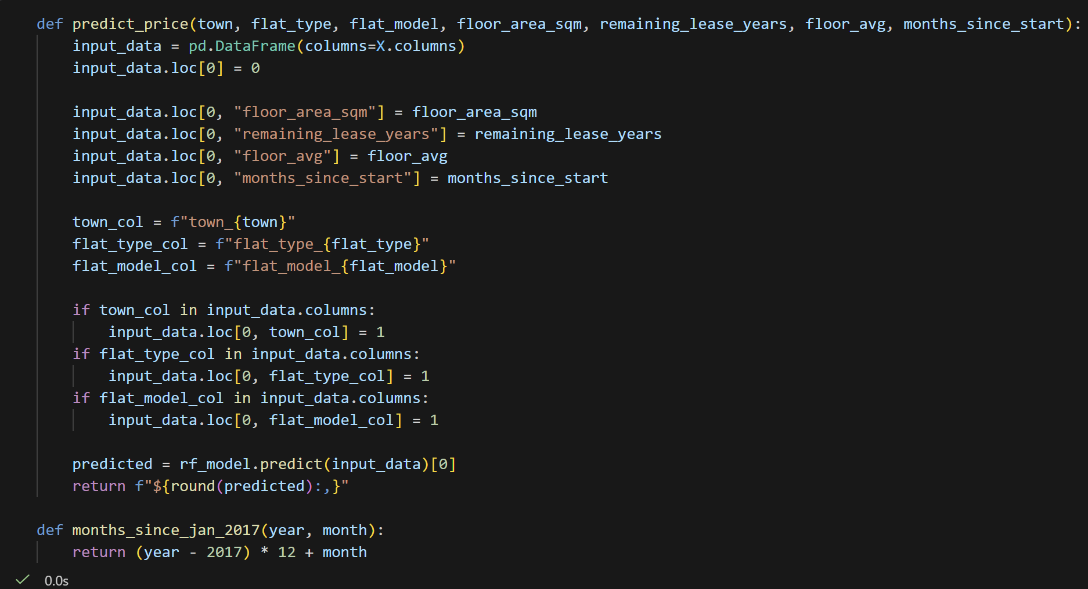

Tech Stack
- Python: pandas, scikit-learn
- Environment: Jupyter Notebook
- Models tested: Linear Regression, Random Forest Regressor
What I would Improve Next
- Add distance to MRT and distance to nearby necessities like malls & schools as features (These are likely significant price drivers that were not captured)
- Build a small interactive input (Streamlit or similar) instead of manually calling the prediction function which could get repetitive
- Expand real world validation to a larger sample of 10+ real PropertyGuru listings for a proper accuracy check, rather than a handful of spot checks
Key Takeaway
The biggest lesson from this project was not a specific line of code but learning to treat model improvement as an experiment; change one thing, measure the effect, and understand why it did or did or did not help, rather than tweaking blindly until a number looks better.

