

Timing is Key: Utilizing New Product Forecasting and Optimizing Market Entry to Reduce Cannibalization



“Venture Towards Operational Excellence”

Timing is Key: Utilizing New Product Forecasting and Optimizing Market Entry to Reduce Cannibalization
Final Report

Submitted to:
Tim Behling | VP of Supply Chain, Gemline
Chris Harrison | Manager of Supply Chain, Gemline
9 International Way,
Lawrence, Massachusetts 01843

Dr. Prakash Sathe
IOE 424 Instructor, University of Michigan
1205 Beal Avenue
Ann Arbor, MI 48109

Submitted by:
Trinity Briggs
Valeria Marin Gallo
Nikhil Satpathy
Emmanuel Tchonang
Vent Consulting
IOE 424, University of Michigan
1205 Beal Avenue
Ann Arbor, MI 48109

Date Submitted: December 8, 2025

Approved by: __________________________________________ __________________
Tim Behling, Gemline Date

__________________________________________ __________________
Chris Harrison, Gemline Date

__________________________________________ __________________
Dr. Prakash Sathe, IOE 424, University of Michigan Date

Table of Contents
Foreward 6
Background and Situation Analysis 6
Sponsor Background 6
Current Situation 2
Problem Definition 2
IISE Body of Knowledge 2
Project Scope 3
Deliverables 3
Goals and Objectives 5
Measuring Project Success 6
Analytical Model Formulation 6
Model Description 6
Predicting Sales Distribution Using Random Forest 7
Table 1: Predicted sales distribution 7
Predicting Total Sales Using Gradient Boosting 7
Table 2: Predicted total first year sales 8
Combining Results From Demand Profile and Total Demand Predictions 8
Figure 1: Sales forecast for item 101364-181 8
Dashboard 9
Constraints 9
Alternative Options Considered 10
Diffusion Model 10
Exponential Smoothing 10
Figure 4: sMAPE Percentages for each SKU using Exponential Smoothing 11
Data Collection Approach and Analysis 12
Data Loading and Cleaning 12
Data Manipulation and Preparation 12
Analytical Tool Development 12
Findings 13
Recommendations 13
Table 1: Launch month recommendations with 100% confidence 13
Results Achieved 14
Cannibalization (Analysis #1) 14
Data Preparation and Event Definition 14
Z-Score Framework for Cannibalization 15
Interpreting Z-Score Thresholds 15
Cannibalization Output 16
Figure 5: Definitions for each column in the final cannibalization table 16
Cannibalization (Analysis #2) 17
Potential Financial Impacts and Benefits 20
Michigan Difference 20
References 21
Appendix A: Gantt Chart 22
Appendix B: Team Member Contributions 23
Appendix C: Project Personnel 24

Executive Summary
Gemline initially approached our team with a set of problems they were facing, including sales forecasting inaccuracies, unoptimized market entry times, and cannibalization between products within the company. They have a current method of forecasting, however, expressed concerns with its accuracy and when products should be launched. These issues that Gemline is facing are likely contributing to the cannibalization that they have been noticing. In order to solve these issues, the team created an interactive dashboard for sales forecasting and analyzed past sales data to determine optimal product launch months and the likelihood of a product experiencing cannibalization due to its characteristics.

During the development process, the team worked with sponsors to ensure that they were targeting the specific issues that Gemline anticipated while ensuring that team members had a complete and accurate understanding of the provided data. Once the problem and data was fully understood, the team began implementing three separate models for forecasting. By comparing results from the models, the team was able to establish which model did the best job based on the sales forecast accuracy that was received.

A thorough analysis of the data allowed the team to come to a conclusion on specific launch months for four groups at 100% confidence, and 27 groups at 66.66% confidence. The four groups with 100% confidence had the same month, for three years, with the highest sales for the year. While the other confidence level had the same month, for two out of three years, with the highest sales. By comparing previous sales for each product, we could determine that in November serverware should be launched and in December mugs, tumblers, and mailers should be launched. By following these launch dates, Gemline should obtain the optimal sales while also avoiding excess inventory.

To address cannibalization, we built a diagnostic framework that compares subcategory-level sales before and after each new SKU launch. Every introduction uses Z-scores to benchmark changes against historical seasonality, flagging cases where sales declines are unlikely to be driven by normal variation alone. We then roll this up into category- and subcategory-level summaries and heat maps that highlight where cannibalization risk is concentrated. Because some negative deltas may instead be driven by stockouts or broader demand shifts, the framework is designed to provide a structured range of cannibalization signals rather than a single definitive value, guiding Gemline’s follow-up investigation at the SKU level.

After consulting with Gemline, the team was able to establish a year one savings of $1-2 million if they were to enact our recommendations. This savings would be driven by a reduction in excess inventory due to more accurate forecasting, and incremental sales revenue being captured better by anticipating upside demand and having inventory available. Our recommendations would not cost Gemline any extra money, nor would our forecasting tool as it was built with Python.

Foreward
Gemline, a global leader in high-quality promotional merchandise, currently faces challenges in efficiently and accurately forecasting demand for both new and existing products. The company’s current process relies on manual spreadsheet analysis, which makes it difficult to account for product seasonality, cannibalization, and variations across categories. As a result, our team has set out to develop a combined analytical forecasting and visualization tool to support Gemline’s decision-making process for product launches and inventory planning.

Gemline has asked our team to create a data-driven system that can analyze historical sales data, identify seasonality patterns, and cluster similar SKUs to improve forecasting accuracy and interpretability. Given this task, our team is responsible for developing an analytical model in Python and a visual dashboard in Excel (or Power BI) to communicate model outputs. The tool will incorporate smoothing and clustering approaches while tracking error metrics such as MAPE and RMSE to evaluate model performance.

Our team is using Python (Google Colab) for model development and Excel dashboards for data visualization and summary reporting. This report summarizes work completed from September 2025 through November 2025, covering the project background, data analysis process, and the preliminary testing conducted to date. As the project scope evolves through weekly collaboration with Gemline, this report represents the most complete version of our analytical framework at this stage.

Background and Situation Analysis
This section provides an overview of Gemline’s business background, the forecasting challenges currently faced by the company, and the analytical problem definition that frames our project.

Sponsor Background
Founded in 1958 and headquartered in Lawrence, Massachusetts, Gemline is a premier supplier in the promotional products industry, producing a wide range of high-quality branded merchandise including bags, drinkware, technology accessories, and home goods. The company partners with over 40 consumer brands such as Moleskine, Osprey, and Samsonite, while managing a large portfolio of in-house brands.

Gemline’s global sourcing network spans more than 10 countries, with facilities in China and Vietnam that support the company’s supply chain operations. With over 450 employees worldwide, Gemline is known for its innovation, commitment to sustainability, and strong reputation within the industry. The company introduces hundreds of new SKUs each year, reflecting variations in color, design, and product attributes across sixteen core product categories.

Current Situation
Gemline’s current forecasting and planning processes rely heavily on manual methods using Excel spreadsheets. These methods present several limitations:

- Forecasts cannot easily account for seasonal demand patterns
- Launch timing and new product cannibalization are difficult to assess
- SKU-level variability produces highly complex (“spaghetti”) graphs that obscure underlying trends
- Manual updates are time-consuming and error-prone, limiting forecast frequency

As a result, Gemline’s Forecasting Team spends extensive time generating forecasts that may not fully reflect true demand patterns. This inefficiency poses risks of stockouts, excess inventory, and missed insights into launch timing—all of which can affect profitability and service levels.

Problem Definition
In this project we have to solve the industrial and engineering problem dealing with the improvement of both sales forecasting and market entry to combat potential cannibalization. The current manual process limits the company’s ability to make data-driven inventory and product launch decisions, especially in the presence of seasonal variation and product overlap.

The key objectives of this project are to:

- Accurately predict sales trajectories for existing and new SKUs
- Quantify and visualize potential cannibalization effects among similar products
- Capture seasonal trends and improve forecast interpretability
- Reduce manual forecasting time and improve scalability of future forecasting efforts

The final output will be a combined analytical forecasting model and dashboard that integrates smoothing and clustering methods, generates category-level predictions, and reports model accuracy using MAPE and RMSE metrics.

IISE Body of Knowledge
One of the IISE Body’s of knowledge that this project falls under is Operations Research and Analysis[3]. From an industrial engineering perspective, this includes managing and evaluating data to optimize areas that are lacking, such as: cannibalization, market entry, and sales forecasting amongst others. Additionally, this project utilizes Information Engineering[3]. The main concerns of this Body of Knowledge is combining computer science and various information systems to develop and manage complex systems including: sales forecasting models, dashboards for determining product launch correlations, and storing assorted data to determine a cannibalization likeliness score.

Project Scope
The scope of this project centers on developing a comprehensive analytical and visualization tool to enhance Gemline’s forecasting accuracy, with a specific focus on improving product launch timing, understanding seasonality, and identifying potential cannibalization within product categories. To accomplish this, our team is using two primary datasets provided by Gemline: one containing an exhaustive list of all SKUs, and the other containing sales data dating back to the beginning of 2022. While these datasets are maintained separately, they are merged within our Python scripts using key linking columns to form a unified analysis table for modeling and visualization purposes.

Our analysis encompasses all 20+ category groups in Gemline’s catalog rather than focusing on a subset, ensuring a broad and scalable approach. This allows us to capture diverse product behaviors across categories such as drinkware, bags, coolers, and home goods. We apply clustering techniques to group SKUs by shared characteristics—including Category, Subcategory Description, and CommGroup2 Description—alongside selected product attributes like price. These clusters enable Gemline to visualize relationships between products and identify how trends vary by category type.

To model and forecast sales patterns, our team employs smoothing-based techniques (specific methods such as Holt-Winters Exponential Smoothing, will be determined and detailed later). Each model is trained on the first two to three years of sales data (2022–2024) and then tested by forecasting the subsequent year to evaluate performance accuracy. This back-testing process ensures that the model is not only statistically sound but also practically applicable to Gemline’s real-world operations.

The deliverable for this project is a forecasting and visualization tool that enables Gemline to interactively explore demand trends across product categories and time periods. The tool will allow users to filter by Category, Subcategory Description, and CommGroup2 Description, and visually assess whether certain months or quarters consistently yield higher sales—insights that directly inform product launch strategies. This system will ultimately help Gemline understand the optimal times to introduce new products and manage existing inventory more effectively.

Deliverables
The deliverables for this project consist of two primary analytical tools—a forecasting model and a market entry tool—both built in Python within Google Colab. Together, these deliverables are designed to provide Gemline with scalable, data-driven methods to forecast sales, evaluate launch timing, and better understand relationships between new and existing SKUs. Each tool is supported by a structured Python workflow, complete documentation, and modular code to ensure Gemline can independently operate, interpret, and update the analyses after project completion.

In addition to these two analytical deliverables, the project also includes the creation of a reproducible data pipeline that consolidates and cleans Gemline’s SKU and sales datasets, transforming them into a consistent analytical structure for future use. This pipeline ensures that future iterations of the forecasting or market-entry analyses can be easily rerun by simply updating the source data. The framework is designed with flexibility in mind, allowing Gemline’s analytics team to incorporate additional product categories, attributes, or new years of sales data with minimal modification. As a longer-term vision, the team’s Python codebase and outputs can serve as the foundation for future integration into Excel-based or Power BI dashboards, should Gemline wish to scale or operationalize these tools across departments.

The forecasting model serves as the project’s core analytical component. It is designed to predict sales trajectories for both Gemline’s current SKUs and planned new products by comparing upcoming items to historically similar ones based on shared attributes such as category, subcategory, and price range. The model produces both numerical forecasts and visualized demand patterns, illustrating category-level sales trends across time. Its modular Python structure allows Gemline to easily rerun forecasts as new data become available, ensuring long-term usability. Beyond standard forecasting, the model introduces the capability to estimate cannibalization effects, assessing how the introduction of a new SKU might impact sales of existing products in the same segment. Although quantifying cannibalization remains complex due to overlapping sales trends (“spaghetti graphs”), this deliverable provides a replicable foundation that Gemline can continue to refine and expand upon for future analyses.

The market entry tool complements the forecasting model by analyzing the correlation between product launch timing and sales performance, helping Gemline determine the most strategic months or quarters for introducing new products. This tool highlights category- and subcategory-specific seasonality patterns, quantifying the relationship between the month of product introduction and subsequent sales activity. It outputs both correlation tables and visualization plots to clearly communicate these trends. Users can filter or subset the analysis by Category, Subcategory Description, and CommGroup2 Description, enabling flexible exploration of different product groupings. If time permits, the team plans to integrate this tool into a simple interactive dashboard interface, allowing Gemline’s team to toggle between product categories and visualize relationships more intuitively.

Both analytical tools are supported by a detailed documentation package that includes annotated Python notebooks, a step-by-step user guide, and instructions for integrating new data sources or updating model parameters. The final submission will also include a comprehensive written report summarizing all methods, results, and recommendations for continued improvement. The project will culminate in a live demonstration and presentation to Gemline in November 2025, during which the team will showcase the tools’ functionality, explain key analytical insights, and provide recommendations for long-term adoption and expansion within Gemline’s forecasting and product development workflows.

Goals and Objectives
The overarching goal of this project is to create a scalable, data-driven forecasting framework that strengthens Gemline’s ability to anticipate demand, improve product launch timing, and manage inventory across its extensive SKU portfolio. We have to find a solution to the above-mentioned design problem by designing a model that can predict sales forecasts with limited data, determine optimal product launch dates based on past sales, and draw commonalities between cannibalized products to better predict cannibalization. The project is guided by three primary objectives: increasing forecasting accuracy, identifying seasonal launch windows, and quantifying potential product cannibalization. By addressing these objectives, our team aims to provide Gemline with the tools necessary to make informed, evidence-based decisions that enhance both operational efficiency and profitability.

From a technical perspective, the project seeks to reduce forecasting uncertainty through the application of advanced smoothing and clustering techniques, complemented by rigorous model validation. Forecast performance will be assessed using error measurement metrics such as MAPE and RMSE, with additional benchmarking criteria to be incorporated later by our modeling subteam. Beyond model accuracy, our team’s focus extends to interpretability and usability—ensuring the results are presented in a clear, actionable format that aligns with Gemline’s decision-making needs.

Strategically, the forecasting tool will support Gemline’s annual product planning cycle, allowing the company to visualize sales projections one year in advance and make more informed choices about when to introduce new SKUs. The sponsor has already expressed interest in expanding the application of our methods to specific product lines, including the Igloo® collection (e.g., Igloo® Yukon Box Cooler, Igloo® Juneau Backpack Cooler, and Igloo® Rowan Lunch Cooler). This demonstrates the project’s potential for long-term scalability and integration into Gemline’s ongoing forecasting and product development processes. By the end of November 2025, our team aims to deliver a validated, documented, and sponsor-approved forecasting tool that can be integrated into Gemline’s analytics workflow for future use across all product categories.

Measuring Project Success
The success of our project will be measured using a combination of quantitative performance metrics and qualitative sponsor feedback, ensuring that the tool delivers both analytical accuracy and practical usability for Gemline’s forecasting needs.

From a quantitative perspective, the primary indicators of success are forecast accuracy, correlation between sales and product launch timing, and the reduction in manual forecasting limitations. Our objective is to achieve at least 80% forecasting accuracy for products with sufficient historical sales data, while maintaining a Mean Absolute Percentage Error (MAPE) below 20%, aligning with industry benchmarks for demand forecasting performance. Additionally, we aim to establish at least a 66% correlation between month of launch and sales performance, a metric that helps Gemline identify the optimal timing for new product introductions. The tool’s computational efficiency also marks a significant improvement—our models can run in under 10 minutes and generate forecasts for an entire year, a process that was previously infeasible due to data complexity and manual limitations. These improvements collectively represent a major step toward enabling Gemline to make informed, data-driven launch and inventory planning decisions at scale.

Beyond accuracy and performance, project success will also be evaluated qualitatively through feedback from Gemline’s analytics and product management teams. Following the implementation of the month-versus-launch analysis tool, the sponsor expressed high satisfaction with the insights produced, noting that the results were clear, actionable, and directly relevant to their strategic planning. This positive reception underscores the practical value of our approach and sets the standard for future deliverables. While financial impact is difficult to quantify at this stage, improvements in forecasting precision and reduced cannibalization losses are expected to enhance both sales outcomes and operational efficiency. In summary, project success will be defined not only by achieving quantitative accuracy benchmarks but also by delivering a tool that Gemline’s team finds meaningful, intuitive, and scalable for long-term forecasting use.

Analytical Model Formulation
We used a machine learning model involving tree-based models to predict monthly sales for a new product throughout their first year, a choice corroborated by the multitude of tree-based approaches that have consistently appeared amongst the most accurate models in forecasting competitions held in recent years [1]. The primary advantage of this model is that it does not require prior sales data, so it can forecast demand even in the case that a product has no prior sales history.

Model Description
Tree-based models work by using a hierarchy of “if-then” rules to split data into groups that are increasingly similar with respect to the target variable. Each internal node represents a decision based on a feature (e.g., “if age < 30”), each branch represents an outcome of that decision (true or false), and each leaf node represents a final prediction (a class label or a numerical value). In essence, the model asks a sequence of yes/no questions about the features to narrow down to the most likely outcome — just like following a flowchart.

There are three main types of tree-based models: decision trees, random forests, and gradient boosting trees. Decision trees make one tree by repeatedly splitting the data based on the feature that does the best job separating the outcomes. Random forests build many decision trees combining predictions by either taking the average or mode. Gradient boosting trees build one decision tree at a time, where each new tree focuses on fixing the mistakes made by the earlier trees. In our model we use random forests and gradient boosting trees.

Definitions of Indices, Variables, and Constants
- Training set: The set of training items along with their class labels
- Attribute list: The set of attributes used to split the data

Assumptions:
- The year has no effect on the demand for an item. Because the model will be used to predict the demand for products in future years we could not use the year as a predictor since the training set will only include the years 2022 to 2025
- The attributes are independent. It is assumed that the attributes are not highly correlated because too high of a correlation will cause the model to ignore one of the two correlated attributes even if the ignored attribute has a causal effect on what we are predicting

Predicting Sales Distribution Using Random Forest
After normalizing monthly sales so that we would have a table showing the percent of first year sales that occurred in each month, we trained a random forest regressor model to predict the sales distribution of an item. We used subsubcategory and intro month as our attributes. We restricted predictors to these two features to avoid the model overfitting and because we believed these were the factors with the greatest impact on the sales distribution: subsubcategory influences an item’s seasonality and intro month determines when an item experiences its ramp up period. Below table 1 shows the model's prediction of the sales distribution of the training set. [2]

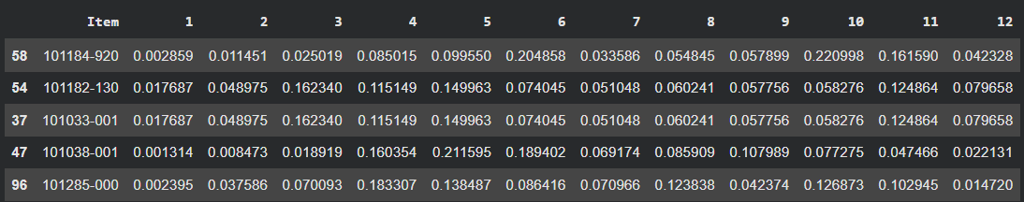

Table 1: Predicted sales distribution

Predicting Total Sales Using Gradient Boosting
We used gradient boosting to predict the total sales of an item during its first year of sales. We used gradient boosting instead of random forest because gradient boosting allows you to calculate upper and lower ranges easily. For the upper range we set the loss function so that the model was 90% confident that value would be lower than the upper range, and for the lower range we set the loss function so that the model was 90% confident that value would be higher than the lower range. For the training set we used the same items as the random forest model with the total amount of the item sold in its first intro year as the class label. We trained the model using the subsubcategory, intro month, brand, and price range attributes. Below table 2 shows the model's prediction of the total sales of the training set. [2][4]
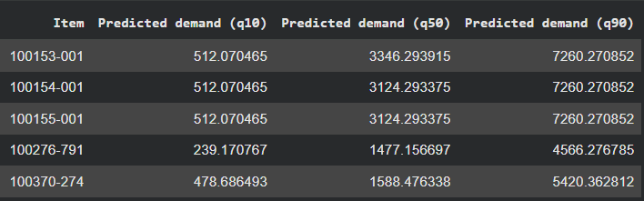

Table 2: Predicted total first year sales

Combining Results From Demand Profile and Total Demand Predictions
The results from the results from the demand profile and total demand predictions were multiplied together to get a monthly forecast of the demand of each item in the test set along with a high and low range. An example is shown below in figure 1. [2]
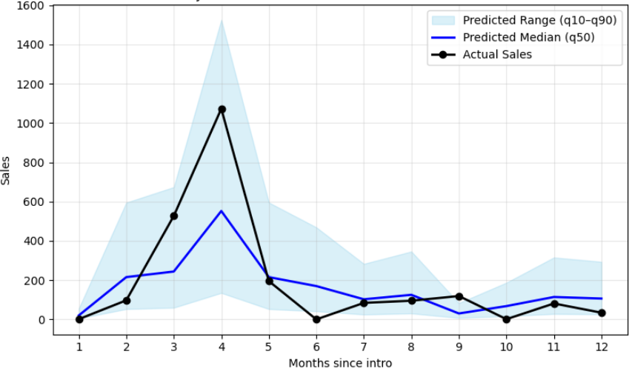

Figure 1: Sales forecast for item 101364-181

We defined accuracy as how often the actual monthly sales in the test data set fell within the predicted range. Our model was able to generate 7 subcategory forecast predictions with an accuracy ≥ 75% and 12 subcategory forecast predictions with an accuracy ≥ 65%. The top 5 highest performing subcategory predictions had the following accuracies: 91.67%, 83.33%, 75.83%, 75%, and 75%.

Subcategory | % of Actual Monthly Sales within Predicted Range
1WRT | 91.67%
1BAR | 83.33%
1EVRD | 75.00%
1OTD | 75.00%
1STK | 75.00%
1ENTR | 75.00%
1CAM | 75.00%
1STRK | 66.67%
1CHRG | 66.67%
1HDEV | 66.67%
1DECR | 66.67%
1FJR | 66.67%

Figure 2: Top 12 Highest Performing Subcategories and the Percentage of Actual Monthly Sales that were in their Predicted Ranges

Dashboard
We also developed a Python-based dashboard that allows Gemline to input new product features (subsubcategory, intro month, brand, and price range) and automatically generate a sales forecast. The dashboard is shown in Figure 2.
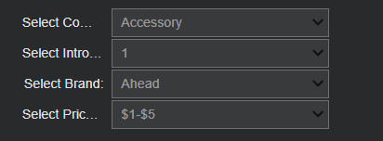
Figure 3: Python dashboard

Constraints
Internal constraints received from our sponsor is that our model cannot rely on prior sales history to make predictions and our model has to predict sales up to one year after an item is introduced.

Our work is on new product demand forecasting. We investigated the available standards pertaining to Safety, OSHA, HIPPA, EPA, etc. and could not find anything relevant to our project scope. Therefore our model is not constrained by any external standards.

Alternative Options Considered
For Gemline’s issue of forecasting sales with limited sales data, our team considered three model options: diffusion with bass increment, exponential smoothing, and tree based models. We ultimately decided on tree-based models after discussing that this model seems to be able to capture product attributes, and use those to forecast new products with similar attributes but limited sales data. Our method of evaluating each of these models is described below.

Diffusion Model
The first forecasting model we decided to explore was the diffusion model, a choice that was supported by Ching-Chin’s exploration of the New Product Forecasting system and a collective team discussion of which models we should try from the five models that the system utilizes[5]. The primary advantage of this model is that it employs both innovation and imitation effects to visualize how new products spread throughout a market over time, using minimal data to produce accurate forecasts. However, this model not only struggled to pick up peaks and valleys within the data, it also had runtimes exceeding 20 minutes for forecasting based on two years of training data.

Upon further analysis, it was found that the model did not reach a test MAPE score of less than or equal to 20% for any of the thousands of SKU’s that were provided to us by Gemline. In fact most of the MAPE scores that were achieved from the diffusion model were close to the order of 10^11 percent. This large MAPE score, which is not anywhere near our goal, and examining the forecasted sales against the actual sales informed us of the shortcomings that the diffusion model was experiencing. In an attempt to combat these challenges, different market potentials were considered in the model. The market potentials that we first implemented looked at the cumulative sales for a SKU, and set the market potential to a couple hundred sales below and above the cumulative sales. After not receiving results with the accuracy we were hoping for, the market entry was switched to a sinusoidal changing variable in attempts to have more accurate forecasting during periods of maximum and minimum sales. Finally, a pieceswise summation was enacted based on the specified launch dates that Gemline provided the internal team with.

With a closer look at visuals created using the diffusion model for forecasting, it was clear that changing the market potential did not have the intended results. While sharing these results with our internal team, it was decided that the diffusion model wasn’t handling the constantly changing demand for products, and therefore we decided to explore other models.

Exponential Smoothing
The second analytical model under consideration was the Holt-Winters Exponential Smoothing model, a choice substantiated by the frequency of its use in industry and the nature of sales at Gemline, which tend to depend on seasonality. Gemline currently receives many seasonal orders, with many products only having high demand for a specific set of months throughout the year. The seasonality leads to volatile sales demand, which in turn causes models to struggle with capturing maximums and minimums in the sales. The primary advantage of this model is that it can account for both item specific trends and general seasonal patterns in its forecasts as well as its ability to dynamically weigh older or more recent data more or less heavily depending on the patterns seen in historical sales. However, this model generally tends to yield more inaccurate results for highly volatile data, and certain items in Gemline’s product portfolio have historically fluctuated greatly.

During the beginning steps of model formulation, the results we received were promising. With the lowest achieved Symmetric Mean Absolute Percent Error (sMAPE) being 16%, which is above our goal of 80% accuracy. However, once we began to apply the model to more SKUs in Gemline’s directory we noticed that while some products received low percent errors, others were much higher than the industry's accepted sMAPE error of 20%-50%. In an attempt to combat this error, additive and multiplicative models were compared by the model and chosen based on which achieved the lowest error. Additionally, once more research was done, it was decided to add a damping parameter to account for some of the demand lags that Gemline experiences. It is important to note that with this model, the MAPE scores were not giving reliable numbers hence we switched to sMAPE. The two error metrics work the same, with the exception that sMAPE is bounded and symmetric while MAPE is asymmetric and can go on infinitely leading to error percentages in the thousands or higher. With such widespread error percentages given from MAPE, the internal team struggled to compare results with the Diffusion Model.

While these steps allowed us to reach a slightly lower sMAPE of 11.63%, we decided to create a histogram of bins based on ten percent increments, as seen in Figure 5. This allowed the team to better visualize how well the model was doing. An analysis of the histogram led the team to conclude that while Holt-Winters Exponential Smoothing model performs well for some of Gemline’s products, it really struggles with others. The model seems to lag behind when forecasting demand for products with a maximum or minimum sales compared to the cumulative sales. Upon receiving these results, the team decided to look into a different model for forecasting. [3]
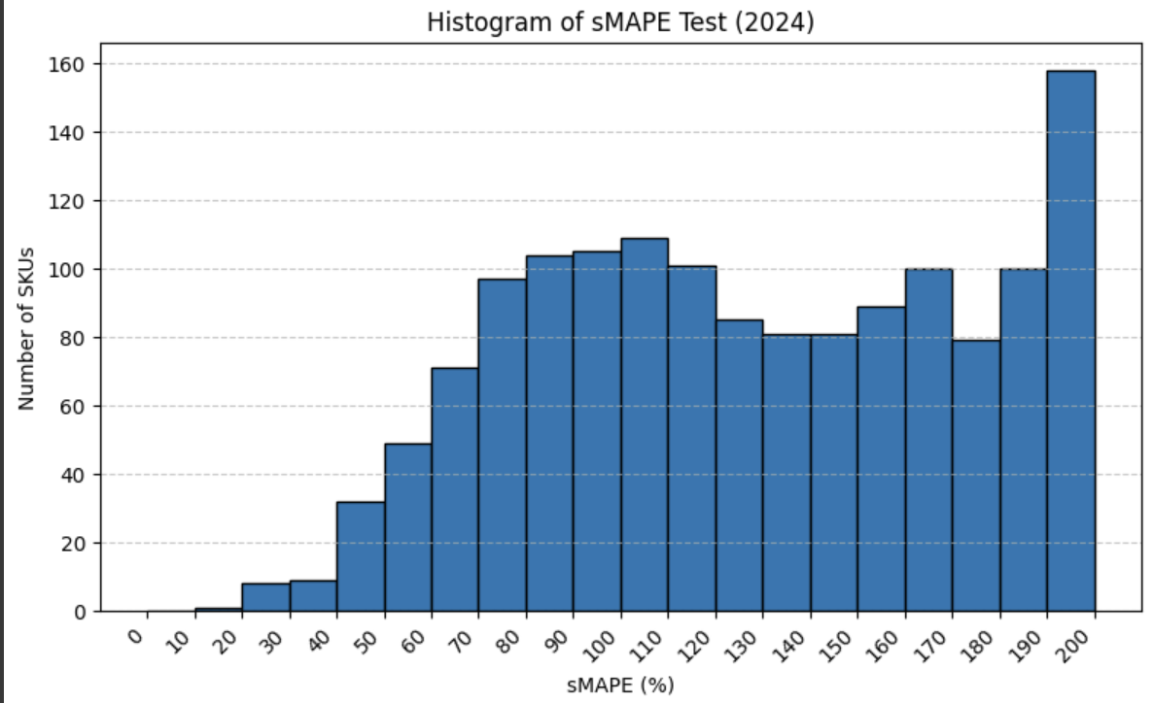

Figure 4: sMAPE Percentages for each SKU using Exponential Smoothing

Data Collection Approach and Analysis
The data used for this project was provided directly by Gemline in the form of two main datasets: (1) the SKU Attributes Report V2, containing all active and historical product attribute information, and (2) the Sales and Pricing Data (January 2022–August 2025), which records transactional-level details of product sales across Gemline’s portfolio. These two sources serve as the foundation for all subsequent analysis and were linked using the common identifier “Item,” ensuring each SKU’s sales data could be matched with its corresponding category, subcategory, and descriptive attributes.

Data Loading and Cleaning
The datasets were imported into Python (Google Colab) using the pandas library. Before merging, extensive preprocessing was performed to standardize column names, remove blank or null entries, and strip excess whitespace from string-based columns. The SKU Attributes dataset required particular attention because of inconsistent labeling across columns (e.g., “Subcategory Desc” vs. “Subcategory_Desc”), so a helper function was created to robustly locate and align column names regardless of formatting differences.

Following this, the data was normalized to ensure that categorical descriptors such as Category, Subcategory Description, and CommGroup2 Description were free from missing or redundant entries. Any rows with incomplete classification data (e.g., missing subcategory or CommGroup2 fields) were excluded to preserve analytical integrity. We also removed discontinued or irrelevant SKUs, including those marked under Intro Code = OOC, as well as products belonging to the PPE and PAD categories, which Gemline indicated were not relevant to forecasting or market entry analysis.

The cleaned dataset was then merged into a unified analytical table containing SKU-level sales, product attributes, and derived temporal variables such as ShipDate, Year, and Month. The combined dataset spans 2022 through mid-2025 and includes over 100,000 sales records, representing the most complete historical snapshot of Gemline’s sales performance to date.

Data Manipulation and Preparation
To support time-series forecasting and market entry analysis, the data was transformed into a monthly sales format. Each product’s sales quantities were aggregated by Category, Subcategory Description, and CommGroup2 Description for each month and year. This structure allowed us to identify sales seasonality patterns at multiple hierarchical levels rather than focusing solely on SKU-level volatility, which can obscure broader demand cycles.

To ensure statistical reliability, we filtered the dataset to include only group-year combinations with all 12 months of sales data. This step prevented partial-year trends from biasing the identification of seasonal peaks. Once this filtering was complete, the monthly data was used to calculate average monthly sales, peak months, and year-over-year consistency for each product group.

Analytical Tool Development
A custom Python tool was developed to automate this analysis pipeline. The tool consolidates, cleans, and evaluates Gemline’s sales data through the following major steps:

- Data Standardization: Converts raw sales inputs into consistent date and quantity formats
- Grouping and Aggregation: Aggregates sales by month across categories and subcategories
- Peak Month Detection: Identifies the month with the highest sales per category and measures the stability of this peak across multiple years
- Confidence Scoring: Quantifies the reliability of each peak month by computing the proportion of years where that month held the highest sales (e.g., 66% or 100% confidence)
- Visualization and Reporting: Outputs a summary table showing category, subcategory, confidence score, peak month, and adjacent month averages, highlighting where seasonal effects are most pronounced

The resulting table provides an interpretable summary that allows Gemline to pinpoint when specific product groupings consistently reach their sales peaks. This insight supports data-driven decisions about launch timing, marketing strategy, and inventory positioning.

Findings
The cleaned and processed data enabled us to uncover consistent seasonal patterns across several key product groupings. Using the tool’s filtering capabilities, we found that 27 product groupings showed at least 66.6% confidence in their peak month occurring in the same period each year, while 4 groupings maintained 100% confidence.

These findings imply that products within these groupings experience stable, predictable seasonality. As a result, the model recommends that new SKUs introduced under the same Category, Subcategory Description, and CommGroup2 Description should ideally be launched one to two months prior to their historical peak months—allowing sufficient ramp-up time before peak demand.

Recommendations
Category | Subcategory Desc. | CommGroup2 Desc. | Confidence | Peak Month
Drinkware | Coffee and tea | Mug | 100% | December
Drinkware | Coffee and tea | Tumbler | 100% | December
Home | Entertainment | Serveware | 100% | November
Packaging | Kraft Box | Mailer | 100% | December

Table 1: Launch month recommendations with 100% confidence

For the market entry portion of the project, our approach included filtering the data by some of the most important product attributes, such as Category, Subcategory Description, and CommGroup 2 Description (an internal label that further describes the type of product). We successfully created a widget that groups the data by these key attributes and identifies with a certain confidence (quantified as a percentage) the peak month of sales. For 27 of these groupings, we were able to identify that the peak month of sales was the same on a year to year basis with 66.6% confidence. For 4 of these groupings, the peak month of sales was the same across all years, leading to 100% confidence in our predictions (these groupings are shown above). Thus, we can confidently make a recommendation to Gemline to launch products that fall into these groupings in or around the months shown above. Gemline has informed us that new products typically have a ramp-up period due to internal logistics, so based on their business / product expertise and discretion, they may want to launch products a month or so before the months shown above.

Results Achieved
Since Gemline typically follows the same yearly launch schedule for similar groupings of products, the recommendations related to market entry have not yet been implemented. In addition, we hope to integrate our forecasts for 2025 sales into our current market entry model to see if our recommendations change, especially for the products / product groupings that have a percentage confidence around the threshold that we have decided is acceptable. With this being said, due to the very high confidence intervals for certain product groupings that you can see above, we are confident that products that fall into these groupings will follow the same historical trends identified by our tool.

Cannibalization (Analysis #1)
In addition to understanding when Gemline should launch new products, our team also examined how new SKUs may cannibalize existing items within the same product family. Cannibalization in this context refers to cases where the introduction of a new SKU is associated with a drop in sales of other SKUs in the same Category and Subcategory, rather than incremental demand for the overall subcategory.

Data Preparation and Event Definition
Using the same cleaned data pipeline described in earlier sections, we first merged Gemline’s SKU Attributes Report V2 with the Sales and Pricing data from January 2022 through August 2025. After standardizing column names and stripping whitespace, we expanded the internal category codes into a readable Category (Expanded) field and parsed the textual Intro Code into a timestamp (Intro_ParsedDate).

The merged sales table was then filtered to remove records that would not support reliable cannibalization analysis:
- SKUs with Intro Code = OOC* (out-of-catalog items)
- SKUs in categories designated as out of scope (PPE and Padfolio)
- Records with missing Category, Color, or Subcategory Description
- SKUs whose intro dates preceded January 2022

This filtering ensured that every record used in the cannibalization analysis had a valid category, subcategory, color, and intro date aligned with our 2022–2025 analysis window.

From this cleaned dataset, we constructed a monthly sales table indexed by Category (Expanded), Subcategory Description, Item, Month, and Year. We then identified “events” where a new SKU was introduced and the existing SKUs in the same Category–Subcategory experienced a negative change in sales over the first three months after the new item’s launch. Each such combination of (new item, intro month, category, subcategory) formed one potential cannibalization event.

Z-Score Framework for Cannibalization
To quantify whether a new SKU’s performance was unusually strong relative to its subcategory’s historical baseline, we developed a z-score-based screening metric.

For each event:
- We looked back 12 months from the new item’s intro month within the same Category (Expanded) and Subcategory Description, excluding the new item itself
- We aggregated existing SKUs’ sales into rolling 3-month totals, capturing the short-term subcategory demand pattern prior to launch
- From these 3-month totals we calculated:
  - Pre_3M_Means – the average 3-month subcategory total
  - Pre_3M_STDs – the standard deviation of those totals
- We then computed the new item’s first three months of sales after launch (New_SKU_Sales)

Using these values, we calculated a z-score for the new item:
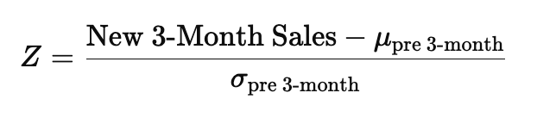
Where $μ_{pre 3-month}$ and $σ_{pre 3-month}$ are the historical mean and standard deviation of the 3-month subcategory totals, respectively. Intuitively, this metric compares how “big” the new item’s initial three months of sales are relative to the range of what is normally observed for that subcategory.

To avoid spurious results from extremely small launches, we also enforced a minimum volume filter of 50 units sold in the first three months. Events were retained only if:

- The new SKU sold at least 50 units in its first three months
- The subcategory’s existing SKUs experienced a negative change in sales over the same window (Delta_Sales_Excl_New_SKU < 0), and
- The event’s z-score exceeded a configurable threshold

Interpreting Z-Score Thresholds
Recognizing that there is no single “correct” cutoff for defining cannibalization, we chose to give Gemline a range of z-score thresholds rather than a single binary classification. In our tool, Gemline can view cannibalization candidates at several levels of strictness:
- Z $≥$ - 0.5
- Z $≥$ - 1.0
- Z $≥$ - 1.5
- Z $≥$ - 2.0
These thresholds are provided in increments of 0.5 from –0.5 down to –2.0. Less negative thresholds (e.g., –0.5) label more events as potential cannibalization, capturing a broader set of “weak” signals. More negative thresholds (e.g., –1.5 or –2.0) focus on only the most extreme cases where the new item’s early sales are well above typical subcategory behavior while existing SKUs simultaneously lose volume.

Practically, this allows Gemline’s teams to tune the sensitivity of the cannibalization view depending on their risk tolerance and business context. For early exploratory analysis, they might start with a looser cutoff (–0.5) to see many possible signals; for action-oriented decisions, they may narrow to events that still appear at stricter thresholds.

Cannibalization Output
The final cannibalization table (canni_final) summarizes each retained event with the following fields:

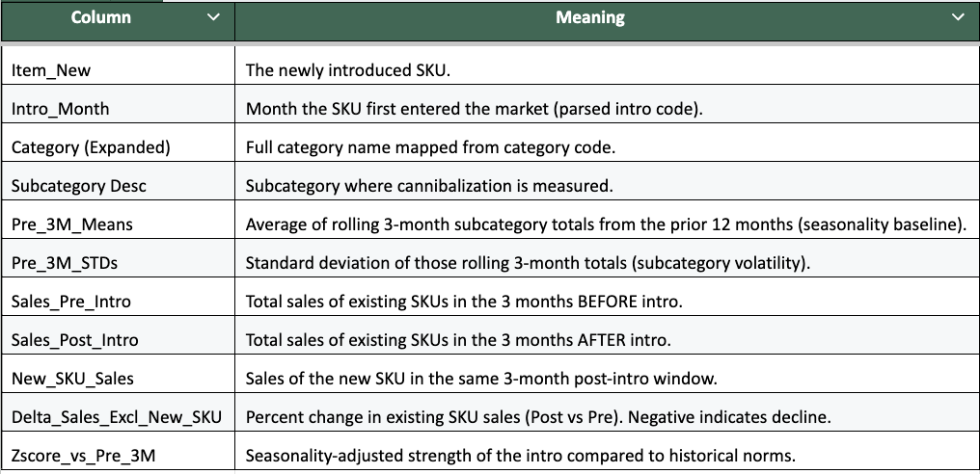

Figure 5: Definitions for each column in the final cannibalization table

This table provides Gemline with a shortlisted view of potential cannibalization cases that can be further evaluated with business knowledge—such as known stockouts, customer transitions, or deliberate SKU replacement decisions that may explain specific patterns. Rather than claiming to perfectly quantify cannibalization, our framework creates a repeatable, transparent method for flagging where it is most likely to be occurring and how strong the signal appears under different z-score thresholds.

Cannibalization (Analysis #2)
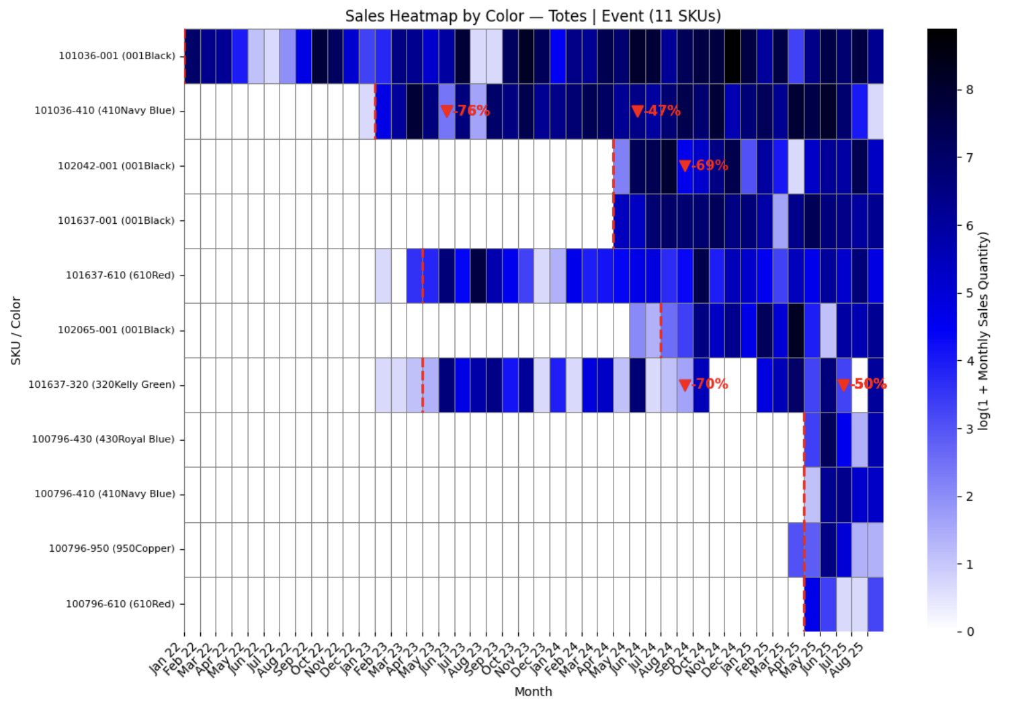
Figure 6: Heatmap of Potential Cannibalization of Totes in the Event Subcategory by Color

In order to visualize potential cannibalization across similar products that fell into the same Category and Subcategory grouping, we pivoted away from our original line graph approach which was very visually cluttered as a result of the large number of products that fell into each respective grouping. Heatmaps provided a way to easily compare the monthly sales of up to 25 SKUs. This is an upper limit that the team agreed upon in order to ensure readability. In the graph above, each rectangle represents a month’s worth of sales, with darker colors representing a greater volume of sales and vice versa. To make potential occurrences of cannibalization more salient, we included red arrows which quantified the percentage decrease in the sales of a product in the three months after a new product launch compared to the sales in the three months before (launch month is excluded in said calculations). Each time a new product is launched (marked by the red dashed lines in the figure above), every other product in the grouping is analyzed for cannibalization using the following logic. If the sales in the three months after a launch decrease by greater than 30% but less than 80%, this is marked by a red arrow and tabulated as an instance of potential cannibalization.
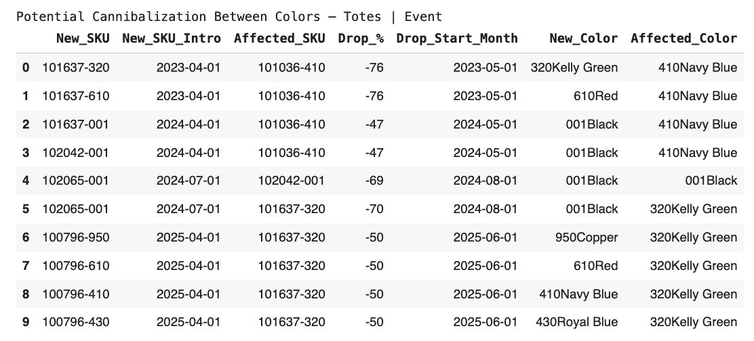

Figure 7: Corresponding Table of Potentially Cannibalized Totes in the Event Subcategory by Color

We chose the 30-80% threshold in order to capture potential occurrences that were significant enough but also to exclude extreme cases (> 80%) that were most likely caused by stockouts and other uncommon circumstances. With this being said, our analysis still requires human oversight, since even a month’s worth of stockouts can skew a percentage decrease value but not to a great enough extent to be filtered out. Being able to clearly see stockouts (white rectangles in the midst of dense sales represented by darker rectangles) is another added benefit of the heatmaps. Additionally, we decided not to include the heatmaps or tables for Category and Subcategory groupings that had less than 5 SKUs or less than 7 months of sales, since these groupings did not have enough data to create an informative heatmap.

Each heatmap has a corresponding table where all potential instances of cannibalization are listed and organized chronologically starting with the oldest instance. Something important to note is that although we capped the visuals to only display a maximum of 25 occurrences of cannibalization for the sake of clarity, the tables include all potential occurrences. The SKU numbers in each instance are listed, as well as the month of introduction for the new SKU, the percentage decrease in sales of the affected SKU, and the month in which that decrease began.

Our analysis includes a more general approach that creates heatmaps for all Category and Subcategory groupings and also a more granular view where we look at cannibalization across different color and brand variations. For the heatmaps that analyzed products by color, the new color and affected color are listed in their respective tables as well. In regards to the heatmaps that analyzed products by brand, the brands of both the new product and the affected product are listed in their respective tables as well. The visuals of our analysis by brand are nearly identical to the other analyses (general and by color) with one exception: occurrences of cannibalization across different brands are marked by pink arrows instead of red. An example of our analysis across different brands in the same Category and Subcategory grouping is shown below.
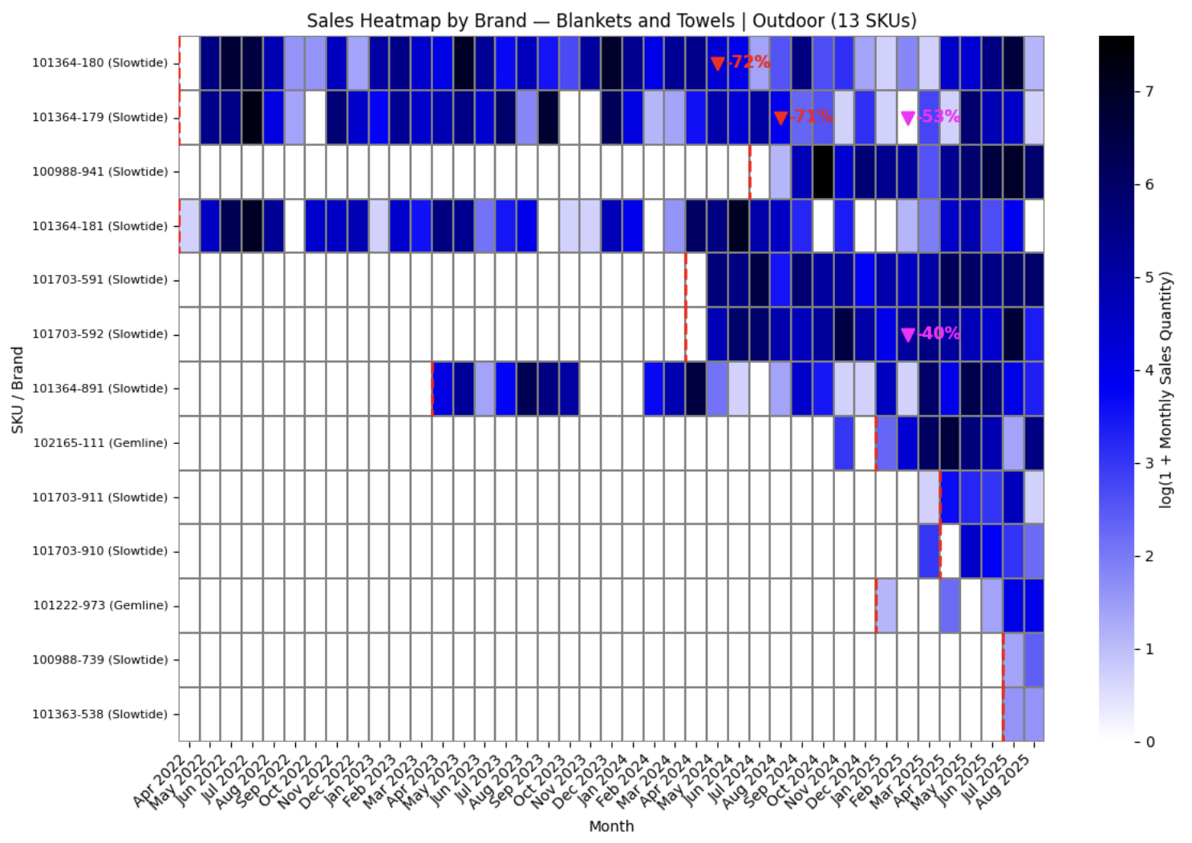
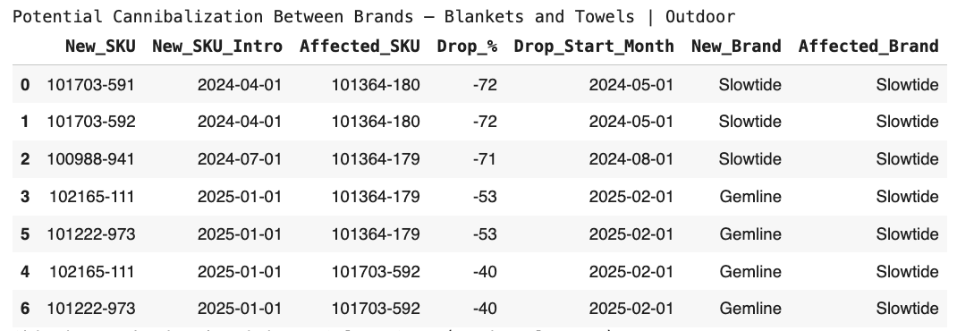
Figure 8: Heatmap of Potential Cannibalization of Blankets and Towels in the Outdoor Subcategory by Brand

Figure 9: Corresponding Table of Potentially Cannibalized Blankets and Towels in the Outdoor Subcategory by Brand

Potential Financial Impacts and Benefits
Our solution should not cost Gemline any money to implement as both our market entry tool and our demand forecasting model utilize Python. There is also no time learning cost associated with our solution, since we will be providing Gemline with a live demonstration of both tools and documentation that they will be able to reference if need be. Gemline does not compute any error metrics for the forecasting methods they are using at the moment, so there is no way for us to quantify the losses they may be experiencing due to stockouts or obsolete inventory. These numbers also vary widely for each of the thousands of SKUs that are part of Gemline’s product portfolio. With this being said, our forecasting tool will help partially automate Gemline’s current forecasting process, which typically involves several team members using their business expertise to create an estimate that they feel is appropriate. Our solution will generate cost savings by cutting down the time it takes to create a forecast and also producing more accurate results. Gemline estimates that our models will save 1–2 million dollars in their first year, mainly driven by reduced excess inventory from more accurate forecasting and incremental sales revenue captured by better anticipating upside demand and having inventory available.

Michigan Difference
Our team demonstrated the Michigan Difference by taking a technical and analytical approach to Gemline’s new product demand forecasting. Our project exemplifies how Michigan students combine academic rigor, practical application, and collaboration to create impactful, data-driven solutions for real-world business challenges. Several aspects of the Michigan Difference are outlined below:
- Academic Rigor: Our team drew upon the analytical foundation developed through coursework from IOE 373: engineering data analytics, applying advanced engineering and data analysis concepts to structure our problem, build our model, and test solutions. This process required critical thinking, as we evaluated multiple modeling approaches to identify the most efficient and accurate solution for our client
- Practical Application: We translated classroom theory into practice by using tools such as python and excel to design and implement a working solution. This allowed us to simulate new product demand forecasting and deliver recommendations that can be immediately applied to improve operations

References

[1] T. Januschowski, “Forecasting with trees ,” Science Direct,
https://www.sciencedirect.com/science/article/pii/S0169207021001679 (accessed Oct. 25, 2025).

[2] R. M. van Steenbergen, “Forecasting demand profiles of New Products,” Research Gate,
https://www.researchgate.net/publication/346313899_Forecasting_demand_profiles_of_new_products (accessed Oct. 25, 2025).

[3] Kirill Kashtanov, et al. “Using Triple Exponential Smoothing and Autoregressive Models to
Mining Equipment Details Sales Forecast.” Communications in Computer and Information
Science, 1 Jan. 2022, pp. 506–521, doi: 10.1007/978-3-030-93715-7_36.

[4] X. Zhang, L. Chen, and Y. Wu, “New product demand forecasting using gradient boosting and clustering with seasonal effects,” Computers & Industrial Engineering, vol. 187, p. 110345, 2024.doi:10.1016/j.cie.2024.110345

[5] Ching-Chin, Chern, et al. “Designing a decision-support system for new product sales
forecasting.” Expert Systems with Applications, vol. 37, no. 2, pp. 1654–1665, Mar. 2010, doi: 10.1016/j.eswa.2009.06.087.

[6] “Check this out from Gemline.,” Gemline, https://gemline.com/s/ (accessed Sep. 17, 2025).

[7] “Counselor top 40 suppliers 2025,” ASI Central, https://members.asicentral.com/news/strategy/july-2025/counselor-top-40-suppliers-2025/ (accessed Sep. 17, 2025).

[8] Aft, L., et al.. Industrial and Systems Engineering Body of Knowledge. https://www.iise.org/uploadedFiles/IIE/Technical_Resources/Publications/Industrial_and_Systems_Engineering_Body_of_Knowledge_2021.pdf

Appendix A: Gantt Chart
The Gantt Chart below outlines the proposed plan for the project timeline.
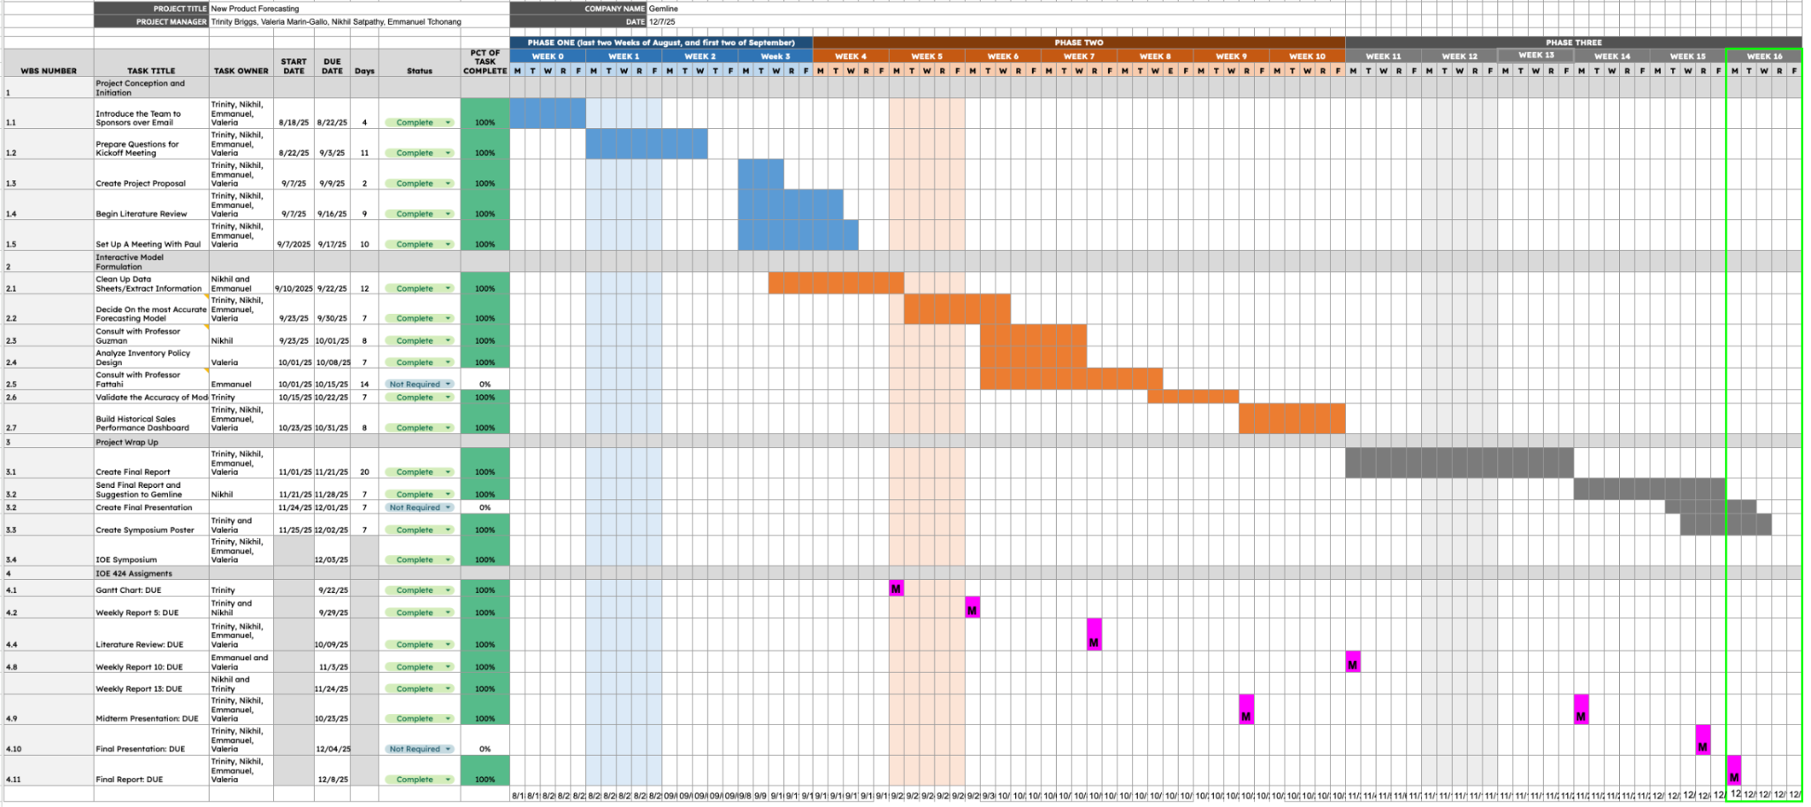
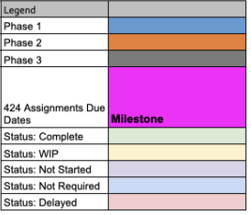

Link to Gantt Chart: VENT Consulting: Gantt Chart

Appendix B: Team Member Contributions
The contributions list below highlights each member's individual work.

Name | Contributions
Trinity | - Forecasting dashboard  - Improving accuracy of model  - Respective sections of Final Report
Emmanuel | - Forecasting dashboard  - Sales forecast for Igloo Cooler  - Respective sections of Final Report
Nikhil | - Cannibalization z-scores  - Market launch months  - Respective sections of Final Report
Valeria | - Cannibalization heat maps  - Improving accuracy of model  - Respective sections of Final Report

Appendix C: Project Personnel
The Project Personnel List below provides the contact information of key project participants for convenient reference for all those involved.

Contact Name | Position | Location | Email | Phone
Dr. Prakash Sathe | IOE | Ann Arbor, MI | ptsathe@umich.edu
Lisa Grimble | Tech Comm | Ann Arbor, MI | lgrimble@umich.edu
Tim Behling | VP of Supply Chain, Gemline | Lawrence, MA | tbehling@gemline.com | (978) 691-2000 x 4095
Chris Harrison | Manager of Supply Chain, Gemline | Lawrence, MA | charrison@gemline.com | 978.691.2000 x2139
Emmanuel Tchonang | Project Team Member | Ann Arbor, MI | tchonang@umich.edu | 248-662-7096
Nikhil Satpathy | Project Team Member | Ann Arbor, MI | nikhilsa@umich.edu | 860-970-5345
Trinity Briggs | Project Team Member | Ann Arbor, MI | rmbriggs@umich.edu | 989-443-0896
Valeria Marin Gallo | Project Team Member | Ann Arbor, MI | vmgallo@umich.edu | 908-347-6846

