ETECHFLOW MODULE
Variant Links
Magento 2 Extension — Licensing, Configuration & Storefront Guide
Adds smart “View Other Options / Finishes / Sizes” buttons to product pages that send shoppers straight to the matching variant products — by manual link, a point-and-click builder, bulk CSV, or fully automatic generation.
Applies to ETechFlow_VariantLinks v1.1.1 · Magento 2.4.9 · Luma + Hyvä

1. What Variant Links does
Variant Links solves a common catalog problem: the "same" product often exists as several separate products — the same bag in three colours, the same key blank for five car makes, the same lock in four sizes. Customers landing on one of them have no easy way to discover the others. Variant Links adds a row of "View Other …" buttons to the product page that link to a filtered category listing of the related variants, so shoppers can jump straight to the colour / finish / size they actually want.
Typical merchant problems it solves:
- Colour/finish ranges split across separate products with no cross-links between them.
- Customers bouncing because they can’t find the size or variation they need.
- Cross-sell links hand-coded into product descriptions that break when the domain or URL changes.
- No scalable way to add these links to hundreds of products at once.

The three built-in buttons
Each button links to the same category as the current product, holding certain attributes fixed so that only the intended dimension varies:
Button | Holds fixed | What varies for the shopper
View Other Options | Manufacturer / brand | The brand’s full range in this category
View Other Finishes | Manufacturer + size | Finish / colour
View Other Sizes | Manufacturer + finish | Size / length

On top of these, you can define your own unlimited Custom Buttons (e.g. "View Other Lengths"). A button only appears when it has somewhere to point — either a link you set, or one the module generates.

Four ways to set the links
- Visual builder — pick a target category and filters from dropdowns on the product page (no URLs).
- Simple link field — paste a relative URL; the module adds the domain automatically.
- Bulk CSV import — set links on hundreds of products by SKU in one upload.
- Dynamic auto-generation — the module builds the link on the fly from the product’s own category + attributes, with zero per-product setup.

How this document is laid out
We walk through the module in the order a merchant actually experiences it:
- Section 2 — No-access state: what you see before the module is licensed.
- Section 3 — Getting access: enter or buy a licence key.
- Section 4 — Module navigation: the admin entries you get after licensing.
- Section 5 — Global configuration: buttons, labels, dynamic mode, custom buttons.
- Section 6 — Setting links on a product (the visual builder + simple fields).
- Section 7 — Bulk CSV import and command-line tools.
- Section 8 — Legacy button stripping.
- Section 9 — Storefront result: what the customer sees.
- Section 10 — Troubleshooting.

2. No-access state — module is locked
Variant Links is licence-gated. When the module is installed but the licence key is missing, invalid, or the server has been removed from the portal subscription, the module is inert: no storefront buttons render, the admin pages redirect to a licence gate, and the console commands refuse to run.

2.1 Module Status banner shows what’s wrong
Open Stores → Configuration → ETECHFLOW → Variant Links. The first row, Module Status, tells you the exact licence state for this host.
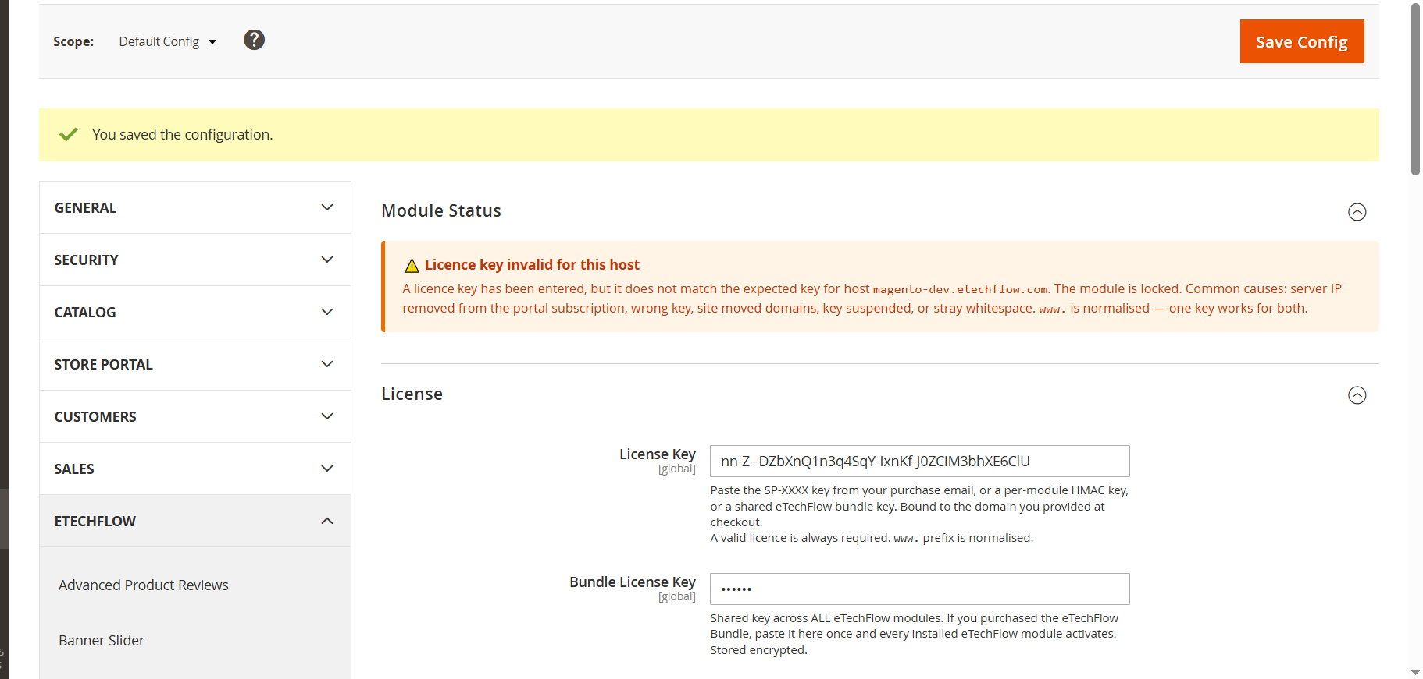
Figure 2.1 — Module Status shows the licence is invalid for this host, so the module is locked. Common causes: missing/wrong key, server IP removed from the subscription, site moved domains, key suspended, or stray whitespace. (A leading "www." is normalised — one key works for both.)
What is blocked storefront "View Other" buttons (none render), the Bulk Import page, and the two console commands all stop while unlicensed.
What stays accessible the Configuration page itself (so you can paste a key) and the licence gate / checkout pages.

3. Getting access — licensing
There are two ways to authorise the module: paste a key you already own, or buy one through the in-admin gate. Either way the licence is bound to your domain and validated against the eTechFlow licensing portal.

3.1 License section
On the Configuration page, the License section accepts three kinds of key:
- License Key — the SP-XXXX key from your purchase email, or a per-module HMAC key.
- Bundle License Key — one shared key that activates every installed eTechFlow module at once (stored encrypted).
- License Portal URL — the validation endpoint (pre-set to the eTechFlow portal).
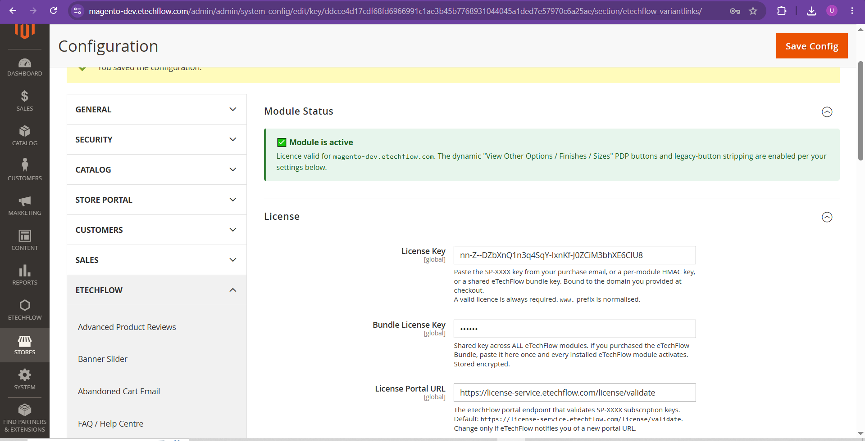
Figure 3.1 — Once a valid key is saved, Module Status turns green ("Module is active") and the buttons + legacy-stripping switch on. The licence is bound to the domain you provided at checkout.

3.2 Buying a licence in-admin
If you don’t have a key, the admin pages redirect to a License Required gate where you choose a billing period (Weekly / Monthly / Yearly) and pay with Stripe. On success the key is saved automatically and the module unlocks — no manual copy-paste needed. Payment is handled entirely by the portal; no Stripe keys live inside the Magento store.

4. Module navigation — after licensing
Once licensed, Variant Links adds its own group under the Catalog sidebar, with two entries.
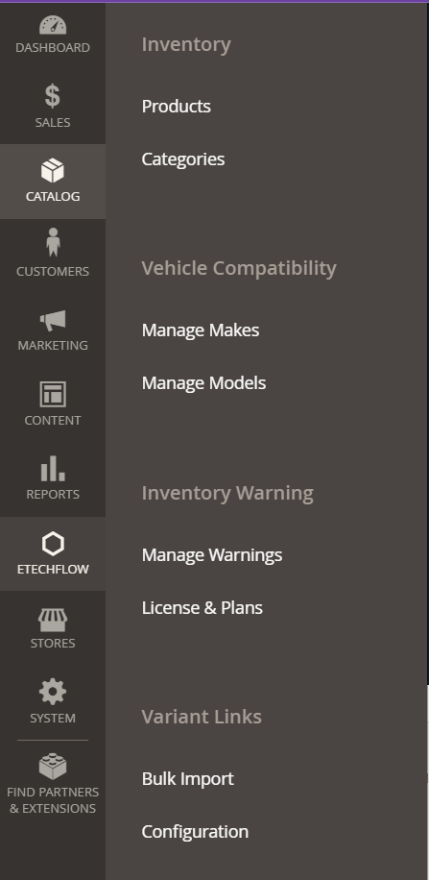
Figure 4.1 — Catalog → Variant Links: "Bulk Import" (CSV upload) and "Configuration" (jumps to the settings section). Per-product links are set on the product edit page itself (Section 6).

5. Global module configuration
Stores → Configuration → ETECHFLOW → Variant Links groups every store-wide setting. Beyond Module Status and License (above), there are three functional groups: Buttons, Auto-Generated Links (Dynamic), and Custom Buttons.

5.1 Buttons — which buttons show, their labels, and legacy cleanup
This group controls the built-in buttons. "Buttons to show" is a multiselect that decides which of Options / Finishes / Sizes are allowed to appear store-wide — deselect one and that button never renders, even if a product has a link for it. The label fields rename each button (e.g. Finishes renamed to "See Other Colours"). "Strip old in-description buttons" removes hand-coded buttons from the rendered description (Section 8).
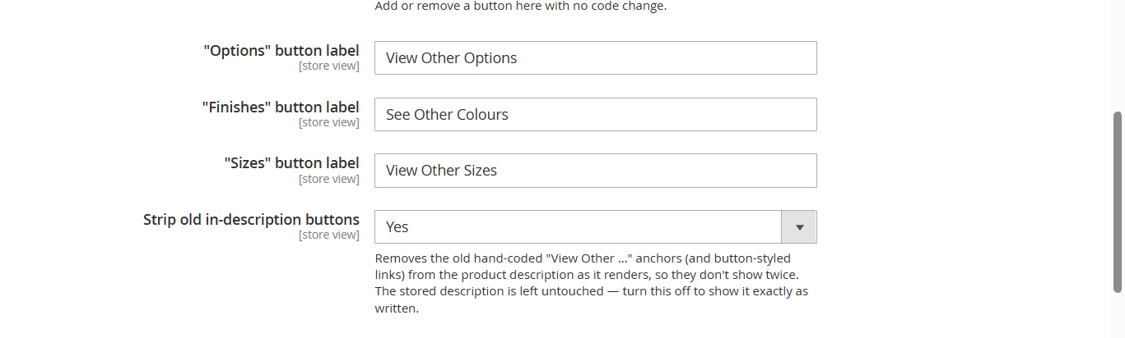
Figure 5.1 — Per-button labels (Finishes shown renamed to "See Other Colours") and the "Strip old in-description buttons" toggle. Leaving a label blank falls back to the default text.
Setting | What it does
Buttons to show | Multiselect of which built-in buttons may render store-wide. Clear it = no built-in buttons.
"Options/Finishes/Sizes" label | Custom text for each button; blank = the default "View Other …".
Strip old in-description buttons | Removes legacy hand-coded buttons from the description as it renders (reversible).

5.2 Auto-Generated Links (Dynamic)
When enabled, any product that has no manually-set link gets a "View Other" link generated automatically from its own primary category plus Manufacturer / Finish / Size. Manual per-product links always take priority — dynamic mode only fills the gaps.
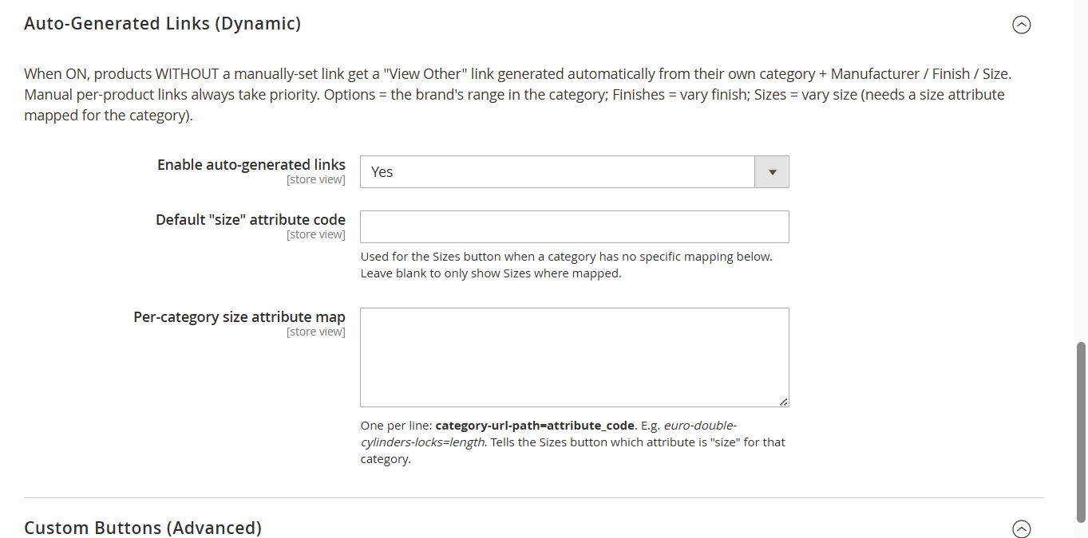
Figure 5.2 — Dynamic mode. "Default size attribute code" and the per-category size map tell the Sizes button which attribute counts as "size" for each category.
Button | Generated link (same category +)
Options | ?manufacturer=… (the brand’s range; needs a category)
Finishes | ?manufacturer=… &size=… (only if the product has a finish)
Sizes | ?manufacturer=… &finish=… (only if a size attribute is mapped for the category)

5.3 Custom Buttons (Advanced)
Define your own buttons with no code — one per line, in the form Button Label|attributes_to_keep_the_same. The button links to other products in the same category with those attributes held to this product’s values, so everything else varies. Use __size__ for the per-category size attribute. A button auto-hides on any product missing one of the held attributes.
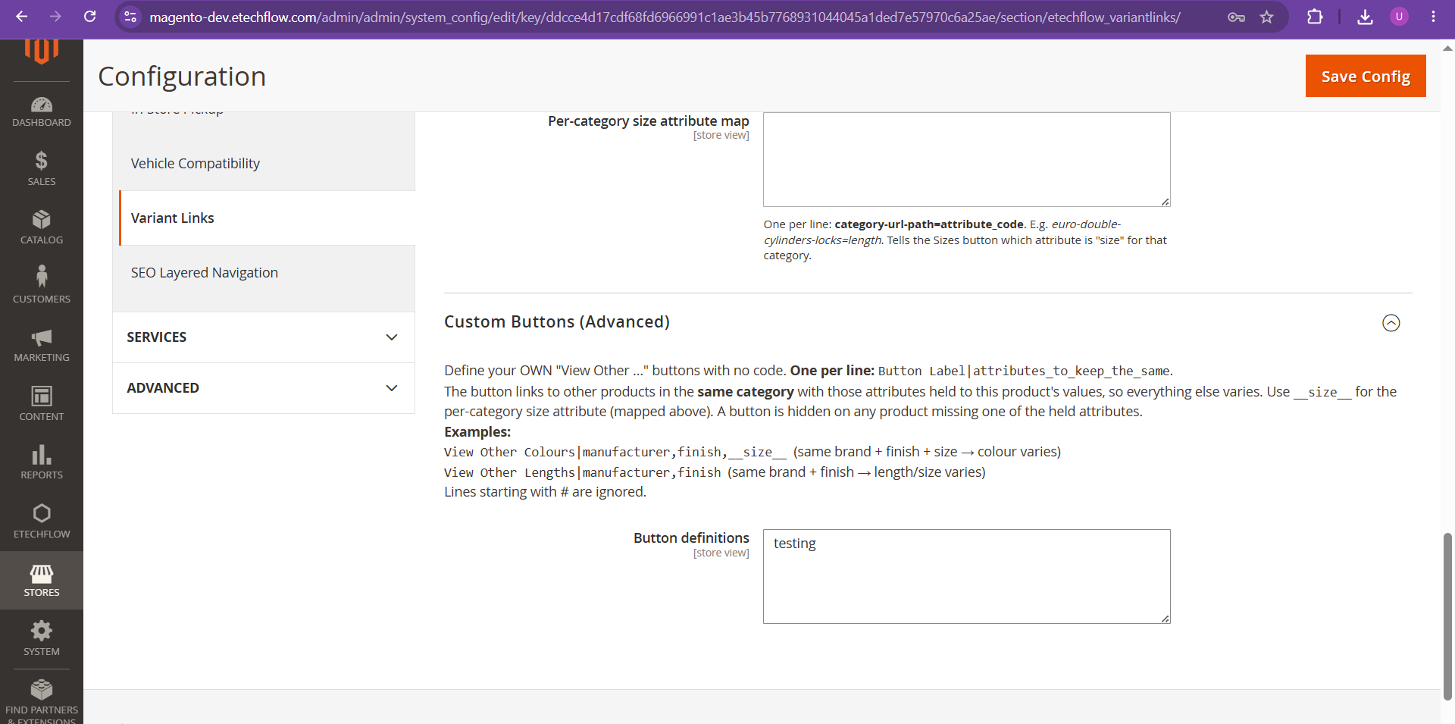
Figure 5.3 — Custom Buttons. Each line is "Label|attr1,attr2". Examples: "View Other Colours|manufacturer,finish,__size__" (colour varies); "View Other Lengths|manufacturer,finish" (length varies).
Note a label-only line with no "|attributes" (e.g. just "testing") creates a button that links to the whole category — useful as a "see everything in this category" link, but not a true variant filter.

6. Setting links on a product
Per-product links live in the "Variant Links" section on the product edit page (Catalog → Products → edit a product). There are two ways to fill them in.

6.1 The visual builder (recommended)
For each button you pick a Target category from a dropdown and add up to five Attribute = Value filter rows. The module assembles the correct filtered-category URL for you — no need to know or type any URL. Leave the Target category blank to fall back to dynamic auto-generation (Section 5.2); set one only to override.
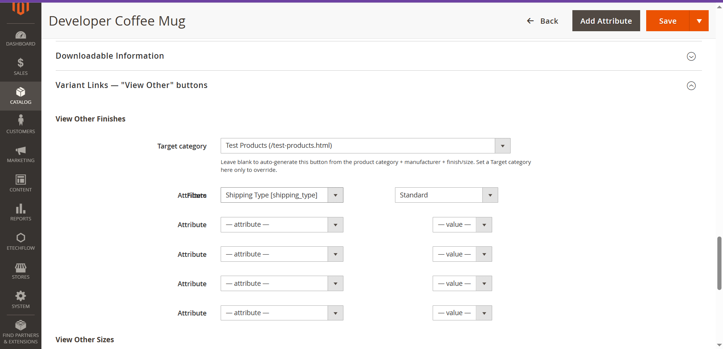
Figure 6.1 — The visual builder. "View Other Finishes" points to Test Products with the filter Shipping Type = Standard, so the button lands the shopper on exactly that filtered listing.

6.2 The simple link field
Alternatively, paste a relative URL (path + filters) straight into the field, e.g. /euro-cylinders?manufacturer=2081. Blank hides that button. You never include the domain — the module prepends the current store’s domain at render time, so links never break if the store moves domains.
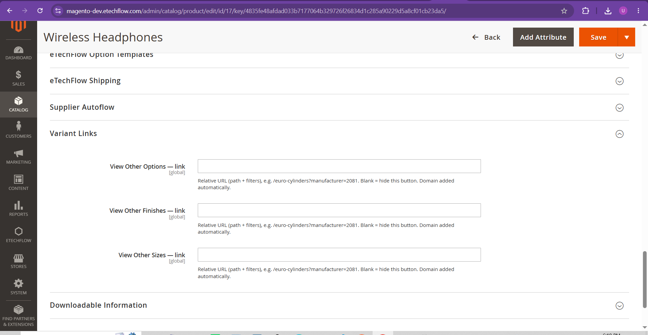
Figure 6.2 — The simple per-button link fields. The helper text confirms: "Relative URL (path + filters)… Blank = hide this button. Domain added automatically."

6.3 The attributes behind the filter
A filter only returns products that actually carry the chosen attribute value. In the example the button filters on Shipping Type = Standard, so the destination page lists every product whose Shipping Type attribute is set to Standard. If that attribute is empty on the other products, the filtered page will be empty — the button works, but there is nothing to show.
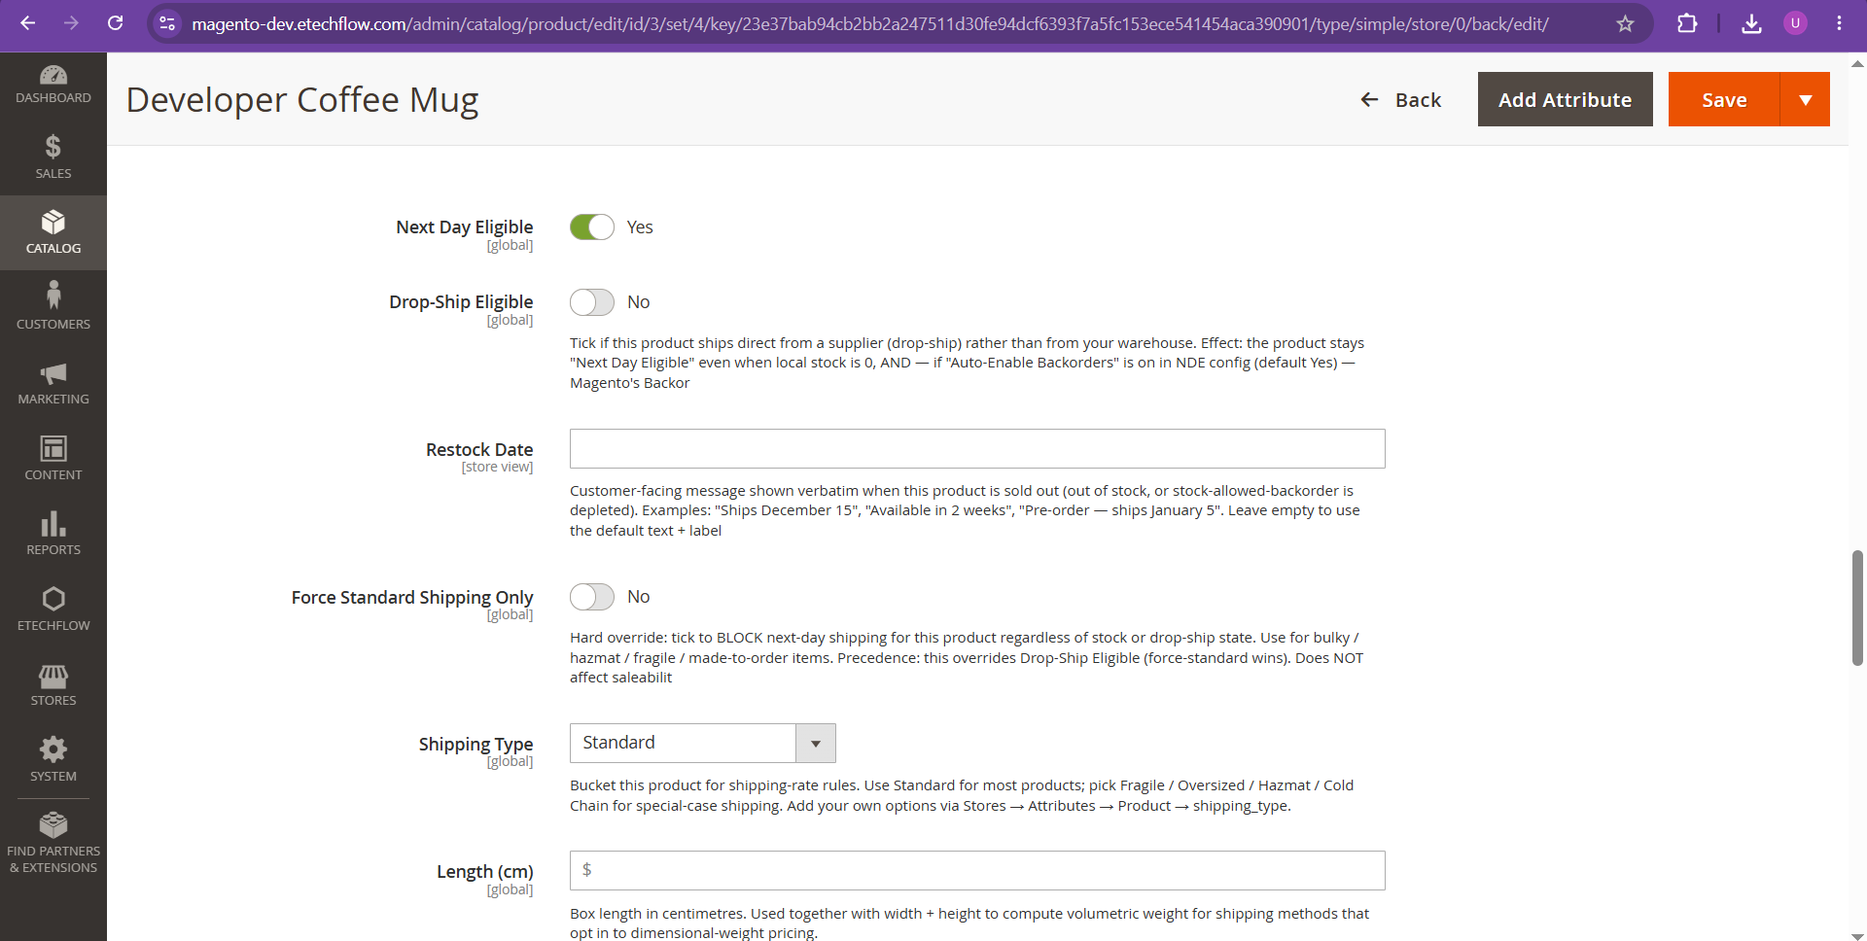
Figure 6.3 — The Shipping Type attribute set to "Standard" on the product. This is the value the Finishes filter in Figure 6.1 targets.

7. Bulk import & command line

7.1 Bulk Import (CSV)
Catalog → Variant Links → Bulk Import sets the "View Other" links on many products at once. Upload a CSV keyed by SKU; include only the columns you need. Tick "Dry run" first to preview how many rows match before anything is saved.
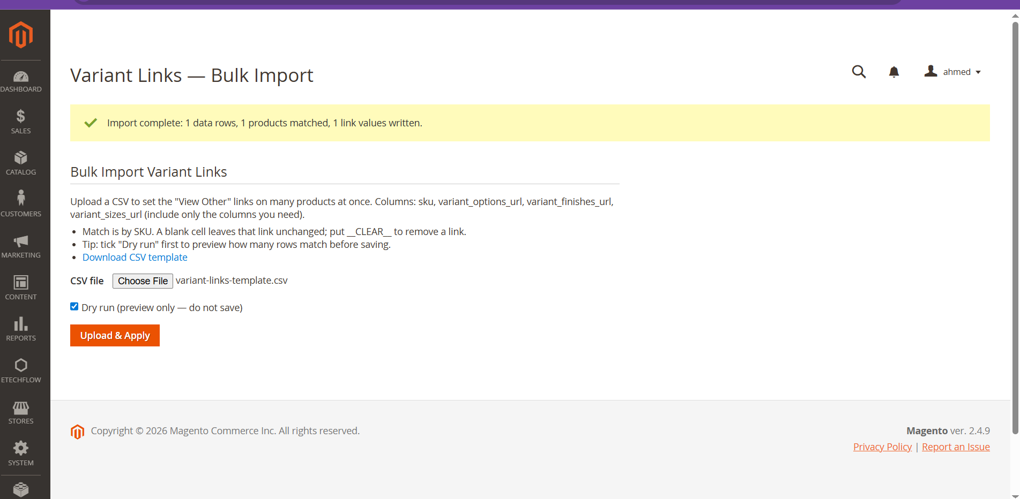
Figure 7.1 — Bulk Import. After upload it reports rows read, products matched, and links written. A "Download CSV template" link gives you the correct header row.
CSV column | Meaning
sku | The product to match (required).
variant_options_url | Relative link for the Options button.
variant_finishes_url | Relative link for the Finishes button.
variant_sizes_url | Relative link for the Sizes button.

A blank cell leaves that link unchanged; the special value __CLEAR__ removes a link.
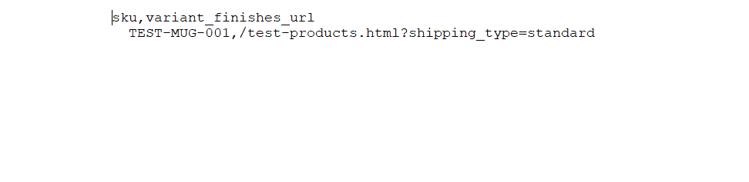
Figure 7.2 — A minimal CSV: one header row, then SKU + the relative URL for that button.

7.2 Console commands
Two CLI commands support automation and migration (both licence-gated):
- etechflow:variantlinks:import — apply a CSV from the command line (same as the admin importer).
- etechflow:variantlinks:migrate-legacy — scan product descriptions for old hand-coded buttons and convert them into proper variant-link attributes.

8. Legacy button stripping
Many catalogs already have "View Other …" buttons hand-coded into product descriptions. Showing those alongside the new module buttons would duplicate them. With "Strip old in-description buttons" = Yes (Figure 5.1), the module removes legacy buttons from the description as it renders — both the text-style "VIEW OTHER OPTIONS/FINISHES/SIZES" anchors and any anchor styled as a button (a border-radius in its inline style, e.g. an old red "VIEW CYLINDER LOCKS" link).
Fully reversible only the rendered HTML is cleaned — the stored description is never altered. Turn the toggle off to show it exactly as written.
Theme-agnostic it hooks the shared Catalog output helper, so it works on both Luma and Hyvä with no template edits.

9. Storefront result
On the product page the buttons render as a tidy row directly under the price / stock area.
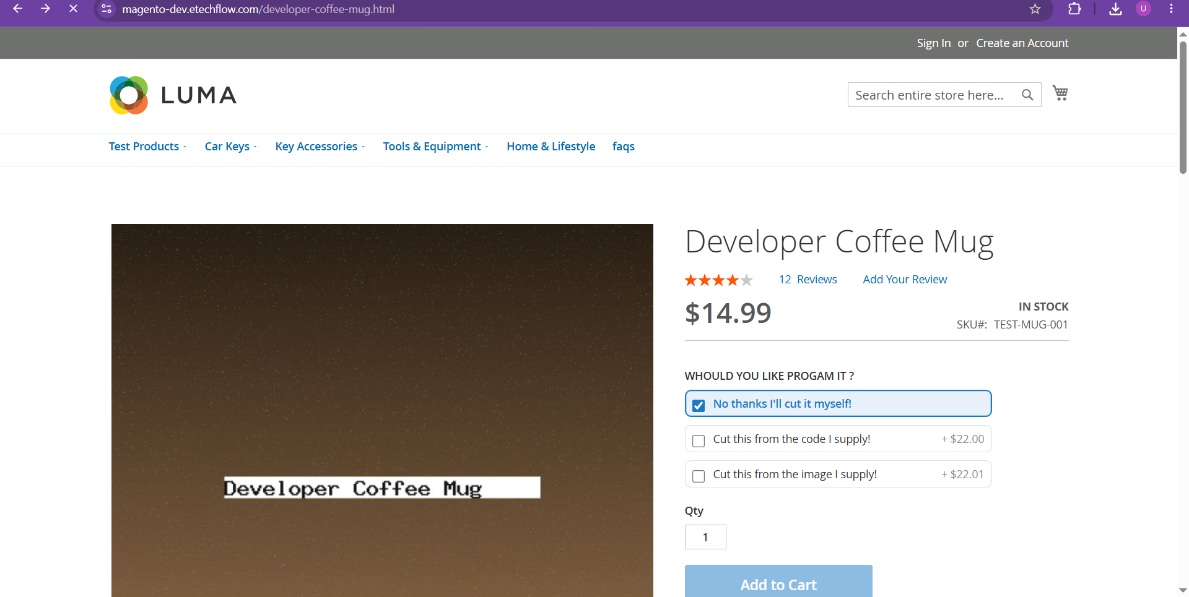
Figure 9.1 — The default "View Other Finishes" button on the product page.
Renaming the label in config (Section 5.1) changes the button text immediately:
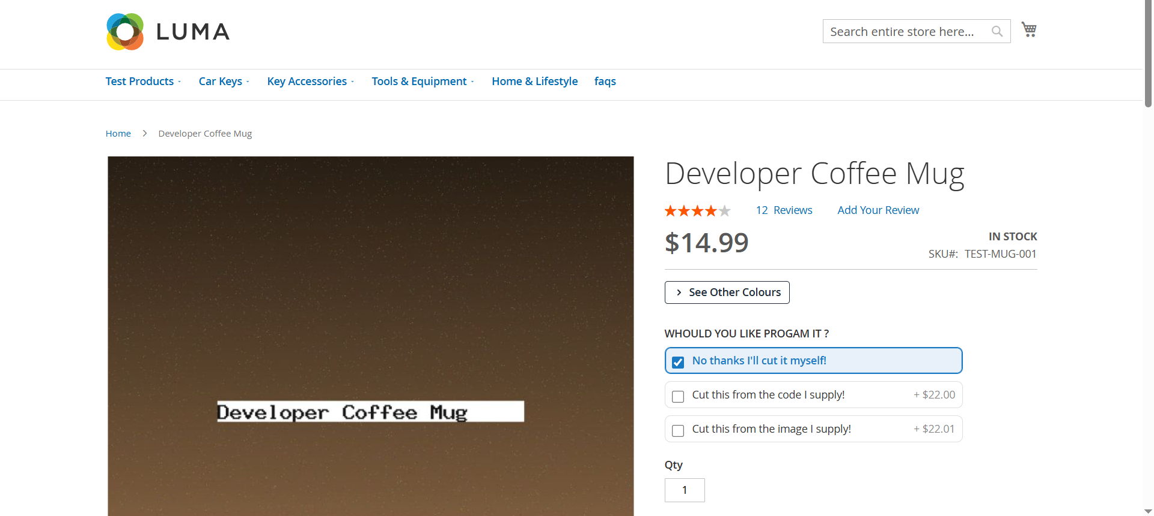
Figure 9.2 — The same button after renaming the Finishes label to "See Other Colours".
Multiple buttons — built-in and custom — render side by side:
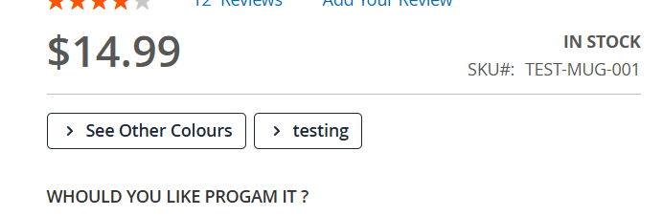
Figure 9.3 — Two buttons: the built-in "See Other Colours" plus a custom button ("testing").
Clicking a button lands the shopper on the filtered category listing — exactly the related variants:
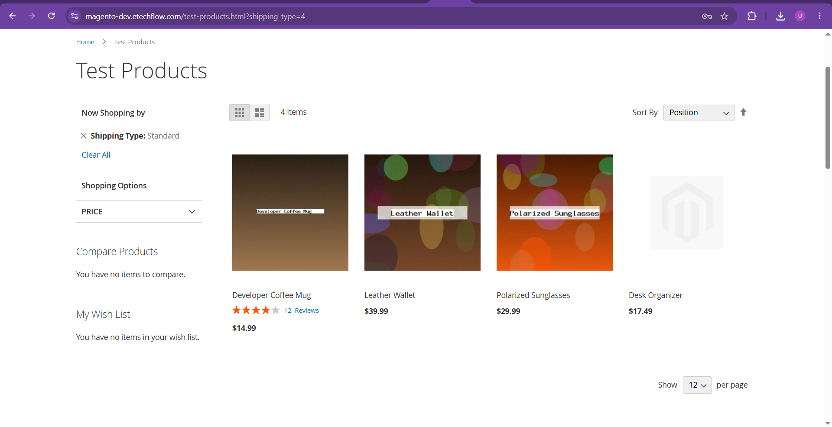
Figure 9.4 — The destination: Test Products filtered to "Shipping Type: Standard" (4 matching items). The active filter shows under "Now Shopping by".

10. Troubleshooting
Symptom | Likely cause | Fix
No buttons on any product | Module unlicensed | Paste a valid key; Module Status must be green (Sec. 3).
A button type never shows | Not in "Buttons to show" | Add it to the multiselect (Sec. 5.1).
One product has no button | No link set and dynamic off | Set a link (Sec. 6) or enable dynamic mode (Sec. 5.2).
Button shows but page is empty | No products carry the filtered value | Set the attribute on the other products / reindex.
Old button still in description | Strip legacy off | Set "Strip old in-description buttons" = Yes.
Link points to wrong domain | n/a — handled automatically | Store only the relative path; the domain is added at render.

