Atividade 05 – Dado Eletrônico, Servo Motor e Sensor de Distância

DISCIPLINA | TURMA | PROFESSOR | DATA
Sistemas Embarcados | 1ºC2 | ROBERTO / RONILDO | 28/07/2026

Integrantes: Felipe Barbosa Santos e Gabriel Fernandes Barbarini
Turma: 1ºC2 — Sistemas Embarcados

1. Montagem do Projeto

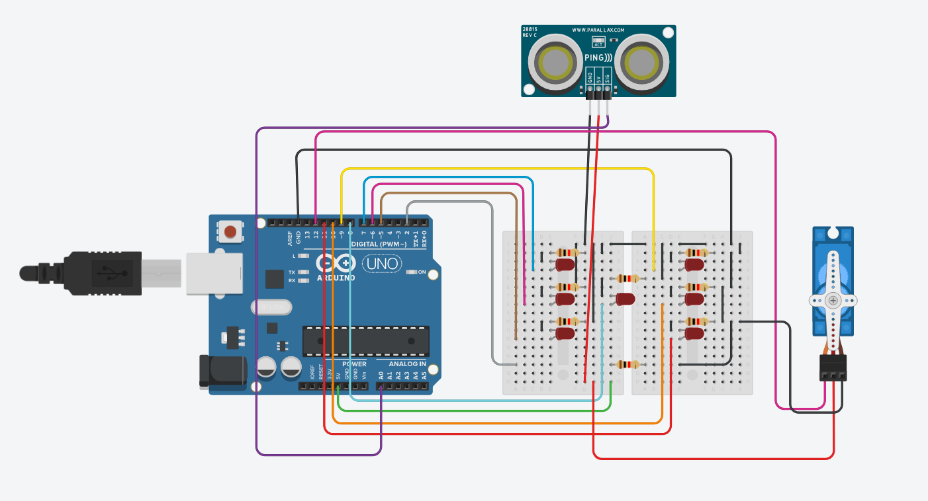

2. Código Desenvolvido

#include <Servo.h>

long readUltrassonicDistance(int triggerPin, int echoPin)
{
pinMode(triggerPin, OUTPUT);
digitalWrite(triggerPin, LOW);
delayMicroseconds(2);
digitalWrite(triggerPin, HIGH);
delayMicroseconds(10);
digitalWrite(triggerPin, LOW);
pinMode(echoPin, INPUT);
return pulseIn(echoPin, HIGH);
}

bool Rolou = false;
float centimetro;
int valor;
Servo servo1;

void apaga(){
digitalWrite(11, LOW);
digitalWrite(10, LOW);
digitalWrite(9, LOW);
digitalWrite(8, LOW);
digitalWrite(7, LOW);
digitalWrite(6, LOW);
digitalWrite(5, LOW);
}

void setup()
{
randomSeed(analogRead(A1));
pinMode(11, OUTPUT);
pinMode(10, OUTPUT);
pinMode(9, OUTPUT);
pinMode(8, OUTPUT);
pinMode(7, OUTPUT);
pinMode(6, OUTPUT);
pinMode(5, OUTPUT);
pinMode(4, OUTPUT);
pinMode(3, OUTPUT);
apaga();
servo1.attach(12);
servo1.write(0);
}

void sorteio(){
valor = random(1,7);
if (valor == 1){
digitalWrite(8, HIGH); }
if (valor == 2){
digitalWrite(7, HIGH); digitalWrite(11, HIGH); }
if (valor == 3){
digitalWrite(7, HIGH); digitalWrite(11, HIGH);
digitalWrite(8, HIGH); }
if (valor == 4){
digitalWrite(5, HIGH); digitalWrite(11, HIGH);
digitalWrite(7, HIGH); digitalWrite(9, HIGH); }
if (valor == 5){
digitalWrite(5, HIGH); digitalWrite(11, HIGH);
digitalWrite(7, HIGH); digitalWrite(9, HIGH);
digitalWrite(8, HIGH); }
if (valor == 6){
digitalWrite(10, HIGH); digitalWrite(11, HIGH);
digitalWrite(7, HIGH); digitalWrite(9, HIGH);
digitalWrite(6, HIGH); digitalWrite(5, HIGH); }

delay(4000);
apaga();
}

void s_motor(){
servo1.write(90);
delay(2000);
servo1.write(0);
delay(1000);
}

void loop() {
centimetro = 0.01723 * readUltrassonicDistance(A0, A0);
if (centimetro < 40){
if (!Rolou){
Rolou = true;
sorteio();
if (valor % 2 == 0) {
s_motor();
}
}
} else {
Rolou = false;
}
}

