Etec Vasco Antônio Venchiarutti

Vitor Paulielo Galvão de França Asturiano Moretti

Kevin Silva Fernandes

Turma: 1ºc2

Semáforo com botão

Imagem: 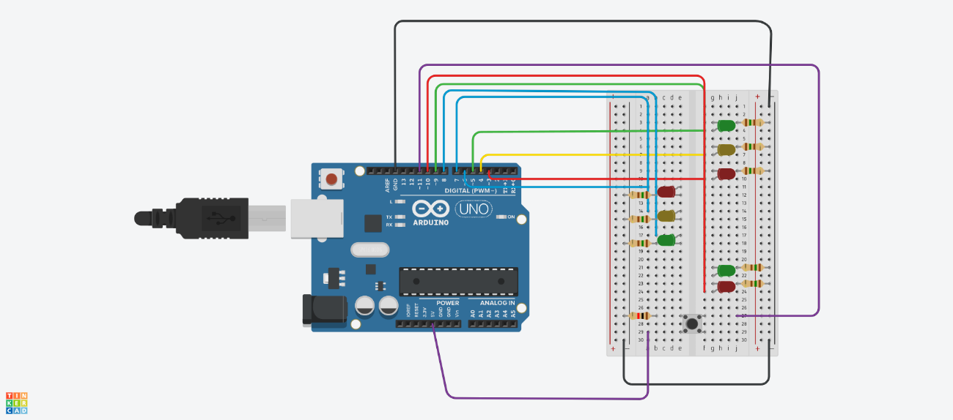

int pinoled1 = 5;
int pinoled2 = 4;
int pinoled3 = 3;
int pinoled4 = 6;
int pinoled5 = 7;
int pinoled6 = 8;
int pinoled7 = 9;
int pinoled8 = 10;

int pinobotao67 = 11;

void setup()
{
pinMode(pinoled1, OUTPUT);
pinMode(pinoled2, OUTPUT);
pinMode(pinoled3, OUTPUT);
pinMode(pinoled4, OUTPUT);
pinMode(pinoled5, OUTPUT);
pinMode(pinoled6, OUTPUT);
pinMode(pinoled7, OUTPUT);
pinMode(pinoled8, OUTPUT);

pinMode(pinobotao67, INPUT_PULLUP);
}

void loop()
{

if (digitalRead(pinobotao67) == HIGH) {
digitalWrite(pinoled1, LOW);
digitalWrite(pinoled2, LOW);
digitalWrite(pinoled3, LOW);
digitalWrite(pinoled4, LOW);
digitalWrite(pinoled5, LOW);
digitalWrite(pinoled6, LOW);

digitalWrite(pinoled7, HIGH);
delay (4000);
digitalWrite(pinoled7, LOW);
delay (1000);
digitalWrite(pinoled8, HIGH);
delay (500);
digitalWrite(pinoled8, LOW);
digitalWrite(pinoled8, HIGH);
delay (500);
digitalWrite(pinoled8, LOW);
digitalWrite(pinoled8, HIGH);
delay (500);
digitalWrite(pinoled8, LOW);
digitalWrite(pinoled8, HIGH);
delay (500);
digitalWrite(pinoled8, LOW);
digitalWrite(pinoled8, HIGH);
delay (500);
digitalWrite(pinoled8, LOW);
} else {
digitalWrite(pinoled1, HIGH);
digitalWrite(pinoled4, HIGH);

delay (5000);

digitalWrite(pinoled1, LOW);
digitalWrite(pinoled4, LOW);

delay (2000);

digitalWrite(pinoled2, HIGH);
digitalWrite(pinoled5, HIGH);

delay (2000);

digitalWrite(pinoled2, LOW);
digitalWrite(pinoled5, LOW);

delay (2000);

digitalWrite(pinoled3, HIGH);
digitalWrite(pinoled6, HIGH);

delay (5000);

digitalWrite(pinoled3, LOW);
digitalWrite(pinoled6, LOW);

delay (2000);
}
}

