Jonathan Trevisan – 1C3
Cesar Henrique Bertola – 1C3

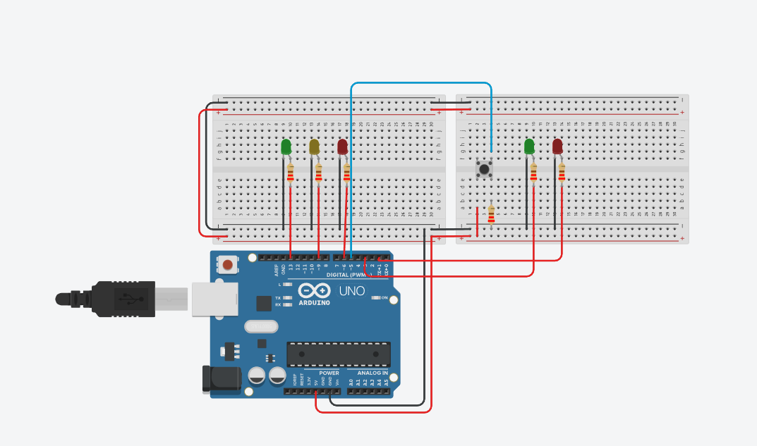

CÓDIGO
int LedVermelho = 6;
int LedVerde = 13;
int LedAmarelo = 9;
int LedVerdeP = 3;
int LedVermelhoP = 1;
int botao = 5;
int estadoBotao = 0;
int x;

void setup()
{
pinMode(LedVermelho, OUTPUT);
pinMode(LedAmarelo, OUTPUT);
pinMode(LedVerde, OUTPUT);
pinMode(LedVerdeP, OUTPUT);
pinMode(LedVermelhoP, OUTPUT);
pinMode(botao, INPUT);
}

void loop()
{
digitalWrite(LedVerde, HIGH);
digitalWrite(LedVermelhoP, HIGH);
estadoBotao = digitalRead (botao);
if (estadoBotao == HIGH){
delay (10000);
digitalWrite (LedVerde, LOW);
digitalWrite (LedAmarelo, HIGH);
delay (2000);
digitalWrite (LedAmarelo, LOW);
digitalWrite (LedVermelho, HIGH);
digitalWrite (LedVermelhoP, LOW);
digitalWrite (LedVerdeP, HIGH);
delay (7000);
for (x = 0; x < 2; x++){
digitalWrite (LedVerdeP, LOW);
delay(500);
digitalWrite (LedVerdeP, HIGH);
delay(500);
}
for (x = 0; x < 2; x++){
digitalWrite (LedVerdeP, LOW);
delay(250);
digitalWrite (LedVerdeP, HIGH);
delay(250);
}
}
else {

digitalWrite (LedVerdeP, LOW);
digitalWrite (LedVermelho, LOW);
digitalWrite (LedVermelhoP, HIGH);
digitalWrite (LedVerde, HIGH);
}
}

