[Table_Main]
Research Report
16 Mar 2026
L'Oréal Group(OR PA)
Enduring Power and Innovation Driving the Global Beauty Leader: Initiation
 |  | L'Oréal Group: Global Beauty Leader. Founded in 1909 and headquartered in Paris, France, L'Oréal is the undisputed leader in the global beauty and personal care industry. In 2025, the Group recorded revenue of €44.052 billion and has consistently held the No.1 position in global beauty market share for many years (≈18.0% in 2024).The business is organized into four divisions (2025 revenue breakdown): Consumer Products: €16.090 billion (36.5%),Luxury Products: €15.595 billion (35.4%),Dermatological Beauty: €7.204 billion (16.4%),Professional Products: €5.163 billion (11.7%).L'Oréal manages over 40 international brands spanning the full price spectrum from mass to ultra-luxury.  Global Beauty Market: Mature, Steady Growth with Increasing Concentration. The global beauty market has entered a mature phase of stable expansion. Market size grew from USD 473.2 billion in 2016 to USD 677.19 billion in 2025 (CAGR 4.06%), and is projected to rise from USD 703.31 billion in 2026 to USD 799.07 billion in 2030 (CAGR 3.24%).Key structural trends include: Luxury/Prestige categories expected to grow at 7–9% CAGR (2023–2028), outperforming the overall market (~6%);Functional/efficacious skincare at 7–9% CAGR (vs. overall skincare 5–6%).The industry exhibits a clear Matthew effect: the top 10 players increased their combined global share by 5.2 percentage points from 2020 to 2024, reaching ≈38%.  L'Oréal’s Five Mutually Reinforcing Competitive Moats. 1) R&D and Innovation Leadership;2) Broad and Well-Managed Brand Portfolio;3) Global Scale with Localized Execution;4) Comprehensive Omnichannel Coverage;5) Digital & Beauty Tech Advantage.  Growth Drivers: Organic Momentum + Strategic Acquisitions. Focus on high-growth categories and emerging markets:1) Dermatological Beauty (Strongest Engine) — driven by patented actives (Melasyl™, P-Tiox), cross-category scalp care expansion, and digital-first / city-by-city penetration in India, Mainland China, Southeast Asia, Latin America, and GCC. 2) Luxury Products — capturing fragrance structural upgrade and ultra-premium gaps via Creed and the €4 billion Kering beauty alliance (licensing Bottega Veneta, Balenciaga, Gucci, etc.).3) Bolt-on Acquisitions — continuously strengthening the global brand operating platform.  Valuation and Recommendation. We forecast 2026–2029 revenue at €46.055 / €48.398 / €50.953 billion and net profit at €6.786 / €7.382 / €7.932 billion. Using a DCF valuation model, we initiate coverage with an Outperform rating and a target price of €408.  Risk: Raw material price volatility; supply chain disruptions; intensified competition; shifts in consumer preferences.
  [Table_Info]
  Initiate with OUTPERFORM
  Rating | OUTPERFORM
  Current Price | 353.65
  Target Price | 408
  Market cap | 187.17bn
  Shares in issue | 533.78mn
  1 yr high - low | 406.70-329.63
  Note: Current Price 353.65 is the close price on 13 Mar 2026
  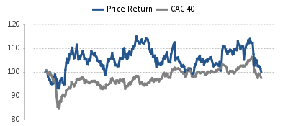
  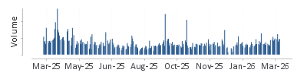
  Source: HFI
  [Table_Profit]
  US$ mn | Dec-24A |  | Dec-25E |  | Dec-26E |  | Dec-27E
  Revenue | 43,487 |  | 44,052 |  | 46,055 |  | 48,398
  （+/-） | 5.60% |  | 1.30% |  | 4.55% |  | 5.09%
  Net profit | 6,409 |  | 6,127 |  | 6,786 |  | 7,382
  （+/-） | 4% |  | -4% |  | 11% |  | 9%
  Diluted EPS (US$) | 11.95 |  | 11.44 |  | 12.70 |  | 13.83
  GPM | 74.2% |  | 74.3% |  | 74.4% |  | 74.7%
  ROE | 20.6% |  | 18.0% |  | 18.8% |  | 19.0%
  P/E | 30 |  | 31 |  | 28 |  | 26
  Source: Company data, HFI
[Table_Author]
Bin Yang, SFC:BSQ313
harryyang@hfisec.com.hk

Contents
1 L'Oréal: Global Leader in Beauty & Personal Care 3
1.1 Company Overview 3
1.2 Ownership Structure & Management 4
1.3 Core Product Categories 6
1.4 Financial Performance 7
2 Global Beauty Market: Steady Upward Growth, Strong Players Maintain Dominance 12
2.1 Stable Overall Growth, Outperformance in Premium Segment 12
2.2 Competitive Landscape: Significant Matthew Effect 15
3 Five Core Competitive Strengths Building a Corporate Moat 18
3.1 Consumer Products Division: Premium Technology at Accessible Prices, Deep Channel Penetration 21
3.2 L'Oréal Luxe Division: Strong Brand-Building Capabilities Establish Brand Premium 23
3.3 Professional Products Division: Specialized Products & Channel Partnerships Build Brand Moats 25
3.4 Dermatological Beauty Division: Science-Backed Skincare Solving Consumer Pain Points 27
4 Future Highlights: Driving Growth Through Organic Expansion and External Acquisitions 29
4.1 L'Oréal Luxe Division: Capitalizing on Structural Upgrades in Fragrances and Filling Super-Premium Gaps 29
4.2 Dermatological Beauty Division: Targeting Consumer Needs to Accelerate Emerging Market Penetration 31
4.3 Expanding through Acquisitions: Continuously strengthen the international brand operating platform 33
5.Valuation and investment rating 34
5.1 Profit Forecast 34
5.2 Valuation Analysis 36
6. RISK 38

1 L'Oréal: Global Leader in Beauty & Personal Care

1.1 Company Overview
L'Oréal is a global leader in beauty, founded in 1909 and headquartered in France. Its core business encompasses a broad range of beauty products, including skincare, cosmetics, fragrances, hair colouring, and personal care. Over a century of scientific innovation, strategic expansion, and social responsibility, L'Oréal has established itself as the world's foremost beauty company. Its corporate development can be divided into six distinct phases:
Phase 1 — 1909–1956: Founding and Brand Building
Founder and chemist Eugène Schueller placed scientific innovation at the heart of the company, laying the groundwork for the L'Oréal brand. In 1909, he established the Société Française des Teintures Inoffensives pour Cheveux and introduced a mild hair dye called 'L'Auréale' (inspired by a popular hairstyle of the era). In 1934, the company launched the world's first soap-free shampoo; in 1935, it introduced Ambre Solaire, pioneering the suncare category; and in 1939, the company was officially renamed L'Oréal and relocated its headquarters to 14 Rue Royale, Paris.
Phase 2 — 1957–1983: Seizing Opportunities and Growth Through Acquisitions
Under Chairman François Dalle and his 'Seize the Moment' philosophy, the company focused on R&D and consumer needs, expanding through strategic acquisitions. L'Oréal listed on the Paris Stock Exchange in 1963 and went on to acquire brands including Mixa, Lancôme, Biotherm, and Laboratoires Garnier. Landmark product launches during this period included Kérastase haircare, the Lancôme Ô fragrance, Cacharel Anaïs Anaïs, Elsève shampoo, Garnier Ultra Doux, and the Plénitude Revitalift skincare line.
Phase 3 — 1984–1987: Deepening the 'Beauty Science' Strategy and Entering Men's Care
Under CEO Charles Zviak, the company made substantial investments in R&D. In 1984, it secured the Ralph Lauren fragrance licence for the US market; in 1985, Biotherm launched a men's skincare range; and in 1986, Vichy introduced men's skincare products.
Phase 4 — 1988–2005: Becoming the Undisputed Leader in Beauty
Under President Lindsey Owen-Jones, L'Oréal became the world's number-one cosmetics company through strategic acquisitions, including Helena Rubinstein, the Giorgio Armani fragrance licence, La Roche-Posay, Maybelline, Kiehl's, and SkinCeuticals. The group also launched the L'Oréal–UNESCO 'For Women in Science' international programme during this period.
Phase 5 — 2006–2021: Introducing the 'Beauty for All' Mission
Under CEO Jean-Paul Agon, the group adopted a 'Beauty for All' mission, with an emphasis on diversity, inclusivity, and sustainable responsibility.
Phase 6 — 2021 to Present: Creating Beauty That Moves the World Forward
Under CEO Nicolas Hieronimus, the group focuses on high-quality, scientifically validated, and ethically produced products, accelerating its Beauty Tech and sustainability agenda. Key milestones include the reopening of the historic La Roche-Posay thermal centre in France (2022), the acquisition of Aesop (2023), the inauguration of the François Dalle Beauty Research Space, a collaboration with the Louvre and Lancôme, the acquisition of the Miu Miu licence (2024), and the group's inaugural keynote address at CES Las Vegas as the first beauty company to do so. Looking ahead, L'Oréal aims to 'invent the beauty of the future' through Beauty Tech, green science, biotechnology, and artificial intelligence.
Figure: L'Oréal Corporate Milestones
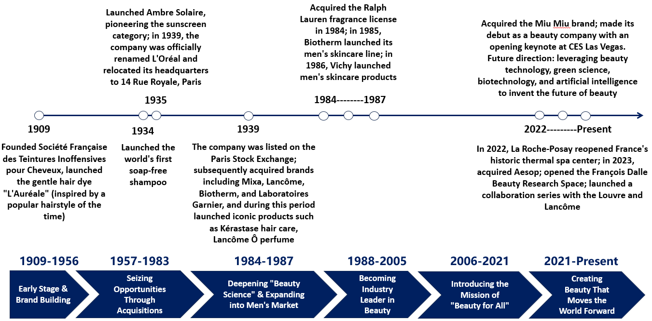
Source: L'Oréal Annual Reports, HFI

1.2 Ownership Structure & Management
L'Oréal's shareholder structure is characterised by considerable stability and concentrated family control. The largest shareholder is the Bettencourt Meyers family, holding 34.76% of shares. Nestlé is the second-largest shareholder with a 20.14% stake. Employee share ownership stands at 1.05%, with staff participating in the company's equity incentive scheme. The remaining shares are held by international and French institutional investors, providing a diversified shareholder base. This ownership structure ensures stable corporate governance while preserving the family's pivotal role in strategic decision-making.
Figure: L'Oréal Group Ownership Structure
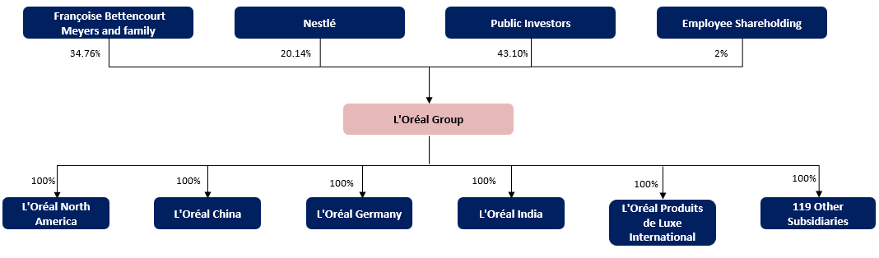
Source: Company Financial Reports, HFI

L'Oréal's management structure consists of an effective Executive Committee and a Board of Directors. The Executive Committee is responsible for translating the Board's strategic direction into operational practice and managing the group's global operations; its members lead the group's various divisions, functional departments, and regional markets. The Board of Directors comprises a number of independent and experienced directors, including members of the founding family and external directors, ensuring transparency and independence in corporate governance.
L'Oréal's leadership team provides strong strategic support through a stable governance structure and diverse leadership, reinforcing the group's leading position in the global beauty industry and driving its continuous innovation and sustainable development.

Table: Senior Management Team
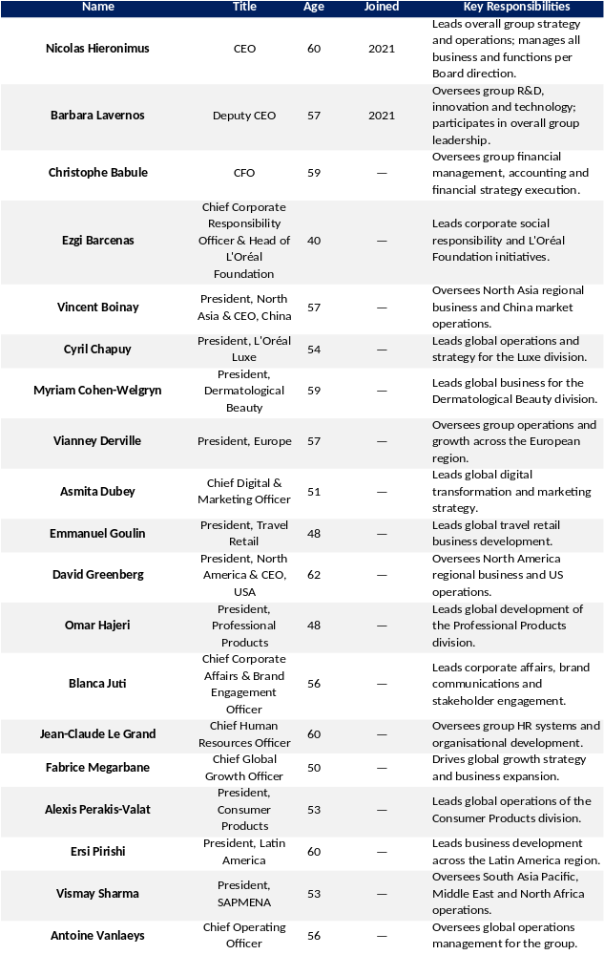
Source: Company Financial Reports, HFI

1.3 Core Product Categories
L'Oréal's core products span a wide range of beauty and personal care segments, encompassing skincare, colour cosmetics, hair care, fragrances, and hair colouring.

Skincare: L'Oréal's largest product category, covering the full price spectrum from mass to luxury. Core brands include L'Oréal Paris, Garnier, La Roche-Posay, CeraVe, and Vichy, with dermatology-focused brands registering especially strong growth.

Color Cosmetics: Another key business pillar, spanning face, eye, and lip make-up. Through internationally recognized brands such as Maybelline New York, NYX Professional Makeup, and L'Oréal Paris, the group commands a significant share of the global color cosmetics market.

Hair Care & Cleansing: L'Oréal's hair care portfolio includes shampoos, conditioners, and styling products, anchored by key brands such as L'Oréal Professional, Kérastase, and Redken. In the premium haircare segment, Kérastase and Redken attract a large affluent consumer base through innovative care solutions and professional formulations.

Fragrances: Fragrances remain an important component of L'Oréal's Luxe division, with brands including Yves Saint Laurent, Lancôme, Valentino, and Prada enjoying strong global reputations. In 2024, new launches such as Paradoxe (Prada), Libre (Yves Saint Laurent), and Born in Roma (Valentino) performed strongly, sustaining growth in the luxury fragrance market.

Hair Coloring: Hair coloring encompasses dyes and treatment products. Brands such as L'Oréal Professional and Garnier continue to drive this sub-segment. In 2024, new product launches including Garnier Color Sensation attracted broad consumer interest with their accessible price points and innovative formulations.

Other Beauty & Personal Care: L'Oréal's portfolio also covers nail care, body care, and personal hygiene. Through brands such as Biotherm, Mixa, and Yves Saint Laurent Beauty, the group continues to broaden its product offering to meet the needs of a wider consumer base.

Figure: L'Oréal Key Brands and Product Categories
Source: Company Financial Reports, HFI

1.4 Financial Performance
L'Oréal's revenue demonstrated consistent and healthy growth from 2019 to 2025. Group sales increased from €29.87 billion in 2019 to €44.05 billion in 2025, representing a CAGR of 6.7%, continuously reinforcing its position as the world's number-one beauty company. In 2020, the COVID-19 pandemic caused global beauty consumption to contract sharply, with group revenue declining 6.3% year-on-year to €27.99 billion. As restrictions eased in 2021, consumer demand rebounded strongly and revenue grew 15.3% to €32.29 billion. In 2022, despite elevated inflation and geopolitical disruption, the group maintained high-speed growth of +18.5%, reaching €38.26 billion, driven primarily by the Dermatological Beauty and L'Oréal Luxe divisions, and underpinned by the structural upgrading of global premium beauty demand. Revenue reached €41.18 billion in 2023 (+7.6% YoY), as cautious consumer sentiment in China weighed on North Asia, though strong performances in Europe and North America provided an effective offset. In 2024, group revenue reached €43.49 billion (+5.6% YoY); despite a -3.4% decline in North Asia, Latin America (+13.3%) and the SAPMENA region (+12.0%) emerged as key growth engines. Revenue grew further to €44.05 billion in 2025, up 1.3% reported (+4.0% organic at constant exchange rates), with the narrowing growth rate primarily attributable to currency headwinds from euro appreciation.

Figure: L'Oréal Revenue and Growth Rate 2020–2025 (€ million)
Source: Company Financial Reports, HFI

In terms of business structure, all four divisions contributed to group growth, though divergence was pronounced; the sustained high-speed expansion of the Dermatological Beauty Division represented the most significant structural change over the past six years. From 2020 to 2025, consolidated group sales grew from €27.99 billion to €44.05 billion, with a CAGR of 9.5%. Among the four divisions, the Dermatological Beauty Division achieved a CAGR of 19.1%, followed by Professional Products at 10.8%, L'Oréal Luxe at 8.9%, and Consumer Products at 6.6%. In terms of revenue mix, the Dermatological Beauty Division's share rose sharply from 10.8% in 2020 to 16.4% in 2025, while Consumer Products narrowed from 41.8% to 36.5%, reflecting the group's broader transition from volume-driven expansion to higher value-added growth.

Figure: L'Oréal Revenue by Division (€ million)
Source: Company Financial Reports, HFI
- Dermatological Beauty Division
The fastest-growing and most profitable of the four divisions, with an operating profit margin of 26.1% in 2025. Revenue expanded from €3.01 billion in 2020 to €7.20 billion in 2025 (CAGR 19.1%). The division maintained approximately 30% annual growth in 2021–2022, more than doubling in scale over five years. Growth moderated to 25.5%, 9.3%, and 2.5% from 2023 to 2025 respectively, yet the division continues to lead the group and to significantly outperform in the North Asia market.

Figure: Dermatological Beauty Division Revenue 2020–2025 (€ million)
Source: Company Financial Reports, HFI

- L'Oréal Luxe Division
L'Oréal Luxe generated revenue of €15.60 billion in 2025 (CAGR 8.9%) and became the group's largest division by revenue for the first time in 2021, surpassing the Consumer Products Division. Fragrances rebounded strongly, with luxury fragrance brands including YSL, Armani, and Prada growing more than 20% in 2022, driving the division to achieve 21.2% and 18.7% growth in 2021 and 2022 respectively. Growth narrowed significantly from 2023 to 2025, to 2.0%, 4.5%, and 0.0% respectively.

Figure: L'Oréal Luxe Revenue 2020–2025 (€ million)
Source: Company Financial Reports, HFI

- Consumer Products Division
The Consumer Products Division is the group's largest by volume, with revenue of €16.09 billion in 2025 (36.5% of total group revenue; CAGR 6.6%). Growth was relatively stable, with stronger performance in 2021–2022 (4.6% and 14.6% respectively) as color cosmetics demand recovered, before returning to the low-to-mid single-digit range of 8.2%, 5.3%, and 0.7% from 2023 to 2025.

Figure: Consumer Products Division Revenue 2020–2025 (€ million)
Source: Company Financial Reports, HFI

- Professional Products Division
The Professional Products Division generated revenue of €5.16 billion in 2025 (CAGR 10.8%). The division was hit hardest by COVID-19 — widespread salon closures in 2020 caused a 10% revenue decline — but the crisis accelerated an e-commerce and omnichannel pivot, with the SalonCentric platform achieving breakthroughs in North America and Tmall in China. As salons reopened, the division rebounded strongly in 2021 and 2022, with growth of 22.0% and 18.5% respectively. Growth normalized and even accelerated from 2023 to 2025 (4.0%, 5.0%, and 7.5%), with Kérastase having become the division's largest brand while maintaining double-digit growth and the premiumization strategy continuing to deliver steady momentum.

Figure: Professional Products Division Revenue 2020–2025 (€ million)
Source: Company Financial Reports, HFI

L'Oréal's profitability remained broadly steady from 2022 to 2025, with a moderate improvement across all key metrics.
1) Gross Profit and Gross Margin: Group gross profit grew from €27.68 billion in 2022 to €32.74 billion in 2025 (three-year CAGR of 5.8%). The gross margin expanded continuously from 72.4% to 74.3%, a cumulative improvement of 1.9 percentage points, primarily driven by an ongoing product-mix shift towards higher value-added categories, favourable pricing dynamics, and disciplined purchasing and manufacturing cost management, partially offset by currency headwinds.
2) Expense Ratios: L'Oréal's cost structure remained broadly stable from 2022 to 2025. Advertising and promotion expenditure was consistently maintained in the range of 31%–33% of sales, R&D expenses held steady at 3.1% of sales, and the selling, general and administrative expense ratio edged up slightly from 18.4% in 2022 to 18.9% in 2024 before declining to 18.8% in 2025, as efficiency gains from regional restructuring began to materialise.
3) Operating Profit and Operating Margin: Operating profit grew from €7.46 billion in 2022 to €8.89 billion in 2025 (three-year CAGR of 6.0%), with the operating margin improving year by year from 19.5% to 19.8%, 20.0%, and 20.2% — setting a record high for four consecutive years. This reflects the combined effect of operating scale and leverage, demonstrating L'Oréal's dual-track approach of 'investing in brands while improving efficiency'.

4) Net Profit: Net profit attributable to the parent company moved from €5.71 billion in 2022 to €6.13 billion in 2025, with the net profit margin maintained in the 14.7%–15.0% range. The 2025 net profit declined 4.4% year-on-year due to non-recurring impairment losses; excluding this item, adjusted net profit was €6.81 billion, up 0.3% YoY, reflecting robust underlying earnings quality.

Figure: L'Oréal Gross Profit and Gross Margin 2020–2025 (€ million) |  | Figure: L'Oréal Expense Ratios 2020–2025
Source: Company Financial Reports, HFI |  | Source: Company Financial Reports, HFI

Figure: L'Oréal Net Profit and Net Margin 2020–2025 (€ million) |  | Figure: L'Oréal Operating Profit and Operating Margin 2020–2025 (€ million)
Source: Company Financial Reports, HFI |  | Source: Company Financial Reports, HFI

2 Global Beauty Market: Steady Upward Growth, Strong Players Maintain Dominance

2.1 Stable Overall Growth, Outperformance in Premium Segment
The global beauty market has entered a relatively mature phase, with overall steady growth. According to data, the total size of the global beauty and personal care market increased from USD 47.32 billion in 2016 to USD 67.719 billion in 2025, representing a compound annual growth rate (CAGR) of approximately 4.06% over the decade. Although market size saw short-term volatility in 2020 affected by external factors, it subsequently demonstrated strong recovery and rebound momentum.
As the industry has become relatively mature, Statista projects that the global beauty market will expand further from USD 70.331 billion in 2026 to USD 79.907 billion in 2030, with a compound annual growth rate (CAGR) of 3.24% during the 2026–2030 period.

Figure: Global Beauty Market Size and YoY Growth, 2015–2025 (USD billions) |  | Figure: Estimated Global Beauty Market Size, 2026–2030 (USD billions)
Source: Statista，HFI |  | Source: Statista，HFI

In terms of the segment structure of the global beauty market, personal care and skin care account for the core market share. In addition, segments exhibit significant divergence in their growth contribution. In terms of incremental contribution by segment, personal care is the primary driver of market expansion, with its size rising from USD 24.516 billion to USD 29.308 billion, contributing 40.66% to the total incremental growth. Skin care follows closely, with an increment of USD 3.456 billion during the period and a growth contribution of 29.32%. Color cosmetics, the third-largest source of growth, expanded from USD 8.989 billion to USD 11.469 billion, with a contribution of 21.04%. Fragrance and beauty tech contributed 7.49% and 1.47% of the market incremental share, respectively, between 2019 and 2025.

Figure: Global Beauty Market Size by Category, 2018–2025 (USD billions) |  | Figure: Growth Contribution of Each Segment to the Global Beauty Market, 2019–2025
Source: Statista，HFI |  | Source: Statista，HFI
In terms of product categories, science-backed high-efficacy products are leading the market into a phase of structural expansion amid stock competition. The growth focus of the skin care market is shifting rapidly toward the high-efficacy segment.
Furthermore, shifting demand among young consumers forms the long-term driver of this growth. According to the Numerator 2024 Beauty Trends Report, when Gen Z purchases personal care and skin care products, their emphasis on "products for specific needs" (50%) and "beneficial ingredients" (35%) is significantly higher than the average. "Efficacy" (22%) and "natural/organic ingredients" (22%) also rank high, while experiential factors (e.g., sensory experience 16%, novelty 10%) are relatively lower. Such consumption preferences, rooted in scientific validation and targeted pain-point solutions, have become a key driver for skin care categories to achieve differentiated competition and maintain premium pricing in the stock era.

Figure: Top Considerations for Gen Z When Purchasing Personal Care and Skin Care Products
Source: Numerator，HFI

In terms of growth trends across price tiers, the high-end market has generally outpaced the mass market. According to McKinsey projections, the high-price segment will grow faster than the overall market between 2023 and 2028. Among them, the Luxury and Prestige categories demonstrate the strongest growth momentum, with compound annual growth rates (CAGR) of 9% and 7% respectively, both exceeding the overall market average of 6%.In comparison, the Entry prestige and Masstige categories show steady growth, each with a CAGR of 6%, in line with the market average. The Mass market segment grows at a more moderate pace, with a CAGR of 5%.

Figure: Projected CAGR of Global Beauty Market by Price Tier, 2023–2028
Source: McKinsey，HFI

2.2 Competitive Landscape: Significant Matthew Effect
From a global perspective, the global beauty market has witnessed substantial structural divergence over the past five years, with a growing trend toward industry consolidation. The top ten beauty companies account for approximately 38% of the global market share, representing an increase of 5.2 percentage points compared with 2020, as resources and growth continue to concentrate among leading enterprises. As the industry leader, L’Oréal Group has demonstrated remarkable growth resilience, with its global market share rising from 15.8% in 2020 to 18.0% in 2024, firmly ranking first worldwide.

Figure: Market Share of Leading Global Beauty Companies, 2024 (%)
Source: Euromonitor，HFI

L’Oréal’s brands have achieved outstanding market share performance across various segments:

1）In the global mass beauty and personal care market, L’Oréal Group has continuously consolidated its leading position through a multi-brand portfolio. According to Euromonitor data, the Group’s aggregated corporate share in this segment rose steadily from approximately 8.1% in 2019 to about 9.4% in 2024, representing a cumulative increase of 1.3 percentage points over five years.
Among its brands, L’Oréal Paris, as the top mass-market brand, edged up from 4.3% to 4.6% and has ranked first for six consecutive years. Garnier grew from 2.0% to 2.2%, supported by the iteration of natural, affordable, and effective products. Maybelline New York remained stable at around 1.5%. Such steady growth in market share was mainly driven by L’Oréal’s deep penetration in digital channels, which significantly improved brand reach and conversion among young consumers.

Figure: Market Share of the Top 10 Brands in the Global Mass Beauty & Personal Care Market, 2019–2024 (%)
Brand Name | 2019 | 2020 | 2021 | 2022 | 2023 | 2024
L'Oréal Paris | 4.3 | 4.4 | 4.6 | 4.5 | 4.6 | 4.6
Nivea | 3.3 | 3.2 | 3.3 | 3.2 | 3.4 | 3.5
Dove | 2.8 | 2.9 | 2.9 | 3 | 3 | 3.1
Garnier | 2 | 2 | 2 | 2.1 | 2.2 | 2.2
Natura | 1.6 | 1.5 | 1.5 | 1.7 | 1.9 | 2
Pantene | 1.6 | 1.7 | 1.7 | 1.7 | 1.7 | 1.7
Maybelline New York | 1.6 | 1.3 | 1.4 | 1.5 | 1.5 | 1.5
Head & Shoulders | 1.4 | 1.4 | 1.4 | 1.4 | 1.3 | 1.3
O Boticário | 1 | 0.8 | 0.7 | 1 | 1.2 | 1.2
Olay | 1.2 | 1.3 | 1.3 | 1.3 | 1.2 | 1.2

Source: Euromonitor，HFI

2）In the global high-end beauty and personal care market, L’Oréal Group has maintained a steady and rising market share. According to Euromonitor data, the combined share of the Group’s brands increased from 8.4% in 2019 to 10.0% in 2024, representing a rise of 1.6 percentage points over five years, and among the top five brands, Lancôme (owned by the Group) remained stable at 4.2% and retained its leading position, Chanel rose from 3.2% to 3.6%, Christian Dior edged up slightly from 3.0% to 3.1%, La Roche-Posay (owned by the Group) grew significantly from 1.6% to 2.8%, climbing to fourth place, and Estée Lauder declined from 3.5% to 2.8%, with two major brands of the Group together contributing approximately 7.0% of the market share, and the increase in L’Oréal’s share was mainly driven by the recovery of high-end consumption in the Asia-Pacific region and growing consumer preference for products combining luxury and efficacy.

Figure: Market Share of the Top 10 Brands in the Global High-End Beauty & Personal Care Market, 2019–2024 (%)
Brand Name | 2019 | 2020 | 2021 | 2022 | 2023 | 2024
Lancôme | 4.2 | 4.5 | 4.6 | 4.6 | 4.4 | 4.2
Chanel | 3.2 | 3.1 | 3.3 | 3.5 | 3.6 | 3.6
Christian Dior | 3 | 2.9 | 3.1 | 3 | 3.1 | 3.1
La Roche-Posay | 1.6 | 1.8 | 1.9 | 2.1 | 2.6 | 2.8
Estée Lauder | 3.5 | 3.7 | 3.6 | 3.4 | 3 | 2.8
Clinique | 2.4 | 2.2 | 2.1 | 2.1 | 2.1 | 2
Yves Saint Laurent | 1.4 | 1.3 | 1.4 | 1.6 | 1.7 | 1.7
Mac | 2.1 | 1.7 | 1.6 | 1.7 | 1.7 | 1.6
Shiseido | 1.8 | 1.9 | 1.9 | 1.8 | 1.6 | 1.6
Clarins | 1.5 | 1.5 | 1.4 | 1.5 | 1.4 | 1.4

Source: Euromonitor，HFI

3）In the global high-efficacy skin care market, L’Oréal Group’s brands hold a significantly leading position. L’Oréal Group’s brands have shown rapid growth in market share, rising from approximately 19.9% in 2019 to about 31.5% in 2024, representing a cumulative increase of 11.6 percentage points over five years, with the combined share of its brands accounting for nearly one-third of the market. Among the top five brands, the Group’s brands performed prominently: La Roche-Posay rose from 11.1% to 15.0%, firmly maintaining its first position; CeraVe achieved explosive growth from 2.7% to 11.7%, jumping to second place; Vichy slightly decreased from 6.1% to 4.8% but remained in the top five. This performance is mainly attributed to CeraVe and La Roche-Posay accurately capturing young consumers through clinically proven ingredients and social media promotion, thereby consolidating and strengthening their market positions.

Figure: Market Share of the Top 10 Brands in the Global High-Efficacy Skin Care Market, 2019–2024 (%)
Brand Name | 2019 | 2020 | 2021 | 2022 | 2023 | 2024
La Roche-Posay | 11.1 | 10.9 | 11.6 | 12.2 | 14.1 | 15
CeraVe | 2.7 | 5.3 | 7.5 | 9.4 | 11.4 | 11.7
Neutrogena | - | - | - | - | 9.9 | 9
Vichy | 6.1 | 5.6 | 5.1 | 4.7 | 4.6 | 4.8
Avene | 6.7 | 5.6 | 6 | 5.3 | 4.9 | 4.8
Eucerin | 4.1 | 4.1 | 4 | 4.3 | 4.5 | 4.5
Cetaphil | 3.6 | 4 | 3.7 | 4.2 | 4.1 | 4.3
Aveeno | - | - | - | - | 3.5 | 3.3
Winona | 2 | 2.7 | 3.3 | 3.8 | 3.5 | 3.3
Bioderma | 4 | 3.7 | 3.5 | 3.4 | 3.2 | 3.1

Source: Euromonitor，HFI

3 Five Core Competitive Strengths Building a Corporate Moat
As the undisputed leader in the global beauty industry, L'Oréal Group has built five deep competitive barriers since its founding in 1909: strong R&D and innovation capabilities, brand portfolio and brand management, globalized operations and localization strategy, broad omnichannel coverage, and digital and data-driven capabilities. These five barriers mutually reinforce one another, creating a flywheel effect that has enabled the group to consistently outperform the global beauty market over the past fifteen years.

- Strong R&D and Innovation Capabilities
L'Oréal is the highest R&D investor in the global beauty industry, with R&D expenditure exceeding EUR 1.3 billion in 2025 (approximately 3.1% of sales), far surpassing its major competitors. The group operates 21 R&D and innovation centres across 7 countries, employing over 4,000 scientists (85 nationalities, 70% women). In 2024, the group filed 694 patent applications (52% completed by female inventors) and launched over 3,600 new formulations, continuously introducing efficacy-driven active ingredients — from Pro-Xylane to the Melasyl anti-hyperpigmentation molecule, from UVMune 400 sunscreen technology to the Cell BioPrint proteomics-based skin analysis system.

Figure: L'Oréal R&D Investment 2020–2025 |  | Figure: Annual Patent Applications 2020–2025(units)
Source: Company Annual Reports, HFI |  | Source: Company Annual Reports, HFI

- Rich Brand Portfolio and Strong Brand Management Capabilities
Through continuous acquisitions and disciplined brand management, the group has assembled a portfolio of 40 international brands spanning four divisions and covering the full price spectrum from mass to ultra-luxury. In 2024, Consumer Products (EUR 15.44 billion) and L'Oréal Luxe (EUR 14.92 billion) each accounted for approximately 35% of total revenue, with Dermatological Beauty (EUR 7.05 billion) and Professional Products (EUR 4.72 billion) providing effective complementary coverage. Of the approximately 40 brands in the group's portfolio, organic brands include L'Oréal Paris (1909), L'Oréal Professionnel, and Kérastase (1964), while the vast majority were acquired. Among organic brands, L'Oréal Paris has grown over 116 years to become the world's number-one beauty brand, and Kérastase became the Professional Products division's largest brand in 2024 while maintaining double-digit growth. In terms of acquisition and integration, the group has demonstrated outstanding capability in scaling regional brands into global leaders: Maybelline was acquired in 1996 for USD 758 million and, after approximately 25 years of global operations, became the world's number-one colour cosmetics brand; CeraVe was acquired in 2017 for USD 1.3 billion with annual revenue of approximately USD 168 million at the time, and just seven years later in 2024 surpassed EUR 2 billion in brand revenue — a more than 12-fold increase; La Roche-Posay has grown from a French regional dermo-cosmetics brand since its acquisition in 1989 into the world's third-largest skincare brand. This brand management flywheel of "acquire → empower with global distribution and R&D platform → scale up" underscores the group's formidable platform-based operating capabilities.

Figure: Key Acquisition Timeline and Growth Trajectories
Brand | Acquisition Year | Acquisition Price | Strategic Rationale | Current Market Position | Growth Trajectory
Lancôme | 1964 | — | French Luxury Brand | Global Top-Tier Prestige Beauty Brand | 60 Years of Sustained Leadership
Garnier | 1965 | — | French Haircare Brand | Global Leading Mass Beauty Brand | 60 Years
Helena Rubinstein | 1988 | — | American Prestige Brand | Ultra-Premium Skincare Positioning | 37 Years
La Roche-Posay | 1989 | — | French Dermo-Cosmetic Brand | World's #3 Skincare Brand | 36 Years
Redken | 1993 | — | American Professional Haircare | #1 Professional Haircare Brand in the US | 32 Years
Maybelline | 1996 | $758M | American Mass-Market Makeup | World's #1 Makeup Brand | 28 Years to #1
Kiehl's | 2000 | — | NYC Niche Apothecary | Globally Recognized Prestige Skincare Brand | 25 Years
SkinCeuticals | 2005 | — | American Medical-Grade Skincare | Leader in Medical-Grade Vitamin C Serums | 20 Years
YSL Beauté | 2008 | $1.8B | Fashion House Beauty License | Core of Couture Brand Portfolio; MYSLF Men's Fragrance Global Hit | 17 Years
Essie | 2010 | — | American Nail Polish Brand | Category Leader in Nail Color | 15 Years
NYX | 2014 | — | American Indie Makeup Brand | Global Leading Professional Makeup Brand | 11 Years
CeraVe | 2017 | $1.3B | Revenue ~$168M at Acquisition | Gen Z's #1 Skincare Brand | 12x Revenue Growth in 7 Years
Aēsop | 2023 | $2.53B | Australian Ultra-Luxury Brand | Rapid Global Expansion Underway | 2 Years (Integration Ongoing)

Source: Company Annual Reports, HFI

- Globalized Operations and Localization Strategy
The group operates in more than 150 countries, with 36 manufacturing facilities and 21 R&D centers. It has a dedicated R&D center in China and manufacturing plants in Suzhou and Yichang, established a new R&D and innovation center in India in August 2024, and develops dedicated products for Brazil's diverse hair types.

Figure: Distribution of L'Oréal Research Centres 2020–2025 |  | Figure: Distribution of L'Oréal Manufacturing Facilities 2020–2025
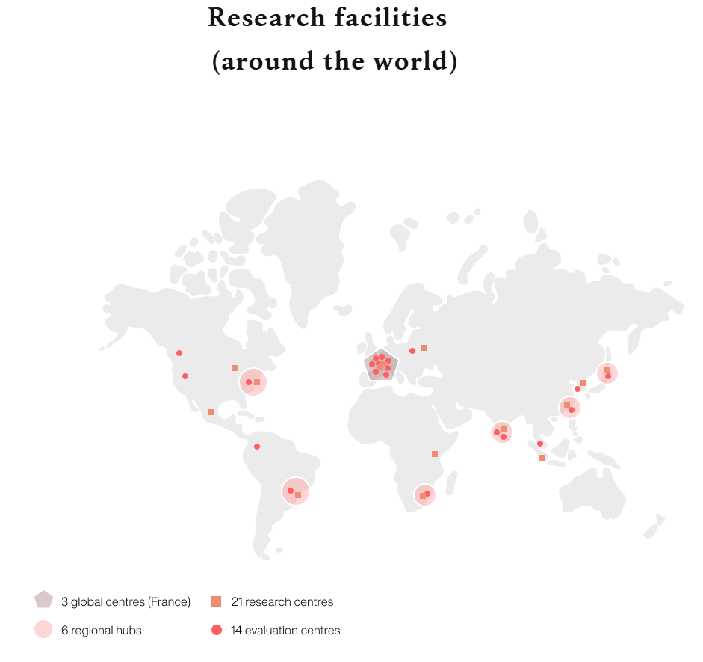 |  | 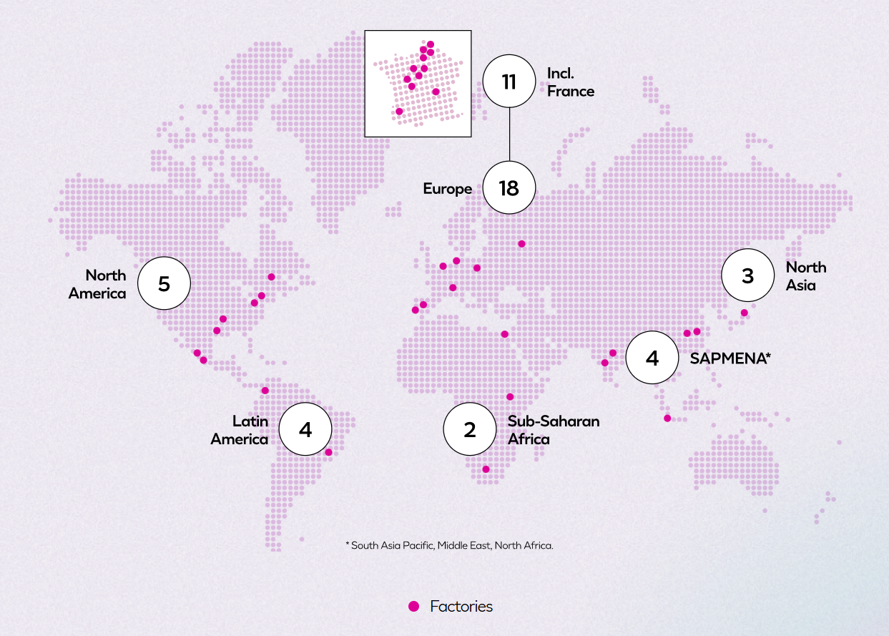
Source: Company Annual Reports, HFI |  | Source: Company Annual Reports, HFI

- Broad Channel Coverage
L'Oréal is one of the very few beauty companies with deep coverage across all six major channels: pharmacies, department stores, supermarkets, professional hair salons, e-commerce platforms, and proprietary DTC channels. Different divisions precisely match channels to their core customer segments: Consumer Products targets supermarkets, drugstores, and e-commerce platforms; L'Oréal Luxe controls brand positioning through department store counters, brand boutiques, and travel retail; Professional Products uses approximately 400,000 hair salons as its core base while expanding into e-commerce and selective retail; and Dermatological Beauty anchors in pharmacies and drugstores as its core prescription channel, extending into e-commerce. In the Professional Products division, Kérastase's "salon experience → online repurchase" consumer loop drives double-digit growth, with the division's market share reaching a record 26% in 2024; in Dermatological Beauty, CeraVe leveraged a combination of TikTok social media marketing and drugstore distribution to grow from under USD 200 million at acquisition to over EUR 2 billion within seven years. The quantified evidence of channel capability is that e-commerce's share of group revenue rose from 15.6% in 2019 to 28.2% (EUR 12.3 billion) in 2024, surpassing 30% in 2025.

Figure: L'Oréal E-Commerce Revenue as a Percentage of Total Sales
Source: Company Annual Reports, HFI

- Digital and Data-Driven Capabilities
In 2018, the group acquired AR/AI company ModiFace, formally launching its Beauty Tech strategy and evolving its ambition from "beauty for all" to "beauty for each". The group now employs over 8,000 digital and technology specialists and has accumulated 14,500 TB of data assets. On the consumer side, ModiFace's virtual try-on was used more than 110 million times in 2024. On the R&D side, the group unveiled the Cell BioPrint proteomics-based skin diagnostic device at CES 2025 and partnered with IBM to develop AI-powered formulation models. The Beauty Tech strategy has directly driven e-commerce's share of total sales from approximately 11% in 2018 to over 30% in 2025, with digital capabilities having evolved from a marketing tool into a core competitive barrier.

3.1 Consumer Products Division: Premium Technology at Accessible Prices, Deep Channel Penetration
The global mass beauty market reached approximately USD 360 billion in 2025, with sustained growth over the past five years. It is the largest sub-segment in the beauty industry by volume and breadth of consumer reach. Key market characteristics include relatively high price sensitivity (core price points of €5–30), low consumer switching costs, high e-commerce penetration (over 40% in the US market), and significant influence of social media and KOLs on purchasing decisions.

Figure: Global Mass Beauty Market Size 2019–2025 (USD million)
Source: Company Annual Reports, HFI

The Consumer Products Division manages a portfolio of more than ten international brands. Core brands include: L'Oréal Paris (founded in 1909, the world's number-one beauty brand, covering skincare, colour cosmetics, haircare, and hair colouring); Maybelline New York (acquired in 1996, the world's number-one colour cosmetics brand); Garnier (acquired in 1965, focused on natural plant-based skincare and haircare); NYX Professional Makeup (acquired in 2014, democratising professional makeup); Essie (acquired in 2010, the leading nail colour brand); and Mixa (the fastest-growing brand in 2024, expanding in the European market). In December 2024, the division also acquired Korean dermatological brand Dr.G, entering the K-Beauty segment.

Figure: Consumer Products Division Brand Portfolio
Brand | Founded / Acquired | Positioning | 2024 Key Highlights | Hero Products
L'Oréal Paris | Founded 1909 | World's #1 Beauty Brand; Full Category Coverage | Outstanding Year Across All Categories | Revitalift, Panorama Mascara, Elvive Glycolic Gloss
Maybelline New York | Acquired 1996 | World's #1 Makeup Brand | Teddy Tint Breakout Success | Lash Sensational, Superstay, Fit Me
Garnier | Acquired 1965 | Natural & Plant-Based Skincare and Haircare | Vitamin C UV Sunscreen Mass Adoption | Fructis, Good Hair Color
NYX Professional Makeup | Acquired 2014 | Democratizing Professional Makeup | Outperformed Broader Makeup Market | Fat Oil, Duck Plump, Butter Melt
Mixa | Proprietary Brand | Baby / Body / Facial Care | Fastest-Growing Brand in the Division | Hyalurogel, Sensitive Skin Range
Essie | Acquired 2010 | Category Leader in Nail Color | — | Gel Couture, Expressie
Dr.G | Acquired 2024 | Korean Dermo-Mass | Entry into K-Beauty Segment | K-Beauty Skincare

Source: Company Annual Reports, HFI
Using L'Oréal Paris as an example, the brand penetrates the market through deep channel investment and premium technology at accessible price points, combining tailored channel and product strategies suited to consumer purchasing habits in different regions. L'Oréal Paris is positioned as "high-quality beauty made accessible through science", targeting women across all age groups (and an increasingly significant male audience), with distinct product lines for each consumer sub-segment. In skincare, the Revitalift range (featuring hyaluronic acid, retinol, and other active ingredients) serves as the flagship; the Bright Reveal range launched in 2024 was the first to bring the group's proprietary Melasyl molecule to the mass market. In haircare, Elvive Glycolic Gloss, with its proprietary glycolic acid technology, has become the number-one haircare brand in Brazil. In China, the division has stepped up investment in online channels through collaborations with leading KOLs; in India, the Glycolic Bright affordable brightening range has been launched; in Brazil, sachet single-use packaging is used to penetrate lower-tier markets; and Garnier Vitamin C Daily UV promotes daily sun protection habits at accessible price points.

Figure: L'Oréal Paris Brand Overview
Category | Hero Products | 2024 Innovation Highlights | Channel Mix
Skincare | Revitalift HA, Glycolic Bright Serum, UV Defender | Glycolic Bright Range (Melanin-targeting molecule) | Mass Retail + E-Commerce
Makeup | Panorama Mascara, Infallible Series, Color Riche | Panorama Mascara: #1 Global New Product Launch by Sales | Mass Retail + E-Commerce
Haircare | Elvive Glycolic Bright, Hyaluronic Acid Series, Dream Sleek | Elvive: #1 Haircare Brand by Sales in Brazil | Mass Retail + E-Commerce
Hair Color | Excellence Créme, Préférence, Colorsonic | Colorsonic: AI-Powered At-Home Hair Color Device | Mass Retail + DTC
Men's | Men Expert | Continued Expansion of Men's Grooming Portfolio | Mass Retail + E-Commerce

Source: Company Annual Reports, HFI

3.2 L'Oréal Luxe Division: Strong Brand-Building Capabilities Establish Brand Premium
The global luxury beauty market reached approximately USD 160 billion in 2024, maintaining growth over the past four years. Core consumers in this market place high value on brand narrative, brand heritage, and experience, with brand loyalty significantly higher than in the mass market and relatively lower price elasticity. The premiumization trend has been the most important structural variable in the global beauty market over the past five years, particularly pronounced in the fragrances category.

Figure: Global Luxury Beauty Market Size 2019–2024 (USD million)
Source: Company Annual Reports, HFI

L'Oréal Luxe manages the most recognizable portfolio of luxury beauty brands globally. By brand type: Lifestyle brands include Lancôme (acquired in 1964, the division's flagship) and Kiehl's (acquired in 2000). Couture brands include YSL Beauté (acquired in 2008), Giorgio Armani (licensed since 1988), Prada Beauty (licensed since 2019), Valentino Beauty (licensed since 2019), Maison Margiela, and Miu Miu (licensed since 2024). The ultra-luxury tier includes Aēsop (acquired in 2023 for USD 2.53 billion). Efficacy skincare brands include Medik8 (acquired in 2025) and Takami (acquired in 2023). Furthermore, the acquisition of Kering Beauté, completed in October 2025, added Creed and brands including Gucci and Balenciaga to the portfolio.

Figure: L'Oréal Luxe Brand Portfolio
Brand | Type | Year | Hero Products | 2024 Key Highlights
Lancôme | Lifestyle | Acquired 1964 | Absolue, Teint Idole, La Vie est Belle | Flagship Brand; Top 3 Prestige in China
Giorgio Armani Beauty | Couture | Licensed 1988 | Luminous Silk Foundation, Sì, Privé | —
Helena Rubinstein | Prestige | Acquired 1988 | Re-Plasty, Powercell | Ultra-Premium Skincare Positioning
YSL Beauté | Couture | Acquired 2008 | MYSLF, Libre, Loveshine | MYSLF Becomes Global Fragrance Blockbuster
Kiehl's | Lifestyle | Acquired 2000 | Ultra Facial Cream, Midnight Recovery | —
Prada Beauty | Couture | Licensed 2019 | Paradoxe, Paradigme | Valentino & Prada Drive Couture Category Growth
Valentino Beauty | Couture | Licensed 2019 | Born in Roma, Donna Born in Roma | Strong Expansion across North Asia
Aēsop | Ultra-Luxury | Acquired 2023 | Resurrection, Marrakech | 42 New Store Openings in 2024 (incl. 13 in China)
Maison Margiela | Couture | — | Replica Collection | Niche Fragrance Growth
Miu Miu Beauty | Couture | Licensed 2024 | Miutine (Launch 2025) | Targeting Gen-Z Consumers
Medik8 | Skincare | Acquired 2025 | Crystal Retinal | —

Source: Company Annual Reports, HFI
The brands in this division command powerful premiums through unique brand stories and innovative technology, demonstrating the group's exceptional brand-building capabilities. Taking Lancôme as an example: founded in 1935 and acquired by L'Oréal in 1964, Lancôme is positioned around French elegance and cutting-edge science, ranking as a leading luxury beauty brand in 130 global markets. At the brand narrative level, Lancôme uses the rose as its inspirational symbol — drawn from the château at Lancosme — and conveys an ethos of elegance and confidence through global celebrity ambassadors including Julia Roberts and Zendaya. At the product technology level, the Génifique serum deploys the group's proprietary Bifidus fermentation technology, and the Absolue range targets ultra-luxury anti-ageing using Pro-Xylane and rose extract, translating the group's EUR 1.38 billion annual R&D investment into product differentiation. In terms of channel management, Lancôme strictly limits distribution to premium channels — department store counters, brand boutiques, and official e-commerce — maintaining a unified brand positioning. This is validated by the L'Oréal Luxe division's overall operating profit margin of 22.3% in 2024, confirming the sustainability of brand premium.

Figure: Lancôme Brand Overview
Category | Hero Products | Target Consumer | Highlights
Skincare | Advanced Génifique Serum; Biotic Serum | Women  25–55 | Top 3 Prestige Serum in China
Anti-Aging | Absolue Collection; Rose + Pro-Xylane | Women 40+ | Ultra-Premium Anti-Aging Line
Makeup | Teint Idole Ultra Wear Foundation | Women  20–45 | One of the Best-Selling Prestige Foundations Globally
Fragrance | La Vie Est Belle | Women  25–50 | Top 5 Best-Selling Women's Fragrance Worldwide

Source: Company Annual Reports, HFI

3.3 Professional Products Division: Specialized Products & Channel Partnerships Build Brand Moats
The global professional hair salon market reached approximately USD 11.8 billion in 2025, with continuous growth over the past five years. The segment has distinctive characteristics: the salon channel (B2B) is its core, with extremely high requirements for product professionalism and safety; consumers place greater value on the service experience than on the product itself; and stylist recommendations are the most important purchase driver. The industry is undergoing a transition from a pure B2B model to a hybrid B2B+B2C approach. Growth in the premium haircare market has been particularly strong, with consumers increasingly willing to pay a premium for salon-quality products.

Figure: Global Professional Hair Salon Market Size 2019–2025 (USD million)
Source: Company Annual Reports, HFI

All brands within the Professional Products Division centre their distribution on the professional hair salon channel: Kérastase (founded in 1964, the division's largest brand, maintaining double-digit growth), L'Oréal Professionnel (the original founding brand, with the broadest salon coverage), Redken (acquired in 1993, the number-one professional haircare brand in the US market), Matrix, Biolage, and Pureology. The acquisition of Color Wow in June 2025 further enriched the premium haircare portfolio.

Figure: Professional Products Division Brand Portfolio
Brand | Positioning | Hero Products | Channel Mix
Kérastase | Division's #1 Brand; Double-Digit Growth | Première, Gloss Absolu | Salon + E-Commerce + Selective Retail
L'Oréal Professionnel | Founding Brand; Largest Salon Footprint | iNOA, Absolut Repair, Série Expert Moleculaire | Salon-Led
Redken | #1 Professional Haircare Brand in the US | Acidic Bonding Concentrate, Shades EQ | Salon + Selective Retail
Matrix | Mass Professional Positioning | SoColor, Total Results | Mass Professional Channels
Color Wow | Acquired June 2025; Premium Haircare | Dream Coat, Money Masque | Prestige Retail

Source: Company Annual Reports, HFI

The division maintains its competitive strength through proprietary formulations that raise barriers to entry, continuous technology iteration, and close engagement with hair stylists globally. Taking Kérastase as an example: founded in 1964 and positioned as "salon-grade luxury haircare", Kérastase surpassed L'Oréal Professionnel to become the division's largest brand in 2024 while maintaining double-digit growth. The brand's core philosophy of "bringing skincare thinking to haircare" emphasises a trinity of scientific formulation, personalised diagnostics, and the salon service experience. At the product level, formulations must meet the professional and safety standards required for salon application. In terms of continuous innovation, the Première range uses citric acid to repair broken di-sulphide bonds, and Gloss Absolu was the brand's largest new product launch in 2024; the Genesis range is precisely positioned to address the growing hair loss and scalp care trend; and Elixir Ultime and Chronologiste target the ultra-luxury tier in premium haircare oils. From a channel perspective, close engagement with the hairstylist community — combined with maintaining the salon as the core channel while actively expanding into e-commerce and selective retail (such as Sephora) — creates a consumer loop of "discover in salon, repurchase online".

Figure: Kérastase Key Milestones
Year | Key Events | Key Launches
2020 | COVID-19 Impact; Salon Closures | —
2021 | Post-Pandemic Salon Recovery | Curl Manifesto
2022 | Prestige Haircare Boom | Première (Citric Acid Bond Repair)
2023 | Omnichannel Acceleration | Elixir Ultime
2024 | Surpassed L'Oréal Professionnel to Become Division's #1 Brand; Double-Digit Growth | Gloss Absolu (New Launch)

Source: Company Annual Reports, HFI

3.4 Dermatological Beauty Division: Science-Backed Skincare Solving Consumer Pain Points
The global dermatological skincare market reached approximately USD 23.8 billion in 2024, maintaining growth over the past five years, with growth rates exceeding double digits in both 2021 and 2023. Key trends include: growing consumer focus on ingredients and clinical efficacy evidence; the "Skintok" effect — dermatologists and skincare creators on TikTok and Xiaohongshu have substantially elevated awareness of dermatological skincare products; and channel diversification, expanding from traditional pharmacies and hospital prescription channels to e-commerce and selective retail.

Figure: Global Dermatological Skincare Market Size 2019–2024 (USD million)
Source: Euromonitor

The Dermatological Beauty Division is anchored in dermatological science and home to the world's leading dermo-skincare brands: La Roche-Posay (the world's largest dermatological brand), CeraVe (surpassed EUR 2 billion in 2024, Gen Z's favourite skincare brand), Vichy (renowned for its thermal water and the Dercos scalp care range), SkinCeuticals (acquired in 2005, renowned for its medical-grade Vitamin C serum and antioxidant products), and Skinbetter Science (acquired in 2023, focused on post-injectable skincare).

Figure: Dermatological Beauty Division Brand Portfolio (2024)
Brand | Hero Products | Channel Mix | 2024 Key Highlights
La Roche-Posay | Toleriane, Vitamin B3 Serum, Cicaplast B5 | Pharmacy + E-Commerce | Division Growth Leader; Double-Digit Growth in SAPMENA
CeraVe | Moisturising Cream, Hydrating Cleanser | Mass Retail + Pharmacy + E-Commerce | Gen Z's #1 Skincare Brand; Driven by International Expansion
Vichy | Dercos, Minéral 89 Serum, Liftactiv | Pharmacy | Thermal Water Heritage + Scalp Care
SkinCeuticals | C E Ferulic, P-Tiox | Medi-Spa + DTC | Medical-Grade Positioning; High DTC Mix
Skinbetter Science | AlphaRet, InterFuse | Medi-Spa + DTC | Post-Procedure Skincare Specialist

Source: Company Annual Reports, HFI

Brands within this division achieve sustained, market-leading growth through physician endorsement and rigorous ongoing research into skin concerns that address consumer needs. Taking La Roche-Posay as an example: founded in 1975 by dermatologists and built on the thermal spring water of La Roche-Posay, France, the brand is recommended by over 90,000 dermatologists worldwide. Its Effaclar range is one of the world's best-selling acne care products; the Mela B3 range, launched in 2024 and featuring the group's proprietary Melasyl molecule, represents a breakthrough innovation in the anti-hyperpigmentation space; and the Anthelios suncare range perennially ranks first in the pharmacy channel.
In terms of revenue scale, the Dermatological Beauty Division is the group's fastest-growing division. Its like-for-like growth from 2022 to 2024 was +21.1%, +18.3%, and +9.8% respectively, substantially outperforming the group-level LFL of +10.9%, +11.0%, and +5.1% over the same period. By comparison, L'Oréal Luxe achieved LFL growth of only +2.7% in 2024, Consumer Products +5.4%, and Professional Products +5.3%. The division's outperformance reflects the high growth momentum in the global dermatological skincare segment (Euromonitor CAGR 2019–2024 of approximately 10.6%), as well as the group's first-mover advantage in physician prescription channels and its multi-brand portfolio.

Figure: La Roche-Posay Brand Overview
Dimension | Highlights
Positioning | World's Leading Dermatological Skincare Brand; Founded by Dermatologists in 1975
Hero Products | Effaclar (Acne) | Mela B3 (Pigmentation, Melasyl Molecule) | Cicaplast B5 (Repair) | Anthelios (Sun Protection) | Toleriane (Sensitive Skin)
Clinical Authority | 200+ Clinical Studies over 3 Years
Channel Mix | Pharmacy | E-Commerce
Innovation | Melasyl Molecule | UVMune 400 Sun Protection Technology
Growth Markets | Double-Digit Growth in SAPMENA | Leading Dermocosmetic Brand in China
Social Media | TikTok #LaRochePosay Billions of Views | #SkinTok Effect

Source: Company Annual Reports, HFI

4 Future Highlights: Driving Growth Through Organic Expansion and External Acquisitions

4.1 L'Oréal Luxe Division: Capitalizing on Structural Upgrades in Fragrances and Filling Super-Premium Gaps
The company's Premium Consumer Goods Division will focus on two key dimensions: structural upgrades within the fragrance category (targeting young male consumers, leveraging Asia's rise, and capturing premium value through uniqueness) and rapid expansion of its high-end brand portfolio (filling super-premium gaps through Creed and Kering licensing agreements).

- Fragrances serve as the strongest growth engine within the Luxe division, having made significant contributions over the past few years. Key drivers include platforms like TikTok, which have spurred young men to layer multiple scents rather than using just one and share their combinations; additionally, Asian fragrance consumption is experiencing a structural surge. The company has strategically positioned itself in this sector with brands including YSL (blockbusters like Libre and MYSLF maintain strong sales, with annual revenue exceeding €3 billion and sustained double-digit growth over multiple years), Valentino (the Born in Roma collection has surpassed €700 million in sales), Prada (new releases like Paradoxe and Paradigme demonstrate robust performance), and Miu Miu.

Figure: 2020–2025 Global Perfume Retail Sales (in millions of USD) |  | Figure: 2022–2024 Sales Revenue of the Top Three Brands (in 100 millions of USD)
Source: Euromonitor, HFI |  | Source: Euromonitor, HFI

2) The Group will rapidly fill gaps in the ultra-luxury perfume and Couture beauty segments through acquisitions and licensing, establishing a formidable competitive barrier. L'Oréal Luxe's brand matrix strategy has proven highly effective: starting with licensing (YSL as a model), scaling rapidly (Valentino/Prada exceeding €700 million), making major acquisitions to fill gaps (Creed in ultra-luxury), and expanding through long-term licensing (Kering alliance), forming a closed-loop ecosystem. In 2025, the Luxe division achieved actual like-for-like growth of +2.8% (accelerating to +3.6% in H2, nearing +5% excluding Asia travel retail), with Fragrances outperforming the market at double digits and Couture brands (YSL, Prada, Valentino) delivering standout contributions. In 2026, this matrix is expected to further drive structural growth through Creed integration, gradual Kering brand infusion, and Asian recovery, solidifying the group's leadership in luxury beauty.

Figure: L'Oréal Group's Luxe Brands: Scale and Growth Projections for 2025
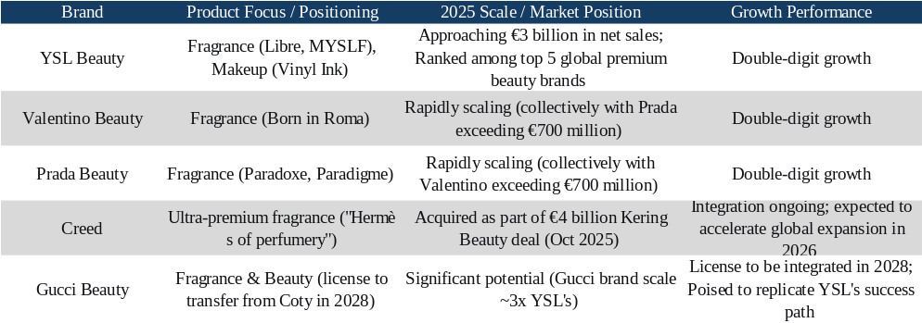
Source: L'Oréal Annual Report, dfnionline, HFI

4.2 Dermatological Beauty Division: Targeting Consumer Needs to Accelerate Emerging Market Penetration
The Active Health Cosmetics Division precisely targets consumer demands, capitalizing on sustained upward trends.
Emphasizing "dermatologist-endorsed + patented technology," it addresses consumers' essential needs for efficacy, safety, and gentleness. Under CeraVe, the focus is on "Triple Ceramide" barrier repair, with core business recovery driven by innovative products like Intensive Moisturizing Lotion in the second half of 2025. La Roche-Posay's Cicaplast line remains a bestseller as the go-to repair solution. Mela B3 (featuring patented Melasyl™) leads in addressing hyperpigmentation, leveraging robust scientific patents to excel in Asia, particularly China. Expansion of the P-Tiox line and new launches like HA Intensifier drive double-digit growth, targeting $1 billion in revenue by 2025. Future plans include increased investment in patented technologies (e.g., Melasyl™ expansion, P-Tiox globalization) and launching breakthrough products targeting hyperpigmentation, aging, and barrier damage. The brand will capitalize on the "longevity science" and preventative skincare trends, with CeraVe planning to enter the sunscreen category by late 2025 or early 2026.

Figure: L'Oréal Group Active Health Cosmetics Division Growth Driver Model
Source: L'Oréal Annual Report, HFI

Capturing scalp care trends to accelerate product portfolio expansion. Consumers now view the scalp as "skin on the head," shifting demand from cleansing to prevention/therapy. The company successfully entered this trend with CeraVe scalp care products, addressing high-frequency treatment pain points and driving cross-category vitality within the division. Vichy (Dercos line) launched dandruff solutions in markets like the U.S., contributing to its recovery. Moving forward, we will build upon CeraVe's scalp care foundation to deepen our "hair-skin convergence" strategy, capturing the growing demand for scalp health prevention.

Figure: CeraVe and Vichy hair-skin Products
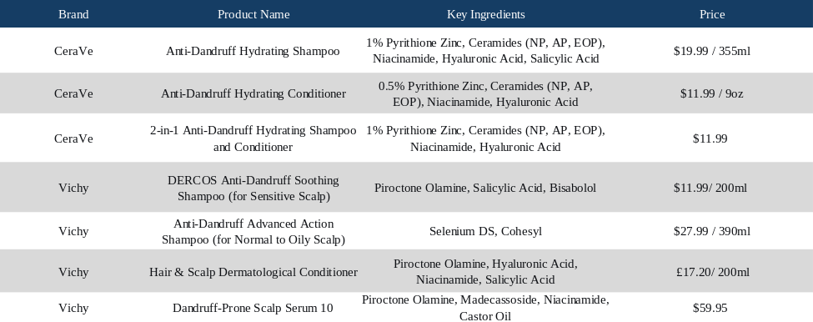
Source: Amazon Official Website, HFI

Focus on untapped/high-growth regions including India, Mainland China, Southeast Asia, Latin America, and the GCC, employing a "city-by-city" or digital-first strategy to rapidly capture market share (emerging markets have become the department's primary growth driver). In India, the strategy emphasizes city-by-city penetration + digital-first (Nykaa e-commerce + social), with localized solutions for hyperpigmentation/dullness (La Roche-Posay Mela B3, CeraVe Gentle Repair). Demand significantly exceeded expectations in 2025, driving high single-digit growth, with acceleration anticipated in 2026. Southeast Asia adopts a digital-first approach (Shopee/Lazada + social education) with localized gentle barrier/oil-sensitive products, achieving strong double-digit growth by 2025. GCC (Gulf Cooperation Council) markets leverage online dominance + cosmeceutical/ dermatologist endorsements, building premium dermo trust. These regions will become key growth drivers by 2025, with increased investment anticipated. The Latin American market focuses on cosmeceutical-driven strategies + localized sun protection/repair solutions, with ongoing channel optimization and product upgrades. In the Mainland China market, the company will continue expanding e-commerce channels and new product iterations, anticipating recovery in the second half of 2025. Future strategies will prioritize premium segment recovery and digitalization maintenance.

Figure: Regional Product Layout
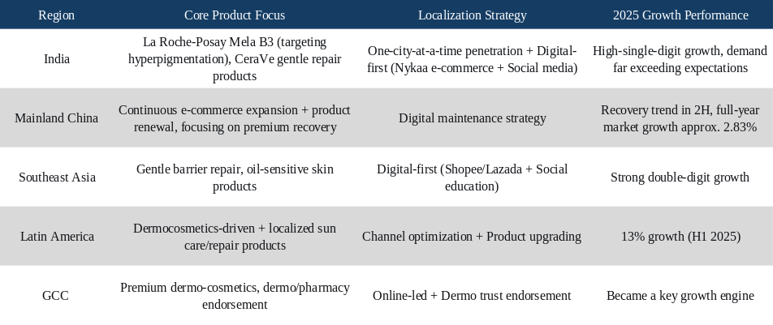
Source: L'Oréal Group Official Website, beauty packaging, HFI

4.3 Expanding through Acquisitions: Continuously strengthen the international brand operating platform
L'Oréal Group has achieved sustained global expansion through strategic brand acquisitions and licensing, significantly enhancing its competitiveness in high-end luxury, niche segments, and high-growth categories. Notable historical examples include Yves Saint Laurent (licensed in 2008, starting from hundreds of millions of euros and surging to over €3 billion after years of double-digit growth), Valentino and Prada (both with initial sales of €50-100 million, now exceeding €700 million each), and more recently Aesop (acquired in 2023 for $2.5 billion), and Color Wow (to be acquired in 2025, strengthening its premium haircare portfolio). The most significant move in 2025 is the €4 billion strategic alliance with Kering: Acquiring Creed (filling the ultra-luxury/niche fragrance market gap, transaction expected to close in H1 2026) and securing 50-year exclusive beauty licensing rights for brands including Bottega Veneta and Balenciaga (Gucci's beauty operations will transition post-2028), further cementing the group's leadership in luxury beauty.

Figure: Time and Amount of Brand Acquisition
Brand | Acquisition time and Amount
YSL Beauty | 2008，$1.8B
Valentino | 2019
Prada | 2021
Aesop | 2023，$2.5B
Color Wow | 2025，$1B
Creed | 2025，€4B

Source: L'Oréal Group Official Website, HFI

Looking ahead, L'Oréal will continue to leverage mergers and acquisitions as one of its core growth engines. Acquisition decisions are primarily based on three considerations: First, strategic alignment and category/price point complementarity, prioritizing premium/luxury, niche, or high-growth segments (such as fragrances and hair care) to fill gaps in the existing portfolio; Second, growth potential and scalability, where target brands must demonstrate the ability to rapidly scale from a low base (as demonstrated by historical examples like YSL and Valentino); Third, long-term value and synergies, where brands must possess strong DNA and leverage the Group's R&D, channels, marketing, and global resources to accelerate worldwide expansion while exploring emerging segments like wellness/longevity. Historical data indicates acquired brands typically require 3-8 years to achieve significant sales growth: YSL achieved double-digit growth for years starting in 2008, surpassing €3 billion; Valentino/Prada surged from low bases to over €700 million within several years; new brands like Creed are projected to rapidly scale from their current €300-350 million potential to €1 billion levels. Leveraging robust operational and integration capabilities, L'Oréal typically delivers significant growth within 3-5 years post-acquisition, supporting the group's sustained outperformance relative to the market.

5.Valuation and investment rating

5.1 Profit Forecast
- Total Revenue
We expect the company to maintain steady revenue growth in the coming years. Total revenue is projected to reach €46.06bn / €48.40bn / €50.95bn in 2026–2028, representing YoY growth of 4.55% / 5.09% / 5.28%, respectively. Overall growth will mainly be driven by premiumization trends, strong demand for dermatological beauty products, and the recovery of professional salon channels.

1）Professional Products：Revenue from Professional Products is projected to reach €5.63bn / €5.95bn / €6.30bn in 2026–2028, corresponding to YoY growth of 9.05% / 5.75% / 5.75%.

Growth is expected to be mainly supported by the recovery of professional salon demand and the increasing penetration of premium haircare products. Meanwhile, the company continues to strengthen its digital platforms and partnerships with salons, which should further improve channel efficiency and enhance brand influence.
2）Consumer Products：Revenue from Consumer Products is expected to reach €16.54bn / €17.14bn / €17.76bn in 2026–2028, representing YoY growth of 2.78% / 3.62% / 3.62%.

As the company’s largest business segment, the division is expected to maintain relatively stable growth. The expansion is primarily driven by demand growth in emerging markets and product upgrades that support higher average selling prices. At the same time, the company continues to increase investment in e-commerce channels and social media marketing, which should help maintain stable market share.
3）Luxury Products：Revenue from Luxury Products is projected to reach €16.26bn / €17.25bn / €18.39bn in 2026–2028, corresponding to YoY growth of 4.27% / 6.09% / 6.59%.

Growth will mainly be driven by continued demand for premium beauty products and strong performance in fragrance and makeup categories. Core brands such as Lancôme, YSL Beauty, and Armani Beauty maintain strong brand equity in the global premium market. In addition, the recovery of travel retail channels is expected to further support the growth of this segment.
4）Dermatological Beauty：Revenue from Dermatological Beauty is expected to reach €7.63bn / €8.06bn / €8.51bn in 2026–2028, representing YoY growth of 5.87% / 5.63% / 5.63%.
The growth of this segment is mainly supported by increasing global demand for efficacy-driven skincare products and the expansion of dermatology-related channels. Brands such as La Roche-Posay, Vichy, and CeraVe maintain strong competitive advantages in the dermatological skincare market.
Figure: Revenue breakdown by business segment, 2024–2028 (EUR million)
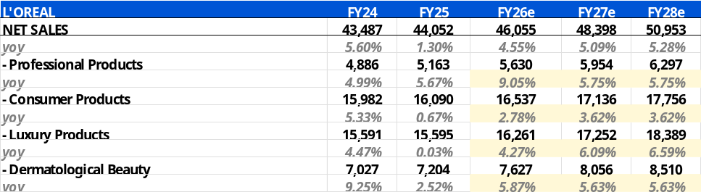
Source: Wind, HFI

- Gross Margin

1) Drivers of gross margin improvement
As the company continues to implement its premiumization strategy, the increasing revenue contribution from Luxury Products and Dermatological Beauty, which generally carry higher margins, is expected to provide structural support to overall gross margins. In addition, economies of scale and improvements in supply chain efficiency are likely to further enhance cost control.

2) Cost-side considerations
Although raw material price volatility and channel mix changes may introduce some uncertainty in the short term, continued improvements in supply chain management and product mix optimization are expected to keep the cost ratio on a gradual downward trend.

Overall, we expect the company's gross margin to reach 74.4% / 74.7% / 75.0% in 2026–2028, showing a modest upward trend.

- Operating Expense Ratio

R&D Expense Ratio: The company continues to increase investment in dermatological science, beauty technology, and product innovation to maintain its technological leadership in the global beauty industry. We expect R&D spending to grow steadily going forward. The R&D expense ratio is projected to remain stable at around 3.1% during 2026–2028.

Advertising and Promotion Expense Ratio: Advertising and promotion expenses mainly relate to brand marketing, digital campaigns, and channel promotion activities. As the company continues to strengthen brand positioning and increase investments in social media, e-commerce platforms, and global marketing initiatives, advertising and promotion expenses are expected to maintain steady growth. The advertising and promotion expense ratio is projected to reach 31.8% / 31.7% / 31.7% in 2026–2028, showing a slight decline mainly due to economies of scale from revenue expansion.

SG&A Expense Ratio: SG&A expenses primarily include administrative costs, operational management expenses, and global corporate overhead. With the continued expansion of revenue scale, SG&A expenses are expected to remain stable while gradually declining as a percentage of sales. The SG&A expense ratio is expected to reach 18.9% / 18.8% / 18.7% in 2026–2028.
Considering revenue growth, gross margin improvement, and the evolution of expense ratios, we expect the company’s profitability to improve steadily. As product mix continues to shift toward higher-margin categories and operating leverage gradually materializes, earnings growth is expected to remain solid.
At the same time, the company continues to invest in brand marketing, product innovation, and channel development, which keeps short-term operating expenses at relatively high levels. However, overall expense ratios are expected to remain stable, with limited impact on profit growth.
Based on the above assumptions, we forecast net profit attributable to shareholders to reach €6.79bn / €7.38bn / €7.93bn in 2026–2028, representing YoY growth of 10.75% / 8.79% / 7.45%, indicating steady and sustainable earnings growth.

5.2 Valuation Analysis
Based on the Discounted Cash Flow (DCF) valuation model, we have forecasted the company's future operating cash flows. Taking into account industry growth prospects and the company's position as a global leader, we assign a target price of €408.
We initiate coverage on L'Oréal Groupe with an "Outperform" investment rating.

Figure: DCF Model
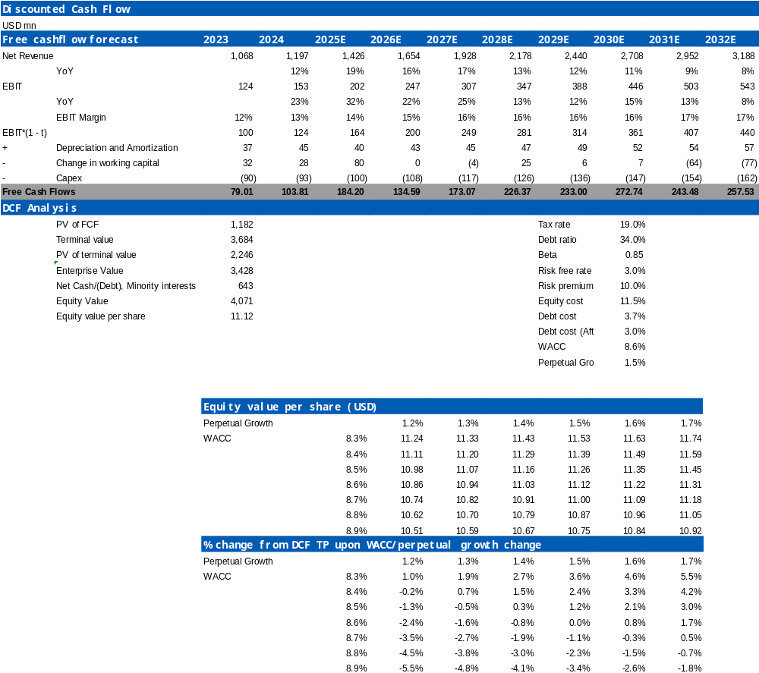
Source: Wind, HFI

Figure: Summary of Financials
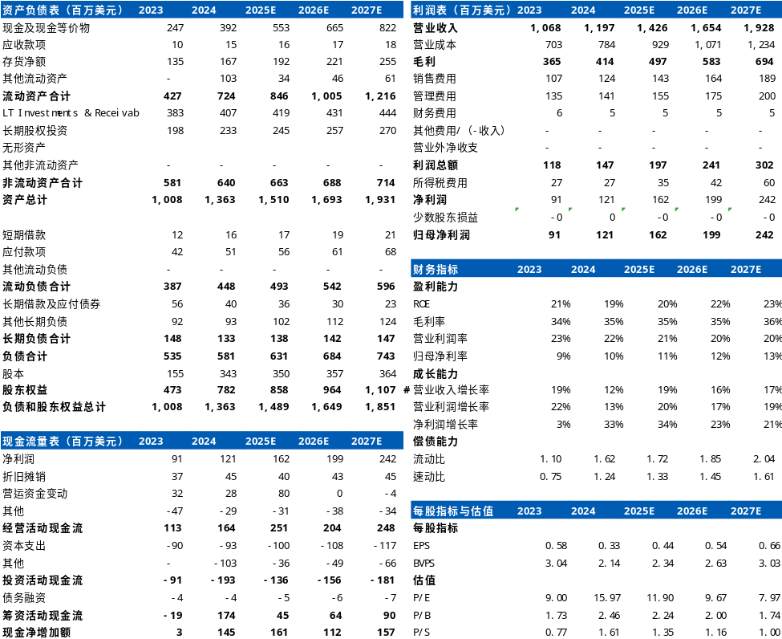
Source: Wind, HFI

6. RISK
Raw material price fluctuations; supply chain disruptions; intensified market competition; changes in customer demand and preferences.

[Table_APPENDIX]
[Table_disclaimer]
APPENDIX
IMPORTANT DISCLOSURES
This research report is distributed by HuaFu International (HK) Financial Holdings Limited (referred as HuaFu International below), which is authorized to engage in securities activities in its respective jurisdiction.
Analyst Certification:
I, Bin Yang, certify that (i) the views expressed in this research report accurately reflect my personal views about any or all of the subject companies or issuers referred to in this research and (ii) no part of my compensation was, is or will be directly or indirectly related to the specific recommendations or views expressed in this research report; and that I (including members of my household) have no financial interest in the security or securities of the subject companies discussed.
Conflict of Interest Disclosures
HuaFu International and some of its affiliates may engage in investment banking and / or serve as a market maker or hold proprietary trading positions of certain stocks or companies in this research report. As far as this research report is concerned, please send an email to lcd@hfisec.com.hk if the information about any company mentioned in this report is needed).
Ratings Definitions (from 1 Jul 2020):
HuaFu International uses a relative rating system using Outperform, Neutral, or Underperform for recommending the stocks we cover to investors. Investors should carefully read the definitions of all ratings used in HuaFu International Research. In addition, since HuaFu International Research contains more complete information concerning the analyst's views, investors should carefully read HuaFu International Research, in its entirety, and not infer the contents from the rating alone. In any case, ratings (or research) should not be used or relied upon as investment advice. An investor's decision to buy or sell a stock should depend on individual circumstances (such as the investor's existing holdings) and other considerations.
Analyst Stock Ratings
Outperform: The stock’s total return over the next 12-18 months is expected to exceed the return of its relevant broad market benchmark by over 10%, as indicated below.
Neutral: The stock’s total return over the next 12-18 months is expected to be in line with the return of its relevant broad market benchmark, as indicated below. Underperform: The stock’s total return over the next 12-18 months is expected to be below the return of its relevant broad market benchmark by over 10%, as indicated below.
Benchmarks for each stock’s listed region are as follows: Japan – TOPIX, Korea – KOSPI, Taiwan – TAIEX, India – Nifty100, US – SP500; for all other China-concept stocks – MSCI China.

HuaFu International Non-Rated Research: HuaFu International publishes quantitative, screening or short reports which may rank stocks according to valuation and other metrics or may suggest prices based on possible valuation multiples. Such rankings or suggested prices do not purport to be stock ratings or target prices or fundamental values and are for information only.
HuaFu International Coverage of A-Shares: HuaFu International may cover and rate A-Shares . HuaFu Securities, the ultimate parent company of HuaFu International based in FuZhou, covers and publishes research on these same A-Shares for distribution in mainland China. However, the rating system employed by HuaFu International differs from that used by HuaFu Securites and even the teams covering the same A-share stocks might be totally independently different, as a result there may be a difference in their coverage ratings, target prices and research logics for the same A-share stocks.
IMPORTANT DISCLAIMER
The research report is issued by HuaFu International, a licensed corporation to carry on Type 4 regulated activity (advising on securities) for the purpose of the Securities and Futures Ordinance (Cap. 571) of Hong Kong.
The information and opinions contained in this research report have been compiled or arrived at from sources believed to be reliable and in good faith but no representation or warranty, express or implied, is made by HuaFu International or any other related members from which this research report may be received, as to their accuracy, completeness or correctness. All opinions expressed herein are as of the date of this research report and are subject to change without notice. This research report is for information purpose only. Descriptions of any companies or their securities mentioned herein are not intended to be complete and this research report is not, and should not be construed expressly or impliedly as, an offer to buy or sell securities. The securities referred to in this research report may not be eligible for purchase or sale in some jurisdictions. If an investment product is denominated in a currency other than an investor's home currency, a change in exchange rates may adversely affect the investment. Past performance is not necessarily indicative of future results. Certain transactions, including those involving derivatives, give rise to substantial risk and are not suitable for all investors. You should also bear in mind that recommendations in this research report are not tailor-made for you. The analyst has not taken into account your unique financial circumstances, such as your financial situation and risk appetite. You must, therefore, analyze and should, where applicable, consult your own legal, tax, accounting, financial and other professional advisers to evaluate whether the recommendations suits you before investment. Neither HuaFu International nor any of its directors, employees or agents accepts any liability whatsoever for any direct or consequential loss arising from any use of the materials contained in this research report.
HuaFu International and its affiliates, officers, directors, and employees, excluding the analysts responsible for the content of this document, will from time to time have long or short positions in, act as principal in, and buy or sell, the securities or derivatives, if any, referred to in this research report. Sales, traders, and other professionals of HuaFu International may provide oral or written market commentary or trading strategies to the relevant clients and the companies within HuaFu International that reflect opinions that are contrary to the opinions expressed in this research report. HuaFu Internatioal may make investment decisions that are inconsistent with the recommendations or views expressed in this research report. HuaFu International is under no obligation to ensure that such other trading decisions, ideas or recommendations are brought to the attention of any recipient of this research report.
Please refer to HuaFu International’s website www.hfisec.com.hk for further information on HuaFu International’s organizational and administrative arrangements set up for the prevention and avoidance of conflicts of interest with respect to Research.

DISTRIBUTION AND REGIONAL NOTICES
Except as otherwise indicated below, any Recipient wishing to discuss this research report or effect any transaction in any security discussed in HuaFu International’s research should contact the HuaFu International salesperson in their own country or region.
Notice to Hong Kong investors: The research report is distributed by HuaFu International, which is a licensed corporation to carry on Type 1 regulated activity (dealing in securities) in Hong Kong. This research report does not constitute a solicitation or an offer of securities or an invitation to the public within the meaning of the SFO. This research report is only to be circulated to "Professional Investors" as defined in the SFO. This research report has not been reviewed by the Securities and Futures Commission. You should not make investment decisions solely on the basis of the information contained in this research report. Recipients of this research report are to contact HuaFu International salespersons in respect of any matters arising from, or in connection with, the research report.

People’s Republic of China (PRC): In the PRC, the research report is directed for the sole use of those who receive the research report in accordance with the applicable PRC laws and regulations. Further, the information on the research report does not constitute "production and business activities in the PRC" under relevant PRC laws. This research report does not constitute a public offer of the security, whether by sale or subscription, in the PRC. Further, no legal or natural persons of the PRC may directly or indirectly purchase any of the security or any beneficial interest therein without obtaining all prior PRC government approvals or licenses that are required, whether statutorily or otherwise. Persons who come into possession of this research are required to observe these restrictions.
This research report is intended for the recipients only and may not be reproduced or redistributed without the written consent of an authorized signatory of HuaFu International.
Copyright: HuaFu International 2025. All rights reserved

Recommendation Chart
[Table_RecommendationChart]
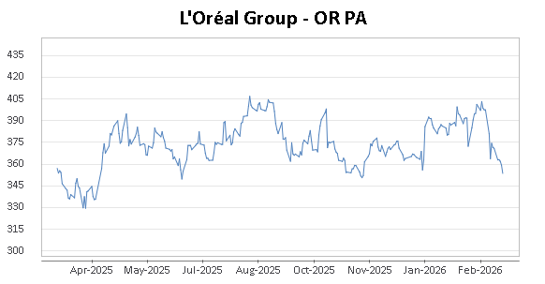
Source: Company data Bloomberg, HFI estimates

