[Table_Main]
研究报告Research Report
25 Mar 2026
西锐飞机Cirrus Aircraft(2507 HK)
2025年年报点评：全年收入强劲增长，飞机交付量走高，均价持续向上
Strong Revenue Growth, Higher Aircraft Deliveries, Rising Average Prices

 | (Please see APPENDIX 1 for English summary)  西锐飞机2025年全年实现强劲收入增长。1）收入表现：2025年全年公司实现总营业收入13.54亿美元，同比增长13.1%，2025H2收入7.60亿美元，同比增长约5.3%；其中，西锐服务及其他收入2025年全年同比增长17.0%至2.03亿美元。2）费用率表现：2025年销售费率提升0.32pct至10.64%，其中2025H2提升1.37pct至10.59%，主要因 G7+全球推广、广告投入及交付量增加所致；2025年行政开支费率提升0.24pct至12.04%，其中2025H2提升1.03pct至12.25%，主要费用投放涉及到新机型认证、研发迭代及行政扩张费用。3)盈利水平：全年毛利率35.2%，同比提升约2.0pct，其中2025H2毛利率34.4%，同比提升约1.2pct。全年经调整净利润1.42亿美元，同比增长18.3%，其中2025H2经调整净利润0.77亿美元，同增3.8%。全年经调整净利率10.48%，提升0.42pct，其中2025H2经调整净利率10.13%，同比提升0.29pct。  西锐飞机2025年交付量走高，单机售价持续向上。1）从交付量上看，2025年全年共交付797架飞机，同比增长9%（H2交付447架），其中SR系列691架，愿景喷气机106架。2)单机售价：全年SR2X交付均价约116万美元，同比增加约5.5%（2024全年均价110万美元）；愿景喷气机均价约352万美元，同比增加约3.5%（2024全年均价340万美元）。3)生产及订单情况：通过推动生产线一致性及可预测性，公司显著减少往年因季节性导致的交付波动。2025年全年生产809架飞机（690架SR2X系列和119架愿景喷气机），交付797架，分别高于2024年全年的生产731架（617架SR2X系列和114架愿景喷气机）和交付731架。截至2025年12月31日，公司拥有1,066架飞机储备订单，其中包括约221架愿景喷气机订单。全年公司合计净订单728架，较2024年全年增加95架，主要得益于G7+系列持续热销。  展望2026年两大重磅新品有望持续催化需求订单，带动公司收入向上。公司两大重磅新品SR Series G7+和Vision Jet G3将显著催化需求，其中G7+全面升级连接性、航电与硬件配置，G3则带来CPDLC电子沟通、自动数据库、后排空间及性能提升，有望进一步拉动ASP上行与高端配置渗透。此外，公司服务生态高粘性也将持续贡献稳定利润，叠加核心零部件长协锁定成本，预计2026年交付量、毛利率及净利润均表现出色。  估值与投资建议：我们预计西锐飞机在2026年至2028年期间的收入将分别达到15.22/16.77/18.44亿美元，净利润分别为1.56/1.79/1.99亿美元。基于贴现现金流（DCF）估值模型，我们给予“中性”评级，目标价为6.7美元（对应港币52.45元）。  风险提示：原材料价格波动；供应链中断；市场竞争加剧；客户需求变化；政策变化。
  [Table_Info]
  下调至中性Downgrade to NEUTRAL
  评级 | NEUTRAL
  现价 | 47.96
  目标价 | 52.45
  市值 | 17.55bn
  发行股票数目 | 365.99mn
  1年股价最高最低值 | 73.40-25.20
  注：现价47.96为2026年03月24日收盘价
  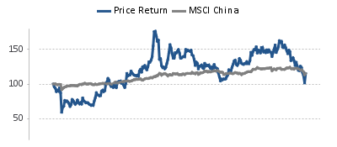
  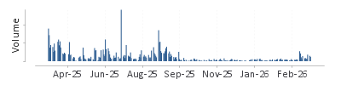
  资料来源：HFI
  [Table_Profit]
  US$ mn | Dec-24A |  | Dec-25E |  | Dec-26E |  | Dec-27E
  营业收入 | 1,197 |  | 1,354 |  | 1,522 |  | 1,677
  (+/-) | 12.12% |  | 13.13% |  | 12.40% |  | 10.14%
  净利润 | 121 |  | 139 |  | 156 |  | 179
  (+/-) | 32% |  | 15% |  | 13% |  | 14%
  全面摊薄EPS (US$) | 0.33 |  | 0.38 |  | 0.43 |  | 0.49
  毛利率 | 34.5% |  | 35.2% |  | 35.1% |  | 35.4%
  净资产收益率 | 19.2% |  | 16.7% |  | 16.9% |  | 17.3%
  市盈率 | 145 |  | 126 |  | 112 |  | 98
  资料来源：公司信息, HFI
[Table_Author]
杨斌Bin Yang, SFC:BSQ313
harryyang@hfisec.com.hk

表：DCF模型
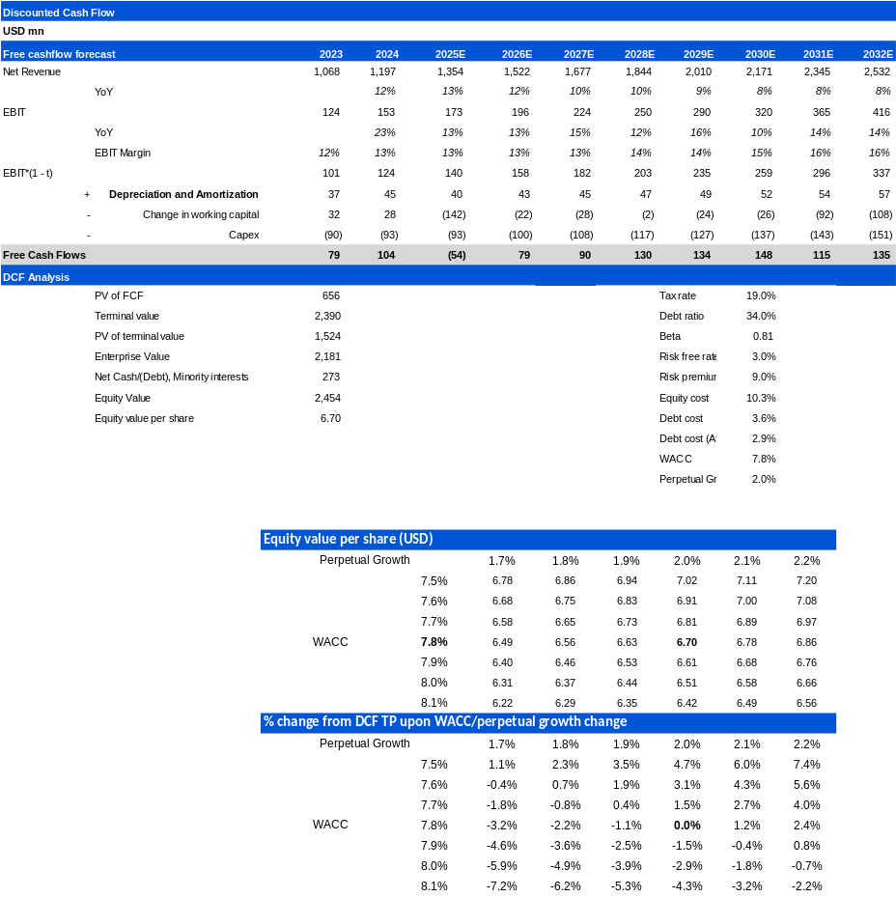
资料来源: Wind, HFI

表：财务汇总
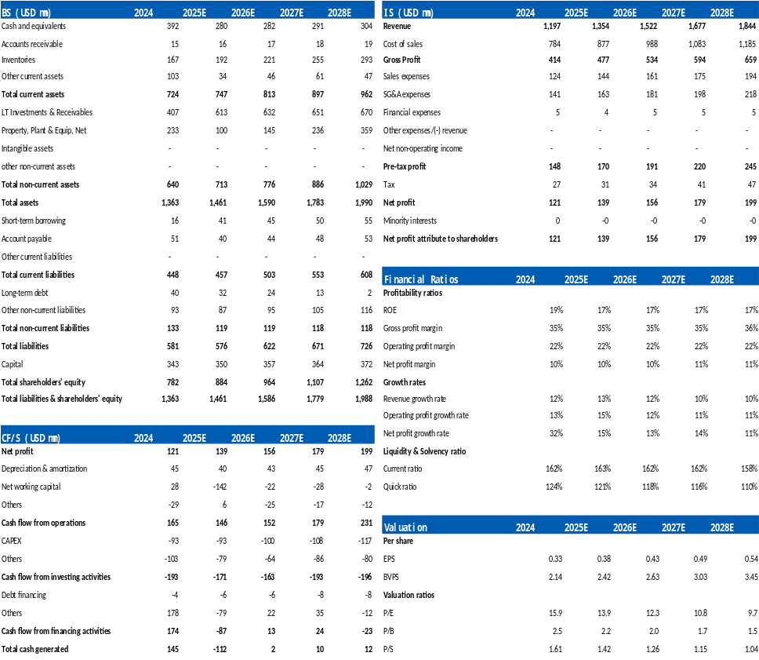
资料来源: Wind, HFI

APPENDIX 1
Summary
Cirrus Aircraft Achieved Strong Revenue Growth in 2025.
1) Revenue Performance: For the full year 2025, the company reported total operating revenue of USD 1.354 billion, up 13.1% year-over-year. Revenue in H2 2025 reached USD 760 million, representing approximately 5.3% year-over-year growth. Within this, Cirrus Services and other revenue grew 17.0% year-over-year to USD 203 million for the full year.
2) Expense Ratio Performance: The 2025 selling expense ratio increased by 0.32 percentage points to 10.64%, with the H2 2025 ratio rising 1.37 percentage points to 10.59%, mainly due to global promotion of the G7+, higher advertising investment, and increased deliveries. The 2025 administrative expense ratio rose by 0.24 percentage points to 12.04%, with H2 2025 increasing 1.03 percentage points to 12.25%. The elevated expenses were primarily related to new model certification, R&D iterations, and administrative expansion.
3) Profitability: The full-year gross margin reached 35.2%, up approximately 2.0 percentage points year-over-year, while the H2 2025 gross margin was 34.4%, an increase of about 1.2 percentage points. Full-year adjusted net profit amounted to USD 142 million, growing 18.3% year-over-year. H2 2025 adjusted net profit was USD 77 million, up 3.8%. The full-year adjusted net profit margin was 10.48%, an improvement of 0.42 percentage points. The H2 2025 adjusted net profit margin stood at 10.13%, up 0.29 percentage points year-over-year.

Cirrus Aircraft Saw Higher Delivery Volume and Continued Rise in Average Selling Prices in 2025.
1) In terms of deliveries, the company delivered a total of 797 aircraft in 2025, representing a 9% year-over-year increase (447 units delivered in H2). This included 691 units from the SR Series and 106 Vision Jets.
2) Average Selling Prices: The full-year average price for SR2X deliveries was approximately USD 1.16 million, an increase of about 5.5% year-over-year (2024 full-year average: USD 1.10 million). The average price for Vision Jets was approximately USD 3.52 million, up about 3.5% (2024 full-year average: USD 3.40 million).
3) Production and Order Backlog: By enhancing production line consistency and predictability, the company significantly reduced delivery volatility caused by seasonality in previous years. In 2025, the company produced 809 aircraft (690 SR2X series and 119 Vision Jets) and delivered 797 units, both higher than 2024’s full-year production of 731 aircraft (617 SR2X series and 114 Vision Jets) and deliveries of 731 units. As of December 31, 2025, the company had a backlog of 1,066 aircraft orders, including approximately 221 Vision Jet orders. Net orders for the full year totaled 728 units, an increase of 95 units compared to 2024, primarily driven by strong sales of the G7+ series.

2026 Outlook: Two Major New Products Expected to Catalyze Demand and Drive Revenue Growth.
The company’s two flagship new products — the SR Series G7+ and Vision Jet G3 — are expected to significantly boost demand. The G7+ offers comprehensive upgrades in connectivity, avionics, and hardware, while the G3 brings CPDLC electronic communication, automatic database updates, expanded rear-cabin space, and performance enhancements. These upgrades should further support average selling price (ASP) growth and higher penetration of premium configurations. In addition, the company’s highly sticky service ecosystem will continue to contribute stable profits. Combined with long-term agreements locking in core component costs, delivery volume, gross margin, and net profit in 2026 are all expected to perform strongly.
Valuation and Investment Recommendation: We forecast Cirrus Aircraft’s revenue for 2026–2028 to reach USD 1.522 / 1.677 / 1.844 billion respectively, with net profits of USD 156 / 179 / 199 million. Based on the Discounted Cash Flow (DCF) valuation model, we assign a “NEUTRAL” rating with a target price of USD 6.7 (equivalent to HKD 52.45).
Risk Factors: Raw material price fluctuations; supply chain disruptions; intensified market competition; changes in customer demand; policy changes.

[Table_APPENDIX]
[Table_disclaimer]
附录APPENDIX
重要信息披露
本研究报告由华福国际（香港）金融控股有限公司（下称华福国际）分销，在其许可的司法管辖区内从事证券活动。
IMPORTANT DISCLOSURES
This research report is distributed by HuaFu International (HK) Financial Holdings Limited (referred as HuaFu International below), which is authorized to engage in securities activities in its respective jurisdiction.
分析师认证Analyst Certification:
我， 杨斌，在此保证（i）本研究报告中的意见准确反映了我们对本研究中提及的任何或所有目标公司或上市公司的个人观点，并且（ii）我的报酬中没有任何部分与本研究报告中表达的具体建议或观点直接或间接相关；及就此报告中所讨论目标公司的证券，我们（包括我们的家属）在其中均不持有任何财务利益。I, Bin Yang, certify that (i) the views expressed in this research report accurately reflect my personal views about any or all of the subject companies or issuers referred to in this research and (ii) no part of my compensation was, is or will be directly or indirectly related to the specific recommendations or views expressed in this research report; and that I (including members of my household) have no financial interest in the security or securities of the subject companies discussed.
利益冲突披露Conflict of Interest Disclosures
华福国际及其某些关联公司可从事投资银行业务和/或对本研究中的特定股票或公司进行做市或持有自营头寸。就本研究报告而言，如需了解其中提到的某一公司信息，请发邮件至lcd@hfisec.com.hk）
HuaFu International and some of its affiliates may engage in investment banking and / or serve as a market maker or hold proprietary trading positions of certain stocks or companies in this research report. As far as this research report is concerned, please send an email to lcd@hfisec.com.hk if the information about any company mentioned in this report is needed).
评级定义（从2020年7月1日开始执行）：
华福国际采用相对评级系统来为投资者推荐我们覆盖的公司：优于大市、中性或弱于大市。投资者应仔细阅读华福国际的评级定义。并且华福国际发布分析师观点的完整信息，投资者应仔细阅读全文而非仅看评级。在任何情况下，分析师的评级和研究都不能作为投资建议。投资者的买卖股票的决策应基于各自情况（比如投资者的现有持仓）以及其他因素。
分析师股票评级
优于大市，未来12-18个月内预期相对基准指数涨幅在10%以上，基准定义如下
中性，未来12-18个月内预期相对基准指数变化不大，基准定义如下
弱于大市，未来12-18个月内预期相对基准指数跌幅在10%以上，基准定义如下
各地股票基准指数：日本 – TOPIX, 韩国 – KOSPI, 台湾 – TAIEX, 印度 – Nifty100, 美国 – SP500; 其他所有中国概念股 – MSCI China.
Ratings Definitions (from 1 Jul 2020):
HuaFu International uses a relative rating system using Outperform, Neutral, or Underperform for recommending the stocks we cover to investors. Investors should carefully read the definitions of all ratings used in HuaFu International Research. In addition, since HuaFu International Research contains more complete information concerning the analyst's views, investors should carefully read HuaFu International Research, in its entirety, and not infer the contents from the rating alone. In any case, ratings (or research) should not be used or relied upon as investment advice. An investor's decision to buy or sell a stock should depend on individual circumstances (such as the investor's existing holdings) and other considerations.
Analyst Stock Ratings
Outperform: The stock’s total return over the next 12-18 months is expected to exceed the return of its relevant broad market benchmark by over 10%, as indicated below.
Neutral: The stock’s total return over the next 12-18 months is expected to be in line with the return of its relevant broad market benchmark, as indicated below. Underperform: The stock’s total return over the next 12-18 months is expected to be below the return of its relevant broad market benchmark by over 10%, as indicated below.
Benchmarks for each stock’s listed region are as follows: Japan – TOPIX, Korea – KOSPI, Taiwan – TAIEX, India – Nifty100, US – SP500; for all other China-concept stocks – MSCI China.

华福国际非评级研究：华福国际发布计量、筛选或短篇报告，并在报告中根据估值和其他指标对股票进行排名，或者基于可能的估值倍数提出建议价格。这种排名或建议价格并非为了进行股票评级、提出目标价格或进行基本面估值，而仅供参考使用。
HuaFu International Non-Rated Research: HuaFu International publishes quantitative, screening or short reports which may rank stocks according to valuation and other metrics or may suggest prices based on possible valuation multiples. Such rankings or suggested prices do not purport to be stock ratings or target prices or fundamental values and are for information only.
华福国际A股覆盖：华福国际可能会就中国A股进行覆盖及评级。华福证券，华福国际于福州的母公司，也会于中国发布中国A股的研究报告。但是，华福国际使用与华福证券不同的评级系统，且可能有完全独立的不同研究覆盖团队，所以华福国际与华福证券的中国A股评级、目标价乃至分析逻辑可能有所不同。
HuaFu International Coverage of A-Shares: HuaFu International may cover and rate A-Shares . HuaFu Securities, the ultimate parent company of HuaFu International based in FuZhou, covers and publishes research on these same A-Shares for distribution in mainland China. However, the rating system employed by HuaFu International differs from that used by HuaFu Securites and even the teams covering the same A-share stocks might be totally independently different, as a result there may be a difference in their coverage ratings, target prices and research logics for the same A-share stocks.
重要免责声明：
本报告由华福国际发行，该公司是根据香港证券及期货条例（第571章）持有第4类受规管活动（就证券提供意见）的持牌法团。
本文件所载信息和观点已被编译或源自可靠来源，但华福国际或任何其他属于华福国际的成员对其准确性、完整性和正确性不做任何明示或暗示的声明或保证。本文件中所有观点均截至本报告日期，如有更改，恕不另行通知。本文件仅供参考使用。文件中提及的任何公司或其股票的说明并非意图展示完整的内容，本文件并非/不应被解释为对证券买卖的明示或暗示地出价或征价。在某些司法管辖区，本文件中提及的证券可能无法进行买卖。如果投资产品以投资者本国货币以外的币种进行计价，则汇率变化可能会对投资产生不利影响。过去的表现并不一定代表将来的结果。某些特定交易，包括设计金融衍生工具的，有产生重大风险的可能性，因此并不适合所有的投资者。您还应认识到本文件中的建议并非为您量身定制。分析师并未考虑到您自身的财务情况，如您的财务状况和风险偏好。因此您必须自行分析并在适用的情况下咨询自己的法律、税收、会计、金融和其他方面的专业顾问，以期在投资之前评估该项建议是否适合于您。若由于使用本文件所载的材料而产生任何直接或间接的损失，华福国际及其董事、雇员或代理人对此均不承担任何责任。
除对本文内容承担责任的分析师除外，华福国际及我们的关联公司、高级管理人员、董事和雇员，均可不时作为主事人就本文件所述的任何证券或衍生品持有长仓或短仓以及进行买卖。华福国际的销售员、交易员和其他专业人士均可向华福国际的相关客户和公司提供与本文件所述意见相反的口头或书面市场评论意见或交易策略。华福国际可做出与本文件所述建议或意见不一致的投资决策。但华福国际没有义务来确保本文件的收件人了解到该等交易决定、思路或建议。
请访问华福国际网站 www.hfisec.com.hk ，查阅更多有关华福国际为预防和避免利益冲突设立的组织和行政安排的内容信息。
IMPORTANT DISCLAIMER
The research report is issued by HuaFu International, a licensed corporation to carry on Type 4 regulated activity (advising on securities) for the purpose of the Securities and Futures Ordinance (Cap. 571) of Hong Kong.
The information and opinions contained in this research report have been compiled or arrived at from sources believed to be reliable and in good faith but no representation or warranty, express or implied, is made by HuaFu International or any other related members from which this research report may be received, as to their accuracy, completeness or correctness. All opinions expressed herein are as of the date of this research report and are subject to change without notice. This research report is for information purpose only. Descriptions of any companies or their securities mentioned herein are not intended to be complete and this research report is not, and should not be construed expressly or impliedly as, an offer to buy or sell securities. The securities referred to in this research report may not be eligible for purchase or sale in some jurisdictions. If an investment product is denominated in a currency other than an investor's home currency, a change in exchange rates may adversely affect the investment. Past performance is not necessarily indicative of future results. Certain transactions, including those involving derivatives, give rise to substantial risk and are not suitable for all investors. You should also bear in mind that recommendations in this research report are not tailor-made for you. The analyst has not taken into account your unique financial circumstances, such as your financial situation and risk appetite. You must, therefore, analyze and should, where applicable, consult your own legal, tax, accounting, financial and other professional advisers to evaluate whether the recommendations suits you before investment. Neither HuaFu International nor any of its directors, employees or agents accepts any liability whatsoever for any direct or consequential loss arising from any use of the materials contained in this research report.
HuaFu International and its affiliates, officers, directors, and employees, excluding the analysts responsible for the content of this document, will from time to time have long or short positions in, act as principal in, and buy or sell, the securities or derivatives, if any, referred to in this research report. Sales, traders, and other professionals of HuaFu International may provide oral or written market commentary or trading strategies to the relevant clients and the companies within HuaFu International that reflect opinions that are contrary to the opinions expressed in this research report. HuaFu Internatioal may make investment decisions that are inconsistent with the recommendations or views expressed in this research report. HuaFu International is under no obligation to ensure that such other trading decisions, ideas or recommendations are brought to the attention of any recipient of this research report.
Please refer to HuaFu International’s website www.hfisec.com.hk for further information on HuaFu International’s organizational and administrative arrangements set up for the prevention and avoidance of conflicts of interest with respect to Research.

分发和地区通知：
除非下文另有规定，否则任何希望讨论本报告或者就本项研究中讨论的任何证券进行任何交易的收件人均应联系其所在国家或地区的华福国际销售人员。
香港投资者的通知事项：华福国际负责分发该研究报告，华福国际是在香港有权实施第1类受规管活动（从事证券交易）的持牌公司。该研究报告并不构成《证券及期货条例》（香港法例第571章）（以下简称“SFO”）所界定的要约邀请，证券要约或公众要约。本研究报告仅提供给SFO所界定的“专业投资者”。本研究报告未经过证券及期货事务监察委员会的审查。您不应仅根据本研究报告中所载的信息做出投资决定。本研究报告的收件人就研究报告中产生或与之相关的任何事宜请联系华福国际销售人员。
DISTRIBUTION AND REGIONAL NOTICES
Except as otherwise indicated below, any Recipient wishing to discuss this research report or effect any transaction in any security discussed in HuaFu International’s research should contact the HuaFu International salesperson in their own country or region.
Notice to Hong Kong investors: The research report is distributed by HuaFu International, which is a licensed corporation to carry on Type 1 regulated activity (dealing in securities) in Hong Kong. This research report does not constitute a solicitation or an offer of securities or an invitation to the public within the meaning of the SFO. This research report is only to be circulated to "Professional Investors" as defined in the SFO. This research report has not been reviewed by the Securities and Futures Commission. You should not make investment decisions solely on the basis of the information contained in this research report. Recipients of this research report are to contact HuaFu International salespersons in respect of any matters arising from, or in connection with, the research report.

中华人民共和国的通知事项：在中华人民共和国（下称“中国”，就本报告目的而言，不包括香港特别行政区、澳门特别行政区和台湾）只有根据适用的中国法律法规而收到该材料的人员方可使用该材料。并且根据相关法律法规，该材料中的信息并不构成“在中国从事生产、经营活动”。本文件在中国并不构成相关证券的公共发售或认购。无论根据法律规定或其他任何规定，在取得中国政府所有的批准或许可之前，任何法人或自然人均不得直接或间接地购买本材料中的任何证券或任何实益权益。接收本文件的人员须遵守上述限制性规定。
本项研究仅供收件人使用，未经华福国际的书面同意不得予以复制和再次分发。
版权所有：华福国际2025年。保留所有权利。
People’s Republic of China (PRC): In the PRC, the research report is directed for the sole use of those who receive the research report in accordance with the applicable PRC laws and regulations. Further, the information on the research report does not constitute "production and business activities in the PRC" under relevant PRC laws. This research report does not constitute a public offer of the security, whether by sale or subscription, in the PRC. Further, no legal or natural persons of the PRC may directly or indirectly purchase any of the security or any beneficial interest therein without obtaining all prior PRC government approvals or licenses that are required, whether statutorily or otherwise. Persons who come into possession of this research are required to observe these restrictions.
This research report is intended for the recipients only and may not be reproduced or redistributed without the written consent of an authorized signatory of HuaFu International.
Copyright: HuaFu International 2025. All rights reserved

Recommendation Chart
[Table_RecommendationChart]
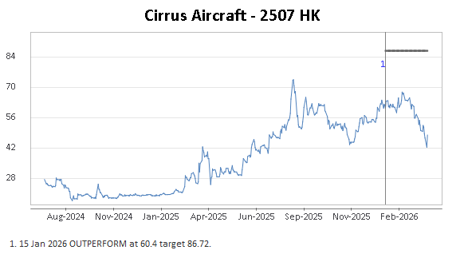
Source: Company data Bloomberg, HFI estimates

