[Table_Title]
研究报告Research Report
24 Feb 2026
全球宏观World Macro
SpaceX 100万卫星发射计划：收购xAI布局 "发射-算力-传输"垂直整合，解构地面算力核心成本困局重构商业版图
SpaceX 1M-Satellite Launch Plan: Acquires xAI for "Launch-Compute-Relay" Vertical Integration, Deconstructing Terrestrial Compute Cost Trap to Reshape Business Landscape
[Table_Author]
杨斌Bin Yang, SFC:BSQ313
harryyang@hfisec.com.hk

[Table_summary]
(Please see APPENDIX 1 for English summary)
事件一
1月30日（周五），埃隆·马斯克的 SpaceX 公司向美国联邦通信委员会（FCC）提交了一份申请，计划建造一个由多达一百万颗卫星组成的巨型星座，这些卫星将拥有前所未有的计算能力（轨道数据中心），为先进的人工智能（AI）提供支持。该申请声称“轨道数据中心”是满足日益增长的人工智能计算能力需求的最经济、最节能的方式。

事件二
2月2日（周一），SpaceX正式收购埃隆·马斯克的另一家公司xAI。SaceX公司表示：“收购xAI将打造地球上（乃至太空）最具雄心、垂直整合程度最高的创新引擎，涵盖人工智能、火箭、太空互联网、移动设备直连通信以及全球领先的实时信息和言论自由平台。” 通过此次合并，埃隆·马斯克计划利用SpaceX在快速发射、卫星制造和管理方面的深厚专业知识，部署一个由多达100万个轨道数据中心组成的星座。这将为xAI的运营提供强大的计算能力支撑。

点评
地面算力瓶颈凸显“天地迁移”：能源-土地-碳减排三重约束下，地面AI数据中心已面临物理成本与监管成本的双重天花板，太空轨道算力有望成为“最低成本AI算力生成地”。前 Terrestrial AI Data Center（地面数据中心）正面临物理成本与监管成本的双重绞杀。以1GW算力中心为例，按美国平均工业电价$0.15/kWh计算，年电费成本高达13亿美元。更严峻的是冷却用水约束：1MW数据中心年耗水2550万升，1GW级 facility 年耗水即达2.55亿升（约255,000吨），相当于5万人口城市日用水量，在干旱地区已引发"数据中心抢水"社会冲突。叠加欧盟碳边境税（CBAM）及美国各州潜在碳税压力，到2030年AI数据中心年碳排放将达2400-4400万吨（相当于500-1000万辆汽车），面临巨额外部性成本。SpaceX此次轨道方案或可针对性解套：卫星部署500-2000km太阳同步轨道，实现24/7不间断太阳能供电，真空环境红外辐射散热免水冷，彻底摆脱电网依赖与土地约束。根据Ars Technica报告，马斯克测算Starship每小时发射，每次飞行200吨，年可向轨道运送百万吨卫星，按每吨产生100kW算力计，年增100GW AI算力且"无持续运维需求"，估计2-3年内太空将成为"最低成本AI算力生成地"。

垂直整合闭环：星链中继+xAI算力+国防合同构筑“太空基建运营商”协同模式。SpaceX拟通过Starlink V3平台实现“观测-通信-计算-传输”分层架构，与xAI形成业务协同，从“火箭发射商”向“太空基础设施运营商”转型。太阳同步轨道卫星承担持续计算负载，低倾角轨道处理峰值需求，经星间激光链路构成分布式网络回传地面。这一架构与xAI形成业务协同——2025年7月，xAI与OpenAI、Google等共同获得美国国防部首席数字与人工智能办公室（CDAO）最高2亿美元合同，开发国防用途AI工具。SpaceX同时计划2026年以1.5万亿美元估值推进IPO（募资规模或超300亿美元），业务叙事从"火箭发射商"向"太空基础设施运营商"转型。然而，该模式依赖Starship达到每小时发射的频次目标，且卫星5年设计寿命意味着需持续补充发射以维持星座规模，实际运维成本与发射可靠性尚待验证。

全球格局与轨道资源重构：从资源分配到环境转移的多维透视。SpaceX百万级星座计划或将根本性改变近地轨道（LEO）资源格局，轨道资源分配逻辑正从“适度利用”转向“先占先得”。当前全球在轨活跃卫星约1.45万颗，SpaceX已占其中约9,600颗；百万级星座将使公司拥有相当于现存总量100倍的轨道资产，主要占据500-2,000km高度的太阳同步轨道。从天文观测角度，NASA Ames研究中心模拟显示，仅增加50万颗卫星即可能导致几乎所有地基望远镜图像被污染，届时夜空中每15个可见光点中约1个为移动卫星。环境层面，卫星5年设计寿命结束后需再入大气层销毁，向平流层释放铝等金属颗粒的累积效应尚待评估；Starship高频发射的化石燃料消耗亦将构成新的排放源。监管层面，现行国际空间法规定国家（而非企业）对太空物体造成的损害负责，但FCC审批仍基于"先占先得"原则，尚未建立针对巨型星座的累积性环境影响评估机制。这意味着轨道资源的分配逻辑正从"适度利用"转向"先发占有"，其长期影响有待观察。

图：1957-至今全球卫星发射格局的三次范式转移 |  | 图: SpaceX复用星链平台经验构建轨道数据中心星座
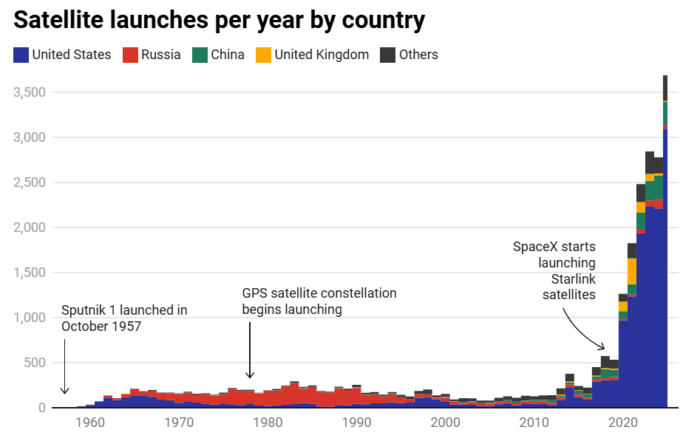 |  | 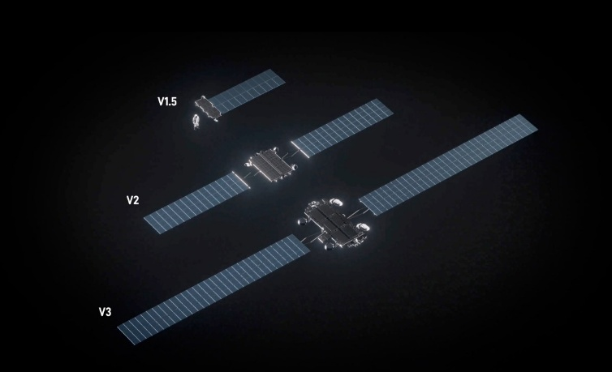
资料来源: European Space Agency, HFI |  | Source: SpaceX, HFI

投资建议
我们建议关注火箭制造与高频发射核心部件配套的企业【Howmet Aerospace】、【GE Aerospace】、【Safran】；航天级材料与卫星关键子系统的企业【Carpenter Technology】、【Honeywell】、【Eaton】；以及航天资产地面保障与供应链服务的企业【VSE Corporation】。

风险
火箭复用技术迭代不及预期影响发射效率与部署进度；FAA/FCC部门监管政策收紧延缓发射许可及星座审批；商业航天板块估值波动加剧投资不确定性。

APPENDIX 1
Summary
SpaceX filed on Jan 30 to deploy a 1-million-satellite orbital data center constellation and acquired xAI on Feb 2 to form a vertically integrated "launch-compute-relay" stack, targeting a $1.5tn IPO. The plan addresses terrestrial AI cost bottlenecks—$1.3bn annual electricity per GW and 255mn liters water consumption—by utilizing 24/7 space solar power and vacuum cooling, aiming for 100GW annual orbital compute capacity at "lowest cost within 2-3 years." If executed, the plan would drive a structural shift of global compute infrastructure from ground grid dependency to orbital solar supply, while triggering a fundamental transition in LEO resource allocation logic from "moderate use" to "preemptive occupation."

[Table_APPENDIX]
[Table_disclaimer]
附录APPENDIX
重要信息披露
本研究报告由华福国际（香港）金融控股有限公司（下称华福国际）分销，在其许可的司法管辖区内从事证券活动。
IMPORTANT DISCLOSURES
This research report is distributed by HuaFu International (HK) Financial Holdings Limited (referred as HuaFu International below), which is authorized to engage in securities activities in its respective jurisdiction.
分析师认证Analyst Certification:
我， 杨斌，在此保证（i）本研究报告中的意见准确反映了我们对本研究中提及的任何或所有目标公司或上市公司的个人观点，并且（ii）我的报酬中没有任何部分与本研究报告中表达的具体建议或观点直接或间接相关；及就此报告中所讨论目标公司的证券，我们（包括我们的家属）在其中均不持有任何财务利益。I, Bin Yang, certify that (i) the views expressed in this research report accurately reflect my personal views about any or all of the subject companies or issuers referred to in this research and (ii) no part of my compensation was, is or will be directly or indirectly related to the specific recommendations or views expressed in this research report; and that I (including members of my household) have no financial interest in the security or securities of the subject companies discussed.
利益冲突披露Conflict of Interest Disclosures
华福国际及其某些关联公司可从事投资银行业务和/或对本研究中的特定股票或公司进行做市或持有自营头寸。就本研究报告而言，如需了解其中提到的某一公司信息，请发邮件至lcd@hfisec.com.hk）
HuaFu International and some of its affiliates may engage in investment banking and / or serve as a market maker or hold proprietary trading positions of certain stocks or companies in this research report. As far as this research report is concerned, please send an email to lcd@hfisec.com.hk if the information about any company mentioned in this report is needed).
评级定义（从2020年7月1日开始执行）：
华福国际采用相对评级系统来为投资者推荐我们覆盖的公司：优于大市、中性或弱于大市。投资者应仔细阅读华福国际的评级定义。并且华福国际发布分析师观点的完整信息，投资者应仔细阅读全文而非仅看评级。在任何情况下，分析师的评级和研究都不能作为投资建议。投资者的买卖股票的决策应基于各自情况（比如投资者的现有持仓）以及其他因素。
分析师股票评级
优于大市，未来12-18个月内预期相对基准指数涨幅在10%以上，基准定义如下
中性，未来12-18个月内预期相对基准指数变化不大，基准定义如下
弱于大市，未来12-18个月内预期相对基准指数跌幅在10%以上，基准定义如下
各地股票基准指数：日本 – TOPIX, 韩国 – KOSPI, 台湾 – TAIEX, 印度 – Nifty100, 美国 – SP500; 其他所有中国概念股 – MSCI China.
Ratings Definitions (from 1 Jul 2020):
HuaFu International uses a relative rating system using Outperform, Neutral, or Underperform for recommending the stocks we cover to investors. Investors should carefully read the definitions of all ratings used in HuaFu International Research. In addition, since HuaFu International Research contains more complete information concerning the analyst's views, investors should carefully read HuaFu International Research, in its entirety, and not infer the contents from the rating alone. In any case, ratings (or research) should not be used or relied upon as investment advice. An investor's decision to buy or sell a stock should depend on individual circumstances (such as the investor's existing holdings) and other considerations.
Analyst Stock Ratings
Outperform: The stock’s total return over the next 12-18 months is expected to exceed the return of its relevant broad market benchmark by over 10%, as indicated below.
Neutral: The stock’s total return over the next 12-18 months is expected to be in line with the return of its relevant broad market benchmark, as indicated below. Underperform: The stock’s total return over the next 12-18 months is expected to be below the return of its relevant broad market benchmark by over 10%, as indicated below.
Benchmarks for each stock’s listed region are as follows: Japan – TOPIX, Korea – KOSPI, Taiwan – TAIEX, India – Nifty100, US – SP500; for all other China-concept stocks – MSCI China.

华福国际非评级研究：华福国际发布计量、筛选或短篇报告，并在报告中根据估值和其他指标对股票进行排名，或者基于可能的估值倍数提出建议价格。这种排名或建议价格并非为了进行股票评级、提出目标价格或进行基本面估值，而仅供参考使用。
HuaFu International Non-Rated Research: HuaFu International publishes quantitative, screening or short reports which may rank stocks according to valuation and other metrics or may suggest prices based on possible valuation multiples. Such rankings or suggested prices do not purport to be stock ratings or target prices or fundamental values and are for information only.
华福国际A股覆盖：华福国际可能会就中国A股进行覆盖及评级。华福证券，华福国际于福州的母公司，也会于中国发布中国A股的研究报告。但是，华福国际使用与华福证券不同的评级系统，且可能有完全独立的不同研究覆盖团队，所以华福国际与华福证券的中国A股评级、目标价乃至分析逻辑可能有所不同。
HuaFu International Coverage of A-Shares: HuaFu International may cover and rate A-Shares . HuaFu Securities, the ultimate parent company of HuaFu International based in FuZhou, covers and publishes research on these same A-Shares for distribution in mainland China. However, the rating system employed by HuaFu International differs from that used by HuaFu Securites and even the teams covering the same A-share stocks might be totally independently different, as a result there may be a difference in their coverage ratings, target prices and research logics for the same A-share stocks.
重要免责声明：
本报告由华福国际发行，该公司是根据香港证券及期货条例（第571章）持有第4类受规管活动（就证券提供意见）的持牌法团。
本文件所载信息和观点已被编译或源自可靠来源，但华福国际或任何其他属于华福国际的成员对其准确性、完整性和正确性不做任何明示或暗示的声明或保证。本文件中所有观点均截至本报告日期，如有更改，恕不另行通知。本文件仅供参考使用。文件中提及的任何公司或其股票的说明并非意图展示完整的内容，本文件并非/不应被解释为对证券买卖的明示或暗示地出价或征价。在某些司法管辖区，本文件中提及的证券可能无法进行买卖。如果投资产品以投资者本国货币以外的币种进行计价，则汇率变化可能会对投资产生不利影响。过去的表现并不一定代表将来的结果。某些特定交易，包括设计金融衍生工具的，有产生重大风险的可能性，因此并不适合所有的投资者。您还应认识到本文件中的建议并非为您量身定制。分析师并未考虑到您自身的财务情况，如您的财务状况和风险偏好。因此您必须自行分析并在适用的情况下咨询自己的法律、税收、会计、金融和其他方面的专业顾问，以期在投资之前评估该项建议是否适合于您。若由于使用本文件所载的材料而产生任何直接或间接的损失，华福国际及其董事、雇员或代理人对此均不承担任何责任。
除对本文内容承担责任的分析师除外，华福国际及我们的关联公司、高级管理人员、董事和雇员，均可不时作为主事人就本文件所述的任何证券或衍生品持有长仓或短仓以及进行买卖。华福国际的销售员、交易员和其他专业人士均可向华福国际的相关客户和公司提供与本文件所述意见相反的口头或书面市场评论意见或交易策略。华福国际可做出与本文件所述建议或意见不一致的投资决策。但华福国际没有义务来确保本文件的收件人了解到该等交易决定、思路或建议。
请访问华福国际网站 www.hfisec.com.hk ，查阅更多有关华福国际为预防和避免利益冲突设立的组织和行政安排的内容信息。
IMPORTANT DISCLAIMER
The research report is issued by HuaFu International, a licensed corporation to carry on Type 4 regulated activity (advising on securities) for the purpose of the Securities and Futures Ordinance (Cap. 571) of Hong Kong.
The information and opinions contained in this research report have been compiled or arrived at from sources believed to be reliable and in good faith but no representation or warranty, express or implied, is made by HuaFu International or any other related members from which this research report may be received, as to their accuracy, completeness or correctness. All opinions expressed herein are as of the date of this research report and are subject to change without notice. This research report is for information purpose only. Descriptions of any companies or their securities mentioned herein are not intended to be complete and this research report is not, and should not be construed expressly or impliedly as, an offer to buy or sell securities. The securities referred to in this research report may not be eligible for purchase or sale in some jurisdictions. If an investment product is denominated in a currency other than an investor's home currency, a change in exchange rates may adversely affect the investment. Past performance is not necessarily indicative of future results. Certain transactions, including those involving derivatives, give rise to substantial risk and are not suitable for all investors. You should also bear in mind that recommendations in this research report are not tailor-made for you. The analyst has not taken into account your unique financial circumstances, such as your financial situation and risk appetite. You must, therefore, analyze and should, where applicable, consult your own legal, tax, accounting, financial and other professional advisers to evaluate whether the recommendations suits you before investment. Neither HuaFu International nor any of its directors, employees or agents accepts any liability whatsoever for any direct or consequential loss arising from any use of the materials contained in this research report.
HuaFu International and its affiliates, officers, directors, and employees, excluding the analysts responsible for the content of this document, will from time to time have long or short positions in, act as principal in, and buy or sell, the securities or derivatives, if any, referred to in this research report. Sales, traders, and other professionals of HuaFu International may provide oral or written market commentary or trading strategies to the relevant clients and the companies within HuaFu International that reflect opinions that are contrary to the opinions expressed in this research report. HuaFu Internatioal may make investment decisions that are inconsistent with the recommendations or views expressed in this research report. HuaFu International is under no obligation to ensure that such other trading decisions, ideas or recommendations are brought to the attention of any recipient of this research report.
Please refer to HuaFu International’s website www.hfisec.com.hk for further information on HuaFu International’s organizational and administrative arrangements set up for the prevention and avoidance of conflicts of interest with respect to Research.

分发和地区通知：
除非下文另有规定，否则任何希望讨论本报告或者就本项研究中讨论的任何证券进行任何交易的收件人均应联系其所在国家或地区的华福国际销售人员。
香港投资者的通知事项：华福国际负责分发该研究报告，华福国际是在香港有权实施第1类受规管活动（从事证券交易）的持牌公司。该研究报告并不构成《证券及期货条例》（香港法例第571章）（以下简称“SFO”）所界定的要约邀请，证券要约或公众要约。本研究报告仅提供给SFO所界定的“专业投资者”。本研究报告未经过证券及期货事务监察委员会的审查。您不应仅根据本研究报告中所载的信息做出投资决定。本研究报告的收件人就研究报告中产生或与之相关的任何事宜请联系华福国际销售人员。
DISTRIBUTION AND REGIONAL NOTICES
Except as otherwise indicated below, any Recipient wishing to discuss this research report or effect any transaction in any security discussed in HuaFu International’s research should contact the HuaFu International salesperson in their own country or region.
Notice to Hong Kong investors: The research report is distributed by HuaFu International, which is a licensed corporation to carry on Type 1 regulated activity (dealing in securities) in Hong Kong. This research report does not constitute a solicitation or an offer of securities or an invitation to the public within the meaning of the SFO. This research report is only to be circulated to "Professional Investors" as defined in the SFO. This research report has not been reviewed by the Securities and Futures Commission. You should not make investment decisions solely on the basis of the information contained in this research report. Recipients of this research report are to contact HuaFu International salespersons in respect of any matters arising from, or in connection with, the research report.

中华人民共和国的通知事项：在中华人民共和国（下称“中国”，就本报告目的而言，不包括香港特别行政区、澳门特别行政区和台湾）只有根据适用的中国法律法规而收到该材料的人员方可使用该材料。并且根据相关法律法规，该材料中的信息并不构成“在中国从事生产、经营活动”。本文件在中国并不构成相关证券的公共发售或认购。无论根据法律规定或其他任何规定，在取得中国政府所有的批准或许可之前，任何法人或自然人均不得直接或间接地购买本材料中的任何证券或任何实益权益。接收本文件的人员须遵守上述限制性规定。
本项研究仅供收件人使用，未经华福国际的书面同意不得予以复制和再次分发。
版权所有：华福国际2025年。保留所有权利。
People’s Republic of China (PRC): In the PRC, the research report is directed for the sole use of those who receive the research report in accordance with the applicable PRC laws and regulations. Further, the information on the research report does not constitute "production and business activities in the PRC" under relevant PRC laws. This research report does not constitute a public offer of the security, whether by sale or subscription, in the PRC. Further, no legal or natural persons of the PRC may directly or indirectly purchase any of the security or any beneficial interest therein without obtaining all prior PRC government approvals or licenses that are required, whether statutorily or otherwise. Persons who come into possession of this research are required to observe these restrictions.
This research report is intended for the recipients only and may not be reproduced or redistributed without the written consent of an authorized signatory of HuaFu International.
Copyright: HuaFu International 2025. All rights reserved

